The Title of the Abstract Should be Written in Title Case

First Author1, Second Author2, and Third Author3

Corresponding Author: [email@address.com](mailto:email@address.com)

1. Affiliation of the first author, including Department/Institution, City and Country.

2. Affiliation of the second author, including Department/Institution, City and Country.

3. Affiliation of the third author, including Department/Institution, City and Country.

Welcome to APT&M 2018! Your abstract should be no more than one page in length, including all figures, tables, and references. The abstract should be written in English. Please do not alter the margins, text sizes, or other formatting used in this template. Abstracts that do not meet the template guidelines may be modified to fit the template, or may be excluded from the proceedings.

Please submit your abstract in Microsoft Word format, or as a PDF, via email to [aptm2018@nist.gov](mailto:aptm2018@nist.gov). In the subject line of your email please indicate the type of presentation you prefer: Müller, Oral, or Poster. Also, please indicate a [topic area](https://www.nist.gov/mml/agenda-0) to help us assign this abstract to a session. You should receive a reply message indicating that your submission was received. The abstract submission deadline is January 15, 2018. **The submission deadline for** [Müller competition](https://www.nist.gov/mml/e-w-muller-young-scientist-award) **is also January 15, 2018, and this cannot be changed.** We encourage authors to also submit a full-length paper for peer review/publication in a special APT&M 2018 issue of the journal *Microscopy and Microanalysis*. The deadline for submission of this full-length paper is July 10, 2018. Details on how to submit the full-length paper will soon be posted on the APT&M 2018 conference website. You will be notified of the status of your abstract submission by February 28, 2018.

Thank you for submitting an abstract to APT&M 2018!

****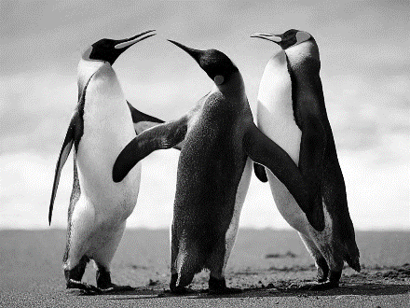**(a)**

**Figure 1 (a)** Please provide a caption for your figure. **(b)** Figures may be submitted in color, although figures in the printed program will be displayed in greyscale. Figures should be understood without the use of color.

References:

[1] F. Author, S. Author and T. Author, Article title, Journal Name volume(year), 1-10.

[2] F. Author, et al., Book Title, fourth ed., Publisher, Place of Publication, year.

[3] F. Author, *et al*., Chapter title in: F. Editor, *et al*., Book Title, Publisher, Location, year, pp. 1-10.

[4] Please include any acknowledgements as the final entry in the reference list.