Title: 14 pt, Times New Roman: A template for SPW2017 abstracts

First¹, Second², Third¹ Author, etc. (Times New Roman, 9 pt)
¹Affiliation: Times New Roman, 8pt, italicized, Institute, city/town, country

Abstract. Times New Roman, 10 pt. One page, including references. Please send a finalized word or pdf copy of your abstract to: spw2017@nist.gov, with the subject: SPW 2017 abstract. Of course, you can create your abstract in latex. However, in this case please compile it to a 1-page pdf.

Body text. SPW 2017 is intended to bring together a broad range of scientists, engineers and newcomers in the field of single-photon generation and detection for fundamental science and applications. Researchers from universities, industry, and government will present their latest developments in single-photon devices and methods with a view toward improved performance and new application areas. It will be an exciting opportunity for those interested in single-photon technologies to learn about the state-of-the-art and to foster continuing partnerships with others seeking to advance the capabilities of such technologies. One day of the workshop will be devoted to lab-tours on the campus of NIST.

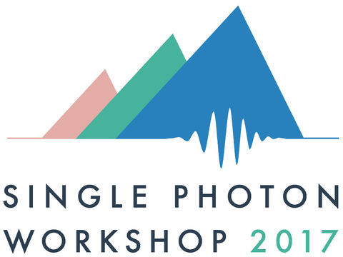

Fig 1. Figure caption: Times New Roman, 8 pt. The single photon workshop will be held in the week from July 31st 2017 through August 4th 2017 [1].

Table 1: Workshop topics
Single Photon Detectors | Single Photon Sources | Metrology | Applications of single photon technologies
Single photon avalanche detectors | Spontaneous parametric downconversion and four-wave-mixing | Methods for characterizing single-photon detectors and sources | Quantum communication
Superconducting single photon detectors | NV centers | Quantum Sensing | Optical quantum-state generation
Single Photon Detector arrays | Quantum Dots | Weak measurements | Quantum random number generators
Photon-number-resolving detectors | On-demand single-photon sources | Novel measurement schemes | Biology/Chemistry
Integrated Single Photon Detectors | Integrated single-photon sources |  | Telecom
Entangled photon-pair sources. |  |  | Imaging and ranging
 |  |  | Spectroscopy

References
[1] We are looking forward to seeing you in Boulder!

