FAX TO: (301) 975-8943 FOR NIST USE ONLY:
NIST RECEIVABLES GROUP PROJECT/TASK: 683C595
ATTENTION: Ann Marie Walsh

Dimensional Metrology Workshop
May 2 to 4, 2017
*Payment information (tuition is $625):

Last Name First Name
Title
Organization
Business Address
Room or Mail Code
City/State/Zip
Telephone ( )
Fax ( )
E-Mail

☐ Purchase Order/Training Order No.

☐ Credit Card (circle one): MasterCard, Visa, Discover, or American Express

Total due: $625

Credit Card Number:
Name on Credit Card:
Expiration Date
Card Identification Number (see next page for instructions):

Authorized Signature

☐ Check enclosed (please make checks payable to “DOC/NIST”) Total Enclosed $
Please complete this form and return by MAIL OR FAX ONLY no later than Friday, April 14, 2017, to:

NIST
ATTN: Ann Marie Walsh
Finance Division/Receivables Group
100 Bureau Drive, Stop 1624
Gaithersburg, MD 20899-1624
FAX: (301) 975-8943
(NIST’s Federal ID No. is 530-20-5706)
*YOUR PLACE IN THE TRAINING EVENT IS NOT CONFIRMED UNTIL PAYMENT IS RECEIVED
**To protect your credit card information, please do not use email.
Credit Card Identification Numbers
The card identification number is an important security feature that helps validate that the account is legitimate.

Visa & MasterCard
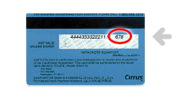

Visa, MasterCard and Discover card identification numbers are three (3) digit numbers printed to the right of the account number on the reverse side of the card.

American Express
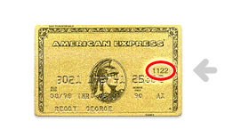

American Express card identification numbers are four (4) digit numbers printed to the right above the account number on the face of the card.

