Manipulation

Metric
In-hand manipulation is a kinematic measure of how well a robotic hand can control the pose of an object. The pose of an object is described in Cartesian coordinates, and the manipulation efficacy is captured in terms of control error between the desired object Cartesian pose and the measured object Cartesian pose over a time-varying trajectory. This capability is arguably one of the most difficult to achieve and measure, but is paramount to achieving dexterous robotic systems.

Dependencies
In-hand manipulation is an apex function for a robotic hand, and therefore depends on everything ranging from its mechatronic design and basic components to its control software. Performance is also substantially dependent on the object’s properties: friction coefficient, mass, mass distribution, geometric dimensions, and morphology. Performance also depends on finger-object contact configuration, and number of fingers as well.

Test Method
Artifact:
Due to object dependency, the test should be conducted across a range of objects of varying properties. Most objects can be retrofitted with reflective markers in order to measure the object’s Cartesian pose during manipulation with a reference motion capture system (MOCAP).

Description:
Of the previously listed dependencies, only the object will be taken as a controlled test variable. It will be up to the user to place the fingers appropriately on the object that maximizes performance. Once appropriate contact has been established by an object and a robotic hand, an object-fixed coordinate system should be known to both the robotic hand and the reference MOCAP system with the respective transformations. From the object’s initially grasped pose, $r_{c}\left(t_{0}\right)∈R^{6×1}$, $t_{0}$ is the time at initial grasp acquisition, the hand should individually manipulate the object along as many independent Cartesian axes as possible (up to six) along a desired Cartesian trajectory, $r_{cd}\left(t\right)∈R^{6×1}, r_{cd}=[x,y,z,γ,β,α]$, where $x,y,z$ are translations and $γ$,$β$, $α$ are rotations about the $X$, $Y$, and $Z$ axes. Along each viable axis, the object should be moved both positively and negatively from the initial condition (starting point) on that axis. The desired magnitude and rate of travel from $r_{c}\left(t_{0}\right)$ should be recorded. A simple method for doing so is to define the desired Cartesian trajectory as $r_{cd,i}\left(t\right)=Asin\left(2πft\right)+r_{c,i}\left(t_{0}\right)$ for $i=1,…,6$. In this case, $A$ is the motion magnitude, and $f$ is the number of motion cycles per second. The total manipulation error, $e_{total}=r_{cd}-r_{c}$, should be recorded over time during a manipulation test.
INSERT FIGURE

Figure 1: Finger-Object Configuration

Performance Measures:
The main performance measure should be the Root Mean Squared Error of $e_{total}$, ${RMSE}_{e,total}$. ${RMSE}_{e,total}$ is calculated for each set of manipulation tests. For thorough experimentation, several runs should be conducted for a manipulation test, and the mean and standard deviation of ${RMSE}_{e,total}$ can be calculated to capture a more accurate representation of performance.

Example Implementation
Test Setup:
A three-fingered, 7 degree-of-actuation robotic hand retrofitted with bio-inspired tactile sensors was used as the test platform to manipulate several objects (see Fig. 2). Also shown in this figure are three geometrically primitive artifacts – sphere, cuboid, and cylinder. The sphere has a diameter of 120 mm and mass of 286 g, the cuboid has dimensions of 90 mm by 90 mm by 75 mm and a mass of 178 g, and the cylinder has a diameter of 90 mm, a height of 75 mm, and a mass of 143 g. The artifacts are retrofitted with reflective markers for position tracking using a motion capture system (MOCAP). The time-variant desired translation and rotation trajectories were defined as follows:

1) $r_{cd,z}=-0.0075sin(t)+0.1425$ (m)
2) $r_{cd,γ}=-\frac{π}{25}sin(1.25t)$ (rad)
3) $r_{cd,β}=-\frac{π}{25}sin(0.75t)$ (rad)

For these objects, these three pose axes were deemed controllable by this hand, and therefore, $r_{cd,x}$, $r_{cd,y}$, and $r_{cd,α}$ were left equal to their respective initial conditions.

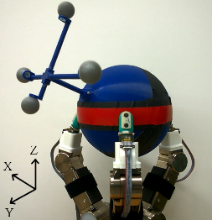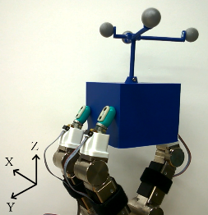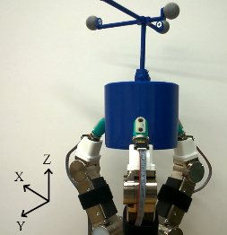
Figure 2. Robotic hand holding a a) sphere, b) cuboid, and c) cylinder with attached reflective markers for object motion tracking.

Results:

The desired object trajectory can be deconstructed in terms of manipulation amplitude and frequency as shown in Table 1.
- Motion magnitude and motion cycles per second across independent axes.
$r_{cd}$ component | Amplitude, $A$ | Frequency, $f$ (Hz)
$$r_{cd,x}$$ | N/A | N/A
$$r_{cd,y}$$ | N/A | N/A
$$r_{cd,z}$$ | 7.5 (mm) | 0.16
$$r_{cd,γ}$$ | 7.2 (deg) | 0.20
$$r_{cd,β}$$ | 7.2 (deg) | 0.12
$$r_{cd,α}$$ | N/A | N/A
Given these trajectory parameters, the following manipulation performance was captured in Table 2. The orientation error remained relatively low. The translation performance was most accurate in the Z-axis across all objects. Substantial translation error accrued in the X and Y axes.
- Total manipulation performance for object translation and object orientation.
Object | ${RMSE}_{e,total}$ (mm) | ${RMSE}_{e,total}$ (deg)
Sphere | [19.61,6.05,1.89] | [0.79,0.57,1.20]
Cuboid | [8.93,5.15,2.55] | [1.21,0.58,0.41]
Cylinder | [12.57,6.85,2.57] | [0.76,0.62,1.48]

Notes:
The desired trajectories were concatenated for a single manipulation operation. Retrospectively, a single manipulation test should consist of the hand manipulating the object along a single, independent axis only.

Data (to do):
Data File Archive:
Data Files:
File Format:
Data Values:
Units:
Data Sample Rate:

