Service Life Prediction for Concrete Pavements and Bridge Decks Exposed to Sulfate Attack and Freeze-Thaw Deterioration, Volume I: CONCLIFE User’s Manual

Mark A. Ehlen
Dale P. Bentz

Building and Fire Research Laboratory

National Institute of Standards and Technology

Gaithersburg, MD 20899

Abstract
This user’s guide describes the set of screens and an example analysis for CONCLIFE, user-friendly software for estimating the service life of concrete pavements and bridge decks exposed to sulfate attack and freeze-thaw deterioration. CONCLIFE uses three concrete models and user-specified data on concrete properties and external environmental conditions to estimate the time at which the concrete spalls beyond a user-specified limit. Sorptivity of sulfate ions and water are the primary means of degradation; the software uses a laboratory test, currently in the ASTM standardization process, for measuring concrete sorptivity. The software also produces graphs of concrete sorptivity, annual precipitation, and estimated rates of concrete spalling. This report is volume I of a two-part series. Volume II provides the details of the experimental program conducted at the National Institute of Standards and Technology in support of the software development and provides details on the underlying technical bases for the models employed in CONCLIFE.

Keywords: building technology, concrete bridge decks, concrete pavements, environmental conditions, freeze-thaw deterioration, service life, sorptivity, sulfate attack.

TABLE OF CONTENTS

Section Page

CHAPTER 1: INTRODUCTION TO CONCLIFE VERSION 1.0 1
1.1 Introduction 1
1.2 Disclaimer 2
CHAPTER 2: USING CONCLIFE 3
2.1 Installation 3
2.2 Main CONCLIFE Screens 3
Analysis Set Section 4
Sulfate Attack Tab Panel 5
Input parameters 5
Time of wetness 6
Sorptivity function 7
Service life 7
Freeze-Thaw Tab Panel 7
Input parameters 8
Time of wetness 9
Sorptivity function 9
Service life 9
CHAPTER 3: SUPPLEMENTARY CONCLIFE SCREENS 11
3.1 Edit own weather data window 11
3.2 Compute sorptivity function window 12
3.3 Graphs and maps 13
U.S. map for weather locations 13
Sorptivity function graph 14
Weather data graph 15
Spalling graph 16
CHAPTER 4: EXAMPLE ANALYSIS 17
CHAPTER 5: SUMMARY AND PROSPECTUS 19
REFERENCES 20

LIST OF FIGURES

Figure Page

Figure 1. CONCLIFE main window showing Sulfate attack tab panel. 4
Figure 2. Basic configurations of one-dimensional heat transfer models for concrete pavements and bridge decks. 6
Figure 3. Freeze-thaw tab panel. 8
Figure 4. Generate own data window. 11
Figure 5. Screen for computing sorptivity function from measured data. 12
Figure 6. Map of weather data cities. 13
Figure 7. Graph of typical sorptivity function. 14
Figure 8. Time-of-wetness data for a concrete pavement in Providence, RI. 15
Figure 9. Graph of estimated spalling over time for a pavement in Providence, RI exposed to sulfate attack. 16

LIST OF TABLES

Table Page

Table 1. Generic material properties for the heat transfer/TOW model. 7
Table 2. Modulus of elasticity for the concretes from reference (4). 17
Table 3. Sorptivity properties for the concretes. S is the sorptivity and I_{o} is the initial sorption.^{(4,5)} 17
Table 4. Predicted service lives for the concretes.⁽⁵⁾ 18

CHAPTER 1: INTRODUCTION TO CONCLIFE VERSION 1.0

1.1 Introduction

Even though concrete is the second most widely used material in the world, concrete designers have had only limited success in getting this material to perform over the long term as intended. The degradation and ultimate failure of concrete is a complex process highly dependent on the internal properties of the concrete, on structural loads imposed on the concrete member, and on external environmental conditions.^{(1,2)} In recent years, much research has focused on developing comprehensive computer models that predict the service life of concrete structures. CONCLIFE is one such model.

CONCLIFE estimates the service life of concrete pavements and bridge decks exposed to sulfate attack and freeze-thaw degradation, where the major transport mechanism for water and sulfate ion ingress is sorption by partially saturated concrete. To predict service life, CONCLIFE uses models with parameters that include concrete material properties, typical environmental conditions, and concrete sorptivities measured in the laboratory on extracted field core specimens. Laboratory evaluation of sorptivity was selected over in situ field evaluation due to the inherent problems associated with both pre-conditioning concrete in the field to a known water saturation state and the variable temperature and relative humidity conditions present in a field environment.⁽³⁾ Therefore, to generate data for the sorptivity model, a laboratory test for evaluating the sorptivity of concrete cylinders was developed⁽⁴⁾ and is currently in the process of ASTM standardization by Committee C 09.

Using these laboratory-measured sorptivity properties, CONCLIFE applies three computer models to estimate service life.^{(4,5,6)} The first, a finite difference heat transfer model, estimates the surface temperature and time-of-wetness of the concrete in a user-specified climate.⁽⁶⁾ Time-of-wetness events can be due to precipitation, or due to condensation when the concrete surface temperature falls below the current dew-point temperature. Sample time-of-wetness data for specific locations is provided by the Typical Meteorological Year weather data available from the National Renewable Energy Laboratory (NREL- http://www.nrel.gov).⁽⁷⁾ In CONCLIFE, the user can select default time-of-wetness files, or generate their own time-of-wetness files by providing inputs on pavement or bridge deck geometry and on concrete thermal properties.

The second model, based on Atkinson and Hearne’s work,⁽⁸⁾ uses the time-of-wetness data and measured sorption coefficients to predict the service life of the concrete under sulfate attack conditions. But, whereas Atkinson and Hearne considered diffusion to be the dominant mechanism of sulfate ion transport, CONCLIFE uses sorption as the primary mechanism. The CONCLIFE user selects the concentration of sulfate ions in the external solution (rainwater or condensation) for the selected geographical location.

The third model in CONCLIFE estimates the service life of the concrete pavements or bridge decks when the primary mechanism of degradation is freeze-thaw deterioration. Based on the research of Fagerlund,⁽⁹⁾ the model considers that failure (concrete cracking) under freeze-thaw conditions is due to the slow saturation of the concrete’s air void system, which compromises the protection normally provided by the “empty” air voids. The slow saturation rate is characterized by the sorption rate after the “nick-point” time in the measured sorptivity-vs.-time curve.^{(4,5)} For this prediction, the user provides estimates of concrete porosity, air content, and critical saturation (zero to one) necessary to compromise the air void system, along with the concrete sorptivity and time-of-wetness data.

1.2 Disclaimer

This software was developed at the National Institute of Standards and Technology by employees of the Federal Government in the course of their official duties. Pursuant to title 17 Section 105 of the United States Code, this software is not subject to copyright protection and is in the public domain. CONCLIFE is an experimental system. NIST and FHWA assume no responsibility whatsoever for its use by other parties, and make no guarantees, expressed or implied, about its quality, reliability, or any other characteristic. We would appreciate acknowledgement if the software is used.

The U.S. Department of Commerce makes no warranty, expressed or implied, to users of CONCLIFE, and accepts no responsibility for its use. Users of CONCLIFE assume sole responsibility under Federal law for determining the appropriateness of its use in any particular application, for any conclusions drawn from the results of its use, and for any actions taken or not taken as a result of analyses performed using these tools.

CONCLIFE is intended for use only by those competent in the field of concrete technology and is intended to supplement the informed judgment of the qualified user. Lack of accurate predictions by the CONCLIFE models could lead to erroneous conclusions with regard to materials selection and design. An informed user should evaluate all results.

CHAPTER 2: USING CONCLIFE

2.1 Installation

If the user is installing CONCLIFE from a CD, they should access their CD-ROM drive and double click the INSTALL.BAT icon. If they are downloading CONCLIFE from the web, they should uncompress the zip file and double-click INSTALL.BAT. The installation program will give the user the option of changing the CONCLIFE program directory; if the default location is acceptable, press the OK button. Once installation is completed, start CONCLIFE by accessing it in the Start/Programs/CONCLIFE menu choice.

Minimum configuration required:

- PentiumTM P5 (80585) – 100 MHz Processor or better.
- Windows 95/98TM, Windows METM, Windows 2000TM, or Windows NTTM operating system.
- 64 Mbytes RAM
- SVGA (1024x768x8bpp) or higher resolution monitor.

2.2 Main CONCLIFE Screens

CONCLIFE allows the user to create, conduct, and save numerous analyses, each called an “analysis set.” In each analysis set, the user specifies concrete material properties, environmental conditions, the sorptivity of the concrete over time, and the level of concrete spalling at which failure as defined by the user occurs. CONCLIFE then estimates the service life of the concrete based on deterioration from either sulfate attack or freeze-thaw. The CONCLIFE screens needed to complete these steps are shown in turn.

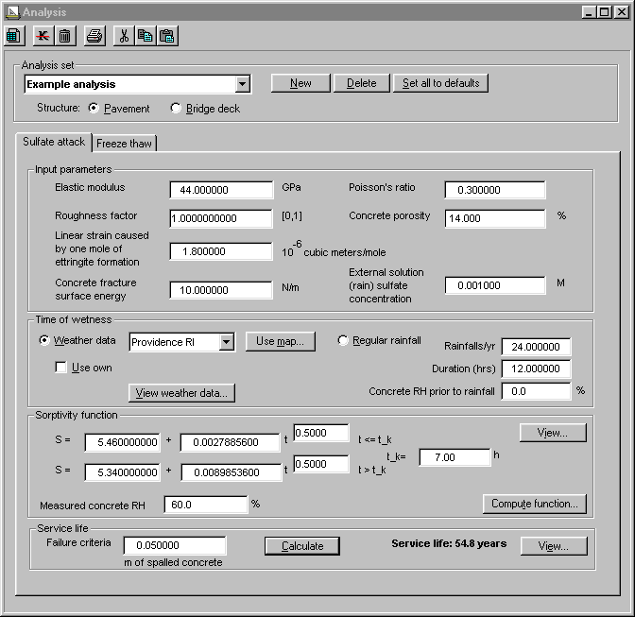

Figure 1. CONCLIFE main window showing Sulfate attack tab panel.

The Analysis window, shown in figure 1, has three main areas: the Analysis set section, the Sulfate attack tab panel, and the Freeze-thaw tab panel.

Analysis Set Section

The Analysis set section maintains the database of CONCLIFE analysis sets. The drop-down box lists the current set of saved analyses. To create a new analysis set, press the New button; the user will be asked to enter a name for this new analysis. The Delete button will delete the currently displayed analysis (after asking for confirmation). The Set all to defaults button will set all of the sulfate attack and freeze-thaw parameter values in the currently displayed analysis set to their default values (after asking for confirmation).

Use the Pavement or Bridge deck button to specify whether a concrete pavement or bridge deck is being analyzed. This is an important distinction: because of the differences in their geometries and thermal boundary conditions, the temperature and time-of-wetness behavior of concrete pavements and bridge decks will be different, even when they are produced from the same materials and placed in the same geographical location. For example, departments of transportation often post “bridge freezes before road surface” signs because concrete suspended above ground freezes sooner than the same type of concrete in direct contact with the ground. CONCLIFE models this difference, by maintaining separate pavement and bridge deck time-of-wetness files for each of the thirteen sample geographical locations provided.

Sulfate Attack Tab Panel

The Sulfate attack tab panel is divided into four major areas: Input parameters, Time of wetness, Sorptivity function, and Service life.

Input parameters

The Sulfate attack tab panel uses a model based on the Atkinson and Hearne model,⁽⁸⁾ which requires the following parameters, shown in the Input parameters section:

- measured elastic modulus of the concrete in GPa (default value is 44 GPa) – the elastic modulus is the ratio of applied stress to the measured strain for the initial elastic region of the response obtained during a compression test;
- roughness factor for the fracture path through the concrete (zero to one, one is the default);
- linear strain caused by the reaction of sulfate ions to form one mole of ettringite (expressed in units of m³/mol x 10⁻⁶, with a default value of 1.8 x 10⁻⁶,⁽⁸⁾ equal to one-third of the bulk expansion caused by one mole of ettringite formation);
- concrete fracture surface energy (in N/m, default value is 10 N/m);
- Poisson’s ratio for the concrete (0.3 is the default value) – it is the ratio of the transverse contraction per unit dimension of a bar of uniform cross-section to its elongation per unit length, when subjected to a tensile stress;
- concrete porosity (percent, default value of 14 percent); and
- sulfate ion concentration of the solution (precipitation or condensation) to which the concrete is being exposed (in units of mol/liter, default value of 0.001 M) – measured sulfate ion concentrations in precipitation at a variety of geographical locations throughout the U.S. are available at the WWW site of the National Atmospheric Deposition Program (http://nadp.sws.uiuc.edu).

CONCLIFE provides default values for each of these parameters. However, whenever possible, the user should use their own values from experimental measurements made on the concrete and/or environment under analysis.

Time of wetness

After specifying the concrete material properties, next select in the Time of wetness section the environment to which the concrete is exposed. Environmental data can be specified in one of two ways. First, the user can select a typical time-of-wetness (TOW) history from the Weather data drop-down box or by pressing the Use map button and selecting a city. These default TOW files, generated form typical meteorological year data (TMY2DATA) files provided by the National Renewable Energy Laboratory,⁽⁷⁾ are based on specific geometries for the pavements and bridge decks as shown in figure 2 and a specific set of thermal properties for the concrete and pavement sub-base as provided in table 1. (See below for a description on how to change these default data on geometry and thermal properties.)

To view the weather data, press the View weather data button. This will display a histogram of the duration of each wetting event during the year for the geographical location currently shown in the weather data text box. These features will be discussed in more detail below.

Figure 2. Basic configurations of one-dimensional heat transfer models for concrete pavements and bridge decks.

A second, simpler model of environmental data can instead be specified by inputting “regular” rainfalls in the Rainfalls/yr and Duration (h) fields. In this case, specify the number of rainfalls per year, the duration of each rainfall, and the typical RH of the concrete just prior to the rainfall. Whether using the time-of-wetness histories or using the “regular rainfall” data, CONCLIFE uses this weather data to model the concrete’s sorption of water over time.

Table 1. Generic material properties for the heat transfer/TOW model.
Material | Heat Capacity  (J/(kg ºC)) | Thermal Conductivity  (W/(m ºC)) | Density  (kg/m³) | Emissivity | Solar Absorptivity
Concrete | 1000 | 1.5 | 2350 | 0.9 | 0.65
Soil | 800 | 0.3 | 1600 | --- | ---

Sorptivity function

The Sorptivity function section is used to input, view, and potentially generate the function describing the sorptivity of the concrete under analysis. Input the values that describe the concrete’s sorptivity over time (where time is measured in minutes and sorptivities in mm). As described in References (4) and (5), experimental sorptivity vs. time curves typically exhibit distinct behavior at early times and at later times. Both behaviors can be fit by a square root of time function with an intercept term. The “nick-point” time is the time when the sorptivity switches from the early-age behavior to the later-age behavior. The parameters describing the sorptivity can be determined either by (1) using an analysis tool outside of CONCLIFE, such as a spreadsheet, or (2) using the Compute sorptivity function window in CONCLIFE (accessed by pressing the Compute function button in the Sorptivity function section of the Sulfate attack tab panel). To compute a sorptivity from available measured experimental data, see the Compute sorptivity function section below. The user will also need to provide the measured concrete RH prior to sorptivity testing, as described in the proposed ASTM sorptivity test.⁽⁴⁾ To view a graph of the current sorptivity function, press the View button.

Service life

In the Service life section input the criteria for concrete failure (measured in terms of m-depth of spalled concrete). When the user has input all parameters for the four sections, they should press the Calculate button to have CONCLIFE estimate the time required for spalling to caused by sulfate attack to reach this depth. They may press the View button to view a graph of this spalling over time.

Freeze-Thaw Tab Panel

Estimating freeze-thaw deterioration, the second degradation mechanism that CONCLIFE models, is analogous to that for sulfate attack. The Freeze-thaw tab panel, shown in figure 3, has the same four sections as the Sulfate attack tab panel: Input parameters, Time of wetness, Sorptivity function, and Service life.

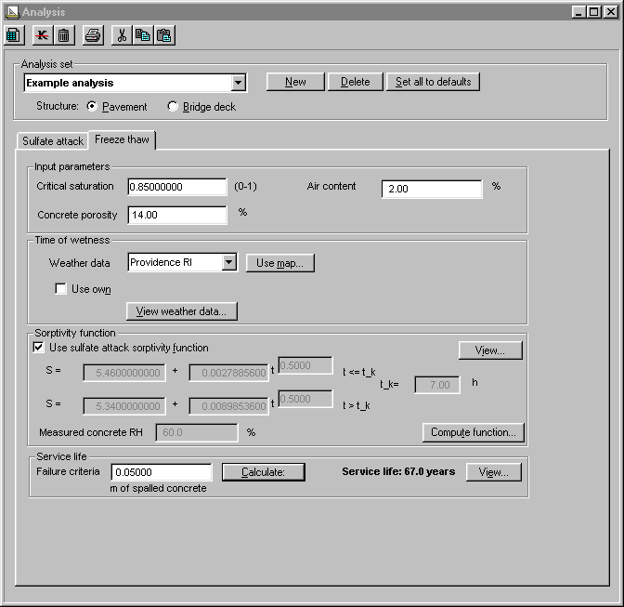
Figure 3. Freeze-thaw tab panel.

Input parameters

The freeze-thaw model is based on the work of Fagerlund,⁽⁹⁾ and requires the following parameters:

- Critical saturation (zero to one) of the air void system necessary to cause damage during a freezing event,
- Concrete porosity (percent), and
- Concrete air void content (percent).

Input these values in their corresponding fields in the Input parameters section.

Time of wetness

The freeze-thaw model uses only the TOW files generated from typical meteorological year data (TMY2DATA) files provided by the National Renewable Energy Laboratory,⁽⁷⁾ not any user-specified constant values. Select a particular location from the Weather data drop-down box, or press the Use map button to select from the geographical map. See below for a description of how to create your own TOW files using a different geometry or thermal properties than the defaults provided above in Figure 2 and Table 1.

Sorptivity function

Values for the sorptivity function are input in the same fashion as for the sulfate attack model. To use the same function being used in the Sulfate attack tab panel, check-mark the Use sulfate attack sorptivity function box.

Service life

As with the sulfate attack model, failure is measured in terms of the depth of spalled concrete. After inputting this depth (in m) and verifying all other input parameters, calculate the estimated time for failure to be reached by pressing the Calculate button. A graph of this spalling can be viewed by pressing the View button.

CHAPTER 3: SUPPLEMENTARY CONCLIFE SCREENS

CONCLIFE also provides windows for: constructing new weather data files using your own concrete and environmental data; constructing sorptivity functions using laboratory data; and displaying weather data, sorptivity functions, and spalling over time.

3.1 Edit own weather data window

In addition to the supplied weather data files in the Sulfate attack and Freeze-thaw tab panels, the user can create their own weather data files based on their own data on the geometry of the concrete structure and the thermal properties of the concrete and the soil sub-base. To access the Generate own data window (figure 4), check-mark the Use own box in the Time of wetness section of either model and press the Edit button that appears.

Figure 4. Generate own data window.

Up to six weather data sets can be created for each city listed in the Weather data drop-down boxes of the Sulfate attack and Freeze-thaw tab panels. To create a new own-data set in the Generate own data window, select the set in the Thermal set drop-down box.
Be sure to name the set so that it is recognizable in future work. Edit the slab and sub-base values for thickness (there is no sub-base for a bridge deck) and thermal properties. When done, press the Go button to create the new weather data set (this may take up to 10 minutes). When the new set is created, it will appear as a choice in the Own data drop-down boxes in the Sulfate attack and Freeze-thaw tab panels; if the user doesn’t press Go, the set will be saved in this Generate own data window but will not appear in the Sulfate attack and Freeze-thaw tab panels.

3.2 Compute sorptivity function window

If the user has sorptivity data generated from the proposed ASTM laboratory test for sorptivity,⁽⁴⁾ CONCLIFE can estimate a sorptivity function based on this data. In the Sorptivity function section of either the Sulfate attack or Freeze-thaw tab panels, press the Compute function button to access the Compute sorptivity function window (shown in figure 5). Input the laboratory data in the spreadsheet on the left (clear any old data by pressing the Clear button), then press the Compute function button. If the computed sorptivity parameters are acceptable, press the Use this function button; the sorptivity values in the Sulfate attack tab panel will then be updated. Press the Cancel button to exit this screen without updating the sulfate attack sorptivity function.

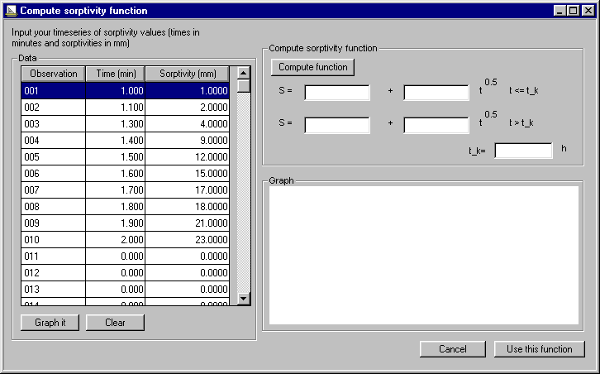
Figure 5. Screen for computing sorptivity function from measured data.

3.3 Graphs and maps

A number of graphs and maps are provided throughout CONCLIFE to aid in the understanding of the environmental data, of the sorptivity of concrete over time, and of the spalling of concrete over time.

U.S. map for weather locations

The weather location map, shown in figure 6, displays the cities for which CONCLIFE provides time-of-wetness data. Select sample weather data for a particular city by clicking on the city name. To access this map, press the Use map button in the Time of wetness section of either the Sulfate attack or the Freeze-thaw tab panel.

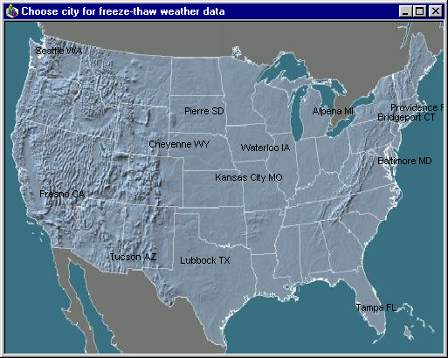
Figure 6. Map of weather data cities.

Sorptivity function graph

A graph of the current sorptivity function (figure 7) can be viewed by pressing the View button in the Sorptivity function section of either the Sulfate attack or Freeze-thaw tab panel. The graph can be printed by selecting the Print/Graph selection from the menu.

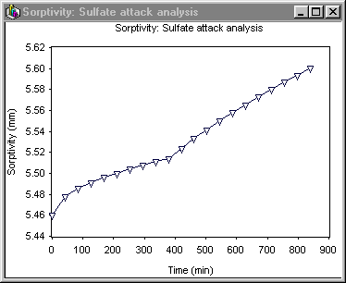
Figure 7. Graph of typical sorptivity function.

Weather data graph

The time-of-wetness data files can be graphed by pressing the View weather data button in the Time of wetness section of either the Sulfate attack or Freeze-thaw tab panel. This graph, shown in figure 8, can be printed by selecting Print/Graph from the CONCLIFE menu.

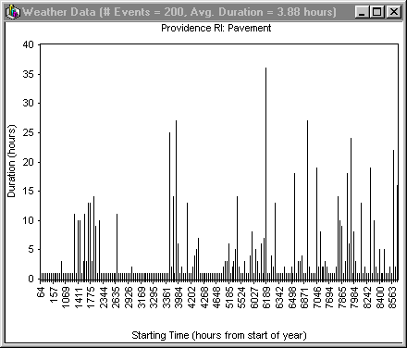
Figure 8. Time-of-wetness data for a concrete pavement in Providence, RI.

Spalling graph

A graph of estimated spalling over time (figure 9) can be viewed for either model by pressing the View button in the Estimated failure section. (The View button appears only if the service life has been estimated.) To print this graph, select Print/Graph from the CONCLIFE menu.

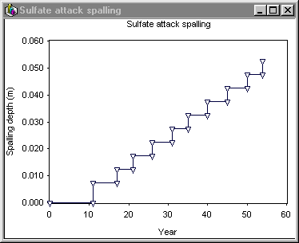
Figure 9. Graph of estimated spalling over time for a pavement in Providence, RI exposed to sulfate attack.

CHAPTER 4: EXAMPLE ANALYSIS

To illustrate the use of CONCLIFE, this section describes an analysis performed by NIST⁽⁵⁾ that compared the predicted service lives of concrete pavements in Rhode Island and Missouri. The parameters and assumptions used in this analysis can be found in the analysis set “Example analysis” included with CONCLIFE.

NIST, with cooperation from the Rhode Island and Missouri departments of transportation (DOTs), measured and developed estimates of the material characteristics, structural geometries, and environmental conditions of sample concrete pavements in the two states, and then used CONCLIFE to estimate service lives. NIST first measured the elastic moduli and sorptivity coefficients of concrete cores obtained from the two states’ DOTs.^{(4,5)} The measured values are shown in tables 2 and 3.

Air content of the concretes was assumed to be a marginal air void system with only two percent air. The sulfate concentration of the rainwater/condensation was estimated to be 0.001 mol/L, the concrete porosity to be 14 percent (based on measurements on the Rhode Island cores), and the critical saturation of the air void system necessary to cause freeze-thaw damage to be 0.85. Pavement “failure” in both states was defined as spalling in excess of 0.05 m. Figures 1 and 3 show these and the other values used in the CONCLIFE analysis. The resulting CONCLIFE estimates of the service lives are shown in table 4.

Table 2. Modulus of elasticity for the concretes from reference (4).
Rhode Island | Missouri Rt.65 |  | Missouri Rt. 13
Rhode Island | Driving lane | Passing Lane | Driving Lane | Passing lane
44 ± 1 GPa | 46 ± 0.3 GPa | 42 ± 0.2 GPa | 48 ± 0.3 GPa | 43 ± 0.2 GPa

Table 3. Sorptivity properties for the concretes. S is the sorptivity and I_{o} is the initial sorption.^{(4,5)}
Sorption Property | Rhode Island | Missouri Rte 65 Driving Lane | Missouri Rte 13 Driving Lane
I₀ (early age) (mm) | 5.46 | 0.075 | 0.017
S (early age) (10⁻³ mm/√min) | 2.79 | 3.25 | 3.64
Nick point time (h) | 7 | 7 | 6
I₀ (later age) (mm) | 5.34 | 0.065 | 0.034
S (later age) (10⁻³ mm/√min) | 8.98 | 3.95 | 3.02

Table 4. Predicted service lives for the concretes.⁽⁵⁾
Degradation mode | Rhode Island | Missouri Rte. 65 Driving Lane | Missouri Rte 13 Driving Lane
Sulfate attack | 54.8 years | > 99 years | > 99 years
Freeze-thaw | 67.0 years | > 99 years | > 99 years

The very low sorptivities of the Missouri concretes result in estimated sulfate attack and freeze-thaw service lives that exceed 99 years (the maximum computed lifetime in the NIST CONCLIFE software). The higher I₀ (early age) and S (later age) values for the Rhode Island concrete result in sulfate attack and freeze-thaw predicted service lives of about 55 years and 67 years, respectively. While these analyses are quite preliminary in nature, they serve to illustrate the significant influence of concrete sorptivity on service life. Much effort remains to evaluate the reliability and accuracy of such predictions on field structures with known service lives.

CHAPTER 5: SUMMARY AND PROSPECTUS

The CONCLIFE software has been developed to simulate the influence of environmental conditions and concrete physical properties (elastic modulus, sorptivity, etc.) on the service life of field concretes based on existing models for sulfate attack⁽⁸⁾ and freeze-thaw degradation.⁽⁹⁾

In the future, it is expected that improvements in all of these areas will increase the accuracy of such service life estimates. As the fundamental mechanisms of concrete degradation are further elucidated, revisions to and extensions of the degradation models will become possible. More accurate and complete data on the “local” concrete environmental conditions can also be incorporated into future versions of CONCLIFE. Thus, CONCLIFE is viewed as a starting point for the complex topic of service life prediction for concrete pavements and bridge decks. It addresses only specific modes of failure (sulfate attack and freeze-thaw degradation due to sorption) based on the current state-of-the-art and understanding of these degradation modes. But the general methodology of combining concrete physical properties and local environmental data to predict concrete performance must surely be utilized in all future service life models if the state-of-the-art and our understanding are to be significantly advanced.

REFERENCES

- Basheer, P.A.M., Chidiac, S.E., and Long, A.E., “Predictive Models for Deterioration of Concrete Structures,” Construction and Building Materials, Vol. 10 (1), 27-37, 1996.
- Nilsson, L.O., “Interaction Between Microclimate and Concrete- A Prerequisite for Deterioration,” Construction and Building Materials, Vol. 10 (5), 301-308, 1996.
- Bentz, D.P., Clifton, J.R., Ferraris, C.F., and Garboczi, E.J., “Transport Properties and Durability of Concrete: Literature Review and Research Plan,” NISTIR 6395, U.S. Department of Commerce, September 1999.
- Bentz, D.P., Ferraris, C.F., and Winpigler, J., “Service Life Prediction for Concrete Pavements and Bridge Decks Exposed to Sulfate Attack and Freeze-Thaw Deterioration, Volume II: Technical Basis for CONCLIFE: Sorptivity Testing and Computer Models,” FHWA Report, 2001.
- Bentz, D.P., Ehlen, M.A., Ferraris, C.F., and Garboczi, E.J., “Sorptivity-Based Service Life Predictions for Concrete Pavements,” 7th International Conference on Concrete Pavements, Orlando, FL, September 2001.
- Bentz, D.P., “A Computer Model to Predict the Surface Temperature and Time-of-Wetness of Concrete Pavements and Bridge Decks,” NISTIR 6551, U.S. Department of Commerce, August, 2000.
- Marion, W., and Urban, K., User’s Manual for TMY2s: Typical Meteorological Years, National Renewable Energy Laboratory, June 1995.
- Atkinson, A., and Hearne, J.A., “Mechanistic Model for the Durability of Concrete Barriers Exposed to Sulphate-Bearing Groundwaters,” MRS Symposium Proceedings, Vol. 176, 149-156, 1990.
- Fagerlund, G., “Modeling the Service Life of Concrete Exposed to Frost,” International Conference on Ion and Mass Transport in Cement-Based Materials, University of Toronto, October, 1999.

? Certain commercial products are identified to completely specify the research program. In no case does such identification imply endorsement by NIST or the FHWA or that the identified products are the best available for the purpose.

