Speaker Bios:
Session 1 – Simulations 10:30 AM - 12:00 PM (90 minutes)
Leonardo Bacciottini U Mass
Leonardo is a postdoctoral researcher at UMass Amherst, working with Professors Don Towsley, Stefan Krastanov, and Gayane Vardoyan. He received his Ph.D. from the University of Pisa, Italy, in 2025. His research interests on quantum networks include architectures, resource allocation, and entanglement distribution protocols. He is also currently involved in the development of QuantumSavory, the Center for Quantum Networks flagship quantum simulation toolkit.

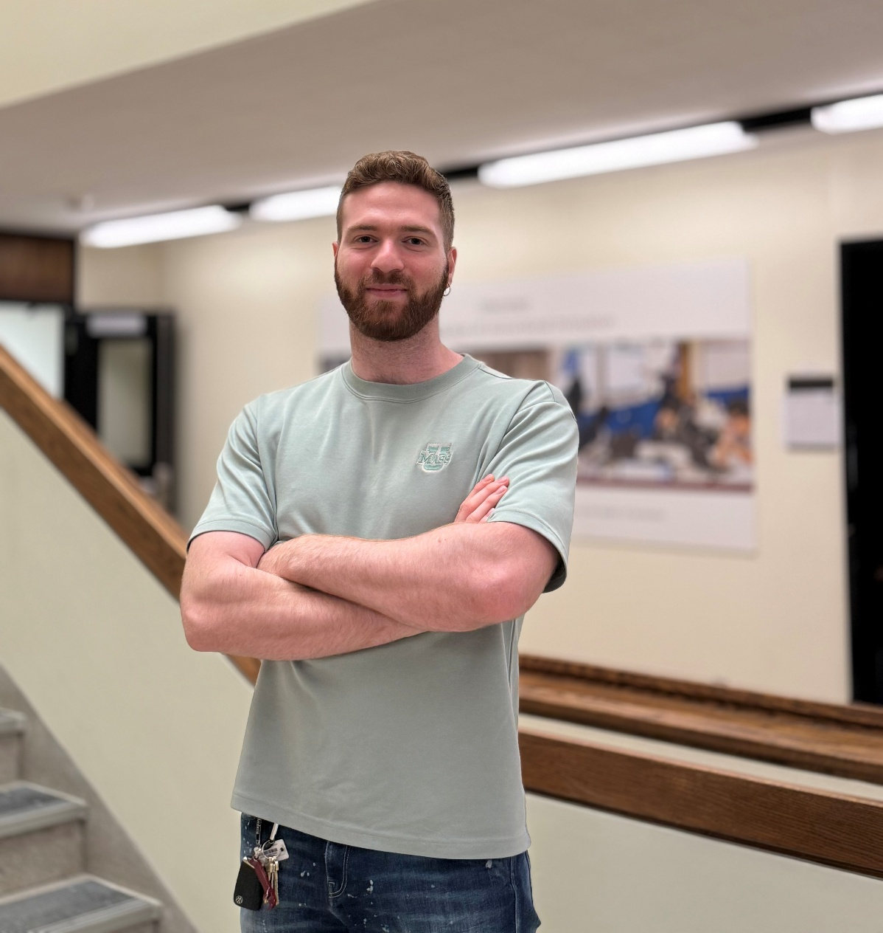

Cara Alexander, Aliro
Cara leads Aliro's product strategy, vision, and roadmap, bridging the gap between rapidly evolving user needs and technical possibilities.
Her uniquely multidisciplinary perspective and broad technical domain stem from her work as a manager, software developer, and researcher in applied physics, AI, and quantum computing at stage startups and large institutions. Cara has a diverse academic research background from stellar astrophysics to medical physics and applied deep neural networks. In the public and private sector, she has focused on bringing highly technical advances in the quantitative sciences out of the lab and into people’s lives by creating functional and transformative tangible solutions. Her previous industry roles include bringing AI to clinical workflows at BC Cancer, quantum computing research and software development at Agnostiq, and product management at Agnostiq. Cara holds a Master of Applied Computing degree from the University of Toronto and a Bachelor of Science degree in Physics and Mathematics from the University of British Columbia.
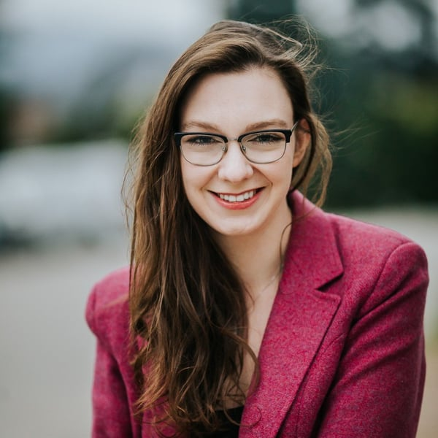

Joaquin Chung, Argonne National Laboratory
Joaquin Chung is a research scientist in computer networking and system software at the University of Chicago and he holds a joint appointment at the Data Science and Learning Division at Argonne National Laboratory. His work spans diverse areas that go from designing systems for enabling memory-to-memory data streaming between federated instruments to architecting the control plane of future quantum communication networks to exploring advance wireless network solutions for scientific use cases. He received both his B.S. in Electronics and Communications Engineering (2007) and his M.Sc. in Communication Systems Engineering with Emphasis in Data Networks (2013) from University of Panama, Panama. He received his Ph.D in Electrical and Computer Engineering (2017) at Georgia Institute of Technology, Atlanta, USA. He is a Fulbright alumn, an IEEE senior member, and an ACM member.
T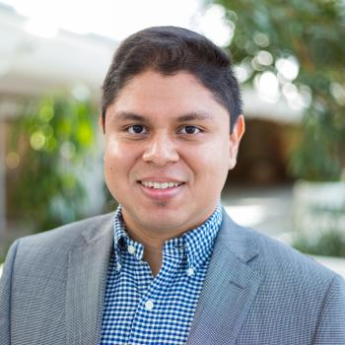

Session 2: Experiments- 1:00 PM - 2:30 PM (90 minutes)
Dr. Janis Nötzel, Technical University of Munich (TUM).
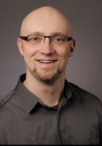
Dr. Janis Nötzel is a researcher and leader of the Emmy Noether Research Group for Theoretical Quantum Systems Design at the Technical University of Munich (TUM). He studied physics at the Technical University of Berlin before completing his doctorate at TUM in 2012 with a dissertation titled "Quantum Communication under Channel Uncertainty". Following postdoctoral work as a Deutsche Forschungsgemeinschaft (DFG) scholar at the Universitat Autònoma de Barcelona and leading a research transfer team in the 5G Lab at TU Dresden, he returned to TUM in December 2018 to establish the DFG's first Emmy Noether Group focused on quantum technologies in electrical engineering. Affiliated with the Chair of Theoretical Information Technology, his research centers on quantum information theory, secure message transmission, physical layer security, and developing mathematical concepts, software tools, and emulator models to integrate quantum communication technologies into conventional networks.

Dr. Ivan A. Burenkov, Joint Quantum Institute (JQI), the University of Maryland, (NIST).
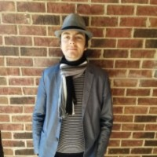
Dr. Ivan A. Burenkov is an Assistant Research Scientist at the Joint Quantum Institute (JQI) and the University of Maryland, working in collaboration with the National Institute of Standards and Technology (NIST). He received his Ph.D. degree from Lomonosov Moscow State University, where he initially served as a postdoctoral research fellow building a laboratory for experimental cold atom physics and atomic optics. In 2015, he joined the quantum optics group led by Sergey V. Polyakov at NIST/JQI. Dr. Burenkov’s research spans experimental and theoretical quantum optics, focusing on single-photon sources and detectors, quantum metrology, quantum measurements, quantum biophotonics (including single-photon sensitive quantum flow cytometers), and the characterization and stabilization of metropolitan-scale quantum networks. Ivan developed a collection of analysis tools for quantum photonics, available free of charge at: https://www.iburenkov.com/

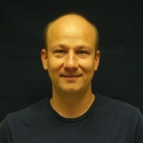
Thomas Gerrits is a Physicist in the Applied and Computational Mathematics Division at the National Institute of Standards and Technology. He received his M.S. and PhD degree from the University of Nijmegen, The Netherlands. In 2006 he joined the Faint Photonics and Quantum Nanophotonic groups at NIST and has pioneered the applications of high-efficiency superconducting single photon detectors for quantum optics and quantum information. He also worked on establishing a quantum standard for traceable optical radiometry. In 2020 he joined ITL’s Computing and Communications Theory Group at NIST, where he is developing widgets, methods and protocols for the characterization of future quantum networks and network components. His research interests include the generation of exotic quantum states of light, optical quantum metrology, development of measurement tools for quantum and classical optics, single photon imaging and quantum radiometry.

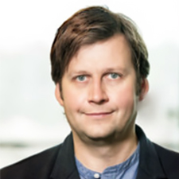
Dr. Sergey V. Polyakov is a physicist and Chief of the Quantum Measurement Division within the Physical Measurement Laboratory at the National Institute of Standards and Technology (NIST). He earned his B.S. and M.S. degrees in physics from Moscow State University in 1998, followed by an M.S. (2000) and Ph.D. (2003) in optics from the University of Central Florida's CREOL. Before joining NIST as a permanent staff member in 2013, Dr. Polyakov conducted postdoctoral research on atomic ensemble-based quantum memory at Caltech in the group of H. Jeff Kimble and worked as a guest researcher at NIST and the Joint Quantum Institute (JQI) beginning in 2005. An Optica Fellow, his research centers on quantum optics, single-photon generation and detection, quantum-enabled communications, and quantum biophotonics—utilizing the quantum properties of light to advance precision measurement, optical metrology, and biosensing beyond classical limits.

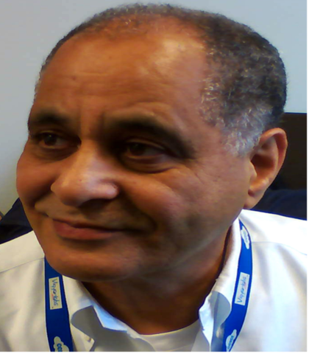
Dr. Abdella Battou is the Chief of Smart Connected Systems in the Communication Technology Laboratory (CTL) at the National Institute of Standards and Technology (NIST), where he also leads the NIST Cloud Computing Program. Before joining CTL, Dr. Battou served from 2012 to 2021 as the Division Chief of the Advanced Network Technologies Division within NIST's Information Technology Laboratory. His earlier career includes leadership and research roles across industry, academia, and government, including serving as the Executive Director of the Mid-Atlantic Crossroads (MAX) GigaPop (2009–2012), Chief Technology Officer and Vice President of R&D at Lambda OpticalSystems (2000–2009), and senior research scientist for the Naval Research Laboratory's high-speed networking group at the Center for Computational Sciences (1992–2000).

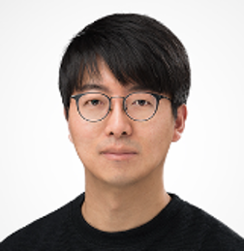
Byungkyu Ahn received the B.S., M.S., and Ph.D. degrees in electrical engineering from Korea University, Seoul, South Korea, in 2011, 2013, and 2019, respectively. From 2019 to 2022, he was a Research engineer at LG Electronics, Seoul. He is currently a Senior Research Engineer with LG Electronics Company Inc. His research interests include quantum (secure) communications, quantum and classical error correction code, and hardware implementation.

Session 3: - Standards and Use Cases: 3:00 PM – 4:30 PM (90 minutes)
Angela Sara Cacciapuoti, University of Naples Federico II
Angela Sara Cacciapuoti is a Professor of Quantum Communications and Networks at the University of Naples Federico II (Italy) and co-founder of the Quantum Internet Research Group (www.quantuminternet.it). She is an ERC grantee for the ERC Consolidator-Grant QNattyNet, which aims to lay the foundations of a truly quantum-native Internet (www.qnattynet.quantuminternet.it).
In recognition of her pioneering contributions, she received numerous honors, including the “2024-IEEE Communications Society Award for Advances in Communication”, one of the Society’s most prestigious technical awards, conferred to an outstanding paper that has opened new lines of research and significantly shaped the field of communications engineering over the past 15 years. Other distinctions include the “2022-IEEE ComSoc Best Tutorial Paper Award”, the “2022-WICE Outstanding Achievement Award”, the “2021-N2Women: Stars in Networking and Communications”, and the “2023-IEEE ComSoc Distinguished Service Award (EMEA Region)”.
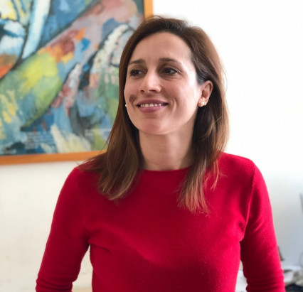
Prof. Cacciapuoti has served as an IEEE ComSoc Distinguished Lecturer, delivering talks on the Quantum Internet design and quantum communications. Currently she serves as member of the TC on SPCOM within the IEEE Signal Processing Society. She is also an Area Editor for IEEE Transactions on Communications, and a Senior Editor for the IEEE JSAC Quantum Series. Moreover, she serves on the editorial board of npj Quantum Information, IEEE Transactions on Quantum Engineering, and IEEE Communications Surveys & Tutorials. She previously served as Area Editor for IEEE Communications Letters (2019–2023), where she received the 2017 Exemplary Editor Award. She has held other leadership roles within IEEE such as serving as Vice-Chair of the IEEE ComSoc Women in Communications Engineering, Publicity Chair of WICE, and Treasurer of the IEEE Women in Engineering Affinity Group (Italy Section).

Timothy Burt, QED-C, L3Harris
Tim Burt has over 30 years experience in Defense and Aerospace, 19 of that with L3Harris Space and Airborne Systems. He obtained a Ph.D. in Theoretical Quantum Optics studying the quantum-classical correspondence in the extended Jaynes-Cummings model. He worked at Raytheon as a high-performance computing Software Engineer, complex Systems Engineer, and Staff Physicist. At L3Harris he has specialized in physics-based modeling of optical imaging chains and Quantum Solutions to design and analyze systems and applications. He is the Chair of the Industry Advisory Board for the Center for Quantum Networks, and the Deputy Technical Advisor for the US National Committee for IEC/ISO JTC 3 Quantum technologies.



Taesang Choi, Korea University
Taesang Choi is a principal researcher and research professor with over 30 years of experience at Electronics and Telecommunications Research Institute (ETRI) and Korea University. He has been actively involved in the domestic and international R&Ds of Traffic Engineering, Traffic Measurement and Analysis with machine learning, SDN/NFV management, 5G/6G network slice and resource management, Cyber Security Attack Analysis, 5G & beyond network/service agile autonomic federation, and recently Quantum Key Distribution Network (QKDN) and Quantum Network control and management. He has also actively contributed in various SDOs and open-source activities such as 3GPP, IETF, ITU-T, ONF, ONOS and etc. He has published over 20 QKDN related ITU-T Recommendations and initiated developing Quantum Network related standards. He is currently acting as ITU-T SG13 Question 6 Rapporteur and a contributor of IRTF QIRG (Quantum Internet Research Group) and 3GPP SA5 (for 6G management). He received his MS (1990) and Ph.D (1995) degrees in Computer Science and Telecommunications in Univ. of Missouri-Kansas City.
