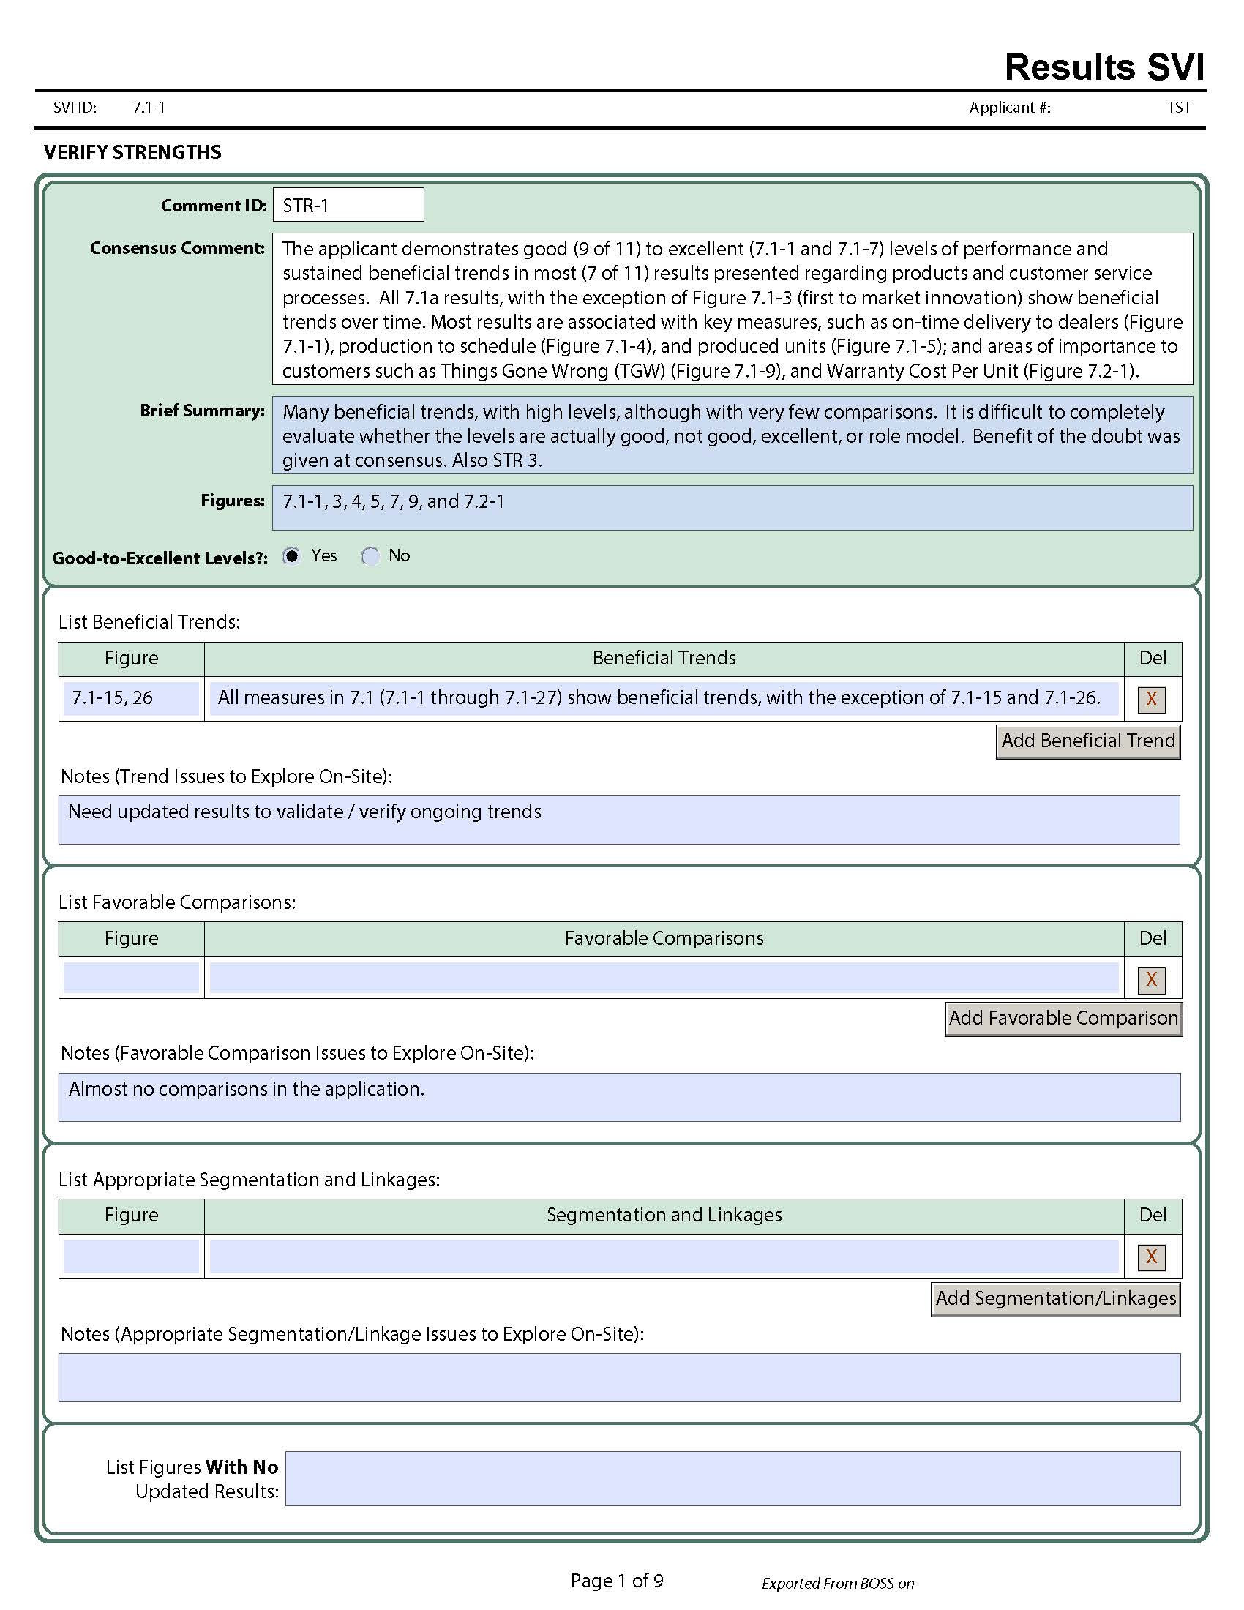

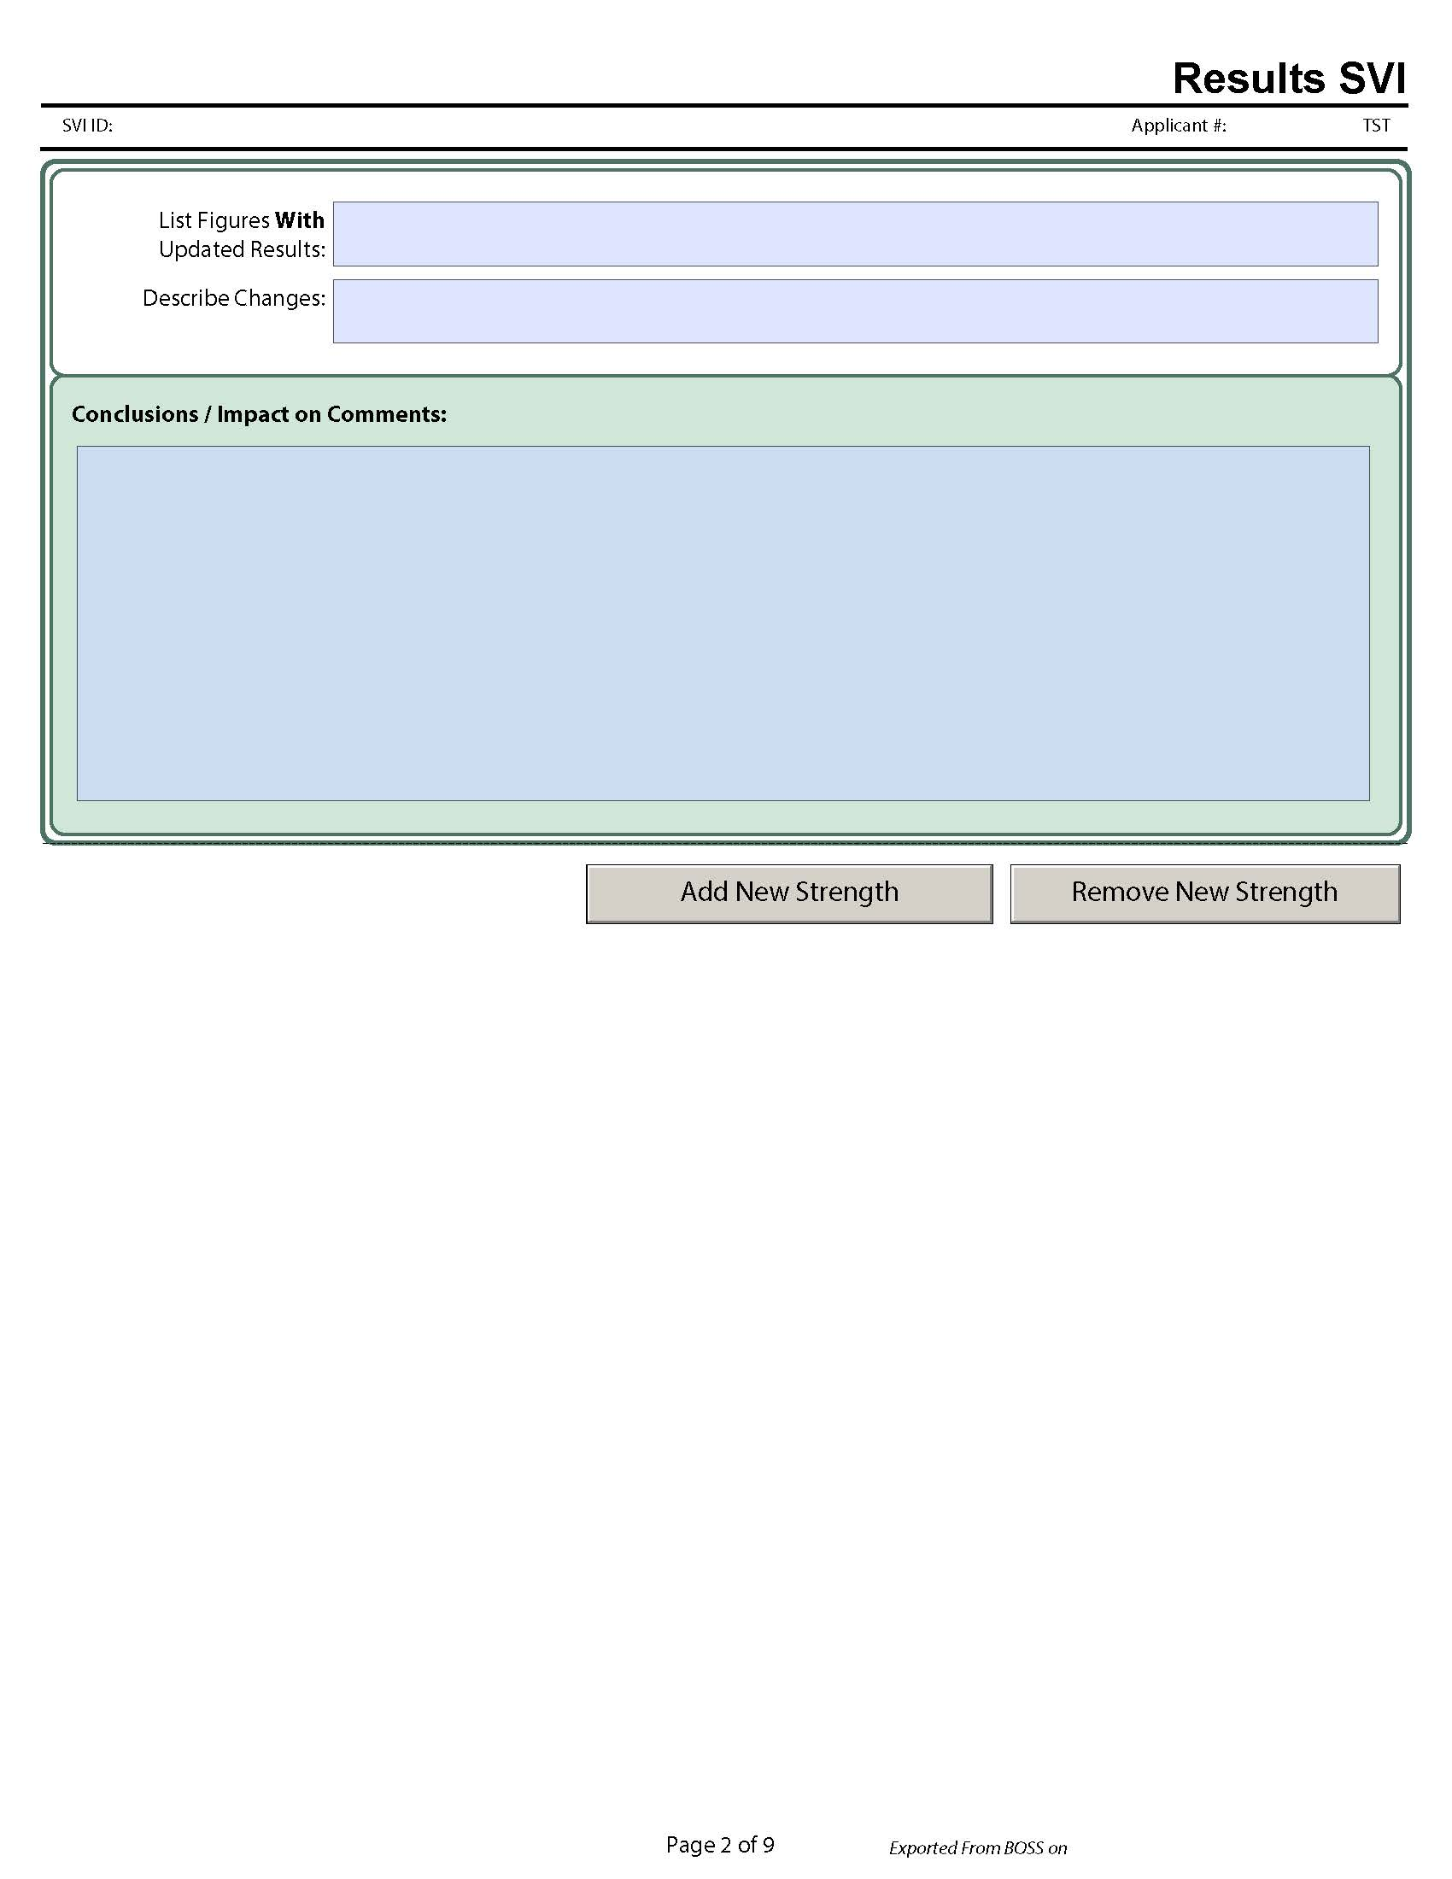

Clarify OFIs. OFI-1 Many expected results are missing such as those for some customer requirements (safety, reliability, quality of cut), or measures to control and improve key work processes (Figure 6.1-2); no results for design quality measures [6.1a(1)] such as time for the design of new mowers; or key support process results (e.g., Maintenance). There are no results for safety and emergency preparedness effectiveness, supply chain management (to include CEVA), or the operational performance of the applicant's innovation process.  The measurement and analysis of these results may assist the organization in addressing its off-shore competition challenge.Results are missing in areas identified as important to the applicant in the processes and/or profile.  Poor Levels: No Lack of Segmentation and Linkages to Explore On-Site: customer requirements (safety, reliability, quality of cut)
Measures to control and improve key work processes (Figure 6.1-2)
Design quality measures [6.1a(1)] such as time for the design of new mowers
Key support process results (e.g., Maintenance). T
Safety and emergency preparedness effectiveness
Supply chain management (to include CEVA)
Operational performance of the applicant's innovation process

OFI-2. The applicant demonstrates adverse trends in performance in several areas of importance.  For example, results for First-to-Market Product Innovations (Figure 7.1-3) declined in four of six areas including Safety which declined from 5 in 2013 to 1 in 2017.  Key Recycling Trends (7.1-18) does not show improvement in five of the six measures: Paper, Cardboard, Solvent & Oil, Wood, and Aluminum/Plastic.  Improvement in these performance results may assist the applicant in meeting its CSF to Increase percent of solid waste stream recycling. Brief Summary: Some of the trends were declining.  Need to verify that beneficial trends have continued to move in the desired direction and whether adverse trends have reversed.  Need to verify levels and trends for any missing measures. Poor Levels: No; Adverse Trends:7.1-3 First-to-Market Product Innovations
7.1-15 Inherent Availability
7.1-26 SCM Inventory (Days)

