Touch Sensitivity

Metric
Touch sensitivity is a kinetic measure of the smallest self-registered contact force exerted by a robotic finger on an object. The significance of this trait revolves around the hand’s ability to delicately interact with minimal disturbance to the immediate environment as well as detect small force perturbations. Direct applications would include touch-based grasp planning, or part acquisition with object location or shape uncertainties.

Dependencies
This characteristic is a function of the hand’s sensor capabilities, motion controllers, bandwidth, closing speed, finger size, and finger-object configuration.

Test Method
Apparatus:
Option 1: Object fixed to load cell, three-axis load cell measuring the forces imposed on the object
Option 2: Position tracking system to measure relative translation and rotation of an object in space during touch interaction.

Description:
In order to most accurately capture the performance of a hand in this category, a dynamic test is needed. Of the previously listed dependencies, only the closing speed and finger configuration are assumed controllable. In order to reduce the performance search space, the test is simplified by entertaining a worst-case scenario. In particular, the robotic finger(s) are commanded close on an object at a specified joint velocity. An important finger-object configuration for benchmarking occurs at a specified joint velocity and at a fully-extended configuration with the finger orthogonal to the palm surface (see Figure 1). At this configuration, the Cartesian velocity at the fingertip is maximized which will induce the highest impact forces upon collision. By commanding different closing speeds, a spread of behavior can be generated that will provide the user valuable insight on the tradeoff between speed and touch sensitivity for any particular robotic hand.

Performance Measures:

- Force – If using a sensor capable of resolving forces in three dimensions, compute the resultant magnitude of contact forces from the load cell data, $F_{contact}$, by computing the $L_{2}$ norm of the three-dimensional contact forces as

$$F_{contact}= \sqrt{{F_{x}}^{2}+{F_{y}}^{2}+{F_{z}}^{2}}$$

Extract the peak $F_{contact}$ for each touch test cycle over a range of hand closing speeds. After collecting these maximum forces for each closing speed, compute the mean and 95% confidence intervals to evaluate the force associated with the closing speed.

- Displacement – If using an object position tracking system compute the resultant relative translation, $T_{contact}$ and rotation, $R_{contact}$.

$$T_{contact}= \sqrt{{T_{x}}^{2}+{T_{y}}^{2}+{T_{z}}^{2}}$$

$$R_{contact}= \sqrt{{R_{x}}^{2}+{R_{y}}^{2}+{R_{z}}^{2}}$$

After collecting these displacements for each closing speed, compute the mean and 95% confidence intervals to evaluate the displacement associated with the closing speed.

Example Implementation (Force)

Test Setup:
The test was performed with a mounted robotic hand and an external 6-axis load cell. The calibrated load cell is used as ground truth for measuring contact forces. A robotic arm was used to position the hand relative to the load cell, however, once positioned, the arm remained stationary throughout the test with its brakes engaged. To begin, the robotic finger under test is placed in a fully extended configuration with fingertip touch occurring on a cylinder mounted to the load cell (see Figure 1). Next, the finger is fully retracted to remove contact with the load cell and to provide sufficient offset for the finger to obtain the desired closing speed before contact. While recording the load cell force data, the hand was commanded to close at a preset joint velocity while polling the fingertip sensor for the slightest indication that contact has been established. Once contact is detected by the hand, the control program automatically commands the finger to hold position. This process was repeated 10 times for 6 different closing velocities.

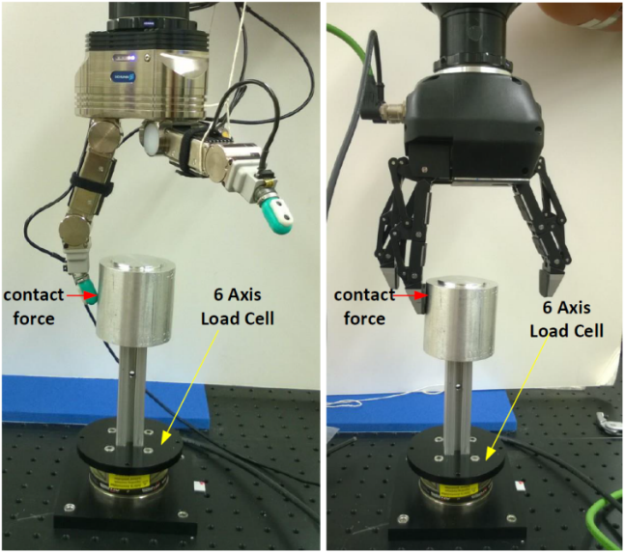
Figure 1. Finger-artifact configuration during touch sensitivity testing.

Results:
After data collection, a touch sensitivity performance measure is extracted. First, the resultant magnitude of contact forces from the load cell data is calculated by computing the $L_{2}$ norm of the three-dimensional contact forces ($F_{contact}$). This yields the overall size of the contact force exerted by the finger onto the artifact. Next, the peaks of the force data are extracted which yield the maximum impact forces for each test cycle, $F_{contact,max}$ (see Figure 2). After collecting these maximum forces for each closing speed, the mean and 95% confidence intervals are calculated to establish a most likely performance point and the uncertainty.

After data collection and analysis across Hand 1 with impedance and resistance sensing, and Hand 2 with current sensing, the data is displayed to show not only an absolute performance, but relative performance (see Figure 3). The lower the maximum contact force, the more sensitive and reactive the finger.

Data:
Data File Archive: | Touch Sensitivity.zip
Data Files: | Hand 1 Impedance/Finger[No.]_Vel_[val]
Hand 1 Resistance/Finger[No.]_Vel_[val]
Hand 2/Finger[No.]_Vel_[val]
File Format: | ASCII, comma delimited
Data Values: | $F_{x}$, $F_{y}$, $F_{z}$ (one set per line)
Units: | Newtons
Data Sample Rate: | 3 kHz

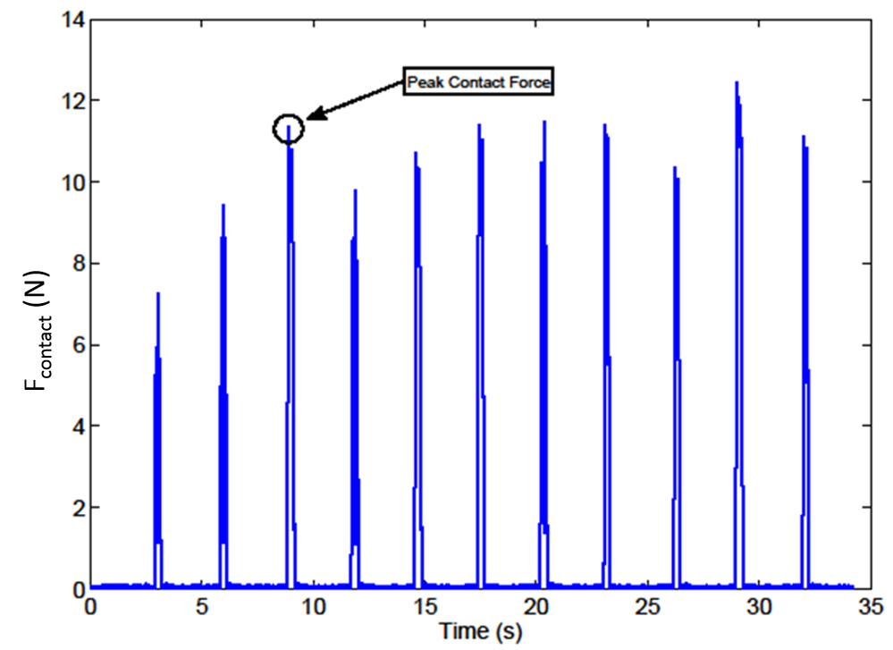
Figure 2. Contact force profile for Hand 1, Finger 1 with resistance sensing at 20 rad/s closing speed.

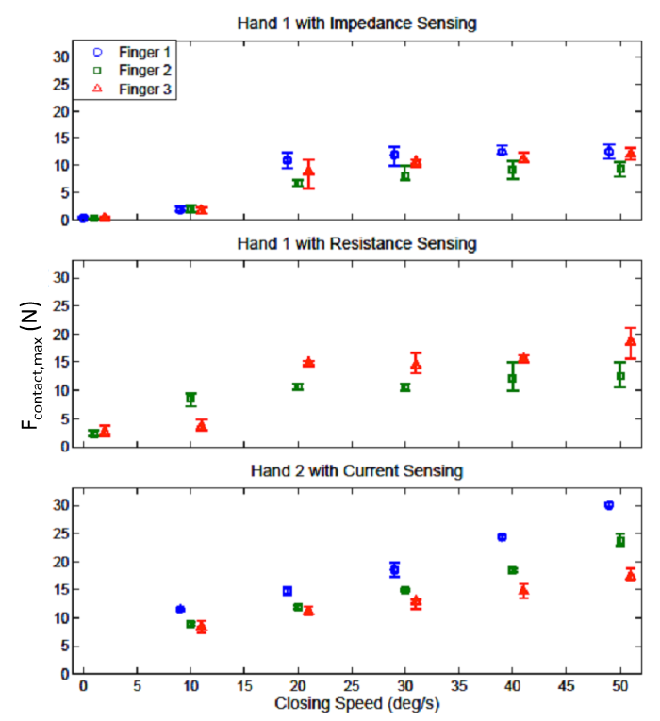
Figure 3. Maximum contact force of all robot fingers across three robotic hands and different sensing strategies. Note that in the 2nd plot, Finger 1 of Hand 1 was not tested due to a faulty contact sensor.

