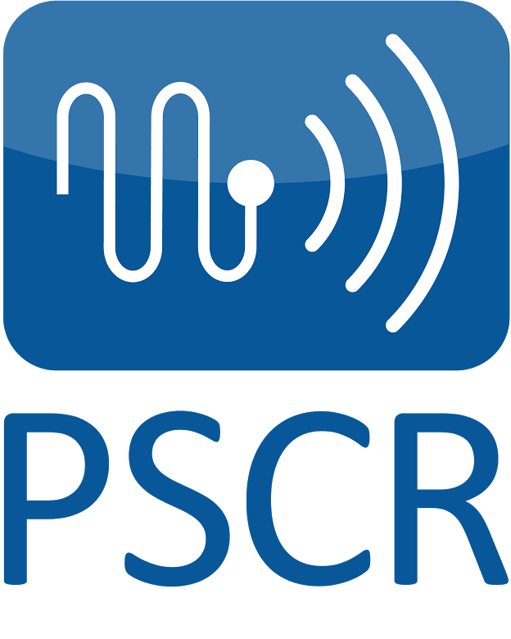
NIST Public Safety Innovation Accelerator Program –
Augmented Reality (AR)
Notice of Funding Opportunity
Frequently Asked Questions

- How do I apply?

Applicants must submit their applications materials via grants.gov. The application package is available at www.grants.gov under Funding Opportunity Number 2020-NIST-PSIAP-AR.
For further information or questions regarding submitting electronic applications on Grants.gov, contact:
Name: Christopher Hunton
Phone: christopher.hunton@nist.gov
Email: (301) 975-5718

- What are the application submission deadlines?

Applications must be received at grants.gov no later than 11:59 p.m. Eastern Time, October 1, 2020.

- Can I submit multiple applications?

NIST will consider multiple applications per applicant; however, an individual researcher may only be listed as the principal investigator on one application. In addition, applicants should refrain from submitting multiple applications with related subject matter.

- What type of work will be performed under the award?

PSCR is seeking to fund projects that accelerate research and development (R&D) around the use of augmented reality (AR) for improving public safety user interfaces. The purpose of this NOFO is to implement technology that will enable researchers to test and develop user interfaces to enhance public safety. Award recipients can help achieve this by creating new technology or applying current technology to a specific public safety use case. Recipients may also conduct research to support the use of AR hardware and applications including cybersecurity, usability, and human-computer interaction. The R&D produced from the awards made under this NOFO should aid in the future development and adoption of AR systems for first responder operations.

- Who is eligible to apply for this award?

This NOFO is open to all non-Federal entities. Eligible applicants include institutions of higher education, non-profit organizations, for-profit organizations, state and local governments, Indian tribes, hospitals, and foreign organizations. Please note that individuals and unincorporated sole proprietors are not considered “non-Federal entities” and are not eligible to apply under this NOFO. Although Federal entities are not eligible to receive funding under this NOFO, they may participate as unfunded collaborators.

- This program is for 2-year, $600,000 projects, correct?

Not necessarily - Individual awards can range from $300,000 to $600,000 per year. The maximum project duration is 2 years, except for proposals submitted by institutions of higher education for the purpose of supporting research by graduate students as part of a doctoral program, for which the period of performance may be up to three 3 years. A 2-year, $1,200,000 project would represent the maximum anticipated amount of funding NIST could provide to awardees that do not meet the exception criteria described above. NIST anticipates funding up to $5,000,000 total in new awards.

- How will public safety organizations be involved in this funding opportunity?

Projects funded by the PSIAP-AR program will include active and sustained engagement with Public Safety Organizations (PSO). This engagement ensures that the R&D outputs of each PSIAP-AR project are highly relevant and will have a meaningful impact on the public safety community. All applicants must include signed letters of commitment from at least one PSO, unless the applicant organization is itself a PSO.

- We are already working with NIST under a CRADA (Cooperative Research and Development Agreement). Are we eligible to apply for this grant?

Potentially: Being a CRADA partner does not, in itself, preclude you from applying to this competition, but conflicts are possible. For example, an entity cannot receive NIST funds for the same activities being performed under the CRADA. If you are a current CRADA partner and considering applying, please contact us directly to discuss your specific situation.

- When will NIST announce the award recipient?

Review of Applications, selection of successful applicants, and award processing is expected to be completed by November / 2020. The earliest start date for awards under this NOFO is expected to be December / 2020.

- What’s the “unique entity identifier number”?

Applicants will need a “D-U-N-S” number, which is a free, unique identifier provided by Dun and Bradstreet. Applicants will also need to obtain an Employer Identification Number (EIN) provided by the Internal Revenue Service.

Note, if your organization does not have these numbers, it may take some time to acquire them. Please see the Organization Applicant Registration page on the Applicants tab on Grants.gov.

- Do references and citations count towards the page limit?

Yes, the page limits include all tables, charts, graphs, figures, maps, photos, graphics, and citations. Submitted content that exceeds the page limits will not be reviewed.

12. What if my institution will be collecting data about animals, people, subjects, or participants during our proposed project?

Protection of human subjects is a priority of PSCR’s research and development programs. If you receive funding for a project that potentially includes research involving human subjects, or data or recordings involving human subjects (including software testing), the NIST Research Protection Office (RPO) must perform a review of your proposal as described in the Notice of Funding Opportunity. You may be asked to provide details about your proposed human subjects research; supporting documents such as consent forms; survey instruments; and IRB documentation. Before research involving human subjects may commence, it must be explicitly authorized by the NIST Grants Officer in the form of a Specific Award Condition.
NIST uses the Common Rule for the Protection of Human Subjects, codified by the Department of Commerce at 15 C.F.R. Part 27, to define its criteria for research involving human subjects.
Any application that proposes research activities involving live vertebrate animals to accomplish research goals, teaching, or testing must meet the requirements of the Animal Welfare Act (AWA) (7 U.S.C. § 2131 et seq.), and the AWA final rules (9 C.F.R. Parts 1, 2, and 3), and if appropriate, the Good Laboratory Practice for Nonclinical Laboratory Studies (21 C.F.R. Part 58). NIST reserves the right to conduct an administrative review of all applications that potentially include research activities that involve live vertebrate animals, or custom samples from, or field studies with live vertebrate animals. If the application includes research activities, field studies, or custom samples involving live vertebrate animals, the applicant will be required to provide additional information for review and approval. In addition, NIST will verify the applicant’s determination(s) of excluded samples from vertebrate animals. Before research involving live vertebrate animals may commence, it must be specifically authorized by the NIST Grants Officer in the form of a Specific Award Condition.

13. Are federally funded research and development centers (FFRDC) eligible to apply?

Because of the funding instruments used to manage FFRDCs, FFRDCs are generally not eligible to apply. Interested FFRDCs should discuss this further with their Contracting Officer. FFRDCs are, however, eligible to be subcontractors to other eligible applicants.

14. Where can I find information about past awards?

To learn more about research and development projects funded by PSCR, visit https://www.nist.gov/ctl/pscr/funding-opportunities/past-funding-opportunities.

15. Can you review our technical proposal and provide comments to ensure it meets the objectives in the NOFO?

No. Applicants should refer to Section I of the PSIAP-AR NOFO for details about the program goals and objectives. Applicants can send questions to pscr@nist.gov before submitting their proposal but will not receive feedback about specific research questions or proposed projects.

16. Can organizations partner together as a consortium to apply for this award?

Yes, partnering is encouraged, but there must be a primary applicant organization that, if awarded, will be legally responsible for the award.

17. How should we estimate travel cost to the PSCR Annual Stakeholder Meeting?

The PSCR Annual Stakeholder Meeting is typically in the summer, held in the continental United States, scheduled for 3-4 days, and registration is about $300-$400 per person.

18. Are bibliographies required? Do bibliographies count towards the 20-page limit?

No, bibliographies, citations, and references are optional. If they are included, they should be part of the Project Narrative and should match the Project Narrative’s format. See the NOFO for Project Narrative format specifications. Bibliographies should not be attached in the online application’s optional field, as anything attached in that field will not be reviewed.

Yes, Bibliographies do count towards the Project Narrative’s 20-page limit. If the Project Narrative exceeds twenty pages, subsequent information will be redacted.

