Calibration of radiation detectors in terms of absorbed dose to water

using gamma-ray beams

Purpose

The purpose of this document is to describe the setup, measurement and reporting procedures for absorbed-dose-to-water calibrations.

Scope

This procedure covers the absorbed-dose-to-water calibration of ionization chambers in a ⁶⁰Co beam¹ that is traceable to the NIST water calorimeter². All chambers must be waterproof or able to be made waterproof as measurements are made with chambers submersed in a water phantom.

Definition

Absorbed dose to water is defined as the energy from ionizing radiation absorbed by a given mass of water, 1 J/kg = 1 Gy.

Equipment

- Computer with LabView absorbed-dose-to-water calibration program and appropriate boards to handle instrument control and data acquisition,
- Electrometer (may belong to NIST or customer) with suitable computer control,
- Computer-interfaced temperature probes for continuous temperature monitoring of both the air and the water in the phantom,
- Pressure gauge with computer readout capabilities,
- ⁶⁰Co source traceable to NIST primary standard,
- Water phantom with chamber mounting apparatus,
- The aluminum meter scale with 1 mm precision,
- An in-house secondary standard ionization chamber.

The temperature probes, pressure transducers and electrometers used constitute essential equipment used for the calibration service. The temperature probes are calibrated against a reference standard thermometer. The pressure transducers are calibrated against a reference standard barometer. The electrometers are calibrated against reference class air capacitors. The calibration of the reference standards are provided by the NIST process measurements division. A NIST check chamber is used to decide if this auxiliary equipment needs to be checked against reference standards calibrated by the process and measurements division.

Safety

Radiation safety
Rooms containing ⁶⁰Co sources commonly used for absorbed-dose-to-water calibrations have been designated as High Radiation Areas and therefore are interlocked with the source-opening shutter control. Specific requirements for entry and exit from the rooms are contained in these procedures and are posted on entry doors and walls. Radiation safety training and assessment services are provided by the NIST Health Physics Office.

Electrical safety
To avoid possible shock, one should not touch any chamber or connector once voltage has been applied to the chamber when negatively biased. Certain chambers (for example, the Exradin A12) can carry the voltage on the outside of the chamber. When these chambers are submerged in the water tank, the water and any metal part coming in contact with the water become a potential shock hazard. As a good safety practice, the high voltage should be turned off before making a height adjustment.

Procedures

Acceptance of chambers and equipment

- Ensure that all incoming support equipment has a current calibration or calibration check.

- When calibrating a customer chamber, inspect for any shipping damage. If damage has occurred, follow the IRD Nonconformance Guide. If equipment has been damaged, customer will be notified immediately.

- Chambers are assumed to be open to the atmosphere unless informed otherwise by customers.

- Obtain a DG (Dosimetry Group) number (unique to each calibration) from the current Calibration Logbook in the Group secretary’s office and record.

- Record and file in calibration folder the following:

- DG number,
- Owner of the chamber to be calibrated (if other than NIST),
- Shipping address,
- Contact person phone and fax numbers and e-mail address,
- Make, model and serial number of the chamber,
- Date received.

Customer chamber set-up and calibration

Follow the procedures for the setup and calibration sections below for one of the NIST secondary standard ionization chambers and then again for the customer chamber, readjusting equipment where necessary.

Set-up

- Set the water phantom on the moveable cart of the ⁶⁰Co platform and fill approximately 2/3 full of water. Allow water to come to temperature equilibrium, which is usually 1to1.5 ºC lower than room temperature. This can take up to 24 hours.

- Turn on the source control panel. Set timer to 99999 and press the initialize button.

- Enter name, date and other pertinent information in the appropriate source logbook. Test lights and interlocks during this time using manual source controls.

- Turn on the computer and click on the “absorbed dose calibration” icon to launch the Labview program (see Appendix C for the entries to the program).

- The following environmental conditions should be followed when performing calibrations: The temperature of the room should be stable within one single measurement and ideally around 22 C. If the temperature is not stable during a single measurement calibrations should be postponed. Also the temperature shouldn’t exceed 25 C and shouldn’t be lower than 19 C. If the temperature falls out of this range the calibration should be postponed until the temperature is back within the working range. Preferred humidity conditions are between 20% and 50% but calibrations still can be performed if humidity levels fall out of this range. It’s preferred to calibrate instruments on days that the pressure is around 760 Torr but calibrations can still be performed if the atmospheric pressure deviates from this value. Calibrations should be postponed however if the pressure is not stable during a single measurement.

Calibration

- Ensure that the chambers to be calibrated are properly waterproofed. When applicable, ensure that air vents extend beyond the phantom to prevent water from entering the chamber.

- Thread the waterproof temperature probe from the bottom of the mounting apparatus through the hole in the horizontal mounting bracket where the chamber is to sit, then lay it along the groove.

- Mount the chamber onto the bracket in such a way that allows the temperature probe to lay along the underside of chamber. Lower the chamber (by rotating the height adjustment dial) into the water to approximately the desirable depth, or at least to a depth such that the entire mounting block is under the water. Connect signal and high voltage cables to the chamber.

- On the ⁶⁰Co housing, find the two dials each controlling a pair of collimator jaws, east/west and north/south, respectively. Locate the plumb-bob attached to a 50.8 mm x 50.8 mm aluminum block. Insert the block into the source collimator opening, align the front (south) edge of phantom with the center and remove the block when completed. This procedure places the front water surface at the focal plane of the telemicrocrope. Once this position is established, a physical mark of the phantom with respect to the fixed part of the platform can be used for repositioning in lieu of the plumb-bob centering device.

- Fully open both pairs of jaws, then close each of them to 10.75 on the dial. Do not touch the trimmer adjustment knobs.

- Allow water to settle such that the surface is stable. Adjust the telemicroscope such that the horizontal crosshair centers on the bottom-most line of the water surface. (Due to surface tension and optical effects there are multiple lines visible on in the scope. Always align with the bottom-most one.) Record the readings on the scale of the telemicroscope, h₁. This reading should be between 7 cm and 8 cm such that when performing step 7 the travel range is in the center portion of the scale (full scale 10 cm). Push the phantom away from the center (toward north).

- Insert the meter scale onto the holders under the source opening such that it suspends under the source. Adjust the height of the entire platform using the wall-mount control unit such that the horizontal crosshair in the telemicroscope centers on 53.8 cm on the meter scale. In B036, this position corresponds to a distance of 95 cm from the source. Turn off the motor controller. Lower the telemicroscope by 5.00 cm from the recorded position to a new position h₂ = h₁ – 5.00 cm using the dial with a scale. Ensure that it reads 58.8 on the large scale suspended from the source opening. This position is the calibration distance of 1 m. Remove the scale.

- Slide the phantom back under the source, this time using the laser to align the chamber in the center of the beam. Adjust the height of the chamber so that its center aligns with the horizontal crosshair of the telemicroscope.

- Activate the interlock and exit the room. Push the interlock button on the source control panel to enable shutter control.

- Apply voltage at the polarity and maximum allowable value as specified by customer. Allow time for chamber to “warm up” – this can take up to one hour, depending on the chamber. A periodic check measurement can determine if the current has stabilized. Perform pre-irradiation by manually opening the shutter at this time if necessary.

- Complete the calibration following the prompts on the computer program (see Appendix A for the program main panel).

- Adjust the high voltage on the chamber to half of its initial value. Allow at least 15 minutes before repeating the calibration.

- Turn off high voltage to chamber. Remove chamber from water. Compare calibrations to chamber history if available.

Analysis and Report
The average current, in the unit of A, or C/s, measured in the above procedures is normalized to reference environmental conditions (22°C and 760 mmHg). It is divided by the decay corrected absorbed dose rate (traceable to NIST primary standard), in the unit of Gy/s, to obtain a calibration coefficient, C/Gy. This is the value reported to the customer. In addition, the ratio of current at full voltage to that at half voltage is also reported. See Appendix B for a report template.

Quality Control
A minimum of 5 total measurements should be made for each calibration point. The standard deviation within these 5 or more measurements should not be greater than 0.1% for reference class chambers. If it is greater, additional time or pre-irradiation may be required to help the chamber settle.

For working chambers, a standard deviation of up to 0.20% may be acceptable. For abnormally high standard deviations, the owner of the chamber should be contacted to verify that the chamber is acting in its “normal” manner.

Chambers with histories should agree to within 2% of any previous calibration. If this criterion is not met, check for trends in the data. It may also be advisable to contact the customer to see if they have noticed any unusual behavior with the chamber.

Uncertainty Analysis

The uncertainty analysis of the absorbed-dose-to-water calibration of ion chambers is outlined in the NIST Special Publication 250-74¹. In brief, the various sources of the uncertainty of the calibration outlined in the NIST SP250-74 reference are:

The determination of the reference absorbed-dose-to-water rate².

⁶⁰Co decay constant

Charge variability – this value is obtained from the standard deviation of replicate measurements incorporating several reference class ionization chambers. For working standards, this value will be higher.

Correction due to recombination loss.

Time – shutter control reproducibility, a type B uncertainty.

Air density – the type A portion of the uncertainty is determined from the standard deviation of replicate measurements. The manufacturers of the temperature probe and the pressure gauge provide the type B uncertainty.

Humidity – No correction is made for the effect of water vapor on the instrument being calibrated. It is assumed that both the calibration and the use of that instrument take place in air with a relative humidity between 10% and 70%, where the humidity correction is nearly constant.

Variation in response due to positioning uncertainty at 5 cm depth in water – 0.05%.

Variation in response due to positioning uncertainty at 1 m from the source – 0.02%.

Records
A folder is created upon receipt of the chambers. All the information related to the calibration including calibration data, date the chambers were received and a
copy of the signed calibration report (original sent to customer) identified by DG numbers are stored in the folder.

Traceability
The SI unit of absorbed dose is the Gray (Gy), which is is defined as the energy from ionizing radiation absorbed by a given mass of water, 1 J/kg = 1 Gy, directly determined by the NIST water calorimeter in a ⁶⁰Co. More detailed information concerning traceability and uncertainty analyses is summarized in references 1 and 2.

International Comparisons
International comparisons have been made with other National Metrology Institutes around the world. During these international comparisons a reference class chamber is calibrated at both facilities and the value of the calibration coefficients obtained at both institutions is compared. The reference section lists comparisons made in the last few years using the same ⁶⁰Co gamma ray beam that is used for the calibration service described in this procedure.

Filing and Retention
The Ionizing Radiation Division (IRD) Quality Manager shall maintain the original and all past versions of this IRD Procedure.

References
- Minniti R., Shobe J. Seltzer S. M., Chen-Mayer H. and Domen, S.R., Absorbed Dose to Water Calibration of Ionization Chambers in a ⁶⁰Co Gamma-Ray Beam, NIST Special Publication 250-74, September 2006.

- Domen, S.R., A sealed water calorimeter for measuring absorbed dose, J. Res. Natl. Inst. Stand. Technol., 99, pp. 121 – 141, 1994.

- P. J. Allisy-Roberts and J. Shobe, “Comparison of the standards of absorbed dose to water of the NIST and the BIPM for ⁶⁰Co gamma rays”, Rapport BIPM 98/5 (1998).

- I. Csete, AG. Leiton, V. Sochor, A. Lapenas, J.-E Grindborg , I. Jokelainen, H. Bjerke, J. Dobrovodsky, A. Megzifene, H. J. Costas, R. Ivanov, B. Vekic, J. , Kokocinski, J. Cardoso, L.Buermann, W. Tiefenboeck , G. Stucki, E. van Dijk, M. P. Toni, R. Minniti, J. P. McCaffrey, C. N. M. Silva, I. Kharitonov, D Webb, M. Saravi, F. Delaunay, “Comparison of air kerma and absorbed dose to water measurements of ⁶⁰Co radiation beams for radiotherapy, Report on EUROMET project no. 813, identifiers in the BIPM key comparison database (KCDB) are EUROMET.RI(I)-K1 and EUROMET.RI(I)-K4,” Metrologia Vol. 47, Tech. Suppl 06012, April 2010.

Appendix A

Sample Uncertainty Analysis

Type A (%) Type B (%)

Absorbed dose rate at 5 cm in water¹ 0.16 0.39
Charge 0.10 0.10
Time 0.05
Air density 0.03
Positioning at 5 cm depth in water 0.03
Positioning at 1 m source distance 0.05
Measurement reproducibility 0.05
Recombination 0.01 0.05
Humidity 0.06
⁶⁰Co decay constant⁵ 0.05

quadratic summation 0.19 0.43

Relative combined standard uncertainty 0.47

Relative expanded uncertainty, k = 2 0.94

Appendix B

Sample of Calibration Report
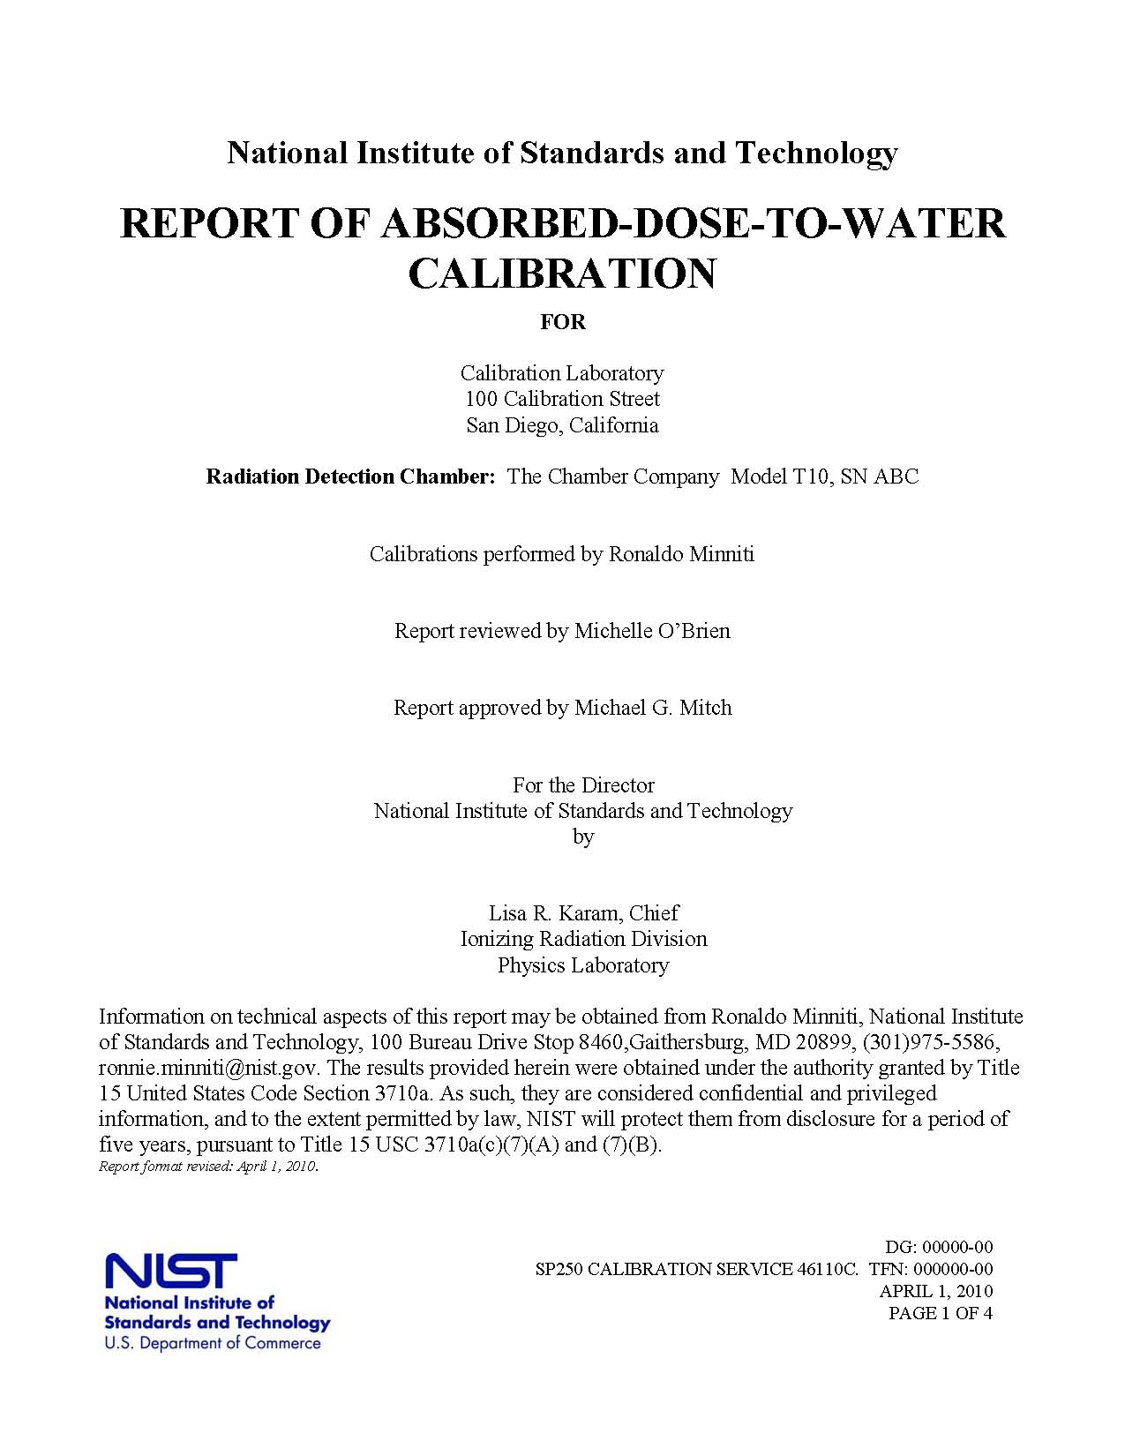

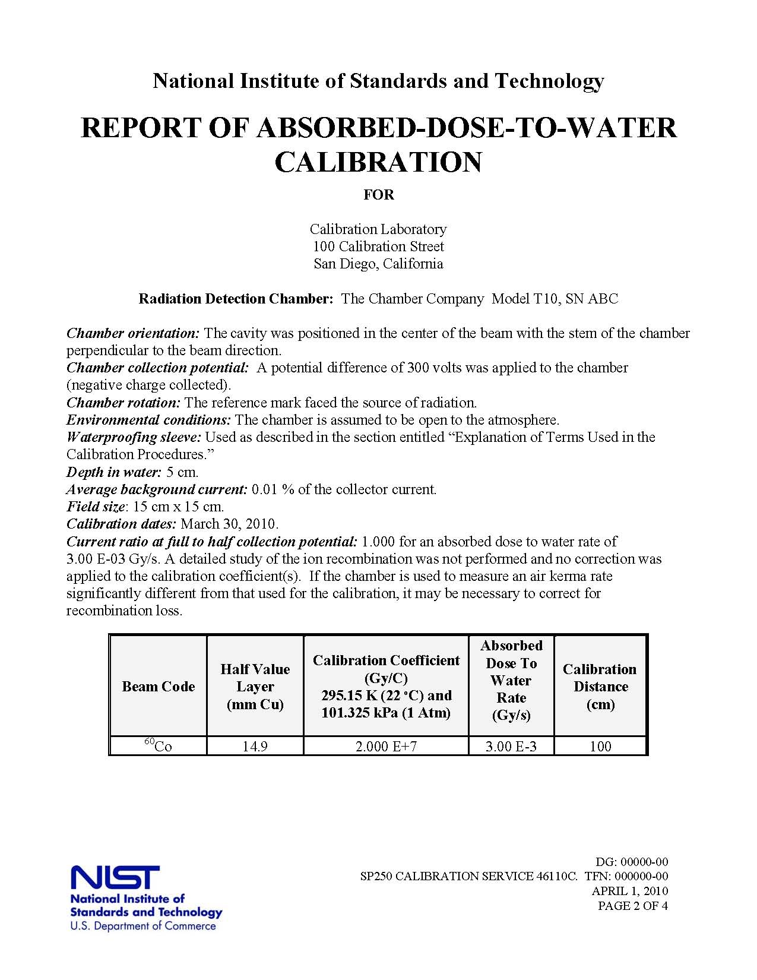
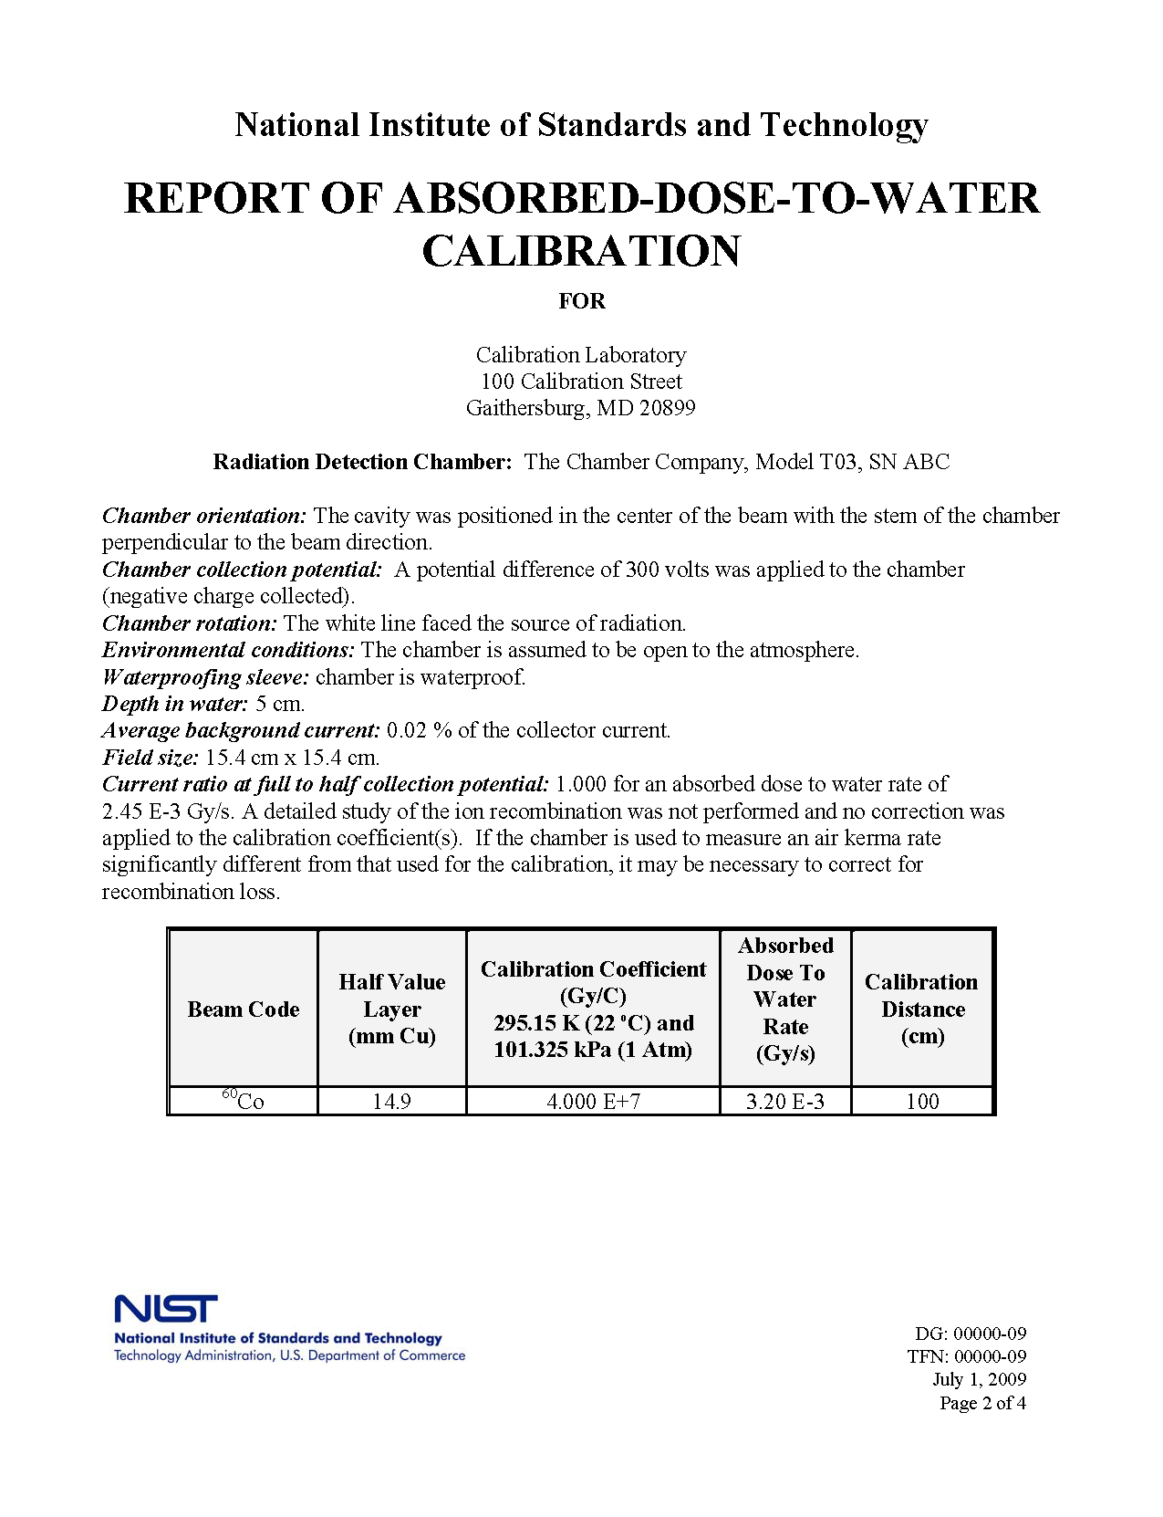
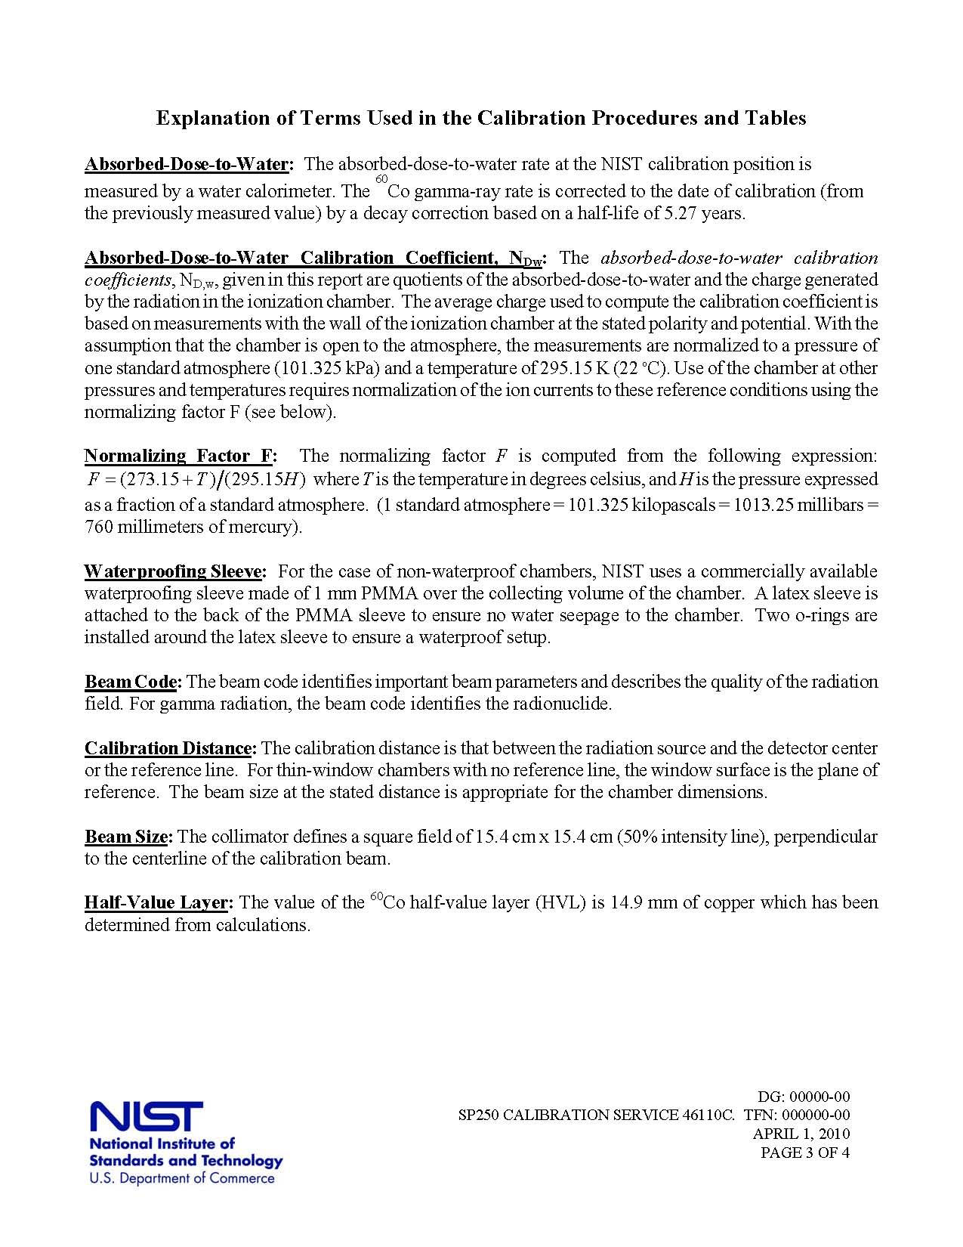
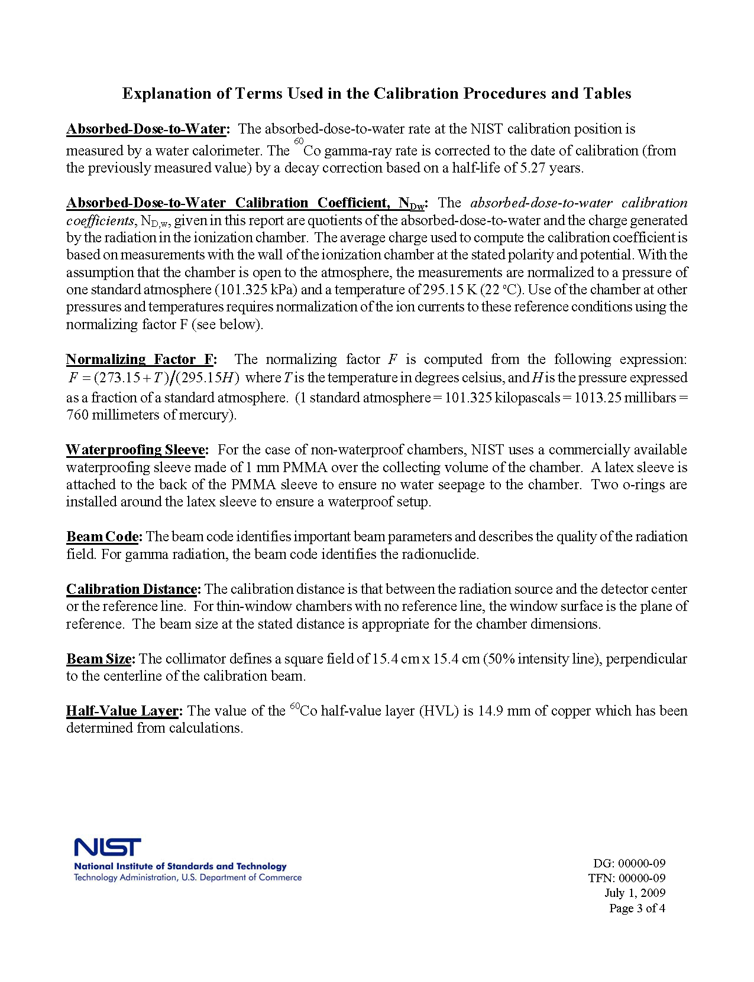
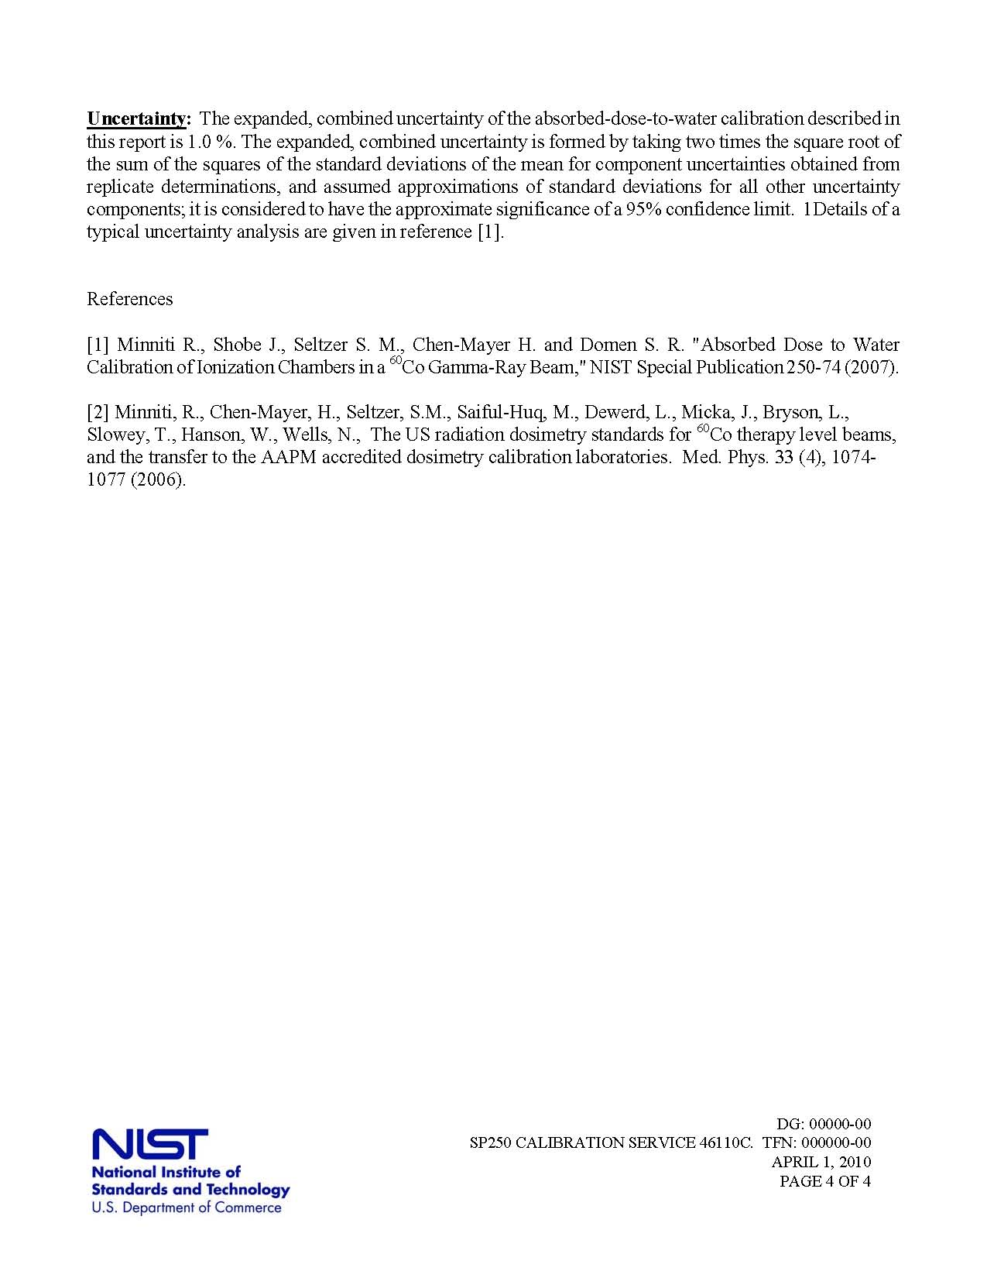

Appendix C

Calibration Program Control Panel

Notes:
- Fields with on the left is a “counter” which accepts either manual input or incremental input from the counter.
- Fields with “t” on the right is a “pull down” menu containing pre-entered values for selection.
- The two internal reference fields, upon program execution, will automatically provide for the user the decay corrected air kerma rate (irrelevant to this calibration procedure) and absorbed dose rate used in the calibration.
- Other fields accept manual input.

