Instructions to Produce an ICRA 2022 Manufacturing Track Practice Task Board
This document conveys fabrication instructions for assembling the practice task board for the Manufacturing Track of the ICRA 2022 Grasping and Manipulation Competition. All major components are identified figures 1 and 2 below.

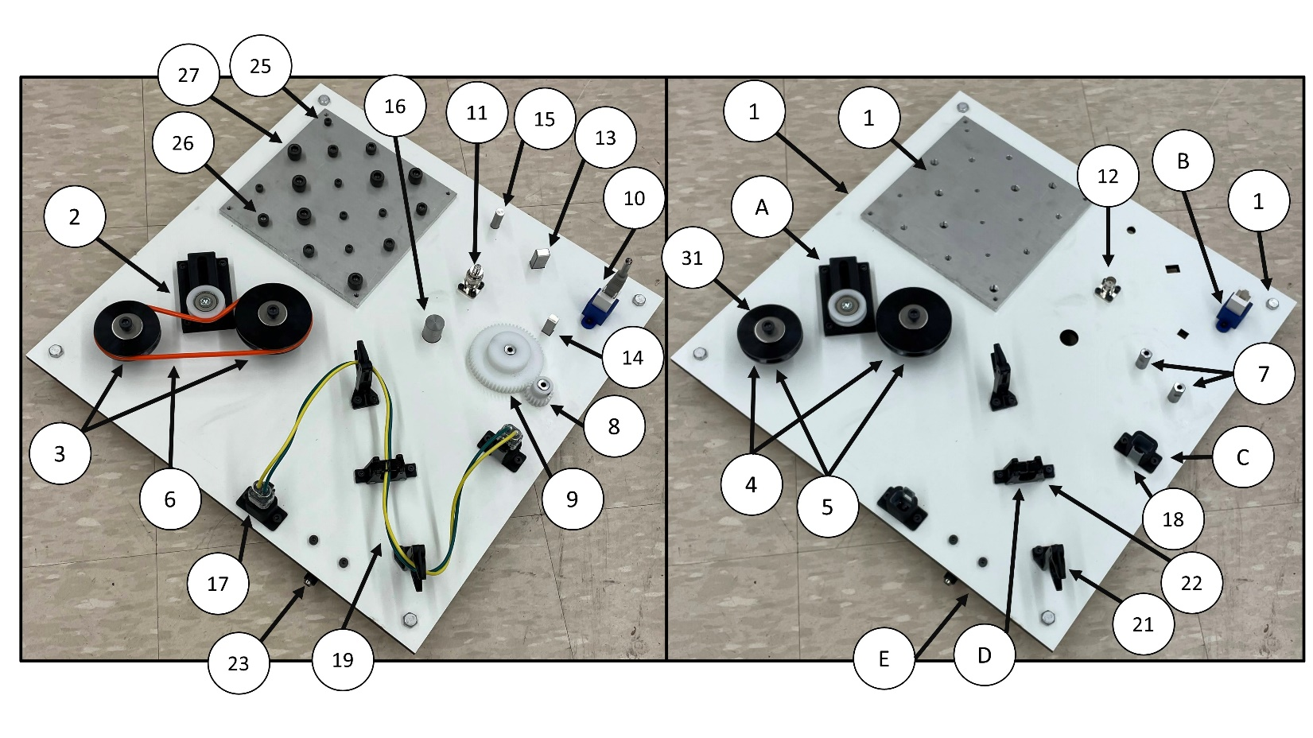
- Assembled (b) disassembled

Figure 1. Identification of key components as labeled in the subsequent parts list and their locations on the task board.

Purchasing:
- Majority of parts specified based on availability through MISUMI, an international distributor of components. Other vendors may supply the same parts. Note that this task board uses many parts from the three NIST Task boards found at https://www.nist.gov/el/intelligent-systems-division-73500/robotic-grasping-and-manipulation-assembly/assembly. If previously purchased, they can be used with the practice task board.
- Some other parts, namely electronic/wiring related, were ordered through Allied electronics, but these parts can be found at a variety of other online vendors. Feel free to use whatever vendor is most convenient as long as specified parts are the same.
- The laser-cut board can be produced and ordered through Ponoko.com. The board file is located in the “miscellaneous files” on the NIST ICRA webpage. Select “Add to Personal Factory”. Log-in or if a first-time user of Ponoko, create a new user account. Select where you want the board manufactured (US or New Zealand) and follow check-out prompts.

Disclaimer: Certain commercial equipment, instruments, or materials are identified in this paper to foster understanding. Such identification does not imply recommendation or endorsement by the National Institute of Standards and Technology, nor does it imply that the materials or equipment identified are necessarily the best available for the purpose.
Parts List- ICRA 2022 Practice Task Board
(Example)
ID | Item | MISUMI Part Number | Unit Cost ($)  (as of 9-9-2019) | Unit
1 | Laser cut board (Ponoko.com) | N/A | 74.40 + Ship | 1
2 | idler with bearing (30 mm OD) | EUBHS30 | 17.59 | 1
3a | Round belt pulley  (48 mm nominal dia.) | MBRF48-2-H10 | 12.35 | 1
3b | Round belt pulley  (60 mm nominal dia.) | MBRF60-2-H10 | 19.87 | 1
4 | Shafts for round pulley (3a) | SFAD10-31-F20-B16-P8-N6 | 12.99 | 2
5 | Collar for round pulley/shaft (3a & 3b) | NCLC10-12-20 | 5.88 | 2
6 | Polyurethane round belt (4mm dia. – 500 mm length) | MTB4-500 | 4.51 | 1
7 | Gear Shafts | SPTR10-20-M6-SC12 | 16.33 | 2
8 | Small Gear | GEABP1.0-20-10-B-10 | 13.60 | 1
9 | Large Gear | GEABP1.0-60-10-B-10 | 25.29 | 1
10 | RJ45 Male and Female Connectors | ADT-EX-CRS5EK | 14.77 | 1
11 | BNC Female Connector | BNC-R | 16.90 | 1
12 | BNC Male Connector | BNCP-1.5A-K | 14.03 | 1
13 | Bar 12 mm x 8 mm x 300 mm | KET12 | 6.73 | 1
14 | Bar 8 mm x 7 mm x 300 mm | KET8 | 4.81 | 1
15 | Rod 8 mm | RGOCG8-50 | 4.70 | 1
16 | Rod 16 mm | RGOCG16-50 | 7.88 | 1
17* | AT02 Male connector with LED | Alliedelec.com: AT06-2p | 6.79 | 2
18* | AT02 female connector | Alliedelec.com: AT04-2s-LED1201 | 0.39 | 2
19* | 16 GA wire (2 colors preferred) | Alliedelec.com: 4520041 | 0.23/ft | 2
20a* | Round wire pins | Alliedelec.com: AT60-202-16141 | 0.45 | 4
20b* | Round wire sockets | Alliedelec.com: AT62-201-16141 | 0.57 | 4
21* | Routing Corner post | Alliedelec.com: CPH.75-S8-X | 8.58 | 2
22* | 0.5” Elastic retainer | Alliedelec.com: ER.5-E4-X | 19.84 | 1
23* | Power adapter connector | Alliedelec.com: LS-00015 | 6.02 | 1
24* | Wall plug power source | Alliedelec.com: VEL24US120-US-JA | 18.65 | 1
25* | M4 Socket Cap Screw  (20 mm length -pitch 0.7 mm) | F010410 | 2.03 | 24
26* | M6 Socket Cap Screw  (20 mm length -pitch 1.0 mm) | F010610 | 2.03 | 10
27* | M8 Socket Cap Screw  (20 mm length -pitch 1.25 mm) | F010810 | 1.96 | 6
28* | M3 Socket Cap Screw  (20 mm length -pitch 0.5 mm) | F010310 | 1.87 | 6
29* | M3 Socket Cap Screw  (30 mm length -pitch 0.5 mm) | F010312 | 1.90 | 2
30* | M6 Square Nut  (10mm x 10mm x 5mm – pitch 1.0 mm) | NSQ-SUS-M6 | 3.67 | 1
31* | M6 - Flat Washer (24mm OD) | WSX-SUS-M6X24-2 | 0.36 | 3
32* | M3 Hex Nut | HNT1-ST-M3 | 0.09 | 8
33* | M4 Hex Nut | HNT1-ST-M4 | 0.09 | 16
34* | M6 Hex Head Screw  (50 mm length – pitch 1.0 mm) | HXN-ST3B-M6-35 | 3.53 | 4
A** | Slide tensioner | N/A | N/A | 1
B** | Ethernet housing | N/A | N/A | 1
C** | 2pin housing | N/A | N/A | 2
D** | Elastic retainer stool | N/A | N/A | 1
E** | Power connector housing | N/A | N/A | 1
F** | Bolt rack | N/A | N/A | 1(optional)
G** | Wire rack | N/A | N/A | 1(optional)
* Choice of supplier if specifications are met. Part numbers provided are associated with us.misumi-ec.com or alliedelec.com
** Printed plastic parts: Files for printed parts are provided on the NIST ICRA webpage.

Tools List
- Metric hex key set
- 10mm wrench
- 5.5mm wrench
- Wire strippers
- AT round pin crimpers

Assembly Instructions
Pegs and Holes:
- Manually insert all four steel pegs in their corresponding holes, entering from topside of board to ensure correct sizes
- Prismatic pegs will come in bar stock lengths of 300 mm. Cut to 50 mm segments.
- Optional: per good design practices for assembly, chamfer one side of all pegs at 45 degrees and 0.1 times the largest cross-sectional side or diameter. E.g., 16 mm circular peg has 1.6 mm chamfer and 16 mm x 10 mm peg has 1.6 mm chamfer. Chamfering only one end of pegs allows for performance testing with and without the assistance of chamfers.

Bolts and Nuts:
- Attach the aluminum bolt plate to the board over the large square opening. Thread screws up from the bottom of the board to avoid the head of the screw interfering with assembly processes.
- Thread each bolt into the respective holes to ensure all threads are clean.

Gears\Pulleys:
- Insert two M6 bolts from underside of task board and tighten to two gear shafts (see below). Location of the gears is shown in Figure 1.

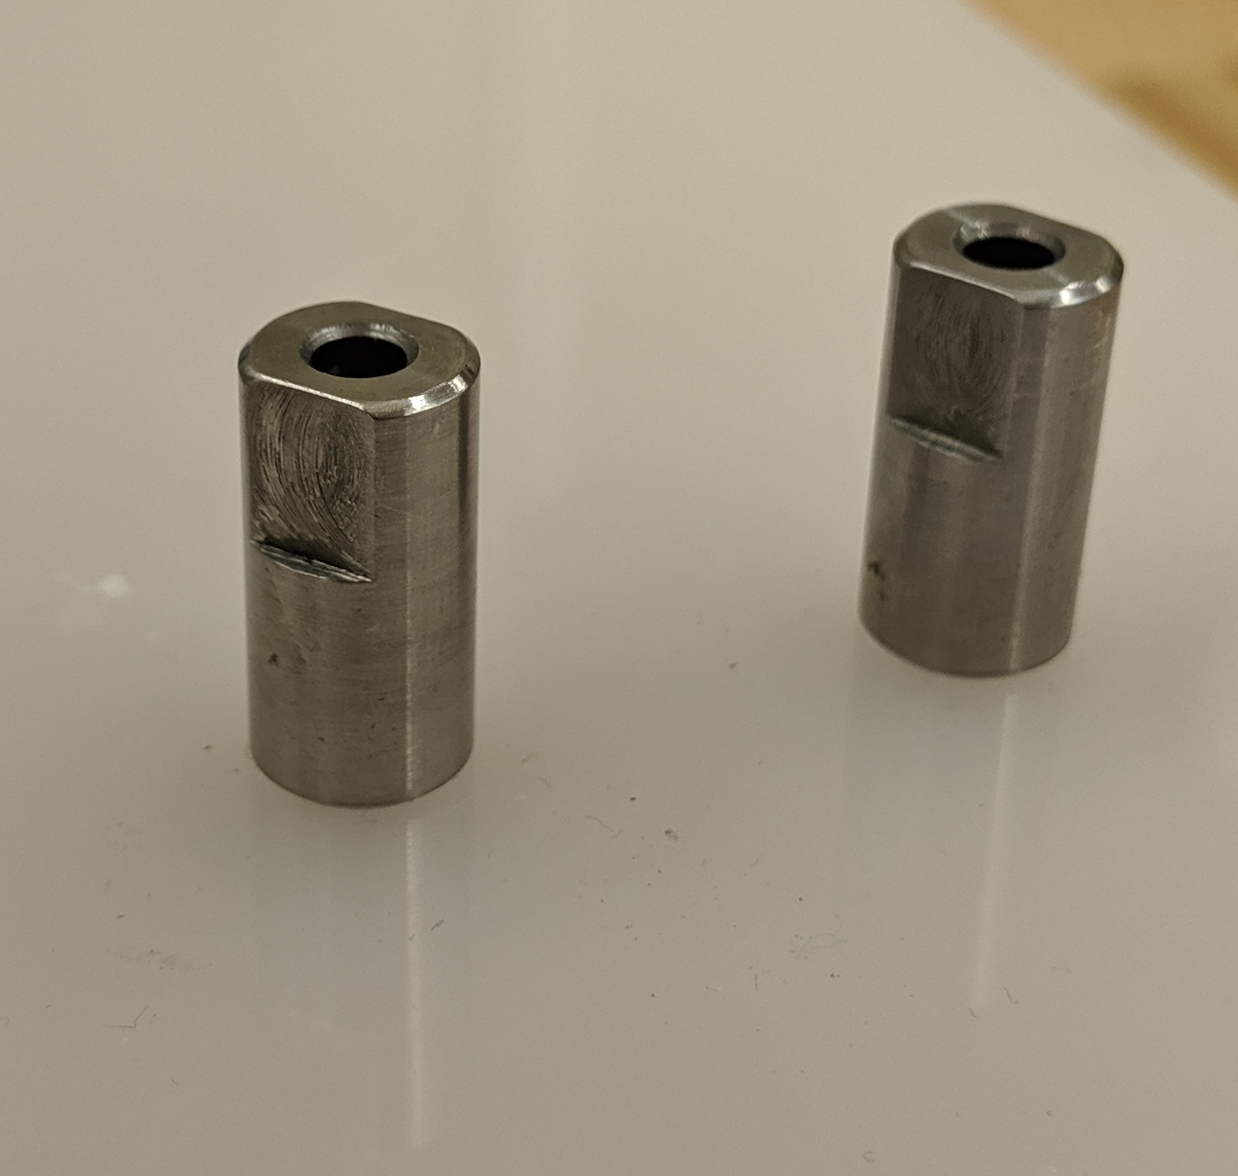

- Attach long shafts for round pullies as shown in Figure 1 and tighten to underside of task board using one M8 nut. Insert collar and round pulley on shaft and fasten using one M6 x 10 mm bolt and one M6 washer (see below).

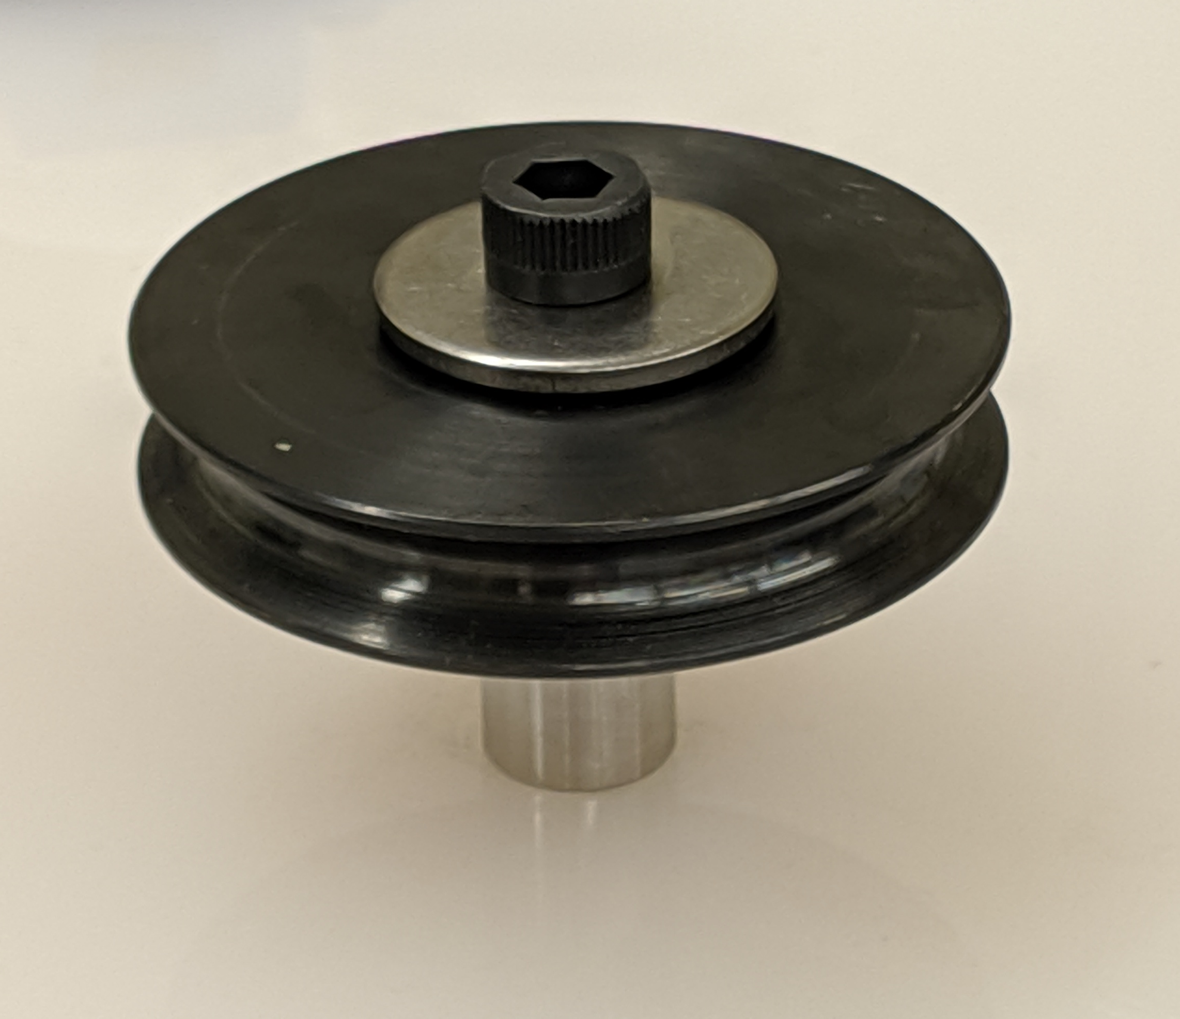

- Attach the 3D printed tensioner to the board using four M4 bolts and M4 nuts. Place the square nut within the tensioner and thread the M6 screw of the plastic idler into nut such that it is captured within the tensioner (see below).

Connectors:
- Tighten female BNC connector to board in location per figure 1 with four M3 x 20 mm bolts and four M3 nuts.

- Tighten 3D printed RJ45 housing to board in corresponding location as shown in Figure 1 with two M3 x 20 bolts and two M3 nuts. Press female RJ45 connector into housing. If female connector with housing is loose, then a glue or epoxy may be used to fix connector to housing.

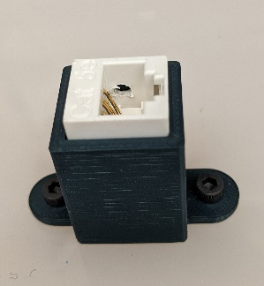

Wire Harness components:
- Attach 3D printed 2-pin housings to the board over top of the female AT02-pin connectors (see below). Be sure to orient the connectors and housings according to Figure 1. Tighten with two M4 bolts and two M4 nuts.
- Attach the tall corner posts to the board facing away from each other (see below) using two M4 bolts and two M4 nuts.
- Attach the elastic retainer to the board by placing it on top of the 3D printed retainer stool and running the M3 x 30 bolts through each piece and the board according at the location shown in Figure 1. Tighten using M3 nuts on the underside of the board.
- Attach the 3D printed power adapter housing to the board around the power adapter. Use M4 bolts and M4 nuts (see below)
Wire preparation
- Cut one red and one black wire to 55 mm long. Cut another red and black wire to 20 mm long. Use wire strippers to strip approximately 5mm from the end of both sides of the wires. Place a round female socket on both ends of the 55mm wires and on one male pin on one end of the 20mm wires. Crimp sockets onto the wires (see below).
- Press the wires with one crimped socket end into the holes in the underside of the AT02-pin connector until a ‘click’ is heard. Tug back on the wires to ensure they are secure.
- Feed the uncrimped ends of the wires into the power adapter and tighten the screws firmly. Tug back on the wires to ensure they are secure. (see below)
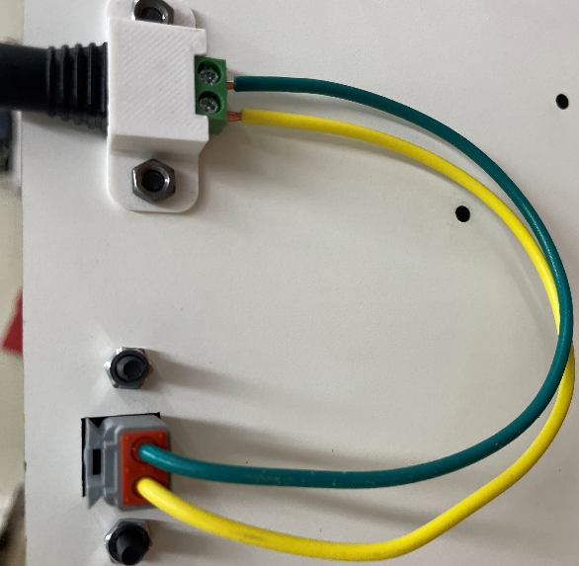

Bolt Rack:

This is an example bolt rack that supports the 18 fasteners to be assembled during the competition. If used, it may be useful to finish the holes using a drill bit in order to keep the threads from binding on the plastic surface. Otherwise, teams can develop their own bolt dispensing systems, whether it be a rack or automated feeder.

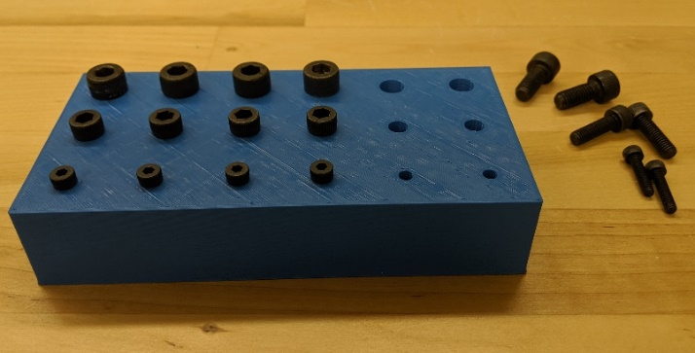

Wire rack:
This is an example of a wire dispensing mechanism. Teams are welcome to use what ever wire rack/dispensing mechanism they desire.

Standoffs:
- Connect the two threaded aluminum strips with Velcro to two corner holes of the board using the two M6-35mm hex bolts on opposing sides as shown in Figure 1. Tighten one nut to the strip and the other to the board.

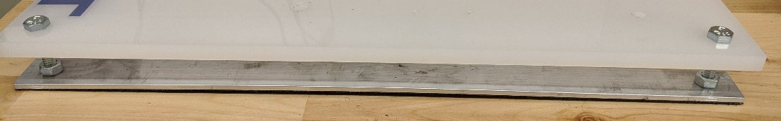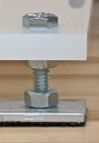

Please contact Joe Falco (falco@nist.gov) or Kenny Kimble (kennith.kimble@nist.gov)
with any questions regarding the
production of this task board.

