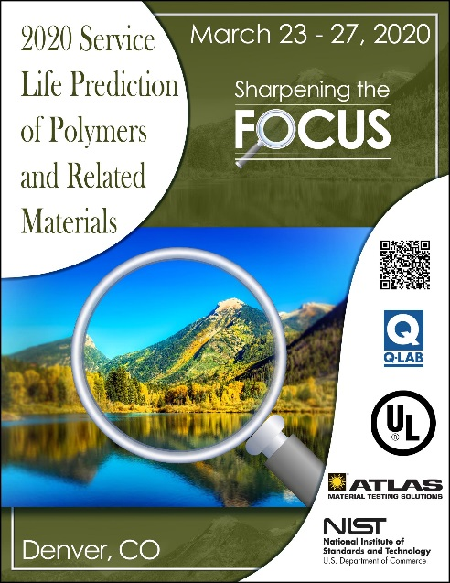
ABSTRACT Poster SUBMISSION
Submit completed abstracts to Christopher.white@nist.gov by February 15, 2020

Service Life Prediction of Polymeric Materials: Focus 2020
March 23-27, 2020

Author name(s):

Job title:

Affiliation:

Contact information including physical address, phone and email:

Abstract Title:

Abstract description (500 words or less):

