Template for One-Page Abstract for 2021 Standards for Wastewater Surveillance

First A. Author¹, Second B. Author, Jr.², and Third C. Author^{1,2}
¹Author affiliation; ²Second author affiliation
Abstract/Poster Title

The abstract must be less than or equal to 350 words. You may include a list of references. Please include one anchor figure (e.g., diagram, data plot, data table); the figure must be clear enough, with a standard of 300 dots per inch (dpi). You may consider using a text box to insert the graphic. As an optional second step, you will receive an email to upload a poster file. This file could be a full poster or simply the information provided here.

Key words: Key word 1; Key word 2; etc.

Standards and control materials used: (short answer)

Email for corresponding author:

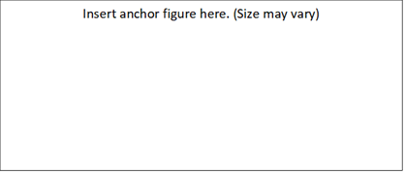

Figure 1. Example of a figure caption.

