NIST Split Cylinder Artifact

The split cylinder artifacts support the grasp strength, slip resistance and grasp efficiency NIST elemental grasp performance test methods and are used to measure the resultant internal forces of both precision and power grasps on a cylinder. In addition, force measurement techniques are used to resolve external forces applied to the cylinder. The cylinder artifacts incorporate ASTM D2665 PVC pipe for the following reasons: 1) the cylindrical pipe comes in a variety of standard diameters with dimensions that are compatible with robot hand volumetric capabilities, and 2) the surface properties of these pipes are relatively consistent. A 304.8 mm (12 inch) segment of PVC pipe is cut in half along the axial direction. Each PVC pipe half is then glued to the two pipe cores using epoxy resin. The primary alignment of the plastic cores is accomplished using two 4 mm diameter dowel pins. The pin holes in the 3D printed core are drilled to achieve a slip fit. Figure 1 and Figure 2 show the 50.4 (2 inch) inner diameter PVC split cylinder designs using single axis load cells and lower cost resistive force sensor force measurement techniques respectively. Split cylinder artifacts can be constructed for larger diameter PVC pipe configurations. These larger diameter artifacts require two additional sensors to stabilize the axial forces as shown with 76.2 mm (3 inch) PVC pipe configuration in Figure 3. Files are provided on the NIST Performance Metrics and Benchmarks to Advance the State of Robotic Grasping (http://www.nist.gov/el/isd/grasp.cfm) for reproduction of 3D printed parts.

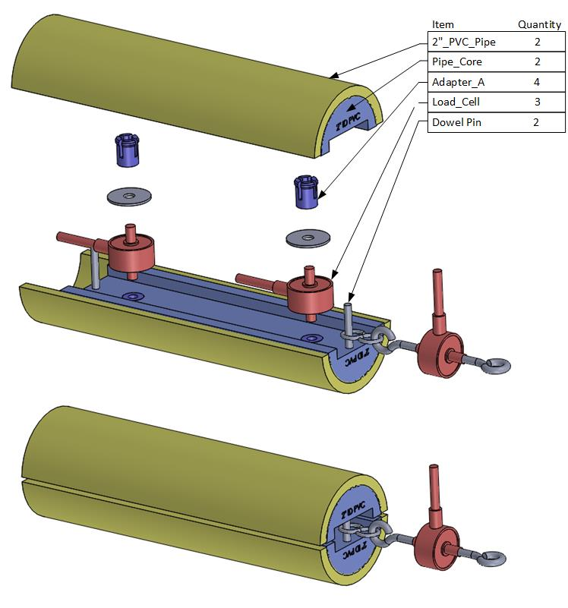
Figure 1: 2” ID PVC Split Cylinder Artifact with Single Axis Load Cells

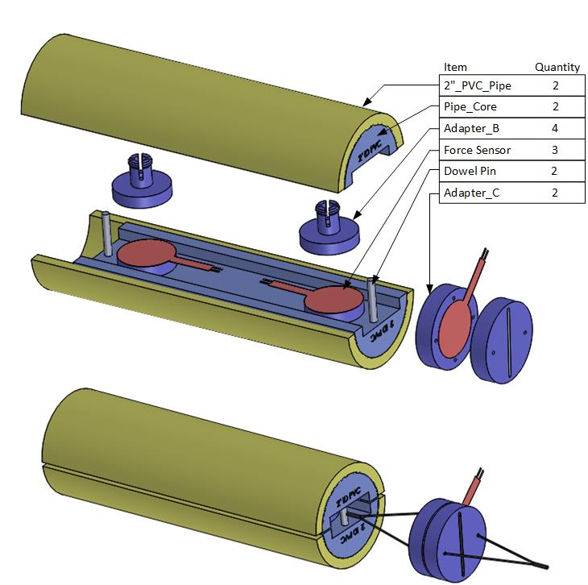

Figure 2: 2” ID PVC Split Cylinder Artifact with Low Cost Force Sensitive Resistors

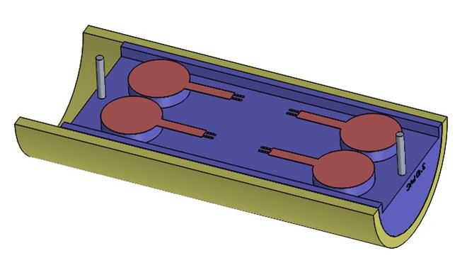
Figure 3: 3” ID PVC Split Cylinder Artifact Half with Low Cost Force Sensitive Resistors

