Neutron Reflectivity investigation of the structure of an incomplete phospholipid bilayer membrane with defect-binding proteins.

Summer School on the Fundamentals of Neutron Scattering
NIST Center for Neutron Research
July 2018

Introduction

Phospholipid bilayers are the basic structural element of biological membranes. They separate the various cell compartments found in eukaryotic cells and form the outer barrier (cell membrane or plasma membrane) of eukaryotic and prokaryotic cells separating the cytoplasm from the extra-cellular space. The composition of phospholipid bilayers varies with the cell type and function of the membrane. It commonly contains, for example, charged lipids, neutral or zwitterionic lipids, glycolipids, cholesterol, and sphingomyelin. The hydrocarbon core of the lipid bilayer forms a passive barrier for ions, sugars, and other metabolites. The lipid components of the membrane provide a matrix for incorporation of membrane proteins that are involved in cell processes such as transport of ions and molecules across the membrane, cell signaling, and ligand recognition (receptors). Biological phospholipid bilayers are actively kept in a fluid state [Sin72], allowing lipids and membrane proteins to diffuse in the lipid bilayer and to form functional domains for cell processes.

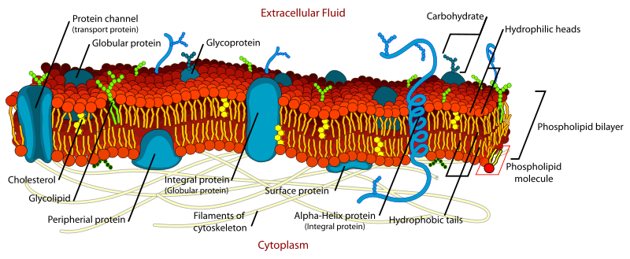
Illustration of a biological cell membrane. From www.wikipedia.org.

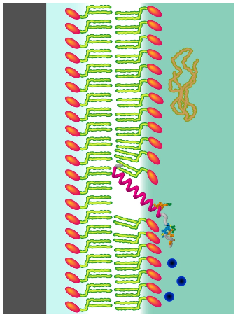
For biophysical investigations of a protein with the lipid membrane, a lipid membrane of a biological composition would be far too complex. Instead, well-characterized model membranes of controlled composition and physical properties are employed [Cas06]. For geometrical reasons, model membranes for reflectivity experiments have to be supported by a planar substrate. The simplest model system, which will be structurally characterized during this tutorial experiment, is a lipid bilayer of a single type of lipid directly deposited onto a silicon wafer. The silicon wafer provides an atomically flat surface and has a comparably low scattering cross-section – two properties that make it an ideal substrate for reflectometry. The deposited lipid bilayer is separated from the substrate by an approximately 5 Å water gap, and therefore interacts strongly with the substrate. This interaction impairs the fluidity of the lipid leaflet proximate to the substrate and impedes the incorporation of integral membrane proteins due to steric constraints. Nevertheless, the described model system can be successfully applied for investigations of the interaction of peripheral proteins with the outer lipid leaflet.
Illustration of a solid supported lipid bilayer membrane interacting with various biomolecules.

More complex model systems, like the tethered lipid bilayer system routinely used at the NCNR [Gil07, Hei09], decouple the lipid bilayer from the solid support using spacer molecules that provide a relatively large water-filled sub-membrane space. This model system allows for the incorporation of integral membrane proteins, and both lipid leaflets are in the fluid state.

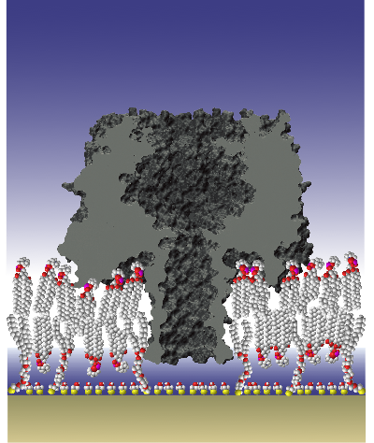
Illustration of a tethered lipid bilayer (tBLM) with a transmembrane pore, as measured using neutron reflectivity at the NCNR [Gil09]. A sparse coverage of tether molecules creates a water-filled sub-membrane space between the lipid bilayer and the substrate, which decouples the membrane and the protein from the substrate. The small molecules are called backfill molecules and regulate the tether density.

Goal of the Tutorial Experiment

The goal of this tutorial experiment is to measure the interaction of a common protein (BSA or lysozyme) with the large defects in incomplete lipid bilayer membranes, and compare the result to intact membranes. It has the following goals:

- Learning about membrane model systems for neutron reflectivity and the various factors that contribute to a successful biological experiment.
- Structural characterization of tethered lipid bilayer membranes (tBLM) formed on a gold substrate. This includes:
  - the characterization of bilayer thickness.
  - the determination of the headgroup hydration
  - the determination of the bilayer completeness
  - the determination of the area per lipid
  - the measurement of the thickness of the hydration layer between the bilayer and the substrate.
- Adding a protein (BSA or lysozyme) to the tBLM and measure protein adsorption. This protein is known to interact with defects in the lipid bilayer, and is therefore used as a quality control for bilayer preparations.
- Additionally, test the effect of the protein on the bare gold surface and the hydrophobic surface presented by tether molecules without added lipid.
- Learning about the optimal number of isotopic solvent contrasts per condition to be measured during the biological reflectometry experiment.

Planning of the Experiment and Sample Preparation

Samples of tBLMs are prepared on 3’’ silicon. The lipids used during this experiment will be zwitterionic POPC. The completeness of the formed bilayer and thickness of the sub-membrane water gap can be determined from the reflectivity data if the sample is measured in contact with at least two isotopically distinct aqueous buffers, such as D₂O-based and H₂O-based buffer. This is why at least two reflectivity measurements per sample will be carried out and the buffer solution will be exchanged between the measurements.

The sample preparation is a multi-step process. First, lipids are dissolved in an alcoholic solution and injected into a wet cell. The deposition of a lipid bilayer will be achieved by slow exchange of the lipid solution by an aqueous buffer of a defined pH value. Finally, excess lipids are rinsed off the interface at a higher flow rate. This easy preparation technique is assumed to result in a very complete lipid bilayer formation over large areas; this tutorial experiment will verify this assumption.

The NCNR wet cell possesses one inlet and one outlet for solvent exchanges. The water reservoir above the prepared film is only 100 µm thick. After measurement of the as-prepared bilayer, protein will be added in situ, and structural changes will be characterized using at least two isotopic solvent contrasts.
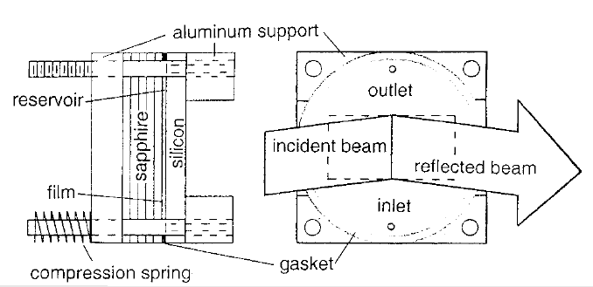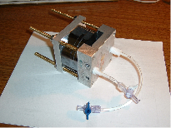
Left: Drawing of the NCNR wet cell [Maj00]. In the drawing the film is prepared on a wafer made of sapphire instead of silicon. Right: Photo of the NCNR wet cell. The wafer with the film is the thin 5 mm wafer in the middle of the sandwich. To the left from it there is the thick 15 mm fronting wafer, to the right there is the thin 7 mm wafer with holes for the buffer exchange inlet and outlet.

Data Collection and Data Reduction

For a detailed description of the neutron reflectometry technique see the excellent tutorial written by Andrew Jackson, posted on the Summer School website.

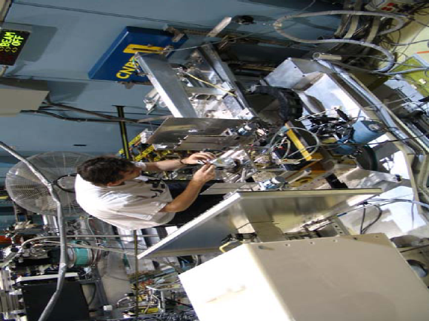
The prepared wet cell has to be aligned on the instrument. Prior to the neutron reflectivity measurement, an incident beam scan through the thick fronting wafer is performed in order to measure the direct beam intensity. The specular reflectivity, measured later, will be normalized to the direct beam incident intensity.

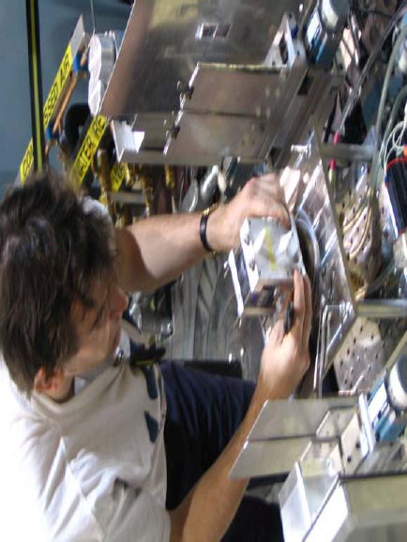
Duncan McGillivray aligns the NCNR wet cell.

The aligned wet cell is first filled with D₂O-based buffer and the specular reflectivity is measured between momentum transfers 0 ≤ q_{z} ≤ 0.30 Å⁻¹. The background intensity offset to both sides of the specular ridge is measured separately. A large contribution to the background neutron radiation originates from incoherent scattering from the bulk solvent reservoir. The measurement is repeated after filling the wet cell with H₂O-based buffer. This way two distinct data sets of the same sample in contact with isotopically different bulk solvents are recorded. The neutron reflectivity is calculated from the measured specular raw data, the background data and the incident beam data. This process is called data reduction.

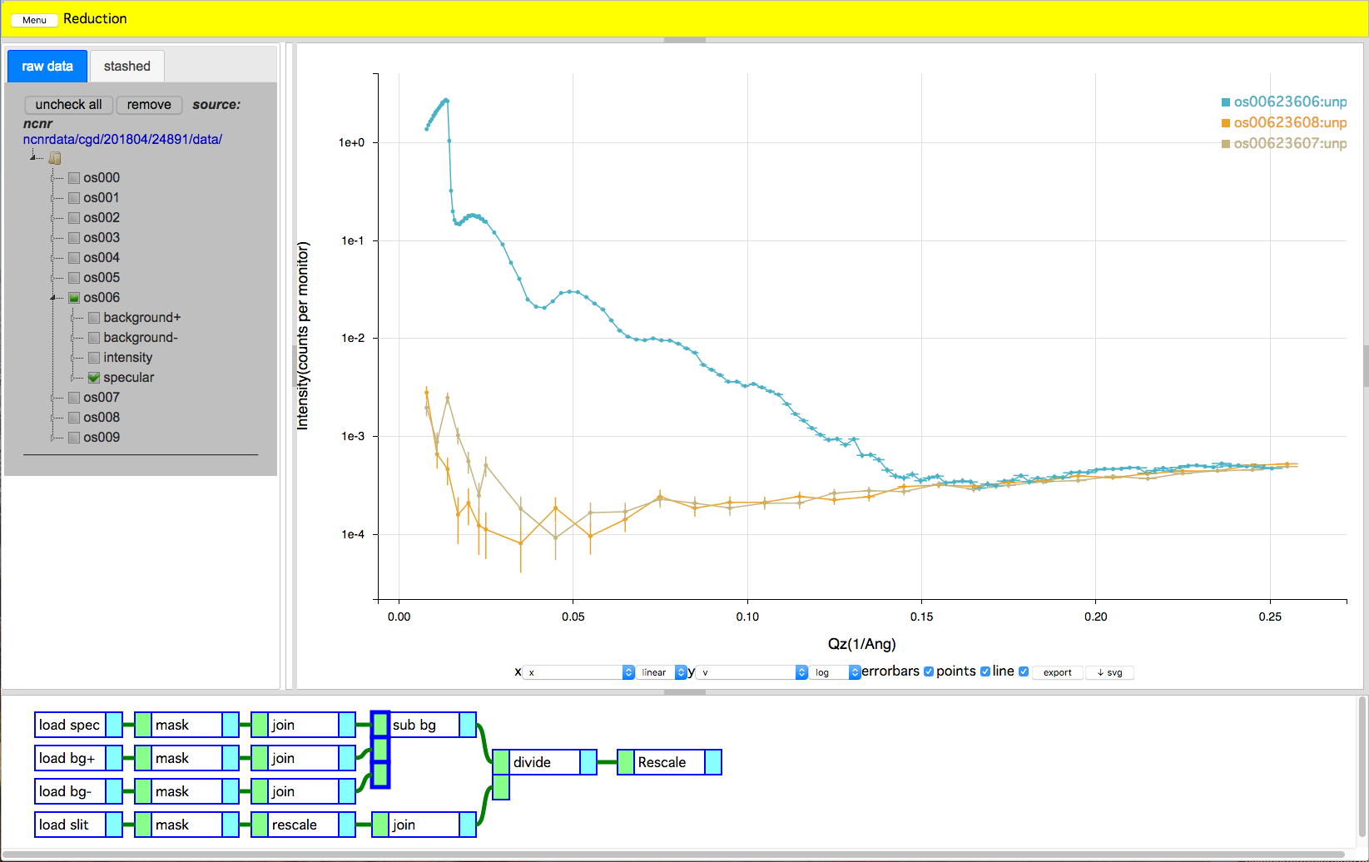
Data reduction using the NCNR online software ‘Reductus’ [Mar18] (https://reductus.nist.gov). The reflectivity data set was obtained from a lipid bilayer on a solid support. The teal curve shows the raw specular reflectivity for the sample in contact with a D2O-based buffer. The orange and brown curves are the separately measured scattering background. To calculate the neutron reflectivity, the background intensity is subtracted from the specular reflectivity and the difference is divided by the incident beam intensity (not shown). This ratio, the neutron reflectivity, is always ≤ 1.

Data Analysis

After reducing the neutron reflectivity data, the data is fitted to a model of the neutron scattering length density (nSLD) profile along the axis perpendicular to the substrate surface. In the simplest approach, the nSLD profile is modeled in terms of layers of constant nSLD. This type of model is called a ‘box model’. Layer thicknesses, layer nSLD, and interlayer roughness are model parameters that are determined by the fit procedure. For data fitting using a box model, the NCNR online reflectometry calculator (https://www.ncnr.nist.gov/instruments/magik/calculators/calcR_d3_dark.html) will be used. More advanced modeling techniques [Hei14] will also be introduced.

Within a box model, the fitted nSLD profile is structurally interpreted in terms of chemically distinct layers. In the case of a tethered lipid bilayer, the following order of layers is used: the silicon substrate, the silicon oxide layer, the hydrated tether layer between the substrate and the bilayer, the inner headgroup layer, the hydrocarbon region of the bilayer, the outer headgroup layer, and the bulk solvent phase. From the nSLD and thickness of the hydrocarbon layer the area per lipid molecule can be obtained. From simultaneous fits of the data sets with isotopically different bulk solvent phases, the hydration of the various layers and the completeness of the lipid bilayer can be calculated. Using advanced modeling techniques, those quantities can be directly parameterized and determined.

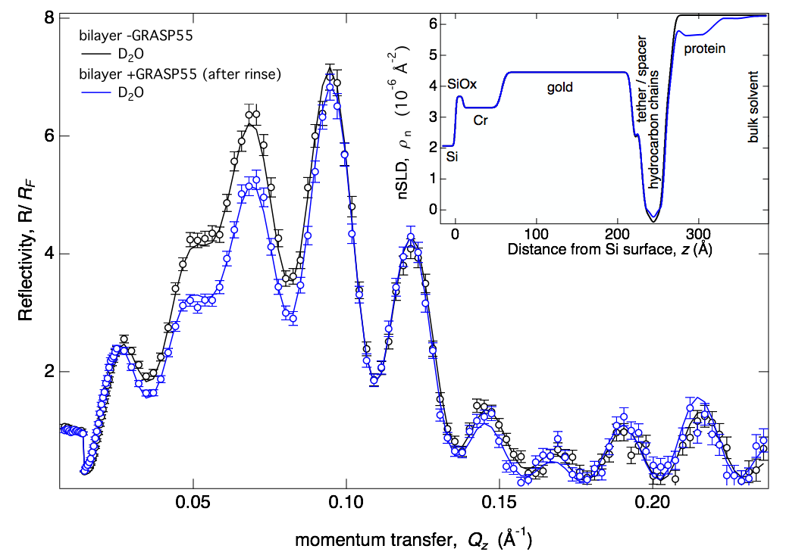
Neutron Reflectivity, fit, and nSLD profile for a system similar to the tethered lipid bilayer prepared during this tutorial experiment (only D₂O-based bulk solvent contrasts shown). The two data sets show the tethered lipid bilayer before and after incubation with protein (GRASP55 [Hei14b]).

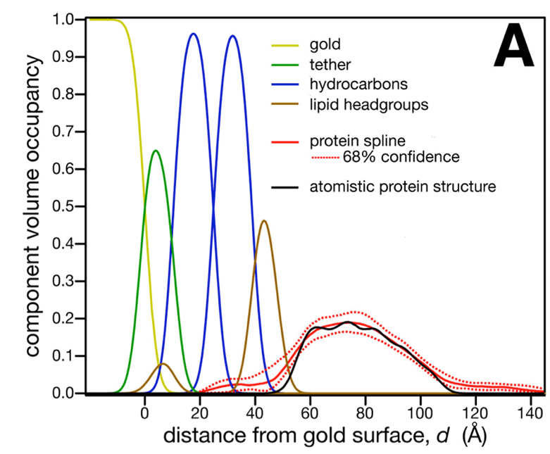
Advanced modeling shown for the data set with membrane-associated GRASP55. Instead of homogeneous slabs of constant scattering length density (box model), volume distributions of molecular groups are modeled (composition-space model). Therefore, quantities of interest can be directly obtained from the fit. Here, for example the penetration of the GRASP protein into the lipid bilayer and the orientation of the protein using an atomistic protein structure was determined [Hei14b]).

References

[Cas06] Castellana et al. Solid supported lipid bilayers: From biophysical studies to sensor design. Surface Science Reports (2006) vol. 61 pp 429-444

[Dur06] Dura et al. AND/R: Advanced neutron diffractometer/reflectometer for investigation of thin films and multilayers for the life sciences. Rev Sci Instrum (2006) vol. 77

[Gil07] McGillivray et al. Molecular-scale structural and functional characterization of sparsely tethered bilayer lipid membranes. Biointerphases (2007) vol. 2 p. 21

[Gil09] McGillivray et al. Structure of Functional Staphylococcus aureus alpha-Hemolysin Channels in Tethered Bilayer Lipid Membranes. Biophys J (2009) vol. 96 (4) pp. 1547-1553

[Hei09] Heinrich et al. A New Lipid Anchor for Sparsely Tethered Bilayer Lipid Membranes. Langmuir (2009) vol. 25 (7) pp. 4219-4229

[Hei14] Heinrich, F., & Lösche, M. (2014). Zooming in on disordered systems: Neutron reflection studies of proteins associated with fluid membranes. Biochimica Et Biophysica Acta (BBA)-Biomembranes. doi:10.1016/j.bbamem.2014.03.007

[Hei14b] Heinrich, F., Nanda, H., Goh, H. Z., Bachert, C., Lösche, M., & Linstedt, A. D. (2014). Myristoylation Restricts Orientation of the GRASP Domain on Membranes and Promotes Membrane Tethering. Journal of Biological Chemistry, 289(14), 9683–9691. doi:10.1074/jbc.M113.543561

[Mar18] Maranville, B., Ratcliff, W., Kienzle, P. (2018). Reductus: A Stateless Python Data-Reduction Service with a Browser Frontend, submitted to Journal of Applied Crystallography.

[Maj00] Majkrzak et al. First-principles determination of hybrid bilayer membrane structure by phase-sensitive neutron reflectometry. Biophys J (2000) vol. 79 pp. 3330-3340

[Sin72] Singer et al. The Fluid Mosaic Model of the Structure of Cell Membranes. Science (1972) vol. 175 p. 720

