Item: 320-2:
Appendix A

NIST Handbook 44 – Scales

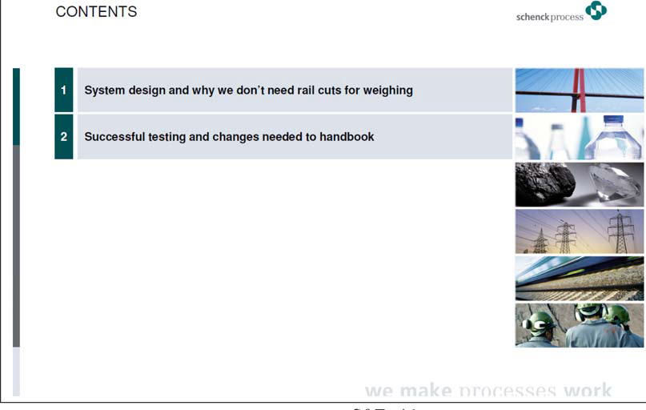
UR.2.4. Foundations, Supports, and Clearance

THIS PAGE INTENTIONALLY LEFT BLANK

THIS PAGE INTENTIONALLY LEFT BLANK

