Appendix B
History of Professional Certification Program
Source:
Carryover Item 401-1 (This item originated from the Committee and first appeared on its Agenda in 2003 and has undergone continuing development.) The numbering change reflects harmonization in all NCWM reports. Copies of reports from recent years are also available on the website under interim and annual meeting archives pages.
Background/Discussion:
It is important that users of the Professional Certification Program understand how the pieces fit together and form a coherent system. To illustrate the relationships the Committee can describe the system as a triangle of interdependent parts (see diagram below). The standards come in the form of goals with measureable learning objectives. The education part involves training provided to help the candidate reach the desired level of proficiency for each of the learning objectives. The certification involves an assessment of proficiency that measures whether or not the objectives have been met.
Certification Triangle
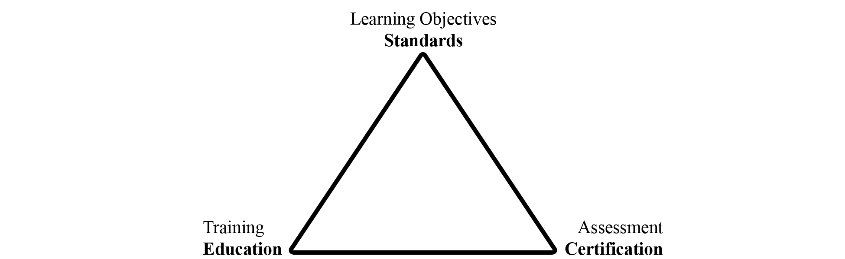

The Committee has until now focused attention on the standards and the certification pieces in the triangle as illustrated in the following flowcharts.

Standard Subsystem
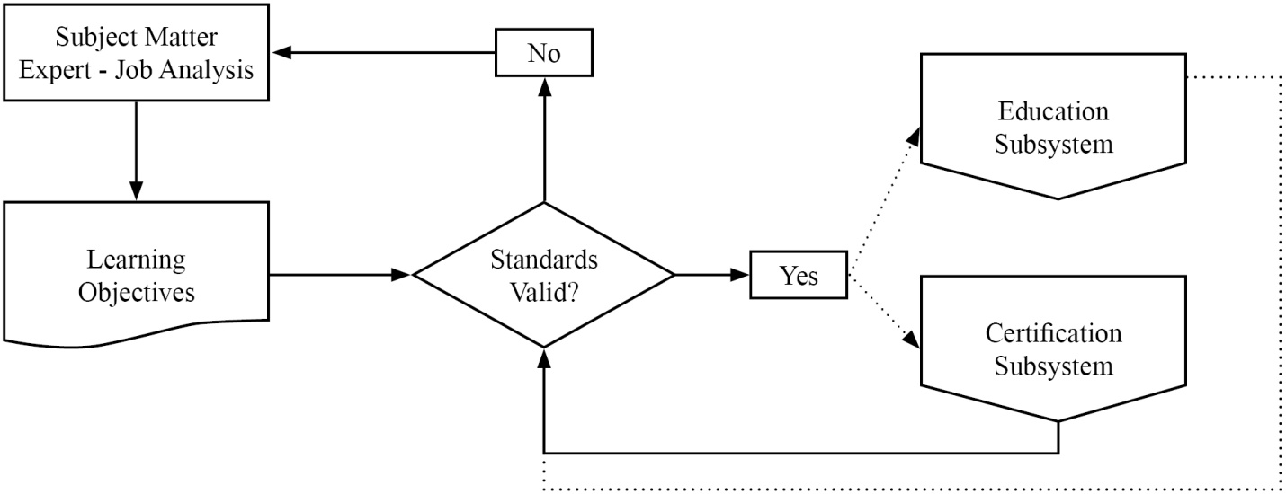

Certification Subsystem

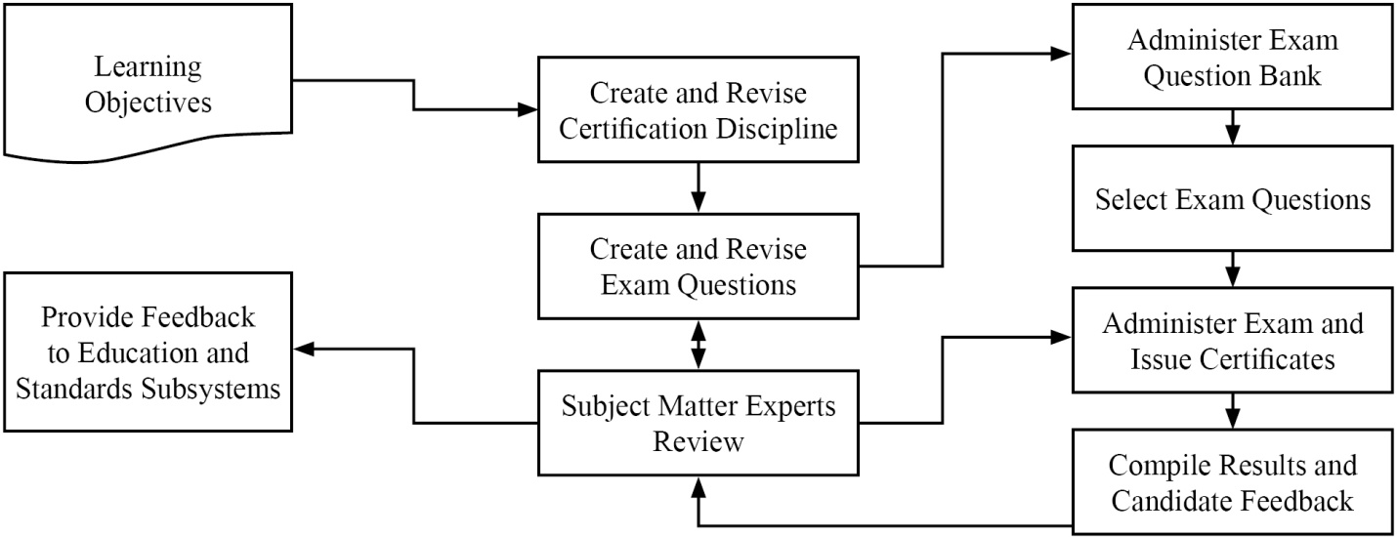
The Committee has described this work in a number of documents. In those documents the Committee is using terminology consistent with current usage in the education and certification field. The following important terms will be used throughout the Committee’s work on the subject.
Body of Knowledge (BOK) – refers broadly to the knowledge and skills required to function as a weights and measures professional. The term may refer broadly to the entire scope of knowledge and skills required within the profession or in a more directed manner to any selected subset for which the particular person is responsible. The BOK describes what you expect the weights and measures professional to achieve as opposed to how he/she will achieve it. To make the BOK more manageable in administration of the Professional Certification Program, it will be subdivided into modules in a tree-like structure moving from general knowledge and skills to more specific.
Module – refers to a group of related subject materials within the Body of Knowledge Model (BOK). The module contains the articulated learning objectives for the subject area. Each module is considered a single, self-contained course of study. However, a broader course may span multiple modules and specific training may include only part of a module or parts of multiple modules. The PDC has created a standard format to create modules for the Professional Certification Program. The Committee has also created the Curriculum Outline and work plans to help manage the work activities within the program to create the many modules necessary to cover the entire profession.
Learning Objective – refers to the articulation of expectations of performance in measureable terms. Learning objectives are stated using active terms to be precise and measureable. There are two types of learning objectives, a terminal objective, and an enabling objective. Terminal objectives state broadly the expectation of performance. The enabling objectives state the specific parts or steps required to demonstrate competence. The PDC has developed a guide to writing the learning objectives for both terminal and enabling which include the active verbs associated with the cognitive levels in Bloom’s Taxonomy. In training, the instructor will typically choose learning activities to explore each of the enabling objectives in an attempt to reach the terminal objective. In assessment, the questions will typically test for competence in each of the enabling objectives to demonstrate that the terminal objectives have been met.
Professional Certification – refers to verification of proficiency relative to all or part of the BOK for the profession as designated by the PDC for inclusion in a certification exam. The selected BOK includes all or part of specific modules, and it is documented in an exam description. Each of the modules, or combinations, is given a specific weighting in the design of the exam. After obtaining a passing score on the exam, the candidate is issued a certificate stating he/she has met the competency standard.
Curriculum – refers to the list of modules that are used to document the BOK (see Appendix A).
Bloom’s Taxonomy – refers to a classification of levels of cognitive leaning widely used in the field of education. The levels are knowledge, understanding, application, analysis, integration, and evaluation. The active verbs used in the articulation of learning objectives define the cognitive level. In training, the learning activities are matched to the cognitive level. In assessment, the form of the question is also matched to the cognitive level. The use of Bloom’s Taxonomy is described in detail in the Body of Knowledge Model document.
The PDC has prepared program documents that are available on NCWM website.
- The Curriculum Outline, which breaks the profession of weights and measures into component parts called modules.
- The Body of Knowledge Model, which explains how to create modules to document the learning objectives.
- The Modules developed thus far.
- The Certifications developed thus far.
Results of the Retail Motor Fuel Dispensing Systems exam indicate it will be very important as the program moves forward that trainers integrate the learning objectives into their materials and design courses in such a way that candidates will achieve the desired levels of learning. See Item 401-2 Instructor Improvement.
2011 NCWM Interim Meeting: The Committee addressed the need to build partnerships between the states, National Institute of Standards and Technology (NIST), Office of Weights and Measures (OWM), and NCWM. Each group has roles in relation to the Certification Triangle as shown in the diagram below.
Professional Certification Program
Applying Certification Triangle (Triumvirate Partnership)
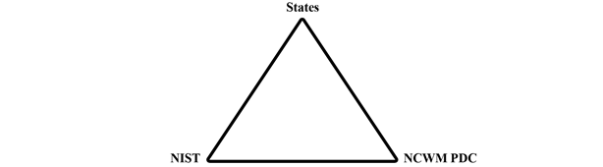
States | NCWM PDC | NIST
- National Certified Workforce  - Assessment Tools and Certification Triangle Applied  - Student Meets Training Milestones  - Feedback to Trainer and Employee  - Value Exam Results = Recognition + Adult Learning  - Develop New Training Standards  - NCWM/NIST Regional Education and Training | - Website and Administer Professional Certification Program  - Enlist SMEs  - Learning Objectives and Standards  - Curriculum Work Plans, Discipline, Segments  - Write/Verify Exam Questions  - Exam Evaluation/Statistical Analysis | - Training and Education  - Instructor Improvement “ADDIE”  - State Instruction Support  - Technical Materials  - Train the Trainer Material  - Classroom and Field Training

NCWM 2012 Interim Meeting: The Committee received a comment from NIST OWM that there is a need to provide an assessment tool to measure basic competence in fundamental subject areas such as NIST Handbook 44. They hope to partner with NCWM to administer those assessments using NCWM testing service. This would assure that participants at NIST OWM sponsored training possess basic levels of proficiency in prerequisite materials so that instructors can deliver the primary material rather than spend time bringing all students up to the prerequisite level.
The Committee agrees and believes this fits with ongoing efforts to create a BOK and an exam to assess competence in mathematics for the entry level inspector. This could also be a useful tool to any jurisdiction offering training in these basic areas. The Committee will call these baseline competency examinations defined as:
Baseline Competency Examination - refers to verification of proficiency relative to one of the basic modules in the BOK for the profession. After obtaining a passing score on the exam, the candidate is issued a certificate stating he/she has met the competency standard.
The initial modules under consideration for the basic competency examinations are:
- Module XX. Weights and Measures Core Mathematics
- Module 4.2. NIST Handbook 44 – Introduction to Device Control
- Module 4.3. Weighing Systems – General
- Module 4.4. Dynamic Volume Measuring Systems – General
The BOK document for the Core Mathematics module has been drafted and will be posted on the website and appears in Appendix B.
The professional certifications currently developed (or in development) are:
- Retail Motor Fuel Dispensing Systems (Available)
- Package Checking Basic (Available)
- Small Capacity Weighing Systems Class III (Available) and
- Vehicle Tank Meters (In Development)
The Committee reported that 18 Subject Matter Expert (SME) volunteers are working on the basic package checking exam and 20 SME volunteers are working on the small capacity scale Class III exam. Those exams are nearing completion. Invitations will be sent shortly to NCWM members to solicit SME volunteers to work on the vehicle tank meter exam. The Committee noted that SMEs are the backbone of the program but also that they have competing priorities. One consideration is the idea of doing this work using web meetings, one to brief and train SMEs at the start of a project, and one at the end to resolve any remaining issues with complex questions on the exam. The idea is to minimize the time commitment of our SME volunteers while maintaining high quality in our exams.
The PDC conducted a survey in November 2011 to evaluate priorities for future exam development, appropriate range of device capacities to include in the medium or large capacity scale modules, request feedback from people who had taken the Retail Motor Fuel Dispensing Systems Exam, appropriateness of our examinations for Registered Service Agents (RSA’s), and potential problems in standardizing exams on the current NCWM standards.
The Committee received 134 responses covering 25 states, approximately 80 % weights and measures and 20 % industry. Based on the responses the Committee has selected the following subjects for priority development and will be requesting that the Board of Directors extend the Certification Coordinator’s contract for these new projects:
- Medium Capacity Scales
- Large Capacity Scales III and IIIL
- Liquefied Petroleum Gas (LPG) and Anhydrous Ammonia Liquid
- Price Verification
Survey questions on the Retail Motor Fuel Dispensing Systems Exam indicated that the majority were somewhat or very satisfied with the test taking experience, that the exam questions were appropriate to the basic level inspector, that the questions were straight forward and clearly written, and that they were able to finish in the allotted time. The only problems identified seemed to be related to computer connections and loading of graphics. NCWM staff worked with the testing service to mitigate these issues.
On the issue of using NCWM professional certifications for RSAs, the majority responded with interest in this area. The Committee worked with NCWM staff to solicit RSA volunteers to take the exam for free in order to obtain feedback. Volunteers who passed the exam would receive the formal certificate if they were members or if they pay the $75 testing fee as non-members. Four RSAs took the exam thus far and others are scheduled to take it. The Committee will gather additional data, evaluate the results, and report at the Annual Meeting.
NCWM 2012 Interim Meeting: Several state officials questioned the appropriateness of charging these volunteers for the certificate if they are non-members. They noted that the service agents invested considerable time in taking the exam so that those who passed could have been rewarded with a waiver of the fee. Mr. Onwiler, NCWM Executive Director, reported that the exam fee structure is controlled by the Board of Directors. The exam fee is waived for members as a way to improve membership value. The exam has always been available to service agents, but this was a means of acquiring volunteers for data collection without making them pay fees as non-members. The Committee verified that participants were advised of the conditions when the volunteers were contacted. The Western Weights and Measures Association (WWMA) made a proposal in 2011 that NCWM consider a tiered membership that would allow for a group rate category or reduced fees for non-members presently employed in a weights and measures related field wishing only to take the examinations. The Committee will ask the Board of Directors to consider these comments.
On the subject of the use of the current NCWM standard as the basis of all exams, the feedback from the survey clearly indicated that this should not be a problem for most jurisdictions. Therefore the Committee will develop all exams based on the current editions of NCWM standards.
Officials had concerns about preparing their workforce for taking the Retail Motor Fuel Dispensing Systems Exam. As the PDC proceeds in offering other certifications, the Committee wants jurisdictions and industry to feel supported and confident that the training they provide for their workforce will be comprehensive and will prepare their people to take the certification exams without providing them with the exam questions. The Committee therefore recommends better communication so they understand what tools are available to help them create their own comprehensive training programs. The critical viewpoint is that a professional has to be prepared to perform the job and not just prepared to take the exam. This is the age old question of training to the learning objectives (the BOK) or training to the exam. The Committee strongly believes that training has to focus on the BOK and not on the exam questions.
NCWM 2012 Annual Meeting: The Committee met with the Board of Directors to provide an update on progress and agree on priorities. The Certification Coordinator reported that two additional question banks for small capacity scales Class III and package checking had passed the technical review and were submitted to NCWM Headquarters. He also reported that SME volunteers are now working on the vehicle tank meter exam, and that he is expecting to start the search for SME volunteers for the medium and large capacity scale exams shortly after the Annual Meeting. NCWM Executive Director Don Onwiler reported that there has been a slight glitch in the system that must be corrected before two new the exams can be opened for use. This involves making sure that Headquarters controls the individual’s access to exams. Each candidate gets access to initially take the exam and then can get a retest if they fail. The original process had given the candidate access to all exams using the same credentials. As soon as this is corrected they will broadcast the availability of the two new exams.
The idea of accrediting the certification program was discussed. The Executive Director reported that he had been discussing the idea with the Institute for Credentialing Excellence (ICE) to see what parts of our program might be potential stumbling blocks. One area involves the SMEs who develop and vet the test questions. Our problem is that our SMEs are virtually all trainers within their jurisdictions and the vetting and training functions need to be separated. One possible avenue that we are pursuing is to restrict the access each SME has to the exam bank by only allowing them to review a part (~ ¹/₄) of the test bank. The advice also suggested that SMEs be asked to sign over rights to the test questions and that NCWM seek to copyright its exams. The Committee and the Coordinator will continue to work with the Executive Director toward the goal of meeting the accreditation standards and both the Coordinator and Headquarters will work on documenting procedures as a necessary step in that process. The Executive Director will continue to seek advice towards this long term project from ICE.
The Executive Director provided the Committee and the Board of Directors with following statistics on the Retail Motor Fuel Exam.
 | FY 2011 | FY 2012
Number of Individuals taking the exam | 76 | 128
Number of Organizations taking the exam | 32 | 68
Number of Exams taken | 189 Note(1) | Note (2)
Number of Certificates issued | 45 | 79
Further Breakout State Gov’t  Local Gov’t  Industry |  | 86  37  5
Note 1. In the Beta testing phase several took the exam multiple times.
Note 2. Results unavailable yet for FY 12.
The Committee and the Board of Directors agreed that priorities will remain on the Professional Certifications. The Committee will not be pursuing the competency exams. This will help focus efforts to get the exams out based on priorities established by the survey the Committee conducted.
The Committee understands that the SMEs are a critical part of the certification program. The Committee wants to recognize the individuals that are contributing and also encourage others to volunteer on future projects (i.e., the medium and large capacity scale exams) that will start soon. To this end the Committee wants to express gratitude by giving recognition to the following who contributed to the package checking and small capacity scale Class III exams.

Package Checking Basic | Small Capacity Scales Class III
D'Arcy, Carlos, Florida | Smith, Dan, Arkansas
Wilson, Peter, Virginia | D'Arcy, Carlos, Florida
Gurney, Brett, Utah | Wilson, Peter, Virginia
Chesser, Tim, Arkansas | Gurney, Brett, Utah
Merritt, Kevin, Idaho | Chesser, Tim, Arkansas
Shultz, Steve, Nevada | Merritt, Kevin, Idaho
McGee, Robert, South Carolina | Shultz, Steve, Nevada
Hicks, Tyler, Oklahoma | Stokes, John, South Carolina
Johnson, Ray, New Mexico | McGee, Robert, South Carolina
Paquette, Marc, Vermont | Hicks, Tyler, Oklahoma
Tubacki, Jeff, Illinois | Johnson, Ray, New Mexico
Dillibaugh, John, Pennsylvania | Paquette, Marc, Vermont
Miller, Rachelle, Wisconsin | Tubacki, Jeff, Illinois
Feagan, Bruce, Washington | Dillibaugh, John, Pennsylvania
Butcher, Ken, NIST, OWM | Miller, Rachelle, Wisconsin
 | Feagan, Bruce, Washington
The Committee heard testimony from a number of individuals during the open hearings and appreciates the comments. In particular, the Committee is very pleased that states are starting to find ways to integrate our standards and the certifications in their programs. One state reported their efforts to mandate in regulation that Registered Service Agents get NCWM certification to demonstrate competence. Another is giving CEUs to county officials who obtain NCWM Certification. Others are using the exam results to evaluate their training efforts. One jurisdiction is using NCWM certifications in labor relations to demonstrate that retention and promotion decisions are being based on an unbiased third party assessment. The CWMA is considering whether it might be possible to use the NCWM exam in their reciprocal testing program for RSAs.
One state director reported that he had his entire staff take the RMFD exam. He provided some valuable feedback that the Committee and the Coordinator will consider. One involved making clear which version of the Handbooks is being used in the exams. He also reported that candidates taking the exam wanted to learn about which questions they got wrong. He also wanted the Committee to look at extending the Certification Program to accredit the overall weights and measures program.
The Committee understands the concern about the wrong answers, but maintaining integrity of the test precludes us from giving that kind of specific feedback on the exam. At the end of the exam, the candidate is provided with the pass/fail on each segment of the exam and the final score. The candidate is also provided with the option of designating the e-mail address where the results will be sent. Thus, the results could go to a supervisor or the director. The Committee is considering avenues to provide feedback that will help states identify potential weaknesses in their training programs. Again, the Committee wants to divert the focus from the test back to ensuring mastery of the learning objectives in the BOK. To that end, the Committee is considering providing general statistics on each part of the exam so that a jurisdiction/company could compare their staff’s results with the composite of all those who took the exam. There is a further fear that providing detailed feedback on specific learning objectives where exam results showed low scoring would then divert the focus from the broad objectives of the BOK.
CWMA 2012 Interim Meeting: There was general support for removing much of the content in this item and making it reference material on the NCWM website. There was question regarding how NCWM assesses exam difficulty and a suggestion to look at professional certification programs for other industries to see what the passing rates are and what they use to know if the exams are at the appropriate difficulty level. There were several suggestions to improve the exam process, including a flag button on each test question that test takers could select to notify that a specific question was problematic. Another was to provide a direct link at the end of the test to a survey site or other site for immediate feedback on the test. Another suggestion was to disclose to test takers which areas of NIST Handbook 44 they should study based on their results, without being told the actual questions that were incorrect. This would maintain the integrity of the test while providing guidance to the test taker.
WWMA 2012 Annual Meeting: The WWMA PDC chair presented a PowerPoint presentation reviewing the Professional Certification Program (PCP) entitled “Using the NCWM Program” during the open hearings. One comment/question was received during the open hearings regarding the time limit to take an exam after an individual has registered and received their passcode. The Committee, in conversation with the NCWM Executive Director by telephone, confirmed that there is no time limit for initial log in or between taking the first and second exam. Furthermore, if a NCWM member fails the second exam, he or she can reapply and retest until they pass the exam, free of charge. The Committee discussed the draft FAQ sheet developed by Mr. Ross Andersen and recognized that it is a good start and is in need of further development. The Committee is willing to assist with enhancing and clarifying this document. The Committee discussed the exam result data compiled on the three exams to date. The RMFD exam has been available since 2010. The Package Checking Basic and Small Capacity Scales Class III have been available since August 2012. The Committee recognized the likelihood that the pass/fail rate on the exams to date may not reflect the difficulty of the exam since many may be taking the exams to familiarize themselves with the exam process, not necessarily for obtaining the certificate. The Committee discussed accreditation of the PCP, the benefits to both industry and regulatory individuals, and the issue created by crossover between persons serving as both Subject Matter Experts (SMEs) and trainers. The Committee discussed the difference between certification to demonstrate basic competency, accreditation, and licensing with continuing education requirements. The Committee believes that for the PCP to be accredited, more information is needed about the specific accreditation requirements so the NCWM Professional Development Committee (NCWM PDC) can efficiently and correctly design the Program. The Committee encouraged the WWMA audience to take one or more of the three exams that are available. The Committee discussed the need for volunteer SMEs, exam results data, and feedback on the exam taking experience, to assist the NCWM PDC in the continuous improvement of existing exams, and development of future exams. Feedback can be submitted to the NCWM PDC through NCWM via e-mail to info@ncwm.net or call (402) 434-4880. The concept of free exams or a “rollback” in pricing for a period of time was discussed. There may be jurisdictions, business organizations, or other entities that desire to take the exams, but find the cost of membership is prohibitive. The Committee believed there might need to be an initial incentive to encourage participation. The Committee recommends the following:
- NCWM survey jurisdictions to find out the number of Registered Service Agents (RSA) within the jurisdiction, whether these jurisdictions require the RSA to pass an examination, and what fees and timelines are associated with these requirements; Determining the number of jurisdictions that require licensing and the content of their examinations, e.g. regulatory vs. technical requirements, would allow the NCWM PDC to evaluate the appropriateness of administering the same exams for RSA’s or development of separate exams particular to RSA’s. The jurisdictions using these written exams in their training programs could do so in conjunction with a field component to certify inspectors and RSA’s.
- NCWM Executive Director continue research into the accreditation requirements and recommend the appropriate accreditation body for the PCP; Weights and measures jurisdictions and industry organizations that may require certification recognize the value and credibility provided through formal accreditation.
- NCWM PDC continue its work refining the PCP FAQ Sheet. The WWMA PDC Committee is willing to assist with enhancing and clarifying this document; The PCP FAQ Sheet is a valuable tool for new exam takers.
- NCWM PDC consider implementing a policy of offering newly introduced exams at a reduced price for a fixed period of time (e.g., $30 per exam for six months) providing the exam taker agree to provide feedback on the exam contents and exam taking experience before receiving their certificate. NCWM needs to encourage the widest possible participation in the early stages of PCP development. To bring the PCP to full program fruition, offering incentives to exam takers may assist the NCWM in reaching its goals.
One jurisdiction indicated that they would begin using the examinations as part of their annual performance plans and performance evaluations for their staff. The Committee realized that the PCP was originally designed for weights and measures officials, but discussed whether the exams should be modified for RSA to put more emphasis on proper calibrations, sealing, etc.

THIS PAGE INTENTIONALLY LEFT BLANK

