Appendix A
NTEP Statistics Report
General NTEP Statistics | Last Year | This Year | Grand Total
 | 10/01/12 – 9/30/13 | 10/01/13 – 6/30/14 | 10/1/00 – 6/30/14
Total Applications Processed | (8) 255 | (32) 251 | (184) 3538
Applications Completed | 252 | 230 | 3436
New Certificates Issued | 253 | 214 | 3062
Active NTEP Certificates on 6/30 | 1977 | 1887
( ) = Reactivations
Assignments to Labs per Year | 10/1/12 – 9/30/13 | 10/1/13 – 6/30/14 | 10/1/00 – 6/30/14
California | (1) 38 | 29 | (17) 475
Canada | 2 | 1 | (4) 46
GIPSA-DC | 1 | 0 | 17
GIPSA-KC | 9 | 6 | 102
Maryland | (7) 50 | (2) 35 | (46) 453
New York | (2) 10 | 7 | (19) 180
NIST Force Group | 4 | 4 | (1) 96
North Carolina | 8 | 20 | (4) 140
Ohio | 62 | 37 | (28) 876
NTEP Staff | (2) 70 | 109 | (12) 1019
Applications Not Yet Assigned to a Lab |  | 6
( ) = Reassignments from another lab
Process Statistics |  | 2013 - 2014 | 2000 - 2014
Average Time to Assign an Evaluation |  | 3.8 Days | 8.6 Days
Average Time to Complete an Evaluation |  |  | 131.2 Days

Report on Evaluations in Progress
Evaluations in Progress | 0-3 Months | 3-6 Months |  | 6-9 Months |  | 9-12 Months |  | Over 1 Year |  | Total
June 30, 2010 | 37 | 12 |  | 11 |  | 13 |  | 24 |  | 97
October 30, 2010 | 40 | 30 |  | 8 |  | 8 |  | 20 |  | 106
December 31, 2010 | 39 | 25 |  | 22 |  | 5 |  | 20 |  | 111
March 31, 2011 | 37 | 27 |  | 13 |  | 19 |  | 17 |  | 107
June 30, 2011 | 47 | 20 |  | 7 |  | 7 |  | 21 |  | 102
September 30, 2011 | 42 | 28 |  | 11 |  | 5 |  | 19 |  | 105
December 31, 2011 | 37 | 19 |  | 23 |  | 5 |  | 17 |  | 101
March 31, 2012 | 40 | 17 |  | 7 |  | 21 |  | 14 |  | 99
June 30, 2012 | 41 | 21 |  | 10 |  | 6 |  | 20 |  | 98
September 30, 2012 | 50 | 30 |  | 15 |  | 7 |  | 19 |  | 121
December 31, 2012 | 32 | 24 |  | 17 |  | 7 |  | 18 |  | 98
March 31, 2012 | 36 | 12 |  | 14 |  | 12 |  | 18 |  | 92
June 30, 2013 | 53 | 18 |  | 6 |  | 6 |  | 19 |  | 102
September 30. 2013 | 44 | 32 |  | 5 |  | 4 |  | 21 |  | 106
December 31. 2013 | 41 | 25 |  | 24 |  | 2 |  | 24 |  | 116
March 31, 2014 | 53 | 23 |  | 13 |  | 17 |  | 11 |  | 117
June 30, 2014 | 55 | 30 |  | 14 |  | 8 |  | 19 |  | 126
In Progress by Lab | 0-3 Months | 3-6 Months |  | 6-9 Months |  | 9-12 Months |  | Over 1 Year |  | Total
California | 7 | 6 |  | 5 |  | 0 |  | 7 |  | 25
Canada | 0 | 1 |  | 0 |  | 0 |  | 0 |  | 1
GIPSA-DC | 0 | 0 |  | 0 |  | 0 |  | 1 |  | 1
GIPSA-KC | 4 | 2 |  | 0 |  | 1 |  | 1 |  | 8
Maryland | 6 | 5 |  | 3 |  | 1 |  | 1 |  | 16
New York | 1 | 1 |  | 1 |  | 0 |  | 0 |  | 3
NIST Force Group | 1 | 0 |  | 2 |  | 2 |  | 2 |  | 7
North Carolina | 6 | 8 |  | 2 |  | 1 |  | 1 |  | 18
Ohio | 9 | 2 |  | 1 |  | 3 |  | 6 |  | 21
NTEP Staff | 16 | 4 |  | 0 |  | 0 |  | 0 |  | 20
Unassigned | 5 | 1 |  | 0 |  | 0 |  | 0 |  | 6
 |  |  |  |  |  |  | Total Pending: |  | 126

Report on Applications Received by Quarter
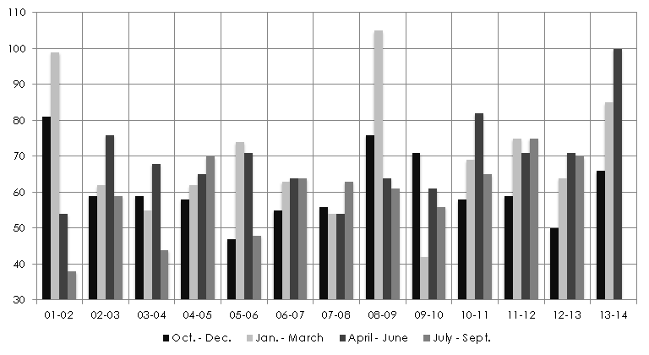
NTEP – A3
 | 01-02 | 02-03 | 03-04 | 04-05 |  | 05-06 | 06-07 | 07-08 | 08-09 | 09-10 | 10-11 | 11-12 | 12-13 | 13-14
Oct – Dec | 81 | 59 | 59 | 58 |  | 47 | 55 | 56 | 76 | 71 | 58 | 59 | 50 | 66
Jan – Mar | 99 | 62 | 55 | 62 |  | 74 | 63 | 54 | 105 | 42 | 69 | 75 | 64 | 85
Apr – Jun | 54 | 76 | 68 | 65 |  | 71 | 64 | 54 | 64 | 61 | 82 | 71 | 71 | 100
Jul - Sep | 38 | 59 | 44 | 70 |  | 48 | 64 | 63 | 61 | 56 | 65 | 75 | 70
Total | 272 | 256 | 226 | 255 |  | 240 | 246 | 227 | 306 | 230 | 274 | 280 | 255 | 251
Average Per Quarter Overall: |  |  | 65.1
Average Per Quarter This FY: |  |  | 83.7

THIS PAGE INTENTIONALLY LEFT BLANK

