Classroom Speaking Tips
Classroom Presentations | Tips and Tricks | Ice Breaker Examples | Handouts

Classroom Presentations
It is important to understand the difference between cybersecurity career awareness and cyber awareness. In many cases teachers are requesting a career briefing and become disappointed when the content covered seems more geared towards cyber awareness (internet safety). Topics such as strong passwords, privacy, use of social media, and online reputation management are now usually covered in detail due to the federal mandates associated with E-rate funding. Teachers may be disappointed, and students may also become bored as they have already heard the cybersafety messaging. While these topics can be briefly covered, the key is to make the connection between the cyber awareness topics and the career opportunities and pathways. What are jobs in cybersecurity? How does choosing a strong password make the job of a cybersecurity practitioner easier? Can students think of other ways besides passwords to make information confidential and secure?
What are different job roles and responsibilities in cybersecurity?

Tips and Tricks, and Things to Know

School Requirements for outside visitors
Depending on the school or school district, you may be asked to provide evidence of a background check or participate in a volunteer screening process. You or a representative of your organization might want to verify the requirements. Always ask that a second adult be present during your presentation. Make sure you have a state or federal government-issued form of identification on hand when arriving at the school. Most schools now require proper identification at the main office before allowing you to be escorted to your presentation location.

Grab their attention
The key to a successful presentation is to capture the audience’s attention from the start and hold throughout. You might want to start with a brain teaser, short video, open-ended question, magic trick, age-appropriate story, or demonstration that introduces your topic.
NOTE: Handouts and giveaways should be given towards the end of your presentation.

Presentation pointers
Here are some tips to help your presentation go smoothly.
- Introduce yourself with age appropriate vocabulary
- Avoid (spell out and explain) acronyms; assume the audience is not familiar with any acronyms or titles
- Make eye contact
- Whenever possible, make it active, animated, and include discussion and hands-on activities
- Use minimal PowerPoint and/or video
- Do not assume there will be electricity, laptop, projector, screen, or Internet access
- Get students engaged by asking questions and continue to check often for understanding
- Use props, activities, student demos, and other visual materials to make the presentation more interactive
- Close with a summary of your key points, or, better yet, ask students to summarize their key take- aways

Thanks all around
Be sure to thank the students, teachers, chaperones, parents, and administrators for allowing you to visit.

Ice Breaker Examples
Here are a few crowd pleasers to help capture the student’s attention.
Handout | Poster or Handout
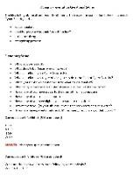
Title: Opening Questions  Description: Opening questions and/or riddles to grab the  student’s attention. | Title: 3D Eyes  Description: 3D Poster
Poster or Handout | Poster or Handout
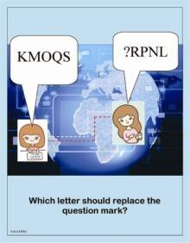 | 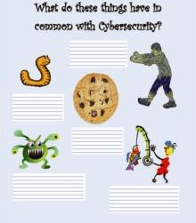
Title: Next Letter  Description: Which letter comes next? | Title: Things in Common  Description: What do these things have in common?

Poster or Handout | Poster or Handout
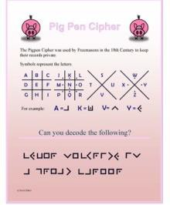 | 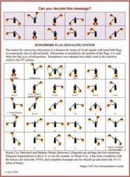
Title: Pig Pen Cipher  Description: Pig Pen Cipher puzzle. | Title: Flag Poster  Description: Flag poster. Also, great to have the flags for  students to try out the messaging.

Handouts
Include handouts that discuss the topic and marketing material of your organization.
Poster or Handout | Handout
 | 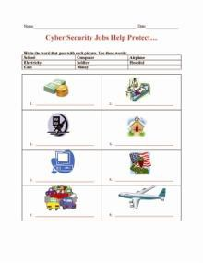
Title: Careers in Cybersecurity  Description: Visual display of career options | Title: Name the Picture  Description: Cybersecurity and protection

