NIST Special Publication

Mobile ID Device
Best Practice Recommendation
Version 2.0

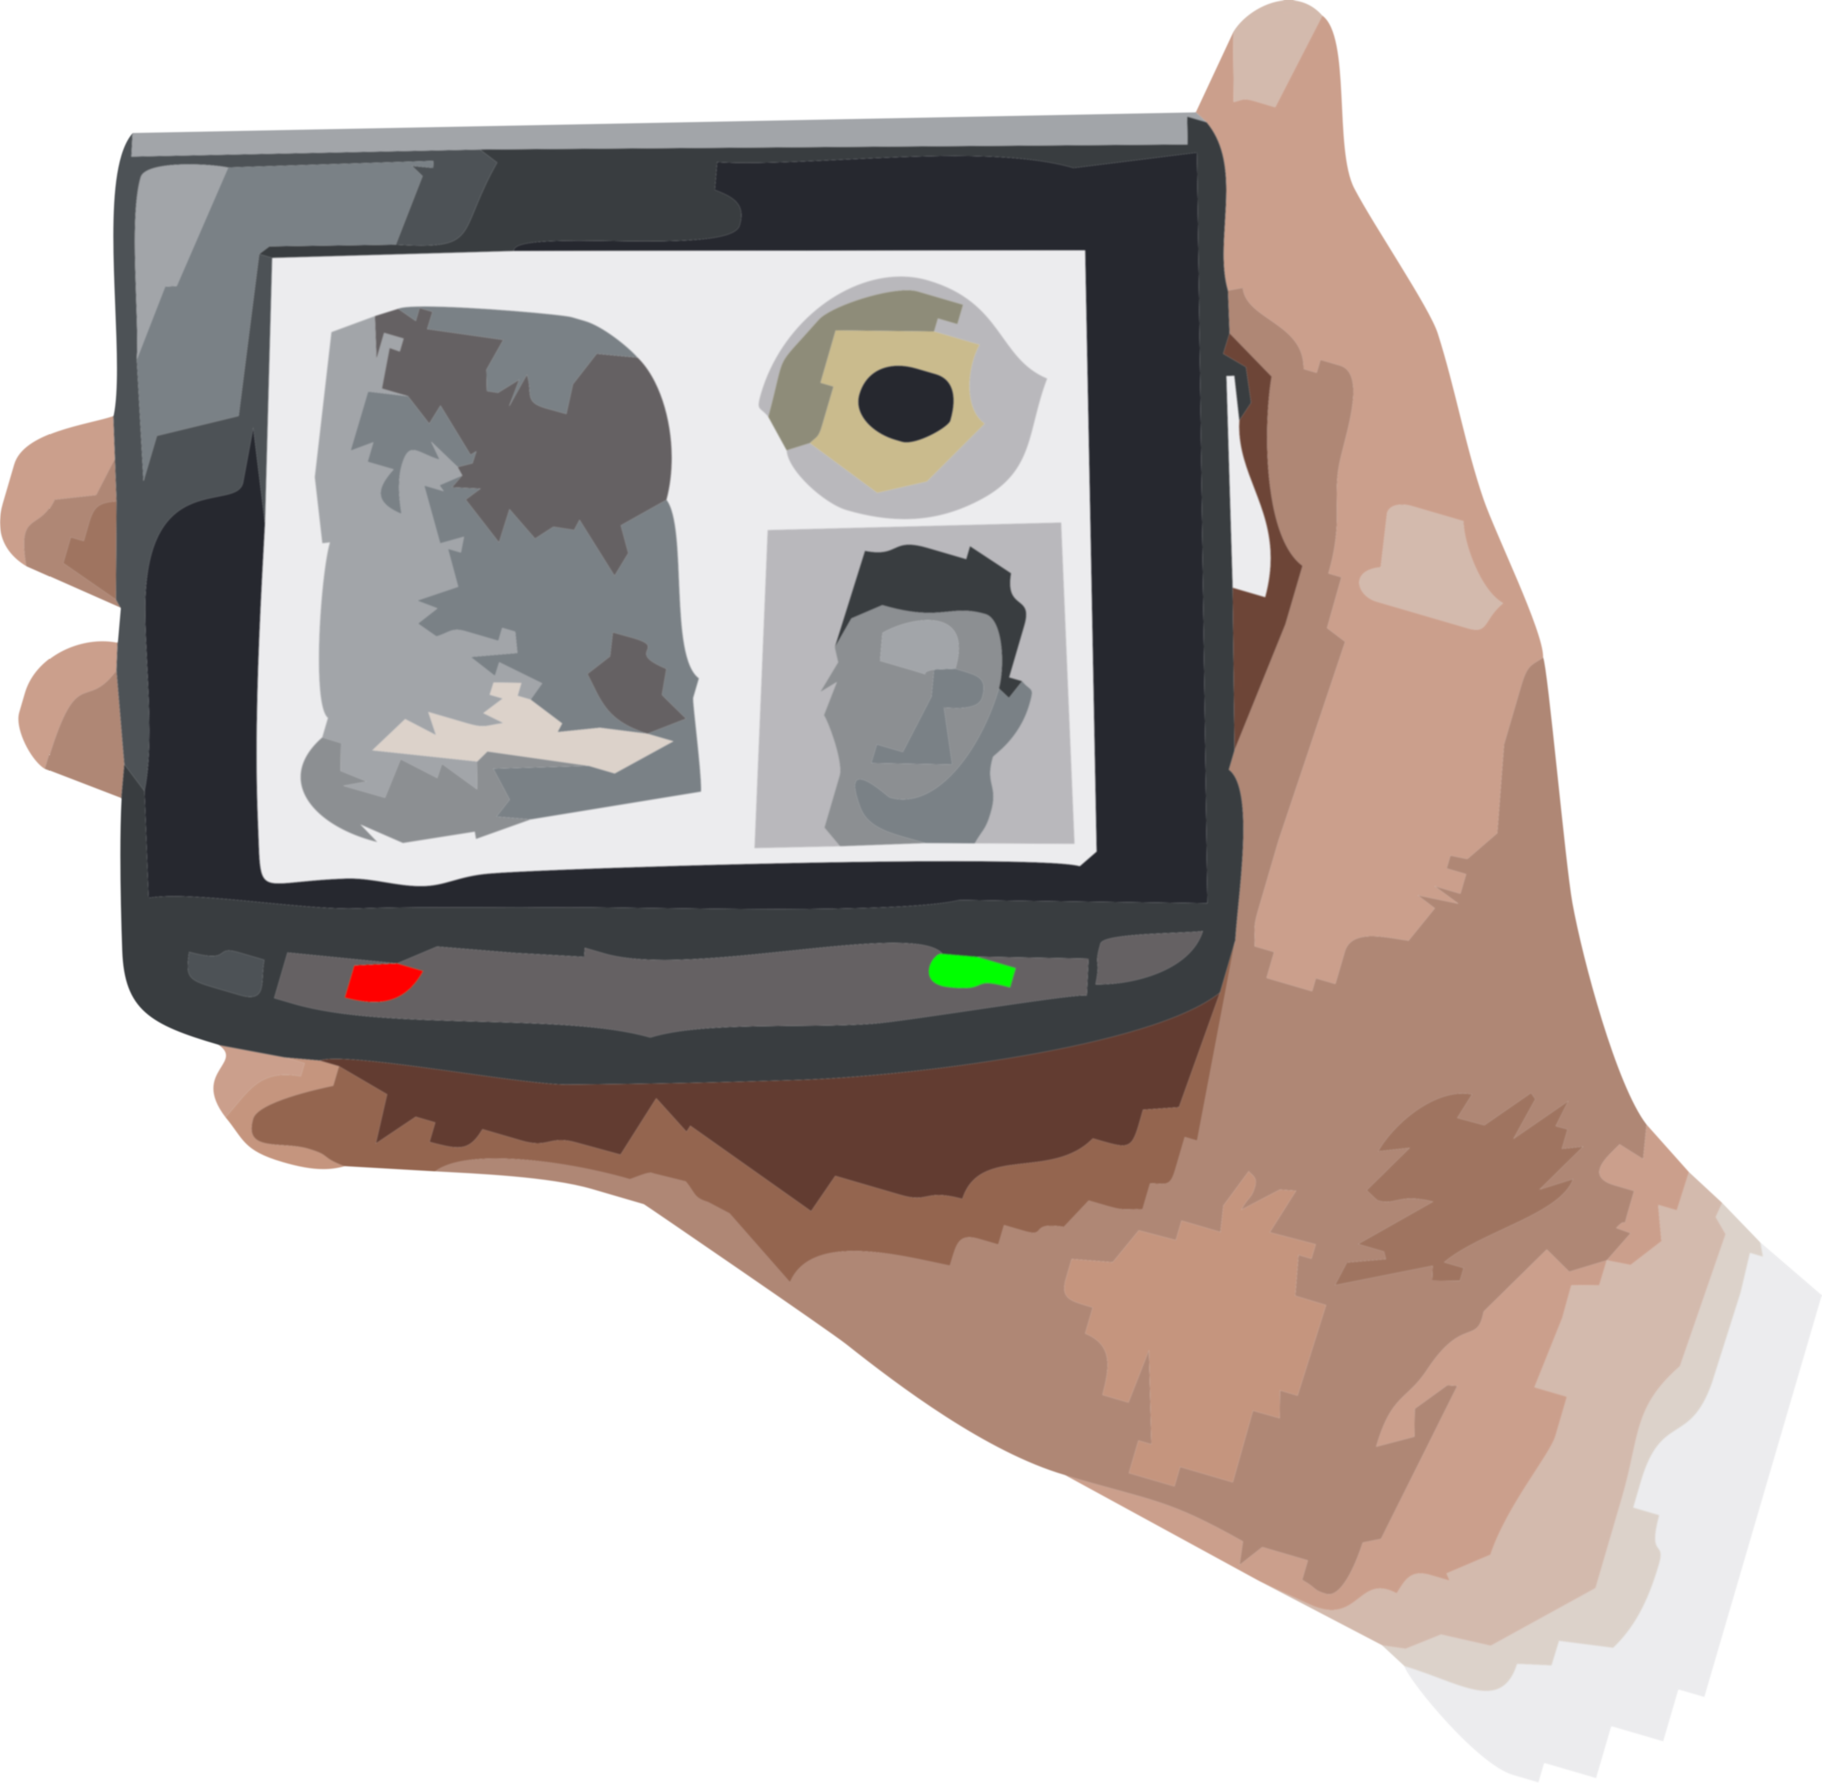

Mobile ID Device
Best Practice Recommendation
Version 2.0

NEW DATE

TABLE OF CONTENTS

Table of Contents
1 Introduction 4
2 Scope 5
3 Taxonomy and Definitions 6
4 System Design Considerations 8
5 Data Format 14
6 Data Quality 14
7 Mobile ID Devices – Modality-Specific Recommendations 16
7.1 Friction Ridge capture devices 16
7.1.1 Friction Ridge Acquisition Profiles 19
7.1.1.1 Flat images and rolled images 20
7.1.1.2 Gray levels 20
7.1.1.3 Acceptable Image Resolution 21
7.1.1.4 Image Dimension 21
7.1.1.5 Compression Algorithm 21
7.1.1.6 Compression Ratio 22
7.1.1.7 Simultaneous Fingers 22
7.1.1.8 Sensor Certification 22
7.2 Fingerprint capture unit equipment specifications 23
7.3 Fingerprint Capture of Exemplars from Persons 25
7.3.1 Capturing Fingerprints from living persons 25
7.3.2 Capturing fingerprints from deceased persons 26
7.3.3 Capture of Latent Fingerprints from Objects 27
7.3.4 Palmprint capture unit equipment specifications 30
7.3.5 Capturing Palmprints from Living Persons 31
7.3.6 Capturing Palmprints from Deceased Persons 31
7.3.7 Palmprint Capture of Latent Prints from Objects 32
7.4 Toe and Sole Capture of Exemplars from Persons 32
7.4.1 Toe and Sole (Plantar) Capture of Latent Prints from Objects 33
7.5 Friction Ridge Interchange Requirements 33
7.5.1 Image vs. Template 35
8 Mobile ID 2D Photographic Image Capture Devices 36
8.1 Overview 36
8.2 Basic Equipment Requirements 36
8.3 Image Data Handling Requirements – On Device 38
8.3.1 Still Photograph 38
8.3.2 Video 40
8.4 Image Data Handling Requirement -- Transmission 40
8.5 Face Photograph Capture Requirements 42
8.6 Face Photograph Transmission Requirements 42
8.7 Scar / Mark / Tattoo (SMT) Image Capture Requirements 46
8.8 Scar / Mark / Tattoo (SMT) Image Transmission Requirements 47
8.9 Forensic Dental Image Capture Requirements 48
8.10 Forensic Dental Image Transmission Requirements 48
8.11 Photographic Image Capture for Other Body Parts 49
8.12 Photographic Image Transmission for Other Body Parts 49
8.13 Biometric 2D Photo Verification and Identification -- On Device 50
8.14 Biometric 2D Photo Verification and Identification – Off Device 50
9 Iris Images 50
9.1 Iris Capture Devices 51
9.2 Iris Image Capture 53
9.3 Iris Image Transmission 54
10 Voice Signals 55
10.1 Voice Signal Capture Devices 56
10.2 Voice Signal Capture 56
10.3 Voice Signal Transmission 57
11 Multiple modalities in a single unit 57
12 Mobile ID Use Cases 58
12.1 Use Case Level 0 61
12.2 Use Case Level 1 61
12.3 Use Case Level 2 61
12.4 Use Case Level 3 61
12.5 Extreme Environment 61
12.6 Moderate Environment 62
12.7 Moderate Environment 64
13 Mobile Device Security & Encryption 64
13.1 Transmissions 64
13.2 Data at Rest 65
13.3 Authentication and Authorization 65
13.4 Device and Data Authentication 66
14 Communication Protocols 66
15 Environmental Protocols 67
15.1 Indoor Profile 68
15.2 Law Enforcement Profile 68
13.1 Military Profile 69
References UPDATE 70
Acronyms/Glossary UPDATE AS NEEDED BY TEXT 72

Introduction

Version 1 of the Mobile ID Best Practice Recommendation (BPR) was released in 2009. It has been referenced in many Government procurement acquisitions and has provided information helpful to companies developing mobile ID solutions. This version of the BPR builds upon that solid foundation, with the intent of reflecting changes in technology, the operating environment and standards since 2009.

The original BPR played a direct role in the 2011 update of the ANSI/NIST-ITL standard. The modality-specific application profiles for fingerprint and iris of the BPR were directly incorporated into the standard.

This revision modifies the application profiles and adds some new ones, which are also reflected in the 2015 update to the ANSI/NIST-ITL standard.

The original BPR included only face, fingerprint and iris as modalities. Voice is now included in the ANSI/NIST-ITL standard and is also included in this version of the BPR.

Although closely tied to the ANSI/NIST-ITL standard in content, this is a separate document and may be used independently of the standard.

Scope

A Mobile ID Device, for purposes of this document, is defined as a portable biometric acquisition station used by governmental organizations to capture high quality biometric samples of one or more modalities from a subject – done in near-real-time at any (even remote) location. It is expected to operate in relatively unconstrained conditions. It is not intended to be stationary and hardwired to a much larger system.

The functions performed or supported by the Mobile ID Device are:
- Enrollment
- Identification
- Verification

These devices are used by several governmental organizations, across a wide range of areas, including:
- Law enforcement
- Criminal justice
- Military
- Homeland security
- First responder
- Forensic analysis
- Identification of unknown deceased, including disaster victim identification

The quantitative requirements and specifications of required biometric characteristics typically vary by use case, which can vary substantially for each of the areas shown above.

This document focuses upon generalized characteristics that can be quantified for groupings of use cases. Specific use cases will require further refinement of specifications on the part of the procurement and operations teams.

Readers should also be aware of the Technical Report 30125 “Information Technology – Biometrics – Biometrics used with mobile devices” issued by the International Organization for Standardization (ISO) and the International Electrotechnical Commission (IEC). TR 30125 is not quoted in this BPR due to copyright restrictions.

Taxonomy and Definitions

The mobile ID device is comprised of several components that may or may not be separate physical elements. This is outlined in the taxonomy shown in Figure 1.

Figure 1
Mobile Handheld Device Taxonomy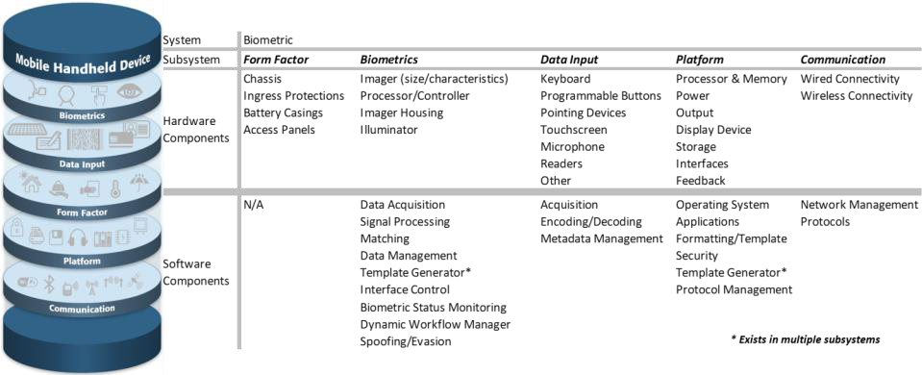

The following terms are defined for use in this document:

Application Profile

A set of characteristics for the mobile ID device and its use that is defined by ‘level.’ This allows a device manufacturer and a procurement officer to state what combination of features is defined in a particular device. In this document the following are described:

      - Face (called ‘Subject Application Profile’ – SAP)
      - Fingerprint (called ‘Fingerprint Application Profile’ – FAP)
      - Palm print (called ‘Palm print Application Profile’ - PAP)
      - Iris (called ‘Iris Application Profile’ – IAP)
      - Toe and foot print (called ‘Toe and foot print Application Profile – TAP)
      - Note that there is not a corresponding item for voice.

These application profiles are the same as in ANSI/NIST-ITL 1/2011 Update:2015.
Environmental Profile

The set of specifications related to a particular type of environmental conditions that the mobile ID device will be used in. These profiles are:

      - Indoor
      - Outdoor – Heavy Use (Law enforcement-like)
      - Outdoor – Rugged (Military-like)

Organization’s Application Profile

Technical specifications developed by specific organizations to control data content and format for submissions, based upon the ANSI/NIST-ITL standard. Some examples are:

      - EBTS for Department of Defense (DoD)
      - EBTS for the Federal Bureau of Investigations (FBI)
      - IXM for Department of Homeland Security (DHS)
      - INT-I for INTERPOL
Risk Profile

The levels established to categorize the public risk associated with the biometric modality profiles. The risk factors are defined as:
      - Severe
      - Moderate
      - Mild
Scenario

A detailed, possibly specific description of the use of the Mobile ID device from a particular end-user point of view.

Use Case

A categorization that groups together concepts-of-operations sharing similar characteristics. In this document, there are four defined use cases (see Figure 11: Use Cases)

System Design Considerations

There are several tasks that may be accomplished by a biometric mobile identification system. The primary ones include signal or image capture, signal or image processing, matching, and ultimately, an output decision that indicates an action to be taken by the operator. This action is based on an application specific decision process. Figure 2 illustrates typical combinations of these tasks across four basic configurations that can be used to divide the workload up between the Mobile ID device and a networked system. The functions shown below the ‘network’ are not included in the mobile device in that particular configuration.

Figure 2: Tasks Across 4 Basic Configurations
The primary tasks of signal or image capture, signal or image processing, matching, and output decision generation can be performed by the Mobile ID device alone or by splitting the workload with a networked system. Factors influencing the operation of these functions include location, availability of network connectivity, bandwidth of the network connection and interoperability with the other systems. The cloud in Figure 2 represents a network connection.

- Column (a) illustrates a standalone approach where the Mobile ID device performs all four functions.
- Columns (b) – (d) illustrate varying degrees of task allocation across a networked system.
The objectives to be accomplished for each of the tasks are:

- Data Capture – The process of acquiring one or more raw biometric samples from a subject
- Signal Processing – The process of extracting distinguishing features from a raw biometric sample, which may include some or all of the following:

  - Signal or image normalization
  - Segmentation
  - Feature extraction
  - Quality assessment
  - Template creation

- Matching – The process of comparing the features extracted from a submitted biometric sample to those of one or more reference templates in a database and generating a resulting similarity score for each template comparison

- Decision – The process of making a match/non-match conclusion based on the similarity score(s) meeting or exceeding a specified threshold, the application of a more complex decision processing such as multi-biometric fusion, or the creation of a candidate list.

The Decision task should be further interpreted in an application dependent manner. Resulting actions may include one or both of the following decision processes:

- Application Level Decision - The result of the search may automatically:

  - Generate one or more predetermined messages to the operator of the device
  - Trigger an alert (to one or more other systems or operators)
  - Initiate a search or retrieve additional data from one or more other systems (e.g. intelligence systems, facial image databases, etc.)
  - Be passed to a human operator for manual verification
  - Be returned as ‘raw’ image data to the operator of the Mobile ID device

Note: An application level decision may take place on either or both sides of any network.

- Operator Decision - Depending on the specific application and the result of the search, the operator of the Mobile ID device may or may not be free to make his or her own decision on how to proceed in a particular case.

  - In some scenarios, specific instructions may be returned, e.g., ‘arrest this person’, ‘do not detain this person’, ‘this is the same person as their supplied credential indicates’, or ‘this is not the same person as their supplied credential indicates’
  - In other scenarios, the search result may be returned to assist the operator in deciding what action to take, possibly in conjunction with demographic, other metadata, or one or more facial images of the potential ‘matches’

Other tasks to be performed, but not illustrated, include the addition of contextual data, the formatting of the data (to the ANSI/NIST-ITL standard and an organization’s application profiles such as FBI EBTS, DoD EBTS; or to other standard format such as an ISO data transmission standard), and the handling of transactions and responses.

There are also administrative tasks that may need to be accomplished. These include configuring the device for a particular scenario, loading/updating of watch-lists, actions to be taken by the operator in different situations, logging of encounters, output of log files and other metrics, etc.

The application requirements for the Mobile ID device drive the overall system architecture and requirements for individual components of that system.

Note that there is flexibility in the overall system design shown in Figure 2. As illustrated in Figure 3, the ‘Signal Processing’ Step may itself be split. In this example, a mobile ID device deals with the face, fingerprints and iris modalities. A separate unit deals with Rapid DNA (not considered to be a mobile ID device for purposes of this document). The output of these two units is combined at a local site to generate a unified transaction for a single individual. That transaction is forwarded to a second site, where the full suite of information is added that is necessary for transmission to one or more sites that handle the matching.

Figure 4 illustrates system architecture when the compressed iris image (only) is transmitted to a local station, where more information is added to the transmission to a central system for matching and processing. The central system may send back a candidate list to the local station for review. Based upon standard operating procedures (which may vary over time and operating conditions) a yes / no actionable response is sent back to the operator. Thus the telecommunications needs of the mobile unit are at an extreme minimum in this design.

Figure 3: Flexibility in System Design –
Illustration of Breaking Apart the Signal Processing Step

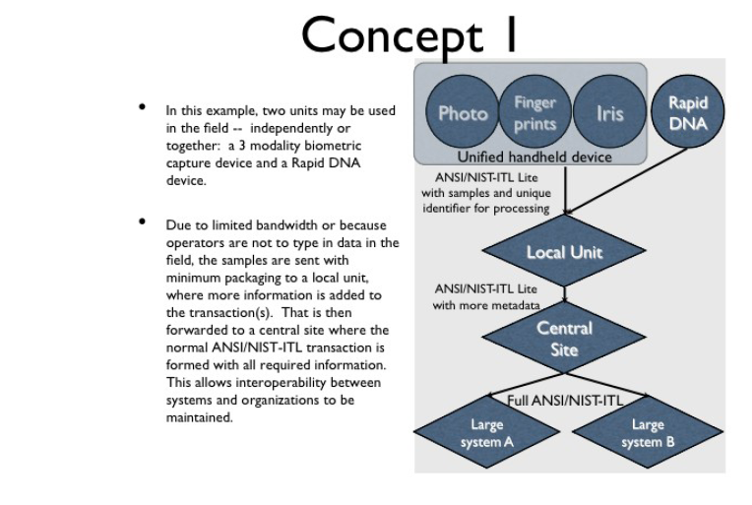

.
Figure 4: Flexibility in System Design –
Illustration of Breaking Apart the Signal Processing Step and
Breaking Apart the Decision Step
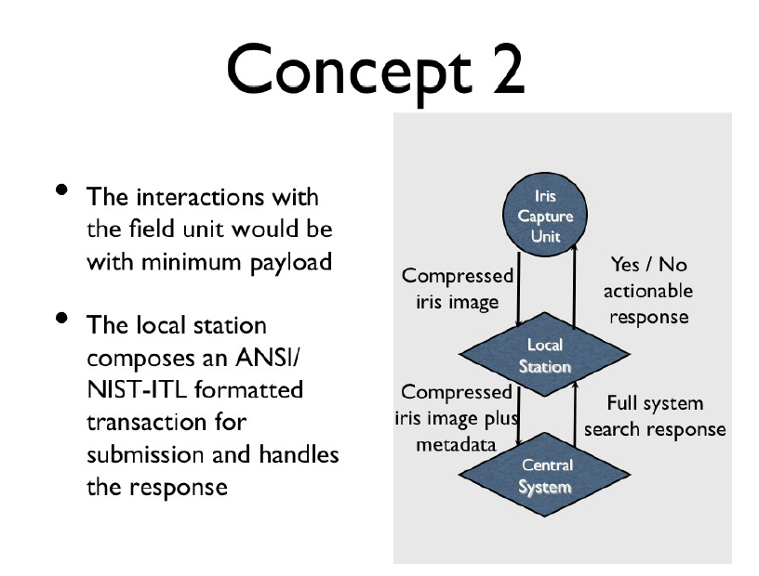

Many more possible configurations are possible other than the two illustrated above. As highlighted above, the physical design of the Mobile ID device impacts system requirements. Physical considerations include:

- System components connections (or lack thereof)
- Connectivity to other systems (sharing/interoperability)
- Security aspects of interconnected components

A partial list of design configurations might include one or more of the following within a system:

- Handheld biometric sensors
- Handheld data entry devices
- Handheld communications to a central location
- Handheld communications to a nearby vehicle
- Vehicle-based or other movable-platform-based data entry
- Vehicle-based or other movable-platform-based communications to a central location

The Mobile ID device may be designed and configured to achieve a level of integration defined as:

- Fully Integrated
- Mated (e.g. smart phone/tablet with case/sled for rolled fingerprint capture)
- Tethered-peripheral (e.g. USB fingerprint reader)
- Physically separate components functioning together (e.g. tablet control of a physically separated biometric device, using WS-BD protocols)

Data Format

Data formats are closely tied to the overall design requirements. Several different data formats may be employed within a system. To the extent possible, it is advisable to use standardized formats. Even for totally self-contained systems, data formats play a role – particularly when a record is to be maintained of the interaction with the subject and the result of the match comparison.

Typical data format considerations include:

- Format in transport, both for transmitting and for receiving data
- Format at exposed interfaces
- Data compression
- Packet size
- Network bandwidth, latency
- Storage space (of processed or raw data)
- Data security for storage and transmission
- Data secrecy and data authentication.

Data Quality

The quality of data is a major factor in how accurately a system can perform. Quality assessment may occur at each stage in Figure 2. Quality is also affected by compression of data. Data shall not be compressed, uncompressed and recompressed at any point in its life cycle of use. Only one data compression is allowed without comprising the integrity and fidelity of the data.

The enrollment data (which resides in a database) and the probe (which is being compared to the stored data) should be of the highest quality possible. Not all biometric modalities have clearly established measures of data quality that are predictive of matcher performance.
It is a best practice to attempt to capture the highest quality data possible, but it is often deemed operationally a best practice to enroll even lower quality data if it is the only data available from a subject. The operator must assess the trade-off of rejection rate vs. improved accuracy in matching. Probes may fail to match against a poor quality enrolled image, or conversely there may be an unacceptable number of potential matches that need to be reviewed manually. A poor quality probe may likewise fail to match even a high quality enrolled image.

A best practice recommendation is that an initial image quality assessment should be done to provide feedback to the operator during the capture process, whether for enrollment or for use as a probe. This may take several forms, such as (but not limited to):
- Use of an automated quality assessment tool
- Meter readings on the capture device (such as light levels on a camera and background noise levels for a voice-recording device.
As an example of an automated quality assessment tool, the NIST Fingerprint Image Quality (NFIQ) has been historically used in many systems. It is based upon a scale of 1 to 5 with 5 being the worst value. It is only applicable to fingerprint exemplars (not latent friction ridge prints, palm print exemplars or plantar print exemplars). If using NFIQ, images captured with a value of 4 or 5 should not be used for enrollment purposes.

Mobile ID Devices – Modality-Specific Recommendations

Capture devices may be designed to operate for only one modality or they may be able to capture multiple modalities. In addition, they may have different levels of ability for the operator to enter metadata (such as the circumstances concerning why the data was collected, the subject’s name, etc.)

Some units may be designed to capture a modality from the subject and use a different (or the same) modality to verify that the operator is authorized to use the unit.

This section describes the features of a capture unit that are specific to each particular modality.

Friction Ridge capture devices

Fingerprint capture devices for exemplars (i.e. captured from an individual, not a surface) have been used in mobile environments for many years. Since the general attributes are similar for all three types of friction ridges (finger, palm and plantar), they are grouped together in this document. In fact, some devices can be (and are) used for capture of different types of friction ridge prints.

There are Application Profiles for contact optical devices, which are described in Section 7.1.1 of this document. The Fingerprint Application Profile (FAP) levels, Palm print Application Profile (PAP) levels and Toe and foot print Application Profile (TAP) levels should be specified in ANSI/NIST-ITL transactions in record types 14, 15 and 19 respectively.

As discussed in Section 7.3.3, fingerprints can also be captured from objects (latent prints) – or even victim’s bodies using mobile technology. These images are transmitted in record type 13 in the ANSI/NIST-ITL standard. Latent prints are sufficiently different from exemplars that they are handled separated in the tables of this section.

Table 1 is from the 2015 Update of the ANSI/NIST-ITL standard. Notice that this table concerns impression types, while Table 2 concerns the capture technology. While one may imply the other, there is not always a direct match between the two. The codes in Table 1 may be entered in fields 13.003, 14.003, 15.003, and 19.003 of ANSI/NIST-ITL transactions. The codes are a subset of the original list of impression types for the ANSI/NIST-ITL standard, which is still retained for Type-4 records. The impression types are mandatory in ANSI/NIST-ITL friction ridge print records.

Table 2 is from the 2015 Update of the ANSI/NIST-ITL standard. The information in this table can optionally be entered in Fields 13.901, 14.901, 15.901, and 19.901 of ANSI/NIST-ITL transactions. Note that there is no capability to encode this information in a Type-4 ANSI/NIST-ITL record. Since Type-9 is not image-based, it is not relevant to that record type.

Table 1
Friction Ridge Impression Types

Exemplar Prints
Contact Impressions
Plain Contact | 0 | Finger(s) presented still on platen
Rolled Contact | 1 | Finger rolled on platen
Vertical Swipe | 8 | Finger swiped on platen
Contactless Acquisitions
Plain Contactless – Stationary Subject | 24 | Finger(s) / palm / plantar presented stationary, in view of a stationary sensor and sensor captures plan equivalent.
Rolled Contactless –  Moving Subject | 25 | Finger(s) /palm / plantar rolled in view of the sensor
Rolled Contactless –  Stationary Subject | 41 | Finger(s) / palm / plantar presented stationary, and sensor captures rolled equivalent
Plain Contactless –  Moving Subject | 42 | Finger(s) / palm / plantar move though the capture volume of a sensor
System Integration Exceptions
Other | 28
Unknown | 29

Latent Prints

Latent image | 4 | Image or impression of friction skin deposited on a surface

Table 2
Friction Ridge Capture Technology
Technology | Code | Description
Unknown | 0 | Capture Technology not provided by sensor manufacturer
Other | 1 | Capture Technology not sufficiently characterized by table
Scanned Ink on Paper | 2 | Ink applied to fingers, and then applied to paper, typically with assistance from a fingerprint collection expert
Optical - Total Internal Reflection (TIR) – Bright Field | 3 | Using optical angle of incidence effects, a contact fingerprint scanner captures ridge information such that ridges absorb light, and absence of ridges reflects light back to the sensor (dark ridges on a white background)
Optical TIR – Dark Field | 4 | Using optical angle of incidence effects, a contact fingerprint scanner captures ridge information such that ridges reflect light (white ridges on a dark background)
Optical Direct Imaging - Native | 5 | Light reflected from the friction ridge is imaged, resulting in a light gray on darker gray image… This may be performed contact or contactless, and may incorporate merging images from multiple sensors or nutation.
Optical Direct Imaging – Low Frequency Unwrapped | 6 | Light reflected from the friction ridge is imaged onto 1 or more sensors. This may be performed contact or contactless, and utilizes the low frequency 3D detail to “unwrap” or project the image texture onto a 2D grayscale image.
3 -Dimensional Imaging – High Frequency Unwrapped | 7 | High frequency friction ridge information is collected (optically, acoustic, etc.), and then “unwrapped” to create a 2D image from the 3D point cloud or mesh
Reserved | 8
Capacitive | 9 | A contact technology in which the capacitance of the fingerprint is assessed via a conducted AC signal
Capacitive – Radio Frequency (RF) | 10 | A contact technology in which the capacitance of the fingerprint is assessed via a radiated RF signal
Electro-luminescent (EL) Optical Direct Imaging | 11 | A contact technology in which the ridges and an Alternating Current (AC) signal cause an EL panel to emit light which is captured by an imaging system
Reflected Ultrasonic Image | 12 | A contact technology in which the friction ridge reflects ultrasonic energy which is assessed by the sensor
Ultrasonic Impediography | 13 | A contact technology in which the absorption of ultrasonic energy is measured by changes in the impedance of a piezo-electric material
Thermal Imaging | 14 | A contact technology in which the sensor measures the heat reflected from the fingerprint in contact with the sensor.
Direct Pressure Sensitive | 15 | A contact technology in which the pressure of the fingerprint ridges against a material is measured.
Indirect Pressure | 16 | A contact technology in which the pressure of the fingerprint ridges against a deformable material is assessed optically to produce a friction ridge image.
Live Tape (One Time Use) | 17 | A technology in which tape is used on a real finger to collect friction ridge detail, and the tape is then subsequently imaged by traditional photography.
Latent Impression | 18 | A capture process in which the digital image of the latent impression is acquired directly from the latent impression, using a flatbed scanner or digital camera.
Latent Photo | 19 | Paper photograph of the latent impression subsequently scanned using a flatbed scanner or digital camera.
Latent Molded/Cast fingerprint | 20 | A capture process in which a mold/cast is taken from a latent fingerprint, and then subsequently a “duplicate” is generated from moldable/printable material and imaged.
Latent Tracing | 21 | An older legacy latent friction ridge capture process in which a hand-drawn or computer-drawn tracing is made of the impression. A hand-drawn tracing would be subsequently imaged by a flatbed scanner or photographed.
Latent Lift | 22 | A process in which powder or a chemical is applied to a latent fingerprint, subsequently transparent tape is applied to lift the fingerprint from the latent surface, and the tape is then placed on paper to be imaged.

In the above table, the codes that are gray do not apply to mobile ID devices. They are shown here for the sake of completeness.

Friction Ridge Acquisition Profiles

Tables 3, 4 and 5 for friction ridge application profiles are applicable to contact optical devices. As noted in Table 2 there are many other types of capture devices. Contact optical devices may be tested according to protocols established by the FBI, and the list of certified products is maintained on the FBI website: https://www.fbibiospecs.cjis.gov A separate set of application profiles exists for each friction ridge type (finger / palm / plantar). They are an easy way to summarize a set of characteristics for procurement actions or product fact sheets. The ANSI/NIST-ITL standard contains fields for the transmission of the application profile specification level for optical capture devices used to generate the images.

It is up to the system designer of each particular application to determine the appropriate levels for each of the enrollment, identification, or verification functions especially if there is an intention to exchange data with other systems.

A single unit may meet a certain fingerprint application profile (FAP) level, and one for palm prints (PAP) and one for plantars (TAP). The concept of application profiles is also extended to other biometric modalities beyond those of friction ridges: face and iris. Therefore, a multi-biometric capture unit / system may also list an iris application profile (IAP) and a subject face application profile (SAP).

The following sections describe the row entries (specifications) in Tables 3, 4 and 5. Note that these Application Profiles do NOT apply to latent prints. They are for acquisition of a print directly from a person (alive or dead).

Flat images and rolled images

This category is associated with fingerprints.

As defined in the ANSI/NIST-ITL standard for fingerprints:

FLAT FINGERPRINT: A fingerprint image resulting from the touching of a single finger to a livescan platen or paper fingerprint card without rolling motion. Also known as a single finger impression.

ROLLED FINGERPRINT: A fingerprint image collected by rolling the finger across a livescan platen or paper fingerprint card from nail to nail. Rolls may be from livescan devices or scanned from paper fingerprint cards.

For units with platens smaller than 1.6” x 1.5”, rolled images cannot be captured. It should be noted that the very small platens associated with FAP 10 might not capture enough of the fingerprint – with resulting higher False Non-Match Rate when compared to a large database. It is strongly recommended that single-finger slap units be a minimum level of FAP 30.

Gray levels

This category is applicable to FAP, PAP and TAP tables.

Note that the minimum gray levels are the same for all levels. Grayscale shall normally be quantized to eight bits (256 gray levels). A zero shall represent a true black pixel and a “1” represents a true white pixel.

Note that this excludes PNG images, since they are quantized to a depth of 1 bit, and therefore 0 = black and 1 = white, with no gradations.

If an image is captured in color, it shall be transformed to grayscale prior to transmission and submission to a matcher. However, the original image should be retained for archival purposes.

Acceptable Image Resolution

This category is applicable to FAP, PAP and TAP tables. The resolution of the images shall be either 500 ppi or 1000 ppi. A small variance is allowed around these two values. For PIV-certified devices, a 2% tolerance level is allowed for 500 ppi devices. For APPENDIX F certified devices, a maximum 1% deviance is allowed from either 500 or 1000 ppi.

Image Dimension
This category is applicable to FAP, PAP and TAP tables. A principal distinguishing characteristic of the various application profile levels is the size of the capture area for the friction ridge sample. There is usually a direct relationship between the size of the capture platen and the size of the unit itself – making smaller units popular for police work. However, there is a tradeoff. Small units require imaging each finger individually. Additionally, very small units (such as FAP 10) only capture a small portion of the fingerprint.

By nature, palm and plantar print image plates are larger and may correspond in size to the units used to capture a full set of flat fingerprints.

Each operating and data processing / matching agency must determine what levels are determined to be acceptable for their operational use. This is usually stated in procurement actions using wording such as ‘A minimum of FAPxx (or PAPxx or TAPxx) level shall be provided by the vendor for all units delivered under this contract.”

Compression Algorithm

If compressed, friction ridge images captured at 500 ppi shall use the Wavelet Scalar Quantization (WSQ) algorithm for compression prior to transmission and/or storage. For platens 3.2” x 1.5” or larger, WSQ Version 3.1 or higher shall be used. Earlier versions of WSQ were not adapted for larger platens and can fail to properly handle data around the edges of the area of capture. WSQ specifications are contained in WSQ Gray-scale Fingerprint Image Compression Specification, October 2010.

Friction ridge images captured at 1000 ppi shall use the Joint Photographic Experts Group (JPEG) 2000 algorithm for compression prior to transmission and/or storage. This shall be in accordance with the JP2 format as described in ISO 15444-1.

Some systems can only accept and process 500 ppi images. Therefore, if a mobile device captures images at 1000 ppi, the image may need to be converted to 500 ppi prior to transmission. This conversion shall be performed according to the guidance in “Examination of Downsampling Strategies for Converting 1000 ppi Fingerprint Imagery to 500 ppi NISTIR 7839”.

Compression Ratio

If an image is compressed too much, it loses salient characteristics that may be useful for matching. NIST performed studies on image compression that analyzed the levels of compression.

For small images, a compression of 10:1 is specified (smaller than 1.6” x 1.5”) at 500 ppi. For larger platens capturing at 500 ppi, a ratio of 15:1 is specified. However, at 1000 ppi, all platen sizes shall use a ratio of 10:1.

Simultaneous Fingers

This is only applicable to the Fingerprint Application Profile. It is contained as a visual reminder of the practical implication of using a unit that has a platen size corresponding to each particular FAP level.

Sensor Certification

Sensor certification can be extremely important in procurement actions. The list of FBI-certified products available at https://www.fbibiospecs.cjis.gov have passed tests to establish conformance to specifications for PIV-devices or FBI-EBTS Appendix F specifications. Note that some organizations may require devices to be subject to further tests.

Table 3
Fingerprint Acquisition Profile (FAP) Levels
Contact Optical Device

Capture | FAP 10 | FAP 20 | FAP 30 | FAP 40
Acquire Flat Images | Yes | Yes | Yes | Yes
Acquire Rolled Images | No | No | No | Optional
Minimum Gray Levels | 256 | 256 | 256 | 256
Acceptable Image Resolution | 500 +/- 2% | 500 +/- 2% | 500 +/- 2% | 500 +/- 2%
Minimum Image Dimension  (W x H) inches | .5”x.65” | .6”x.8” | .8”x1.0” | 1.6”x1.5”
Maximum Compression Ratio | 10:1 | 10:1 | 10:1 | 15:1
Compression Algorithm | WSQ 2.0+ | WSQ 2.0+ | WSQ 2.0+ | WSQ 2.0+
Simultaneous # of Fingers | 1 | 1 | 1 | 1-2
Sensor Certification | PIV | PIV | PIV | PIV
Capture | FAP 45 | FAP 50 | FAP 60 | FAP 145 | FAP 150 | FAP 160
Acquire Flat Images | Yes | Yes | Yes | Yes | Yes | Yes
Acquire Rolled Images | Optional | Optional | Optional | Optional | Optional | Optional
Minimum Gray Levels | 256 | 256 | 256 | 256 | 256 | 256
Acceptable Image Resolution | 500 +/- 1% | 500 +/- 1% | 500 +/- 1% | 1000 +/- 1% | 500 +/- 1% | 1000 +/- 1%
Minimum Image Dimension  (W x H) inches | 1.6”x1.5” | 3.2”x2” | 3.2”x3.0” | 1.6”x1.5” | 3.2”x2” | 3.2”x3.0”
Maximum Compression Ratio | 15:1 | 15:1 | 15:1 | 10:1 | 10:1 | 10:1
Compression Algorithm | WSQ 2.0+ | WSQ 3.1+ | WSQ 3.1+ ⁸ | Jpeg2K | Jpeg2K ⁹ | Jpeg2K
Simultaneous # of Fingers | 1-4 | 1-4 | 1-4 | 1-4 | 1-4 | 1-4

Fingerprint capture unit equipment specifications

Table 3 lists the Acquisition Profile levels for optical capture devices that can be used for fingerprint capture. If it is determined that a non-optical capture device is to be used, it will not be possible to perform tests related to certifications. However, it is highly recommended that the procuring organization adhere to the scanning resolution, gray scale, compression ratios and algorithms specifications of the table. When a FAP level is not applicable due to the technology deployed, then the user shall include the Make and Model of the acquisition unit in Field 14.904 of an ANSI/NIST-ITL transaction record when using that record type.

Fingerprint capture devices with an integrated finger guide are desirable to optimize placement of the finger such that the core and first crease of large thumbs is captured. This may also assist in reducing sequence errors. Finger guides can also protect the fingerprint capture area from direct sunlight if required.

Mobile devices with the capability to detect the location of the fingerprint are desirable to provide a left/right, up/down indication for the operator or subject to insure optimal image content.

Mobile devices with the capability to evaluate each image frame captured are desirable to determine if a fingerprint is present that meets quality requirements and automatically save the image.

Mobile devices with the capability to manually command the device to capture the image currently on the sensor are desirable to insure the ability to capture difficult to image fingers.

After capture of the fingerprint images, a quality check function is desirable based on a combination of:
- Image size
- Light or dark image measurements
- Minutiae count
- Core location
- NIST Image quality scores (NFIQ)

Display of fingerprints on mobile device during the capture process is a useful option for some mobile device applications.

Optical scanner platen surfaces that may be field replaced are desirable to ensure continuity of use.

Aside from the recommendations and requirements listed above for the fingerprint capture device, other factors that affect the performance of these Mobile ID devices and systems need to be considered. Many of these relate to training and include:

- Operation of the device within the temperature and humidity specifications
- Ruggedness of the device
- Officer safety while using
- Use of clean fingers when possible
- Maintain clean platens
- Types of cleaners allowed on platen
- Consistent placement of the same finger(s)
- Consistent centering and use the same area from the flat of the finger
- Optical scanners should avoid excess illumination (or use capture devices that can function effectively in full sunlight)
- If enrolling more than 1 finger, ensure that sequence errors do not occur.
- If enrolling more than 1 finger always reflect accurately which finger is being captured
- On single finger capture devices, sequence errors need to be avoided (especially for enrollments)
- Quality feedback to operator
- How quickly can prints be captured
- How many transactions can be in process simultaneously (can a new set of fingerprints be captured while waiting for search results?)

Fingerprint Capture of Exemplars from Persons

This section details the basic requirements for fingerprint capture using mobile ID devices. It should be noted that additional requirements would be specified based upon the use case.

Capturing Fingerprints from living persons

The ergonomics of fingerprint capture from living persons is an important factor in determining which mobile ID device to acquire and how to use it. When procuring a unit, the authority should determine which use case or group of use cases is applicable. There may be tradeoffs in order to perform multiple operations.

A major factor is whether the subject is likely to be cooperative. Another factor is the ability of the subject to self-manipulate his/her fingers(s) (such as if in handcuffs).

Placing a finger / fingers upon a platen with the appropriate pressure and area of capture is essential for a usable print to be acquired. In cooperative situations, the operator may be able to hold the unit and request the subject to present the finger(s). There should be a quality assessment of the image at the time of capture in order to provide feedback to the operator as to whether recapture of the print is necessary. Thus, there should be a presentation screen for the operator, and the unit should be capable of being held by the operator, unless the concept is to place the unit on a flat surface without holding it. In such a case, the operator may be able to physical assist the subject with placing the finger(s) upon the platen.

For uncooperative subjects, such as those in handcuffs the ergonomics of the capture of the prints may dictate a particular physical form for the device. It is likely that the operator will have to manipulate the device to and possibly around the subject’s finger(s).

- Mobile ID fingerprint devices should be configurable so they can capture the specified fingers for a particular application.
- Use cases (see Table _) should dictate the number of fingers to be used.
- When fewer than 10 fingerprints are captured, it is recommended that fingers 2, 3, 7, & 8 be used.
- When possible, capture of 4 fingers is preferable to capture of 2 fingers. Tests have shown that using 4 fingers rather than 2 results in a significant improvement in accuracy, even though a minimum specification calls for the use of two index fingers.
- Enrollments for a system that supports latent searches should include thumbs.
- Fingerprint images captured with dimensions according to lower FAP levels may not contain the complete fingerprint and thereby may reduce the overall system accuracy. This shortfall should be kept in mind and tradeoffs weighed carefully in utilizing the lower FAP levels.

Capturing fingerprints from deceased persons

For living persons, the finger(s) are typically brought to the device and may be manipulated to acquire the print – such as the operator guiding a subject’s finger to produce a rolled print.

For deceased individuals, the fingers may exhibit rigor mortis, be partially decomposed and / or dehydrated. This provides challenges to the acquisition of prints with a mobile device. There are several choices on how to best acquire the prints:

- Manipulate the device around the finger(s) (with or without re-hydration)
- Sever the finger(s) and press / roll them on the device
- Sever the hand, remove the skin and place an operator’s hand within the skin to acquire the prints in a manner similar to acquiring prints from a living person

An excellent reference on the subject is Chapter X of “The Science of Fingerprints” (Published by the FBI) called “Problems and Practices in Fingerprinting the Dead”.

The quality of the prints may be poor, with little chance of improving the quality – unlike with living individuals, when a recapture often provides a better sample. In many cases, the captured print will be comparable in quality to that of a latent print – with portions of the print unusable for matching. In fact, some jurisdictions submit prints from deceased individuals to be processed as latent prints. In such cases, a Type-13 record is used when transmitting using an ANSI/NIST-ITL transaction. Field 13.046 (Image subject condition) should be completed to indicate that the subject status code (SSC) is D (data obtained from a non-living person). The subject body status code shall be recorded as either 1 (whole) or 2 (fragment). The subject body class code shall also be recorded as either 1 (natural tissue) or 2 (decomposed). There is also a field 14.066 that contains similar information items, if the image is good enough to be submitted as a type-14 record.

Capture of Latent Fingerprints from Objects

The equipment used for capture of latent prints from objects is substantially different from that used to capture prints directly from an individual. The ANSI/NIST-ITL standard states: “ A latent impression is the digital image of the latent impression that was acquired directly from a latent impression, using a flatbed scanner or digital camera.” This document does not deal with other means of acquiring latent prints, such as ‘lifts’ or casts / molds.

It is best practice to record the make and model of the imaging equipment in Field 13.904 of the Type-13 record in an ANSI/NIST_ITL transaction, which is used to transmit latent print images.

When acquiring a latent print using photography, the best practice is to have a ruler or scale present, and this presence should be indicated in Field 13.018. The user indicates whether the scale is in inches (IN), millimeters (MM) or BOTH. If known, the user should also include the maker and model of the ruler or scale.

The determination of pixel density of the image is important. ANSI/NIST-ITL field 13.019 should be used to state how this was done. However, as a best practice, a ruler should be used with mobile ID devices. It is important that the ruler be accurate. Examples of two different types of rulers are shown in Figure 5 and Figure 6. The ABFO Reference Scale # 2 has been in use since 1988. It was designed for imaging of patterned injuries, but may also be useful in imaging latent prints. The ABFO # 2 specifications include reflectance values of grayscale – which is important for latent images. It is important to note that several manufacturers produce rulers resembling ABFO # 2 specifications. NIST performed an analysis of these rulers and found considerable variance in quality¹³.

Figure 5: Sample rulers for Latent Print capture –
ABFO # 2 (NOT TO SCALE -- DO NOT USE OR COPY)

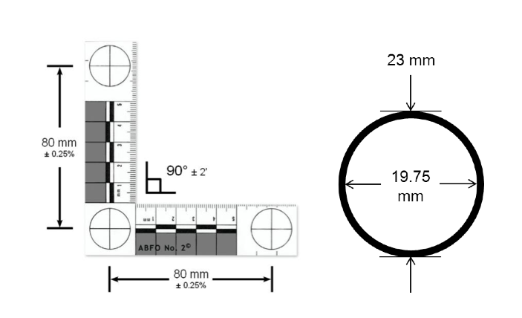
NIST has developed specifications for a scale expressly designed for latent print photography . It not only has measurements, it also includes calibrations for grayscale and color. Note that the scale is printed on both sides. This allows for images to be taken from both sides of an object (such as a transparent surface like a window) and indicate which side (in relation to the side where the object was touched) that is in the image. In addition, NIST has developed a special computational tool that can be integrated into imagers or used post-capture to adjust the image in order to produce 1000 ppi print images in conformance with the specifications of ANSI/NIST-ITL. The goal of the automated tool is to:
- Ensure/validate lock fidelity of the image using machine-readable markers.
- Provide guidance for auto-correction of correctable fidelity issues such as resolution or geometric distortion due to capture angle/position.
- Provide a mechanism to detect image inversions.
- Provide a mechanism to detect alternative illumination strategies that may have been utilized at time of collection.
- Provide a built in globally unique tracking mechanism that can be used to uniquely identify evidence, thereby minimizing chances of evidence duplication.
- Provide a built in mechanism to detect color image capture.
- Provide a built in mechanism to allow for marking of orientation by the forensic capture agent at the time of collection, if an orientation can be determined.
- Provide a built in mechanism to detect capture device dynamic range for grayscale capture.

Figure 6: Sample rulers for Latent Print capture –
NIST Latent Image Scale (NLIS) – NOT TO SCALE -- DO NOT USE OR COPY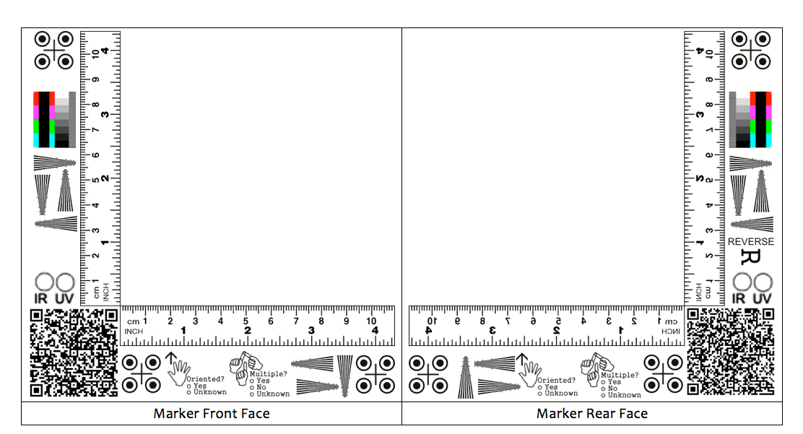

Palmprint capture unit equipment specifications

The capture of palmprint exemplars is similar in concept to that of fingerprints. The principal differences are:

- The area of the print is larger
- The palm is not usually rolled.
This is reflected in the equipment specifications. The minimum platen area is 5.0” x 5.0” corresponding to a PAP 70 level. As with the fingerprint Acquisition Profiles, there are levels corresponding to 500 and to 1000 ppi outputs, with corresponding differences in compression ratio and compression algorithm to be used.

All PAP levels require the ability to capture flat images. Capture of rolled images is optional. The minimum grayscale level is 256.

Not included in these basic specifications are others that will be of interest to the procuring agency, including (but not limited to):

- Weight of the unit
- Ability to capture images outdoors (protection from too much sunlight)
- Ability to withstand environmental conditions typical of the conditions in which the unit will be used (dust, heat / cold exposure, humidity, etc.)
- Routine maintenance requirements

Table 4
Palm print Acquisition Profile (PAP) Levels
Contact Optical Devices

Capture | PAP 70 | PAP 80 | PAP 170 | PAP 180
Acceptable Image Resolution | 500 +/- 1% | 500 +/- 1% | 1000 +/- 1% | 1000 +/- 1%
Minimum Image Dimension  (W x H) inches | 5.0” x 5.0” | 5.0” x 8.0” | 5.0” x 5.0” | 5.0” x 8.0”
Maximum Compression Ratio | 15:1 | 15:1 | 10:1 | 10:1
Compression Algorithm | WSQ 3.1+ | WSQ 3.1+ | Jpeg2K | Jpeg2K

Capturing Palmprints from Living Persons

Note that PAP 70 and 170 will require at least 2 impressions to obtain a full-palm image set, due to the size of the platen. The FBI states: “The entire area of the full palm is defined as that area extending from the writs bracelet to the tips of the fingers and can be represented as one or two images are used to represent the full palm, the lower image shall extend from the wrist bracelet area to the top of the interdigital area (third finger joint) and shall include the thenar and hypothenar areas of the palm. The upper image shall extend from the bottom of the interdigital area to the upper tips of the fingers. This provides an adequate amount of overlap between the two images to facilitate subject verification. By matching the ridge structure and details contained in the common interdigital area, an examiner can confidently state that both images came from the same palm. Because neither plain impressions nor identification flat impressions include this common overlapping interdigital area, they should never be submitted as upper palm images. All friction ridge prints should be captured as closely as possible to an upright position.”

Capturing Palmprints from Deceased Persons

As is the case with fingerprints, the condition of the palm may affect the quality of the acquired print. If rigor mortis is present in a deceased individual, it may not be possible to easily acquire the palm print. The procedures that are to be followed to obtain a palmprint may vary by jurisdiction.

Palmprint Capture of Latent Prints from Objects

The same considerations exist for capturing latent palm prints as for latent fingerprints.

Toe and Sole Capture of Exemplars from Persons

The capture of toe and sole (plantar) exemplars is similar in concept to that of fingerprints. The principal differences are:
- The area of the print is larger
- The foot is not usually rolled.
This is reflected in the equipment specifications. The minimum platen area is 5.0” x 5.0” corresponding to a TAP 70 level. As with the fingerprint Acquisition Profiles, there are levels corresponding to 500 and to 1000 ppi outputs, with corresponding differences in compression ratio and compression algorithm to be used.

Not included in these basic specifications are others that will be of interest to the procuring agency, including (but not limited to):

- Weight of the unit
- Ability to capture images outdoors (protection from too much sunlight)
- Ability to withstand environmental conditions typical of the conditions in which the unit will be used (dust, heat / cold exposure, humidity, etc.)
- Routine maintenance requirements
All TAP levels require the ability to capture flat images. Capture of rolled images is optional. The minimum grayscale level is 256. It is important to note that some scanners large enough to fit a foot upon have been certified as meeting the optical requirements of Appendix F. However, this does not mean that they have been certified for acquisition of exemplars. They were designed to scan cards that are fully stationary upon the imaging surface during the period of scanning. In addition, placing the weight of a foot upon the scanner may not be advisable. There have been no scientific studies performed at the date of production of this document that have examined the quality of images captured directly from a foot on a scanner.

Table 5
Toe and sole (plantar) print Acquisition Profile (TAP) Levels
Contact Optical Devices

Capture | TAP 70 | TAP 80 | TAP 170 | TAP 180
Acceptable Image Resolution | 500 +/- 1% | 500 +/- 1% | 1000 +/- 1% | 1000 +/- 1%
Minimum Image Dimension  (W x H) inches | 5.0” x 5.0” | 5.0” x 8.0” | 5.0” x 5.0” | 5.0”x 8.0”
Maximum Compression Ratio | 15:1 | 15:1 | 10:1 | 10:1
Compression Algorithm | WSQ 3.1+ | WSQ 3.1+ | JPEG2K | JPEG2K

The capture of toe and plantar prints can be difficult. For small infants, a standard sized palm 4-finger slap unit may suffice, which is the same as TAP 70. However, larger feet usually require either a larger device or taking multiple prints. It should be noted that scanners can also be certified under Appendix F. Such scanners may be capable of taking a direct image of the foot, as well as doing their normal function of scanning cards. There has NOT been sufficient research done as to whether prints acquired in this manner have sufficient fidelity to the persons’ friction ridges. It is therefore recommended that for larger feet, that a certified four-finger slap or palm capture device be used and that the portions of the foot be captured in the following manner:

- Flat Toes -- all five together
- Ball of the foot
- Heel of the foot

Toe and Sole (Plantar) Capture of Latent Prints from Objects

The same considerations exist for capturing latent plantar prints as for latent fingerprints.

Friction Ridge Interchange Requirements

It is highly recommended that much of the information needed for an ANSI/NIST-ITL transaction be collected or generated by the collection device.

Most data exchanges of fingerprint information for law enforcement, military and homeland security applications are based upon the ANSI/NIST-ITL standard. Organizations have typically refined the standard using ‘application profiles’ to specify which record types, fields and information items that they require (which may be optional in the standard). Certain application profiles may disallow the use of specific options contained in the standard.

Some applications, such as e-passports and the Indian UID program are based upon the ISO 19794 suite of standards. The principal differences between the standards are the types and amount of metadata associated with the biometric sample.

This document focuses upon the use of the ANSI/NIST-ITL standard since that is most applicable to law enforcement and military and homeland security – the types of users for whom this document was produced.

Friction ridge record types in the ANSI/NIST-ITL standard are divided into 3 principal groups:

- Data for enrollment or matching
    - Exemplar Images
      - Fingerprint
        - Type-4
        - Type-14
      - Palm prints
        - Type-15
      - Plantar prints
        - Type-19
      - Latent prints
        - Type-13
    - Minutiae – all friction ridge types
        - Type-9
- Original Image (if image for use in enrollment or matching was processed)
        - Type-20
It is considered best practice to save the original image. If it is cropped, rotated or otherwise prepared for inclusion in a Type-13, -14, -15, or -19 image then the original should be transmitted with it in a Type-20 record. The method of linking these records (the original and the processed one(s) is described in the ANSI/NIST_ITL standard in detail. Note that this is particularly useful for latent prints with multiple prints in view.

When multiple fingers are captured for an exemplar, the user may either store the original in a Type-20 record and segment each finger for a separate Type-14 record, or the image with all four fingers may be contained in a Type-14 record, with the segmentation coordinates specified.

Record types 13, 14, 15 and 19 contain several fields for metadata associated with an image. Type-4 is an older type of record, which is discouraged from use. The best practice recommendations are that the Type-14 logical record shall be used for flat or rolled impressions at 500ppi WSQ or 1000 ppi (potentially transcoded down to 500 ppi WSQ) and the Type-4 logical record should only be used for rolled impressions at 500 ppi WSQ. However, the record type to be used for either flat or rolled images is dependent on the transaction type, the capabilities, and the protocols of the receiving system. The sender of the transaction must coordinate with the recipient systems in order to determine whether Type-4 or Type-14 is appropriate for a particular transaction type and for that system. Additional considerations are also required for transactions being sent to older legacy systems or a cascaded submission line.

Image vs. Template
To support interoperability between systems without sacrificing search accuracy, the preferred approach is to transmit the finger image(s), thereby enabling the finger minutiae to be extracted and processed on the system where the matching will take place.

However there are some cases where a minutiae based approach may be acceptable or where the transmission of images may not be possible, e.g., if the device is only used in conjunction with a single algorithm or system or due to network bandwidth limitations).

Mobile ID fingerprint devices may also be used to verify a person’s identity against an ID card or token on which a biometric is stored, and such data may be either image or minutia based.

When this mode is used, the minutia extractor shall be one that has been certified by NIST as PIV compliant and interoperable with other templates and systems. These extractors were certified as a result of the Minutiae Interoperability Exchange Test (MINEX) interoperability tests.

Mobile ID 2D Photographic Image Capture Devices

Overview

Mobile ID imaging technology exists that is capable of taking facial images as well as images of other body parts that may be useful in identification or verification. In addition, such images can be used for documentation and for logging of the identity of the operator. An ANSI/NIST-ITL Type-10 record is used to convey 2D photographic imagery of body parts, including faces, unique body features, scars and tattoos.

Videos may be collected and conveyed in a Type-20 record (Original Source Representation) or a Type-21 record (Associated Context). The use of video cameras worn by law enforcement officers is increasing and is recognized as a vital source of data. Videos recorded by bystanders and by surveillance cameras have also proven to be helpful in law enforcement applications.

If videos are used to extract still images for forensic or automated comparison or analysis, then they shall be conveyed in a Type-20 record. If they are used to extract voice information for a Type-11 record, they shall also be conveyed in a Type-20 record. However, if the video is used as the voice recording itself, it shall be conveyed in the Type-11 record. In such as case, the visual content of the video is not used for processing. By placing a video in Type-20, the audio content can be specified and described in the Type-11 record, and the individual frame images can be described in a Type-10 record (if the purpose is biometric identification or recognition of an individual).

Since iris image equipment is relatively specialized and the data is transmitted in an ANSI/NIST_ITL Type-17 record, that category is treated separately in this document.

3D image capture and specialized techniques such as LIDAR are not addressed in this document. However, if they are utilized, the imagery from those units shall be transmitted in an ANSI/NIST-ITL Type-22 record.

Although photographic techniques can be used for fingerprint (and other friction ridge) acquisition that is not covered in this section. Such techniques are covered in Table 1 under codes 24 (Plain contactless – stationary object) and 42 (Plain contactless – moving object).

Basic Equipment Requirements

Additional requirements may be needed to meet the specific situational needs for particular use cases, operating conditions and organizational standard operating procedures.

This section only addresses certain minimum requirements for 2D photographic image capture. Additional requirements are determined by the use cases / agency policies / legal requirements and other factors. Table 6 lists the minimum requirements for Mobile ID photographic capture equipment.

Although most cameras (both still image and video) are digital, it is possible to use film cameras in mobile ID situations. For digital cameras, the cameras should store the date and time in the header of the image. It is highly recommended to also store the GPS location (accessed automatically by the camera) with the image data, if possible.

Table 6 refers to cameras used to capture still photographs, and not to videos. These requirements are mandatory for still image face capture if the SAP levels 32, 42 or 52 are noted. If any one of these conditions is not met by the mobile device, a SAP level of 20 shall be specified. SAP 1 is reserved for surveillance cameras. Note that for purposes of this paper (and the ANSI/NIST-ITL standard), images in wavelengths outside of the specified range (such as x-rays or UV cameras used to image UV-sensitive tattoos) are conveyed in the Type-22 record (Non-photographic imagery).

A recommended, but optional, feature is a xenon flash or an LED / fill-in flash. The ambient light and exposure time are naturally correlated. It is recommended that the ambient light be 4 lux and that the exposure time be less than 1/100 second.

Table 6 Mobile ID Still-Frame Photographic Requirements

Factor | Comments
Capture device color space | Minimum of 36-bit RGB color space or a minimum of 12-bit monochrome color space
Capture distance in cm | 60-200 cm (~ 2 – 6 feet), the longer distance is preferred
Wavelength range | Visible light. 380-780 nanometers

Table 7 Mobile device face Subject Acquisition Profile (SAP) levels
Capture | Comments | Levels
Capture | Comments | 32 | 42 | 52
Image resolution (size) | Lower resolution may reduce accuracy | > 480 x 600 | > 786 x 1024 | > 2400 x 3200
Capture device controls |  | Auto gain and auto shutter, optional: control loop for camera parameter (shutter speed / flash intensity) based on face area on-board | Auto gain and auto shutter, optional: control loop for camera parameter (shutter speed / flash intensity) based on face area on-board (requires continuous face detection) | Auto gain and auto shutter, optional: control loop for camera parameter (shutter speed / flash intensity) based on face area on-board (requires continuous face detection)
Inter-eye distance | Lower resolution may reduce accuracy | > 90 pixels | > 150 pixels | > 300 pixels

Image Data Handling Requirements – On Device

Several photographic imagers (cameras) have the capability to store uncompressed or compressed or both types of images. In addition, some units allow adjustments to compensate for exposure, color variation, to do cropping and other adjustments upon the original image.

Still Photograph

The photograph shall be stored on the camera in a format available on the camera. It shall not be post-processed to another format for transmission.

Note that some mobile units may not meet the requirements of SAP 32, 42 or 52 as described below. In such case, the SAP level shall be entered as Level 20 (Legacy mugshot). This means that if is a mugshot not fully conforming to the SAP level 32 requirements. This would be the case, for instance, if the output of the camera were in a TIFF format.

The composition of a SAP 32 photo may be ‘Head’ or ‘Head and Shoulders’. SAP level 32 images for a face shall be stored using JPEG with a target image file size of 25,000 to 45,000 bytes. SAP 32 requires an image size of at least 480 x 600 pixels and an aspect ratio of 1:1.25. For SAP 32 images, the ratio of horizontal to vertical shall be 4:5.

SAP 42 and SAP 52 images for face shall be compressed using JPEG 2000 with the ration of horizontal to vertical being 3:4. The compression algorithm used is recorded in Field 10.011 of an ANSI/NIST-ITL transaction The maximum compression ratio shall be at most 15:1 for the Region of Interest comprising the exposed skin of the face, from crown to chin and ear to ear. The non-facial portion of the image can be compressed up to a ratio of 120:1. SAP 42 and SAP 52 shall have at leas one full frontal face image captured and the image shall conform to the ‘head and shoulders’ composition.

For both JPEG and JPEG2000, care must be taken to account for automatic compression by camera hardware. Multiple compression stages can damage the quality of photographic data. When possible, minimum compression (highest resolution) should be applied at the camera level when external software platforms perform the final (15:1 or less) compression stage.

Note that there are two fields relating to the date of capture of the image in Record Type-10. Although optional, it is considered best practice to enter the date and time of capture of the video in Field 10.005 (Photo capture date / PHD). This should be automatically captured by the mobile camera. If, however, the exact date and/or time is not known then the approximate date and time shall be entered in this field, and Field 10.034 (Imagery capture date range estimate / ICDR) shall be entered into the record. This field records the amount of time (plus and minus) of which the SRD is the center point during which the image could have been originally collected.

The geographic location of the video capture should be entered into Field 10.998 (Geographic sample acquisition location / GEO).

When transmitting a video, Field 10.996 (Hash / HAS) should also be entered. It has a value calculated using SHA-256. This assists the receiving organization to verify that the data has not been altered during transmission.

Field 10.904 (Make / model / serial number / MMS) should also be completed with the relevant information about the video camera, if at all possible.

If the still image is derived from a video, then Field 10.997 (Source representation / SOR) shall be completed with the cross-reference index to the appropriate Type-20 record in the transaction containing the original source video from which the still image was derived.

All still images transmitted in a Type-10 record shall include the following:

- Field 10.002 (Information Designation Character / IDC) – usually automatically generated)
- Field 10.004 (Source agency / SRC)
- Field 10.005 (Photo capture date / PHD) – described above
- Field 10.006 (Horizontal line length / HLL)
- Field 10.007 (Vertical line length / VLL)
- Field 10.008 (Scale units / SLC)
- Field 10.009 (Transmitted horizontal pixel scale / THPS)
- Field 10.010 (Transmitted vertical pixel scale / TVPS)
- Field 10.011 (Compression algorithm / CGA)
- Field 10.012 (Color space / CSP)
- Field 10.999 (Body part image / DATA)
Note that there is no option in a Type-10 record to store the image off-line as with video (see Section 7.3.2). The image shall be included in the transaction. Fields 10.005 through 10.012 listed above are normally captured from the data header of the still image from the camera and entered by the transmission data generation software. That software is normally also pre-programmed to include the value for Field 10.004. Thus, the requirement to know this data should not be a burden upon the operational agency.

Normally, the photographic image would be captured and later formatted into an ANSI/NIST-ITL transaction prior to relaying to another site. There is no need for an ANSI/NIST-ITL format to be generated by the image capture device.

Video

Video is becoming more ubiquitous in mobile operations. With the advent of lapel-cameras, this type of digital recording has become important to be able to transfer and analyze. Video is stored in a Type-20 record. Individual frames used for facial or other body part imaging are transmitted in a Type-10 record.

Although most video units are digital, it is possible to use film video cameras for some special operations. In such case, the location of the film may be recorded in Field 20.994, External File Reference.

Many cameras and mobile phone devices also have video capability. Lapel cameras may also document interactions with persons by an officer. With such devices, it is best practice to have the position location (GPS) automatically recorded. These videos may be entered in type 20 if they serve as sources for still images, or in type-21, if they are associated context data. If the actual data file is retained at a specified location, that location can be referenced in field 21.994, External File Reference.

Normally, video would be captured and later formatted into an ANSI/NIST-ITL transaction prior to relaying to another site. There is no need for an ANSI/NIST-ITL format to be generated by the video device.

Image Data Handling Requirement -- Transmission

By using Type-20 records, the video can be transmitted, and later analyzed to extract frames with images of tattoos, the face, and other identifying characteristics. Those images would then be transmitted in Type-10 records. In this case, Field 20.003 (SRN cardinality / CAR) has an entry of ‘D’ to indicate that other records in the transaction are derived from it.

Note that it is possible to have a Type-20 record lined to another Type-20 record – such as an extract of the video contained in one record, and the entire recording referenced in another (usually stored offline with a pointer to the storage location in the Type-20 record). This relationship is indicated by an entry of “S” in Field 20.003 (SRN cardinality / CAR) for the original source Type-20 record.

Video stored in a Type-20 record may be stored in any format that is the output of the recording device. The output should not be transcoded into another format. Field 20.014 Acquisition source (AQS) has three codes specific to mobile video:

- 8 = Video sequence from an analog video camera, stored in analog format
- 9 = Video sequence from an analog camera, stored in digital format
- 10 = Video sequence from a digital video camera
Note that there is a code for mobile telephone. However, it is denoted as an audio source, and not a source for video. Use of a mobile telephone with a video shall be indicated as Code 10.

For analog files, it is possible to keep the analog recording (such as on a tape) at a specified location Reference to that location is made in Field 20.994 (External file reference / EFR) . The data itself need not be contained in the transmission file. This is also true of digital files. For extremely large digital files, it is the preferred method -- with the data being stored in a file that may be remotely accessed in a secure manner.

Field 20.015 is required for video data (Source representation format / SFT). It specifies the digital format (such a AVI) or for analog, it is specified as ‘ANALOG. The second information item allows the user to specify any special decoding information, if special keys are needed to access the data, etc.

If the analyst desires to mark relevant portions of the video recording that are of special interest, up to 99 such markings can be entered in Field 20.019 (Time index / TIX). The data elements of this field are the start and end times for each segment.

Note that there are two fields relating to the date of capture of the video in Record Type-20. Although optional, it is considered best practice to enter the date and time of capture of the video in Field 20.005 (Source representation date / SRD). This should be automatically captured by the mobile video camera. If, however, the exact date and/or time is not known then the approximate date and time shall be entered in this field, and Field 20.022 (Imagery capture date range estimate / ICDR) shall be entered into the record. This field records the amount of time (plus and minus) of which the SRD is the center point during which the video could have been originally collected.

The geographic location of the video capture should be entered into Field 20.998 (Geographic sample acquisition location / GEO).

When transmitting a video, Field 20.996 (Hash / HAS) should also be entered. It is calculated using SHA-256. This assists the receiving organization to verify that the data has not been altered during transmission.

Field 20.904 (Make / model / serial number / MMS) should also be completed with the relevant information about the video camera, if at all possible.

Face Photograph Capture Requirements

Annex E of the ANSI/NIST-ITL standard describes the requirements for facial capture. These are applicable to Mobile ID devices, as well. In that Annex, there are specific statements when a section is not applicable to mobile ID (such as for Background and Lighting). The Annex refers to Subject Acquisition Profile (SAP) levels, which for mobile ID photographic devices are 32, 42 or 52. Specifying the SAP level is mandatory field for face images (Field 10.013), but is not specified for other body part images. Table 7 lists only those SAP levels that refer to mobile ID devices.

Only one face per image is allowed. Digital zoom (interpolation) shall not be used for facial images.

The face shall be in focus from the nose to the ears, which may result in the background being out of focus. That is not an issue. Lighting should be evenly distributed over the face, if possible. It is recognized that this may be difficult to achieve in outdoor settings. The subject should be posed full frontal, preferably with a ‘head and shoulders’ composition or a ‘head only’ configuration. Head coverings, including hats and scarves should not be worn. The full face and ears should be displayed. Hair should be moved to reveal the subject’s ears. Images should be taken both with and without glasses, if applicable. The subject should have a neutral expression, with the mouth closed.

The Mobile ID face capture device must be able to measure the face image quality or to provide some means by which the device operator can assess the quality of the captured face image. The best practice recommendation is that an initial image quality assessment should be done to provide feedback to the operator during the capture process. Since there is no standard, recognized set of quality measures for facial photos, the mobile device should, at a minimum, allow the operator to review the image visually, and determine if a re-take is warranted. The operator should visually determine if the subject is in focus, has eyes open, is in a full-frontal pose with a neutral moth expression, that there are no ‘hot spots’ on the face, and that the is consistent with a face-only or head-and shoulder image type.

Face Photograph Transmission Requirements

Table 7 lists the fields in ANSI/NIST-ITL that are mandatory for some or all of the SAP levels associated with still imagery. Note that this ONLY applies to images that are characterized as IMT=FACE. For IMT=FACE, it is highly recommended that the pose be F (full face). In such case, Field 10.021 (POA) is not entered.
Normally, the photographic image would be captured and later formatted into an ANSI/NIST-ITL transaction prior to relaying to another site. There is no need for an ANSI/NIST-ITL format to be generated by the image capture device.

Table 7 - Required ANSI/NIST-ITL Type-10 fields for face images
Ident | Condition Test | Field Number | Field Name
SAP | Mandatory with Field 10.003 (Image type / IMT) is FACE | 10.013 | Subject acquisition profile
POS | Mandatory with Field 10.003 (Image type) is FACE | 10.020 | Subject pose
POA | Mandatory if Field 10.20 has a value of ‘A’ (angled) | 10.021 | Pose offset angle
PAS | Mandatory if SAP 42 or 52 and IMT = FACE | 10.023 | Photo acquisition source
SXS | Mandatory if SAP 42 or 52 and IMT = FACE | 10.026 | Subject facial description [see Table 22 in the standard]
SEC | Mandatory if SAP 42 or 52 and IMT = FACE | 10.027 | Subject eye color [see Table 23 in the standard]
SHC | Mandatory if SAP 42 or 52 and IMT = FACE | 10.028 | Subject hair color [see Table 24 in the standard]

The possible values for PAS (Photo acquisition source) – which is mandatory for SAPs 42 and 52 – are listed in Table 8. If a video is captured and a frame extracted later from it to transmit, then TYPE20 is selected. ANALOG VIDEO and DIGITAL VIDEO are selected only if the original video is not included in a TYPE-20 record. If a ‘freeze frame’ is captured at the time of recording, it is entered as a static photograph from a digital still-image camera. The codes ‘DIGITAL CAMERA’ and ‘DIGITAL VIDEO’ should be able to be added automatically into the field since the source of the data is known. This should require no manual intervention on the part of the operator.

Table 8 – Acquisition source type code
Acquisition source type attribute | Attribute code
Unspecified or unknown | UNSPECIFIED
Static photograph from an unknown source | UNKNOWN PHOTO
Static photograph from a digital still-image camera | DIGITAL CAMERA
Static photograph from a scanner | SCANNER
Static video frame from an unknown source | UNKNOWN VIDEO
Single video frame from an analog video camera | ANALOG VIDEO
Single video from a digital video camera | DIGITAL VIDEO
Vendor specific source | VENDOR
Record TYPE-20 original source representation | TYPE20
Another source image | OTHER

For facial images captured as SAP 42 or 52, the subject facial description shall be entered. It is a mandatory field in ANSI/NIST-ITL. In reality, for mobile applications, a complete description would require an operator to stop and fully analyze each photograph or still image from a video. That is impractical. It is therefore recommended that this field be populated as ‘UNKNOWN’ for mobile applications.

The subject’s eye color is mandatory for SAPs 42 and 52. Like the facial description, it may be impractical for the operator to write down or otherwise tabulate the eye color of subjects whose images he/she has captured in the field. It is therefore recommended that the mobile unit automatically populate the eye color code as ‘XXX’ for Unknown’.

For facial images captured as SAP 42 or 52, the subject’s hair color shall be entered. One or two attribute codes may be selected. It is impractical for operators in the field to record hair color for the subjects that they image. Therefore, it is recommended that the code ‘XXX’ for ‘Unknown or unspecified’ be automatically entered

Scar / Mark / Tattoo (SMT) Image Capture Requirements

There are no special requirements for SMT capture other than the image being in focus and including sufficient detail to make the image useful for future analysis.

It is important that there be no occlusions of the SMT in any part. The background should be plain (as in a face image) in order to establish contrast. The requirements of Annex E, Section 3 (Photographic requirements) also apply to SMT images (Depth of field, subject lighting, background and lighting, exposure calibration, exposure, no saturation, no unnatural color, no grayscale or color enhancement, distortion and angle of view, and allowed color space).

It may also be desirable to have an image of a large tattooed or scarred area, and an image of a smaller portion of the SMT (such as a detail of the tattoo that could be useful for determining gang affiliation). There is a field in the Type-10 record (Field 10.039 Type-10 reference number / T10) that is used to link two or more images of the same SMT by using the same index reference for all of the associated images in a transaction.

Scar / Mark / Tattoo (SMT) Image Transmission Requirements

As mentioned above, a Type-10 record is used to transmit images of tattoos and scars. Marks, for purposes of this document and the ANSI/NIST-ITL standard mean the patterns of needle marks visible on a person’s skin.

Normally, the photographic image would be captured and later formatted into an ANSI/NIST-ITL transaction prior to relaying to another site. There is no need for an ANSI/NIST-ITL format to be generated by the image capture device.

All SMT images are transmitted in a Type-10 record. The only exceptions are images captured outside of the normal visible wavelengths. Special UV-visible tattoos have now been developed that require a UV-filter to capture. UV images are transmitted in record Type-22.

For purposes of the ANSI/NIST-ITL standard and this document, a tattoo is an indelible image on the skin that was applied to the skin. A common tattoo results from picking of the skin with a coloring material. A subclass of tattoo is chemical, which indicates that the pattern was created by the use of chemicals to burn the image into the skin. Another subclass of tattoo is branded which indicates that the pattern was caused by using a branding iron or other form of applied heat. A third subclass of tattoo is cut which indicates that the image was caused by incision of the skin.

For SMT images, the value ‘TATTOO’ is entered in Field 10.003. In Field 10.043 (SMT Descriptors / SMD) the first information item (SMT code indicator) shall be entered as either TATTOO, CHEMICAL, BRANDED or CUT based upon the description provided above.

Piercings are coded as SCAR in Field 10.003 and the SMT code indicator in Field 10.042 (SMT descriptors / SMD) is set to PIERCING. Setting the SMT indicator to SCAR and FIELD 10.003 also to SCAR indicate scars.

It is highly recommended that Field 10.051 (Ruler or scale presence /RSP) be completed. It is best practice to include a ruler in the image of the tattoo – preferably an ABFO # 2 Reference Scale, which is widely used by law enforcement.

Field 10.040 (NCIC SMT code / SMT) is used to enter the location of the SMT. These codes are available at http://www.oregon.gov/OSP/CJIS/NCIC.shtml. Examples are TAT BUTTK for a tattoo on the buttocks and RTAT RBUTK for removed tattoo from the right buttock. Needle marks are indicated using special NCIC codes, such as NM R ARM for needle marks on the right arm. Scars are also indicated by special codes such as SC R ANKL for a scar on the right ankle. Brandings, cuts, and chemical categories shall use the SCAR NCIC codes.

For tattoos (here including tattoo, branding, chemical and cut subcategories) the patterns of the images shall be described. The tattoo classes are: HUMAN, PLANT, ANIMAL, FLAG, OBJECT, SYMBOL, ABSTRACT and OTHER. Subclasses may be optionally entered for each of these classes. However, for mobile applications, that is not recommended. Similarly, Field 10.043 (Tattoo color / COL) is optional and is not recommended for mobile applications.

Forensic Dental Image Capture Requirements

There are no special requirements for forensic dental image capture other than the image being in focus and including sufficient detail to make the image useful for future analysis.

Forensic Dental Image Transmission Requirements

Mobile units are now used to record images for forensic use, including dental forensics. This document focuses upon standard cameras and not specialized equipment (such as portable x-ray equipment). See Section 7.8 for a discussion of patterned injury images that may have been caused by bites.

Normally, the photographic image would be captured and later formatted into an ANSI/NIST-ITL transaction prior to relaying to another site. There is no need for an ANSI/NIST-ITL format to be generated by the image capture device.

The Type-10 record shall indicate the type of forensic dental image as ‘EXTRAORAL’, ‘INTRAORAL’, ‘LIP’ or ‘MISSING’ in Field 10.003. MISSING is used when an image is taken to illustrate that a body part is not associated with the body, such as a lower jaw.

For forensic dentistry applications, the subject is normally deceased. Field 10.046 (Image subject condition / SUB) shall be completed. For deceased individuals, a value of ‘D’ is entered into the subject status code / SSC. The subject status code / SBSC shall have a value of 1 for when there is an entire body and 2 when the image is of a body fragment. The third information item is subject body class / SBCC. Its possible values are:

- 1 = natural tissue
- 2 = decomposed
- 3 = skeletal

For lip images, Field 10.049 (Cheiloscopic image data / CID) should be completed. The lip print characterization is specified in this field. Note that lip pathologies and peculiarities may also be specified in this field, including codes for cleft lip, scars, herpetic lesions, tattoos and piercings.

Field 10.050 (Dental visual image data information / VID) shall be completed if an image type of ‘EXTRAORAL’ or ‘INTRAORAL’ is entered in field 10.003. There is a table in the ANSI/NIST-ITL standard that lists the different view positions that may be encoded for the photos. Descriptive text may also be entered.

Photographic Image Capture for Other Body Parts

There are no special requirements for forensic dental image capture other than the image being in focus and including sufficient detail to make the image useful for future analysis.

Photographic Image Transmission for Other Body Parts

Type-10 records may also be used to transmit images of body parts other than of the face or oral region. This is particularly useful for deceased individuals. In such cases, Field 10.046 (Image subject condition / SUB) shall be completed. For deceased individuals, a value of ‘D’ is entered into the subject status code / SSC. The subject status code / SBSC shall have a value of 1 for when there is an entire body and 2 when the image is of a body fragment. The third information item is subject body class / SBCC. Its possible values are:

- 1 = natural tissue
- 2 = decomposed
- 3 = skeletal
The possible image types that are:

FRONTAL-C (clothed) FRONTAL-N (nude) TORSO-BACK HANDS-PALM
REAR-C (clothed) REAR (nude) TORSO-FRONT HANDS-BACK
FEET HEAD CHEST FEET
GENITALS BUTTOCKS RIGHT LEG LEFT LEG
RIGHT ARM LEFT ARM

There are three other categories that may be used: CONDITION, MISSING, and OTHER.
MISSING is used to image a section of the body where a part normally should be, such as when an arm has been ripped off of a person, and a picture is taken of the ‘arm’ area showing the damage. The list of NCIC codes that correspond to CONDITION are indicated in the ANSI/NIST-ITL standard in the description of Field 10.003. Examples are POCKMARKS, and HERMAPHR. The NCIC codes for OTHER are also listed in the description of Field 10.003. It covers such values as COLOST, BRACE and TRANSVST.

The NCIC code that is associated with CONDITION, MISSING or OTHER should be entered in Field 10.040 NCIC SMT code / SMT.

Images of patterned injuries are conveyed in Type-10 records. Patterned injury images should include an ABFO #2 Reference scale in the image. The part of the body where the injury is located is indicated in Field 10.003, and may include FACE as well as the categories listed above. (Note SCAR, MARK, TATTOO, MISSING, OTHER and CONDITION shall not be entered for patterned injuries).

Biometric 2D Photo Verification and Identification -- On Device

On-device comparison is most commonly used for one-to-one comparisons -- that is to verify the claimed identity of an individual.

Comparing an image captured of a subject ‘in the field’ on a mobile device to a database of known individuals’ images can be performed on the device for a relatively small gallery of pre-enrolled images. Such a capability could be useful for operations with a ‘closed set’ of subjects – such as those in a detention center or asylum camp.

On-device algorithms capabilities vary and should be carefully tested and adapted for the operational environment. There may be options to present the two or top five candidates, or a default to only the top ranked person.

To date, there have not been extensive evaluations of on-board facial recognition systems. Some such systems are entirely proprietary – making evaluation difficult.

Biometric 2D Photo Verification and Identification – Off Device

Some mobile systems are designed to relay an image to a central processing site, which then compares the photo to a gallery or galleries. The bandwidth required to send a photo is a factor, but that is becoming less of an issue with the introduction of better mobile telecom service. Some systems are designed to relay back a set of high matching photos (i.e. those above a certain score level) or a fixed number of candidates (such as 5. The operator can then compare the photo and associated information (sex, age, date of photo etc.) to make an evaluation as to whether an identity is likely to have been established for the subject. This capability can be of great use for officers who need to make a judgment as to whether to apprehend a person based upon an outstanding warrant, etc.

Off-unit verification systems should be carefully evaluated prior to purchase. NIST has run the Face Recognition Vendor Test (FRVT) several times. NIST has also conducted several other face recognition studies – including the Point and Shoot Face Recognition Challenge (PaSC). These studies can be accessed through the website www.nist.gov/itl/iad/ig/face.cfm .

Iris Images

Iris images are treated separately from other images, since they involve non-visible wavelengths and have markedly different data storage and transmission requirements. A normal camera - such as can be used for photographs described above, should not be used for iris capture.

Iris Capture Devices

While it may be possible to compare iris images taken solely in the visible light frequencies, darker irises normally require infra-red imaging to highlight the features of the iris that are used for comparison. Thus, a mobile ID unit used for iris capture shall be based upon near-infrared wavelength capture (approximately 700 to 900 nm.) The iris image capture device must be capable of capturing light in the range of 700 to 900 nanometers. Some systems may use a portion of this range, which is acceptable.

Mobile ID iris image capture devices typically provide infrared lighting using LEDs to illuminate the iris. The illumination is in a range partly visible to the human eye. Illumination shall be compliant with illumination standard IEC 825-1 and safety specification ISO 60825-1. The illumination wavelengths shall have > 90% of energy within the 700-900 nm band; and > 35 % of energy in the 800-900 nm band.

Many contemporary iris imagers are capable of capturing both left and right iris images simultaneously or quasi-simultaneously (within a few milliseconds). Others only capture one iris at a time. For mobile applications, both images should be captured simultaneously or quasi-simultaneously. This reduces the possibility of mislabeling of the individual images (right or left). It also allows for more accurate estimation of the roll angle and potentially higher accuracy and comparison speed.

In order to achieve acceptable time-to-capture and Failure to acquire (FTA) rates, the iris image sampling frequency must be at least 5 frames per second. The iris image capture sensor shall use progressive scanning. The ability for an iris image capture device to suppress motion blur and to freeze motion, is a function of exposure time. The maximum allowable value for the exposure time, expressed in milliseconds, reduces as Iris acquisition profile (IAP) levels increase, from a maximum of 33 ms at IAP 20 to a maximum of 10 ms at IAP 40, as shown in Table 9. Standard ISO/IEC 19794-6:2011 adopted the Modulation Transfer Function (MTF) specification of 0.6 with a spatial frequency of 2 cycles / mm. A typical MTF plot for a device meeting this specification is shown in Figure 7. This specification was also adopted by the 2015 Update of the ANSI/NIST-ITL standard.
Figure 7: MTF and Pixel Resolution

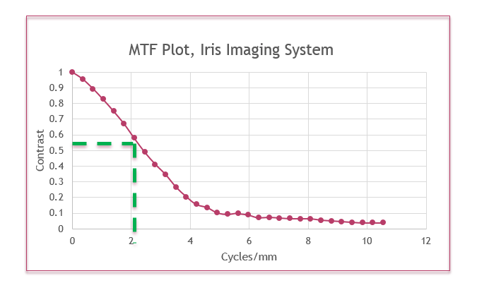

Table 9 – Iris Acquisition profiles (IAP)

Capture | IAP Levels
Capture | 20 | 30 | 40
Spatial sampling rate | 10 pixels / mm. | Up sampling allowed from 10 pixels / mm if algorithms require higher minimum iris diameter in pixels | Up sampling allowed from 10 pixels / mm if algorithms require higher minimum iris diameter in pixels
Exposure time | < 33 milliseconds | < 15 milliseconds | < 10 milliseconds

In order to achieve acceptable recognition accuracy, the iris acquisition sensor must achieve a signal-to-noise ratio of at least 36dB.

Mobile iris image capture devices can be configured differently with regard to the operator interface, in terms of the viewfinder (being external or internal) and the manner of providing image quality feedback to the operator. These factors will influence the rate of successful captures. The best practice recommendation is that an initial image quality assessment should be done to provide feedback to the operator during the capture process. The device should alert the operator if the captured iris image is of insufficient quality.

Iris Image Capture

In order to be considered acceptable as non-intrusive and to avoid excessive geometric distortion, the minimum distance between the mobile iris capture device’s lens and the subject’s eye must be at least 100 millimeters.

In order to provide an acceptable level of usability and ease of alignment, the camera must allow for some variability in the position of the iris center relative to the camera. The 2015 Update to the ANSI/NIST-ITL standard is consistent with ISO/IEC 19794-6 and ISO/IEC 29794-6 specifications concerning image margin requirements. The vertical margin shall be > 0.2 times the radius of the iris. The horizontal margin shall be > 0.6 times the iris radius. See Figure 8.

Figure 8: Image Margin Requirements
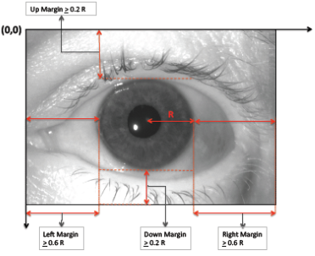

Iris Image Transmission

In order to support interoperability, the Mobile ID iris image capture device shall support ANSI/NIST-ITL Update: 2015 Type-17 records when communicating with a central system. However, as indicated in Figure 3 and Figure 4, alternate configurations are possible without having to fully encode an ANSI/NIST-ITL transaction at the mobile unit level.

The iris image may be stored in one of 4 formats as shown in Table 10.

Table 10 – Iris Storage Formats (ISF)

ISF Code | Description | Iris Centering | Iris Margin Requirement  (R is radius of the iris)
ISF Code | Description | Iris Centering | Horizontal | Vertical
1 | Unconstrained image size | Recommended | > 0.6 R | > 0.2 R
2 | Raw: 640 x 480 | Recommended | > 0.6 R | > 0.2 R
3 | Cropped | Required | = 0.6 R | = 0.2 R
7 | Cropped and Masked | Required | = 0.6 R | = 0.2 R

Figure 9: Examples of ISF image formats from the ANSI/NIST-ITL standard
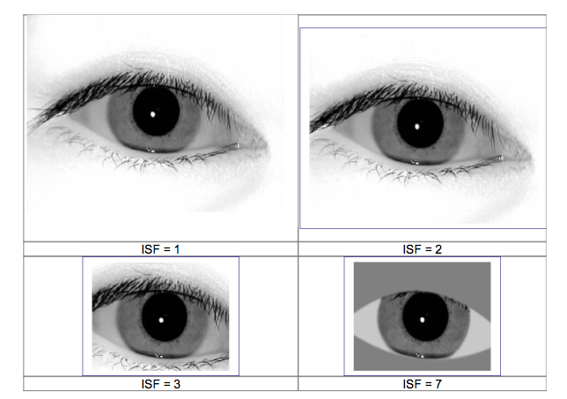

For Mobile applications, it is often best to use the ISF 7 format, since it dramatically reduces the storage requirements for the eye, as well as the data transmission load. For stationary systems, ISF 2 is the most common option deployed. Note that the cropping and masking in ISF 7 does not affect the ability of the iris matching system to accurately perform.

Voice Signals

Voice signals are by their nature something that must be captured over a period of time. The voice signals may be used as input to multiple processes, once captured, such as:

- Speech processing (recognizing the words spoken)
- Language and dialect identification
- Speaker verification and identification (a biometric application)
- Counting the number of participants in a conversation
- Transcription of the conversation
- And others.
Voice sounds carry speech and that speech usually occurs within a social context involving more than one speaker. The human voice – generally carrying both speech and non-speech sounds – propagates varying distances through air (principally) or another medium to reach acoustic transducers (usually microphones, when recorded) of varying amplitude and phase response.

In mobile applications, even a single segment of a voice signal may not be linkable to a single geographic location or to a specific speaker. Unlike other modalities, voice signals may reflect and depend upon the social and behavioral conditions -- as well as the environmental condition of the collection environment, including the relationship between the data subject and any interlocutors.

Voice Signal Capture Devices

Many hand-held devices, such as phones now also include the capability to take photographs and to record voices. The recordings may be in the form of video (also including a visual component) or as totally aural recordings. There are no specific requirements for audio capture devices. However, the operator’s system should be identifiable – through make and model.

Voice Signal Capture
The date of the recording and its duration should be captured at the time of the recording. If possible, geographic location(s) should also be captured. The container format encapsulates the audio data of the electronic file used to carry the voice data in a digital recording. At the time of capture and initial storage, the container code shall be noted. Files having container formats incorporate audio specifications to properly decode the audio, such as number of channels, sampling rate, bit/byte depth, and whether the data is big/little endian. Table 11 lists the most common container formats. If the container format is not shown in the table, then code 2 is selected and entered in the container code / CONC of Field 11.013: Container / CONT and Field 11.051: Comment / COM shall be used to describe the container.
Table 11 – Container Codes
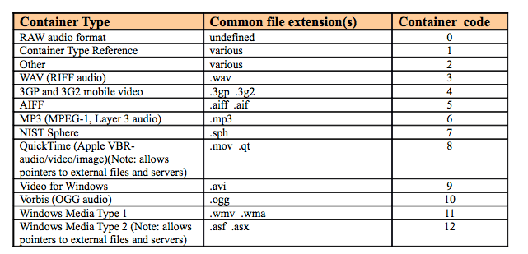

If the container allows different CODECs to be used, then Field 11.014: CODEC / CDC shall be completed with the code for the CODEC used to store the recording. The common CODECs are shown in Table 12.

Table 12 – CODEC Codes
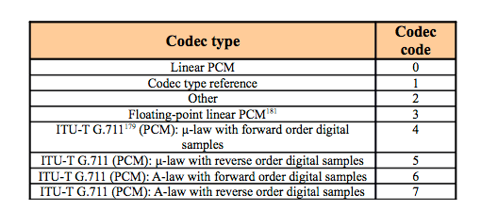

Note that the Container and the CODEC (if specified) shall be captured directly by the voice recorder and shall not require manual intervention on the part of the operator.

Although the standard allows for redaction (overwriting of a portion of the recording), discontinuities, specification of vocal content, and other characteristics of the voice sample, these should not be entered by the operator in the field. They are best entered by analysts reviewing the recording later.

Voice Signal Transmission

The Type-11 record of ANSI/NIST-ITL shall be used to transmit an audio recording to a central repository. However, as noted in Concept 1, Figure 3, the full ANSI/NIST-ITL transmission file need not be generated at the mobile unit level.

Multiple modalities in a single unit

A mobile ID unit may combine the capability to capture multiple different modalities, and several instances of each particular modality. This can great increase efficiency and improve the possibility of a later match (if an enrollment is being performed).

A major concern is that the entire sample set from one particular individual must be properly linked. This becomes problematic if protocol is such that the process of collecting all modalities from a single individual is interspersed with data entries for other individuals. Simple typographical mistakes in entering a reference index (or name) could cause a lack of cross- linkage, or could cause items to be linked (falsely) together for different individuals. There is less change of this happening when samples are collected simultaneously or quasi-simultaneously (such as a facial image taken at the same time as iris images).

The capture devices shall meet all of the characteristics for each of the modalities incorporated into them.

The operation shall follow best practices for each of the individual modalities captured during a particular session.

The unit shall be capable of associating all of the individual samples captured from a single individual together and creating an output file reflecting such.

Mobile ID Use Cases

The Department of Homeland Security, Office of Science and Technology held a series of workshops concerning mobile ID devices. One of their first tasks was to define use cases. The following (Figure 11) is provided by the DHS based upon the results of those workshops:

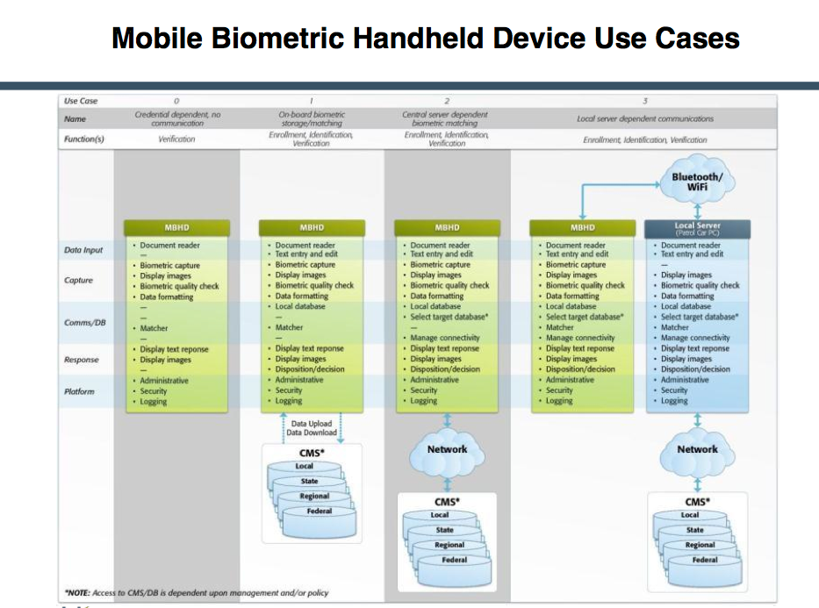Figure 11: Use Cases
An example of Level 0 is mobile use of the Transportation Workers Identification Card (TWIC).
An example of Level 1 is First Responders Site Access Control.
An example of Level 2 is Coast Guard Interdiction and identification at sea.
An example of Level 3 is law enforcement us of mobile identification devices during a public disturbance
The following scenarios were evaluated by the participants in the DHS workshops in order to develop the four generalized use cases described above. It is possible for them to be at any of the above Use Case levels, depending upon the particular environment.
• Patrol Stop • Border / Ports of Entry
• Public Events • Access Control
• Disaster / Emergency Management • Maritime
• Post-mortem identification • Checkpoint operations
• Detention / Asylum Facility Operations • County / local jail booking, transfer & release
• Latent friction ridge print image capture and search from the field
.

Risk Profiles

‘Risk’ here refers to the possible implications of having a false match or a false non-match. The implications of such ‘errors’ can vary substantially. For purposes of this document, they are divided into three levels:
- Severe
- Moderate
- Mild

Severe Risk

Severe risk levels imply that loss of life and/or property can result if accurate identification or verification is not made. In severe risk environments, it is plausible that inconvenience to the subject being identified or verified is secondary to the security of the situation, meaning subjects may be detained longer until the identification or verification process is completed. This assumption means that matching thresholds can be set lower (more aggressively) resulting in a returned list of potential candidates that an examiner may review to determine if a true match has occurred.

For instance with friction ridge prints, it may be deemed prudent to have a forensics examiner review the images. A forensics fingerprint examiner can use level 3 fingerprint information including inter-ridge detail and pore structure to effect identifications. On the other hand, machine matching is typically constrained to level 2 minutiae details and ridge spacing. For this reason, fingerprint sensors for enrollment and identification in a severe environment must meet EBTS Appendix F requirements. In addition, each print that can be compared adds information that can be used by the examiner making full ten-print comparisons desirable.

Examples of enrollment and identification functions in a high-risk environment include background checks conducted to grant access to secure facilities during battle field operations. In this case, enrollment fingerprints would be compared against the latent image database maintained by the Department of Defense (DoD).

The verification function typically compares a processed captured biometric image against previously captured templates. Thus, even for verification functions performed in a severe risk environment, sensors meeting PIV image quality specifications provide the maximum data that will be used for matching. Increased confidence for verification functions can be met using multi-instance (e.g. 2 or more fingers) or multi-modal biometric verification.

Moderate Environment

A moderate risk environment is defined for those encounters with a subject with no or questionable identification. An officer cannot detain a subject for more than a limited amount of time without making an arrest. In this situation, it is necessary to quickly identify the subject or retain biometric information sufficient to verify the subject’s identity at a later date.

For instance, in scenarios relying upon fingerprint matching, PIV image quality enables machine matching of images. In the event these fingerprints are enrolled, these images are sufficient to match the subject when they are later encountered in the court system. Once the subject is in the court system, any images retained using mobile enrollment would typically be replaced by images captured using a ten-print system. Once again, the capture of more images provides more information for later booking. In addition, the capture of two or more fingerprints simultaneously provides additional information on the fingerprint sequence.

Table 1 - Use cases for risks and functions

Risk to Public Safety/Function | Use Case Example
Severe/  Identification | One to many search against a database to identify a subject where there is a high risk of loss of life or assets. Some situations may require multi-modal biometric identification. | Recommend Capture:  Iris = L&R eyes  Finger = 4+  Note for face identifications, attempts should be made to control, background expression and lighting where it is practical to do so.
Severe/  Verification | 1:1 match against a credential or database to verify identity where there is a high risk of loss of life or assets. Some situations may require multi-modal biometric verification. | Recommend Capture:  Iris = Either eye  Finger = 2+  Note for face verifications, attempts should be made to control, background expression and lighting where it is practical to do so.
Moderate/  Enrollment | Mobile booking: Field cite and release when the violation is not high enough to ensure incarceration until arraignment without bail. | Recommend Capture:  Iris = L&R eyes  Finger = 6+  Note for face enrollments and identifications, ideal lighting conditions should be used. Otherwise, fingerprints or irises should additionally be used.
Moderate/  Identification | In field mobile identification of a subject with questionable or no identification. | Recommend Capture:  Iris = Either eye  Finger = 4+
Moderate/  Verification | Personal Identity Verification (PIV) Release from custody. | Recommend Capture:  Iris = Either eye  Finger = 2+
Mild/  Enrollment | The intention is for the biometric enrollment to be of sufficient quality that it shall allow later verification (e.g. e-citations). | Recommend Capture:  Iris = L&R eye  Finger = 4+
Mild  /Identification | Rapid identification in custody prior to formal booking. (Typically done at the jail intake.) | Recommend Capture:  Iris = Either eye  Finger = 2+
Mild/  Verification  (finger images). | Court Appearance/Parole/Workhouse, Personal Identity Verification (PIV). | Recommend Capture:  Iris = Either eye  Finger = 1+
Mild/  Verification  (finger minutiae). | Personal Identity Verification (PIV) (using minutiae). | Recommend Capture:  Finger = 2+  Not recommended for use between AFIS.

Mild Environment

A mild risk environment is defined for those encounters where enrollment and identification data will be used at a later date. At that time the subject would be available for comparison to the data previously retained. The results of an identification or verification should not impact anyone but the subject in question. Examples of normal enrollments include preparing for future logical or physical access control for a subject, or retaining one or more biometric images for verification in court while the subject is available. Verification examples include tracking a subject through the jail or court system using the retained biometric images. In these cases a failure to match would result in additional action to verify the subject’s identity, primarily inconveniencing no one but the subject.

Mobile Device Security & Encryption

The establishment and enforcement of Information Technology (IT) and agency security policies is not the focus of this document. Law enforcement and criminal justice agencies are increasingly realizing the productivity benefits of mobile handheld devices. Mobile ID devices represent a tremendous productivity advantage for criminal justice and ID management.

While this mobile technology and the capabilities it brings, from biometric identification to citations and report writing, will be a great advantage to criminal justice personnel; it is creating a tremendous security management challenge. The small size, large storage capacity and network connectivity of these devices make unprotected mobile devices susceptible to loss, theft and misuse, and possibly a target for someone wanting unauthorized access to information or databases. Mission sensitive and confidential information is now available through Mobile ID devices at locations and under circumstances that are outside the normal security parameters. As a result, unsecured devices can pose a risk to any criminal justice network that the device can access. In order to secure adequately the device from misuse or attack and to meet regulatory standards and requirements, agencies must develop wireless and centralized device security policies. These policies should include measures regarding authentication, data expungement, encryption, application launch controls and device feature disablement.

In order to maintain the highest level of device security, an updating of all devices is needed whenever policies change or software is updated to provide greater protections.

Transmissions

At a minimum, the data encryption algorithm used shall be AES-256. The Mobile ID device shall provide the capability for the encryption and decryption of bidirectional traffic. This should be accomplished in a manner to meet the FIPS 140-2 Type-1 requirements. Such encryption/decryption software should be FIPS 140-2 certified. Even for mobile phones taking pictures for facial Identification?

Data at Rest

The Mobile Id device shall at a minimum provide the capability to encrypt all data residing on the device either as a temporary file or a part of a database in a manner to meet the FIPS 140-2 Type-1 requirements. Such encryption software shall be FIPS 140-2 certified or equivalent. Even for mobile phones taking face pictures?

Authentication and Authorization

The mobile handheld device should provide the capability for an operator to authenticate his/her identity as well as establishing authorization levels for that person based on a two-factor authentication, one of which should be a biometric.

The mobile handheld device should provide biometric operator authentication and a password of minimum length with alphabetical /numeric/special characters.

The mobile handheld device should provide the capability for operator re-authentication after a designated length of time.

The mobile handheld device should provide the capability for operator re-authentication and the device should re-authenticate itself after a designated amount of idle time or result in a device shut-off.

The mobile handheld device should provide the capability to lock the device or render the device inoperable, erase selective files, and/or erase all files on the device based on failed security protocols.

The mobile handheld device should provide the capability to establish a maximum limit of failed authentication attempts before the handheld clears all application data or requires unlock only by an IT administrator.

The data authentication algorithm used shall be RSA-2048 as defined by FIPS-186-3 2006 (DSS). The Secure Hash Function the signature will be evaluated over shall be SHA-256, as defined by FIPS-180-2. The provisioning of certificates, root certificates, and private keys shall remain outside the scope of this standard.I Don’t think that this is applicable to mobile phone devices, etc.

Device and Data Authentication

Once operator authentication and authorization is established, the mobile handheld device should be able to provide device authentication that it is authorized to communicate on the network. There should also be the capability to have the device’s identification verified against a registered list of specified devices (black list, lost/stolen). A device with a matching identification to one on the list should not be authorized to communicate with the central system.

The data authentication algorithm used shall be RSA-2048 as defined by FIPS-186-3 2006 (DSS). The Secure Hash Function the signature will be evaluated over shall be SHA-256, as defined by FIPS-180-2. The provisioning of certificates, root certificates, and private keys shall remain outside the scope of this standard.

Communication Protocols

There are several different approaches for establishing communication between Mobile ID devices and systems. Figure 1 below summarizes the different approaches that can be employed.
Figure 1 Mobile ID Communication Configuration Choices
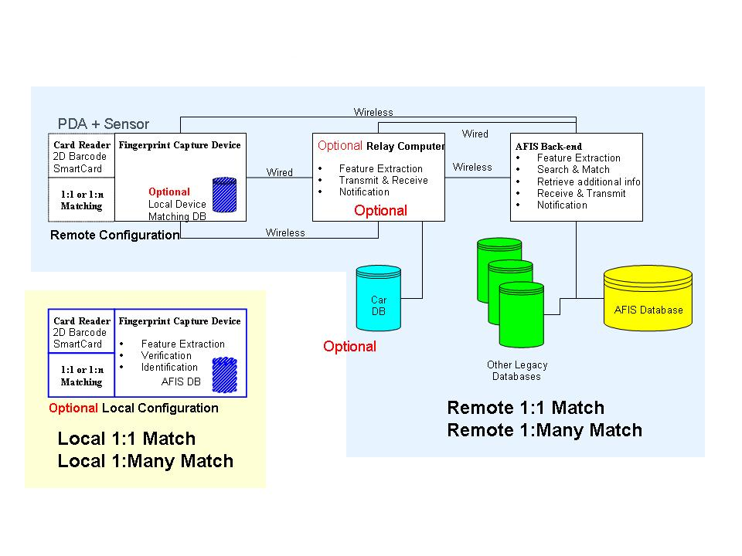

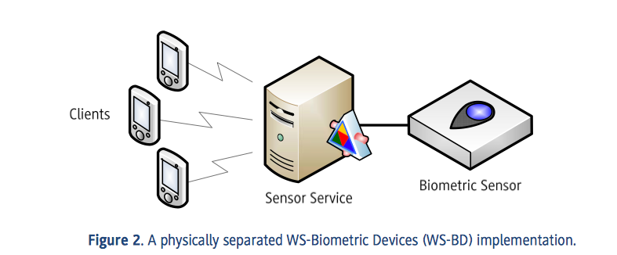
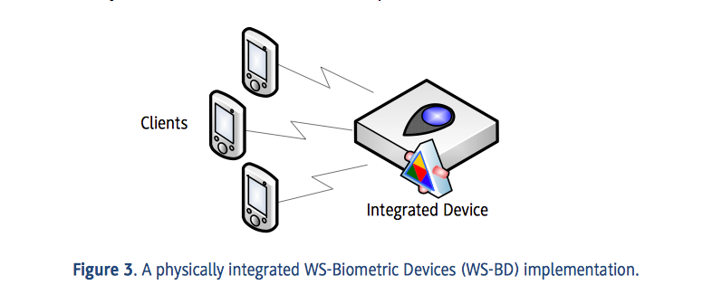

The type of communications selected will vary upon the needs of the mobile ID user. Some scenarios, such as maritime interdiction may require satellite communications while others can use the commercially available mobile phone network. The communications between components can be of many different types, such as Bluetooth.

Environmental Profiles
A Mobile ID device can be used in a variety of different contexts, such as a law court, an airport terminal, by a patrol officer on the street or in a patrol car, or even in a military environment such as a checkpoint or for access control to a military base.

These different use cases each require different levels of resistance to environmental factors such as temperature, humidity, dust, water, vibration, etc. For these reasons, three different profiles are described below (Indoor, Law Enforcement and Military), with increasing levels of resistance to the relevant environmental conditions.

It is the responsibility of the Agency to decide, in the procurement phase of the Mobile ID devices, which profile to request in the Request for Proposal (RFP). This will depend on the expected usage of the devices and the location(s) where they will be required to operate. It is important to choose the right profile since a lower profile could mean that the devices are not able to withstand the operating environment, causing costly failures and decreasing service levels. Conversely, choosing a too high profile is likely to cause an unnecessary increase in the size, weight and cost of the devices.

Indoor Profile

If a Mobile ID device is going to be used only in an environment such as an office building, a court of law, etc. the suggested environmental specifications for the device can be assumed to be similar to those of most commercially available computing devices intended for office use. For these use cases, the recommended minimum environmental specifications are listed in Table 2.

Table 2 - Indoor Profile Recommendations

Operating temperatures | From 32°F to 104°F (0°C to 40°C)
Storage temperatures | From 14°F to 122°F (-10°C to 50°C)
Relative humidity | max. 85% non condensing
Ingress Protection Rating (IP Code) | IP 40 or higher

For more information about the level of ingress protection (IP) refer to the IEC standard 60529 “Degrees of protection provided by enclosures”.

Outdoor – Heavy Use (Law Enforcement – like) Profile

This profile should be used when the Mobile ID devices are going to be used for example by a patrol officer on the street or on-board a patrol car.

These use cases require the devices to be able to withstand high or low operating temperatures, dust, rain, water splashes, the vibrations typically encountered in a vehicle and drop from a limited height. For these use cases, the recommended minimum environmental specifications are listed in Table 3.

Table 3 - Law Enforcement Profile Recommendations

Operating temperatures | From 14°F to 122°F (-10°C to 50°C)
Storage temperatures | From -4°F to 140° F (-20°C to 60°C)
Relative humidity | 10% - 90% non condensing
Ingress Protection Rating  (IP Code) | IP 54 or higher, in operational configuration,  with any existing expansion port closed
Drop resistance | Resistance to multiple drops on concrete from a height of 3 feet (91 cm).

Outdoor – Rugged (Military-like) Profile

This profile should be used when the Mobile ID devices are going to be used in harsh operating environments, when the expected use cases require the devices to provide increased level of protections against high and low temperatures, dust and sand, rain, water splashes, vibrations and drop. For these use cases, the recommended minimum environmental specifications are listed in Table 4.

If the device is going to be used in a maritime environment, an increased level of Ingress Protection should be considered, such as IP 66 (protection against water jet) or IP 67 (immersion up to 1 meter), and compliance with MIL-STD-810F Method 509.4 (Salt Fog).

Table 4 - Military Profile Recommendations

Operating temperatures | From -20°F to 140°F (-29°C to 60°C) according to  MIL-STD-810F Method 501.4 Procedure II at 140°F  MIL-STD-810F Method 502.4 Procedure II at -20°F
Storage temperatures | From -20°F to 140°F (-29°C to 60°C) according to  MIL-STD-810F Method 501.4 Procedure I at 140°F  MIL-STD-810F Method 502.4 Procedure I at -20°F
Relative humidity | MIL-STD-810F Method 507.4
Rain | MIL-STD-810F Method 506.4 Procedure I
Ingress Protection Rating  (IP Code) | IP 65 or higher, in operational configuration, with  any existing expansion port closed
Drop resistance | The devices should comply with MIL-STD-810F  Method 516.5 – Procedure IV (Transit Drop), in  non-operational configuration. If the devices do  not contain a hard drive, compliance is required  also in the operational configuration.
Vibration resistance | The devices should comply with MIL-STD-810F  Method 514.5 – Procedure I (General Vibration), in  both operational and non-operational configurations.

For additional information about the above test procedures refer to: “MIL-STD-810F - Department of Defense Test Method Standard for Environmental Engineering Considerations and Laboratory Tests”, released on Jan. 1st, 2000.

References UPDATE

Advanced Encryption Standard FIPS 197; http://csrc.nist.gov/publications/PubsFIPS.html

American Association of Motor Vehicle Administrators Standard (AAMVA DL/ID 2005); http://www.aamva.org/KnowledgeCenter/Standards/Current/DL-IDStandard2005.htm

ANSI/NIST-ITL 1-2011 Update:2013 , Data Format for the Interchange of Fingerprint Facial, & Other Biometric Information; http://fingerprint.nist.gov/standard/index.htm

Electronic Fingerprint Transmission Specification, EFTS, Version __, http://www.fbibiospecs.org/fbibiometric/ebts.html

EN 60529 Specification for degrees of protection provided by enclosures; http://webstore.ansi.org/FindStandards.aspx?SearchString=IEC+60529&SearchOption=0&Page

FIPS 140-1: Security Requirements for Cryptographic Modules; http://csrc.nist.gov/publications/PubsFIPS.html

FIPS 180-2 Secure Hash Standard (SHS) * Superceded By: FIPS 180 -3 ; http://csrc.nist.gov/publications/PubsFIPSArch.html

FIPS 186-3 DRAFT Digital Signature Standard (DSS); http://csrc.nist.gov/publications/PubsFIPS.html

IEC 825 Eye safety classification of some consumer electronic products; http://ieeexplore.ieee.org/xpl/freeabs_all.jsp?arnumber=543110

International Civil Aviation Organization (ICAO) ; http://csrc.nist.gov/publications/PubsFIPSArch.html

INCITS 378:2004 - American National Standard for Information Technology — Finger Minutiae Format for Data Interchange

INCITS 381:2004 - American National Standard for Information Technology — Finger Image-Based Data Interchange Format

IP xx Ingress Protection Rating; http://www.mpl.ch/info/IPratings.html

ISO/IEC 10918-1 Digital Compression and Coding of Continuous-Tone Still Images Part 1: Requirements and Guidelines (JPEG)

ISO/IEC 19794-2:2004 Information Technology- Biometric data interchange formats- Part 2: Finger Minutiae Data

ISO/IEC 19794-4:2004 Information Technology- Biometric data interchange formats- Part 4: Finger Image Data

ISO/IEC 19794-5:2004 Information Technology- Biometric data interchange formats- Part 5: Face Image Data

ISO/IEC 19794-6:2011 Information Technology- Biometric data interchange formats- Part 6: Iris Image Data

ISO/IEC 29794-6:2015 Information Technology – Biometric sample quality – Part 6: Iris image data

MIL-STD-810F; http://www.dtc.army.mil/navigator

Minutiae Interoperability Exchange Test (MINEX); http://fingerprint.nist.gov/minex04/index.html

National Information Exchange Model (NIEM 2.0) ; http://www.niem.gov/library.php

NIEM XML; http://www.niem.gov/xmlSchemas.php

WSQ Gray-scale Fingerprint Image Compression Specification, Dec., 1997; http://www.fbibiospecs.org/fbibiometric/biometric_specs.html

Acronyms/Glossary UPDATE AS NEEDED BY TEXT

ACRONYM | MEANING
ABIS | Automated Biometric Identification System
AFIS | Automated Fingerprint Identification System
ANSI/NIST | American National Standards Institute / National Institute of Standards and Technology
ARM | Advanced RISC Machine
BAP | Biometric Application Profile
BPR | Best Practice Recommendation
CDMA/1XRTT | Code Division Multiple Access technology
CE | Officially known as Windows Embedded Compact Windows CE is Microsoft’s operating system for minimalistic computers and embedded systems
CPU | Central Processing Unit
dB | Decibels
DHS | Department of Homeland Security
DoD | Department of Defense
DSP | Digital Signal Processors
DSS | Digital Signature Standard
EBTS | Electronic Biometric Transmission Specification
EDGE | Enhanced Data Rates for Global Evolution
EFTS | Electronic Fingerprint Transmission Specification
EVDO/EVDM | EVDO and EVDM are 3G iterations of the CDMA technology that push data rates up to 1 megabits/sec
FBI | Federal Bureau of Investigation
FIPS | Federal Information Processing Standard
FPS | Frames per second
FTA | Failure to acquire
GPRS | Global Packet Radio Services
GPS | Global Positioning System
GSM | Global System for Mobile
HSDPA/WCDMA | The next phase of cellular technology to approach 40 megabytes/sec
IAFIS | Integrated Automated Fingerprint Identification System
ID | Identification
IP | Internet Protocol
IP XX | Ingress Protection Rating
IREX | Iris Exchange evaluation
ISO | International Standards Organization
IT | Information Technology
ITL | Information Technology Laboratory (NIST)
JPEG | Joint Photographic Expert Group
KST | Known or Suspected Terrorist
LED | Light emitting diode
MINEX | Minutiae Exchange evaluation
MRZ | Machine Readable Zone
ms | millisecond
NCIC | National Crime Information Center
NET | The .NET Framework is Microsoft's comprehensive and consistent programming model for building applications
NFIQ | NIST Fingerprint Image Quality
NGI | Next Generation Identification
NIEM | National Information Exchange Model
NIST | National Institute of Standards & Technology
nm | Nanometer
OCR | Optical Character Recognition  Optical Character Reader
OS | Operating System
PC | Personal Computer
PCI | Peripheral Component Interface
PDA | Personal Digital Assistant
PIV | Personal Identity Verification
PIX | Private Internet Exchange
ppi | pixels per inch
R&D | Research and Development
RAM | Random Access Memory
RGB | Red Green Blue
RISC | Repository for Individuals of Special Concern
SAP | Subject Acquisition Profile
SD | Type of data storage card
SMTs | Scars, Marks, and Tattoos
TWIC | Transportation Worker Identification Credential
USB | Universal Serial Bus
US FCC | United States Federal Communications Commission
US VISIT | United States Visitor and Immigrant Status Indicator Technology
VAC | Volts AC
VDC | Volts DC
WCDMA | The next phase of cellular technology to approach 40 megabytes/sec
WSQ | Wavelet Scalar Quantization
XML | Extensible Markup Language

Put in a reference to the final version of the document, if available at time of publication. If not, refer to the ISO website.
From an internal report of the Department of Homeland Security, Office of Science and Technology, 2010 -- provided by DHS for use in this document.
WS-BD refers to Web Services – Biometric Devices. NIST Special Publication 500-288 (Specification for WS-Biometric Devices (WS-BD) Version 1) is available at http://www.nist.gov/itl/iad/ig/upload/NIST-SP-500-288-v1.pdf “WS-BD provides a framework for deploying and invoking core synchronous operations via lightweight web service protocols for the command and control of biometric sensors.” (Quoted from Section 2 of the document)
The database can be anywhere from one sample to millions of samples.
These fields are new for the 2015 Update.
See NISTIR 7950, “Examination of the Impact of Fingerprint Spatial Area Loss on Matcher Performance in Various Mobile Identification Scenarios” March 2014. It is available at http://nvlpubs.nist.gov/nistpubs/ir/2014/NIST.IR.7950.pdf
Available at http://www.nist.gov/customcf/get_pdf.cfm?pub_id=912779
See the studies available at http://www.nist.gov/itl/iad/ig/compression.cfm
In ANSI/NIST-ITL prior to 2015 FAP 50 had a minimum dimension of 1.6” x 1.5” and was specified for 1-3 fingers. However, no devices were created matching these characteristics, and there was a market presence corresponding to the revised FAP 50 specifications in this document and ANSI/NIST-ITL 1-2011 Update 2015.
Larger platens require WSQ 3.1 or higher.
JPEG2K is required for 1000 ppi images. WSQ was designed for 500 ppi compression only.
Up to 4 fingers may be allowed by some systems, if stitched images are acceptable according to the Organization’s Application Profile. Some capture units may be capable of taking two images and stitching them into one output image. 2 fingers fit without stitching on one image for this size platen.
Although technically possible to capture four slap fingers on a FAP 50 device, it requires angling of the fingers, which may be problematic for certain systems. Some application profiles actively discourage slanted fingers. The FBI states, “All friction ridge prints should be captured as closely as possible to an upright position.”
Available at http://www.gutenberg.org/files/19022/19022-h/19022-h.htm#CHAPTER_X
“Dimensional Review of Scales for Forensic Photography”, FILL IN REST
Hyzer WG, Krauss TC, “The Bite Mark Standard Reference Scale – ABFO No.2”, J Forensic Sci. 1988 Mar;33(2):498-506
Put in a reference to the specifications document here.
Put in footnote to the latest edition of the EBTS TOU.
Put in reference to the webpage for MINEX
These band wavelength specifications correspond to those of ISO/IEC 29794-6 and the 2015 Update of the ANSI/NIST-ITL standard.
ISO/IEC 29794-6 specifies 0.5 for contrast with 2 spatial frequency cycles / mm.
Note that this corresponds to ISO/IEC 19794-6 specifications as well as the 2015 Update of the ANSI/NIST-ITL standard. ISO/IEC 29794-6 specified 15.7 pixels / mm. which is allowed with IAP levels 30 and 40.

