NIST Special Publication UNKNOWN NUMBER

Mobile ID Device
Best Practice Recommendation
Version 2.0

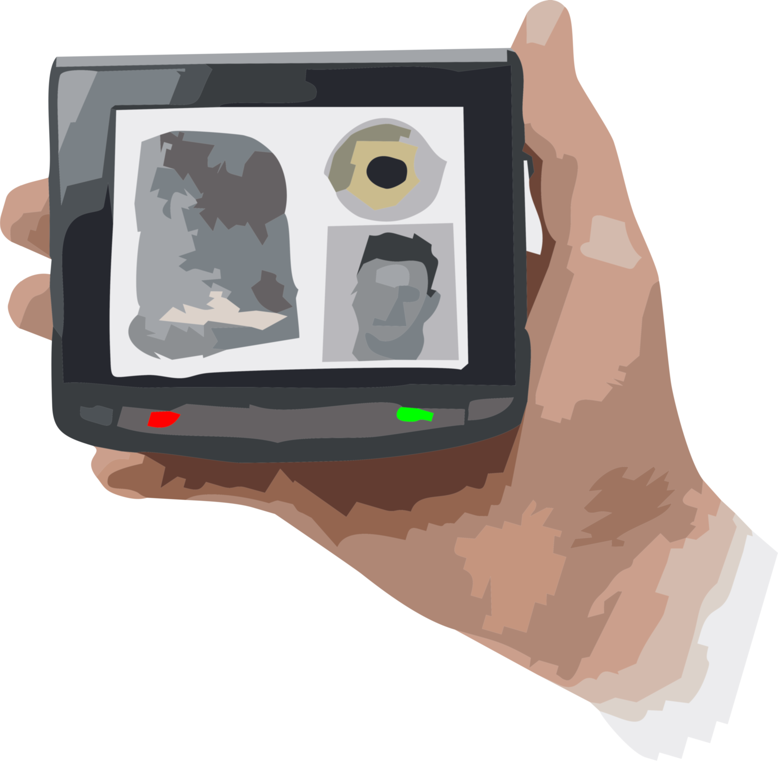

Mobile ID Device
Best Practice Recommendation
Version 2.0

NEW DATE

NOTE:

Black text is original from the 2009 version. The fact that it is still present does NOT indicate that it has been determined to keep it. Deleted text is not shown. Blue text is suggested new text. Red indicates notes to the editor.

All illustrations and content at this point is merely meant to ‘get people thinking’ about what should be included. Anything and everything can be revised / included / excluded at the desire of the working group.

EDITOR REQUESTS HELP FROM ALL INTERESTED PARTIES!!

CONTACT
BRAD.WING@NIST.GOV

Acknowledgements

This section will be updated after the process is complete.
TABLE OF CONTENTS

This section will be updated after the process is complete.

Introduction

Version 1 of the Best Practice Recommendation (BPR) was released in 2009. It has been referenced in many Government procurement acquisitions and has provided information helpful to companies developing mobile ID solutions. This version builds upon that solid foundation, with the intent on reflecting changes to technology, the operating environment and standards since 2009.

The original BPR played a direct role in the 2011 update to the ANSI/NIST-ITL standard. The modality-specific application profiles of the BPR were directly incorporated into the standard. In order to maintain consistency between this BPR and the ANSI/NIST-ITL standard, this version of the BPR references, but does not specify those modality-specific application profiles.

The original BPR included only face, fingerprint and iris as modalities. Voice and DNA modalities now are included in the ANSI/NIST-ITL standard . Units have been developed for mobile applications that employ these two new modalities. Thus, this version of the BPR addresses those modalities as well.

The rest of this section will be written after the content of the document is determined. The above is only ‘suggested’ and not definitive.

Scope

This document is targeted primarily at law enforcement, criminal justice, military, homeland security, and other applications demanding a high degree of accuracy in the enrollment, identification, and verification functions. The focus of this BPR is not only on the Mobile ID device itself, but also on its connection to broader secure systems. Often, these applications have subjects that are unwilling or unable to provide trusted identity information. Whether cooperative or uncooperative, the resulting biometric identification needs to provide a reasonable degree of certainty that it will stand up to scrutiny including potential audits of security access control systems or possible court challenges. This BPR is not designed or intended for consumer devices or other commercial applications requiring only minimal levels of accuracy and reliability.

The rest of this section will be written after the content of the document is determined.

Taxonomy

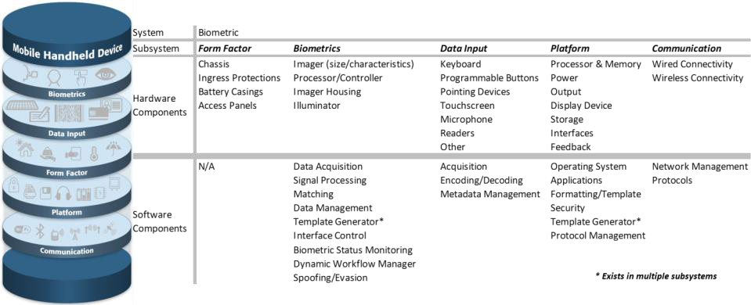

This section would be based upon the DHS document. NEED TO CREDIT DIAGRAM

System Design Considerations

Tasks

There are several tasks to be accomplished by a biometric mobile identification system. The primary ones include signal or image capture, signal or image processing, matching, and ultimately, an output decision that indicates an action to be taken by the operator. This action is based on an application specific decision process. Figure 1 illustrates typical combinations of these tasks across four basic scenarios that can be used to divide the workload up between the Mobile ID device and a networked system.

Figure 1: Tasks Across 4 Basic Scenarios

The primary tasks of signal or image capture, signal or image processing, matching, and output decision generation can be performed by the Mobile ID device alone or by splitting the workload with a networked system. Factors influencing the operation of these functions include location, availability of network connectivity, bandwidth of the network connection and interoperability with the other systems. The cloud in Figure 1 represents a network connection. Column (a) illustrates a standalone approach where the Mobile ID device performs all four functions. Columns (b) – (d) illustrate varying degrees of task allocation across a networked system.

The objectives to be accomplished for each of the tasks are:
- Data Capture – The process of acquiring one or more raw biometric samples from a subject
- Signal Processing – The process of extracting distinguishing features from a raw biometric sample, which may include some or all of the following:
  - signal or image normalization
  - segmentation
  - feature extraction
  - quality assessment
  - template creation

- Matching – The process of comparing the features extracted from a submitted biometric sample to those of one or more reference templates in a database and generating a resulting similarity score for each template comparison

- Decision – The process of making a match/non-match conclusion based on the similarity score(s) meeting or exceeding a specified threshold, the application of a more complex decision processing such as multi-biometric fusion, or the creation of a candidate list.

The Decision task should be further interpreted in an application dependent manner. Resulting actions may include one or both of the following decision processes:

- Application Level Decision - The result of the search may automatically:
  - generate one or more predetermined messages to the operator of the device
  - trigger an alert (to one or more other systems or operators)
  - initiate a search or retrieve additional data from one or more other systems (e.g. intelligence systems, facial image databases, etc.)
  - be passed to a human operator for manual verification
  - be returned as ‘raw’ image data to the operator of the Mobile ID device

Note: An application level decision may take place on either or both sides of any network (e.g. centrally at an ABIS or locally on the device itself).

- Operator Decision - Depending on the specific application and the result of the search, the operator of the Mobile ID device may or may not be free to make his or her own decision on how to proceed in a particular case
  - In some scenarios, specific instructions may be returned, e.g., ‘arrest this person’, ‘do not detain this person’, ‘this is the same person as their supplied credential indicates’, or ‘this is not the same person as their supplied credential indicates’
  - In other scenarios, the search result may be returned to assist the operator in deciding what action to take, possibly in conjunction with demographic, other metadata, or one or more facial images of the potential ‘matches’

Other tasks to be performed, but not illustrated, include the addition of contextual data, the formatting of the data (to the ANSI/NIST-ITL standards, FBI EBTS, DoD EBTS, or other standard format), and the handling of transactions and responses.

There are also administrative tasks that may need to be accomplished. These include configuring the device for a particular scenario, loading/updating of watch-lists, actions to be taken by the operator in different situations, logging of encounters, output of log files and other metrics, etc.

The application requirements for the Mobile ID device drive the overall system architecture and requirements for individual components of that system.

Physical

The physical instantiation of the Mobile ID device also impacts system requirements. Physical considerations include:
- how system components are connected (or not)
- connectivity to other systems (sharing/interoperability)
- security aspects of interconnected components

A physical instantiation might include one or more of the following:
- handheld biometric sensors
- handheld data entry devices
- handheld communications to a central location
- handheld communications to a nearby vehicle
- vehicle-based data entry
- vehicle-based communications to a central location

A biometric sensor can either be a peripheral (wired or wireless) device or integrated into a mobile ID device. As indicated in Figure 1, there are many different solutions that may work depending on the needs of individual workflows. Consider these four basic concepts:
- Capture and transmit to a PC
- Capture and transmit to a PC and receive response for notification to the operator
- Capture and transmit directly to the backend system, then receive response for notification to the operator
- Capture, process (including matching), and respond to the operator.

A Mobile ID device can be implemented either as a self contained unit (a single box) with the communications embedded in the device, as a peripheral or as a set of interconnected peripherals, each with its own function.

This section could be updated to reflect the ‘Concepts’ reflecting that a full ANSI/NIST-ITL transaction is not needed until the last stage (information can by cumulative within a system) Diagrams developed by Brad for present at SWG-BIG

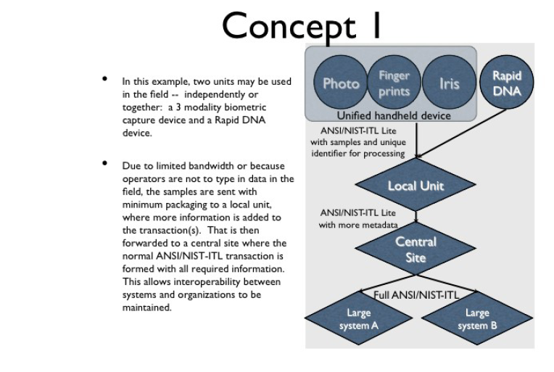

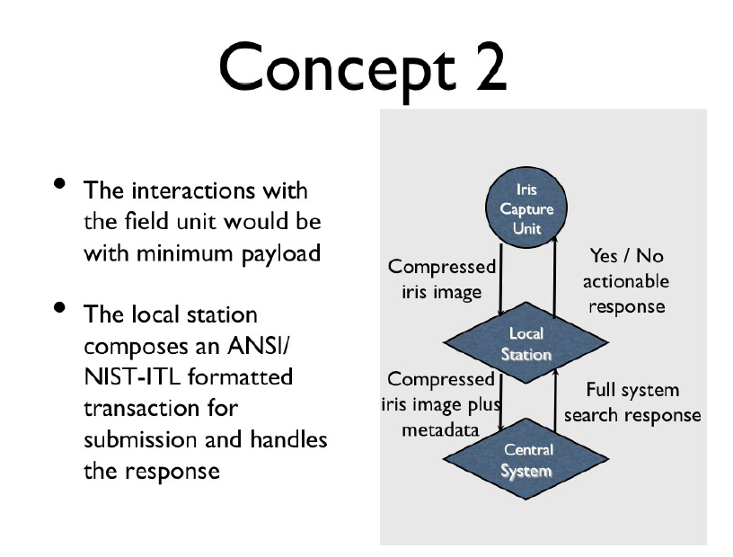

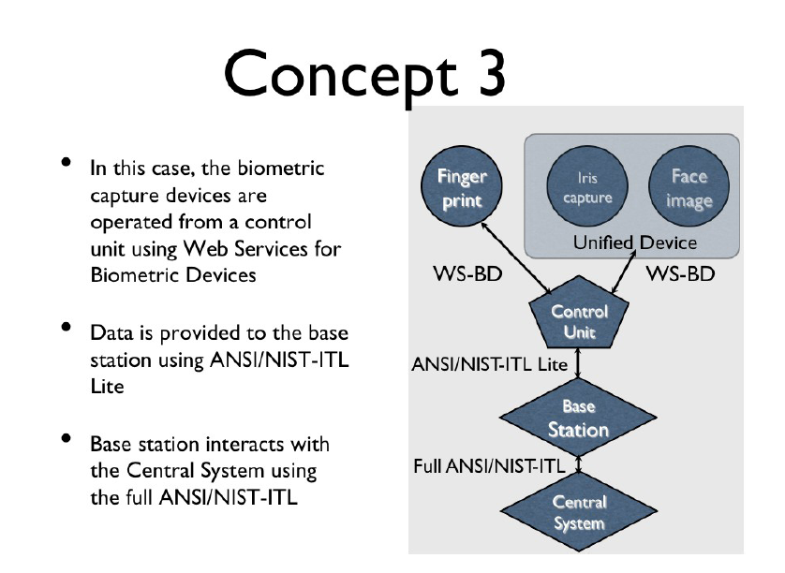

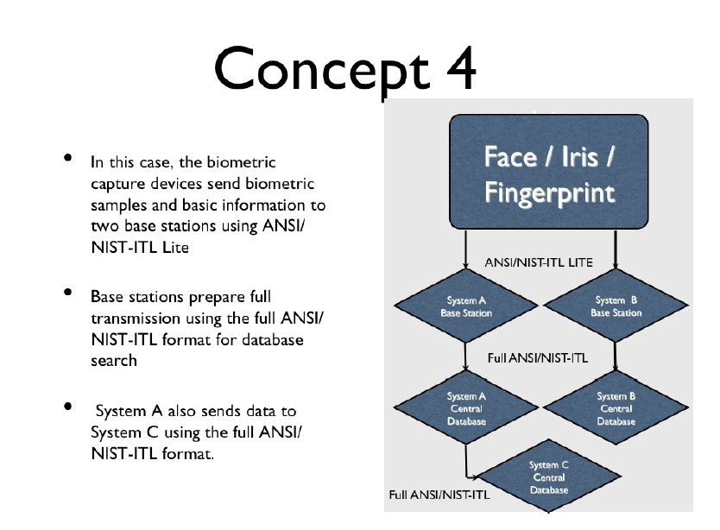

Data Format

The mobile system architecture is also closely tied with the data formats. Typical data format considerations include:
- format in transport, both for transmitting and for receiving data
- format at exposed interfaces
- data compression
- packet size
- network bandwidth, latency
- storage space (of processed or raw data)
- data security for storage and transmission
- data secrecy and data authentication.

Need to expand on the ‘partial’ metadata concept (i.e. the Record stored in RapidDNA units)

THERE ARE (OUTDATED) SECTIONS FOR FACE, FINGER AND IRIS. NEED TO DEVELOP NEW SECTIONS FOR VOICE AND RapidDNA.

WANT TO INCLUDE REFERENCES / DISCUSSIONS OF NEW STANDARDS THAT AFFECT MOBILE ID SUCH AS THE ISO/ISC SC37 QUALITY standards by modality (29794 series)

Also, the development of standardized icons is important, as is the research that has been done on operator tools, such as cross-hairs on viewfinders, etc. Will need to credit figures, etc.
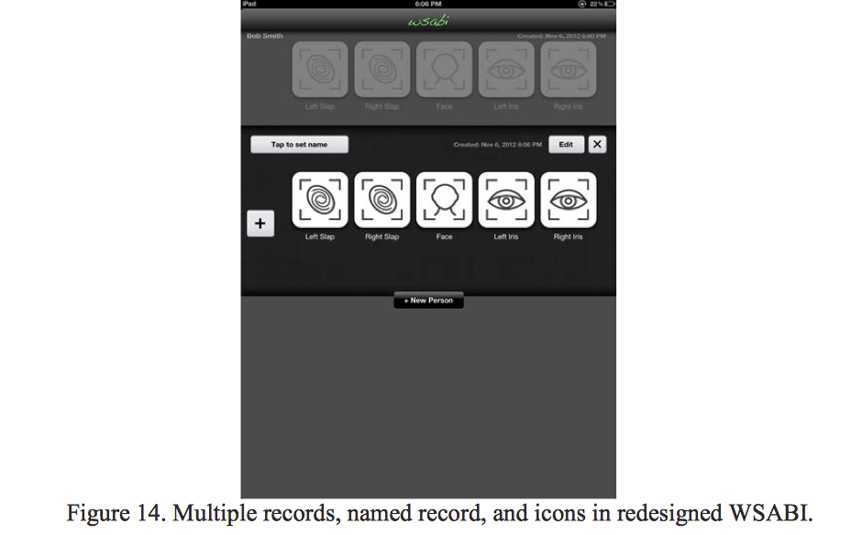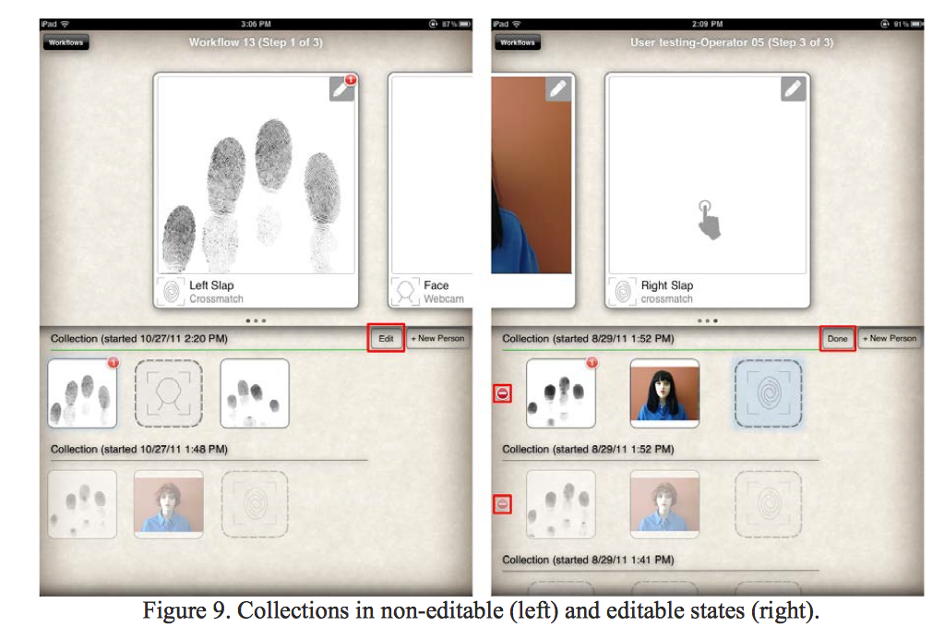

Mobile ID Fingerprint Capture Devices

Overview

The capture of a high quality fingerprint enrollment image is critical. It is the sample against which other samples will be compared. Unacceptable matcher performance due to poor quality stored enrollment images cannot be fixed short of acquiring a new enrollment image. Table 1, divided into capture and interchange categories, lists the minimum requirements by SAP level for Mobile ID fingerprint devices. The enrollment function should be concerned with acquiring one or more very high quality images. For that reason, images captured with a NIST Fingerprint Image Quality (NFIQ) value of 4 or 5 normally should not be used for enrollment purposes. If a very high quality enrollment image has been acquired and stored, images for verification and identification comparisons may be of lower image quality.

It is up to the system designer of each particular application to determine the appropriate SAP levels for each of the enrollment, identification, or verification functions especially if there is an intention to exchange data with other systems. Captured images containing more than a single finger must use the ANSI/NIST-ITL Type-14 record in order to specify the segmentation coordinates for each finger.

The best practice recommendation is that an initial image quality assessment should be done to provide feedback to the operator during the capture process. In most cases, this function is best located on the device, although further quality assessment may also take place elsewhere in the system. The system should use the NFIQ algorithm and should alert the operator if a poor fingerprint image was captured (NFIQ level 4 or 5.)

GENERAL POINT FOR ALL OF THE MODALITIES: HOW MOUCH SHOULD BE INCLUDED HERE THAT IS STATED IN THE STANDARD NOW? WE WANT THE STANDRD TO BE THE RULE. EDITOR THINKS ONLY THINGSA NOT IN THE STANDARD SHOULD BE CALLED OUT IN DETAIL. HOWEVER< REFERENCES TO PARTICULAR PARTS OF ANSI/NIST-ITL SHOULD BE INCLUDED. ALSO,
Current and Future Technology for Mobile ID Fingerprint Capture
Recommendations described in this document are applicable to current and future operational fingerprint systems and devices. For improved interoperability across dissimilar systems, the Mobile ID fingerprint capture device needs to correctly capture, compress and transmit fingerprint images. Careful consideration and compliance to these key criteria can ensure a successful degree of interoperability and verification or identification accuracy using Mobile ID fingerprint capture devices. Quantity of Biometric Data
The number of fingers used and the amount of data captured for each finger significantly affects overall system accuracy. Best practice recommendations are:

- Mobile ID fingerprint devices should be configurable so they can capture the specified fingers for a particular application.
- Use cases (see Table 6) should dictate the number of fingers to be used.
- When fewer than 10 fingerprints are captured, it is recommended that fingers 2, 3, 7, & 8 be used.
- When possible, capture of 4 fingers is preferable to capture of 2 fingers. Tests have shown that using 4 fingers rather than 2 results in a significant improvement in accuracy, even though a minimum specification calls for the use of two index fingers.
- Since the middle finger is effective in matching, two finger systems are expected to transition to middle-index pair in the future.
- Enrollments for a system that supports latent searches should include thumbs.
- Fingerprint images captured with dimensions according to lower SAP levels in Table 1 may not contain the complete fingerprint and thereby may reduce the overall system accuracy. This shortfall should be kept in mind and tradeoffs weighed carefully in utilizing the lower SAP levels.

Finger Position

Update to reflect the modifications to the ANSI/NIST-ITL standard

Sequence Errors
Fingerprint images with mislabeled finger numbers will result in lower identification and verification accuracy. Fingers captured one at a time have a tendency to introduce such sequence errors. Systems with high accuracy requirements will need to search the captured fingers in multiple combinations.

Fingerprint Capture Requirements

Minimum Resolution
The minimum acceptable scanning resolution is 500 ppi with a tolerance of ± 5 ppi for EBTS Appendix F compliance or ± 10 ppi for PIV compliance. Scanning resolutions greater than this may be used according to guidance by the specific use cases and system(s) for which interoperability is being planned.

Minimum Image Dimensions
The minimum acceptable dimensions (specified as width x height) for a fingerprint image captured by a Mobile ID capture device shall be 0.5” x 0.65”, which computes to a minimum area of 0.325 in². These dimensions can only be used to accommodate a partial flat impression. The legacy rolled fingerprint image with dimensions of 1.6”x1.5” and an area of 2.4 in² is captured using an SAP of 45 and meets the quality requirements of Appendix F. An SAP of 40 captures the same sized image at slightly reduced (PIV) quality. As the SAP level increases so does the overall size of the image and number of fingers that can be captured simultaneously.

Compression Algorithm
Fingerprint images captured at 500 ppi shall use the Wavelet Scalar Quantization (WSQ) algorithm for compression prior to transmission and/or storage.

Fingerprint images captured at 1000 ppi shall use the Joint Photographic Experts Group (JPEG) 2000 algorithm for compression prior to transmission and/or storage according to guidance provided by the ANSI/NIST-ITL standards

Fingerprint images captured at 1000 ppi shall be transcoded to 500 ppi using the Profile for 1000 ppi Fingerprint Compression.

Compression Ratio
For images captured at SAP levels of 10, 20, and 30, the maximum compression ratio is 10:1. For images captured at SAP levels 40 or higher, the maximum compression ratio is 15:1. These limits also apply to those images scanned at 1000 ppi and transcoded down to 500 ppi. The increase in the maximum allowable compression ratio when progressing from SAP 30 to SAP 40 should not be viewed as a decrease in requirement stringency.

Sensor Certification
Sensors used to acquire images for SAP levels 45 and above shall have the current EBTS Appendix F certification . Smaller sensors with SAP levels of 40 and below shall have the PIV Image Quality Specifications for Single Finger Capture Devices certification.

Minutiae Extractor Certification

SAP level 5 is used for the exchange of minutiae extracted from an image. When this mode is used, the minutia extractor shall be one that has been certified by NIST as PIV compliant and interoperable with other templates and systems. These extractors were certified as a result of the Minutiae Interoperability Exchange Test (MINEX) interoperability tests.

Fingerprint Interchange Requirements

Image vs. Template
To support interoperability between systems without sacrificing search accuracy, the preferred approach is to transmit the finger image(s), thereby enabling the finger minutiae to be extracted and processed on the system where the matching will take place.

However there are some cases where a minutiae based approach may be acceptable or where the transmission of images may not be possible, e.g., if the device is only used in conjunction with a single algorithm or system or due to network bandwidth limitations).

Mobile ID fingerprint devices may also be used to verify a person’s identity against an ID card or token on which a biometric is stored, and such data may be either image or minutia based.

SAP level 5 used for the exchange of minutiae extracted from an image. Regardless of the size of the image captured, only SAP level 5 can be used to exchange minutiae, in lieu of exchanging the image itself.

Standard Used
ANY REFERENCES IN THE DOCUMENT TO ANSI/NIST-ITL need to be updated. Also, the ISO references are out-of-date. We need to include new guidance on WSQ and down-sampling, etc. that have been developed since 2009.

For the exchange of SAP level 5 minutiae data, INCITS 378-2004 – Information technology – Finger Minutiae Format for Data Interchange shall be used. For all other SAP levels, the ANSI/NIST-ITL 1-2007 standard shall be used to encode image files and other metadata.

For the exchange of SAP level 10 or higher image data, please refer to Sections 6.2.3 and 6.2.4 of this document for guidance on image compression. Additional guidance is available in Section 5.6 of the ANSI/NIST-ITL 1-2007 as well as Section 3.9.2 of the EBTS, Version 8.1 standard in cases where data exchange with the FBI is needed.

The best practice recommendations are that the Type-14 logical record shall be used for flat or rolled impressions at 500ppi WSQ or 1000ppi (transcoded down to 500 ppi WSQ) and the Type-4 logical record should only be used for rolled impressions at 500ppi WSQ. However, the record type to be used for either flat or rolled images is dependent on the transaction type, the capabilities, and the protocols of the receiving system. The sender of the transaction must coordinate with the recipient systems in order to determine whether Type-4 or Type-14 is appropriate for a particular transaction type and for that system. Additional considerations are also required for transactions being sent to older legacy systems or a cascaded submission line.

Mobile ID Facial Image Capture Devices
Major revision needed

Overview
Facial images can be used in situations where fingerprints cannot be taken. Capturing facial images provides a non-contact form of identification/verification for situations where physical contact may not be possible or practical for whatever reason. Capture of facial images can be done at a distance and therefore provides the capability for covert mobile identification operations. Capturing facial images may be of more value than taking fingerprints in some circumstances. For example, known or suspected terrorist databases or other watch lists may be more likely to contain facial images than fingerprints.

Mobile ID Facial Image capture devices may provide the functionality for capturing and/or displaying facial images for two distinct purposes:

- Verification (e.g., for manual corroboration of a proposed identification made through a fingerprint search of a low-quality submitted image)
  - Low-resolution cameras with fixed focal length provide sufficient data for linking the return information to the subject.
  - Video acquisition is acceptable if a single frame is used, as if captured by a digital still camera.
- Identification (e.g., using the facial image to search against a database of other facial images)
  - Mobile identification using facial recognition requires higher end camera features.
  - Video acquisition is acceptable if a single frame is used, as if captured by a digital still camera.

The ANSI/NIST-ITL 1-2007 standard identifies a field [10.013] to register the Subject Acquisition Profile (SAP). This is used to “provide a general description of the criteria under which the facial image was captured.” The possible values for this field are listed in Table 18 of the ANSI/NIST 1-2007 standard. Section 15 of the standard provides a brief description for each of these values. The standard also states that field 10.023 is mandatory for SAP values of 40 or greater. This second field provides acquisition source codes, which are listed in Table 21 of the ANSI/NIST-ITL 1-2007 standard. Many other optional fields, including eye color and hair color, become mandatory for SAP levels of 40 or higher.
SAP levels of 40 or higher require performance that is not easily achieved with a hand held device. Relative centering error and 18% gray backdrop with appropriate lighting are two considerations that affect performance. Therefore, these best practice recommendations do not include full SAP compliance per the ANSI/NIST-ITL 1-2007 standard. Note that the standard also has an informative Appendix I, Best Practice Image Capture Requirements for SAP Levels 40, 50, and 51. This BPR does not recommend that all of these best practices are applicable to Mobile ID Facial Image devices. A good example is that the standard recommends 5 facial images for SAP levels 50 and 51 with very specific roll, yaw, and pitch angles specified.
There is a set of facial image SAP levels and a set of recommendations for implementing them – both in the ANSI/NIST 1-2007 standard. To supplement them for mobile ID applications, this BPR adds a third set of factors to consider. Only the actual normative standard is mandatory and only to the extent specified in the standard. The appropriate fields from the standard are listed in Table 3. Note that there are other mandatory fields such as vertical and horizontal line length that are mandatory – they are not included here because they are insensitive to SAP levels.
Table 3 - Required ANSI/NIST-ITL Type-10 fields
Ident | Condition Code | Condition Test | Field Number | Field Name
SAP | M | N/A | 10.013 | Subject acquisition profile
POS | O | Mandatory for facial images | 10.020 | Subject pose
POA | O | Mandatory if Field 10.20 has an A value | 10.021 | Pose offset angle
PAS | O | Mandatory if SAP has a value of 40 or higher | 10.023 | Photo acquisition source
SXS | O | Mandatory if SAP has a value of 40 or higher | 10.026 | Subject facial description [see Table 22 in the standard]
SEC | O | Mandatory if SAP has a value of 40 or higher | 10.027 | Subject eye color [see Table 23 in the standard]
SHC | O | Mandatory if SAP has a value of 40 or higher | 10.028 | Subject hair color [see Table 24 in the standard]
Table 4 lists the sets of minimum requirements recommended for SAP levels 32, 42, and 52. In order to avoid confusion, these levels are analogous to the recommended SAP levels 30, 40, and 51 definitions contained in the Appendix I of the ANSI/NIST-ITL 1-2007 standard.
The table is divided into capture and interchange requirements. It is up to the system designer of each particular application to determine the appropriate SAP levels for each of the enrollment, identification, or verification functions especially if there is an intention to exchange data with other systems.

The Mobile ID face capture device must be able to measure the face image quality or to provide some means by which the device operator can assess the quality of the captured face image. The best practice recommendation is that an initial image quality assessment should be done to provide feedback to the operator during the capture process. In most cases, this function is best located on the device, although further quality assessment also may take place elsewhere in the system. However, no standardized quality algorithm is broadly available that would aid system interoperability. The device should alert the operator if the captured face image is of insufficient quality.

Face Capture Requirements

Capture Distance
Cameras using facial recognition for mobile identification need a focal length that is compatible with 60 to 200 cm (approximately 2 to 6 feet) of separation between the device and the subject. Self-images of the operator, intended for operator authentication, audit trail, calibration, etc., require images taken at approximately two feet from the operator. Separation between the operator and the subject is typically 100 to 200 cm (approximately 3 to 6 feet).

Capture Device Controls
Camera controls enable the camera, with assistance from the operator or automatically (if set on auto), to capture quality pictures in bright sunlight, overcast light, indoors, or using additional lighting at night.

Capture Device Frame Rate
Image display of 15 frames per second is approximately real time for viewing while the operator frames the facial image properly using the camera display. However, a 12 frames per second rate is adequate for any of the SAP listed in Table 4. Automated facial detection frame rates are typically 5 to 10 frames per second. High-end digital cameras refresh the on-board camera display at a frame rate of about a 6 to 7 frames per second.

Photo Image Format
Images shall be captured at a minimum of 24-bit RGB or 8-bit monochrome and in a format compatible with NIST Best Practices, Appendix I. For facial recognition, color images should be used.

Capture Device Image Size and Aspect Ratio
Image sizes are linked to the ANSI/NIST-ITL 1-2007 specifications in Appendix I for image size.

Capture Device Sensitivity
Cameras with sensitivity to 4 lux provide images sufficient for associating returns in marginal lighting conditions. Images taken under such lighting conditions will not normally be of sufficient quality for automated facial recognition.

Facial Image Compression
Facial image compression shall be in accordance with clauses 5.6.1, 15.1.11, and 15.1.36 of the ANSI/NIST-ITL 1-2007 Standard.

Standard Used
For the exchange of facial images at all of the SAP levels, the ANSI/NIST-ITL 1-2011 (and its updates) Type-10 logical record shall be used to encode compressed image files and other metadata. NEED TO REVISE TO INDICATE THAT THIS IS ONLY AT THE FINAL STAGE OF TRANSMISSION

Mobile ID Iris Image Capture

Major revision needed

Overview

The Mobile ID iris capture device shall be able to measure the iris image quality. The best practice recommendation is that an initial image quality assessment should be done to provide feedback to the operator during the capture process. In most cases, this function is best located on the device, although further quality assessment may also take place elsewhere in the system. However, no standardized quality algorithm is broadly available that would aid system interoperability. The device should alert the operator if the captured iris image is of insufficient quality.

NEED SOMETHING ABOUT THE COMPACT IMAGE FORMATS
PUPIL DILATION, ETC in here.

Iris Capture Requirements

Iris Diameter in True Pixels
The minimum acceptable iris image diameter is 140 true, non-up-sampled pixels. This value increases with the SAP level up to 210 pixels.REVISIT

Number of Simultaneously or Quasi-simultaneously Captured Irises
Some iris imagers are capable of capturing both left and right iris images simultaneously or quasi-simultaneously (within a few milliseconds). The lower SAP level devices may only be required to capture one iris at a time, but at SAP 40 the minimum requirement is that both iris images be simultaneously captured. This feature assures the correct assignment of left-right for each image. It also allows for more accurate estimation of the roll angle and potentially higher accuracy and comparison speed. REVISE

Exposure Time
The ability for an iris image capture device to suppress motion blur and to freeze motion, is a function of exposure time. The maximum allowable value for the exposure time, expressed in milliseconds, reduces as IAP levels increase, from a maximum of 33 ms.

Viewfinder and Image Quality Feedback
Mobile iris image capture devices can be configured differently with regard to the operator interface, in terms of the viewfinder (being external or internal) and the manner of providing image quality feedback to the operator. These factors will influence the rate of successful captures. As SAP level increases, the complexity / sophistication of the feedback mechanisms increases. REVISE

Capture Distance
In order to be considered acceptable as non-intrusive and to avoid excessive geometric distortion, the minimum distance between the mobile iris capture device’s lens and the subject’s eye must be at least 100 millimeters. REVISE

Capture Volume
In order to provide an acceptable level of usability and ease of alignment, the camera must allow for some variability in the position of the iris center relative to the camera. This variability is defined by position tolerances in the horizontal, vertical, and axial dimensions that together define a volume (the “capture volume”) within which the center of the iris must be located in order to enable image capture. For devices that do not utilize mechanical alignment aids, the capture volume should be at least 11 mm wide, 9 mm high, and 20 mm deep. For devices that do possess a mechanical alignment aid, such as a visor or head rest, the capture volume should be at least 11 mm wide, 9 mm high, and 12 mm deep. Devices that capture both eyes without repositioning between captures must have a wider capture volume to accommodate variation in inter-pupillary distance (IPD). In this case the capture volume dimensions for devices without mechanical alignment aids are 19 mm wide, 14 mm high, and 20 mm deep, and for devices with such aids, 19 mm wide, 14 mm high, and 12 mm deep. REVISE

Imaging Wavelength Range and Spectral Spread
The iris image capture device must be capable of capturing light in the range of 700 to 900 nanometers. The camera’s near infrared illuminator(s) must have a controlled spectral content, such that the overall spectral imaging sensitivity, including the sensor characteristics, transfers at least 35% of the power per any 100 nm-wide sub-band of the 700 to 900 nm range.

Scan Type
The iris image capture sensor shall use progressive scanning.

Image Margins in Pixels Around Iris Border
In order to retain sufficient image surrounding of the iris, for the purpose of identifying the left or right eye as well as for a more accurate iris segmentation, the margins around the iris portion of the image need to be at least 50% of the iris diameter on the left and right sides of the image, and a least 25% of the iris diameter on the top and bottom of the image.

Image Evaluation Frame Rate
In order to achieve acceptable time-to-capture and FTA rates, the iris image sampling frequency must be at least 5 frames per second.

Allowable Maximum Average Irradiance
Mobile ID iris image capture devices typically provide infrared lighting using LEDs to illuminate the iris. The illumination is in a range partly visible to the human eye. Illumination shall be compliant with illumination standard IEC 825-1 and safety specification ISO 60825-1.

Sensor Signal-to-noise Ratio
In order to achieve acceptable recognition accuracy, the iris acquisition sensor must achieve a signal-to-noise ration of at least 36dB.

Iris Interchange Requirements

Pixel Depth in (700-900) nm Range
Within the frequency range of interest, 700 to 900 nm, the iris sensor shall generate images with at least 8 bits per pixel.

Format
In order to support interoperability, the Mobile ID iris image capture device shall support ANSI/NIST-ITL Type-17 records, with raw images conformant to ISO 19794-6 rectilinear image standards. REVISE

Iris-specific Peak Signal-to-noise Ratio Due to JPEG/JPEG2K Compression
When iris images are subjected to JPEG or JPEG2000 compression, the peak signal-to-noise ratio shall be at least the level as determined by the NIST Iris Exchange (IREX) Evaluation 2008.

Mobile ID Use Cases
Major revision needed, particularly after the DHS work on mobile ID use cases. Also need to include forensic applications, new military applications, etc. VOLUNTEERS ?

Overview

For Mobile ID devices, Table 6 lists mobile identification use cases applicable to fingerprints, face, and iris. NEED TO UPDATE Ten different scenarios have been defined based on risk levels to public safety and also on the intended function. Risk levels are summarized as severe, moderate, and mild. Each risk level has specific implications for image quality requirements of the three biometric functions: enrollment, identification, and verification.

ADD MORE DECRIPTION. NEED TO CREDIT DIAGRAM

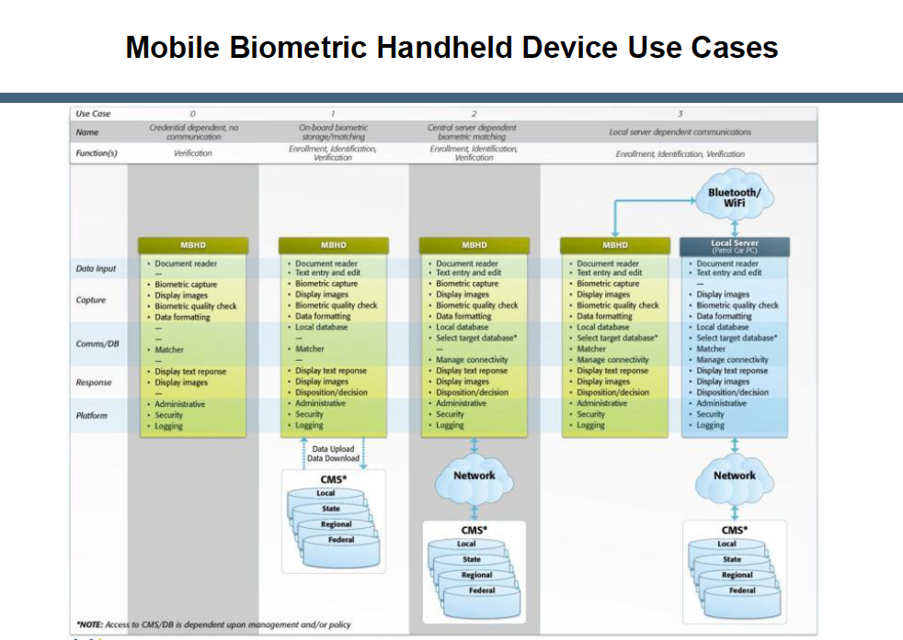

Severe Risk Environments

Severe risk levels imply that loss of life and/or property can result if accurate identification or verification is not made. In severe risk environments, it is plausible that inconvenience to the subject being identified or verified is secondary to the security of the situation, meaning subjects may be detained longer until the identification or verification process is completed. This assumption means that ABIS or other matching thresholds can be set lower (more aggressively) resulting in a returned list of potential candidates that a forensics examiner may review to determine if a true match has occurred. With the ability to have a forensics examiner review the images, image quality meeting the stringent FBI Appendix F requirements or other quality criteria adds information that can be used by the examiner. A forensics fingerprint examiner can use level 3 fingerprint information including inter-ridge detail and pore structure to effect identifications. On the other hand, machine matching is typically constrained to level 2 minutiae details and ridge spacing. For this reason, fingerprint sensors for enrollment and identification in a severe environment must meet EBTS Appendix F requirements. In addition, each print that can be compared adds information that can be used by the examiner making full ten-print comparisons desirable.

Examples of enrollment and identification functions in a high risk environment include background checks conducted to grant access to secure facilities during battle field operations. In this case, enrollment fingerprints would be compared against the latent image database maintained by the Department of Defense (DoD). Applying requirements for EBTS Appendix F maximizes the likelihood of obtaining a match against the latent database.

The verification function typically compares a processed captured biometric image against previously captured templates. Thus, even for verification functions performed in a severe risk environment, sensors meeting PIV image quality specifications provide the maximum data that will be used for matching. Increased confidence for verification functions can be met using multi-instance (e.g. 2 or more fingers) or multi-modal biometric verification. This approach has been applied by the US military in granting access cards to citizens for access to villages in Iraq and Afghanistan.

Moderate Risk Environments
A moderate risk environment is defined for those encounters with a subject with no or questionable identification. An officer cannot detain a subject for more than a limited amount of time without making an arrest. In this situation, it is necessary to quickly identify the subject or retain biometric information sufficient to verify the subject’s identity at a later date. In these situations PIV image quality enables machine matching of images. In the event these fingerprints are enrolled, these images are sufficient to match the subject when they are later encountered in the court system. Once the subject is in the court system, any images retained using mobile enrollment would typically be replaced by images captured using a ten-print system. Once again, the capture of more images provides more information for later booking. In addition, the capture of two or more fingerprints simultaneously provides additional information on the fingerprint sequence.

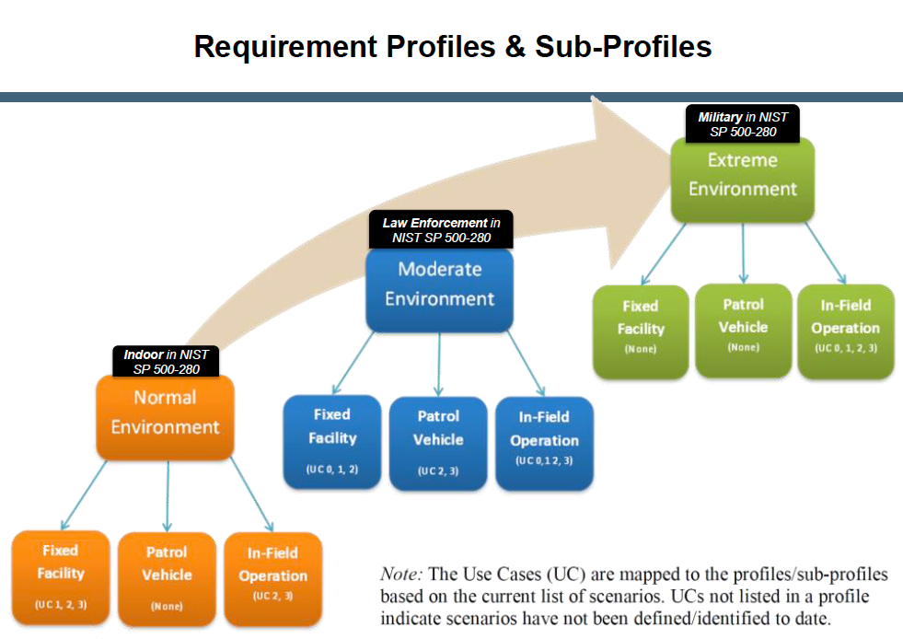

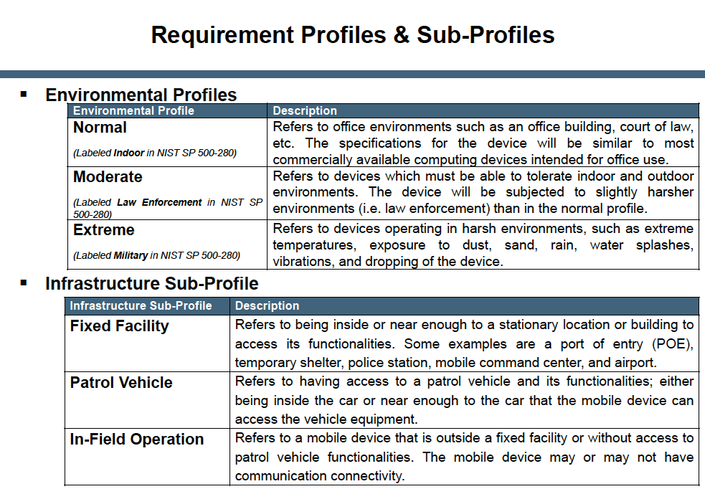

ADDS DESCRIPTION AND CREDIT DIAGRAMS AND TABLES

ADD DESCRIPTION AND CREDIT FIGUREs
Table 6 - Use cases for risks and functions

UPDATE !!! UPDATE !!! UPDATE !!!

Risk to Public Safety/Function | Use Case Example | SAP Level |  |  | Notes
Risk to Public Safety/Function | Use Case Example | Face | Finger | Iris | Notes
Severe/  Enrollment | Field enrollment into databases with applications where there is a high risk of loss of life or assets. Some situations may require multi-modal biometric enrollment. Enrollment should achieve an equivalent level of quality as if conducted in a controlled environment using non-mobile devices. | 42 | 45+ | 40 | Recommend Capture:  Iris = L&R eyes  Finger = 10  Enrolling all ten fingerprints, multiple views faces including full-face with three to five profiles, both irises, and multiple instances (captures) of each biometric provides additional search capabilities.  Note for face enrollments, attempts should be made to control, background expression and lighting where it is practical to do so.
Severe/  Identification | One to many search against a database to identify a subject where there is a high risk of loss of life or assets. Some situations may require multi-modal biometric identification. | 42 | 45+ | 40 | Recommend Capture:  Iris = L&R eyes  Finger = 4+  Note for face identifications, attempts should be made to control, background expression and lighting where it is practical to do so.
Severe/  Verification | 1:1 match against a credential or database to verify identity where there is a high risk of loss of life or assets. Some situations may require multi-modal biometric verification. | 32+ | 20+ | 40 | Recommend Capture:  Iris = Either eye  Finger = 2+  Note for face verifications, attempts should be made to control, background expression and lighting where it is practical to do so.
Moderate/  Enrollment | Mobile booking: Field cite and release when the violation is not high enough to ensure incarceration until arraignment without bail. | 42 | 40+ | 30 | Recommend Capture:  Iris = L&R eyes  Finger = 6+  Note for face enrollments and identifications, ideal lighting conditions should be used. Otherwise, fingerprints or irises should additionally be used.
Moderate/  Identification | In field mobile identification of a subject with questionable or no identification. | 42 | 30+ | 30 | Recommend Capture:  Iris = Either eye  Finger = 4+
Moderate/  Verification | Personal Identity Verification (PIV) Release from custody. | 32+ | 20+ | 30 | Recommend Capture:  Iris = Either eye  Finger = 2+
Mild/  Enrollment | The intention is for the biometric enrollment to be of sufficient quality that it shall allow later verification (e.g. e-citations). | 32 | 30+ | 20 | Recommend Capture:  Iris = L&R eye  Finger = 4+
Mild  /Identification | Rapid identification in custody prior to formal booking. (Typically done at the jail intake.) | 32 | 10+ | 20 | Recommend Capture:  Iris = Either eye  Finger = 2+
Mild/  Verification  (finger images). | Court Appearance/Parole/Workhouse, Personal Identity Verification (PIV). | 22+ | 10+ | 20 | Recommend Capture:  Iris = Either eye  Finger = 1+
Mild/  Verification  (finger minutiae). | Personal Identity Verification (PIV) (using minutiae). | N/A | 5+ | N/A | Recommend Capture:  Finger = 2+  Not recommended for use between AFIS.

Requirements for verification functions in these environments often match those of the high risk environment since machine matching is used against previously captured templates. PIV image quality meets the criteria required for verification in these environments.

Mild Risk Environments
A mild risk environment is defined for those encounters where enrollment and identification data will be used at a later date. At that time the subject would be available for comparison to the data previously retained. The results of an identification or verification should not impact anyone but the subject in question. Examples of mild enrollments include preparing for future logical or physical access control for a subject, or retaining one or more biometric images for verification in court while the subject is available. Verification examples include tracking a subject through the jail or court system using the retained biometric images. In these cases a failure to match would result in additional action to verify the subject’s identity, primarily inconveniencing no one but the subject.

Transactions and Replies

THIS SECTION NEEDS TO BE REVISED. WHAT ABOUT FORENSIC USES, ETC?

Mobile ID devices are just one source of biometric-based search transactions. Just like other transactions from booking stations, all such transactions must be formulated to be compliant with the ANSI/NIST-ITL standard requirements, regarding formats and encoding, and also with the target system’s domain specific requirements. These requirements are typically documented in a domain-specific electronic biometric transmission specification that will also include acquisition profiles and transaction submission and security. Returned responses must also be in compliance with ANSI/NIST-ITL standard record types and the domain-specific specifications.

Transactions originating from Mobile ID devices can be part of a variety of scenarios that rely on enrollment, identification or verification of subjects. Because of the basic portability of these devices, coupled with the fact that they are often used in less controlled situations than at a police station, the urgency of an identity check often dictates a quick biometric capture with the expectation of a fairly rapid response– similar to National Crime Information Center (NCIC) roadside searches and responses. Transaction types originating from Mobile ID devices will generally be one-to-many searches (identification), but will differ in response time and database files searched on a case-by-case basis.

For example, an officer may stop a vehicle for a moving violation and issue the driver a citation. There are several possible scenarios for this type of transaction:
- One or more biometric samples may be captured at this point and enrolled in the system in order to verify the subject’s identity at a later time should it be necessary (warrant issued or possibility of identity theft)
- A search transaction may be triggered to enable a rapid search against special databases containing individuals of interest, including among others subjects with outstanding wants or warrants
- The same transaction may be used to search other agency databases (e.g., the FBI) for known or suspected terrorists, wanted aliens, or other international subjects identified as a threat to the United States. Such transactions should provide responses in a few seconds due to the limited nature of the searches and the risk to officer safety of dealing with such a subject in an uncontrolled environment. However, responses to these transactions may consist of limited feedback in the form of ‘yes’, ‘no’, or ‘possibly’.

Another example could be the use of a Mobile ID device for the purpose of verifying an individual’s identity. This can take the simplest form such as admittance to a government building or entrance into a country or a camp within a war zone.
In order to initiate a biometric-based search, a well-formed ANSI/NIST-ITL standards-compliant transaction must be submitted with the expectation of receiving a similar well-formed ANSI/NIST-ITL standards-compliant transaction in response. Some types of submittal transactions may result in a much longer response time due to requirements for the transmission and processing of large amounts of biometric data (for example, both irises, all 10 fingers, full and profile facial images, etc.) in addition to any required descriptors. A typical set of ANSI/NIST-ITL standards-based records comprising a submission might include:
- • A single Type-1 header record comprised of mandatory and optional fields
- • A single Type-2 record containing mandatory fields of descriptive data
- • From 2 to 10 Type-4 or Type-14 flat or rolled fingerprint images
- • From 1 to 5 Type-10 facial images (or Scars, Marks, and Tattoos images)
- • From 1 to 2 Type-17 iris images
Biometric-specific characteristics will be extracted automatically from acquired biometric images at the target system with no human intervention. These characteristics or templates are then searched against one or more databases or watch lists. When the search is completed, the results are transmitted back to the originator in response to the biometric investigative search request. If the local system communicating directly with the Mobile ID device is capable of responding in ANSI/NIST-ITL standards-compliant record formats than that should be done. However, some local business rules and existence of older, “heritage”, systems might require responses in some other format. This becomes a problem for interoperability with other agencies and departments participating in major events (e.g., disaster recovery, riots, etc.) and should be avoided at all costs. The returned response should be in the form of another ANSI/NIST-ITL standards-compliant transaction containing at least a Type-1 and Type-2 logical record. The match report will include the identification of matching candidates and optionally the corresponding frontal facial image or matching fingerprint images of the candidate with the highest score. Often the submitter of the transaction requires these matching images for comparison and confirmation. It may also be possible to retrieve remaining candidate images through separate image retrieval requests.

Mobile Device Security & Encryption

Overview

THIS SECTION IS VERY OUT OF DATE

The establishment and enforcement of Information Technology (IT) and agency security policies is not the focus of this document. Law enforcement and criminal justice agencies are increasingly realizing the productivity benefits of mobile handheld devices such as Personal Digital Assistants (PDAs) and similar types of technology. Mobile ID devices represent a tremendous productivity advantage for criminal justice and ID management.

While this mobile technology and the capabilities it brings, from biometric identification to citations and report writing, will be a great advantage to criminal justice personnel; it is creating a tremendous security management challenge. The small size, large storage capacity and network connectivity of these devices make unprotected mobile devices susceptible to loss, theft and misuse, and possibly a target for someone wanting unauthorized access to information or databases. Mission sensitive and confidential information is now available through Mobile ID devices at locations and under circumstances that are outside the normal security parameters. As a result, unsecured devices can pose a risk to any criminal justice network that the device can access (for example, CJIS and the National Law Enforcement Telecommunications System (NLETS)). In order to secure adequately the device from misuse or attack and to meet regulatory standards and requirements, agencies must develop wireless and centralized device security policies. These policies should include measures regarding authentication, data expungement, encryption, application launch controls and device feature disablement.

This BPR establishes awareness of mobile handheld security problems and specifies "best practice" counter measures to defend against these threats. In addition, this document identifies key issues that an IT security manager must address while establishing a comprehensive handheld security policy. This document focuses on security as it relates to the mobile device and the operator of that device.

FIPS 140-2 provides a great deal of information and standardization for this area, and provides a foundation for addressing this issue. The BPR references FIPS 140-2 as the primary source of a standard to be addressed for the use of Mobile ID devices. This standard specifies the security requirements for a cryptographic module utilized within a security system protecting sensitive information in computer and telecommunication systems, which addressed the functionality of the mobile devices.

The main focus of this best practices effort is on device capabilities and the ability to implement security protocols that may be specified by the various operators or agencies responsible for these handheld devices. Security policies put in place by the owner of the databases being searched must always be followed.

Data Encryption

WHOLE SECTION NEEDS REVISION.

FIPS 140 Standard
Although the referenced FIPS 140 standards are the ones to be used by US based agencies, agencies and organizations in other countries could require compliance to different standards that provide an equivalent level of security. UPDATE

Transmissions
At a minimum, the data encryption algorithm used shall be AES-256. The Mobile ID device shall provide the capability for the encryption and decryption of bidirectional traffic. This should be accomplished in a manner to meet the FIPS 140-2 Type-1 requirements. Such encryption/decryption software should be FIPS 140-2 certified. UPDATE

Data At Rest
The Mobile Id device shall at a minimum provide the capability to encrypt all data residing on the device either as a temporary file or a part of a database in a manner to meet the FIPS 140-2 Type-1 requirements. Such encryption software shall be FIPS 140-2 certified or equivalent. UPDATE

Storage Cards
Data can be stored both in the device’s RAM and in external storage cards, such as SD/MMC, CF cards and PC storage cards. Since these storage cards can save and store gigabytes of data, the mobile handheld device shall encrypt all of the device data, databases and files written to storage medium in a manner to meet the FIPS 140-2 Type-1 requirements and such encryption software shall be FIPS 140-2 certified. UPDATE

Authentication and Authorization

NEEDS REVISION, FOR INSTANCE FOR THE USMS application, use of PIV, etc.

Operator Authentication
The mobile handheld device should provide the capability for an operator to authenticate his/her identity as well as establishing authorization levels for that person based on a two factor authentication, one of which should be a biometric. NEEDS REVISION

Biometric and Password
The mobile handheld device should provide biometric operator authentication and a password of minimum length with alphabetical /numeric/special characters. NEEDS REVISION

Re-authentication
The mobile handheld device should provide the capability for operator re-authentication after a designated length of time.

Idle Time Re-authentication
The mobile handheld device should provide the capability for operator re-authentication and the device should re-authenticate itself after a designated amount of idle time or result in a device shut-off.

Failed Security Protocols
The mobile handheld device should provide the capability to lock the device or render the device inoperable, erase selective files, and/or erase all files on the device based on failed security protocols.

Failed Authentication Attempts
The mobile handheld device should provide the capability to establish a maximum limit of failed authentication attempts before the handheld clears all application data or requires unlock only by an IT administrator.

Device Authentication
Once operator authentication and authorization is established, the mobile handheld device should be able to provide device authentication that it is authorized to communicate on the network. There should also be the capability to have the device’s identification verified against a registered list of specified devices (black list, lost/stolen). A device with a matching identification to one on the list should not be authorized to communicate with the central system.

Policy and Software Updates
In order to maintain the highest level of device security, an updating of all devices is needed whenever policies change or software is updated to provide greater protections. Un-tethered mobile handheld device should be capable of wireless over-the-air update of device security solution. ???? Still what we want to say?

Memory Card
When inserting a protected (encrypted) memory card into the mobile handheld device’s expansion slot, the device should be able to detect an encrypted card and prompt the operator for the card’s authentication codes. Access to information would be granted only when the correct authentication has been provided. Encryption algorithms shall be FIPS 140-2 certified and designed to provide data encryption in a transparent method. Transparency ensures that the operator is impacted as little as possible while providing the maximum data protection. . REVISE !!!!!

Data Authentication

The data authentication algorithm used shall be RSA-2048 as defined by FIPS-186-3 2006 (DSS). The Secure Hash Function the signature will be evaluated over shall be SHA-256, as defined by FIPS-180-2. The provisioning of certificates, root certificates, and private keys shall remain outside the scope of this standard. REVISE !!!!!

Communication Protocols

Overview

There are several different approaches for establishing communication between Mobile ID devices and systems. Figure 2 below summarizes the different approaches that can be employed.
Figure 2 Mobile ID Communication Configuration Choices
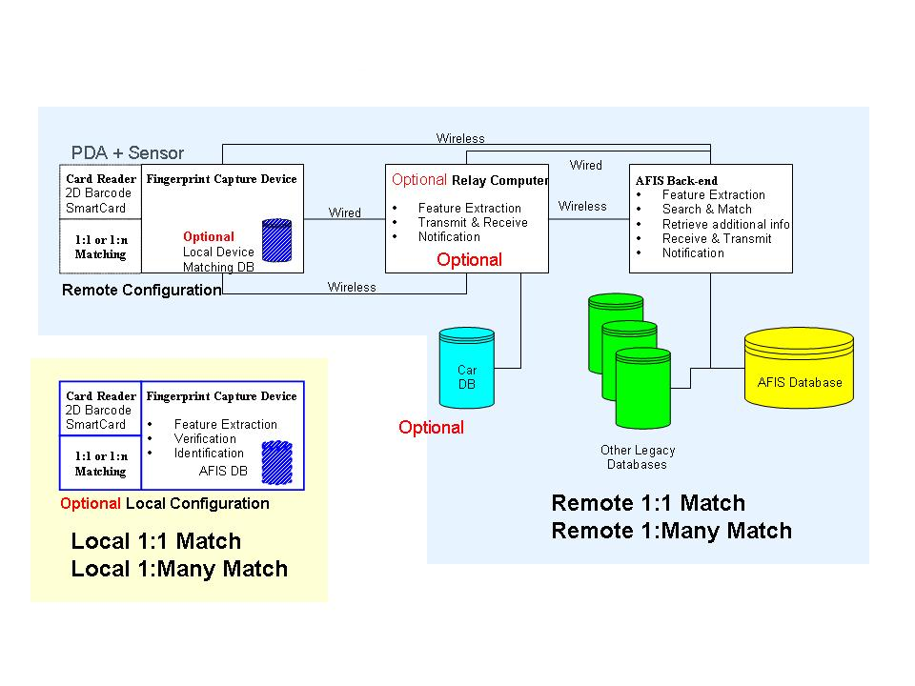

ADD SECTION HERE. WANT TO talk about BIAS, W-SABI, etc. Need to credit diagrams

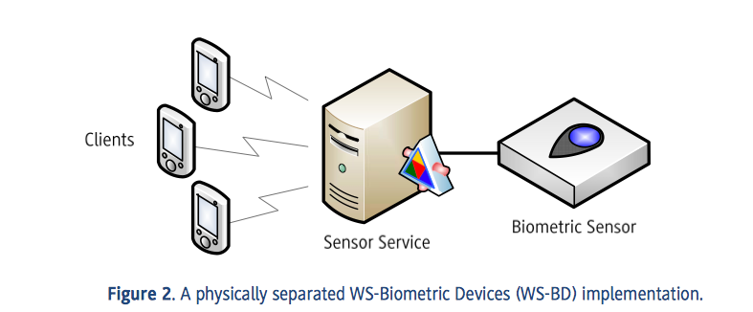
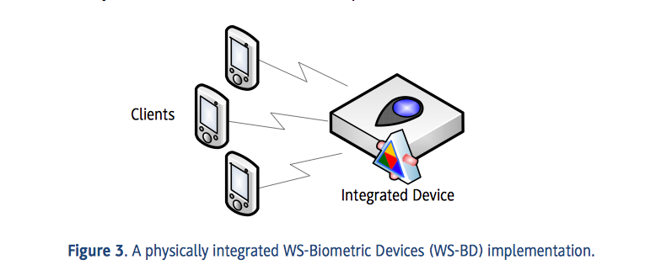

Wireless Connectivity

Mobile ID devices that search a central database may employ a wireless connection to the central site. Wireless connectivity is dependent on local and regional capabilities. Dependent on the region of deployment, connectivity may make use of wireless technologies such as Bluetooth or Wi-Fi connections, cellular data lines, or satellite communications. Acceptable minimum data rates are dependent on the transaction size to be transmitted, reasonable limits on time of detention, and the selected communication protocol. Several different approaches will be presented in this Section for discussion and consideration.

Cellular Connectivity

SHOULD THIS EVEN BE IN HERE< GIVEN HOW FAST THE FIELD CHANGES?

GSM/GPRS/EDGE/UMTS
GSM/GPRS is a pervasive 2.5G cellular technology that is widely used in Europe and Asia and by some U.S. carriers. Data rates are typically 40 kilobytes per second.
EDGE and UMTS are 3G technologies that push data rates up to 1 megabit per second.

CDMA/1XRTT/EVDO/EVDM
CDMA/1XRTT technology is a 2.5G technology that competes with GSM/GPRS and by some U.S. carriers. Data rates are around 40 kilobits per second.
EVDO and EVDM are 3G iterations of this technology that push data rates up to 1 megabit per second.

HSDPA/WCDMA
HSDPA and WCDMA represent the next phase of cellular technology and the convergence of the two technologies discussed above. Future data rates are projected to reach 40 megabytes per second.

Satellite Communication
Satellite communication may be required in remote areas or at sea where other commercial communication systems are not present. Most satellite communications require bulky transmitters/receivers. Mobile ID devices typically communicate to these devices using cables or Bluetooth connection.

802.11b/g
Wi-Fi is a common means of wireless communication built into today’s PDAs and mobile PCs. Wi-Fi communication is high speed with rates exceeding 10 megabits per second and ranges exceeding 300 meters.

Bluetooth
Bluetooth is a wireless method of connecting devices at short range. Data rates for Bluetooth 1.0 are typically around 700 kilobits per second. Range for Bluetooth varies based on the transmit power used. Class 3 Bluetooth devices have a range of approximately 1 meter, class 2 approximately 10 meters, and class 1 approximately 100 meters. Bluetooth 2.0 extends the data rate of the wireless connection to three times that of Bluetooth 1.0.

Global Positioning System (GPS)
GPS functionality adds the ability for devices to location stamp transactions.

May want to include information about other geographical reference systems ???

Integrated Wireless Antenna
Mobile ID devices include integrated antennas that support cellular connection equivalent to commercial cell phones.

Wireless Connection Status
PDA and PC applications for wireless connection provide and display the status of all wireless connections.

Environmental Considerations

Overview

A Mobile ID device can be used in a variety of different contexts, such as a law court, an airport terminal, by a patrol officer on the street or in a patrol car, or even in a military environment such as a checkpoint or for access control to a military base.

These different use cases each require different levels of resistance to environmental factors such as temperature, humidity, dust, water, vibration, etc. For these reasons, three different profiles are described below (Indoor, Law Enforcement and Military), with increasing levels of resistance to the relevant environmental conditions.

It is the responsibility of the Agency to decide, in the procurement phase of the Mobile ID devices, which profile to request in the Request for Proposal (RFP). This will depend on the expected usage of the devices and the location(s) where they will be required to operate. It is important to choose the right profile since a lower profile could mean that the devices are not able to withstand the operating environment, causing costly failures and decreasing service levels. Conversely, choosing a too high profile is likely to cause an unnecessary increase in the size, weight and cost of the devices.

Indoor Profile
If a Mobile ID device is going to be used only in an environment such as an office building, a court of law, etc. the suggested environmental specifications for the device can be assumed to be similar to those of most commercially available computing devices intended for office use. For these use cases, the recommended minimum environmental specifications are listed in Table 7.

Table 7 - Indoor Profile Recommendations

Operating temperatures | From 32°F to 104°F (0°C to 40°C)
Storage temperatures | From 14°F to 122°F (-10°C to 50°C)
Relative humidity | max. 85% non condensing
Ingress Protection Rating (IP Code) | IP 40 or higher

For more information about the level of ingress protection (IP) refer to the IEC standard 60529 “Degrees of protection provided by enclosures”.

Law Enforcement Profile

This profile should be used when the Mobile ID devices are going to be used for example by a patrol officer on the street or on-board a patrol car.

These use cases require the devices to be able to withstand high or low operating temperatures, dust, rain, water splashes, the vibrations typically encountered in a vehicle and drop from a limited height. For these use cases, the recommended minimum environmental specifications are listed in Table 8.

Table 8 - Law Enforcement Profile Recommendations

Operating temperatures | From 14°F to 122°F (-10°C to 50°C)
Storage temperatures | From -4°F to 140° F (-20°C to 60°C)
Relative humidity | 10% - 90% non condensing
Ingress Protection Rating  (IP Code) | IP 54 or higher, in operational configuration,  with any existing expansion port closed
Drop resistance | Resistance to multiple drops on concrete from a height of 3 feet (91 cm).

Military Profile
This profile should be used when the Mobile ID devices are going to be used in harsh operating environments, when the expected use cases require the devices to provide increased level of protections against high and low temperatures, dust and sand, rain, water splashes, vibrations and drop. For these use cases, the recommended minimum environmental specifications are listed in Table 9.

If the device is going to be used in a maritime environment, an increased level of Ingress Protection should be considered, such as IP 66 (protection against water jet) or IP 67 (immersion up to 1 meter), and compliance with MIL-STD-810F Method 509.4 (Salt Fog).

Table 9 - Military Profile Recommendations

Operating temperatures | From -20°F to 140°F (-29°C to 60°C) according to  MIL-STD-810F Method 501.4 Procedure II at 140°F  MIL-STD-810F Method 502.4 Procedure II at -20°F
Storage temperatures | From -20°F to 140°F (-29°C to 60°C) according to  MIL-STD-810F Method 501.4 Procedure I at 140°F  MIL-STD-810F Method 502.4 Procedure I at -20°F
Relative humidity | MIL-STD-810F Method 507.4
Rain | MIL-STD-810F Method 506.4 Procedure I
Ingress Protection Rating  (IP Code) | IP 65 or higher, in operational configuration, with  any existing expansion port closed
Drop resistance | The devices should comply with MIL-STD-810F  Method 516.5 – Procedure IV (Transit Drop), in  non-operational configuration. If the devices do  not contain a hard drive, compliance is required  also in the operational configuration.
Vibration resistance | The devices should comply with MIL-STD-810F  Method 514.5 – Procedure I (General Vibration), in  both operational and non-operational configurations.

For additional information about the above test procedures refer to: “MIL-STD-810F - Department of Defense Test Method Standard for Environmental Engineering Considerations and Laboratory Tests”, released on Jan. 1st, 2000. STILL CURRENT ?

XML Issues

REWRITE TOTALLY BASED ON ISO, INTERPOL, ANSI/NIST-ITL, DOD, FBI, and NIEM changes.
Annex A Mobile ID Device Features
(Informative) What is the meaning of informative and normative in a BPR?
HELP ! THIS NEEDS MAJOR REVISION

General
Mobile ID devices features are driven by the application of the device. As previously stated, applications can be divided into the law enforcement, military (DoD), and civilian verification segments. Each of these segments brings specific requirements to the device feature set and should be evaluated as such.

Platforms

Processors
Standalone capture devices typically use on board Digital Signal Processors (DSP) or embedded processors (such as Advanced RISC Machines (ARM)) meant for low power applications. Operating systems are typically dedicated to the specific processor. Applications are custom to the device and are not interoperable with third party applications.
PDA based applications typically use the same embedded processors, but have operating systems that enable use of third party applications. Typical operating systems are Windows (Embedded, Mobile, CE, or .NET), Linux, Palm OS, or the Symbian OS.

Storage capacity
Standalone capture devices typically provide storage capacity to capture multiple sets of fingerprints, faces, and or irises in an uncompressed format. Total memory required is dependent on the number of biometric samples captured and the number of subjects to be retained on the device. PDA based applications require memory for biometric applications, compression algorithms, and communications software, including encryption and security applications. Current generation PDAs typically provide 128 MB of RAM, 128 MB of Flash, and optional flash cards with storage up to and exceeding several gigabytes of storage. Today’s PC based applications typically have up to 1 GB of RAM or more and over 40 GB of storage capacity on disk drives. Agencies purchasing such systems need to tailor their operational concepts and procedures to manage the use of storage effectively. If, for instance, a PDA has 8 GB of flash memory on a removable disk then issuing multiple flash memory units to an officer would permit an almost unlimited number of collections of biometric samples per shift. On the other hand if a device has a fixed memory storage capacity then the department should determine how much space is available for fingerprints, facial images, and iris images and advise the persons using the Mobile ID devices on how to factor these limitations into the use of the device.

Displays
Displays on Mobile ID devices vary from graphical overlays to small displays capable of showing return messages and photographs. Mobile ID devices intended for outdoor, rugged environments must be capable of displaying images and text in bright sunlight as well as in the dark. Sunlight visible means capability for either a front-lit technology or 1000 NITS minimum backlighting. For viewing in the dark, a minimum of 100 NITS of back or front lighting is required. Application software typically enables multiple preset brightness settings and color schemes for daytime versus nighttime viewing.
Note that depending on the Use Case and the modality, it may not be possible or appropriate to return the results of a search to the same device on which they were captured. In such cases an associated PDA style device or laptop in a nearby vehicle may typically be used to display the returned information or matching image(s).

Audio Feedback
Stand alone capture devices have the capability to generate audio or haptic feedback to the operator. Some devices provide equivalent feedback using a vibration in the device.

Expansion Capability
PDA or PC based mobile identification typically support expansion capabilities through one or more of the following interfaces:
- USB host ports, either USB 1.1 or USB 2.0
- USB client port, typically USB 1.1 NOTE TO EDITOR: THIS IS AN EXAMPLE OF HOW SPECIFYING THINGS TOO MUCH MAKES A DOCUMENT OUT OF DATE REALLY QUICKLY
- Serial port
- PCMCIA slot (type II x 1)
- Mini PCI Express
- SD slot
- Wireless connectivity (discussed below)

Capture Device Features

General
The following capture device features are considered desirable but not mandatory.

Fingerprint Capture

Finger Guide
Fingerprint capture devices with integrated finger guide are desirable to optimize placement of the finger such that the core and first crease of large thumbs is captured. This may also assist in reducing sequence errors. Finger guides can also protect the fingerprint capture area from direct sunlight if required.

Finger Location Indicator
Mobile devices with the capability to detect the location of the fingerprint are desirable to provide a left/right, up/down indication for the operator or subject to insure optimal image content.

Auto-capture of image
Mobile devices with the capability to evaluate each image frame captured are desirable to determine if a fingerprint is present that meets quality requirements and automatically save the image.

Manual capture of image
Mobile devices with the capability to manually command the device to capture the image currently on the sensor are desirable to insure the ability to capture difficult to image fingers.

Quality check function
After capture of the fingerprint images, a quality check function is desirable based on a combination of:
- Image size
- Light or dark image measurements
- Minutiae count
- Core location
- NIST Image quality scores

Finger print image display
Display of fingerprints on mobile device during the capture process is a useful option for some mobile device applications.

Image Enhancement Features
Image enhancing membranes on optical scanners are desirable to improve the ability to capture dry fingers. Membrane materials include silicon pads, epoxy, and urethane coatings.

Platen/Coating replacement
Optical scanner platen surfaces that may be field replaced are desirable to ensure continuity of use.

Other Considerations
Aside from the recommendations and requirements listed above for the fingerprint capture device, other factors that affect the performance of these Mobile ID devices and systems need to be considered. Many of these relate to training and include:

- Operation of the device within the temperature and humidity specifications
- Ruggedness of the device
- Officer safety while using
- Use of clean fingers when possible
- Maintain clean platens
- Types of cleaners allowed on platen
- Consistent placement of the same finger(s)
- Consistent centering and use the same area from the flat of the finger
- Optical scanners should avoid excess illumination (or use capture devices that can function effectively in full sunlight)
- If enrolling more than 1 finger, ensure that sequence errors do not occur.
- If enrolling more than 1 finger always reflect accurately which finger is being captured
- On single finger capture devices, sequence errors need to be avoided (especially for enrollments)
- Quality feedback to operator
- How quickly can prints be captured
- How many transactions can be in process simultaneously (can a new set of fingerprints be captured while waiting for search results?)

Facial Capture

On Board Illumination (Flash)
Mobile identification devices using PDAs typically provide LED illumination. This illumination is sufficient for images to associate with the return information.
Mobile ID devices used for facial recognition provide a high quality flash function as found on commercial or professional cameras.

Docking Station
Download of high resolution images from commercial or professional grade cameras requires a high speed transfer. Docking stations for the camera provide a high speed interface to a PC for transfer to a central location.

Return Data Display
Mobile ID devices using facial recognition typically return a photo lineup of potential matches to the operator. In many scenarios where face recognition is used in this way the display on the capture device is not adequate for an objective decision to be made and so the potential matches are returned to a laptop or PC (perhaps located in a nearby patrol car) for display on a higher resolution screen.

In cases where a single image is returned (perhaps in verification scenarios where the device is used in conjunction with an ID card or token containing a facial biometric) the display on a PDA style device may be perfectly acceptable.

Iris Capture

Transmission of templates/images
Iris templates and images are small enough that transmission can be accomplished using sync cables or wireless connections.

Display of results
Display of captured images is helpful in that it provides direct feedback to the operator in the case that iris image quality is not adequate. Results displayed may range from textual demographics data to photographic images.

Illumination consideration
Use of sunshields or hoods can facilitate outdoor capture and reduce the need for high-power illumination sources.

Textual data entry

Keyboards/Keypads
Demographic entry may be accomplished using on screen keyboards, PDA keyboards or keypads, or PC keyboards.

Magnetic Stripe Readers
A magnetic stripe reader with capability of reading driver’s licenses per AAMVA DL/ID-2005, enable demographic data entry using these cards.

Bar Code Readers
1-D and 2-D bar codes are used on some identification cards such as driver’s licenses. Bar code readers allow input of demographic data from these cards.
In some instances, a 2-D bar code reader may also store fingerprint templates as input for verification.

Smart Card Reader
Smart card reader (contact or contactless) may be used for demographic data entry, for downloading, or storage of templates (fingerprint, facial, or iris) for matching on-board verification devices.

MRZ Reader
In applications using smart cards the information on the passport may include biometrics in compliance with ICAO standards. An MRZ reader, if present in a Mobile ID device, should be able to read an ICAO compliant Machine Readable Zone, in the three different document formats (ID1, ID2 and ID3) defined in ISO/IEC 7810:2003. Optical Character Reader (OCR) software should be integrated in the device, able to analyze the MRZ image and return its content in terms of ASCII characters.

Power Features

Removable Battery
The ability to remove the battery (or “hot swap”) without the loss of stored data or programs allows continuous operation without the need for charging cradles in vehicles.

Charging
The ability to charge from a variety of sources including automotive +12 VDC (+10.0 to +18.0), or from a military vehicle operating off of 24v system, or from chargers running on recognized international power sources (110 to 240 VAC) gives flexibility to operator workflows. Units are typically able to operate while charging. Power filtering and surge protection are recommended.

Battery Life Indicators
Battery life indicators that display the amount of battery power and estimated time of operation remaining are desirable.

Battery Charge Indication
Battery charge indicators that show charging is in process are desirable.

Desktop Battery Charger
Desktop battery chargers are typically available. Desktop chargers, car chargers, and devices using a common connector to the Mobile ID device are desirable.

Vehicle Charger
Vehicle chargers that operate from car cigarette lighters are desirable.

Gang Charger
Gang chargers for charging multiple batteries are desirable.

RAM Holdover Battery
Holdover batteries providing power to on board RAM for up to 30 days are desirable.

Non-Volatile Memory
Application programs stored in non-volatile memory are desirable to prevent loss of applications during a total loss of battery.

Certifications

Mobile device certifications available include:

US FCC class B part 15
CE Certification
EN 60529, Ingress Protection
Multiple levels of ingress protection are available.
Military devices are typically IP65, dust tight and able to survive water spray.
Some naval devices add IP67, dust tight, water tight to 1 meter

Annex B Acquisition Planning
(Informative) What is the meaning of informative and normative in a BPR?

This Annex is not intended to provide all of the considerations for starting a mobile identification project as all implementations are different. However, some considerations are:

Network: Field devices not accessing a resident database or one in the car needs to be reliable and utilize a bandwidth that can support a response within time frames that are deemed within legal detention time frames.

Network / Manual data transfer: Devices accessing a resident database or one in the car need to be kept current this is either network or done manually (portable media or direct on the device).

Responses: Whenever possible, the operator response should optionally include photos with hit notifications. Photos and candidate lists can be useful when the system cannot provide a positive identification. These could add another level of verification for the operator of the device. Additionally, including warrant information with the response based on the ABIS ID is also very useful, however, when confirming a hit, operators should follow their agency’s Standard Operating Procedures.

Training: Operators should be trained in the use of the device. Their testimony in court should be limited to this expertise.

Reporting: Allow for some kind of print out compatible file that can be saved downloaded and then added to a report, citation, or used for court purposes.

E-Citation: If your agency has e-citations, the sensor utilized should meet the minimum specifications in this document. This can aid in having an image that can be enrolled into an AFIS.

Legal: To stay within the limits of existing case law, agencies should adopt an Appropriate Use Policy suitable for their agency mission.

Software updates: As these devices are deployed, they will inevitably require updates. Updating of devices manually is time intensive. Auto updates are recommended.

References
GO THROUGH WITH A FINE-TOOTH COMB
INCLUDE NEW STANDARDS

Advanced Encryption Standard FIPS 197; http://csrc.nist.gov/publications/PubsFIPS.html

American Association of Motor Vehicle Administrators Standard (AAMVA DL/ID 2005); http://www.aamva.org/KnowledgeCenter/Standards/Current/DL-IDStandard2005.htm

ANSI/NIST-ITL 1-2007, Data Format for the Interchange of Fingerprint Facial, & Other Biometric Information – Part 1 ; http://fingerprint.nist.gov/standard/index.htm

ANSI/NIST-ITL 2-2008, Data Format for the Interchange of Fingerprint Facial, & Other Biometric Information – Part 2: XML; http://fingerprint.nist.gov/standard/index.htm

ANSI/NIST-ITL 1-2000, Data Format for the Interchange of Fingerprint, Facial, & Scar Mark and Tattoo (SMT) Information; http://fingerprint.nist.gov/standard/archived_workshops/index.html

Electronic Biometrics Transmission Specification, EBTS, Version 8.1, 2008; http://www.fbibiospecs.org/fbibiometric/ebts.html

Electronic Fingerprint Transmission Specification, EFTS, Version 7.1, 2005; http://www.fbibiospecs.org/fbibiometric/ebts.html

EN 60529 Specification for degrees of protection provided by enclosures; http://webstore.ansi.org/FindStandards.aspx?SearchString=IEC+60529&SearchOption=0&Page

FIPS 140-1: Security Requirements for Cryptographic Modules; http://csrc.nist.gov/publications/PubsFIPS.html

FIPS 180-2 Secure Hash Standard (SHS) * Superceded By: FIPS 180 -3 ; http://csrc.nist.gov/publications/PubsFIPSArch.html

FIPS 186-3 DRAFT Digital Signature Standard (DSS); http://csrc.nist.gov/publications/PubsFIPS.html

IEC 825 Eye safety classification of some consumer electronic products; http://ieeexplore.ieee.org/xpl/freeabs_all.jsp?arnumber=543110

International Civil Aviation Organization (ICAO) ; http://csrc.nist.gov/publications/PubsFIPSArch.html

INCITS 378:2004 - American National Standard for Information Technology — Finger Minutiae Format for Data Interchange

INCITS 381:2004 - American National Standard for Information Technology — Finger Image-Based Data Interchange Format

IP xx Ingress Protection Rating; http://www.mpl.ch/info/IPratings.html

ISO/IEC 10918-1 Digital Compression and Coding of Continuous-Tone Still Images Part 1: Requirements and Guidelines (JPEG)

ISO/IEC 19794-2:2004 Information Technology- Biometric data interchange formats- Part : Finger Minutiae Data

ISO/IEC 19794-4:2004 Information Technology- Biometric data interchange formats- Part : Finger Image Data

ISO/IEC 19794-5:2004 Information Technology- Biometric data interchange formats- Part : Face Image Data

ISO/IEC 19794-6:2004 Information Technology- Biometric data interchange formats- Part : Iris Image Data

MIL-STD-810F; http://www.dtc.army.mil/navigator

Minutiae Interoperability Exchange Test (MINEX); http://fingerprint.nist.gov/minex04/index.html

National Information Exchange Model (NIEM 2.0) ; http://www.niem.gov/library.php

NIEM XML; http://www.niem.gov/xmlSchemas.php

WSQ Gray-scale Fingerprint Image Compression Specification, Dec., 1997; http://www.fbibiospecs.org/fbibiometric/biometric_specs.html

Acronyms/Glossary UPDATE AS NEEDED BY TEXT

ACRONYM | MEANING
ABIS | Automated Biometric Identification System
AFIS | Automated Fingerprint Identification System
ANSI/NIST | American National Standards Institute / National Institute of Standards and Technology
ARM | Advanced RISC Machine
BAP | Biometric Application Profile
BPR | Best Practice Recommendation
CDMA/1XRTT | Code Division Multiple Access technology
CE | Officially known as Windows Embedded Compact Windows CE is Microsoft’s operating system for minimalistic computers and embedded systems
CPU | Central Processing Unit
dB | Decibels
DHS | Department of Homeland Security
DoD | Department of Defense
DSP | Digital Signal Processors
DSS | Digital Signature Standard
EBTS | Electronic Biometric Transmission Specification
EDGE | Enhanced Data Rates for Global Evolution
EFTS | Electronic Fingerprint Transmission Specification
EVDO/EVDM | EVDO and EVDM are 3G iterations of the CDMA technology that push data rates up to 1 megabits/sec
FBI | Federal Bureau of Investigation
FIPS | Federal Information Processing Standard
FPS | Frames per second
FTA | Failure to acquire
GPRS | Global Packet Radio Services
GPS | Global Positioning System
GSM | Global System for Mobile
HSDPA/WCDMA | The next phase of cellular technology to approach 40 megabytes/sec
IAFIS | Integrated Automated Fingerprint Identification System
ID | Identification
IP | Internet Protocol
IP XX | Ingress Protection Rating
IREX | Iris Exchange evaluation
ISO | International Standards Organization
IT | Information Technology
ITL | Information Technology Laboratory (NIST)
JPEG | Joint Photographic Expert Group
KST | Known or Suspected Terrorist
LED | Light emitting diode
MINEX | Minutiae Exchange evaluation
MRZ | Machine Readable Zone
ms | millisecond
NCIC | National Crime Information Center
NET | The .NET Framework is Microsoft's comprehensive and consistent programming model for building applications
NFIQ | NIST Fingerprint Image Quality
NGI | Next Generation Identification
NIEM | National Information Exchange Model
NIST | National Institute of Standards & Technology
nm | Nanometer
OCR | Optical Character Recognition  Optical Character Reader
OS | Operating System
PC | Personal Computer
PCI | Peripheral Component Interface
PDA | Personal Digital Assistant
PIV | Personal Identity Verification
PIX | Private Internet Exchange
ppi | pixels per inch
R&D | Research and Development
RAM | Random Access Memory
RGB | Red Green Blue
RISC | Repository for Individuals of Special Concern
SAP | Subject Acquisition Profile
SD | Type of data storage card
SMTs | Scars, Marks, and Tattoos
TWIC | Transportation Worker Identification Credential
USB | Universal Serial Bus
US FCC | United States Federal Communications Commission
US VISIT | United States Visitor and Immigrant Status Indicator Technology
VAC | Volts AC
VDC | Volts DC
WCDMA | The next phase of cellular technology to approach 40 megabytes/sec
WSQ | Wavelet Scalar Quantization
XML | Extensible Markup Language

http://www.mitre.org/work/tech_papers/tech_papers_04/lepley_fingerprint/lepley_fingerprint.pdf
http://www.fbibiospecs.org/fbibiometric/ebts.html
http://www.fbibiospecs.org/fbibiometric/docs/pivspec.pdf
SAP levels of 13, 14, and 15 can be considered for local use, for instance when verifying against an ID card that has an imbedded facial image on a chip or on an RFID tag.
At this time there is no commonly acknowledged equivalent image quality specifications for either face or iris capture devices.

