=====================================================================================================
To: All GMIS contacts associated to open awards
Subject: “May Newsletter - Important Update: Your DOC Award Will Use eRA Starting October 1, 2026!”

In case you missed the last newsletter, NIST serviced grant awards are transitioning from the Grants Management Information System (GMIS) to a federal shared service called eRA. The goal of this effort is to modernize grants systems and streamline grant processes across the Department of Commerce (DOC). You are receiving this newsletter because NIST has identified that you have an active NIST, NTIA, and/or Census award.
This month, we are pleased to share updates regarding our progress:

- Training is coming, please see the training schedule attached and instructions on how to register.
- The NIST eRA site is now available and has the latest updates for eRA!

Thank you for your cooperation as we work through this transition together.

Financial Assistance Agreements Management Office (FAAMO)
National Institute of Standards and Technology (NIST)
Department of Commerce (DOC)
=====================================================================================================


eRA:
WHAT YOU NEED TO KNOW!

NIST is excited to announce the official launch of eRA (Electronic Research Administration). Effective October 1, 2026, all recipients of awards, including grants, cooperative agreements, and other transactions, from the Department of Commerce Bureaus, will be required to use eRA to perform applicant and recipient activities within the electronic award administration process:
- National Institute of Standards and Technology (NIST)
- National Telecommunications and Information Administration (NTIA)
- U.S. Census Bureau
As we prepare for the upcoming transition to the eRA award system, your involvement is key to a smooth migration. Please review the updates below to stay informed and prepared regarding our progress.

eRA Webpage & Training

NIST has launched a new webpage dedicated entirely to the eRA implementation. This page will serve as your main source for the latest migration updates, past communications, and training resources. You can explore it here: eRA Implementation Page.

The training schedule is now available. These live sessions will be recorded, and eRA will provide registration links ahead of the scheduled dates. Please be on the lookout for future emails regarding registration. Please see the training topics below. If you miss a live session, the recordings will be posted on the eRA Implementation Page afterward. Please see below for the full training schedule:

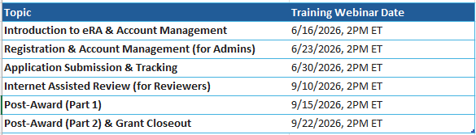

ADDITIONAL RESOURCES

Please see below for helpful links regarding eRA:

- DOC Resource - For the latest eRA information and additional resources, please visit the GEMS External Resource Pages .
- eRA Resource- For more information about the eRA Commons, please visit the eRA Commons Page
- NIST Resource – For the latest GEMS information from the NIST Team - Financial Assistance Agreements Management Office (FAAMO) | NIST Intranet

We look forward to working with you as we move forward with this implementation. Please contact your Grant Specialist should you have any additional questions.
Please do not reply to this message. The broadcast email account is not monitored for incoming mail.

