National Institute of Standards and Technology
Manufacturing Extension Partnership
Advisory Board
Minutes of the May 2010 Meeting

Background
The National Institute of Standards and Technology (NIST) Manufacturing Extension Partnership (MEP) Advisory Board met in an open session from 8:30 a.m. to 4:30 p.m. on May 2, 2010, at the Orlando World Center Marriott in Orlando, Florida. Approximately 45 attendees, composed of Board members, MEP participants and staff, presenters, and observers, attended the meeting.

Attendees

Board Members
Mark Rice, Chair, MEP Advisory Board, and President, Maritime Applied Physics
Lydia Carson, Vice Chair, MEP Advisory Board, and President and Chief Executive Officer, Balm Innovations, LLC
James Bean, President and Chief Executive Officer, Preco Electronics, Inc.
Dennis Dotson, President, Dotson Iron Castings
Cheryl Hill, Owner and Chief Executive Officer, Hill Manufacturing, Inc.
Edward "Ned" W. Hill, Dean, Maxine Goodman Levin College of Urban Affairs, Cleveland State University
James Jacobs, President, Macomb Community College, Michigan
Fred Keller, Chairman and Chief Executive Officer, Cascade Engineering
Capers McDonald, Executive in Residence, Carey Business School, Johns Hopkins University
Ken Priest, President and Chief Executive Officer, Kenway Corporation

MEP Participants
Roger Kilmer, Director, NIST MEP
Aimee Dobrzeniecki, Deputy Director, NIST MEP
Karen Lellock, Senior Policy Advisor, NIST MEP
Mike Simpson, System Operation Director, NIST MEP
Ken Voytek, Chief Economist, NIST MEP

Presenters
Elizabeth Colbert, Director, Ohio Manufacturing Extension Partnership
Bonnie Del Conte, Director, Connecticut State Technology Extension Program
Doug Hall, Founder and Chief Executive Officer, Eureka! Ranch
Nicole Lamb-Hale, Assistant Secretary for Manufacturing and Services, International Trade Administration, Department of Commerce
L. David Snow, Director, Indiana Manufacturing Extension Partnership, Purdue Technical Assistance Program
Mike Stone, Founder and President, Stone and Associates
Mark Tomlinson, Executive Director and General Manager, Society of Manufacturing Engineers

Observers
G. Michael Alder, Chairman, WestCamp Board, Utah Manufacturing Extension Partnership, and Director, Office of Technology Transfer, Brigham Young University
Brian Brothman, Special Assistant, Manufacturing and Services, International Trade Administration, Department of Commerce
Drew Casani, Director, Texas Manufacturing Assistance Center
John Connelly, Director, Enterprise Minnesota
Ronald Gan, Administrative and Financial Management Officer, NIST MEP
Pam Hurt, Program Manager, Workforce Development, Society of Manufacturing Engineers
Jeff Kohler, Director, Virginia's A.L. Philpott Manufacturing Extension Partnership
Joe LaRussa, Director, Membership, Society of Manufacturing Engineers
Natalie Lowell, Manager, Community Services, Society of Manufacturing Engineers
Thomas Mahoney, Director, West Virginia Manufacturing Extension Program
Montana Mallett, Business Trainee, NIST MEP
Petra Mitchell, Director, Catalyst Connection
Bill Murray, Executive Director, Council for International Trade, Technology, Education, and Communication/New York State Foundation for Science, Technology, and Innovation
Tom Palisin, Program Manager, Pennsylvania Department of Community and Economic Development
Dan Pitkin, Business and Technology Advisor, NIST MEP
Ken Poole, Chief Executive Officer, Center for Regional Economic Competitiveness
Deborah Robbins, Manager, Member Industry Relations, Society of Manufacturing Engineers
Larry Stewart, Director, Manufacturing-Works
David Stieren, Technology Acceleration Manager, NIST MEP
Steve Thompson, Program Development Director, NIST MEP
Mark Troppe, Strategic Partnerships and State Relations Manager, NIST MEP
Gary Yakimov, Policy Initiative Manager, NIST MEP
Bob Zider, Director, Vermont Manufacturing Extension Center

Assisted by
SciComm, Inc.

Welcome, Introductions, and Opening Remarks
Moderator: Mark Rice, Chair, MEP Advisory Board, and President, Maritime Applied Physics

Mr. Rice welcomed the Board, MEP participants, presenters, and observers to the May 2010 Advisory Board meeting. MEP, a nationwide manufacturing network, is composed of 1,500 field agents. MEP's goal is to provide small and medium-sized manufacturers with the assistance they need to succeed. MEP was created to improve the nation’s manufacturing sector; the role of the Advisory Board is to help MEP achieve its goals. In its charter, the Advisory Board is called upon to:
- Provide advice on MEP's programs, plans, and policies,
- Assess the soundness of MEP's plans and strategies, and
- Assess MEP's current performance against its program goals.

Two new Board members were introduced: Mr. Dennis Dotson, President, Dotson Iron Castings, and Mr. Ken Priest, President and Chief Executive Officer, Kenway Corporation.

Speaker: Roger Kilmer, Director, NIST MEP
Mr. Kilmer introduced Mark Tomlinson, Executive Director and General Manager, Society of Manufacturing Engineers (SME), to the Board. SME and MEP have a history of collaborating with each other.

Speaker: Mark Tomlinson, Executive Director and General Manager, Society of Manufacturing Engineers
SME is the world's leading professional society created to advance manufacturing knowledge. SME influences more than 500,000 manufacturing practitioners each year. Through its programs, SME promotes manufacturing engineering and keeps manufacturing professionals current on leading trends and technologies.

SME and MEP have partnered over the last five years which provides MEP access to industry and more than 500,000 manufacturing professionals. With such a large base of manufacturing engineers, SME and MEP often share the same market space, the same resources and in many cases, the MEP providers and clients are often SME members. Additionally, in sharing this same market space, there are a great many opportunities for the MEP system and SME to collaborate, partner and support one another in our initiatives and programs.

Through partnership with SME, the MEP can access this broad and expansive network of professionals who have by virtue of their membership with the organization an interest in manufacturing, manufacturing process improvement and excellence. The strong congruence between the missions of these organizations, the mission of the MEP, interest of the members and the services offered by Centers make leads and opportunities that arise through these partnerships much more likely to result in projects with Centers and impacts.

SME is very active in its community activities, events, professional development, education foundation, and publications:
- SME promotes events for members and other manufacturing practitioners to exchange ideas and information.
- SME promotes events, such as expositions and conferences, to educate its members on manufacturing equipment, production methods, and management strategies and to provide networking opportunities.
- SME provides technical and practical training for various manufacturing processes and industries. Professional development includes SME certifications, on-site training, and on-line training.
- SME manages an educational foundation to inspire young people to pursue careers in manufacturing. SME recently awarded $375,000 in scholarships.
- SME produces technical books and magazines. The National MEP System uses many of these products, including the Manufacturing Engineering magazine.

SME's goals are similar to MEP's goals: to revitalize manufacturing in the U.S. and to communicate the importance of manufacturing.

Current State of Manufacturing
Speaker: Ken Voytek, Chief Economist, NIST MEP

Mr. Voytek provided a statistical "tour" of the U.S. manufacturing landscape and a discussion of MEP's performance and client challenges.

Tour of the U.S. Manufacturing Economy
- U.S. is the leading manufacturing country, but its market share in manufacturing is declining.
- Several national indexes (e.g., Chicago Federal Indexes of National Economic Activities, Institute for Supply Management Manufacturing Index) suggest that the economy is improving.
- Manufacturers are facing increased pricing pressure.
- Manufacturing productivity is up. However, manufacturing employment and market share are down.
- Labor productivity and labor compensation are diverging.
- The severity of the economic downturn varies across the nation. Manufacturing is stable or decreasing in every State. No State has seen an increase in manufacturing.
- Long-term trend in inventory-to-sales ratio for manufacturing is decreasing.
- Capacity utilization has been decreasing.
- U.S. balance of trade has declined, but exchange rates positively affect the balance of trade.
- U.S. balance of trade for high-technology goods (e.g., computers, aerospace) has decreased while the balance of trade for other areas has improved. Overall, the balance of trade remains negative.
- U.S. patent share has declined. More patents are being issued to non-U.S. citizens.
- Share of U.S. research and development (R&D) expenditure is decreasing, while other countries, such as China and India, have an increasing R&D expenditure share.
- Most U.S. companies are integrated into the supply chain.
- Manufacturing has seen a significant improvement in its carbon-dioxide emissions efficiency.

MEP Client Reported Challenges
Of 7,700 clients surveyed, clients identified their challenges as:
- Continuous improvements,
- Growth and product opportunities,
- Exporting, and
- Available financing.

Federal Manufacturing Policies
Speaker: Nicole Lamb-Hale, Assistant Secretary for Manufacturing and Services, International Trade Administration, Department of Commerce

Ms. Lamb-Hale thanked the Advisory Board for inviting her to speak at the MEP Advisory Board meeting. It was noted that the Department of Commerce (DOC) has tapped into Board members Lydia Carson’s and Fred Keller’s expertise. MEP is applauded for its role in manufacturing, particularly for its public/private partnerships, for MEP’s 2010 Innovation and Product Development paper, and for collaborating with the International Trade Administration (ITA) on the ITA-sponsored Sustainable Manufacturing American Regional Tours (SMART).

ITA’s Manufacturing and Services (MAS) would like to expand its partnerships with MEP as well as with other Federal, State, local, and private organizations to support U.S. manufacturing.

Manufacturing
Manufacturing has a huge impact on the U.S. economy and a decline in manufacturing has an adverse effect on the economy. It is important to communicate the importance of manufacturing to the U.S. public.

Obama Administration's Goals
President Obama's Administration feels that small and medium-sized businesses play a critical role in the U.S. economy. Following the December 2009 release of A Framework for Revitalizing American Manufacturing, the Administration has developed programs, such as tax-incentives programs, financing programs, and exporting programs, to support U.S. manufacturing competitiveness worldwide.

Manufacturing and Services (MAS) Goals
MAS is an agency within ITA. MAS is committed to enhancing the global competitiveness of the U.S. manufacturing industry, to expanding U.S. market access, and to increasing U.S. exports. MAS industry experts and economists perform strategic research and analysis to shape and implement trade policy, to create conditions that encourage innovation, to lower the cost of doing business, and to promote U.S. economic growth.

MAS strives to:
- Support U.S. industry’s global competitiveness through critical analysis of domestic regulations, legislation, trade policy development, and negotiations.
- Ensure U.S. industry input into interagency trade policy, regulatory, and promotion process.
- Analyze trade data and economic policy to support trade negotiations and bilateral and multilateral discussions.
- Work with industry and government agencies to reduce costs of regulation and other government policies.

MAS Approach
MAS has a three-pronged approach: convene, connect, and collaborate. MAS convenes experts and manufacturers to address issues faced by manufacturers. MAS connects manufacturers to resources within Federal, State, and local organizations. And, MAS collaborates with Congress and Federal agencies to assist manufacturers. MAS is committed to working with MEP to support U.S. manufacturers.

Key Initiatives
Three initiatives were synopsized: SMART, National Export Initiative (NEI), and CommerceConnect.

SMART is a DOC initiative designed to enhance manufacturer’s awareness of the benefits of sustainable manufacturing practices. The tours identify the benefits of being lean, clean, and energy efficient for both global competitiveness and the environment. The first round of tours included manufacturing facilities in Beltsville, MD; Atlanta, GA; and Columbus, OH. One success story involved a Maryland floor-mat producer that retooled its manufacturing process to take advantage of emerging markets and to export its products to Canada.

NEI is an Administration initiative that is designed to improve conditions that affect U.S. manufacturer's ability to export its products and services. NEI will help meet the Administration's goal to double exports over the next 5 years by working to remove trade barriers abroad, by helping firms overcome exporting hurdles, by assisting with financing, and by pursuing a Government-wide approach to advocate exports.

CommerceConnect is a DOC program that is designed to create a one-stop access to all of the bureaus within DOC in order to help businesses at every point of their life cycle and to help businesses transform themselves into globally competitive enterprises. CommerceConnect is a pilot program that began in Plymouth, Michigan. As the CommerceConnect program proves itself, it will be expanded to serve business needs across the country.

Questions and Answers
Q: How can MEP improve its Congressional relationships?
A: MEP is a perfect public/private partnership. MEP's nimble characteristics are good. MEP can respond quickly to a changing environment. MEP can provide a fresh perspective. MEP should speak to the Congressional leadership. MEP should work with Congress to ratify free-trade agreements to support fair trade and open markets.

Q: What is the relationship between MAS and the Middle Class Task Force, which is looking at Recovery Act programs that will accelerate job growth through manufacturing?
A: The task force is looking holistically at the issue. MAS is looking at the decline of manufacturing. Everyone is sharing information with everyone else. We have a single voice. There are no organizational silos.

Q: What are the next steps for A Framework for Revitalizing American Manufacturing?
A: The Framework has been developed and the next step is focused on the implementation. MEP's input contributed to the Framework, especially for small and medium-sized enterprises. MEP has helped to level the playing field in terms of small, medium, and large manufacturers. MEP is helping manufacturers become more competitive. MAS is listening to MEP and to industry.

Q: There are two crises: the current recession and the nation’s long-term manufacturing decline. MEP Centers can assist in making changes more rapidly in the long-term crisis. To achieve this goal, MEP’s budget needs to be increased. With a larger budget, MEP can work on the 30-year crisis. There are fundamental manufacturing issues that need to be addressed. What are your thoughts?
A: These statements are correct. The Administration is committed to manufacturing and to small and medium-sized enterprises. MEP is in a good position to improve manufacturing trends. MAS needs to hear MEP’s ideas. MEP understands the issues and, like MAS, is committed to manufacturers.

Q: The Board would like to thank MAS participation in today’s meeting. MEP is committed to helping MAS and ITA. What can MEP do for MAS?
A: MAS needs help with the Road Show, success stories, and identifying conference presenters. MAS would like to create a community where information is shared.

MEP Center Operations, Structure, and Service Offerings: A Panel Discussion
Moderator: Lydia Carson, President and Chief Executive Officer, Balm Innovations, LLC
Mike Simpson, System Operation Director, NIST MEP
Panelists: L. David Snow, Director, Indiana MEP Purdue Technical Assistance Program
Elizabeth Colbert, Director, Ohio Manufacturing Extension Partnership
Bonnie Del Conte, Director, Connecticut State Technology Extension Program

Lydia Carson introduced the three panelists. The three panelists represent three major types of MEP Centers: Indiana MEP Purdue Technical Assistance Program (PTAP) is a university-based Center, Ohio Manufacturing Extension Partnership (OMEP) is a State-based Center, and Connecticut State Technology Extension Program (CONNSTEP) is an industry-based Center.

Panelist: L. David Snow, Director, Indiana MEP Purdue Technical Assistance Program
Indiana MEP PTAP, which is operated within Purdue University, is a university-based Center. PTAP’s MEP Center is one of three centers within PTAP. PTAP connects companies with university resources and helps companies implement best practices and invest in state-of-the-art technologies. PTAP also provides a portfolio of continuous improvement, energy and sustainability assessments, and training and implementation services.

PTAP's Mission
In Indiana, economic development is very important. PTAP is recognized as the "go-to" manufacturing-assistance organization in Indiana. PTAP's goal is to advance Indiana's economic prosperity and health.

Client Base
PTAP provides technical assistance for manufacturers, businesses, and health-care providers. PTAP assists organizations with product design and problem solving. The food industry sector is also a major sector for PTAP.

Business Model
PTAP is one of the 501(c)(3) MEP Centers that operates within a university. Generally, PTAP uses an internal-delivery business model providing most of its services from internal, university-base staff.

Funding
PTAP generally requires client fees for its services. With the U.S. economy downturn, PTAP's client fees have decreased by about 50%. PTAP is also funded with Federal grants, such as Department of Labor’s Workforce Innovation in Regional Development (WIRED) grant. Contractually, PTAP is not funded directly by MEP. Rather, the contractual relationship is between NIST MEP and the Indiana Economic Development Corporation. The funds then flow to Purdue University. PTAP is a subrecipient to the Indiana Economic Development Corporation. In PTAP's case, its indirect costs are provided by Purdue University.

Partnerships
PTAP currently has about 33 formal partnerships, including local economic-development organizations and other regional partners, to extend its outreach efforts and to expand the program throughout Indiana.

Questions and Answers
Q: What is PTAP’s indirect rate?
A: 26%.

Q: Please discuss innovation.
A: PTAP does a significant amount of work with small manufacturers. These are typically short-term engagements. PTAP helps to move products into the marketplace. PTAP’s MEP Center does more Eureka! Profit 101 than any other MEP Center. PTAP MEP has also developed training programs that lead to SME certificates.

Q: Does PTAP’s MEP Center see linkage to other parts of the University?
A: The Center’s relationship with the Office of Technology Commercialization is increasing. The Office will often prescreen Center ideas.

Q: Who is the Center’s best audience?
A: The Center’s problem is getting to the right people. The Center needs to reach a higher level of management, like the president of a company.

Q: Is the Center providing any exporting services?
A: The Center is not yet involved with exporting.

Q: What are issues related to an MEP Center within a university setting?
A: Originally, establishing a new contract or re-newing an existing contract was a problem; the paperwork took too long. The Center has pushed the university into developing electronic systems that has streamlined the process.

Q: Are there any Intellectual Property (IP) issues?
A: The Center has not been involved in researching, so IP has not been an issue.

Q: Who controls assignments?
A: A counterpart within the University helps assign work across the three PTAP centers.

Q: Where does the money for the first 40 hours come from when providing client services?
A: From the State.

Panelist: Elizabeth Colbert, Director, Ohio Manufacturing Extension Partnership
OMEP is a State-based Center. It is operated within the Ohio Department of Development. Ohio MEP is currently composed of MAGNET and TechSolve. Ohio MEP will be adding two additional entities (BioOhio and the Center for Innovative Food Technology).

Background
The MEP Center and the State’s Edison Centers have historically operated as independent Centers. However, the State is now merging the Edison Centers and the MEP Center into one State-based operation. The new operation will be aligned with seven vertical markets in Ohio (which includes advanced and alternative energy, aerospace and aviation, agriculture and food processing, biomedical manufacturing, instruments/controls/electronics, motor vehicle and parts manufacturing, and polymer/advanced materials).

Goal
Ohio MEP's goal is the same as MEP's goal, to provide small and medium-sized manufacturers with the assistance to succeed.

Partnerships
Ohio MEP actively develops partnerships. OMEP finds that partnerships increase the Center’s outreach efforts and provides a local-services base.

Challenges
Ohio MEP has had two challenges. First, as a State-run organization, Ohio MEP is required to respond to State-reporting requirements. Second, Ohio is merging two independent Centers into a single State-run operation.

Funding
State funding appears to be stable as long as the Center performs.

Performance
There are two types of goals: acceptable goals and stretch goals. Ohio MEP’s MAIM (minimally acceptable impact measures) scores have always been good, but with the current economy, good is not enough.

Strategic Plan
Ohio MEP’s plan is to establish a targeted industry approach to economic development. The State and Ohio MEP plan to invest in technology, innovation, and commercialization. In addition, the State and Ohio MEP plan to grow and to support Ohio minority- and women-owned enterprises and small businesses.

Questions and Answers
Q: Will Ohio MEP be competing for additional NIST funds?
A: Yes. We have already begun the process to develop proposals for additional funds.

Q: Do you see the competitive process for the additional funding as a positive?
A: Yes.

Q: What are Ohio MEP’s challenges with the Edison Centers?
A: The challenge is to make the necessary changes and effectively communicate the need to change.

Q: How is Ohio MEP dealing with budgets that have become less predictable and with the State, which will become more involved?
A: We plan to continue to work closely with the State and because of the reorganization will ask for more money.

Q: Is there any conflict between State goals and MEP goals?
A: MEP's and Ohio MEP's goals are very closely aligned.

Panelist: Bonnie Del Conte, Director, Connecticut State Technology Extension Program
CONNSTEP is an industry-based Center and is operated as a 501(c)(3) entity.

Vision
CONNSTEP helps Connecticut's small and medium-sized manufacturers compete and grow. Through personalized services tailored to the specific needs of its client companies, CONNSTEP develops more effective business leaders, executes plant-wide operational excellence, and promotes creative strategies for business growth and greater profitability.

CONNSTEP is acknowledged as an essential contributor and an integral element to Connecticut’s economic development.

Business Model
CONNSTEP uses a blended business model: the Center uses internal staff and third-party providers for service delivery.

Service Offerings
CONNSTEP focuses more on top-line services (i.e., growth services) and less on bottom-line services (i.e., Lean services).

Partnerships
The Center works closely with the State’s community colleges.

Strategic Plan
CONNSTEP's strategies are aligned with the State's strategy (creation of green jobs, technology transfer, and workforce development) and with MEP's Next-Generation Strategy (continuous improvement, technology acceleration, supplier development, sustainability, and workforce development).

Success Stories
Pegasus Manufacturing, Inc. is a diversified company that provides fabricated tube assemblies and machined-geared components. Pegasus is a family-owned business that has grown to include many other companies. With each acquisition, Pegasus increased its capabilities to include precision manufacturing, fabrication and machining, tube bending, wire forming, welding, brazing, non-destructive testing, tooling, gauges, and contract design. Pegasus now serves industries that include airframes, aerospace engines, military, government, power generation, submarine, medical equipment, nuclear, telecommunication, specialized OEM equipment, food processing, high technology, and computer and chip manufacturers.
CONNSTEP guided Pegasus through the development and execution of their strategic plan. In a 3-day management retreat, the team fleshed out its scorecard, which included 12 metrics in customer satisfaction, operational excellence, financial excellence, and employee satisfaction. The team succeeded in developing an enterprise-wide transformation plan that completely restructured the business strategy, redefining their image, their core competencies, and their values.

Gar-Kenyon Technologies designs and manufactures precision engineered hydraulic and pneumatic actuators, restrictors, shuttle valves, check valves, flow fuses, breaking devices, and other components for the commercial and military aviation industries. Gar-Kenyon is a long-term supplier to companies such as Cessna, Bombardier/Learjet, Lockheed-Martin, Gulfstream, and Bell Helicopter.
CONNSTEP helped Gar-Kenyon accomplish an enterprise-wide Lean transformation. CONNSTEP began with an intensive 3-day strategic planning session with senior management. Then, with the vision of operational excellence in place, CONNSTEP worked with the company to build Lean into its business strategy and to identify appropriate Lean tools. The outcome of the strategic planning workshop was a set of short-, medium-, and long-term strategies for continuous improvement. Management conducted a customer feedback survey and set the schedule of continuous-improvement activities.
RSL Fiber Systems provides advanced fiber-optic illumination systems for the U.S. Navy. RSL’s system is unique because light can be transmitted more than 900 feet in their proprietary fiber-optic cable. Remote-source-lighting technology generates light in one location and then transports it to other locations.

CONNSTEP guided RSL through the ISO (International Organization for Standardization) process. Conformance to ISO-9001 quality-assurance standards meant RSL Fiber Systems had to implement increased documentation, training, procedural changes, and adjustments to their operating systems.

Questions and Answers
Q: Please discuss the transition from a university-based Center to an independent Center.
A: There were cultural issues. The transition was difficult. However, the Center now appreciates its independence.

Q: Does the Center get involved with military work?
A: Yes. The Center does some DOD and military work, mostly related to the supply chain.

Q: The Center has done a good job at keeping its financial match despite the decline of State funding. How has the Center accomplished this?
A: CONNSTEP works to remain very competitive. Recently, CONNSTEP responded to a Request for Proposal for a contract and CONNSTEP had very good rates compared to other respondents.

Moderator: Mike Simpson, System Operation Director, NIST MEP
Mr. Simpson thanked the panelists for their presentations. Mr. Simpson stated that MEP has provided an example of a University-based, a State-based, and an industry-based Center. He asked the Board to note that there are many variations within these general groups.

Advisory Board Requests
- The Advisory Board would like a short description of all MEP Centers.
- How can the Advisory Board interact more with the Centers' Boards of Directors?

MEP Growth Services and the National Innovation Marketplace
Speaker: Aimee Dobrzeniecki, Deputy Director, NIST MEP

Currently, MEP has two prime contracts to support the MEP program. The first prime contract is with Consult/IMC to support growth services. Under this contract, Consult/IMC provides subcontract support through Manufacturers Resource Center (a Pennsylvania MEP Center), Eureka! Ranch, and the Michigan Manufacturing Technology Center (the Michigan MEP Center).
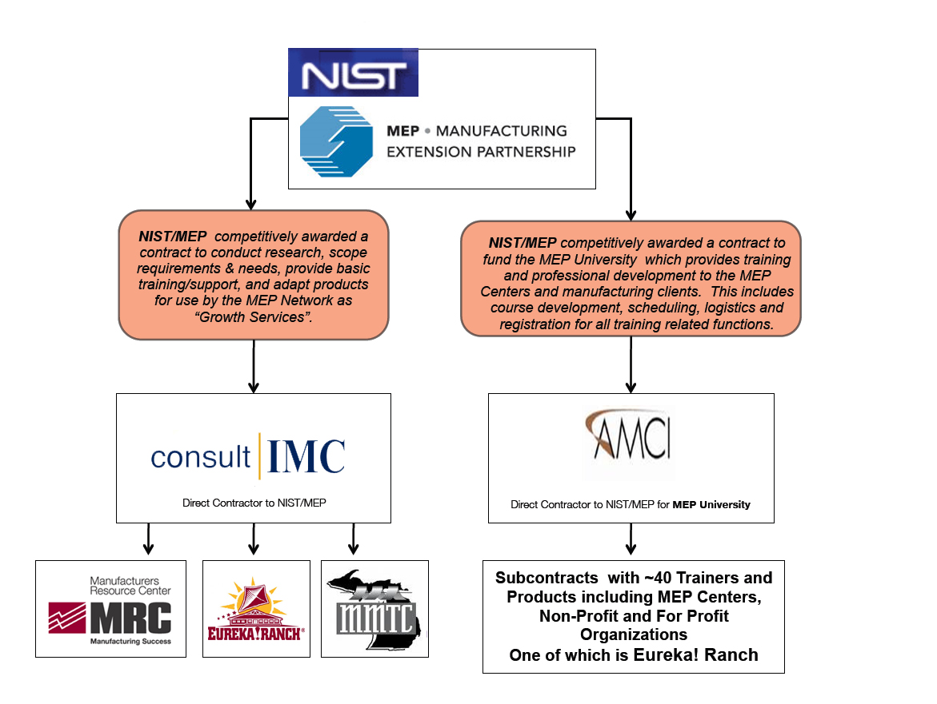

A second prime contract is with AMCI to develop MEP Center staff. Under this contract, AMCI provides subcontract support through several not-for-profit and for-profit organizations, including Eureka! Ranch.

Some of the products developed with Eureka! Ranch include:
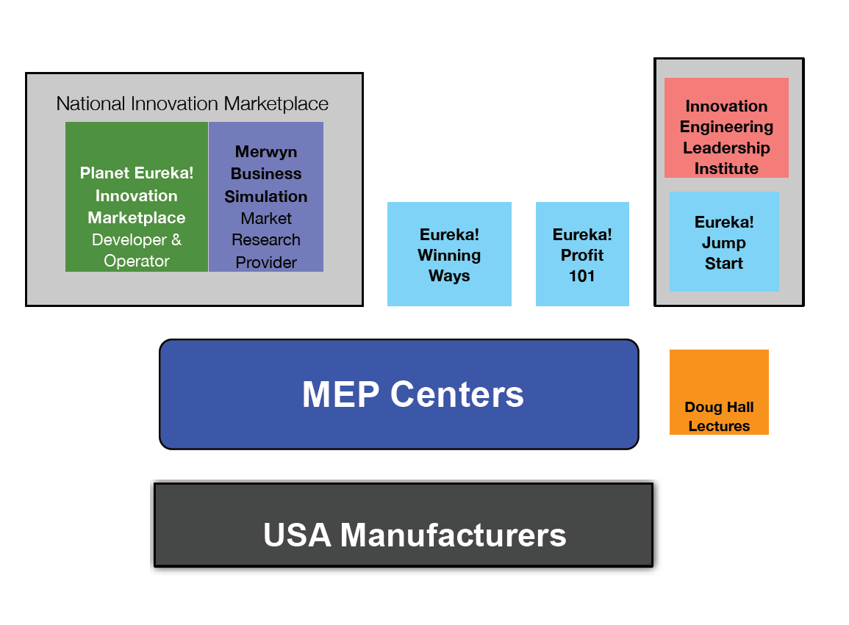
- Eureka! Winning Ways (E!WW),
- Eureka! Profit 101,
- The Eureka! Innovation Engineering Leadership Institute,
- Eureka! Jump Start, and
- Eureka Planet! - National Innovation Marketplace.

Speaker: Doug Hall, President, Eureka! Ranch
- Eureka! Ranch
Eureka! Ranch's goal is to help companies improve their innovation success rates and speed their ideas and products to the marketplace. Eureka! Ranch was created to help companies create, communicate, and commercialize their innovative ideas.

- Definition of Innovation
Innovation is the process of creating products that are both unique and meaningful. While some products may be unique, innovative products must be unique and have value to the marketplace.

- Problems Related to Innovation
There are several problems associated with moving a product from the inventor to the market. These problems include:
- Technical people speak in terms of science and patents,
- Business people speak in terms of products and profits, and
- It is difficult to connect the inventor with the producer.
As a result, very few innovations make it to the marketplace.

- Solution
To solve these issues, U.S. manufacturers need an open innovation-promoting process. An open innovative process includes:
  - Sharing ideas between buyers, sellers, and partners,
- Sharing trademark and patent information,
- Defining business models,
- Working with competitors, and
- Working with customers.

  - Products to Improve Innovation
Eureka! Ranch is working with MEP to develop products to assist U.S. manufacturers. These products include:

- Eureka! Winning Ways (E!WW): teaches & guides teams through a reliable proven innovation system to find, filter and fast track profitable ideas to market. The team learns profitable growth principles that can be applied over and over again to keep their company profitable.

- Eureka! Profit 101- Growth Training: provides a hands on experience with a collection of data-proven tools and tactics for reducing risk and increasing success with new products, services, customers and markets. The half-day simulation program reviews the world's best practice in the areas of innovation, product development, marketing, sales, new customer and market development and accelerating ideas to market.

- Eureka! Jump Start: is designed for businesses in need of immediate help. The program involves a preliminary business assessment; a one-day, intense idea generation session; and 30 days of consulting to turn ideas into reality.

- The Eureka! Innovation Engineering Leadership Institute: teaches government and business leaders a systemic program to lead profitable growth through innovation. In this intensive 3-day program, companies learn how to Create, Communicate and Commercialize meaningfully unique ideas and products.

- Planet Eureka! - National Innovative Marketplace: an online tool providing manufacturers with access to new technologies that can enhance their competitive position in the global marketplace.

  - Planet Eureka! - National Innovation Marketplace (NIM)
Planet Eureka! is a web-based innovation marketplace tool where business opportunities can be found, understood, and valued. Innovations are presented as easy-to-understand products with market-research-driven professional-sales forecasts. Request to purchase, invest, distribute, or manufacture innovations are defined in simple language with direct e-mail links to the person with the need. The NIM is being developed in partnership with a number of organizations, including NIST MEP / DOC.

Initial results of Planet Eureka! are encouraging. One of five innovators gets a win, where a win is defined as a face-to-face meeting between the innovator and the producer.

- Plan/Do/Study/Act (PDSA)
MEP's goal should be to accelerate proactive leaders and to turn reactive leaders into proactive leaders. MEP should take the following steps.
- PDSA # 1 - Increase the use of MEP Centers by better servicing proactive manufacturers. The focus should be on manufacturers that are willing and able to grow.
- PDSA # 2 - Increase the reach of the National MEP System. Currently, the National MEP System is working with 2% of the nation’s small and medium-sized businesses.
- PDSA # 3 - Increase the inventory of university-developed innovations.
- PDSA # 4 - Streamline Planet Eureka! - National Innovation Marketplace’s web site.
- PDSA # 5 - Create a "one piece" innovation business plan.
- PDSA # 6 - Experiment with increasing technology acceleration by a factor of 10.
- PDSA # 7 - Promote innovation leadership.

Questions and Answers
Q: Please discuss the public/private partnership in innovation.
A: These partnerships will happen. The manufacturing community needs innovation supply chains as well as product supply chains. The Federal government has to be a part of the model to change public/private partnerships. The Federal government needs to help develop the infrastructure. Moving ideas from the inventor to the business model is key.

Q: Any other comments?
A: Bob Zider from the Vermont MEP shared his thoughts: “I was a doubter of E!WW. We kicked the tires and after trying E!WW, we found good success with the process. It provided good momentum. So far we have a good start with Eureka! Jump Start and are really beginning to see results. Basically, we needed to see the tool for how it works. Now, I am an advocate. I am a believer.”

Research Study: Expanding the Reach the Hollings Manufacturing Extension Partnership

Moderator: Aimee Dobrzeniecki, Deputy Director, NIST MEP

Mike Stone, President of Stone and Associates, and Ken Poole, Chief Executive Officer of the Center for Regional Economic Competitiveness, have been working together to develop the MEP Business Model Report. The purpose of the Report is to define MEP’s future direction.

Speaker: Mike Stone, President, Stone and Associates
The following is a summary of the draft MEP Business Model Report:

- MEP Business Model Study - Research and Analysis Tasks
To produce the Report, the following tasks were taken:
- Conducted internal focus groups and one-on-one interviews with 50 directors/managers of MEP Centers and NIST MEP,
- Conducted over 50 external interviews,
- Summarized recent market data on manufacturing needs,
- Analyzed MEP client-impact data,
- Conducted literature searches related to economic development in manufacturing,
- Analyzed manufacturing sector data, and
- Conducted research on foreign manufacturing programs.

  - Context - Business Model Report
In an overall assessment, the Report examines how MEP's model can change. These include:
- Expand reach,
- Maximize impact,
- Broaden range of services,
- Better leverage partnerships,
- Determine right size of program, and
- Develop an argument for how and why the National MEP System should be expanded.

  - Traditional MEP Model
In the traditional model, MEP provides:
- Lean,
- Process improvement,
- Quality, and
- Cost reduction.

These services are provided by:
- MEP Centers,
- Small consulting firms,
- Community colleges, and
- Associations.

- Next-Generation MEP Model
MEP should recognize the current challenges faced by small and medium-sized manufacturers. These challenges include:
- Losing market share,
- Having unrealized growth potential, and
- Facing leadership challenges.

MEP should assist manufacturers with:
- Growth and innovation,
- Leadership development,
- Exporting, and
- Sustainability.

  - Why invest in MEP?
- MEP is in a unique position to assist manufacturers,
- MEP is focused on the needs of manufactures,
- MEP has manufacturing experience,
- MEP is an experienced change agent, and
- MEP has a nation-wide network.

  - Assessing the Current Business and Service Model,
- Need to reach a larger portion of the nation’s manufacturers,
- Need to expand the range of services,
- Need to examine the cost-share emphasis,
- Need to examine partnership barriers,
- Need to examine Center-performance criteria, and
- Need to evaluate the organization of the National MEP System.

  - Changing the MEP Model - Four Areas
To reach more clients and to increase manufacturing output, MEP needs to expand its program, to leverage Federal investment, to catalyze Center service expansion and innovation, and to coordinate national activities and investment.
- Expand the Program
  - Expand the program to substantively assist 30,000 firms,
  - Increase the program’s scale from $274 M to $875 M, and
  - Increase Federal program investment from $110 M to $406 M.
    - Leverage Federal Investment
      - Reduce Federal/Center cost-share from 1:2 to 1:1,
      - Reward Centers for high performance,
      - Require re-application of Center cooperative agreements (every 5 years),
      - Require State cost-share (50% of the Federal level),
      - Create a fund to make services more affordable for companies with less than 20 employees, and
      - Re-examine and revise MEP’s measurement system to capture growth in terms of value added and productivity as well as innovation.
  - Catalyze Center Service Expansion and Innovation
    - Designate new Center funding for growth, innovation, and sustainability,
    - Encourage use of outside delivery partners,
    - Encourage innovation in service models (e.g., hybrid, web tools),
    - Offer partnership incentives,
    - Create national delivery/rapid-response teams,
    - Create national product-and-service teams (e.g., NIST MEP, Centers, experts), and
    - Systematically motivate change at Centers (new dollars, re-application, training).
  - Coordinate National Activities and Investment
MEP should expand the national investment and coordination of key areas. These key areas include:
    - Product and service development,
    - Market research,
    - Research on program performance and best practices,
    - National training, certification, skills development, peer-to-peer collaboration, and
    - National partnership development.

Discussion
- An owner organizes a company based on its goals. Goals are different whether it is a small or medium-sized business. MEP needs to be careful with this.
- A challenge for an MEP Center is to balance the Federal investment with the State investment.
- Why not focus on "start-up" companies?
- After 20 years, why are MEP benefits not more pronounced?
- Is MEP recreating programs that are already in place?
- Organizations do not know that MEP is available to them.
- What is market failure? An economist would ask, “What is the problem?” If we want to supplement the consumer, we supplement the manufacturers. MEP may be incorrectly focusing on manufacturing issues and should be focusing on structural issues.
- The Federal government has developed good regulations in the U.S. However, some regulations are disadvantageous to manufacturers and consumers.
- If our goal is safer, better products, then the goals for MEP will change.
- The Report was clear and enlightening. The Report serves MEP, not manufacturers. The Report addresses standard work versus continuous improvement. There is a question of “fixing” manufacturing. Is manufacturing broken or is the U.S. compensating foreign countries in a perverse way? We need to fix trade issues at the policy level.

Wrap-up and Adjournment
Board members, MEP participants, and presenters were thanked. The next Advisory Board meeting will be held on September 13, 2010.

