

August 27, 2018

Dear SRM Customer:

The Office of Reference Materials at NIST is rapidly approaching the time of the year where we are required to conduct an annual SRM inventory. Therefore, our shipping department will not be processing any orders from Thursday, September 20, 2018 through Friday, September 28, 2018.

During that time, we will be happy to accept your orders, but the following schedule will apply to our ability to ship orders:

- Monday, September 17, 2018 is the last day that we will ship dry-ice, hazardous, or international orders.
- Wednesday, September 19, 2018 is the last day that we will accept domestic non-hazardous orders for immediate shipment prior to inventory.
- Thursday, September 20, 2018 through Friday, September 28, 2018 - orders can be taken, but shipping will not occur.
- Monday, October 1, 2018 – all orders will begin to be shipped.

I hope this notice of our inventory dates will enable you to plan your ordering, and minimize the disruption in service to you, our valued customer.

I would like to take the opportunity now to thank you for your business during the past year, and let you know that we, in the Office of Reference Materials, appreciate our customers.

To place an order, please contact our sales office by phone (301) 975-2200 or (301) 975-6776, fax (301) 948-3730, or e-mail: srminfo@nist.gov. Our sales representatives will be happy to assist you.

Sincerely,
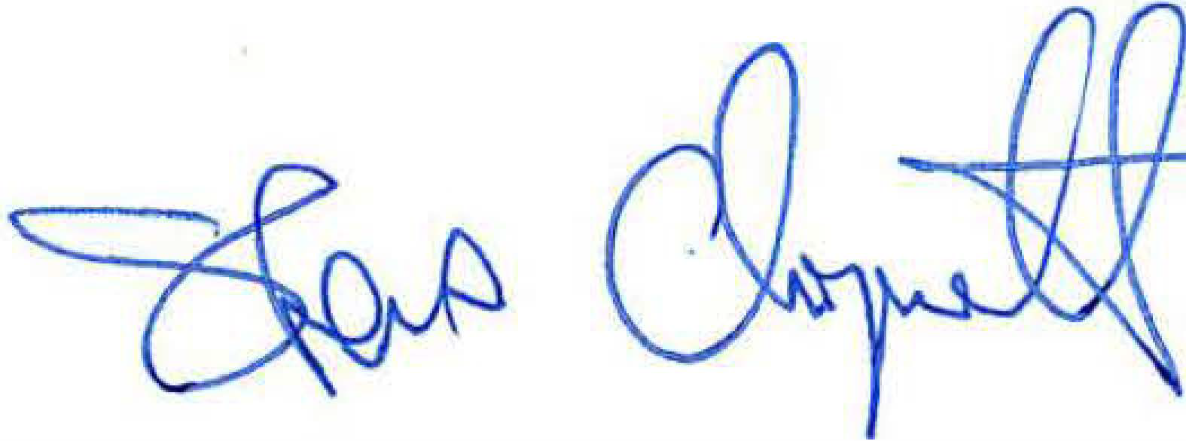
Steven Choquette
Director
Office of Reference Materials
National Institute of Standards and Technology
100 Bureau Drive, Stop 2300

Gaithersburg, MD 20899-2300

