Grasp Efficiency

Metric
Grasp efficiency is a measure of the hand’s ability to modulate grasp force in the presence of increasing object disturbance forces, while minimizing the overall required effort. This measure will yield information regarding a particular hand’s control and sensing capabilities with regard to slip minimization and operational efficiency in grasping objects with uncertain disturbance loads.

Dependencies
Grasp efficiency is a function of the hand’s actuator and sensing capabilities, motion controllers, mechanical design and grasp configuration.

Test Method
Artifact: NIST Split Cylinder Artifact or application relevant artifact with internal force sensing.

Description:
Of the previously listed dependencies, only the grasp configuration, object size and object surface properties are assumed controllable. For this particular test, two common grasp types can be chosen for investigation – pinch and wrap. The pinch grasp allows for measuring performance associated with precision grasping while the wrap grasp allows for measuring performance associated with power grasping. The general setup for this test is shown in Figure 1. The split cylinder artifact is used to measure the internal grasp force F_{Grasp} while an increasing force F_{Pull} is applied to the cylinder artifact in the axial direction. This test assumes that the robot hand is capable to sense slip or friction forces, and increases F_{Grasp} as F_{Pull} increases.

Perform an initial grasp using the minimum force required to constrain the artifact F_{Grasp,Min}. Steadily increase F_{Pull} ultimately approaching F_{Pull,Max} as defined in the slip resistance test. Record F_{Grasp} and F_{Pull} throughout the test.

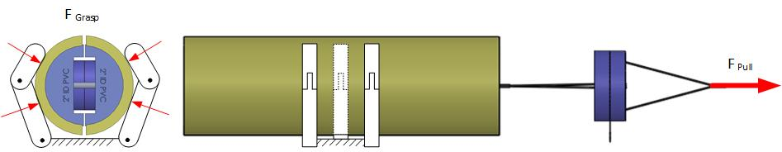

Figure 2: Grasp Efficiency Variables: F_{Grasp} and F_{Pull}
Performance Measures:
For each set of instantaneous force readings, add the forces across the force sensors internal to the grasp artifact since they are in-line to yield a total grasp force$F_{Grasp}$, while synchronously recording F_{Pull}.
$$F_{Grasp }= \sum_{i=1}^{n}{F_{i}}$$

For each test cycle (see Figure 3) compute Grasp Efficiency (E_{Grasp}) at each data point collected from the initial grasp force F_{Grasp,Min} until reaching F_{pull,max}. Compute the mean and 95% confidence intervals to establish a most likely performance point and the uncertainty.

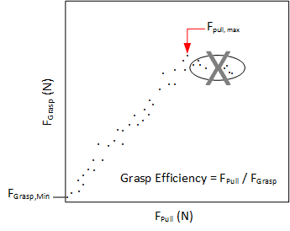
Figure 3: Depiction of a plot of F_{Pull} vs. F_{Grasp} during a Grasp Efficiency test cycle.

Example Implementation (To Do)
Test Setup:

Results:

Data:
Data File Archive:
Data Files:
File Format: | ASCII, comma delimited
Data Values: | F₁ and F₂ (one set per line)
Units: | Newtons, Millimeter
Data Sample Rate: | 3 kHz

