Finger Strength

Metric
Finger strength is a kinetic measure of the maximum force a robotic finger can impose on its environment. This measure relates to the overall strength of the hand during grasping or manipulation capabilities. The reasons for measuring strength on a single finger basis are two-fold: 1.) grasping and manipulation can occur with any number of fingers which means that the most independent measure of strength would be finger strength, and 2.) there can be inherent variability in finger strength across different fingers even in cases where they are mechanically equivalent.

Dependencies
Strength is a function of the hand’s actuator capabilities, motion controllers, mechanical design, and finger-object configuration.

Test Method
Artifact:
Three axis load cell for force measurements in three dimensions ($F_{x}, F_{y}, F_{z}$) or single axis load cell for force measurements in one dimension. Attaching a rigid column to these sensors for finger interaction can help avoid unwanted hand-sensor collisions.

Description:
Of the previously listed dependencies, only the finger-object configuration is a test variable. Using desired finger-object configuration, position the finger under test just above the force sensor and verify a zero force reading. Under position control, the finger is then commanded to close completely which should induce control saturation. Record force sensor data throughout the test. One significant finger-object configuration for benchmarking occurs when the induced moment arm from making contact is at its maximum which means the maximum attainable contact force will be at a minimum for the finger under test. For most hand designs, this occurs when a finger is fully extended and all finger links are extended in the same direction as shown in Figure 1. This configuration is appealing since it measures the global minimum finger strength (i.e. any other configuration would yield higher finger strength.) In the case of using a single-axis load cell, slight adjustments should be made to this finger-object configuration such that the contact force of the finger is normal to force sensor contact surface. This prevents dispersing contact force in directions that are not measurable. Finally, additional finger-object configurations can be evaluated.

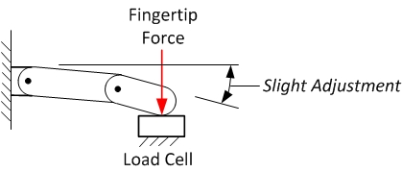

Figure 1: Finger-Object Configuration

Performance Measures:
The fingertip contact force magnitude, $F_{finger}$, should be computed as:

$$F_{finger}= \sqrt{{F_{x}}^{2}+{F_{y}}^{2}+{F_{z}}^{2}}$$

for each set of force readings given by the load cell. Next, the contact force magnitude from the quasi-static force region (see Figure 2) should be extracted for each load cycle, and then averaged to yield the maximum finger strength, $F_{finger,max}$ .

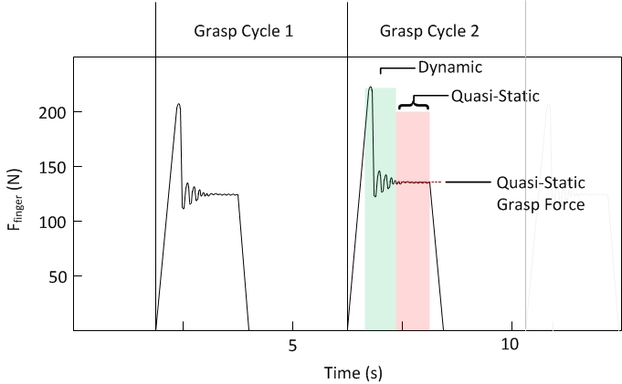
Figure 2: Depiction of dynamic and quasi-static force regions during finger load cycles.

Example Implementation
Test Setup:
The fundamental finger-object configuration is specified by placing the robotic finger in a fully-extended position with the finger orthogonal to the palm surface (see Figure 4.) Once in this configuration, the finger is positioned just above the external force sensor with verification of zero force. Under position control, the finger is then commanded to close completely to induce control saturation at a fully extended configuration. After contact has been established for a few seconds, the finger is retracted again and the process repeated 32 times per finger. Force data is recorded from the external force sensor throughout the test.

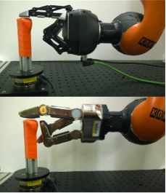
Figure 3: Fingertip force test setup where a 3-fingered robotic hand and load cell are positioned such that contact takes place at the fingertip with the finger fully extended and perpendicular to the palm.

Results:
The resultant contact force is extracted from the quasi static contact force profile and the peak dynamic contact force is ignored (see Figure 4). This measure eliminates the effects introduced through contact momentum, yielding the steady state strength of the finger. Repeating this test, and conducting it across all fingers and both hands yields finger strength results as shown in Figure 5. The higher the maximum fingertip contact force, the higher the finger strength.

Data:
Data File Archive: | Finger Strength.zip
Data Files: | Hand 1/Finger_[Number]
 | Hand 2/Finger_[Number]
File Format: | ASCII, comma delimited
Data Values: | $F_{x}$, $F_{y}$, and $F_{z}$ (one set per line)
Units: | Newtons
Data Sample Rate: | 3 kHz

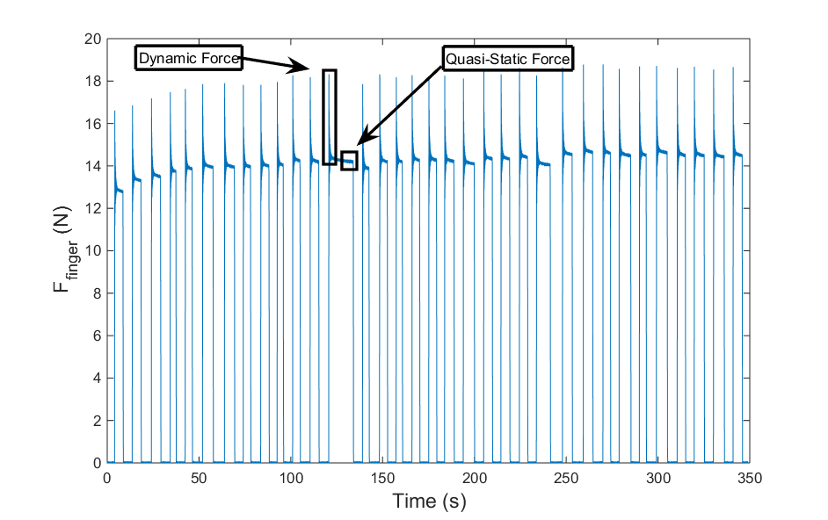
Figure 4: Fingertip contact forces emitted by Hand 1, Finger 1 during repeated testing.

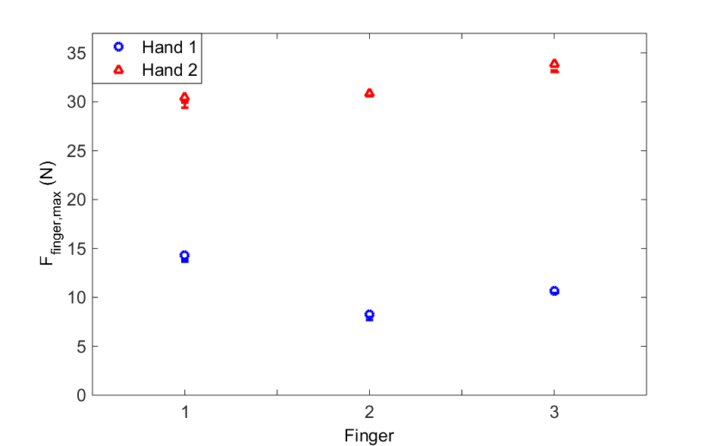
Figure 5: The maximum fingertip contact force magnitude exerted by each finger for each robotic hand measured using a load cell.

