To clear browser cache:
Within Internet Explorer 11:
Click on Tools, Delete Browsing History, and this window will appear. The checked boxes will preserve favorites, and delete temporary files and cookies. Click on Delete to do this, and proceed to the BOSS site.

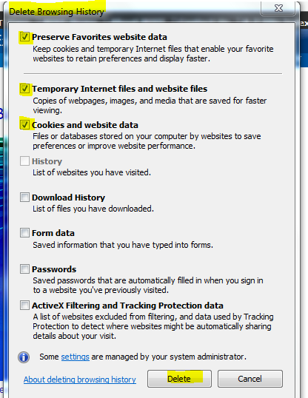

Firefox…click on the “open menu” icon and select ”Options”...the cache options are highlighted below. When you clear now, the values should change to “0”…click OK, and continue to the BOSS site.

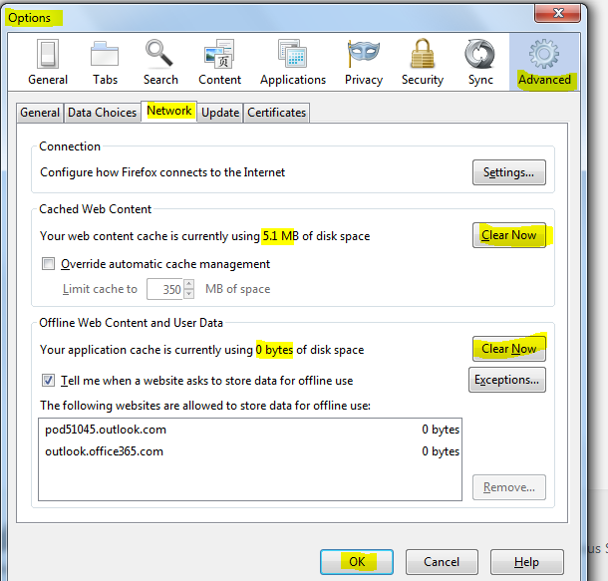

Chrome: Within Chrome, click on the Customize and control icon, go to More Tools, and select Clear browsing data to display your options. Click to clear browsing data and proceed to the BOSS site.

