When you create your VM (tested with VirtualBox) create a minimum 10 GB virtual hard drive, else the tool will not function.

**Known Windows hardware issue running 64-bit VMs**

In a nutshell – Intel Virtualization Technology needs to be enabled in the BIOS settings.  There are a few other solutions – I tried them all – this was the only one that worked.

**Solution 1: Enabling Intel Virtualization Technology**

Virtual Technology is the architecture in computers which allows users to run more than one operating systems using virtualization where the guest operating system is launched in a sandbox. In a sandbox, the application has limited resources and doesn’t have access to the main computer architecture which lies beyond the sandbox. If this basic setting is disabled, you might experience issues with VirtualBox. Here we will enable it in the BIOS.

1.     **Restart**your computer and press **Del or F2**(depends on the motherboard to motherboard. You can click the correct key which appears underneath the Windows logo when you restart your computer) on the **BIOS**.

2.     Once the BIOS is enabled, navigate to the option of **Intel Virtualization Technology**which is usually present in **Advanced**. The menu in which it is present might differ motherboard to motherboard so explore yourself.

In the case of ASUS motherboards, follow the following path:

**Advanced > CPU Configuration > Intel Virtualization Technology**

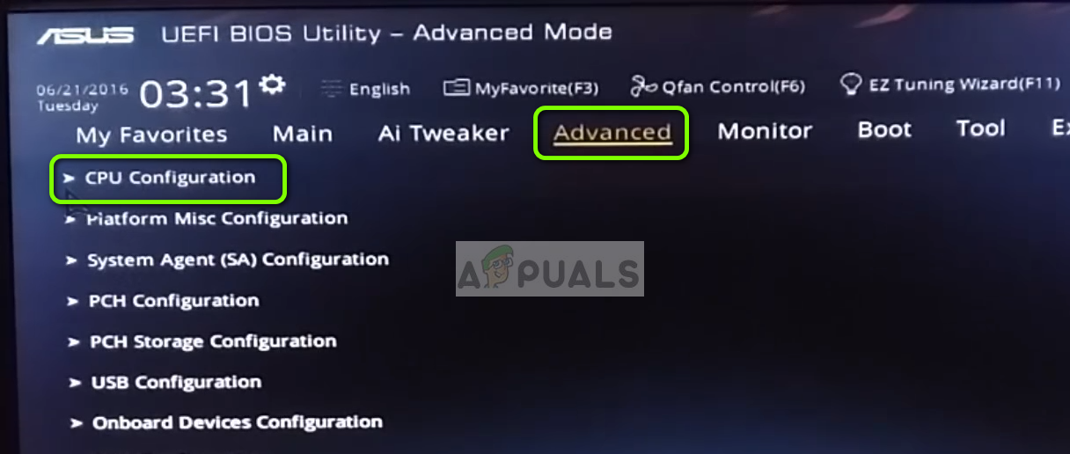Navigating to Intel Virtualization Technology

3.               Now **change**the option to **Enabled**. Save changes and exit the BIOS.

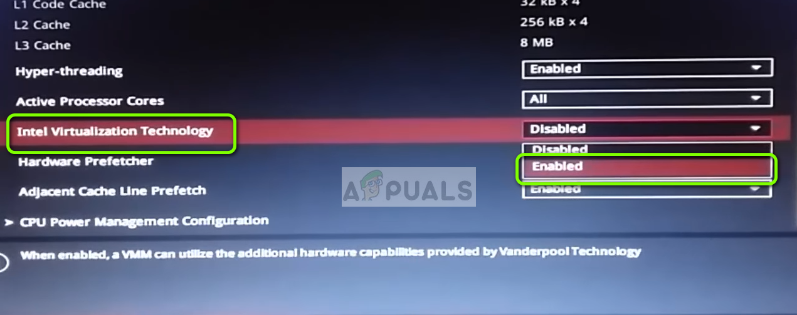Enabling Intel Virtualization Technology

The computer will now restart. Upon the restart, you might need to reinstall the VirtualBox application and after loading all the guest operating systems, check if the issue is resolved.