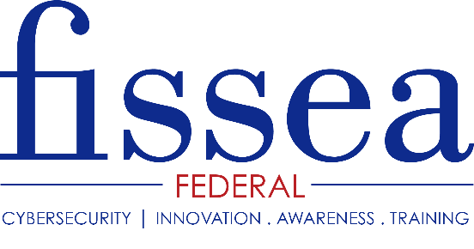
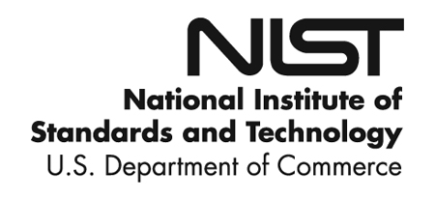

Continuing Education Units
VERIFICATION OF ATTENDANCE FORM

Your Certification Number:________________

attended the following professional educational activity.
(NAME)

Title: Federal Information Systems Security Educators’ Association (FISSEA) 32nd Annual Conference

Date(s): June 27-28, 2019 CPU Hours Earned: 16 hrs

Sponsor(s): National Institute of Standards and Technology (NIST)

Explanation of Event: Approximately 300 information systems security professionals and trainers attend from federal agencies, academia, foreign agencies, and industry representatives from organizations that support federal information systems and security programs. Presenters represent OMB, DoED, DOT, DoD, HHS, CMS, NIST, NIH, DHS, State, NSA, IRS, FHFA, private industry and academia. Attendees have an opportunity to visit industry vendors and federal agencies at the Vendor and Federal Agency Exhibition which provides an opportunity for organizations to share and tell about their specific awareness and training programs.

Traditional FISSEA conference events include announcing the winners of FISSEA security contests and announcing the FISSEA Educator of the Year. The Educator of the Year Award was established to recognize and honor a contemporary who is making special efforts to create, build, manage, or inspire an information systems security awareness, training, or education program. The FISSEA Security Awareness, Training & Education Contest includes six categories from one of FISSEA’s three key areas of Awareness, Training, and Education.

Location: National Institute of Standards and Technology (NIST) 100 Bureau Drive, Gaithersburg, MD 20899

Name of Meeting Chair: Rodney Petersen, NIST, ITL Applied Cybersecurity Division

Contact Information:
www.nist.gov/fissea
fissea@nist.gov

The Continuing Education Units form is provided as a courtesy. It is the responsibility of the attendee to complete and submit with their certifying authority.

