**NIST Task Board #3**

This document conveys fabrication instructions of a NIST task board designed for [benchmarking and performance measurement of robotic systems](https://www.nist.gov/programs-projects/performance-metrics-and-benchmarks-advance-state-robotic-assembly) (testing procedures described in separate document TBD) in various assembly operations dealing with loose parts. Three different cables represent common cables frequently dealt with during cable harnessing operations. A thin flexible 3.5mm cable, a thicker stiff 6mm cable, and a flat wide cable. Tasks include cable tracking, accurate cable placement, and cable threading as well as a final insertion task to show completion. This task board was designed in part to support the WRS challenge.

 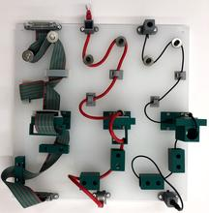

1. Disassembled (b) Assembled

**Purchasing:**

1. Majority of parts specified based on availability through MISUMI, an international distributor of components. Other vendors may supply the same parts.
2. The design files of the laser-cut board can be downloaded in various formats from LINK. The design file can be uploaded to a laser cutting service, e.g., upload task board cable harness V4.svg to Ponoko. To minimize variation in board properties, please select for cutting the design in an acrylic, opal-colored board of 0.354” thickness, 15.1” length, and 15.1” width.

**Parts List**

**(Example)**

|  |  |  |  |  |
| --- | --- | --- | --- | --- |
| ID | Item | Part Number | Unit Cost ($) (subject to change) | Unit |
| 1 | Laser Cut Board (Ponoko) | - | ~75.00 | 1 |
| 2 | Audio mini plug (3.5mm)** | EMSOD-1.5 | 15.45 | 1 |
| 3 | Cat 6 LAN cable** | 4112 | 1.49 | 1 |
| 4 | MIL connector flat cable** | GRPMF-PS-FA-26-1 | 9.57 | 2 |
| 5 | Small cable clip** | DKN-07GSP | 13.44 | 1 |
| 6 | Large cable clip** | DKN-10GSP | 13.66 | 1 |
| 7 | Flat cable clip** | FKNS-40 | 22.52 | 1 |
| 8 | Cat 6 relay connector** | NW080-RJ45-C5-WHR | 7.71 | 1 |
| 9 | M4 low head bolt 20mm long** | CSHELH-SUS-M4-20 | 1.45 | 36 |
| 10 | M4 low head bolt 10mm long** | CSHELH-SUS-M4-10 | 0.87 | 6 |
| 11 | M4 nylon nut** | NN1-M4-SUS | 0.69 | 36 |
| 12 | Special washer M6x24** | WSX-SUS-M6X24-2 | 0.42 | 6 |
| 13 | M6 bolt 28mm long** | HXN-SUS-M6-28 | 0.44 | 4 |
| 14 | M6 bolt 50mm long** | HXN-SUS-M6-50 | 0.48 | 2 |
| 15 | M6 Hex nuts** | SLBNR6 | 0.82 | 10 |
| 16 | M6 or ¼”-20 Threaded Posts/Standoffs and Nuts** | n/a | n/a | 4 |
| 17 | M4 countersunk screw 10mm long** | CSHCS-SUS-M4-10 | 0.32 | 9 |
| 18 | Thin cable mount | 3D printed | n/a | 2 |
| 19 | Thick cable mount | 3D printed | n/a | 2 |
| 20 | Flat cable mount | 3D printed | n/a | 2 |
| 21 | Thin cable tube | 3D printed | n/a | 3 |
| 22 | Thick cable tube | 3D printed | n/a | 3 |
| 23 | Flat cable tube | 3D printed | n/a | 3 |
| 24 | Mounting brackets | 3D printed | n/a | 3 |

** Choice of supplier as long as specifications are met.

**Tools List**



1. 2mm hex key
2. 7mm wrench
3. 10mm socket (it can be useful to have 2 of these)
4. Scissors or snips
5. 4mm tap

Figure 1. Tools that are used for assembly

Figure 1

**Disclaimer**

Certain commercial equipment, instruments, or materials are identified in this paper to foster understanding. Such identification does not imply recommendation or endorsement by the National Institute of Standards and Technology, nor does it imply that the materials or equipment identified are necessarily the best available for the purpose.

**Assembly Instructions**

Step 1 task: Set up

1. Download and print all the 3D files for the Brackets, tubes, and mounts.
2. Unpack and separate all parts. Open all plastic clips as wide as they can go. They will spring back to approximately 90 degrees.
3. Strip the 3.5mm audio cable down to one cord and remove the extra cord. Cut off the female end of the audio cable and place aside. Cut the length of the audio cable to match the length of the ethernet cable.
4. Cut of the female end of one of the flat cables and remove the rest of the cable, place the end aside.
5. Using a 4mm tap, carefully thread the four 3.5mm holes on each of the three previously printed “T- brackets”.

Step 2 task: Mounting the wires and wire mounts

1. Place one end of each of the wires in their respective mounts and allow the wire to exit the bottom of the mount where there is a cut out. Shown in figure 2.
2. Affix one of each of the mounts to the board on the starting side, pressing the wire firmly to the board. Use a bolt and nylon nut to tighten down each of the mounts.
3. Affix the second of each mount to the board on the opposite side. Each mount should have the ending receiver for each of the respective cables. Shown in figure 3.
4. Affix two of each clip to the board in the etched areas according to their size. Affix the third clip to each of the three “T-brackets. To ensure a strong attachment each of the clips should be drilled and tapped to receive the 4mm counter-sink screws. Shown in figure 4

Figure 4

Step 2 task: Mounting the routing obstacles

1. Affix two of each cable tube in their respective positions on the board using the 4mm bolts and the 4mm nylon lock nuts as shown in figure 5.
2. Affix the third of each cable tube to each of the “T- brackets” using the shorter 4mm bolts by threading them through the holes in the “T-bracket”. Shown in figure 6.
3. Affix the “T-brackets in their respective positions on the task board using 4mm bolts and 4mm nylon lock nuts.
4. Place a washer and a 6mm nut on the ends of each of the 6mm bolts and thread the nut all the way to the top, pinching the washer between the nut and the bolt head.

Figure 6

Figure 5

1. Affix the two smallest bolts to the board and lock them into place using a 6mm nut from the back side of the board. Shown in figure 7.
2. thread a second nut to the two middle sized bolts and lock them into place using another 6mm nut from the backside of the board.
3. thread a second nut to the two longest bolts and lock them into place using another 6mm nut from the backside of the board. Spin the previously threaded second nut down the bolt until it locks the bolt in place.

Figure 7

Step 4 task: Completing and resetting the task

1. Run each of the loose wires around each of the bolts (first task), Place the wires in each clip (second task), route the wires through each of their respective tubes (third task), and place the end of each wire in their respective mounts (completion task).
2. Un-thread and un-weave each wire from the task board so that each one is dangling free from the start position. The task board is now ready to be used. Figure 8. shows a completely assembled board.

Standoffs:

1. Connect the threaded standoffs to the four corners of the board as shown in Figure 1 such that the distance from the underside of the board to the supporting surface is 20 mm.
2. There may be variation on how the standoff can connect to the board depending on the chosen standoff, itself. One method is shown below with a threaded standoff and two nuts that pin the plate.

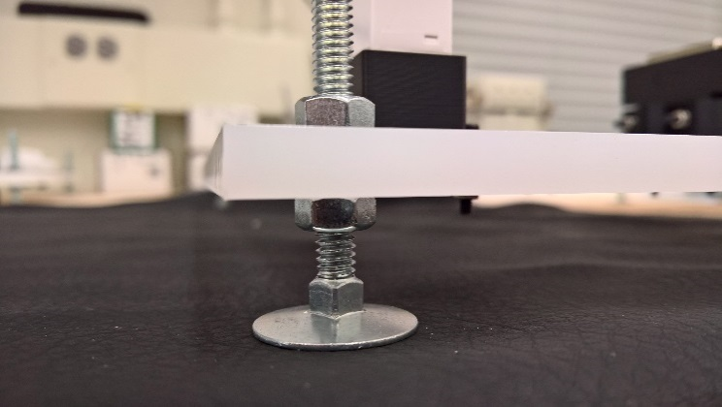

Notes:

1. Board has an etched square for the placement of tags such as an AR tag to help localize the board for testing as seen in Figure 2. This is useful for researchers interested in focusing on the grasping, manipulation, and control aspects for the task board.