Robotic Disassembly/Assembly NIST Task board 1 BENCHMARK

Reference No / Version  URL | RAL-SI-2020-B-1 [Benchmarking Protocols for Evaluating Small Parts Robotic Assembly Systems]-V1.0
 | https://www.nist.gov/el/intelligent-systems-division-73500/robotic-grasping-and-manipulation-assembly/assembly
Authors | Kenneth Kimble¹, Karl Van Wyk², Joe Falco¹, Elena Messina¹, Yu Sun³, Mizuho Shibata⁴, Wataru Uemura⁵, Yasuyoshi Yokokohji⁶
Institution | ¹National Institute of Standards and Technology (NIST), ²NVIDIA, ³University of South Florida, ⁴Kindai University, ⁵Ryukoku University, ⁶Kobe University
Contact information | Joseph.falco@nist.gov, Kenneth.kimble@nist.gov
Adopted Protocol | RAL-SI-2020-P [Benchmarking Protocols for Evaluating Small Parts Robotic Assembly Systems]-V1.0  Kenneth Kimble¹, Karl Van Wyk², Joe Falco¹, Elena Messina¹, Yu Sun³, Mizuho Shibata⁴, Wataru Uemura⁵, Yasuyoshi Yokokohji⁶  ¹National Institute of Standards and Technology (NIST), ²NVIDIA, ³University of South Florida, ⁴Kindai University, ⁵Ryukoku University, ⁶Kobe University
Scoring | Disassembly Score Sheet:  Start Time: End Time:  Item Removed (2 points) Placed in Kit Tray (1 point) Sub-Total  Small Gear 2 1  Medium Gear 2 1  Large Gear 2 1  Rod 4 mm 2 1  Rod 8 mm 2 1  Rod 12 mm 2 1  Rod 16 mm 2 1  Bar 4 mm x 4 mm x 300 mm 2 1  Bar 8 mm x 7 mm x 300 mm 2 1  Bar 12 mm x 8 mm x 300 mm 2 1  Bar 16 mm x 10 mm x 300 mm 2 1  BNC Connector 2 1  Waterproof Connector 2 1  DSUB Connector 2 1  USB Connector 2 1  RJ45 Connector 2 1  M4 Nut 2 1  M8 Nut 2 1  M12 Nut 2 1  M16 Nut 2 1  Note: Max Score = 60 Total Score  Example of start and end of a disassembly trial with 100% completion:  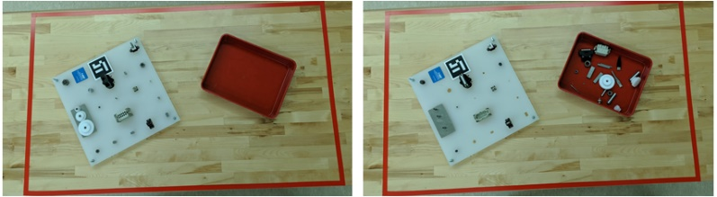  Start End  Assembly Score Sheet:  Start Time: End Time:  Item Inserted/Threaded Seated Place* Sub-Total  Small Gear 3 2 1  Medium Gear 3 2 1  Large Gear 3 2 1  Rod 4 mm 3 2 1  Rod 8 mm 3 2 1  Rod 12 mm 3 2 1  Rod 16 mm 3 2 1  Bar 4 mm x 4 mm x 300 mm 3 2 1  Bar 8 mm x 7 mm x 300 mm 3 2 1  Bar 12 mm x 8 mm x 300 mm 3 2 1  Bar 16 mm x 10 mm x 300 mm 3 2 1  BNC Connector 3 2 1  Waterproof Connector 3 2 1  DSUB Connector 3 2 1  USB Connector 3 2 1  RJ45 Connector 3 2 1  M4 Nut 3 2 1  M8 Nut 3 2 1  M12 Nut 3 2 1  M16 Nut 3 2 1  Note: Max Score = 120 Total Score  *The part is manipulated to the task board and at least sits on the task board  Example of start and end of an assembly trial with 100% completion:  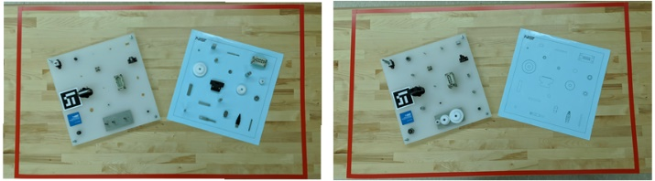  Start End
Details of Setup | Describe your system design including robots and end-effector technologies used, perception type and how it is used to localize board, kit and components, use of CAD. Also describe all tools used with end-effectors.
Results to Submit | Submit scoresheets and a summary of results over 32 trials to include analysis of speed, completion, and reliability. Make notes in the summary of the incomplete/failed tasks and the reasons for the failure. Speed is measured as the completion time of a task board as:  T_{taskboard} = T_{finish} − T_{start}.  Task board completion should be reported as the percentage of total points received for each task board for disassembly and assembly.  % Disassembled = Total Score/60 x 100  % Assembled = Total Score/120 x 100  For each set of 32 trials, compute the mean, standard deviation, and 95% confidence interval of the completion times, disassembly completion and assembly completion.  Reliability can also be captured as the probability of successfully completing a task or sub-task. The theoretical upper bound probability for successfully inserting a component (PS) is calculated given a confidence level (CL), the number of successes (m), and the number of independent trials (n). Given the binomial cumulative distribution function:  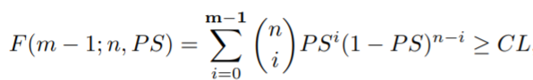  The PS is its minimum value to some precision while still satisfying the above inequality.

