NIST Task Board #2
This document conveys fabrication instructions of a NIST task board designed for benchmarking and performance measurement of robotic systems (testing procedures described in separate document TBD) in various assembly operations that include tasks previously performed on Task Board #1. The overlapping tasks include aligning and inserting cylindrical collars onto shafts, aligning and inserting pulleys and gears onto shafts, and threading screws. Further tasks include handling loose parts (such as a chain, timing-belt, and round belt), tracking the loose parts onto their respective pulleys, and manipulating tensioners to secure the belts (a task that presses the need for dual arm manipulation).

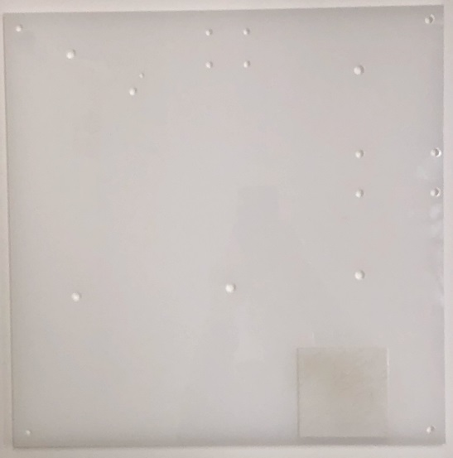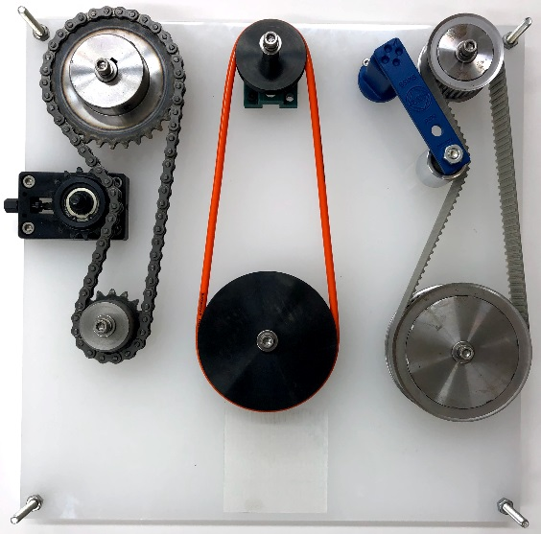

- Disassembled (b) Assembled

Figure 1. Identification of key components as labeled in the subsequent parts list and their locations on the task board.

Purchasing:
- Majority of parts specified based on availability through MISUMI, an international distributor of components. Other vendors may supply the same parts.
- The design files of the laser-cut board can be downloaded in various formats from LINK. The design file can be uploaded to a laser cutting service, e.g., upload Belt drive board v4.svg to Ponoko. To minimize variation in board properties, please select for cutting the design in an acrylic, opal-colored board of 0.354” thickness, 15.1” length, and 15.1” width.

Parts List
(Example)
ID | Item | Part Number | Unit Cost ($)  (Costs are subject to change) | Unit
1 | Laser Cut Board (Ponoko) | -
2 | Large Sprocket | SP35B32-N-15 | 18.05 | 1
3 | Small sprocket | SP35B16-N-10 | 12.97 | 1
4 | Chain | CHE35-64 | 13.66 | 1
5 | Chain tensioner | TSUB35-16-25 | 56.00 | 1
6 | Large shaft for L sprocket | SFAD15-45-F20-B16-P8-N6 | 20.60 | 1
7 | Large Collar for L sprocket | NCLC15-20-22 | 5.00 | 1
8 | Small shaft for Sm sprocket | SFAD10-41-F20-B16-P8-N6 | 12.99 | 1
9 | Small collar for Sm sprocket and both round pulleys | NCLC10-12-20 | 5.88 | 3
10 | Large timing pulley | TTPT60T5250-A-P12 | 78.07 | 1
11 | Small timing pulley | TTPT32T5250-A-H10 | 37.95 | 1
12 | Timing belt | TTBU675T5-250 | 23.30 | 1
13 | Timing belt tensioner*  RSE-11 Rosta Belt Tensioner | No longer available through Misumi | n/a | 1
14 | Large shaft for L timing pulley | SFAD12-43-F20-B16-P8-N6 | 13.18 | 1
15 | Small shaft for Sm timing pulley | SFAD10-43-F20-B16-P8-N6 | 12.99 | 1
16 | Large collar for L timing pulley | NCLC12-15-10 | 5.88 | 1
17 | Small collar for Sm timing pulley | NCLC10-12-10 | 5.88 | 1
18 | Large round pulley | MBRF100-3-H10 | 22.96 | 1
19 | Small round pulley | MBRF50-3-H10 | 17.67 | 1
20 | Round belt | MBT6640 | 13.29 | 1
21 | Shafts for round pulleys | SFAD10-31-F20-B16-P8-N6 | 12.99 | 2
22 | Idler for slide tensioner | EUBH30 | 13.61 | 1
23 | Slide Tensioner | 3-D printed | 0 | 1
24 | **Nylon nut for shafts 8mm | NN1-M8-SUS | 0.99 | 5
25 | **Square nut for slide tensioner | NSQA-SUS-M6 | 1.18 | 1
26 | ** Nylon nuts for timing/slide tensioner | NN1-M4-SUS | 0.69 | 5
27 | **Nut w/ washer for shafts | CSHHNDI3TM-ST-M6-10 | 0.59 | 5
28 | **Nylon nut for chain tensioner 6mm | NN1-M6-SUS | 0.59 | 4
29 | **Screws for chain tensioner 6mm x 22mm long | CSH-SUS-M6-22 | 0.35 | 4
30 | **Nylon nut for timing tensioner 8mm | NN1-M4-SUS | 0.69 | 1
31 | **Screw for timing/slide tensioner | SCB4-16 | 0.36 | 5
32 | **M6 or ¼”-20 Threaded Posts/Standoffs and Nuts | ** | n/a | 4
** Choice of supplier as long as specifications are met.
Part numbers that are provided are associated with us.misumi-ec.com

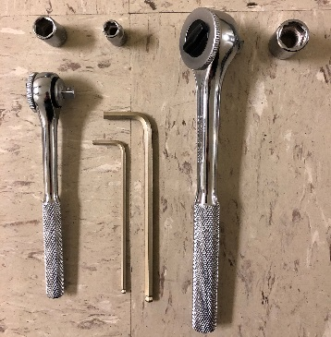
Tools List

- 5mm hex key
- 3mm hex key
- 13mm socket with appropriate wrench
- 10mm socket with appropriate wrench
- 7mm socket with appropriate wrench
- Hand rag (optional)
Figure 2
Figure 2. Tools that are used for assembly.

Disclaimer

Certain commercial equipment, instruments, or materials are identified in this paper to foster understanding. Such identification does not imply recommendation or endorsement by the National Institute of Standards and Technology, nor does it imply that the materials or equipment identified are necessarily the best available for the purpose.

Assembly Instructions

Step 1 task: Set up
- Remove all contents from its packaging and wipe down and oils/residue on any parts. Separate parts into groups of similar kind.
- Attach all M6 screws with attached washer into the ends of each,screw parts together loosely.
- Assemble the timing belt tensioner by tightening the roller bearing to the blue shaft’2 outer most hole labeled “normal”. The bearing should be on the same side as the square handle. (shown in Figure 4)
- Open the chain tensioner as wide as it will allow.
- Assemble the chain by placing the bridge across the two open ends of the chain, closing the loop. Add the small clip to hold the bridge on.
- Slide the square nut into the 3-D printed “slide tensioner” and screw the idler to the nut passing through the slot in the slide tensioner.
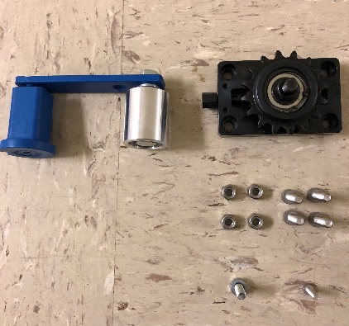
Figure 3
Figure 3. Assembled tensioners and parts needed for assembly.

Step 2 task: Sprocket and pulley preparation
- Add the large sprocket to the widest shaft (15mm). The sprockets should be on the opposite side as the screw and washer are on the shaft. Slide the widest collar on to the shaft following the large sprocket and place the entire kit upside-down on the table. (shown in Figure 5)
- Add the large timing pulley to the 2nd widest shaft (12mm). Slide the 2nd widest collar on to the shaft following the large timing pulley and place the entire kit upside-down on the table
- Add the small timing pulley to the longest remaining shaft (10mm). Slide the shortest collar remaining (10mm long) on to the shaft following the small timing pulley and place the entire kit upside-down on the table.
- Add the large round pulley to one of the 2 identical shafts. Slide one of the 3 identical collars on to the shaft following the large round pulley and place the entire kit upside-down on the table
- Add the small round pulley to the other one of the 2 identical shafts. Slide another one of the 3 identical collars on to the shaft following the small round pulley and place the entire kit upside-down on the table
- Add the small sprocket to the only remaining shaft. The sprockets should be on the opposite side as the screw and washer are on the shaft. Slide the last of the remaining identical collars on to the shaft following the small sprocket and place the entire kit upside-down on the table.

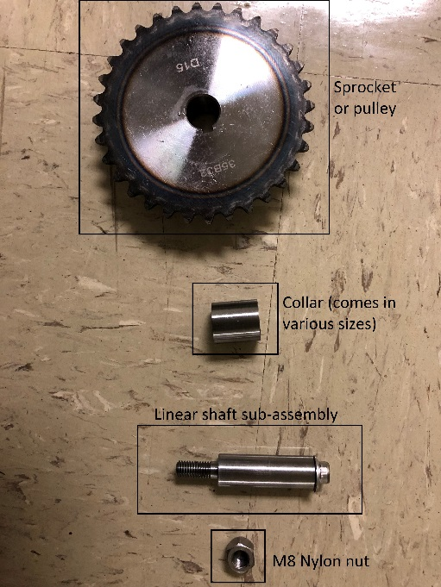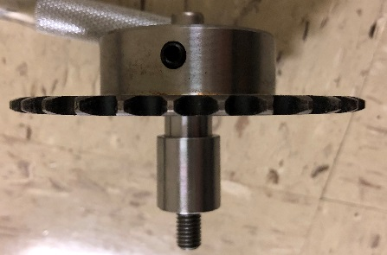
Figure 4
Figure 4. subassembly of a sprocket and shaft

Step 3 task: Attaching to the board
- Place the chain tensioner on the board with the rotary handle facing outwards. Using the four 6mm screws and the 6mm nylons nuts tighten the tensioner to the board.
- Tighten the timing tensioner to the opposite end of the board (shown in Figure 5). Add the 4mm screw to the board within the gap in the tensioner such that the orientation of the tensioner is forced. Tighten the 4mm screw down using the 4mm nylon nut.
- Use the 4mm screws and remaining 4mm nylon nuts to attach the slide tensioner to the appropriate location on the board.
- Place each of the pre-assembled sprocket and pulley kits in their respective locations one at a time as shown in Figure 6. Tighten each of the kits down using the 8mm nylons nuts. Use the 5mm hex key and the 13mm socket to hold either end of the kit and tighten everything until snug to the board. (Each pulley/sprocket should rotate freely even after being tightened down, if not, then the pulleys could be on the wrong shafts.
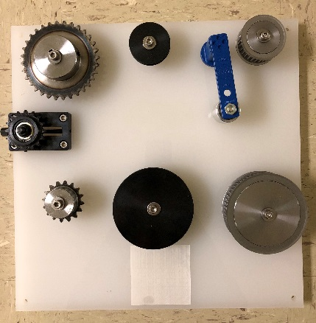
Figure 5. Partially assembled board showing part locations.

Step 4 task: Checking the set-up
- Place each belt on its respective sub-assembly and actuate the tensioners to ensure everything fits properly.
- Release the tensioners and remove each of the belts. Loosen the screws on top of each shaft and remove them. Slide the pulleys and sprockets off their shafts. Slide the collars off the shafts and place them next to their matching pulleys/sprockets. (The board should be ready for robotic assembly benchmarking.)
- Reverse these steps to fully assemble the board.

Standoffs:
- Connect the threaded standoffs to the four corners of the board as shown in Figure 1 such that the distance from the underside of the board to the supporting surface is 20 mm.
- There may be variation on how the standoff can connect to the board depending on the chosen standoff, itself. One method is shown below with a threaded standoff and two nuts that pin the plate.

Notes:

- Board has an etched square for the placement of tags such as an AR tag to help localize the board for testing as seen in Figure 1. This is useful for researchers interested in focusing on the grasping, manipulation, and control aspects for the task board.

