NIST Task Board #1
This document conveys fabrication instructions of a NIST task board designed for benchmarking and performance measurement of robotic systems (testing procedures described in separate document TBD) in various assembly operations including fastening nuts, connecting electrical plugs, meshing gears, and inserting pegs. This task board was designed in part to support the manufacturing track of the IEEE International Conference on Intelligent Robots and Systems Grasping and Manipulation Competition.

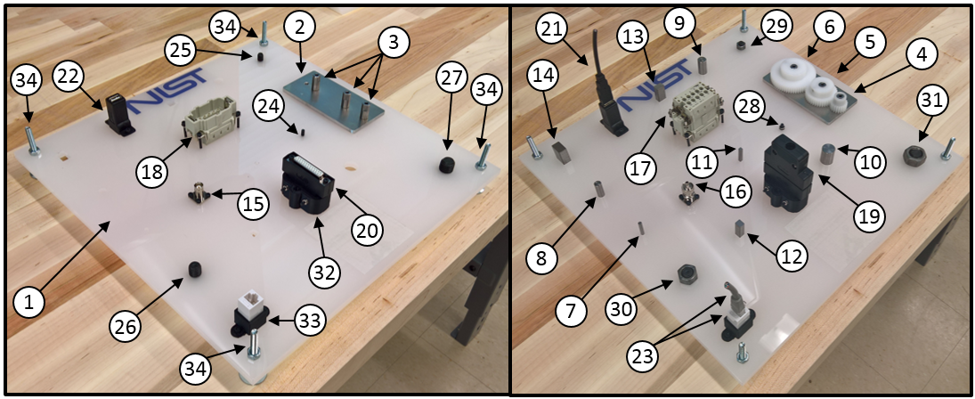
- Disassembled (b) Assembled

Figure 1. Identification of key components as labeled in the subsequent parts list and their locations on the task board.

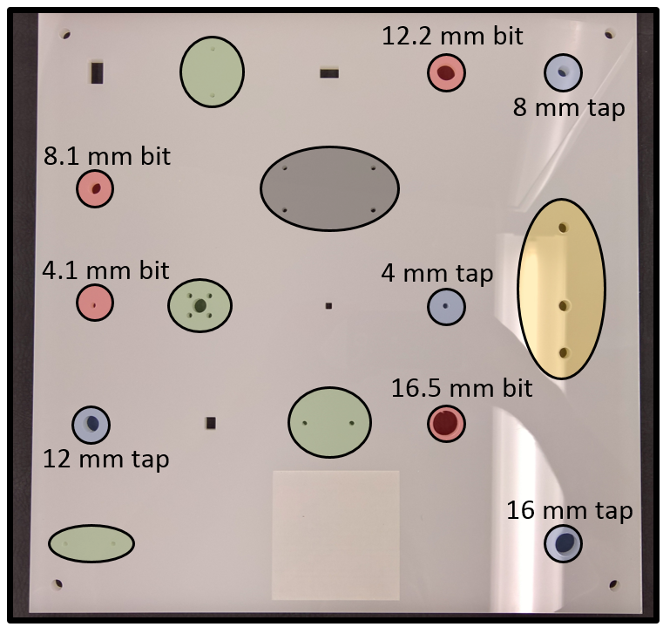
Figure 2. Top view of unfinished board revealing various assembly processing locations. Red indicates pilot holes for drilling holes for round pegs. Blue indicates pilot holes for tapping threads for bolts. Green indicates through holes for M3 x 16 mm bolts and nuts for various connectors. Orange indicates through holes for M6 bolts for fastening gear plate. Grey indicates through holes for M3 x 35 mm bolts and nuts for waterproof connector.

Purchasing:
- Majority of parts specified based on availability through MISUMI, an international distributor of components. Other vendors may supply the same parts.
- The design files of the laser-cut board can be downloaded in various formats from LINK. The design file can be uploaded to a laser cutting service, e.g., upload GMC_Laser_Plate.svg to Ponoko. To minimize variation in board properties, please select for cutting the design in an acrylic, opal-colored board of 0.354” thickness, 15.1” length, and 15.1” width.

Parts List

ID | Item | Part Number | Unit Cost ($) | Unit
1 | Laser Cut Board (Ponoko) | - | ~60.00 | 1
2 | Gear Plate | JTNAS-AM-A120-B60-T5-F30-V15-X10-Y30-M6-L90-S30-MA6 | <= 13.18 | 1
3 | Gear Shafts | SPTR10-20-M6-SC12 | <= 5.43 | 3
4 | Small Gear | GEABP1.0-20-10-B-10 | <= 12.92 | 1
5 | Medium Gear | GEABP1.0-40-10-B-10 | <= 24.03 | 1
6 | Large Gear | GEABP1.0-60-10-B-10 | <= 31.14 | 1
7 | Rod 4 mm | RGOCG4-50 | <= 3.74 | 1
8 | Rod 8 mm | RGOCG8-50 | <= 4.29 | 1
9 | Rod 12 mm | RGOCG12-50 | <= 5.40 | 1
10 | Rod 16 mm | RGOCG16-50 | <= 7.19 | 1
11 | Bar 4 mm x 4 mm x 300 mm | KET4 | <= 1.82 | 1*
12 | Bar 8 mm x 7 mm x 300 mm | KET8 | <= 3.29 | 1*
13 | Bar 12 mm x 8 mm x 300 mm | KET12 | <= 4.61 | 1*
14 | Bar 16 mm x 10 mm x 300 mm | KET16 | <= 7.09 | 1*
15 | BNC Female Connector | BNC-R | <= 7.45 | 1
16 | BNC Male Connector | BNCP-1.5A-K | <= 4.97 | 1
17 | Male Waterproof Connector | MCON-E10-SP | <= 10.31 | 1
18 | Female Waterproof Connector | MCON-E10-SS | <= 10.34 | 1
19 | DSUB Male Connector | SETDSUB-B-ML-PP-25 | <= 9.16 | 1
20 | DSUB Female Connector | SETDSUB-B-ML-PS-25 | <= 9.27 | 1
21 | USB Male Cable | U02-AM-BM-0.5 | <= 3.67 | 1
22 | USB Female Connector | U09-AF-AF-B | <= 6.02 | 1
23 | RJ45 Male and Female Connectors | ADT-EX-CRS5EK | <= 14.77 | 1
24 | M4 Bolt Fully Threaded, Coarse, 16 mm length | ** | n/a | 1
25 | M8 Bolt Fully Threaded, Coarse, 18 mm length | ** | n/a | 1
26 | M12 Bolt Fully Threaded, Coarse, 20 mm length | ** | n/a | 1
27 | M16 Bolt Fully Threaded, Coarse, 25 mm length | ** | n/a | 1
28 | M4 Nut | ** | n/a | 1
29 | M8 Nut | ** | n/a | 1
30 | M12 Nut | ** | n/a | 1
31 | M16 Nut | ** | n/a | 1
32 | DSUB Housing | 3D Printed | n/a | 1
33 | RJ45 Housing | 3D Printed | n/a | 1
34 | M6 or ¼”-20 Threaded Posts/Standoffs and Nuts | ** | n/a | 4
35 | M3 Bolt Fully Threaded, Coarse, 16 mm | ** | n/a | 14
36 | M3 Bolt Fully Threaded, Coarse, 35 mm | ** | n/a | 6
37 | M6 Bolt Fully Threaded, Coarse, 25 mm | ** | n/a | 3
38 | M3 Nut | ** | n/a | 16
* Needs to be cut to 50 mm lengths yielding <= 6 viable rectangular pegs.
** Choice of supplier as long as specifications are met.
Tools List

- Metric L-Keys (hex) wrenches
- Adjustable wrench
- Tap drivers
- 3mm, 4 mm, 8 mm, 12 mm, 16 mm metric taps
- 4.1 mm, 8.1 mm, 12.2 mm, 16.5 mm metric drill bits
- Drill press
- Pliers
- Phillips screwdriver
- Hand files

* Choice of supplier for tools as long as specifications are met.

Disclaimer

Certain commercial equipment, instruments, or materials are identified in this paper to foster understanding. Such identification does not imply recommendation or endorsement by the National Institute of Standards and Technology, nor does it imply that the materials or equipment identified are necessarily the best available for the purpose.

Assembly Instructions

Pegs and Holes:
- Using metric drill bits and drill press, drill out corresponding holes intended for round peg-in-hole insertions in task board (see red areas in Figure 2). The existing holes are only meant as pilot holes to help with drill placement due to issues with the laser cutting process. Drill slowly from underside of board through to topside to prevent cracking of plastic and preserve a smooth topside finish.
- Try inserting all four prismatic pegs in their corresponding holes, entering from topside of board. Some insertions may fail due to excess plastic at the “bottom” of the hole. This is an issue with the cutting laser beam not being perfectly perpendicular to the surface of the board. Use hand files to remove excess plastic at the bottom of the holes until pegs will smoothly insert. Do NOT remove plastic from the upper half of the hole as this will affect the leading hole tolerances.
- Prismatic pegs will come in bar stock lengths of 300 mm. Cut to 50 mm segments.
- Optional: per good design practices for assembly, chamfer one side of all pegs at 45 degrees and 0.1 times the largest cross-sectional side or diameter. E.g., 16 mm circular peg has 1.6 mm chamfer and 16 mm x 10 mm peg has 1.6 mm chamfer. Chamfering only one side of pegs allows for performance testing with and without the assistance of chamfers.

Bolts and Nuts:
- Per bolt specifications in Figure 1, tap the corresponding holes intended for testing nut threading (see blue areas in Figure 2). This includes one each of the following: M4, M8, M12, and M16 course thread tapped holes. Start the tapping process from the underside of the board through to the topside to ensure a clean finish and threads on the topside of the board.
- Once holes are tapped, thread one M4, M8, M12, and M16 bolt starting from the underside of the board. Sufficiently tighten with L-key. These bolts will remain in the board and receive their associated nuts during the assembly benchmarking activities.

Gears:
- Insert three M6 bolts from underside (see orange area of Figure 2) of board and tighten to gear plate in three corresponding locations.
- Tighten three gear shafts to remaining, exposed threads of M6 bolts (see below).

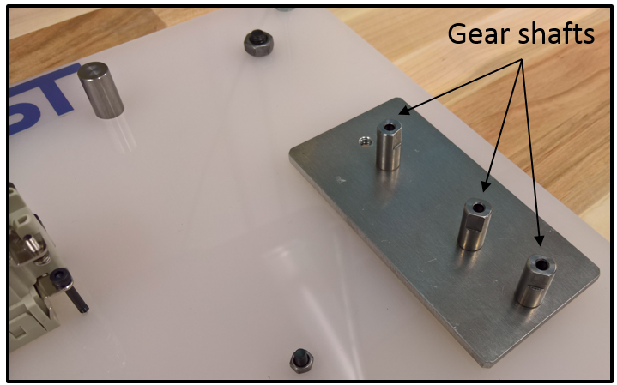

Connectors:
- Tighten female BNC connector to board in corresponding location in Figure 1 with four M3 x 16 mm bolts and four M3 nuts in correct green area in Figure 2.

- Tighten female USB connector to board in corresponding location with two M3 x 16 mm bolts and two M3 nuts as indicated by Figure 1 and correct green area of Figure 2.

- Tighten 3D printed RJ45 housing to board in corresponding location as shown in Figure 1 and correct green area of Figure 2 with two M3 x 16 bolts and two M3 nuts. Press female RJ45 connector into housing. If female connector with housing is loose, then a glue or epoxy may be used to fix connector to housing.

- Assemble male DSUB connector, and fasten with supplied bolts and hex nuts (comes with connector). Tap top holes of connector with M3 tap, and insert two M3 bolts (this helps tighten connector) as shown below.
- Assemble female DSUB connector, and insert into 3D printed DSUB housing (visually align connector and housing holes). Insert two M3 x 35 mm bolts through holes and use supplied nuts and washers to tighten. As before, tap top holes of connector with M3 tap, and insert two M3 bolts. Finally, use two M3 x 16 mm bolts and nuts to fasten DSUB housing to board in corresponding location as shown in Figure 1 and correct green area of Figure 2.

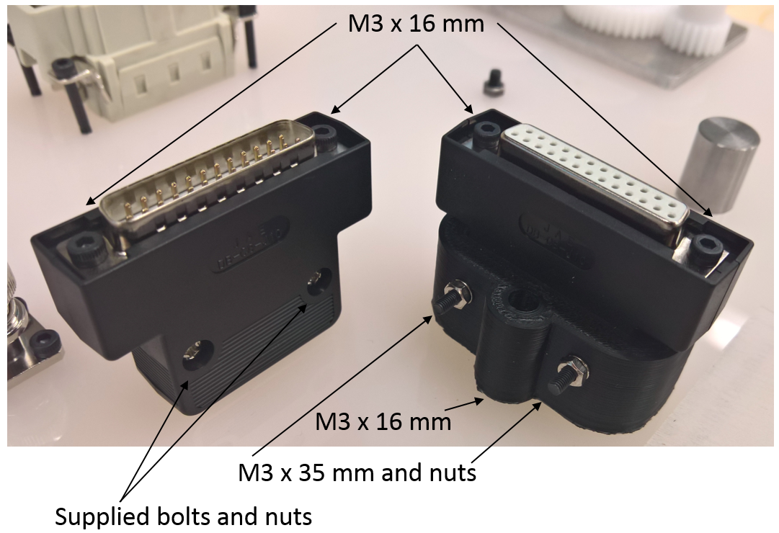

- Attach female waterproof connector to board in corresponding location with four M3 x 35 mm bolts and nuts as shown in Figure 1 and grey area of Figure 2.

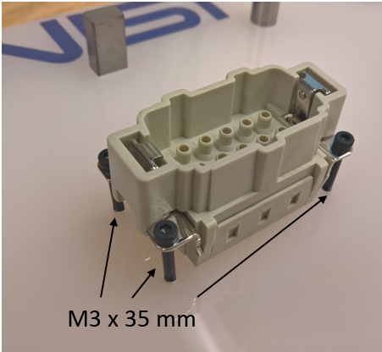

Standoffs:
- Connect the threaded standoffs to the four corners of the board as shown in Figure 1 such that the distance from the underside of the board to the supporting surface is 20 mm.
- There may be variation on how the standoff can connect to the board depending on the chosen standoff, itself. One method is shown below with a threaded standoff and two nuts that pin the plate.

Notes:

- Board has an etched square for the placement of tags such as an AR tag to help localize the board for testing as seen in Figure 2. This is useful for researchers interested in focusing on the grasping, manipulation, and control aspects for the task board.

