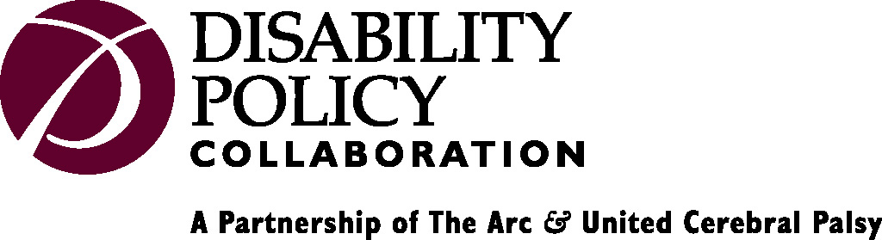

TO: NIST, Technical Guidelines Development Committee April 19, 2005
Election Assistance Commission

First, thanks to everyone for all of your hard work in developing the voting system guidelines and for your careful attention to accessibility to people with a range of disabilities.

I would like briefly to address the needs of the population with cognitive, or intellectual, disabilities. This population includes people with mental retardation, traumatic or acquired brain injury, learning disabilities (e.g. dyslexia), some psychiatric diagnoses, as well as conditions such as Alzheimer’s disease and other dementias.

Although the guidelines clearly state that “there are no design features specifically aimed at helping those with cognitive disabilities,” there are, indeed, a number of features that will benefit those with cognitive disabilities, possibly more than they will benefit any other population. I am not just referring to synchronized video and audio, but to a range of features that have largely been included under the topic of “Usability.” A few random examples of features and procedures, already included in the guidelines, that benefit people with cognitive disabilities are:

DRE voting stations shall allow the voter to change a vote within a race before advancing to the next race.

Consistent with election law, the voting process shall not introduce any bias for or against any of the choices to be made by the voter. In both visual and aural formats, candidates and choices shall be presented in an equivalent manner.

Voters should have access to sample ballots and all relevant instructions before the voting session.

Voters should have an opportunity to practice voting before the actual voting session, especially for DRE systems.

The voting process shall provide clear instructions and assistance so as to allow voters to successfully execute and cast their ballots independently.

The voting station should not visually present a single race spread over two pages or two columns.

Voting stations with electronic image displays shall not require page scrolling by the voter.

The voting station shall provide unambiguous feedback regarding the voter’s selection, such as displaying a checkmark beside the selected option or conspicuously changing its appearance.

There are many more. My point here is that the Committee and the Commission might consider attaching these features (and others that we can help you identify) to the topic of design features that will benefit people with cognitive disabilities. You have certainly considered the needs of voters with cognitive disabilities, and voters with cognitive disabilities and those who support and represent them should know that.

That said, we would still strongly encourage you to address the lingering, but extremely important, issue of pictorial, graphic and iconic representations. We feel that it should be called out in the guidelines in such a way that it is clear that NIST and the Commission are committed to developing legitimate standards and guidance for such features at the earliest feasible time.

We, of course look forward to continuing to dialogue and work with you on these issues that are so vital to the disability community, an integral part of equal rights for all.

Sincerely,

Janna Starr
Director of Disability Rights and Technology Policy
The Arc of the United States and United Cerebral Palsy
Disability Policy Collaboration

202-783-2229
jstarr@thedpc.org

1660 L St. NW
Washington, DC 20036

Cc: Jim Dickson

