NIST Handbook
NIST HB 130-2026
Uniform Laws and Regulations in the Areas of Legal Metrology and Fuel Quality
as adopted by the
110th National Council on Weights and Measures

John T. McGuire
David A. Sefcik
Loren Minnich
Isabel Chavez Baucom
Katrice A. Lippa
Physical Measurement Laboratory
Office of Weights and Measures

This publication is available free of charge from:
https://doi.org/10.6028/NIST.HB.130-2026

December 2025
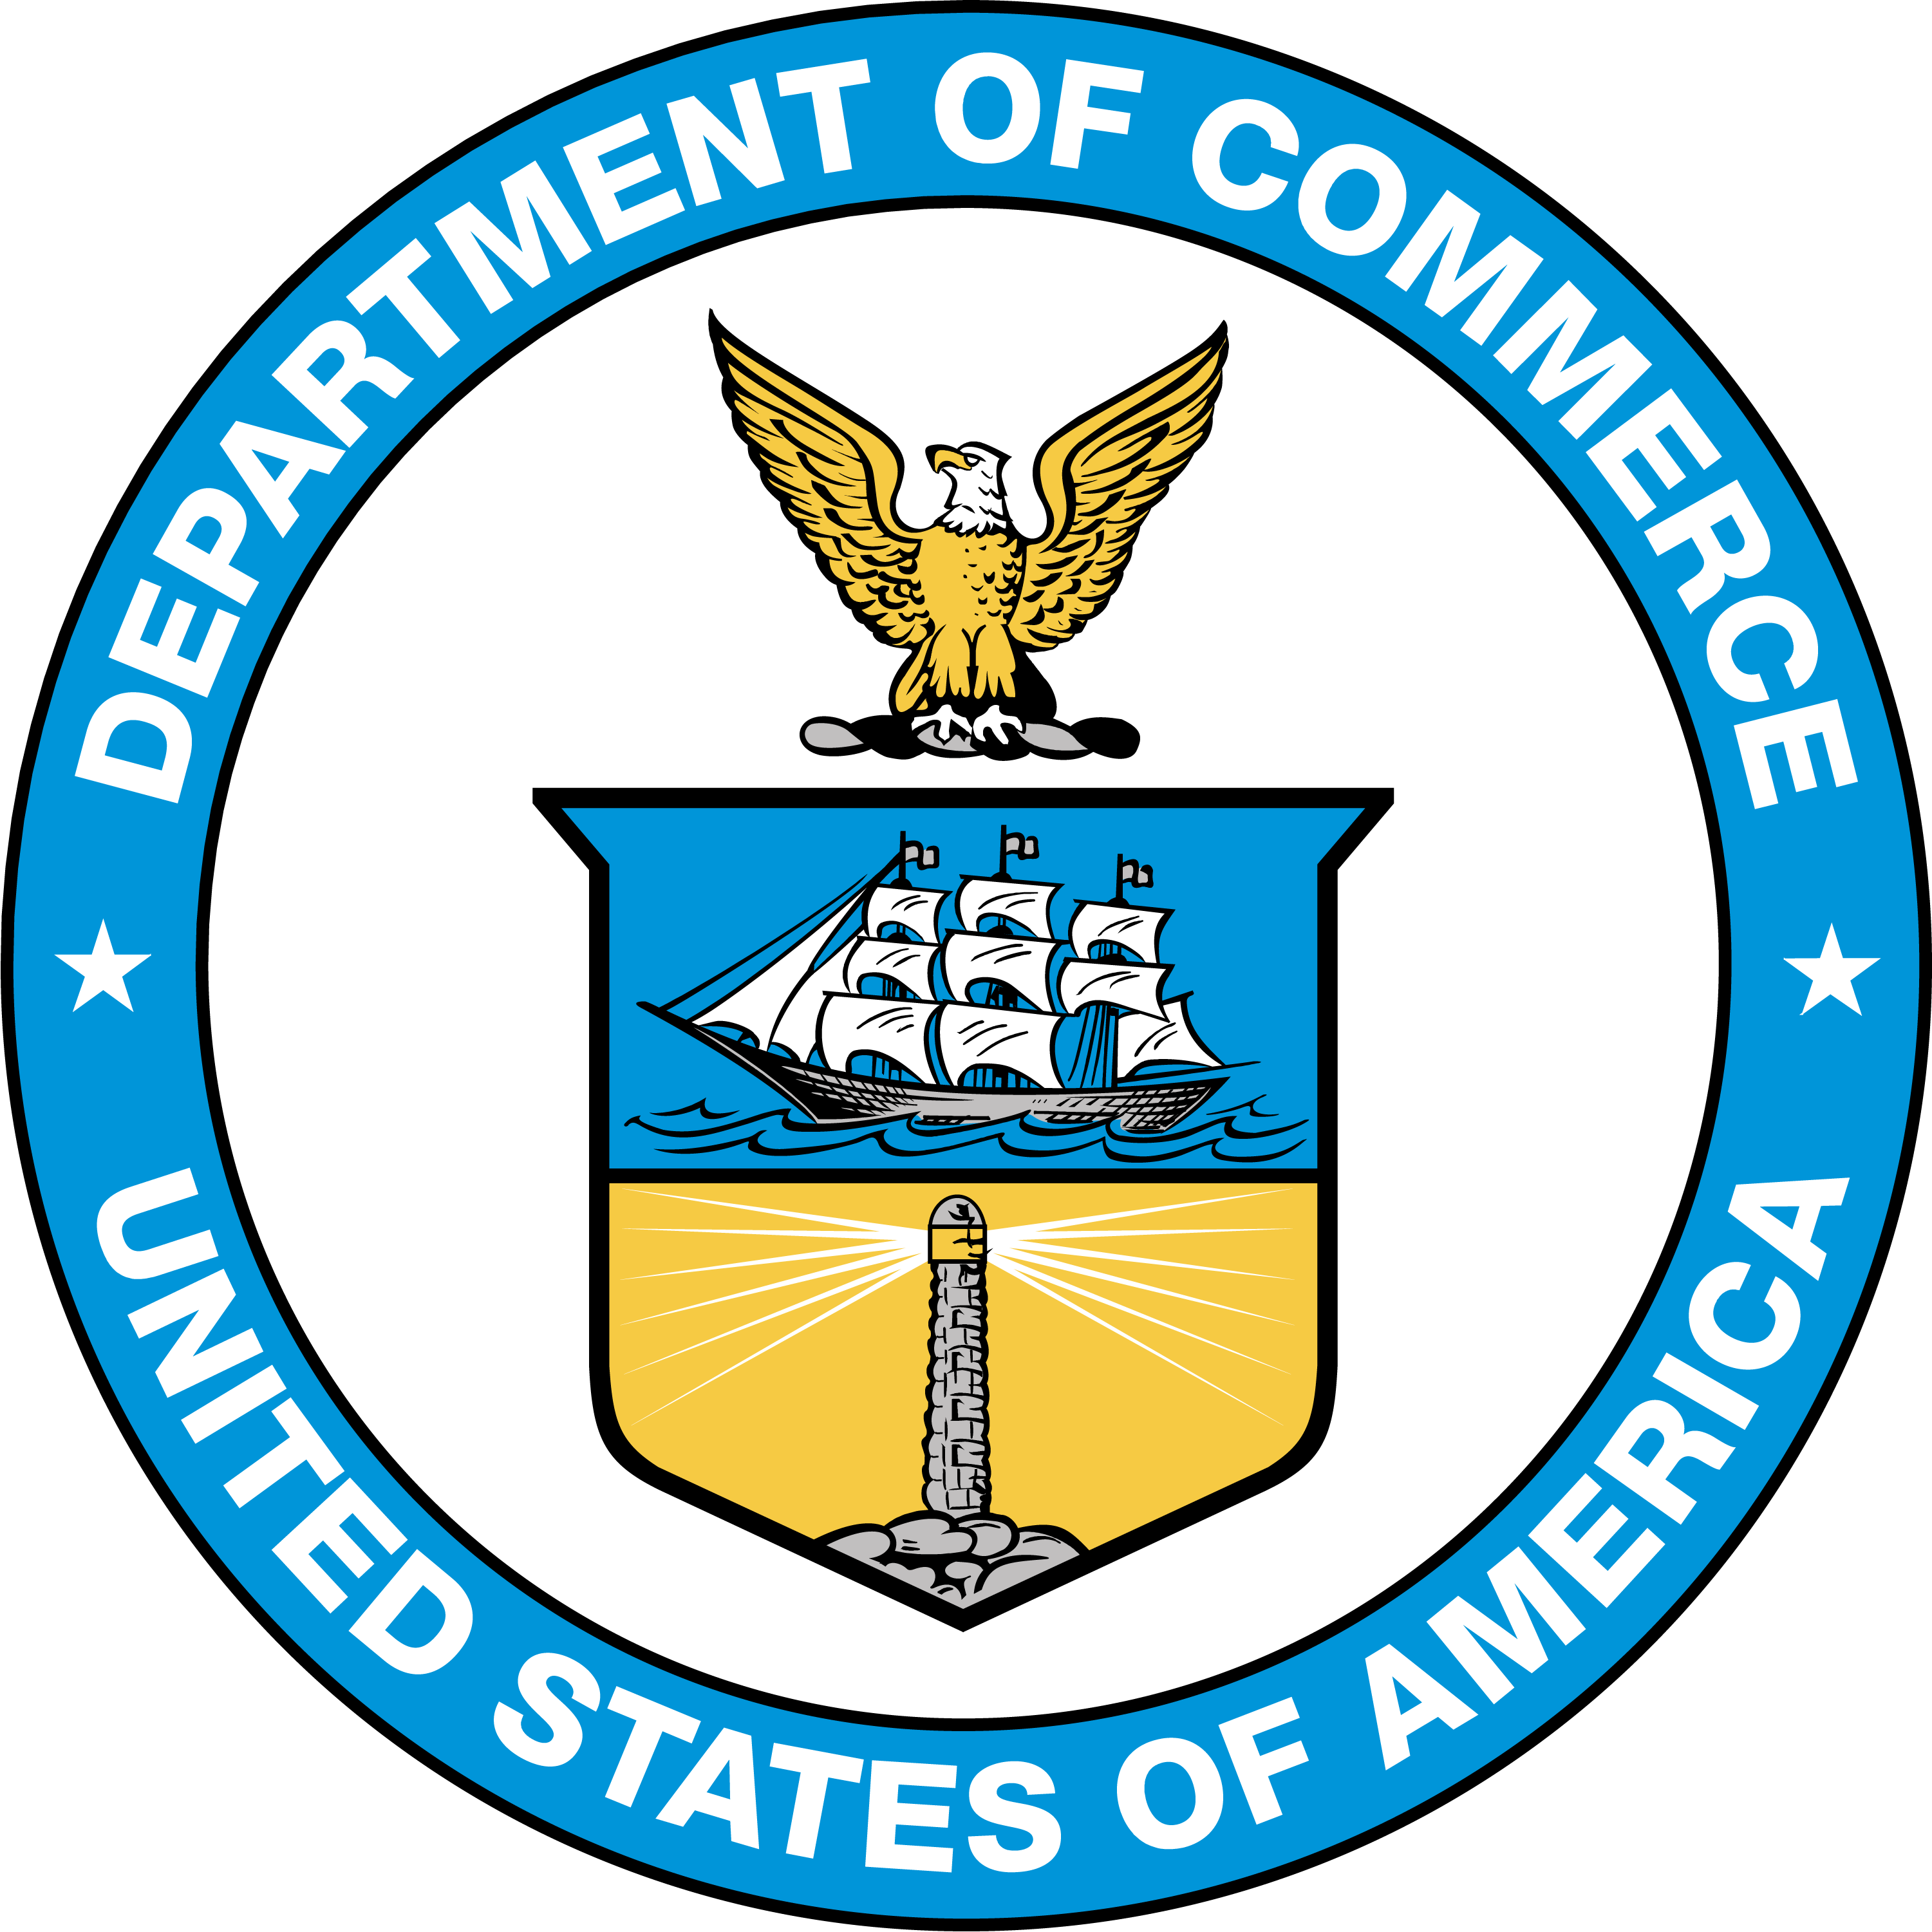
U.S. Department of Commerce
Howard Lutnick, Secretary
National Institute of Standards and Technology
Craig Burkhardt, Acting Under Secretary of Commerce for Standards and Technology and Acting NIST Director

Certain commercial entities, equipment, or materials may be identified in this document to describe an experimental procedure or concept adequately. Such identification is not intended to imply recommendation or endorsement by the National Institute of Standards and Technology (NIST), nor is it intended to imply that the entities, materials, or equipment are necessarily the best available for the purpose.
This handbook promotes the primary use of the International System of Units (SI) by citing SI units before U.S. customary units where both units appear together, and by placing separate sections containing requirements for SI units before corresponding sections containing requirements for customary units. In some cases, however, trade practice is currently restricted to the use of U.S. customary units; therefore, some requirements in this handbook will continue to specify only U.S. customary units until the National Council on Weights and Measures (NCWM) achieves a broad consensus on the permitted metric units.
Marijuana (also referred to as cannabis) remains a Schedule I substance under the Controlled Substances Act. As with all materials, the NIST Office of Weights and Measures (OWM) provides technical analysis and any relevant expertise to help ensure that the standards as developed through the NCWM process are technically sound. As such, NIST publishes the adopted model regulations for cannabis and cannabis-containing commodities by the NCWM in the NIST Handbook 130 as part of NIST’s statutory mission to promote uniformity in state laws, regulations, and testing procedures.
NIST Technical Series Policies
Copyright, Fair Use, and Licensing Statements
NIST Technical Series Publication Identifier Syntax
Publication History
Approved by the NIST Editorial Review Board on 2025-11-17
Supersedes NIST Handbook 130 – 2025 (December 2024) https://doi.org/10.6028/NIST.HB.130-2025
How to Cite this NIST Technical Series Publication
McGuire JT, Sefcik DA, Minnich LB, Baucom ICh, and Lippa KA, (2026) Uniform Laws and Regulations in the Areas of Legal Metrology and Fuel Quality. (National Institute of Standards and Technology, Gaithersburg, MD), NIST Handbook (HB) NIST HB 130-2026. https://doi.org/10.6028/NIST.HB.130-2026
NIST Author ORCID iDs
JT McGuire: 0009-0006-7396-155X
DA Sefcik: 0000-0001-7407-1950
LB Minnich: 0009-0006-8082-2726
ICh Baucom: 0009-0004-8989-2021
KA Lippa: 0000-0001-8651-8326
Contact Information
owm@nist.gov
NIST Office of Weights and Measures
Attention: Publications Coordinator
100 Bureau Drive, MS 2600
Gaithersburg, MD 20899

NIST does not have a policy role related to the legalization of the production, sale, distribution, or use of cannabis (including hemp and marijuana).

