NIST Handbook
NIST HB 44-2023
Specifications, Tolerances, and Other Technical Requirements for Weighing and Measuring Devices
as adopted by the
107th National Conference on Weights and Measures
Tina G. Butcher
Richard A. Harshman
Jan Konijnenburg
G. Diane Lee
Juana S. Williams
Lisa Warfield
Elizabeth J. Benham
Shelby L. Bowers
Katrice A. Lippa

This publication is available free of charge from:
https://doi.org/10.6028/NIST.HB.44-2023

NIST Handbook | 44
2023 Edition
Supersedes NIST Handbook 44, 2022 Edition

NIST Handbook
NIST HB 44-2023
Specifications, Tolerances, and Other Technical Requirements for Weighing and Measuring Devices
as adopted by the
107th National Conference on Weights and Measures
Tina G. Butcher
Richard A. Harshman
Jan Konijnenburg
G. Diane Lee
Juana S. Williams
Lisa Warfield
Elizabeth J. Benham
Shelby L. Bowers
Katrice A. Lippa
Physical Measurement Laboratory
Office of Weights and Measures

This publication is available free of charge from:
https://doi.org/10.6028/NIST.HB.44-2023

November 2022
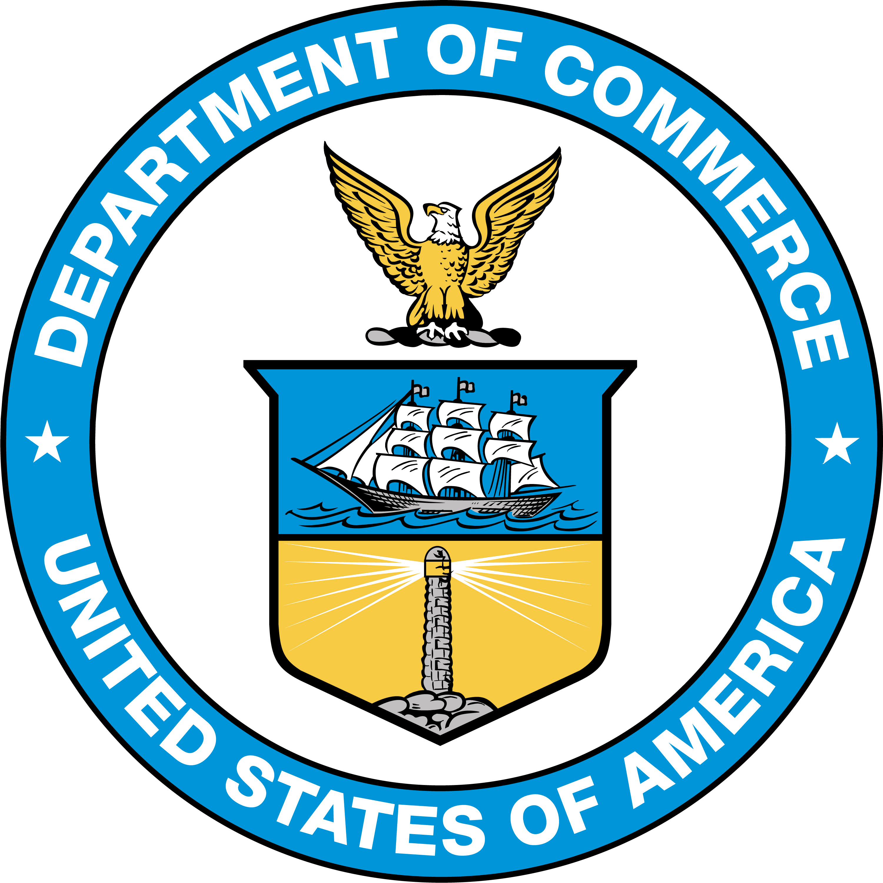
U.S. Department of Commerce
Gina M. Raimondo, Secretary
National Institute of Standards and Technology
Laurie E. Locascio, NIST Director and Under Secretary of Commerce for Standards and Technology

Certain commercial entities, equipment, or materials may be identified in this document in order to describe an experimental procedure or concept adequately. Such identification is not intended to imply recommendation or endorsement by the National Institute of Standards and Technology, nor is it intended to imply that the entities, materials, or equipment are necessarily the best available for the purpose.
This handbook conforms to the concept of primary use of SI (metric) measurements recommended in the Omnibus Trade and Competitiveness Act of 1988 by citing SI units before U.S. customary units where both units appear together and placing separate sections containing requirements in SI units before corresponding sections containing requirements in U.S. customary units. In some cases, however, trade practice is currently restricted to the use of U.S. customary units; therefore, some requirements in this handbook will continue to specify only U.S. customary units until a broad consensus is achieved on the permitted SI units.
In accord with NIST policy, the “meter” and “liter” spellings are used in this document. However, the “metre” and “litre” spellings are acceptable.
It should be noted that a space has been inserted instead of commas in all numerical values having four digits or more in this document. This follows a growing practice, originating in tabular work, to use spaces to separate large numbers into groups of three digits. This avoids conflict with the practice in many countries to use the comma as a decimal marker.
NIST Technical Series Policies
Copyright, Fair Use, and Licensing Statements, NIST Technical Series Publication Identifier Syntax
Publication History
Approved by the NIST Editorial Review Board on 2022-11-18
Supersedes NIST Handbook 44 - 2022 (November 2021) https://doi.org/10.6028/NIST.HB.44-2022
How to Cite this NIST Technical Series Publication
Butcher T, Harshman R, Konijnenburg J, Lee GD, Williams J, Warfield L, Benham E, Bowers S, and Lippa K (2022) Specifications, Tolerances, and Other Technical Requirements for Weighing and Measuring Devices. (National Institute of Standards and Technology, Gaithersburg, MD), NIST Handbook (HB) NIST HB 44-2023. https://doi.org/10.6028/NIST.HB.44-2023
NIST Author ORCID iDs
T Butcher: 0000-0003-2711-9442
R Harshman: 0000-0001-9171-5906
J Konijnenburg: 0000-0003-2592-873X
GD Lee: 0000-0002-8005-0758
J Williams: 0000-0003-4807-9005
L Warfield: 0000-0003-0576-8572
E Benham: 0000-0002-2751-7881
S Bowers: 0000-0002-1902-362X
K Lippa: 0000-0001-8651-8326
Contact Information
owm@nist.gov
NIST Office of Weights and Measures
Attention: Publications Coordinator
100 Bureau Drive, MS 2600 Gaithersburg, MD 20899
Abstract
NIST Handbook 44 includes specifications, tolerances, and other technical requirements for weighing and measuring devices. These requirements are intended to encourage the design, installation, testing, and use of weighing and measuring devices that provide for accurate, repeatable measurements; facilitate clear and transparent transactions for buyer and seller; and do not facilitate fraud.
NIST Handbook 44 is adopted by many state, local, and some federal weights and measures authorities to apply to commercial weighing and measuring equipment and associated equipment and for use in applications for law enforcement and the collection of statistical information by government agencies.
NIST has a statutory responsibility for “cooperation with the states in securing uniformity of weights and measures laws and methods of inspection” and publishes this and other NIST Handbooks in partial fulfillment of this responsibility. NIST Handbook 44 was first published in 1949, having been preceded by similar handbooks of various designations and in several forms, beginning in 1918; the handbook is now typically published on an annual basis.
This 2023 edition includes amendments made through the Committee on Specifications and Tolerances of the National Conference on Weights and Measures (NCWM) with technical guidance from the Office of Weights and Measures (OWM) of the National Institute of Standards and Technology (NIST) and input from weights and measures officials and industry representatives. These amendments were adopted by the NCWM at its 107th Annual Meeting in July 2022.
Keywords
devices; dry measures; electric vehicle fueling systems; grain analyzers; grain moisture meters; hydrogen gas-measuring devices; liquid-measuring devices; LPG and anhydrous ammonia liquid-measuring; mass flow meters; measure-containers; measuring; measuring systems; meters; multiple dimension measuring devices; odometers; scales; taximeters; timing devices; transportation network measuring systems; vehicle tanks; weighing; weighing systems.

Foreword
NIST Handbook 44 was first published in 1949, having been preceded by similar handbooks of various designations and in several forms, beginning in 1918.
NIST Handbook 44 is typically published in its entirety each year following the Annual Meeting of the National Conference on Weights and Measures (NCWM). This handbook includes amendments endorsed by the 107th National Conference on Weights and Measures during its Annual Meetings in 2022.
This handbook conforms to the concept of primary use of SI (metric) measurements recommended in the Omnibus Trade and Competitiveness Act of 1988 by citing SI units before U.S. customary units where both units appear together and placing separate sections containing requirements in SI units before corresponding sections containing requirements in U.S. customary units. In some cases, however, trade practice is currently restricted to the use of U.S. customary units; therefore, some requirements in this handbook will continue to specify only U.S. customary units until a broad consensus is achieved on the permitted SI units.
In accord with NIST policy, the meter/liter spellings are used in this document. However, the metre/litre spellings are acceptable and are preferred.
It should be noted that a space has been inserted instead of commas in all numerical values greater than 999 in this document, following a growing practice, originating in tabular work, to use spaces to separate large numbers into groups of three digits. This avoids conflict with the practice in many countries to use the comma as a decimal marker.

Author Contributions
Elizabeth J. Benham: Writing - Original Draft, Writing - Reviewing and Editing; Tina G. Butcher: Data Curation, Writing - Original Draft, Writing - Reviewing and Editing; Richard A. Harshman: Data Curation, Writing - Original Draft, Writing - Reviewing and Editing; Jan Konijnenburg: Data Curation, Writing - Reviewing and Editing; G. Diane Lee: Writing - Original Draft, Data Curation, Writing - Reviewing and Editing; Juana S. Williams: Data Curation, Writing - Original Draft, Writing - Reviewing and Editing; Lisa Warfield: Writing - Reviewing and Editing; Shelby L. Bowers: Writing - Reviewing and Editing; Katrice A. Lippa: Supervision.

Acknowledgments
NIST OWM would like to thank Michael Dennis (NOAA), for his significant contributions to revise Appendices B and C to describe the retirement of the U.S. survey foot from the U.S. measurement system.
Committee on Specifications and Tolerances of the 107th Conference
Brad Bachelder, Maine
Jason Glass, Kentucky
Nick Owens, Stark County, Ohio
Jason Flint, New Jersey
David Aguayo, San Luis Obispo County, California
Louis Martinet, Measurement Canada, Technical Advisor
Richard Harshman, NIST Technical Advisor
G. Diane Lee, NIST Technical Advisor
Juana Williams, NIST Technical Advisor
Allen Katalinic, NCWM, NTEP Technical Advisor
Mike Manheim, NCWM, NTEP Technical Advisor

Past Chairs of the Committee
Conference | Chair |  | Conference |  | Chair
8-11 | L.A. Fischer, NBS |  | 76 |  | J. Truex, OH
12-28 | F.S. Holbrook, NBS |  | 77-78 |  | C. Carroll, MA
29-38 | J.P. McBride, MA |  | 79 |  | J. Jeffries, FL
39-42 | R.E. Meek, IN |  | 80 |  | R. Suiter, NE
43-44 | J.E. Brenton, CA |  | 81 |  | G. West, NM
45-47 | C.L. Jackson, WI |  | 82-83 |  | R. Murdock, NC
48 | T.C. Harris, VA |  | 84 |  | D. Brown, IA
49-50 | R.E. Meek, IN |  | 85 |  | M. Hopper, CA
51-52 | G.L. Johnson, KY |  | 86 |  | G. Shefcheck, OR
53 | H.D. Robinson, ME |  | 87 |  | M. Coyne, MA
54-55 | R. Rebuffo, NE |  | 88 |  | R. Wotthlie, MD
56-57 | D.E. Konsoer, WI |  | 89 |  | C. VanBuren, MI
58 | J.C. Mays, FL |  | 90 |  | J. Kane, MT
59 | T.F. Brink, VT |  | 91 |  | C. Cooney, OR
60 | W.S. Watson, CA |  | 92 |  | M. Sikula, NY
61 | K.J. Simila, OR |  | 93 |  | C. Fulmer, SC
62 | W.E. Czaia, MN |  | 94 |  | T. R. Lucas, OH
63 | M.L. Kinlaw, NC |  | 95 |  | B. Saum, CA
64 | J.A. Bird, NJ |  | 96-97 |  | S. Giguere, ME
65 | D.A. Guensler, CA |  | 98 |  | K. Ramsburg, MD
66 | G.A. Delano, MT |  | 99 |  | B. Gurney, UT
67 | F.C. Nagele, MI |  | 100-101 |  | M. Albuquerque, CO
68 | L.H. DeGrange, MD |  | 102 |  | M. Curran, FL
69 | S.A. Colbrook, IL |  | 103 | I. Hankins, IA
70 | D.A. Guensler, CA |  | 104 | R. Miller, WI
71-72 | F. Gerk, NM |  | 105 | L. Minnich, KS
73 | K. Butcher, MD |  | 106 | J. Nelson, OR
74 | R. Andersen, NY |  | 107 | B. Bachelder, ME
75 | D. Watson, TX

THIS PAGE INTENTIONALLY LEFT BLANK
Table of Contents
Page
Abstract i
Foreword ii
Author Contributions iii
Acknowledgments iv
2022 Amendments and Editorial Changes viii
Introduction 1
Section 1.
1.10. General Code 1-1
Section 2.
2.20. Scales 2-1
2.21. Belt-Conveyor Scale Systems 2-63
2.22. Automatic Bulk Weighing Systems 2-81
2.23. Weights 2-91
2.24. Automatic Weighing Systems 2-99
2.25. Weigh-In-Motion Systems Used for Vehicle Enforcement Screening – Tentative Code 2-117
Section 3.
3.30. Liquid-Measuring Devices 3-1
3.31. Vehicle-Tank Meters 3-29
3.32. Liquefied Petroleum Gas and Anhydrous Ammonia Liquid-Measuring Devices 3-45
3.33. Hydrocarbon Gas Vapor-Measuring Devices 3-63
3.34. Cryogenic Liquid-Measuring Devices 3-75
3.35. Milk Meters 3-87
3.36. Water Meters 3-97
3.37. Mass Flow Meters 3-107
3.38. Carbon Dioxide Liquid-Measuring Devices 3-123
3.39. Hydrogen Gas-Measuring Devices 3-139
3.40. Electric Vehicle Fueling Systems 3-151
Section 4.
4.40. Vehicle Tanks Used as Measures 4-1
4.41. Liquid Measures 4-9
4.42. Farm Milk Tanks 4-13
4.43. Measure-Containers 4-21
4.44. Graduates 4-27
4.45. Dry Measures 4-33
4.46. Berry Baskets and Boxes 4-39
Section 5.
5.50. Fabric-Measuring Devices 5-1
5.51. Wire- and Cordage-Measuring Devices 5-9
5.52. Linear Measures 5-15
5.53. Odometers 5-19
5.54. Taximeters 5-25
5.55. Timing Devices 5-39
5.56.(a) Grain Moisture Meters 5-47
5.56.(b) Grain Moisture Meters 5-61
5.57. Near-Infrared Grain Analyzers 5-71
5.58. Multiple Dimension Measuring Devices 5-83

Table of Contents (continued)
Page
5.59. Electronic Livestock, Meat, and Poultry Evaluation Systems and/or Devices 5-97
5.60. Transportation Network Measurement Systems – Tentative Code 5-101
Appendices
A. Fundamental Considerations Associated with the Enforcement of Handbook 44 Codes A-1
B. Units and Systems of Measurement - Their Origin, Development, and Present Status B-1
C. General Tables of Units of Measurement C-1
D. Definitions D-1

