NIST Handbook
NIST HB 130-2023
Uniform Laws and Regulations in the Areas of Legal Metrology and Fuel Quality
as adopted by the
107th National Conference on Weights and Measures
Tina G. Butcher
David A. Sefcik
Lisa Warfield
Shelby L. Bowers
Katrice A. Lippa
This publication is available free of charge from:
https://doi.org/10.6028/NIST.HB.130-2023

NIST Handbook | 130

2023 Edition
Supersedes NIST Handbook 130, 2022 Edition

THIS PAGE INTENTIONALLY LEFT BLANK

NIST Handbook
NIST HB 130-2023
Uniform Laws and Regulations in the Areas of Legal Metrology and Fuel Quality
as adopted by the
107th National Conference on Weights and Measures

Tina G. Butcher
David A. Sefcik
Lisa Warfield
Shelby L. Bowers
Katrice A. Lippa
Physical Measurement Laboratory
Office of Weights and Measures

This publication is available free of charge from:
https://doi.org/10.6028/NIST.HB.130-2023

December 2022
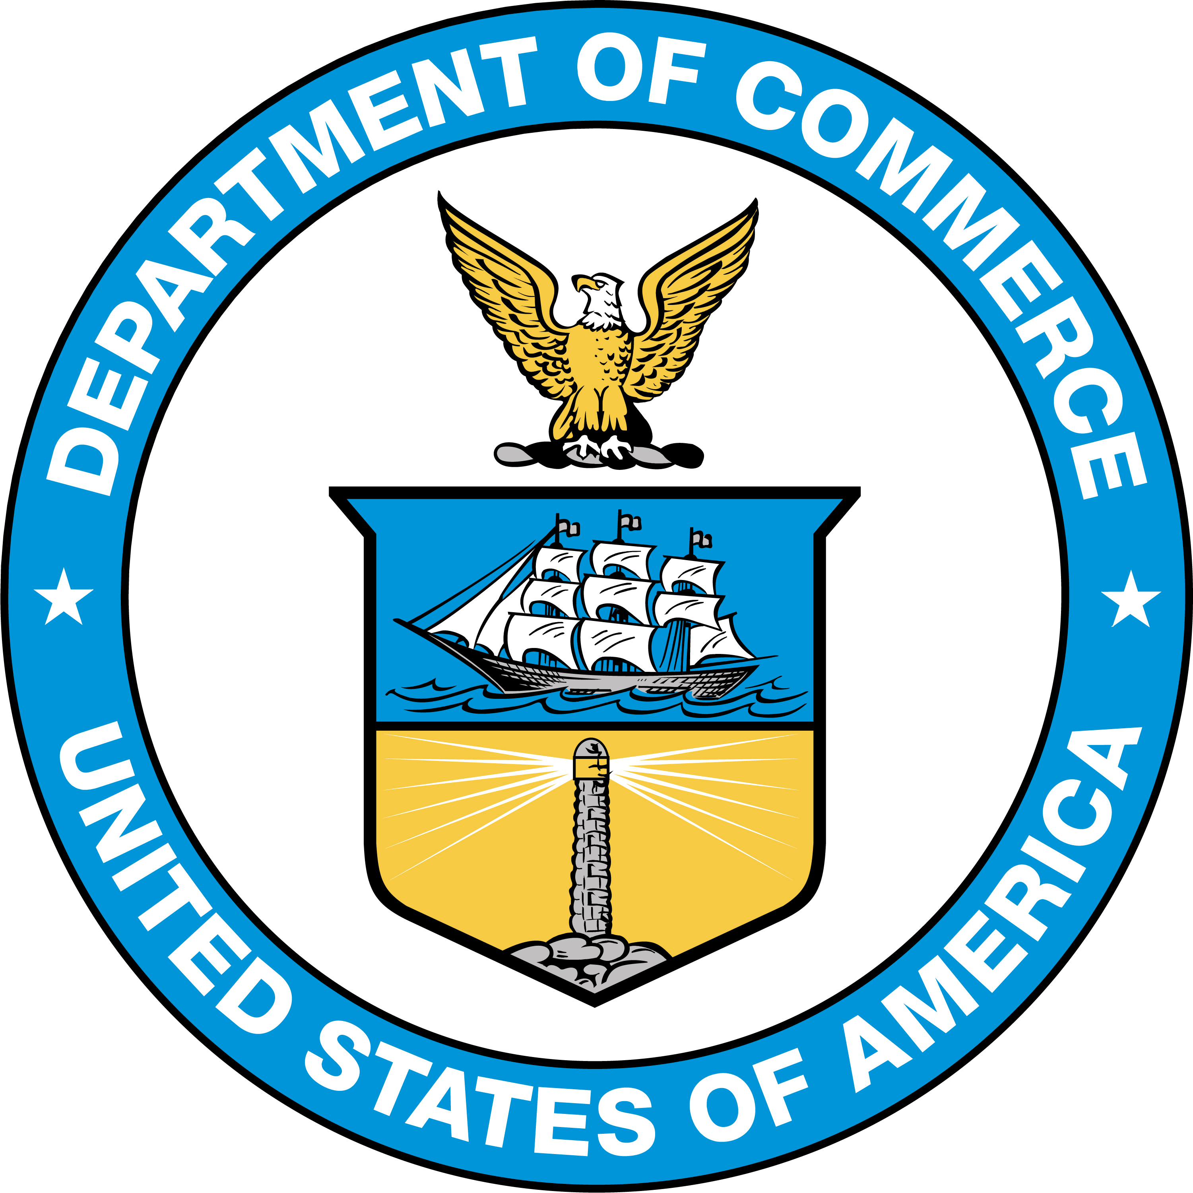
U.S. Department of Commerce
Gina M. Raimondo, Secretary
National Institute of Standards and Technology
Laurie E. Locascio, NIST Director and Under Secretary of Commerce for Standards and Technology

Certain commercial entities, equipment, or materials may be identified in this document in order to describe an experimental procedure or concept adequately. Such identification is not intended to imply recommendation or endorsement by the National Institute of Standards and Technology, nor is it intended to imply that the entities, materials, or equipment are necessarily the best available for the purpose.
This handbook promotes the primary use of the International System of Units (SI) by citing SI units before U.S. customary units where both units appear together, and by placing separate sections containing requirements for SI units before corresponding sections containing requirements for customary units. In some cases, however, trade practice is currently restricted to the use of U.S. customary units; therefore, some requirements in this handbook will continue to specify only U.S. customary units until the NCWM achieves a broad consensus on the permitted metric units.
NIST Technical Series Policies
Copyright, Fair Use, and Licensing Statements
NIST Technical Series Publication Identifier Syntax
Publication History
Approved by the NIST Editorial Review Board on 2022-12-20
Supersedes NIST Handbook 130 - 2022 (November 2021) https://doi.org/10.6028/NIST.HB.130-2022
How to Cite this NIST Technical Series Publication
Butcher T, Sefcik D, Warfield L, Bowers S, and Lippa K, (2022) Uniform Laws and Regulations in the Areas of Legal Metrology and Fuel Quality. (National Institute of Standards and Technology, Gaithersburg, MD), NIST Handbook (HB) NIST HB 130-2023. https://doi.org/10.6028/NIST.HB.130-2023
NIST Author ORCID iDs
T Butcher: 0000-0003-2711-9442
D Sefcik: 0000-0001-7407-1950
L Warfield: 0000-0003-0576-8572
S Bowers: 0000-0002-1902-362X
K Lippa: 0000-0001-8651-8326
Contact Information
owm@nist.gov
NIST Office of Weights and Measures
Attention: Publications Coordinator
100 Bureau Drive, MS 2600
Gaithersburg, MD 20899

Abstract
NIST Handbook 130 includes a compilation of model laws and regulations and related interpretations and guidelines designed to encourage uniformity in adoption and implementation of weights and measures laws and regulations. The model laws and regulations included in NIST Handbook 130 are adopted in various forms by many state, local, and some federal weights and measures authorities. Some authorities adopt the current versions as written; some use them as the basis of adoption, but from an earlier year; some use them as a guideline only; some elect to use their own laws or regulations; and some have no corresponding law or regulation in place.
The National Institute of Standards and Technology (NIST) has a statutory responsibility to promote "cooperation with the states in securing uniformity in weights and measures laws and method of inspection” and publishes this and other NIST Handbooks in partial fulfillment of this responsibility.
This 2023 edition includes amendments made through the Committee on Laws and Regulations of the NCWM with technical guidance from the Office of Weights and Measures (OWM) of the National Institute of Standards and Technology (NIST) and input from weights and measures officials and industry representatives. These amendments were adopted by the NCWM at its 107th Annual Meeting in July 2022.
At the 1983 Annual Meeting, the NCWM voted to change the title of Handbook 130 from “Model State Laws and Regulations” was to be changed to “Uniform Laws and Regulations” to reflect that these Laws and Regulations are (a) intended to be standards rather than just guidelines, and (b) intended for adoption by political subdivisions other than states when deemed appropriate. In 1995 the title was changed to Uniform Laws and Regulations in the areas of legal metrology and motor fuel quality. In the 1997 Edition of Handbook 130 was changed from "Uniform Laws and Regulations the words “motor fuel quality" was changed to “engine fuel quality" to reflect changes made to the Uniform Engine Fuels, Petroleum Products, and Automotive Lubricants Law and Regulation. In 2018, the scope of the Fuels regulation was expanded to encompass the changing fuels in the marketplace, and the title to the Handbook was changed to how it appears today.

Keywords
automotive lubricants; fuels; labeling; laws and regulations; measuring; method of sale; NTEP; packaging; price verification; registration of servicepersons; type evaluation; unit pricing; weighing; weighmaster law; weights and measures law.

Author Contributions
Tina G. Butcher: Writing - Reviewing and Editing; David A. Sefcik: Data Curation, Writing - Original Draft, Writing - Reviewing and Editing; Lisa Warfield: Data Curation, Writing - Original Draft, Writing - Reviewing and Editing; Shelby L. Bowers: Writing - Reviewing and Editing; Katrice A. Lippa: Supervision.

Acknowledgments
Committee on Laws and Regulations of the 107th Conference

John McGuire, New Jersey
Doug Rathbun, Illinois
Kevin Schnepp, California
Tory Brewer, West Virginia
Mauricio Mejia, Florida

Associate Membership Representative: Prentiss Searles, American Petroleum Institute
Canadian Technical Advisors: Lance Robertson and Rowan Hemsing, Measurement Canada
NIST Technical Advisors: Lisa Warfield, David Sefcik
NIST Technical Advisor on the Uniform Regulation for National Type Evaluation: Tina Butcher
NCWM Committee Coordinator: Constantine Cotsoradis

Past Chairs of the Committee

Conference | Chair | Conference | Chair
41 | G. H. Leithauser, MD | 78 | F. Clem, OH
42-43 | F. M. Greene, CT | 79 | B. Bloch, CA
44 | G. L. Johnson, KY | 80 | S. Rhoades, AZ
45 | R. Williams, NY | 81 | L. Straub, MD
46-49 | J. H. Lewis, WA | 82 | S. Millay, ME
50-51 | L. Barker, WV | 83-84 | K. Angell, WV
52 | M. Jennings, TN | 85 | S. Morrison, CA
53 | W. A. Kerlin, CA | 86 | R. Williams, TN
54-55 | J. F. Lyles, VA | 87 | P. D’Errico, NJ
56-58 | S. D. Andrews, FL | 88-89 | D. Johannes, CA
59 | R. M. Leach, MI | 90 | J. Gomez, NM
60 | R. L. Thompson, MD | 91 | J. Benavides, TX
61-62 | C. H. Vincent, Dallas, TX | 92 | J. Cassidy, MA
63 | J. T. Bennett, CT | 93 | Vicky Dempsey, OH
64 | R. W. Probst, WI | 94 | Joe Gomez, NM
65 | D. I. Offner, MO | 95 | Joe Benavides, TX
66-68 | J. J. Bartfai, NY | 96 | John Gaccione, NY
69 | W. R. Mossberg, CA | 97-98 | J. Cardin, WI
70 | E. Skluzacek, MN | 99 | R. Johnson, NM
71 | D. Stagg, AL | 100 | T. Lloyd, MT
72 | A. Nelson, CT | 101 | R. Lewis, GA
73-74 | K. Simila, OR | 102-103 | Ethan Bogren, NY
75 | S. B. Colbrook, IL | 104 | Michelle Wilson, AZ
76 | A. Nelson, CT | 105 | Ethan Bogren, NY
77 | B. Bloch, CA | 106 | John McGuire, NJ

THIS PAGE INTENTIONALLY LEFT BLANK

