

**Site Visit Manual**

2020

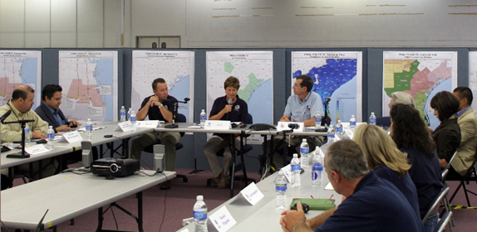

Table of Contents

**(Ctrl + click to follow links)**

SITE VISIT PROCESS OVERVIEW 5

SITE VISIT: PLANNING PHASE 9

DO’S AND DON’TS FOR THE PLANNING PHASE 10

SCOREBOOK PREPARATION AT THE PLANNING PHASE 11

Introduction and General Instructions 11

Scorebook Requirements 11

Building the Site Visit Scorebook 11

Submitting the Site Visit Scorebook 15

How to Prepare Process Item Worksheets and SVI Worksheets 16

How to Prepare Results Item Worksheets and SVI Worksheets 22

Computer Use Instructions 27

SITE VISIT: ON-SITE PHASE 29

ON-SITE PHASE OVERVIEW 29

OPENING MEETING 29

CLOSING MEETING 31

Do’s 32

Don’ts 32

SCOREBOOK DEVELOPMENT CHECKLIST 33

SITE VISIT: POST-SITE PHASE 35

POST SITE OVERVIEW 35

SITE VISIT SCORING 38

COMPLETING THE SCOREBOOK (before leaving the site visit) 38

APPENDIX A: Creating SVIs & Item Worksheets in PDF 40

APPENDIX B: Site Visit Roles & Responsibilities 56

APPENDIX C: AGENDAS AND OTHER TOOLS 62

SITE VISIT DAILY SCHEDULE **EXAMPLE** 62

INTERVIEW LOG 70

INFORMATION REQUEST 71

EFFECTIVE INTERVIEWING STEPS 72

PROCESS FLOW FOR TEAM’S WORK 74

USING THE SCOREBOOK ON SITE (BETWEEN OPENING & CLOSING MEETINGS) 75

EXAMPLE WALK-AROUND QUESTIONS 76

# SITE VISIT PROCESS OVERVIEW

The Site Visit Review is a critical phase of the evaluation process. Site visits entail a team of Baldrige examiners traveling to an applicant’s site(s) to more fully understand how well the organization is applying the Baldrige Criteria and concepts. The ultimate purpose of the site visit is to verify the team’s understanding of key strengths and to clarify its understanding of key vulnerabilities. For each selected applicant that receives a site visit, the team will (1) communicate findings to the judges, (2) determine the feedback that is most relevant for the applicant, and (3) help ensure that the applicant can demonstrate role-model practices to the public should it be named an award recipient.

What is the purpose of the Site Visit Review?

* **Verify and Clarify the comments from the Consensus Review Scorebook**
* **Determine the most relevant feedback**
* **Identify role model practices**

What is the one deliverable of the site visit process? The Site Visit Scorebook. Through the production of this scorebook, the team reaches agreement on the applicant’s strengths and opportunities for improvement (OFIs), the resulting scoring range for each item, and the overall scoring band for the application. The team members accomplish their work through extensive planning, focusing on what is most important to the applicant, communicating with each other and the applicant, and contributing to a shared understanding of findings—which is presented in the form of a scorebook.

The Site Visit Scorebook includes several worksheets:

* **Key Factors Worksheet** and a **Key Themes Worksheet**, which are updated from the Consensus Review to reflect new information collected during the site visit process;
* **Item Worksheets** containing the applicant’s important strengths and opportunities for improvement;
* **Highest-Ranking Official (HRO) Worksheet** listing questions and answers obtained by the team leader and Baldrige staff monitor during the interview with the Applicant’s **highest-ranking** official;
* **Scoring Summary Sheet** that captures changes to team scores for each Baldrige Criteria Item along with an overall scoring band for the applicant;
* **Site Visit Issue Worksheets**, which are used to 1) map out an information collection strategy, and 2) record the findings and conclusions of the Examiners related to specific issues needing clarification or verification;
* Summary of Sites Visited, which is a 1-page document capturing the number and type of employees interviewed at each site that is used by the judges’ panel as part of their award recommendation process;
* Signature page, on which all Examiners sign and attest to the accuracy of the feedback report.

The Site Visit Scorebook is provided to the Judges’ Panel so that they can make accurate decisions about whether to recommend the applicant for the Award.

There are three phases of the site visit process.. They are:

* the Planning Phase
* the On-Site Phase
* the Post-Site Phase

**Planning**

The Planning Phase, which lasts about 4 weeks, begins soon after the Panel of Judges has the candidates and the Examiner teams have been selected, typically in late August.

During the Planning Phase, the team members can expect to spend roughly 35-40 hours preparing for the site visit itself. This time includes conference calls and preparing Site Visit Issues Worksheets (SVIs), which will be described later in this manual. This phase also includes traveling to and meeting at a hotel close to the applicant’s facility early Sunday morning, the day before the site visit kicks off. This meeting averages about 11 hours in length. Time spent in advance preparing plans and documents will affect the time needed in this session.

**Team Member Responsibilities during this Planning Phase:**

* Meet all deadlines
* Arrange transportation to arrive Saturday evening and depart the following Saturday afternoon. Provide your itinerary to ASQ
* Review the Consensus Scorebook and the application.
* Review online materials for site visit contained in the Examiner Resources Center
* Review Updated Results from the applicant. (to be received 10 days prior to the On-Site phase).
* Working with your Item backup, develop Site Visit Issue (SVI) Worksheets for all Items you are assigned as “Item Lead”
* Request documents needed to verify strengths and clarify OFIs from the Consensus Scorebook
* Complete other assignments that your team leader may have (consolidate document requests, establish interview schedule, etc.)
* Provide feedback on all other team members’ SVIs
* Exports all assigned documents as PDFs to take to site
* Complete SVIs prior to the Sunday Planning Meeting
* Review requested documents at the beginning of the Sunday Planning Meeting.

**On-Site**

The On-Site Phase of the process is where team members work at the applicant’s site to investigate and analyze information presented in the application, along with the conclusions reached through Consensus Review so that the team can document the answers to the questions in the SVIs developed during the Planning Phase.

The On-Site Phase is an intense time for the team members. This phase starts in late September – early October and usually lasts three days, Monday through Wednesday, but can vary from two to four days depending on the size and geographic locations of the applicant. During this phase, team members can expect to spend about 10 hours at the applicant’s facility each day and as much as 4 hours each evening back at the hotel doing both individual work and work with the team. These times vary by individual, but the important point is that team members must work diligently during this phase to ensure that they have the information and evidence they need from the applicant before closing the On-Site Phase.

Depending on the size of the organization, it will likely require visiting more than one site. For example, if the organization’s headquarters is in Maryland but its largest production facility is in Ohio, the team may need to visit both sites.

Day 1 of the site visit begins with a one-hour meeting with the applicant at the applicant’s headquarters, during which the Team Leader makes introductory remarks and introduces the Site Visit Team members. The Team Leader presents a brief overview of the Baldrige Award and site visit process and procedures. The applicant then welcomes the team, introduces its representatives, and presents other material as it chooses. Item Leads then meet with the applicant’s representatives and pursue the specific Criteria Items that they have been assigned.

Days 2 and 3 and possibly 4 are spent at the applicant’s facilities either conducting follow-up meetings and interviews to obtain additional information to clarify site visit issues or reviewing additional documents from the applicant.

After the team is satisfied that all issues have been verified or clarified, the team leader, back up team leader, and monitor hold a brief closing meeting with appropriate representatives of the organization. This normally occurs on Thursday morning of site visit week, but this can vary depending on the size and complexity of the applicant. The Team Leader explains the next steps in the process, thanks the applicant for the hospitality shown to the Examiners and commends the applicant for being selected for the site visit. The applicant also makes brief closing remarks. This is the last opportunity for the applicant to provide information to the team. Once the team leadership departs for the hotel, the team will have no further contact with the applicant.

**Team Member Responsibilities during the On-Site Phase**:

* Strictly adhere to all time limits in the on-site schedule provided by the team leader.
* Work in pairs to collect information required by the SVIs for their assigned Items through interviews, documents, observations.
* Attend all team caucuses and meetings and share findings
* Take thorough notes
* Record findings and conclusions on SVI Worksheets on-site or back at the hotel during evening sessions.
* Be flexible – things can change
* Request additional documents on-site through your team leader, if needed.
* Have all documents needed to close out all SVIs before the closing meeting, which marks the end of the on-site phase

**Post-Site**

After the closing meeting at the applicant’s facility, the team returns to the hotel to close out its work. The team completes all remaining SVIs, then completes the remainder of the Site Visit Scorebook. This typically begins Wednesday evening and lasts through Saturday morning or afternoon, but can vary depending on the size and complexity of the applicant. Some of this work is accomplished individually and some is accomplished during periodic team meetings. Team meetings must be attended by all team members.

**Team Member Responsibilities during this Post-Site Phase:**

* Attend all team caucuses/meetings and share findings
* Update SVI Worksheets, seeking shared understanding among team members
* In BOSS, review and provide feedback for all SVIs, Item Worksheets, and Key Themes Worksheets
* Stay with team until scorebook is completed and signed by all team members

|  |
| --- |
| Note: For a complete listing of all team leader , backup team leader, team member, and monitor responsibilities, see Appendix B |

# SITE VISIT: PLANNING PHASE

|  |  |
| --- | --- |
| **@30 days out from site visit** | * Team receives virtual “welcome to the team” site visit emails from ASQ |
| **30 25 days out** | Review the application and Consensus Scorebook. Also review site visit materials in the Examiner Resource Center, including this site visit manual. Although this year we’re conducting site visits virtually, most all materials are still relevant. |
| **28 25 days out** | Attend 1st team planning call – Agenda:   * overview of what will happen between now and the first day of virtual site visit * agree to a schedule and key due dates; * affirm team member Category Item assignments; * explanation of SVI worksheet and how to complete one. |
| **28 –16 days out** | Develop SVI worksheets for your assigned Items. (See “***Scorebook Preparation at the Planning Phase***” following this section.) |
| **18 –16 days out** | Submit Document Request List to the OCP |
| **16 -14 days out** | Attend 2nd team planning call – Agenda:   * TL shares any insights from calls with OCP; * Experienced examiners walk through a well completed SVI worksheet (have everyone in BOSS following along); * Begin logistics planning. |
| **11 –14 days out** | Team members receive applicant’s updated results which will be in BOSS Team Files. |
| **14 – 7 days out** | * Review other team members’ SVI Worksheets and provide feedback * Review applicant’s updated results * Update / revise SVI Worksheets |
| **10 – 7 days out** | Continue to fine-tune SVI Worksheets  Attend 3rd team planning call -- Agenda:   * TL shares any insights from calls with OCP; * Team members who have not walked the team through one of their SVI worksheets will do so * Complete logistics planning. |
| **4 – 1 day out** | * Complete SVI Worksheets * Attend 4th team planning call – Final check on logistics; any final discussion on SVI worksheets; discuss the schedule for the 1st day Planning Meeting |
| **Begin site visit, Day 1** | Team meets on 1st day (week 1: Sept.27th week 2 Oct. 1st) to discuss SVI strategies, finalize plans, and review documents |

## DO’S AND DON’TS FOR THE PLANNING PHASE

Do strictly adhere to the timeline and the schedule for completion of work that your team leader gives you. Time is tight so there can be no extensions. Let your team leader know of any concerns you have.

Be prepared for a heavy schedule; expect 12- to 14-hour work days during your site visit week. The agenda is very full.

Do plan to stay for the entire site visit. Everyone must remain through the completion and signing of the Site Visit Scorebook.

**DON’TS**

Don’t contact the applicant before the site visit unless you are the team leader or backup team leader.

## SCOREBOOK PREPARATION AT THE PLANNING PHASE

### Introduction and General Instructions

The Site Visit Scorebook is the team’s final deliverable. It is the basis for the judges’ recommendations regarding your applicant. It will also be the foundation of the feedback report for the applicant. That is why the quality of your work is so critical. As a team member you are responsible for not only the quality of your work, but that of the entire team.

### Scorebook Requirements

The goal of the Site Visit Scorebook is to provide a well-documented, nonbiased trail of evidence that demonstrates how the final scorebook conclusions relate to information obtained from the written application and the site visit. The trail of evidence is captured in the Item Worksheets, which include consensus comments, a summary of evidence, and updated comments to clearly show the evolution of comments from Consensus Review to Site Visit Review based on the team’s findings. This trail of evidence flows from the SVI Worksheets, which contain the detailed information discovered on site.

### Building the Site Visit Scorebook

All teams need to export their files to PDF version from the Export / Import tab on BOSS the day before start of VSV.

Teams will work in BOSS online to update / complete all BOSS worksheets. They include:

**1. Key Factors Worksheet**

The Key Factors Worksheet records the key business/organization factors that the team considered in evaluating the applicant. Key factors help define what is important and relevant to the applicant. These are listed in the Consensus Scorebook and modified as necessary to reflect new information obtained during the site visit. Knowledge and use of the key factors are essential to the proper conduct of a site visit evaluation. In anticipation of the team leader’s discussion with the Judges Panel, the team provides the consensus key factors, which remain the same in the body of the worksheet, and completes the question at the bottom: “Thinking about the questions in the Organizational Profile, did the team have any new insights about the applicant as a result of the site visit?”

**2. Key Themes Worksheet**

The Key Themes Worksheet provides key points and an overall summary of the Site Visit Team’s evaluation of the applicant. It is an update of the Key Themes Worksheet from Consensus Review.

Key themes are based on the overall context provided by the evaluation framework (the Criteria categories) and the core values and concepts (found in the Criteria for Performance Excellence booklets). The Key Themes Worksheet does not just repeat the findings given in the Item Worksheets. Rather, it puts them in perspective, considering category linkages, key factors, and core values.

The Key Themes Worksheet responds to the following questions:

What are the most important strengths or outstanding practices (of potential value to other organizations) identified in the applicant’s response to process items?

What are the most significant opportunities, concerns, or vulnerabilities identified in the applicant’s response to process items?

Considering the applicant’s key business/organization factors, what are the most significant strengths (related to data, comparisons, and linkages) found in its response to results items?

Considering the applicant’s key business/organization factors, what are the most significant opportunities, vulnerabilities, and/or gaps (related to data, comparisons, and linkages) found in its response to results items?

Key themes comments for questions a. and b. address the evaluation factors of approach, deployment, learning, and integration (ADLI). The comments for questions c. and d. address levels, trends, comparisons, and integration (LeTCI), including segmentation, as well as linkage to the applicant’s organizational requirements and gaps.

**3. Item Worksheets**

This worksheet is the record of your final evaluation of the applicant for each of the Criteria items.

As you clarify or verify all OFIs and all strengths that are bolded and/or appear in the key themes, capture the findings and conclusions on this worksheet. All other comments, whether fully investigated or not, should be reviewed, refined, and included on the Item Worksheet. If you discover nothing related to one of these comments, you may indicate on the worksheet “not investigated on-site.” By the end of the site visit, “it is unclear,” “it is not apparent,” or similar words must not remain in any comment.

BOSS automatically transfers Consensus Review comments and their item references into the appropriate columns of the Item Worksheets for the Site Visit Scorebook and assigns each comment a unique number (ID).

Information gaps or lack of understanding must be resolved through the site visit, using SVI Worksheets.

You will complete the “Summary of Conclusions/Impact on Comments” column of the Item Worksheet on-site, after the strengths and opportunities have been verified and clarified through the accomplishment of the strategies listed on the SVI Worksheet for the item. Then, you integrate these findings into a revised set of strengths and OFIs for each item. These revised, feedback-ready comments are included in the last column.

If new information arises during the site visit, you may add comments to the Item Worksheet. Similarly, if your findings remove a strength or an OFI, you may indicate a comment is deleted but leave the reference as “This comment is deleted” and what happened to it. Describe the findings leading to new or deleted comments in the appropriate SVI Worksheets so that the judges understand how the comments emerged or were deleted.

For items that you lead, indicate in the scoring section your recommendation for the item scoring range. Scoring ranges, not individual item scores, are provided to site-visited applicants. After your team mates individually review and provide feedback on your recommended score, the team will discuss scoring as a final step. Any differences not resolved during the team review process can be resolved during this discussion.

**In the case where online BOSS is not available, and you must use PDFs**: Do not delete or re-order comments in the PDF Key Theme or Item Worksheets because it will cause errors during the import back into BOSS at the end of the site visit. Rather, indicate in the Comments after Site Visit column that “This comment is deleted”. To re-order, indicate that “This comment should become STR-1” or “This comment should become OFI-2” for example. The Team Leader will be able to do the re-ordering later in online BOSS and BPEP will check in the feedback report.

**4. Site Visit Issue (SVI) Worksheets**

You use SVI Worksheets as the primary tool to plan your strategy for finding evidence on site to verify or clarify what is written in the consensus scorebook. All OFIs must be clarified, and all bolded strengths and those strengths that appear within the key themes must be verified. There are usually 1 to 3 strength and/or OFI comments in the consensus scorebook that are related enough to combine into a single site visit issue (SVI). We do this combining of comments where possible to reduce the potential duplication of effort and time wasted devising a strategy to explore every eligible comment.

SVI Worksheets are the judges’ major vehicle for understanding what you heard and saw on your site visit. The judges look for clear “audit trails” from the Consensus Review comments to the site visit conclusions and scores, based on evidence you found on site during your interviews and document and data reviews.

For process items: Issues for on-site verification of strengths and clarification of OFIs include the applicant’s approach (A) and could also include the extent of the approach’s deployment (D), organizational learning (L), and integration (I) related to the approach if indicated in the consensus scorebook comment. For example, if a bolded strength comment discusses the existence of a systematic process called for by a Criteria requirement, you would verify that the process exists and operates as presented in the written application. If it also mentioned the deployment of that approach, you would verify that as well on site. If it appears that the consensus review team gave the applicant the benefit of the doubt, you would need to verify that as well.

During the planning phase of the site visit, you develop two or three SVIs per process item. When you list comments in the “Comments Affected” column of an SVI Worksheet for process items, BOSS will list them in the space provided on the Item Worksheets. These SVIs focus on key processes so that your investigation of each of them provides information needed to finalize more than one comment. Each SVI has its own SVI Worksheet. It is quite possible that your comments may come from other Items as well because of the cross-cutting nature of the Criteria. This will require discussion between you and other Item Leads involved.

**The SVI Worksheet asks you to plan out the questions you will ask on site. There are two levels of questions; analysis questions and interview questions. Analysis questions are the primary questions needing to be explored in order to resolve site visit issues. These questions relate directly to the Baldrige Criteria questions for the Items involved in the SVI and the approach, deployment, learning and integration (ADLI) factors associated with the Criteria question, as appropriate. Analysis questions are often phrased as yes-no questions. At the next level, the interview questions are the specific questions that need to be asked of certain individuals or groups that provide the evidence needed to answer the analysis questions. If the SVI Worksheet has been done correctly, there should be an easily identified logical connection from the interview question through the analysis question to the site visit issue.**

For results items: The SVI Worksheet for results items differs from the one for process items. Each results item has just one SVI Worksheet that combines the strengths that require verification and the OFIs that require clarification for that Item. You select a strength or OFI comment, write a brief summary, and then list the figures associated with it, as well as its beneficial trends and favorable comparisons. Analyses indicate whether the data represent (1) good-to-excellent levels, beneficial trends, and favorable comparisons; (2) segmented results to measure performance across customer groups, products, and/or services, market segments, and workforce groups; and (3) data derived from the applicant’s updated results received one week before the site visit.

Unlike process SVIs, results SVIs have only one level of question – the interview question. The results data is straightforward, so analysis questions are not needed.

In team meetings, you and your team mates will use their SVI Worksheets to discuss preliminary findings and conclusions. Findings might include observations, specific answers, and/or updated results that may lead to revised comments. Conclusions indicate how the findings affect item comments. Until the site visit ends, preliminary conclusions are subject to change as new information becomes available. Your team’s discussions and preliminary conclusions will help guide your work during the site visit.

**5. Score Summary Worksheet**

BOSS transfers the percent score and scoring range for each item and the overall score from the Consensus Review Score Summary Worksheet to the Site Visit Review Score Summary Worksheet. As scores are refined through site visit findings, you finalize the scoring range for each item and record resulting changes (higher range, lower range, same range). Finally, you and the team use the Scoring Band Descriptors to determine which descriptor for process items and which descriptor for results items best reflect the team’s view of the applicant, and the scorekeeper inputs these band numbers on the Score Summary Worksheet.

6. Summary of Sites Visited

The Summary of Sites Visited contains information about the extent and thoroughness of the site visit. The team lists the major locations it visited and describes any important aspects of the sites that are not apparent from the Site Listing and Descriptors section of the Eligibility Certification Form. For example, the list might include “oldest facility,” “site with a major reduction in force,” “location where the newest product will be manufactured,” or “telephone or data service center that runs three shifts.” In addition, examiners describe approaches they used to evaluate sites that they did not visit, including sites outside the United States.

This worksheet also contains any other information about the team’s strategy for a thorough site visit, such as:

* “Interviewed employees on all three shifts”
* “Interviewed categories/types of employees [specify categories/types]”
* “Visited at least one location in each of the operating regions”
* “Did a sampling at all levels and in all locations of the organization’s critical data systems”

7. HRO Interview Worksheet

This worksheet’s purpose is two-fold: 1) to summarize key role-model discussions during the conversation among the team leader, Baldrige monitor, and HRO. It is used to share information within the Site Visit Team; 2) record discussion of any issues that might reflect negatively on the applicant or the Baldrige Program in the event that the applicant would receive the award.

A discussion of the content of this worksheet typically occurs in the evening after the HRO interview has taken place. Based on this discussion, you and your team mates decide which issues require further investigation or need documentation in the scorebook.

**8. Signature Page**

The final requirement of the Site Visit Team is completion of the signature page of the scorebook. The page includes the following statement: “I support the findings of the Site Visit Team contained in this scorebook.” In the spaces provided, you and your team mates each prints their name and then signs the form.

Note: Each evening the Team Leader should perform an export of all files to use in case of a wifi interruption. If wifi is restored, these files would need to be Imported if the team wishes to continue working in online BOSS to make sure that the team is working in the most current version.

Note: If using the PDFs offline, at the end of the site visit, data from the Item Worksheets, SVI Worksheets, Key Factors Worksheet, the Key Themes Worksheet, and the Score Summary Worksheet in PDF forms are imported into BOSS. For all teams, the Summary of Sites Visited and the HRO Interview Worksheet are posted directly to the Team Files.

### Submitting the Site Visit Scorebook

The team leader may review and make final refinements to the scorebook via online BOSS by midnight (PDT) on the 3rd day immediately following the site visit’s completion. This review is not intended to encourage or even permit the team leader’s extensive editing of the report; its purpose is to ensure that the scorebook is complete and accurate. For example, it is not uncommon for one or more worksheets to be missing, for comments to be misplaced or included more than once, for words such as “it is not clear” to be missed in comments, or for scoring information to be missing or inaccurate. All team members must watch for these sorts of edits to give the judges an accurate representation of the team’s findings and conclusions. Tweaking comments for grammar and style is not appropriate at this time.

Note: Three electronic versions of the completed Site Visit Scorebook are kept—one each for the Baldrige monitor, the team leader, and the backup team leader.

### How to Prepare Process Item Worksheets and SVI Worksheets

Planning Phase:

In preparation for the site visit, each team member will be named the Item Lead for several process items and/or results items. Two major types of documents—the Item Worksheets and the Site Visit Issue (SVI) Worksheets—will become part of the scorebook submitted to the judges.

When your team is moved from Consensus Review to Site Visit Review, BOSS fills in eight columns of an Item Worksheet for each item. The first columns are headed with “ID,” “Item Ref, ”Comment at CR,” and “SVI.” The final columns are “Summary of Evidence”, “Summary of Conclusions / Impact on Comments,” “Comments after Site Visit,”, and if it is a double-plus strength or double-plus OFI it will be bolded. As BOSS populates each Item Worksheet with comments from the Consensus Scorebook, it assigns a unique ID to each comment and loads the corresponding item reference. Familiarize yourself with the Item Worksheets.

Here is one way to start an SVI:

Select one OFI comment, since all must be clarified, and determine to which key process it relates. Consider in your SVI the process evaluation factors (approach, deployment, learning, and integration [ADLI]) addressed in the comment.

Review other OFIs and strengths to determine if the issues related to that key process can be clarified and verified through one integrated SVI. **Note**: Integration within an SVI is not the same thing as combining consensus scorebook comments. It can be tempting to put as many comments as possible into a single SVI. This is not helpful when those comments are not related to the same key process. This creates a patchwork of SVI Worksheets that will confuse the team and the judges. If the comments will not be investigated through the same methods (e.g., talking to the same people, reviewing the same documents, making the same observations), it is probably not appropriate to integrate them.

When you have addressed all relevant OFIs, check to see if there are bolded or key theme-related strengths that are related that can also be explored through this SVI.

**To add your Process SVI**, (see BOSS Item Worksheet Example #1 below) click on the SVI Worksheets tab. Or, open a Process Item Worksheet and click the “Add Process SVI” button. Note that the SVI is numbered automatically and sequentially.

BOSS Worksheet Example #1: BOSS Online Process Item Worksheet 5.1 Planning Phase

Start a Process SVI Worksheet by clicking on the “Add Process SVI” button or go to the SVI Worksheets tab. 
The ID, Item Ref, and Comment at CR are filled in by BOSS automatically after the team is switched to site visit stage by BPEP

You will see a box labeled Verify/Clarify (see BOSS Worksheet Example #2 below)

Describe the SVI that you are developing, indicating which processes you will clarify or verify.

Click the button labeled “Edit Comments Affected.” All comments and key themes in the scorebook are available for selection; you can display a comment’s full text by clicking on it. When you click “Add,” the comment ID will be displayed under “Selected Comments.” Select the appropriate evaluation factors for this comment or key theme. Click the “Save” button to complete the “Comments Affected” section. Note: SVIs may involve elements of the key themes. The team leader must ensure that the collective SVIs verify and clarify the key themes.

Write the analysis questions to resolve the SVI in the “Analysis Required” section. If you can, phrase your analysis questions as yes-no questions. Design them to elicit information that verifies or clarifies the original comments in the scorebook by addressing the process evaluation factors (ADLI)   
  
BOSS Worksheet Example #2: BOSS Online Process Site Visit Issue Worksheet 5.1-1

Verify/Clarify is where to write the site visit issue.
Once clicked, a popup window will appear where Comments, Key Themes, and Evaluation Factors can be selected
Once clicked, a popup will appear where Questions and Evaluation Factors can be selected 

Continue through the Site Visit Issue Worksheet, filling in Interviews, Documents to Review, Walk-Around Questions, and Observations to Make. (see BOSS Worksheet Examples #3 & #4 below). These are the multiple methods to obtain the evidence you need. As you add an interview, for example, a prompt will ask you for the people or group to talk with and the specific questions. You will also list documents that you want to review and walk-around questions to determine deployment. List each document or question separately, by clicking the “Add Interview” or “Add Document” button.

BOSS Worksheet Example #3: BOSS Online Process Site Visit Issue Worksheet 5.1-1

Select Add Interview, and a popup window will appear to fill in relevant interview information. This will be compiled from the entire team in to the Consolidated Interview List PDF; one of the Export files.
Select Add Document to add each Document to Review that is being requested from the applicant. This information from the entire team will be added to the Consolidated Document List PDF; one of the Export files.

List each walk-Around Question and Observation-to-Make separately, by clicking the “Add Walk-Around-Question” or “Add Observation” button. ***Note: Even though this year’s site visit is virtual, walk-around questions still apply and will be used as part of group interviews.***

BOSS Worksheet Example #4: BOSS Online Process Site Visit Issue Worksheet 5.1-1

These Walk-Around Questions will be compiled from the entire team to the Consolidated Question List PDF; one of the Export files
Observations to Make could include online demos or processes that need to be seen in person

BOSS will aggregate the list of documents and walk-around questions for the team leader to use in planning the site visit. These two files will be created during the Export and will be included in the SiteVistExport.zip file.

SVIs can be a key source of shared understanding for the team. If the entire team is involved in developing and vetting SVIs during the planning phase, team members will enter the site visit with a common view of their understanding of the applicant and how to fill gaps. This will save much time on site. Use the feedback panel, similar to consensus review, to give a team member feedback on an SVI or strategy. Allowing individual team members to “own” particular issues can lead to difficulties in reaching consensus. Therefore, spend time as a team examining and critiquing SVIs and during planning, the Sunday planning meeting, and throughout the visit.

On the 1st day of the VSV, the team will cover the worksheets and logistics planning. See the sample “Sunday Meeting Planning Agenda” in the Tools section.

**On-Site Phase:**

Complete the “Conclusions/Impact on Comments” for each comment on the SVI Worksheet after you have verified and clarified the strengths and opportunities by accomplishing your SVI strategy for this item. This is a summary of your findings rather than a written transcript. However, provide sufficient data and clear conclusions to give the Judges Panel a clear trail from Consensus Review comments to site visit conclusions to site visit comments and, finally, to scores.

Complete the final sections on the SVI Worksheet: “New Data Found On-Site” and “Newly Recognized Gaps Discovered On-Site.” Write as much detail as necessary for the Judges Panel to understand your findings and their impact on the related comments.

**Post-site Phase:**

Copy sections from the evidence in the SVI in to the Summary of Evidence box on the Item Worksheet. This will need to be edited as it will probably exceed the character limit and is intended to be a summary of the evidence, not just a copy of the SVI evidence.

Summarize the conclusions for each relevant comment in the column labeled “Summary of Conclusions/Impact on Comments.” in the appropriate Item Worksheet.

In the last column of the Item Worksheet, as appropriate, revise comments to reflect these conclusions. Check the box if the comment should be doubled/bolded. If you have a new comment, click the appropriate “Add Comment” button for a strength or OFI and enter the text directly in the “Comments after Site Visit” column.

Let your team know when your revisions are complete and ready for review in BOSS. Based on the team’s feedback, you may edit the Item Worksheet comments or score and then undergo another review if needed.

### How to Prepare Results Item Worksheets and SVI Worksheets

**Planning Phase:**

The format of the Item Worksheet for results items is the same as for process items. However, there is only one SVI Worksheet for each item in category 7.

The SVI Worksheet is organized by comments in the Item Worksheet and documents the figures included within the comments. . On the SVI Worksheet, you will also list any interviews required or additional documents to review.

When your team moves from Consensus Review to Site Visit Review, BOSS begins not only the Item Worksheet but also the SVI Worksheet for each results item. Go to the SVI Worksheets tab and find the Result SVIs. (see BOSS Worksheet Example #6 below) As you open the SVI, you will see several fields. Under “Verify,” list all strength comments with information about the figures included in the comment. Under “Clarify,” do the same for all OFI comments.

Complete the sections headed “People/Groups to Interview” and “Documents to Review” as you did for process items, listing each on a separate line. The sections for “(To be completed on-site) New Data Found On-Site” and “(To be completed on-site) Newly Recognized Gaps Discovered On-Site” later.

Under “Verify,” click “Add Strength.” Select the ID of the strength from the drop-down list. BOSS will display the text of the strength for your review. Some comments are preceded by ++ or, for OFIs, indicate if the comment was doubled/bolded during Consensus Review.

BOSS Worksheet Example #6: BOSS Online Results Site Visit Issue Worksheet 7-3.1

After clicking Add Strength or Add OFI, a popup window appears to select Comments, provide a Brief Summary; describe Levels, Trends, Comparisons, Segmentation; and list applicable Figures.
A popup appears to fill in relevant interview information.  This will be added to the team’s Consolidated Interview List PDF; one of the Export files
A popup appears to Add Document that is being requested from the applicant.  This will be added to the Consolidated Document List PDF; one of the Export files

Click “Continue.” BOSS displays a window where you can enter information about the strength. Start by entering a “Brief Summary,” perhaps a tag line you would use to describe it. (Note that you have a spell-check function for this and other fields.)

After you enter the brief summary, list the figures included in the comment. Separate the figures by commas.

Check whether the figures show “Good-to-Excellent Levels.”

To list any “Beneficial Trends,” click the “Add Trend” button. Summarize the trend data by the appropriate figure number. Use the “Notes” field to expand on results or other findings that you might explore during the site visit.

Follow the same process with “Comparisons” and “Segmentation/Linkages.”

When you have completed entering information about the results for this comment, click “Save & Continue,” or “Save & Close” as appropriate.

Once you have completed data for each individual strength and OFI, consider the “People/Groups to Interview” and the “Documents to Review.” Consider which people and documents would answer your questions and save your work.

When you receive updated results from the applicant, select each results SVI and then each comment within the SVI. Complete the three fields for each comment under “List Updated Results.” Not all results will have updates, but the data received may lead to a new OFI or help clarify an existing OFI. DO NOT WAIT UNTIL YOU ARRIVE ON SITE TO COMPLETE THIS STEP.

(see next page for entering results in the On-Site phase into BOSS)

**On-Site Phase:**

Complete the “Conclusions/Impact on Comments” for each comment on the SVI Worksheet after you have verified and clarified the strengths and opportunities by accomplishing your SVI strategy for this item. This is a summary of your findings rather than a written transcript. However, provide sufficient data and clear conclusions to give the Judges Panel a clear trail from Consensus Review comments to site visit conclusions to site visit comments and, finally, to scores.

Complete the final sections on the SVI Worksheet: “New Data Found On-Site” and “Newly Recognized Gaps Discovered On-Site.” Write as much detail as necessary for the Judges Panel to understand your findings and their impact on the related comments.

**Post-site Phase:**

Copy sections from the evidence in the SVI in to the Summary of Evidence box on the Item Worksheet. This will need to be edited as it will probably exceed the character limit and is intended to be a summary of the evidence, not just a copy of the SVI evidence.

Summarize the conclusions for each relevant comment in the column labeled “Summary of Conclusions/Impact on Comments.” in the appropriate Item Worksheet.

In the last column of the Item Worksheet, as appropriate, revise comments to reflect these conclusions. Check the box if the comment should be doubled/bolded. If you have a new comment, click the appropriate “Add Comment” button for a strength or OFI and enter the text directly in the “Comments after Site Visit” column.

Let your team know when your revisions are complete and ready for review in BOSS. Based on the team’s feedback, you may edit the Item Worksheet comments or score and then undergo another review if needed.

### Computer Use Instructions

During a planning conference call, the team will discuss the following practices and considerations relating to personal computer use. Please follow this guidance in preparing for the site visit.

**In General**

Ensure that your virus software is the most recent version and that it will scan all files automatically for viruses (verifying through the software’s options setting).

Know where you are saving documents you download from team files, like a desktop folder.

Keep your computer secured in such a way as to preclude tampering, with and removal of components and/or files. Lock your computer when not being attended.

Save files frequently to avoid the loss of critical data.

Frequently save your computer files! Backup as needed.

When not using the computer, close all applications and shut it down properly to avoid lost files.

Always secure and protect applicant-specific data.

# SITE VISIT: ON-SITE PHASE

## ON-SITE PHASE OVERVIEW

The on-site phase of the Site Visit Review begins with the opening meeting and ends with the closing meeting, which both take place at the applicant’s site. The entire site visit process is complete when the Site Visit Scorebook is finished and signed by each team member (completion of the scorebook usually takes two-to-three days after the closing meeting with the applicant).

## OPENING MEETING

The opening meeting is held for employees/faculty/staff of the applicant and the Site Visit Team. The applicant will discuss any deviation(s) from this guideline with the team leader and the Baldrige monitor.

If examiners are asked to introduce themselves, they provide only their name and current employer. Examiners are NOT to provide additional background information, such as their Malcolm Baldrige National Quality Award experience, credentials, title, work experience, or specialty in their organization.

The key components of the opening meeting are:

a presentation by the applicant (up to one hour) which includes their business model presentation

introductions of the Site Visit Team members and, using visuals provided by BPEP, a presentation by the Site Visit team leader (five minutes) about the Baldrige Award and the Site Visit Review

The order of the presentations is optional.

**Recording Applicant Interviews**

Participants in virtual applicant interviews are not permitted to record video sessions.

**Consideration of Prior Baldrige Feedback**

Two methods are allowed for the applicant to share previous feedback findings: (1) the Highest-Ranking Official (HRO) may present strengths and/or opportunities from previous reports in his/her opening meeting remarks, and (2) the applicant may voluntarily share its most recent feedback report with the team, provided the report was received within the past two years. However, the team does not request the report.

If a Site Visit Team receives a previous feedback report, the team is not obligated to review the report; the team should use its discretion in deciding whether to conduct a review and, if so, to what extent. If the team chooses to use the report, it must consider the report along with all other data collected on the site visit.

**Emphasis on Changes to Key Factors**

While on-site, many teams identify new or expanded understandings of the applicant’s organization and environment. These changes are considered in the investigation of site visit issues (SVIs). These new key factors are recorded at the bottom of the Key Factors Worksheet, and the team considers their impact, if any, on the organization. The team considers carefully the question on the worksheet, “Thinking about the questions in the Organizational Profile, did the team have any new insights about the applicant as a result of the site visit?” The team leader will expand on these insights during the judges’ call.

**Additional Meetings with the Applicant**

After the opening meeting, the team meets with the applicant’s category counterparts. In addition, the examiners conduct interviews in pairs, and they review documents and associated results. In most cases, examiners are not permitted to interview customers, suppliers, patients, students, parents, or nonemployees (except for volunteers who are supervised by the applicant). Site Visit Teams check with their Baldrige monitor for guidance. The HRO interview is limited to the HRO, team leader, and Baldrige monitor. Each day the team leader checks in with the official contact point (OCP) to finalize the schedule for the next day and to discuss any emerging issues.

**Applicant Materials**

Examiners need to track all applicant materials downloaded from BOSS. Also, clean out your download folder of any applicant materials downloaded. The VSV Team develops a tracking system using the Information Request on-site (see Additional Tools) to ensure documents asked for are received.

**Team Meetings**

Daytime: these meetings are scheduled each day, preferably midmorning and midafternoon, to exchange information and adjust the schedule.

Evening.: team members debrief on their assigned items and the related SVIs during the nightly team meeting. These meetings include discussion on key themes, concerns, needed adjustments to strategies and interviews, and any newly identified SVIs.

The team leader also uses the evening meetings to monitor team members’ progress on closing out their SVIs and on their assignments. If any examiners are not making sufficient progress, it may be necessary for the team leader to determine who will provide assistance to them. Make sure that the “analysis questions” on the SVI Worksheets are not forgotten as examiners prepare their worksheets.

During the on-site and post-site phases, team members keep all notes of their interviews and meetings. This helps the examiners to properly document findings and conclusions on SVI Worksheets. After any relevant information is captured by the team members, these notes must be shredded or deleted.

**Last Chance**

Before the closing meeting, the Site Visit Team must identify any important, remaining site visit issues and discuss what information is needed to close them. It may be necessary to reassign team members to address critical issues. This is normally done on the evening before the day of the closing meeting. Throughout the site visit, the team follows the site visit plan but is flexible, expects surprises, and adjusts as necessary.

The team needs to be sensitive to the applicant. If the applicant says the team is missing the point, the team must make time to listen. If a team member behaves inappropriately, the team leader must immediately confer with the Baldrige monitor and take the necessary action.

## CLOSING MEETING

The closing meeting signifies the end of the on-site phase of the site visit. The closing meeting occurs the day after the team has completed their interviews. This is to provide the team with time to do a final check to ensure they have enough information to close all SVIs.

The closing meeting should last 10 – 30 minutes. The team leader and the Baldrige monitor will attend this meeting. To the extent possible, the applicant should limit its attendees to the HRO, the OCP, and designated members of the Sr. Leadership team if requested. At the end of the meeting, the team leader presents a five-minute closing, using visuals provided by BPEP. The meeting is intended to simply present the next steps (using the slides / handouts provided by BPEP) and thank the applicant for its hospitality and support of the Program.

After the closing meeting, the team may not accept any data or documents, and it has no further contact with the applicant.

DO’S AND DON’TS AT THE ON-SITE PHASE:

## Do’s

Before the site visit, do ask the team leader to request items or information that will require special preparation by the applicant (e.g., requests for interviews with staff members in remote locations or for data that will need compilation or other preparation).

Do exercise common sense when scenarios arise that you have not encountered. Do what makes sense and is consistent with the principles reinforced in the Examiner Preparation Course and through the Code of Ethical Conduct. Discuss issues with your Baldrige monitor.

Do ask for whatever information is needed to clarify or verify your assigned issues. Ask spontaneous questions. However, be realistic, and do not place an undue burden on the applicant by requesting anything unnecessary.

Do work in pairs during interviews. Do be prompt for all appointments.

Do adhere to the agenda items, but be flexible. It is vital for the applicant to feel there were sufficient opportunities to “tell its story.”

Do take thorough notes for documenting the findings. Note the kinds of things that will help the applicant via the feedback report and will assist the judges in understanding the applicant’s processes and results. When backing up another examiner during an interview, offer to take notes for him/her.

Do participate in daily meetings and debriefings to share information and impressions, to ensure that all relevant information is obtained, to ask questions of other examiners about their interviews, and to adjust strategy as needed.

## Don’ts

Don’t discuss any of the following with the applicant:

* personal or team observations, findings, conclusions, or decisions, whether in a critical or complimentary way
* practices of other applicants
* team observations about other applicants
* names of or any other information about other applicants
* your personal or professional qualifications
* information about your own organization

Don’t drink alcohol until the Site Visit Scorebook is completed.

Don’t give verbal or nonverbal feedback during interviews. Do not let the applicant’s representatives know your evaluation of their answers.

Don’t interview consultants, customers/students/patients, or suppliers. In rare instances an exception may be granted by your team leader in consultation with the Baldrige monitor.

Don’t interact with the applicant after completion of the virtual site visit;

Don’t accept gifts of any sort.

## SCOREBOOK DEVELOPMENT CHECKLIST

* Assigned team member(s) revise the Key Factors Worksheet, the Key Themes Worksheet, and the Summary of Sites Visited. Updating these worksheets continues throughout the visit.
* During the on-site phase of the site visit, team members close out assigned SVI Worksheets and revise Item Worksheets. Remember that updating worksheets continues throughout the visit. Occasionally, new SVIs arise because of additional information gathered during the site visit.
* Starting with the 1st day (Sunday planning) meeting and throughout the site visit, team members present an oral summary and status of their SVIs to the team. Team members follow along using BOSS online to call up the SVIs being discussed. Later, they discuss how the Item Worksheets have changed from the Consensus Scorebook. The team discusses, agrees, and revises, using online BOSS. There are typically a couple iterations of this process.
* Team members modify and finalize their SVI Worksheets based on the team’s input.
* In BOSS, team members post their draft Item Worksheets with updated comments, and they recommend a scoring range resulting from their respective SVI Worksheets. Team members review all Item Worksheets and provide input on the comments directly in BOSS. Again, this process usually has a few iterations. The team will later agree on a scoring range for each item, again based on comments and impacts of the SVIs.
* Team members modify their Item Worksheets based on the team’s input.
* An assigned team member refines the Key Themes Worksheet on an ongoing basis.
* The team conducts a final discussion on the Key Themes Worksheet. The assigned team member makes final edits.
* An assigned team member transfers scores from each Item Worksheet to the Score Summary Worksheet. To finalize scoring, the team discusses the selected range determined during a review for each item and whether the range is higher, the same, or lower than at Consensus Review. Also, the team discusses and comes to agreement on the overall process items and results items scoring bands. These determinations are based on results from the findings and their implications on the Item Worksheets. If the team is considering a change in a scoring band, it should discuss the key drivers behind this decision.

# SITE VISIT: POST-SITE PHASE

## POST SITE OVERVIEW

The post-site visit phase consists of two major components. The first is the completion of the Site Visit Scorebook by the Site Visit Team. The second involves the team leader’s conference call with the Judges Panel during the Judges’ Meeting early November and the technical edit conference call with the lead judge and the Baldrige to determine which applicants they will recommend as award recipients.

Completing the Site Visit Scorebook is the culmination of the Site Visit Review. Team members should keep in mind that completing the scorebook requires a significant amount of time and energy. To make the process most efficient and effective, team members must update their SVI Worksheets throughout the week. This helps the team track their progress and ensures that all needed information is obtained before the closing meeting at the applicant’s site. Typically, it takes 28–35 work hours to finish the scorebook after the on-site phase is completed. On the following pages you will see examples of completed “Item Worksheets” that will become the primary input to the applicant’s feedback report, using BOSS online. If you were not able to use BOSS online and had to use the PDF version of the worksheets, there are examples in the Appendix.

Post-Site Example of Process Item WS 
Summary of Evidence, Summary of Conclusions/ Impact on Comments, and Comments after Site Visit are columns filled in during the post-site phase.

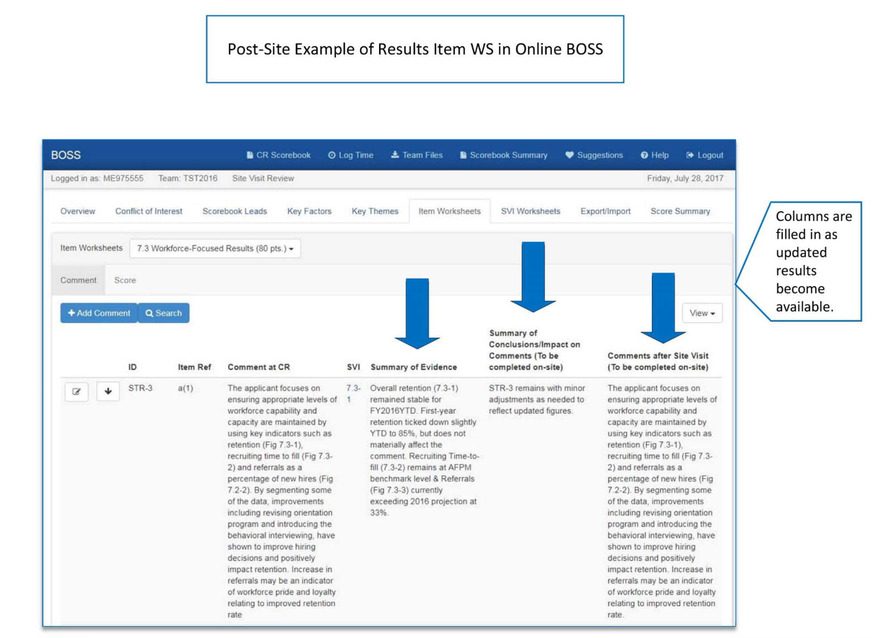

## SITE VISIT SCORING

As a final step in the evaluation process, the team works as a group to confirm the scoring range for each item and to determine the overall bands for process items and for results items.

In BOSS, Item Leads propose recommended scoring ranges and provide rationale using the Score tab BOSS transfers the scores from the Item Worksheets to the Score Summary Worksheet and indicates whether the scoring range changed or stayed the same .

Finally, the team leader conducts a scoring discussion to confirm the ranges or to come to consensus if needed. It is important for the team leader to ensure that the impact on comments, the scores on the Item Worksheets, and the scores on the Score Summary Worksheet match.

The team then refers to the Scoring Band Descriptors and determines which band descriptor for process items and which for results items most accurately reflects the team’s view of the applicant. If the team is considering a scoring band change, the discussion must include reasons for that change (the team leader records the reasons to share during the first call at the November Judges’ Meeting). These scoring band numbers are included on the Score Summary Worksheet. The Scoring Band Descriptors are used in the opening paragraph of the applicant’s feedback report.

## COMPLETING THE SCOREBOOK (before leaving the site visit)

The scorebook editor or team leader revises the final Key Themes Worksheet with updated comments resulting from the findings and the conclusions noted on the SVI and Item Worksheets. Team members provide input on the comments on the Key Themes Worksheet through ongoing discussion and online BOSS review and feedback. To finalize key themes, just as for scoring, the team leader facilitates a team discussion.

The assigned team member drafts the Summary of Sites Visited, shares it with team members, and uploads it to Team Files.

All team members sign the signature page and include their User ID.

**Conducting Final Checks**

Clarify and standardize the language of the item comments and the key themes (e.g., names of the applicant and processes).

Eliminate any conflicts between strengths and OFIs both within and between items and key themes.

Ensure that all comments conform to the Comment Guidelines (e.g., avoid jargon, prescriptive sentences, and negative tone; include specific examples and figure references; focus on the Criteria questions).

Verify that all statements such as “it is not clear,” “it does not appear that,” and “it is not evident” are changed to reflect the site visit findings.

The Baldrige monitor retains an electronic copy of the scorebook and the team’s signature page.

**Checking and Refining Comments in the Site Visit Scorebook**

The team leader may make additional edits after the site visit, posting the scorebook on BOSS by midnight Pacific Time on the Monday following the site visit.

After the site visit has been completed the team leader prepares for the November conference call with the Judges Panel and the technical edit call with the lead judge and the Baldrige monitor. The team leader reviews the report for significant corrections and clarifications. This may take place after the deadline for finalizing in to BOSS and, if revisions are needed, they are discussed on the call with the Judges Panel.

After the technical edit call with the lead judge and Baldrige monitor, the team leader may be asked to make additional edits.

# APPENDIX A: Creating SVIs & Item Worksheets in PDF

In the event that wifi service at the hotel becomes unavailable for an extended period, the team will need to update the PDF files that were created and downloaded during the planning phase. At the end of the site visit week, they will then need to be imported to BOSS. Following are examples of how these PDFs are to be completed.

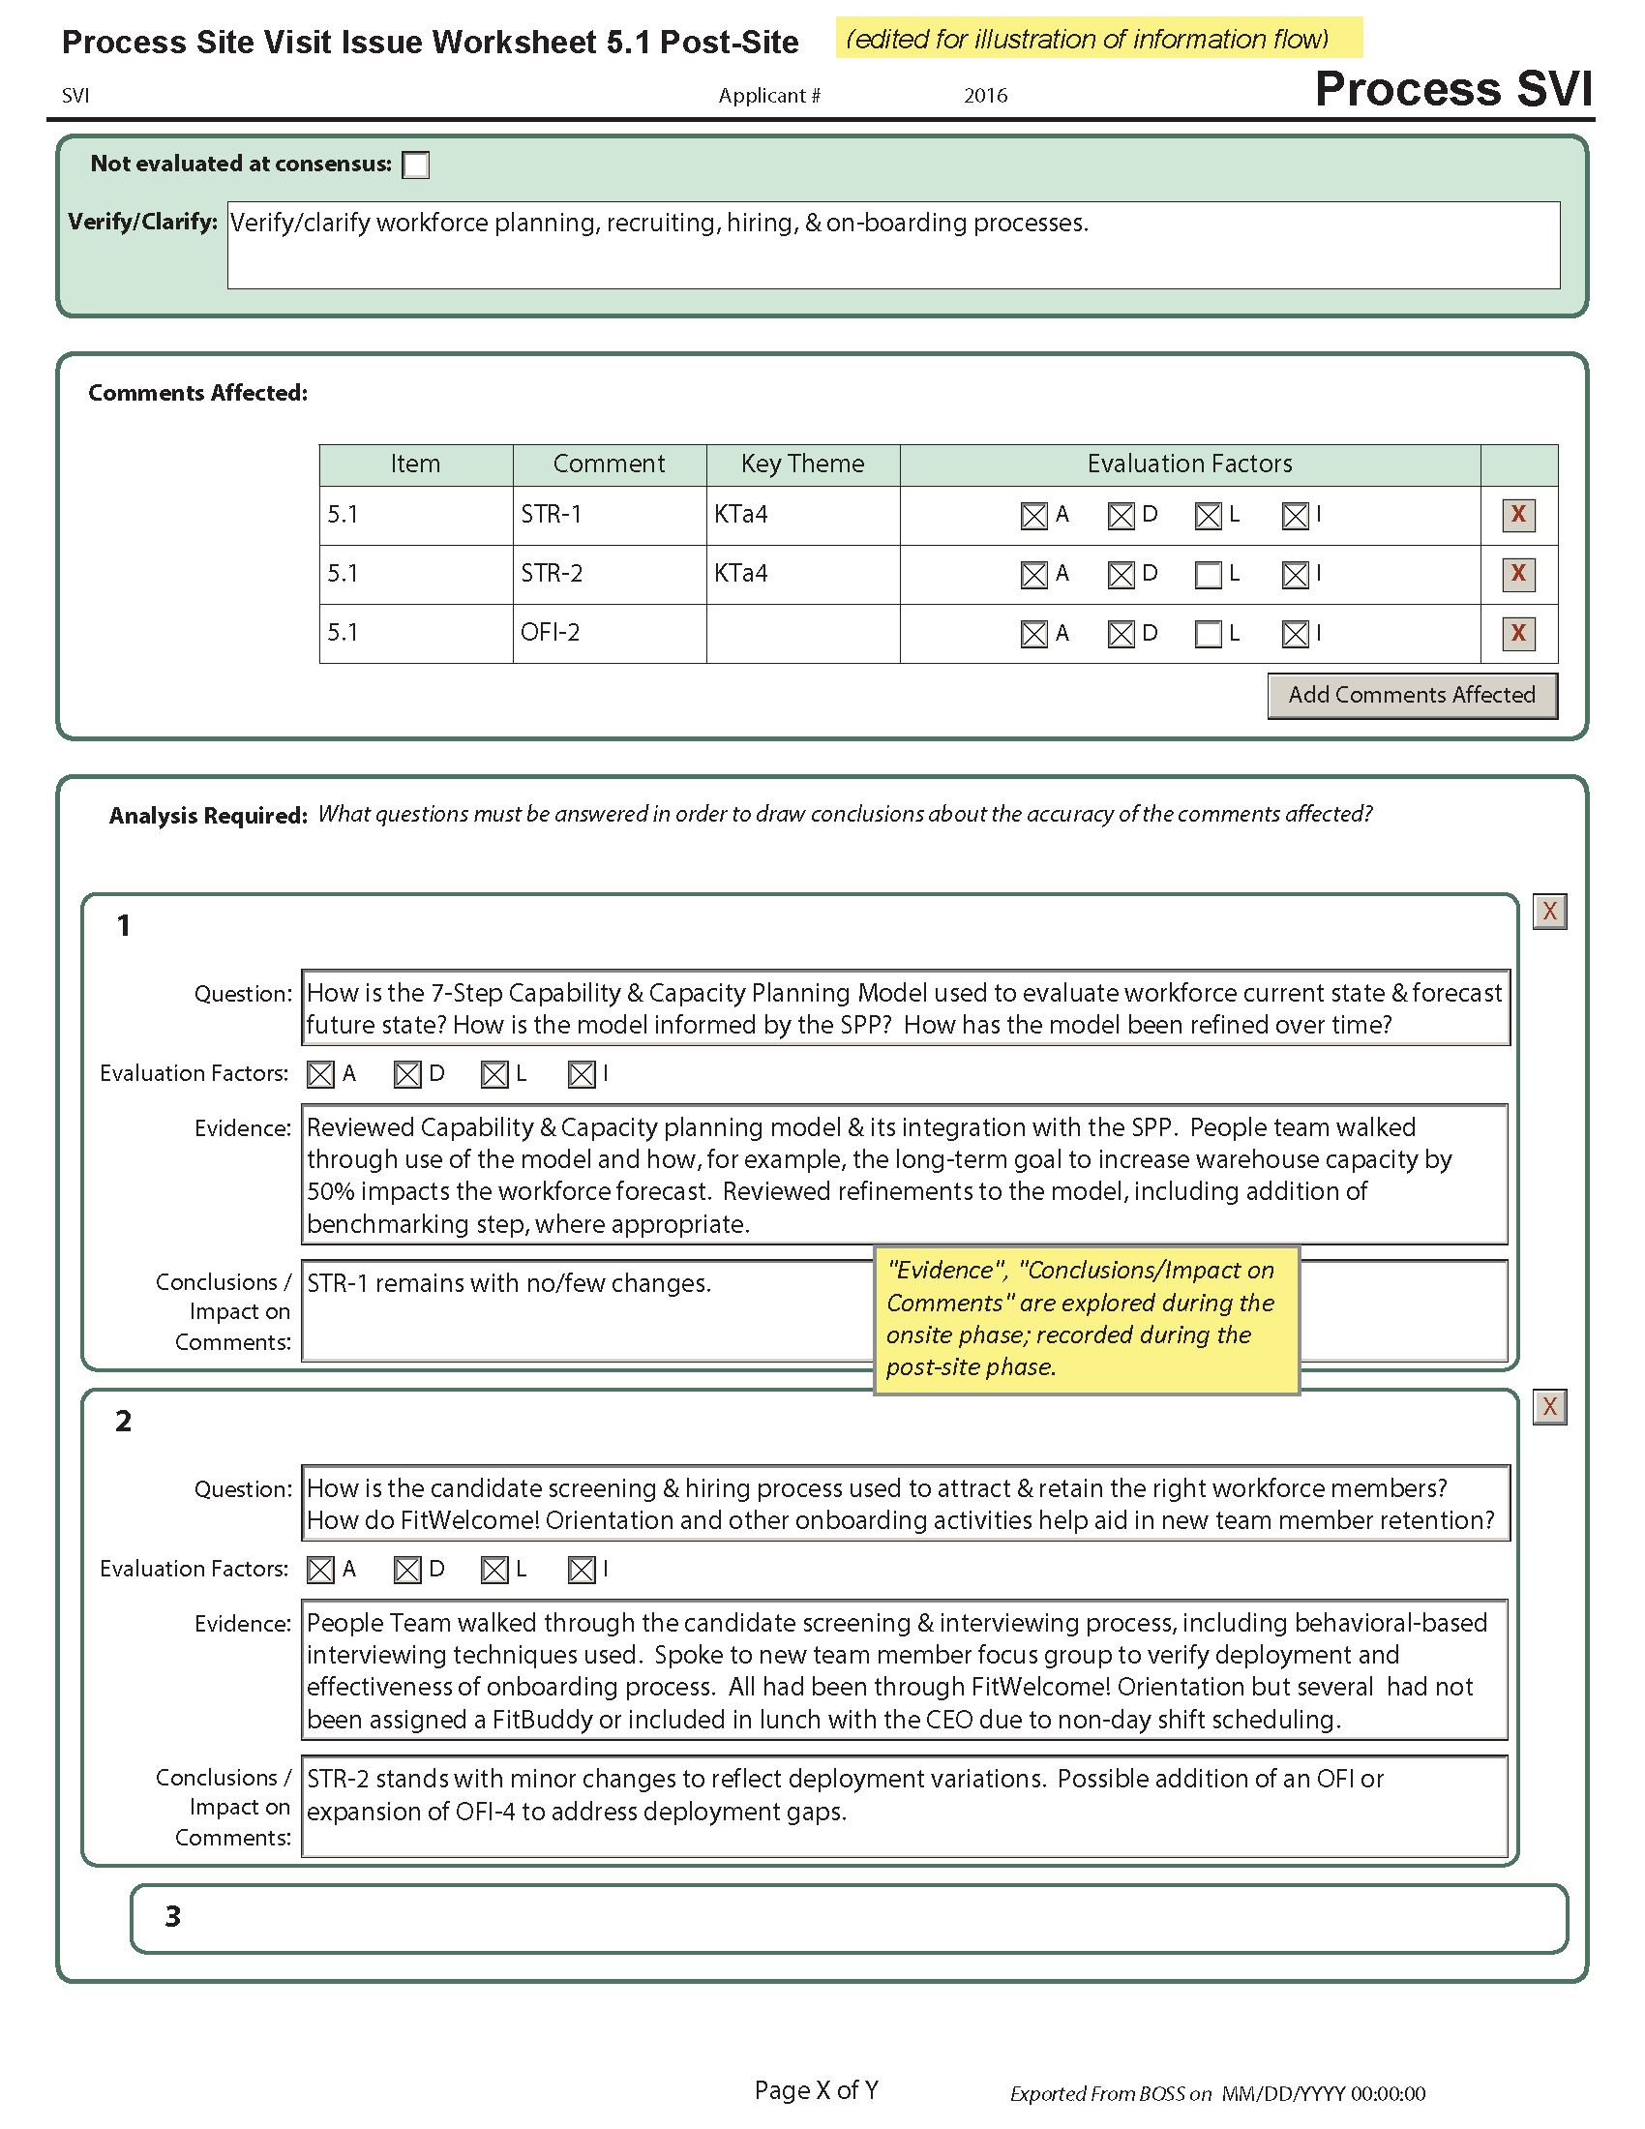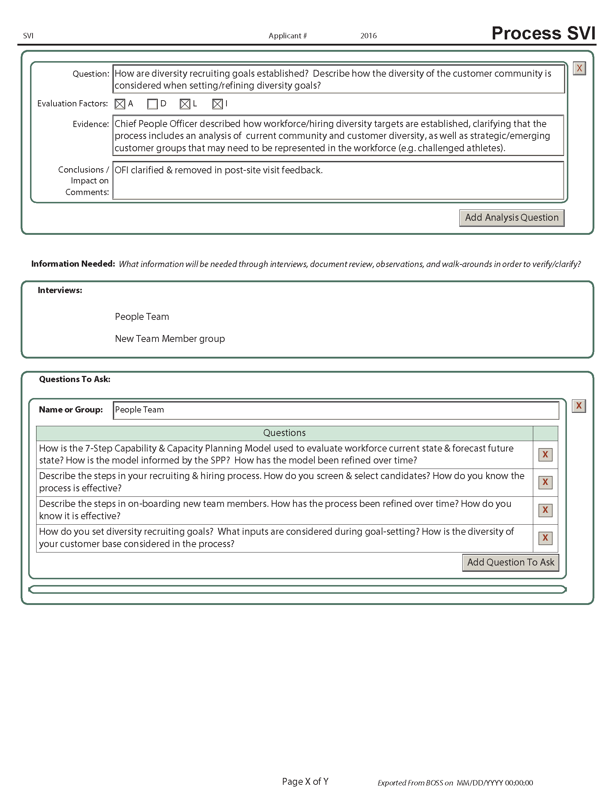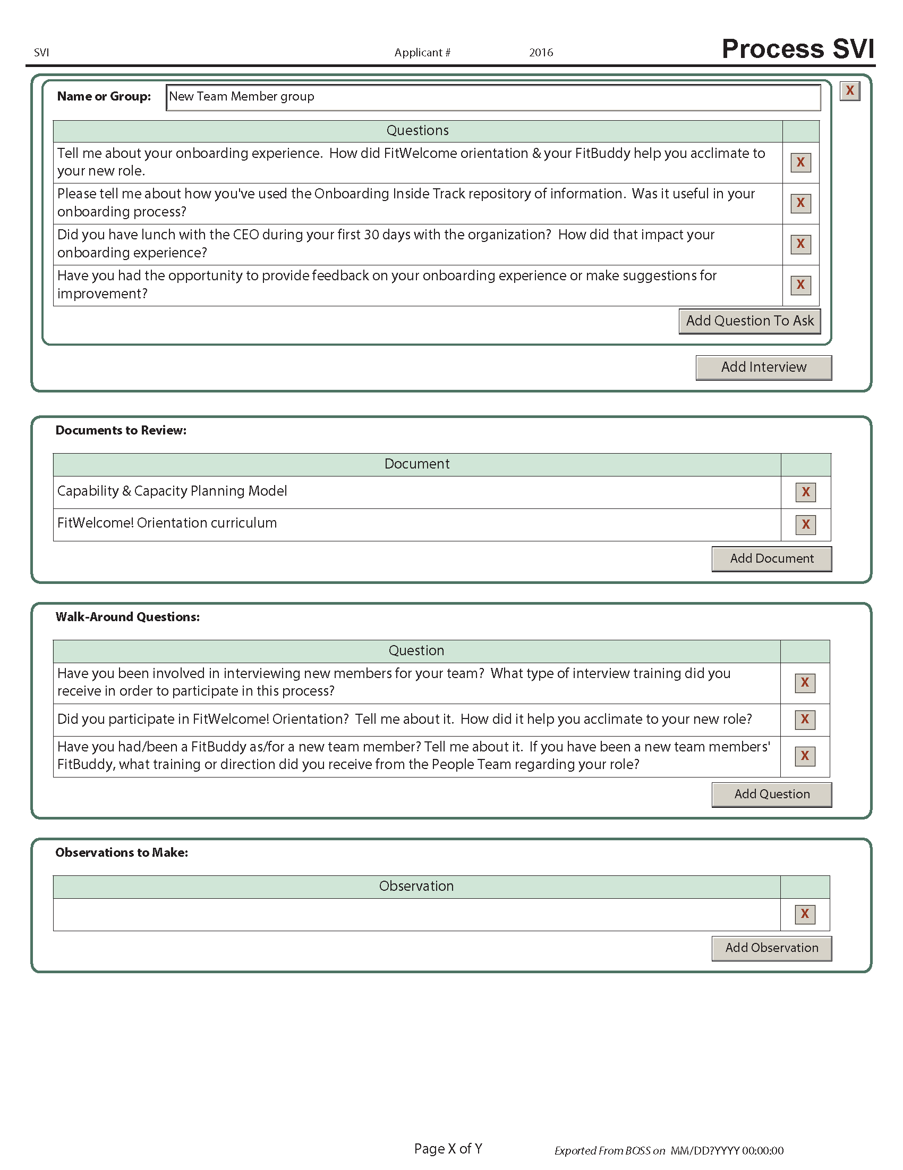

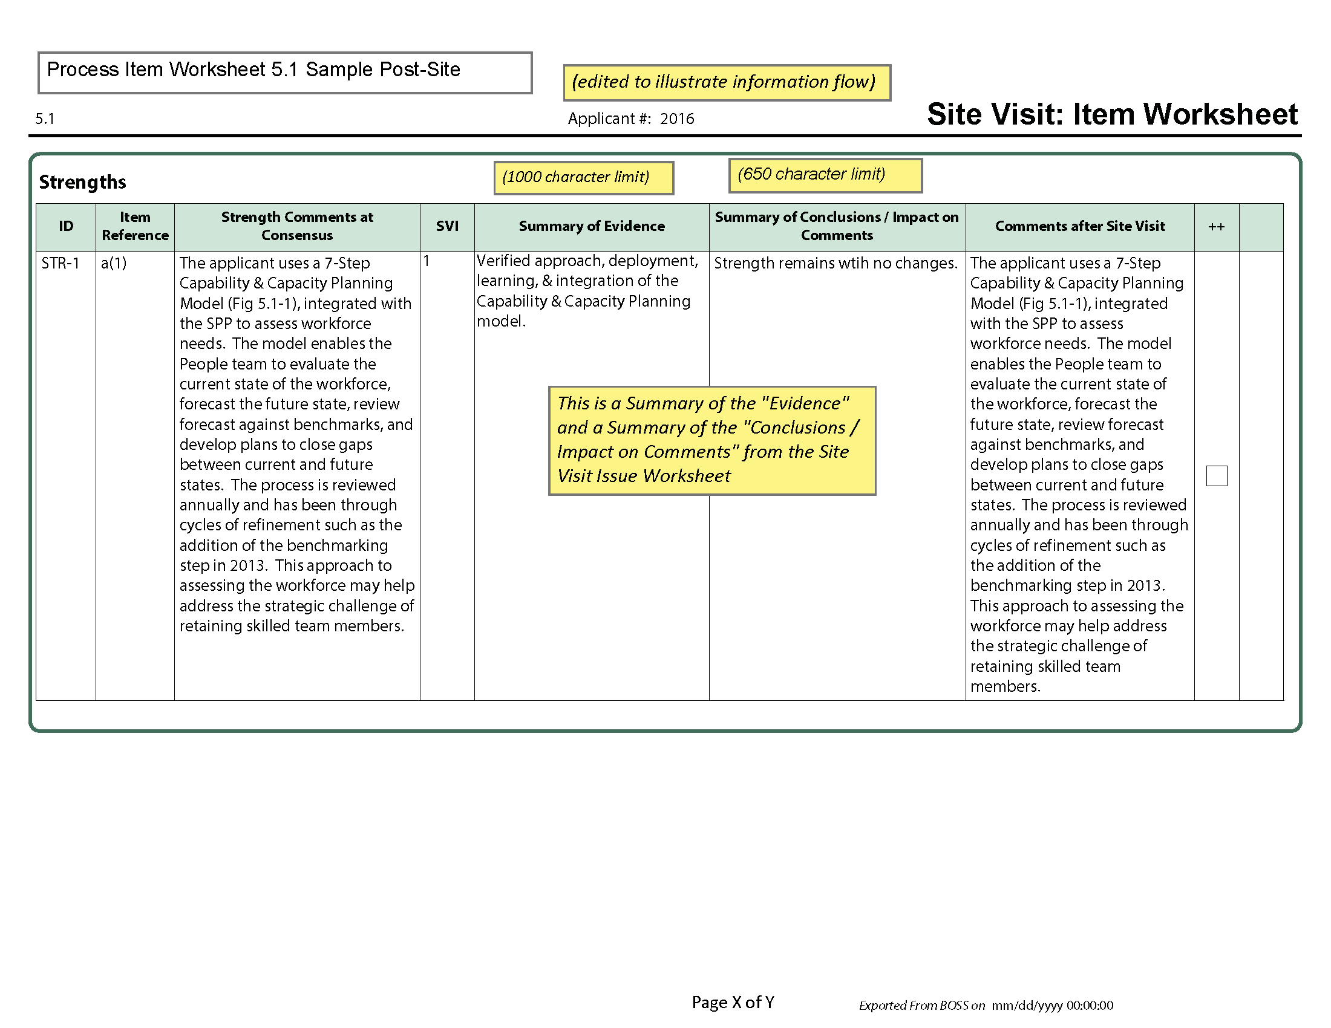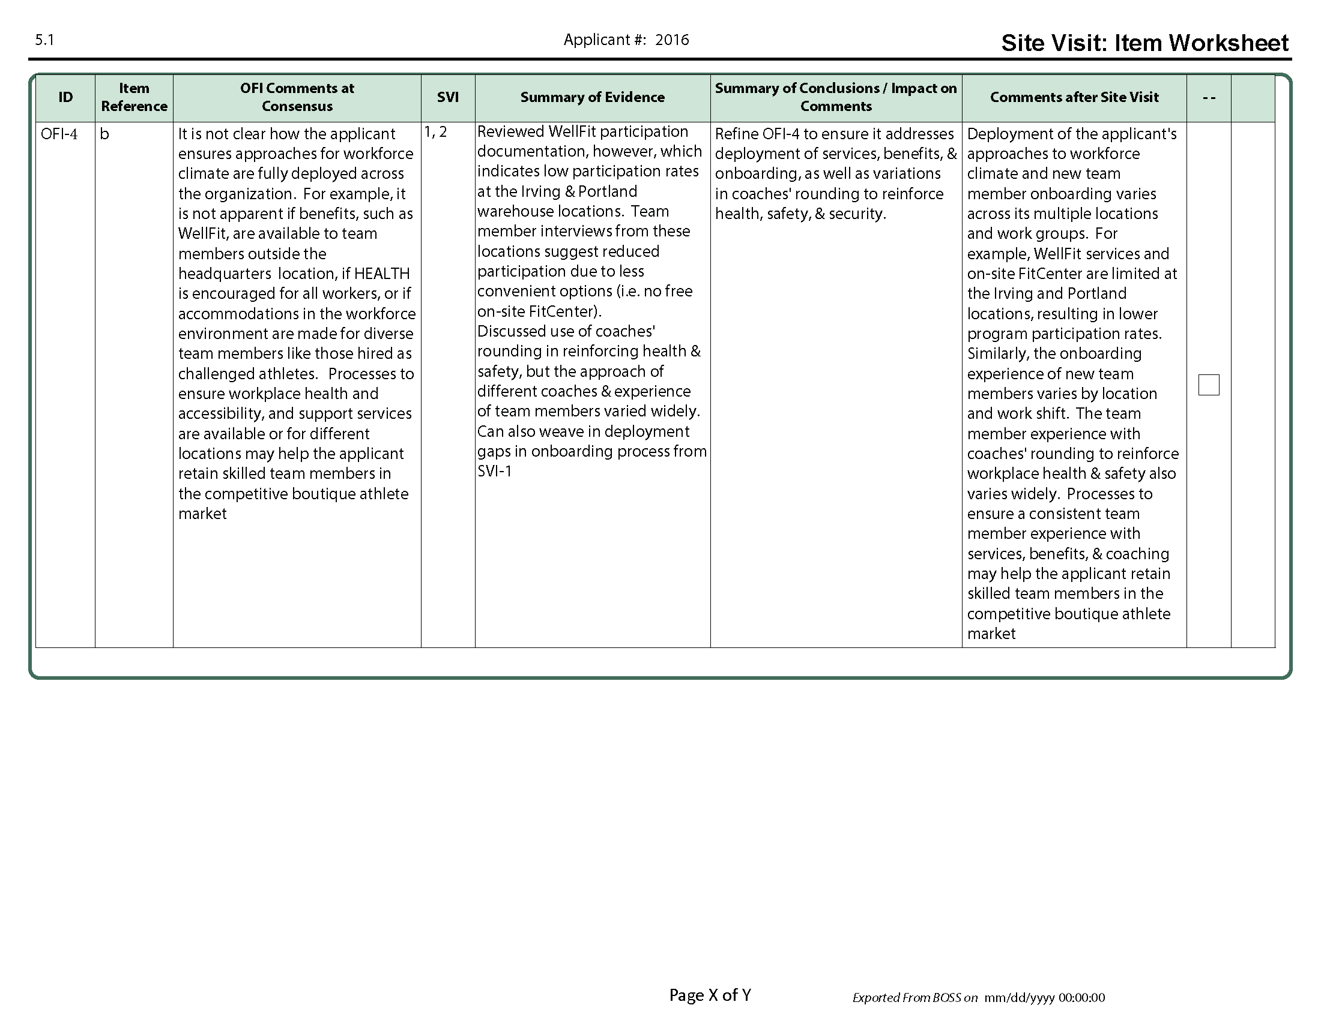

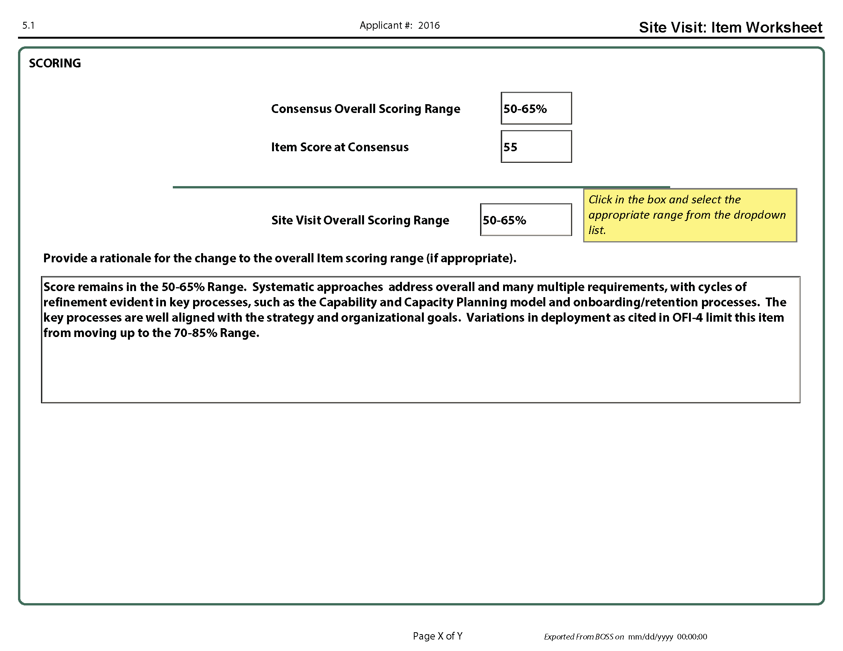

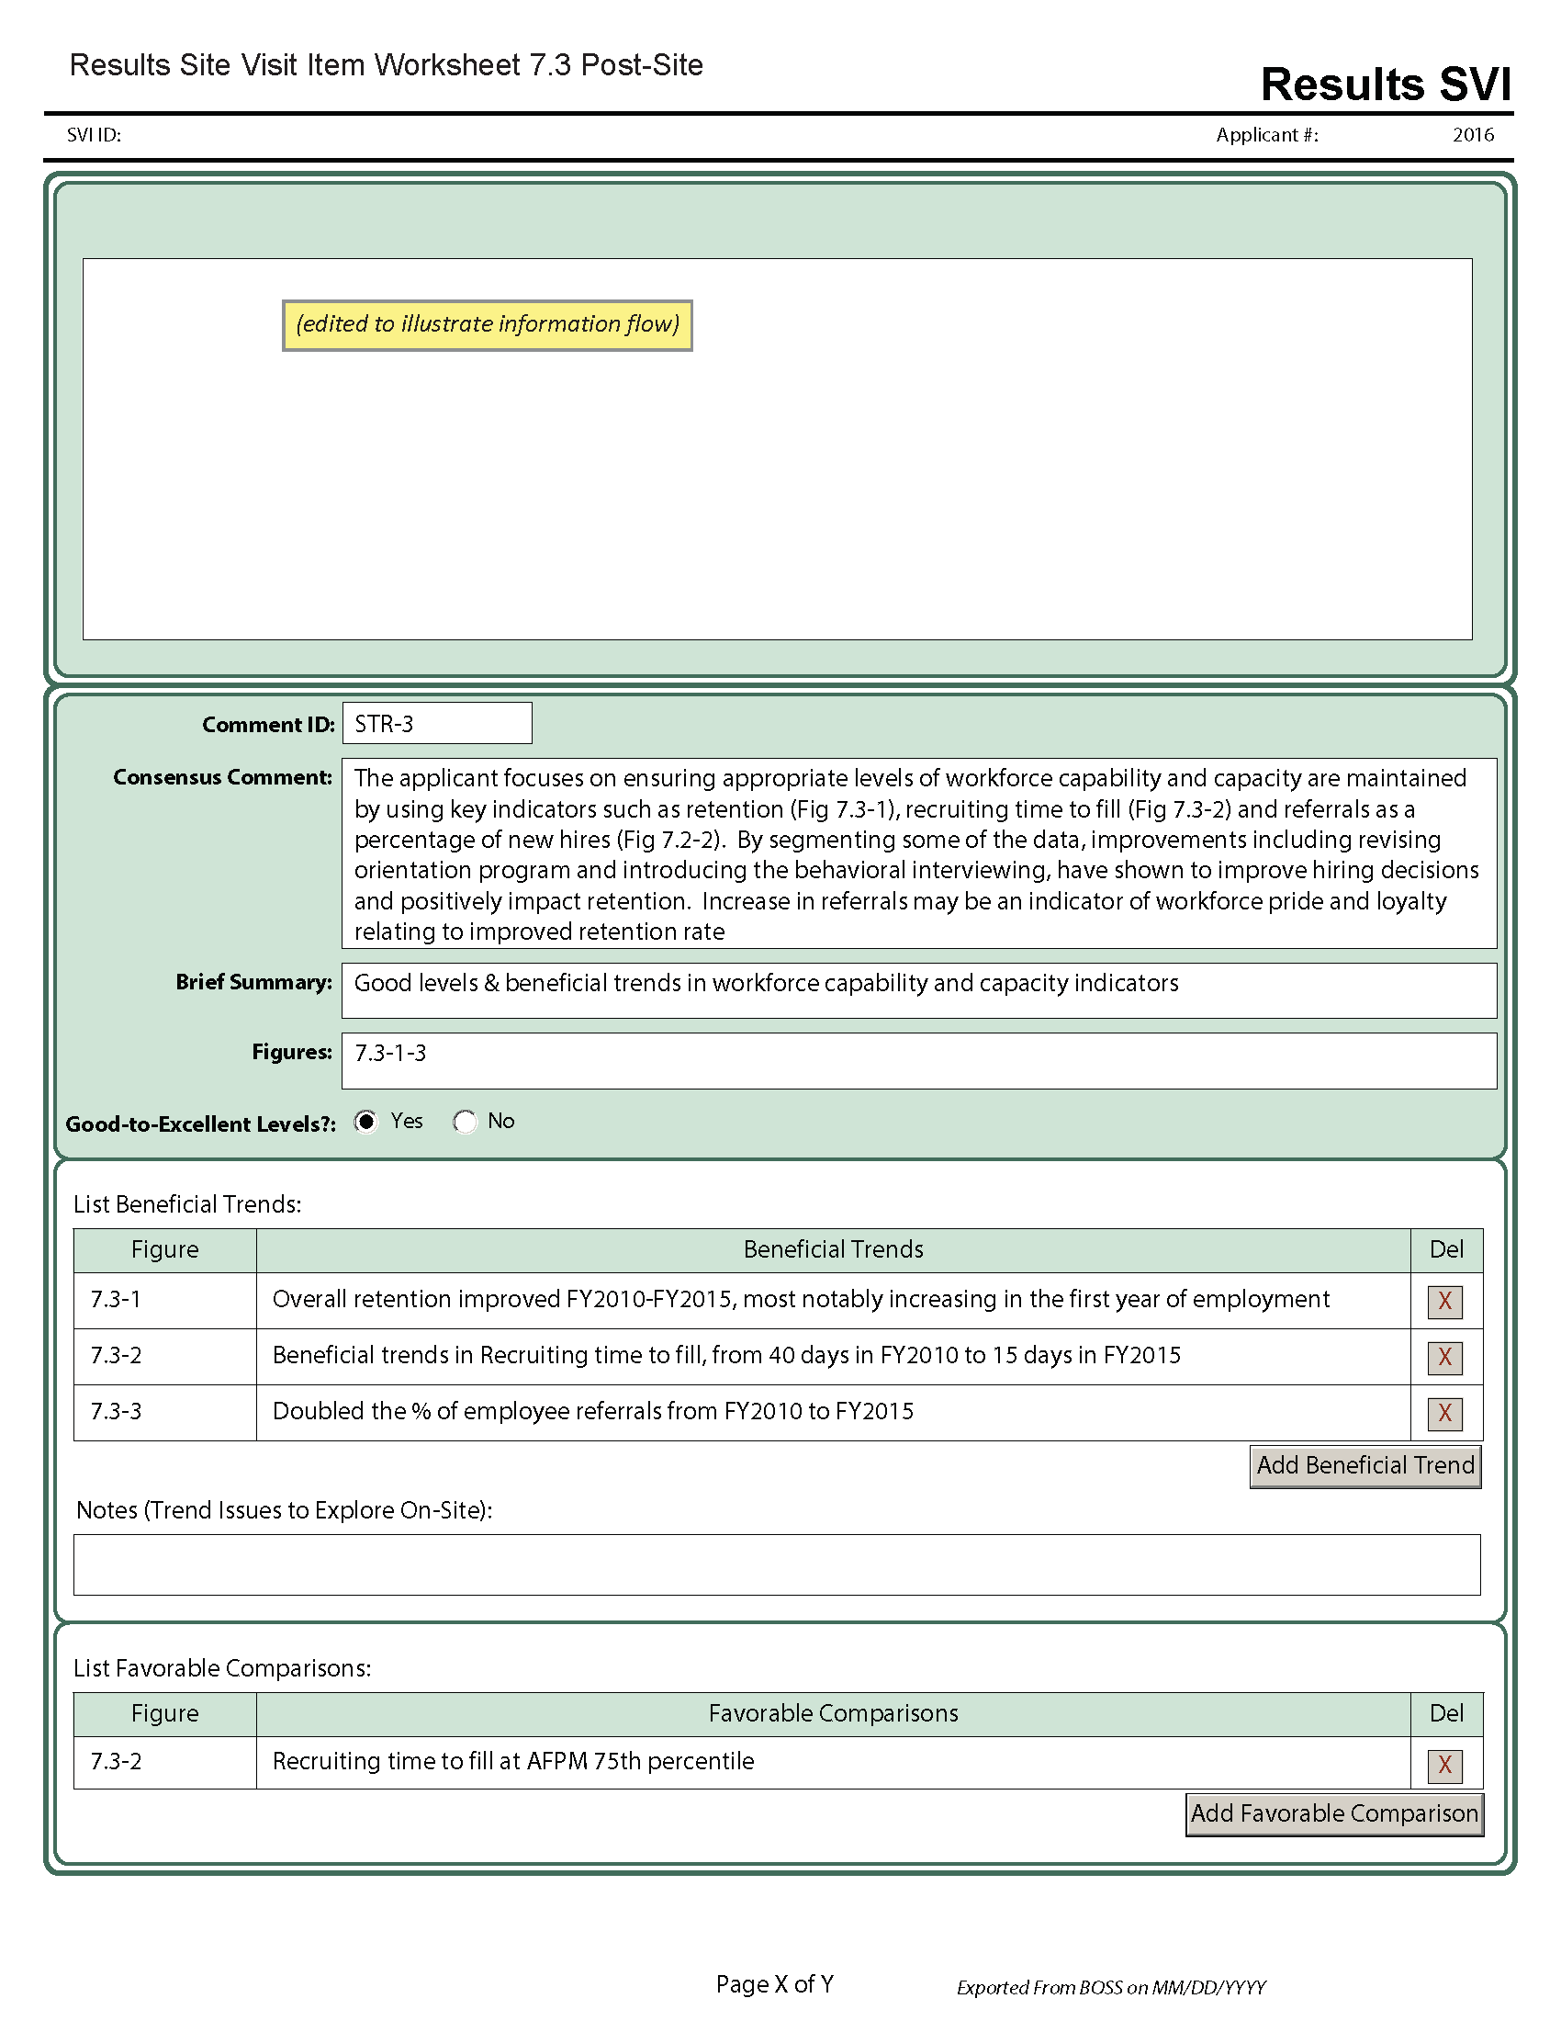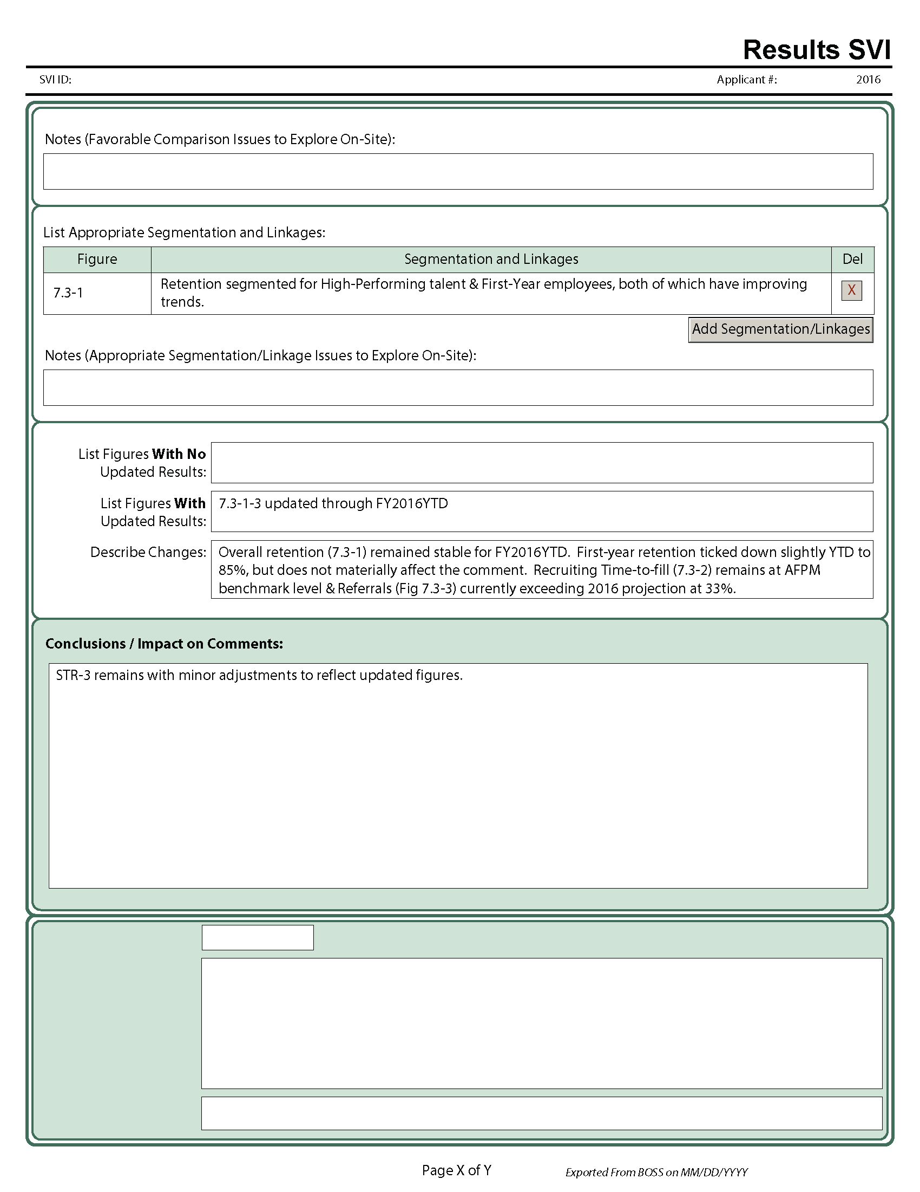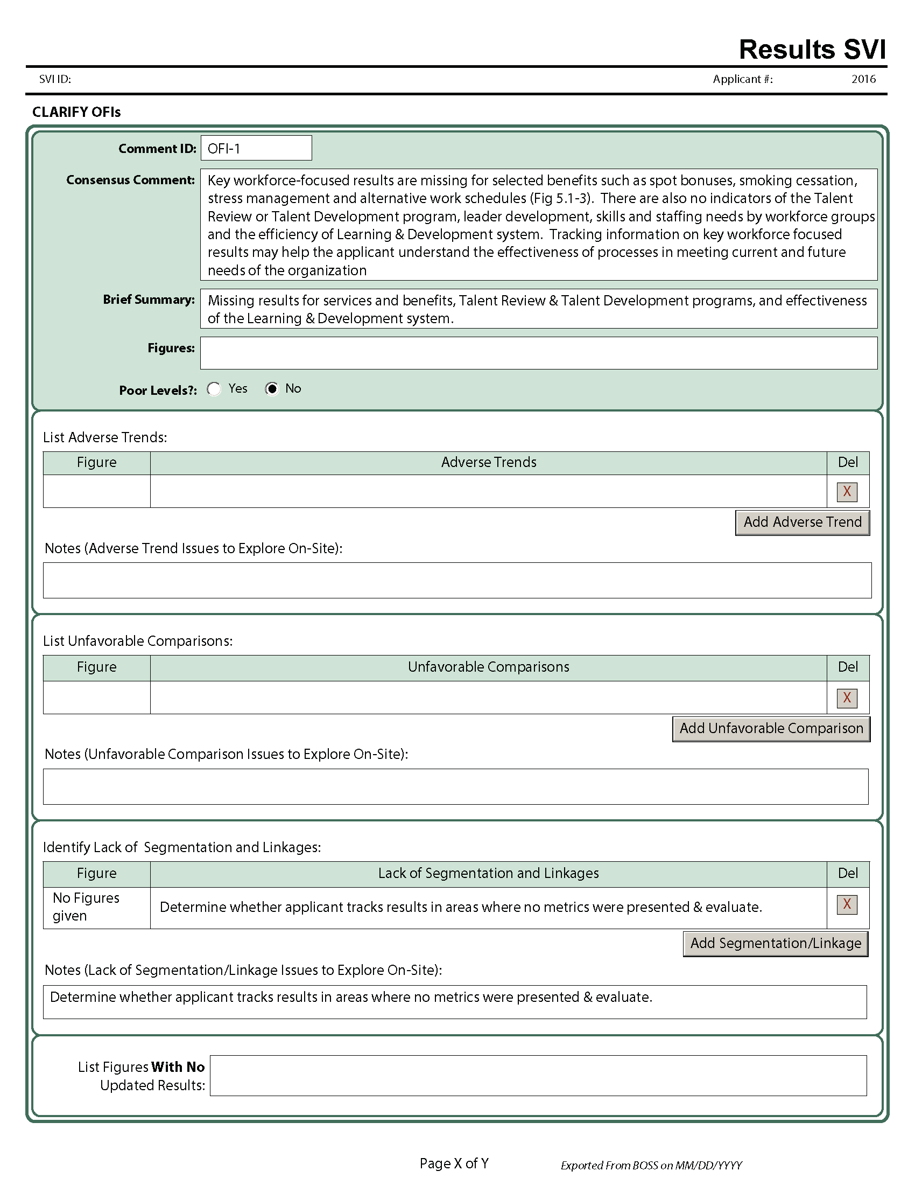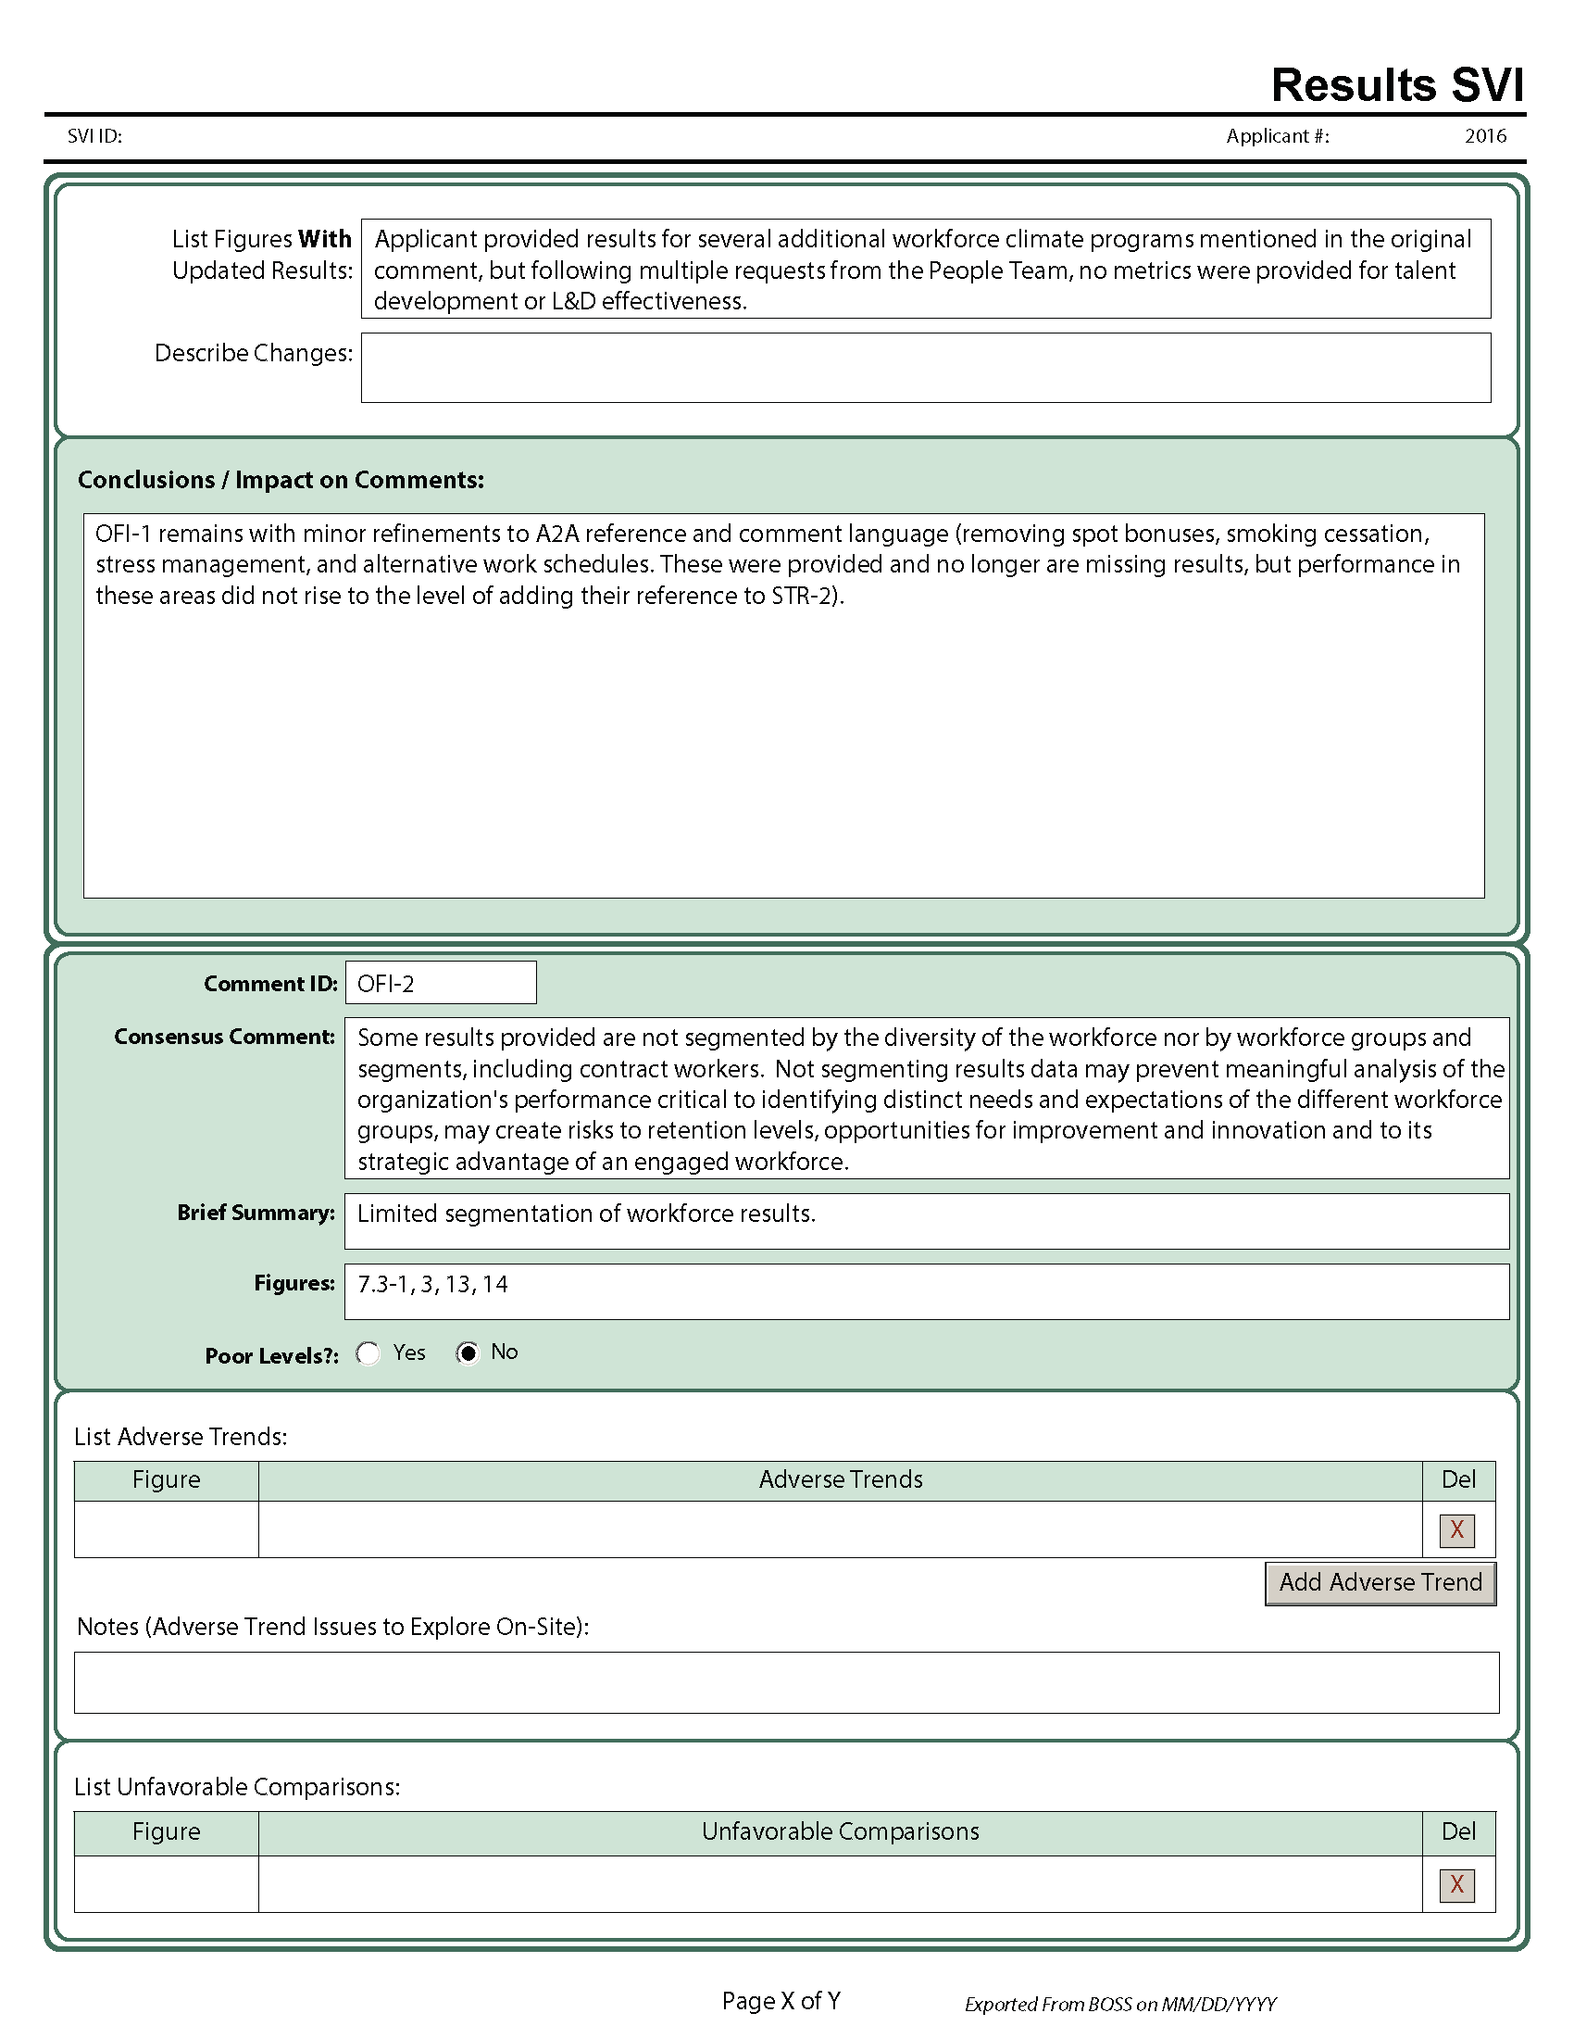

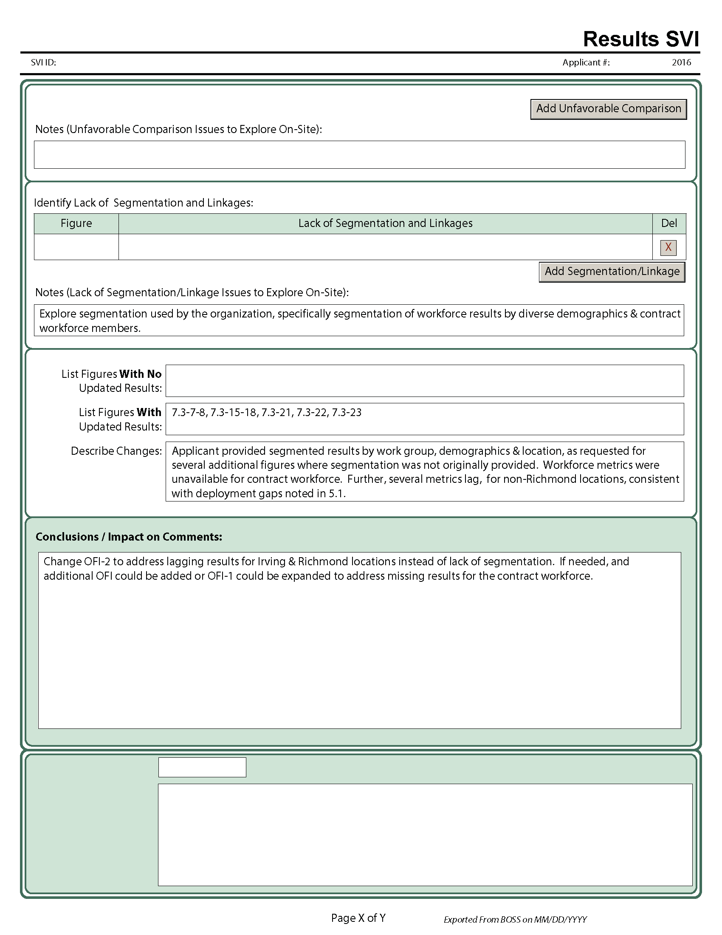

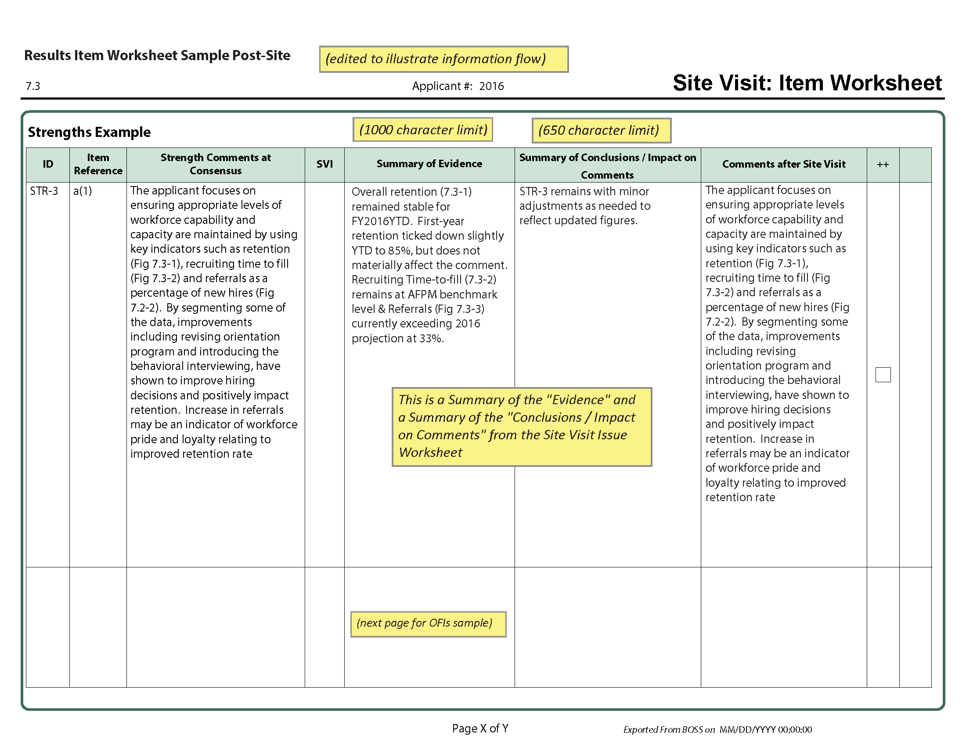

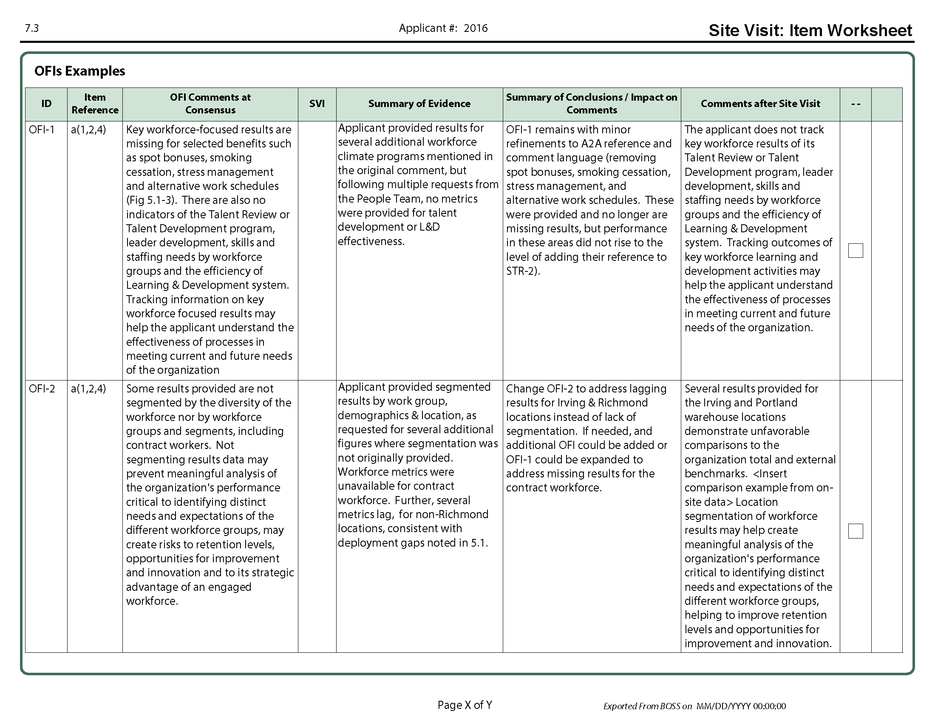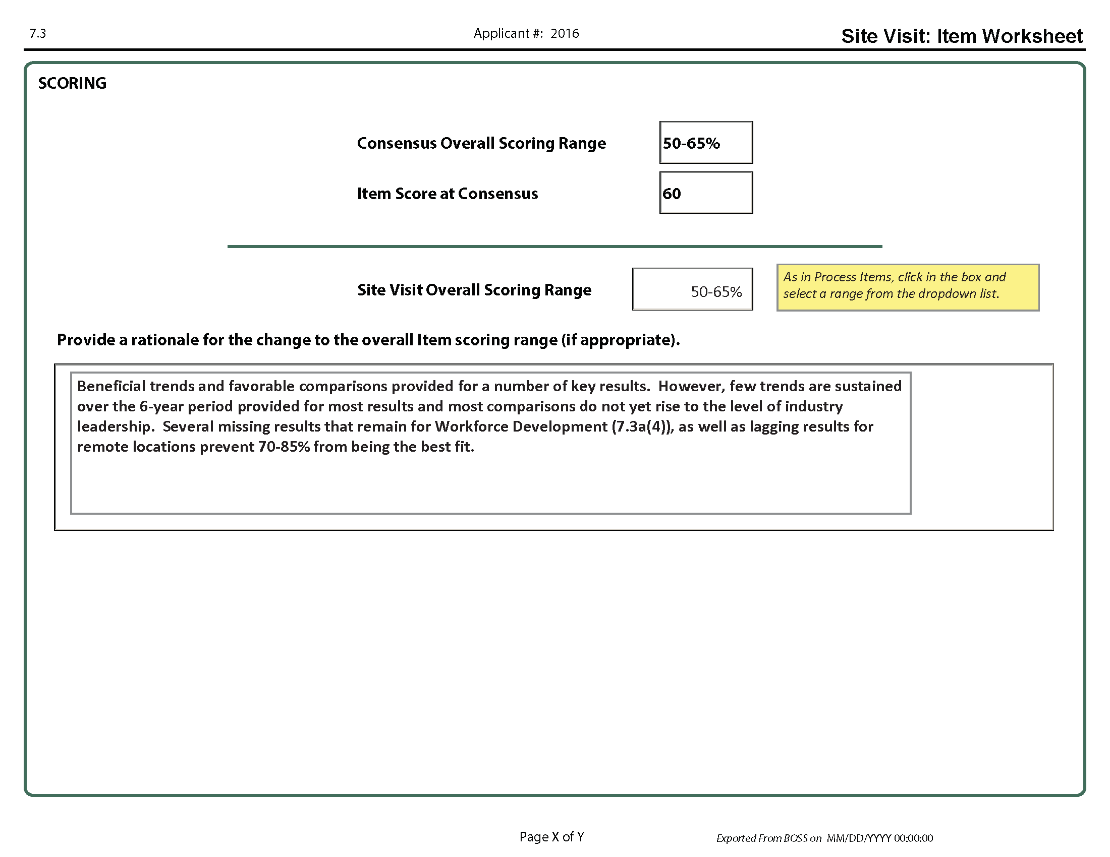

# APPENDIX B: Site Visit Roles & Responsibilities

|  | **Role** | **Initial Planning Preparation** | **Final Preparation  & Sunday Planning Meeting** | **On-Site** | **Preparation of the Site Visit**  **Scorebook** |
| --- | --- | --- | --- | --- | --- |
| **TEAM**  **LEADER**  **(TL)** | * Serves as contact point for OCP and Baldrige monitor * Manages completion of scorebook components * Works closely with backup TL to help the team work effectively * Assigns leads and backups for all items (if possible, TL does not lead any items, allowing more time to back up and coach the entire team) | * Calls team members and OCP * Drafts tentative site visit plan and shares plan with team and Baldrige monitor * Works with the team to develop and finalize SVIs, focusing on issues of central importance to Criteria and applicant * Prepares a list of documents for team review, aggregated in BOSS, to request from the OCP, as well as a tentative interview schedule. If appropriate, interview requests include staff at multiple locations * Keeps OCP apprised of plans during regularly scheduled telephone calls   Notifies Baldrige monitor of inter-site travel, if applicable   * Completes and forwards necessary forms to ASQ * Develops a timeline to help manage the work of the team throughout all phases of the Site Visit Review * Downloads all items, SVI Worksheets, and as PDFs to take to site | Leads development of, reviews, and finalizes site visit strategy, agendas, document requests, and interview schedules  Sends OCP the document request list and a tentative agenda for day one of the site visit ten days in advance  Prepares for opening meeting, featuring BPEP slides  Reviews requested documents | * Begins opening meeting using BPEP slides and providing brief remarks * Makes adjustments to the site visit plan as required * Monitors progress on completion of SVI Worksheets * Keeps the team on task and on schedule * Plans and conducts caucuses to help keep the team focused on key themes and other important issues * Informs OCP of changes and needs * Conducts HRO interview, with Baldrige monitor, and completes HRO Interview Worksheet * Ensures that the team has all relevant information and documents to close out each SVI before ending the on-site phase * Ends the site visit with a short “thank you” and next steps, using BPEP slides, at the closing meeting at the applicant’s location | * Provides the team with a time frame for completion * Facilitates discussion of findings and review of scorebook components * Reviews scorebook and provides edits as necessary * Ensures that SVI, Item, and Key Themes Worksheets are appropriately prepared, reviewed, and finalized in BOSS * Retains an electronic copy of all Item Worksheets and SVIs in PDF and other documents in Word. (Keeping a paper copy is optional.) * Reviews and edits the scorebook as necessary after leaving the hotel, using BOSS or importing any changes to BOSS, by midnight PDT on Monday after site visit * Prepares for the judges’ call in November * Responds to and works with BPEP and judges to address questions/ comments on Site Visit Scorebook after Judges’ Meeting |
| **BACKUP TEAM**  **LEADER**  **(BUTL)** | * Steps in for the TL if the TL is unable to go on-site * Works closely with TL to plan, coordinate, and communicate with the team * Serves as a mentor for team members on-site and assists as needed to keep the team on track * Depending on the makeup of the team and complexity of the applicant, may not have items to lead in order to help coach team members and provide feedback to them on their work. | Assists TL as needed. For example, the backup TL could   * review the draft site visit plan * review other team members’ SVIs and give feedback on improvements * schedule planning calls * suggest item and other team assignments * draft call agendas * take the lead in site visit logistics planning * join TL/ Baldrige monitor on planning call(s) * review the initial document request and edit as needed * orient new team members * review confidentiality requirements * participate in planning calls with TL and OCP * review, manage, and track the leadership questions, walk-around questions, and/or interview requests | Assists TL as needed. For example, the backup TL could   * draft the agenda for the team’s Sunday planning meeting at the hotel * coordinate the initial document request * mentor less-experienced teammates * review requested documents | Assist the TL as needed. For example, the backup TL could   * mentor less-experienced teammates * take the lead on the Key Factors Worksheet, Key Themes Worksheet, and/or Summary of Sites Visited * track progress on completion of SVIs * keep team on task and on schedule * lead daily debrief and/or caucus discussions * take leadership role for traveling teams so TL can remain at headquarters | Assists TL as needed. For example, the backup TL could   * facilitate the discussion of findings and review of scorebook components * review the scorebook and provide edits as necessary * ensure that SVI, Item, and Key Themes Worksheets are appropriately prepared, reviewed, updated and finalized * retain an electronic copy of the Site Visit Scorebook (a paper copy is optional) * help TL prepare for the judges’ call in November |
| **TEAM**  **MEMBERS** | • Plan, maintain focus, contribute, and communicate effectively in performing assigned site visit tasks   * Meet TL’s and backup TL’s schedules and deadlines | * Arrange transportation to and from the site (between home and hotel) and provide travel details to ASQ * Review evaluation materials * Review online training materials * Working with item backup, develop SVIs and start work on SVI Worksheets * Review rules of conduct * Complete other assignments (consolidate document requests, establish interview schedule, etc.) * Provide feedback on team’s SVIs * Exports all assigned documents as PDFs to take to site | * Finalize interview plans, the lists of required documents, and strategies for SVI Worksheets and by the TL * Attend and participate in Sunday planning meeting at hotel * Review requested documents | * Work in pairs for 2-4 days on-site * Gaither information to clarify and verify assigned SVIs * Conduct interviews with applicant’s representatives * Review documents and data * Attend all team caucuses and meetings * Take thorough notes * Record findings and conclusions on SVI Worksheets as site visit progresses * Have all documents needed to close out all SVIs before the closing meeting, which marks the end of the on-site phase | * Share findings with team at team caucuses/meetings * Update SVI Worksheets, seeking shared understanding among team members * In BOSS, review and provide feedback for all SVI, Item, and Key Themes Worksheets * Complete scorebook components, building on content of the Consensus Scorebook * Review scorebook components of other team members * Stay with team until scorebook is completed and signed by all team members (2 – 3 days after the on-site phase) |
| **SCOREBOOK**  **EDITOR**  **(TL, backup TL, or another team member)** | Ensures that the scorebook adheres to Criteria questions and follows the Comment Guidelines | SAME AS TEAM MEMBERS | SAME AS TEAM MEMBERS | SAME AS TEAM MEMBERS | In addition to team member responsibilities:   * Clarifies and aligns the language among item comments and key themes * Eliminates any conflicts between strengths and OFIs within and between items and key themes * Ensures that all statements such as “it is not clear.” “it does not appear that,” and “it is not evident” are changed to reflect the findings of the site visit * Revises scorebook as necessary to ensure that comments adhere to Comment Guidelines |
| **BALDRIGE** **MONITOR** | * Assists the team and TL in planning and conducting the site visit as needed * Assists the applicant in understanding the site visit process and serves as a contact for the applicant to address issues and concerns | * Monitors the process * Supports TL in planning the site visit as needed * Provides coordination and guidance * Contacts OCP to explain the process and answer questions * Reviews draft SVI Worksheets * Participates in planning calls * Coordinates with OCP delivery of documents requested before Sunday planning meeting * Downloads all documents as PDFs before leaving for site | * Supports TL * Stays in contact with OCP * Ensures that all necessary equipment and supplies are available before the beginning of the Sunday planning meeting * Ensures that the team room is set up appropriately * Coordinates arrival of applicant materials at team room before the Sunday planning meeting * Attends Sunday planning meeting to monitor the process and provide logistical assistance | * Attends HRO meeting with TL * Attends team meetings * Answers process questions from applicant and team * Keeps OCP apprised of plans and answers questions each day * Provides logistical support for team (hotel issues, food, etc.) * Serves as the contact person to deal with on-site problems or issues * Coordinates pickup of the applicant’s materials at the end of the visit * Answers any questions from OCP / HRO regarding Category Best Recognition requirements | * Assists team with BOSS * Reviews the work of the team and provides feedback related to the process and Comment Guidelines * Ensures that all applicant materials are returned to OCP at completion of the site visit * Reviews the Site Visit Scorebook, checking comments for consistency with Comment Guidelines * Prepares summary of applicant’s highlights for Judges’ Meeting * Prepares summary of applicant used in briefing the Secretary of Commerce about award recommendations * Retains an electronic copy of the entire Scorebook |
| **JUDGES** | * Recommend applicants to receive the award | * Chair conducts training conference call for TLs |  |  | * Review scorebooks after site visits * Lead judge for each applicant: prepare highlights for briefing other judges * Recommend award recipients & Category Best Recognition * Conduct evaluation of judges’ process * Review and edit Scorebooks |
| **OCP**  **or**  **ALTERNATE  OCP** | * Works with TL and BPEP | * Coordinates arrangements, including on-site meeting space * Works with TL on scheduling and logistics for interviews * Provides information to TL and Baldrige monitor * Schedules inter-site travel and travel of team to/from hotel, as needed * Provides updated data for results charts and graphs | * Based on TL’s request, compiles documents and arranges meetings for first day of site visit * Ensures applicant documents arrive at the hotel conference room before Sunday planning meeting * Arranges logistics and prepares for opening meeting presentation | * Works with TL to schedule interviews * Provides inter-site transportation * Provides additional requested documents * Coordinates adjustments to schedule as needed * Informs Baldrige monitor of any concerns or questions about Site Visit Team interactions | * At the completion of the site visit, picks up all materials from Baldrige monitor |

# APPENDIX C: AGENDAS AND OTHER TOOLS

## SITE VISIT DAILY SCHEDULE **EXAMPLE**

The following example fits **most medium size, medium complexity** applicants. However, every applicant and every site visit team are different, so there is no one-size-fits-all prescription for how each day of site visit should run. Team Leaders, Backup Team Leaders and Monitors may need to work together to make adjustments to this schedule as needed. In making adjustments, ensure that the following must happen:

* **1st Day Planning (Sunday Planning) Meeting** begins at 9 am, and must cover all of the items listed in the agenda, although times may vary as needed.
* **Days 2 through 4 or 5:** End the on-site portion of the day no later than 5 pm . Report out nightly on SVI Worksheet progress, update SVI Worksheets as needed, and review plan for the following day on-site. Again, times may vary. Teams on small applicants may be able to begin R1 on Day 4
* **Day 4, 5, or 6:** Complete R1, prepare for R2. Teams on small applicants may be able to complete R2 and possibly R3 by the end of the day. Teams on very large or complex applicants may not have time to prepare for R2.
* **Day 6, or 7**: Complete R2 early, complete R3, Key Themes and Scoring Bands by the end of the day. Teams on small applicants may be able to complete post site work by day 6. Teams on large organizations may need to go into Day 7 to complete R3, Key Themes, and Scoring Bands. But remember that the goal is to be completely finished the deliverables by day 10 at the latest.

**1st Day (previously the Sunday Planning Meeting) Agenda - Sample**

9:00 am – 9:30 pm Review of the daily site visit schedule (virtual meeting)

9:30 am – 12:30 pm Document review and SVI updates (unless already completed during planning)

12:30 pm– 1:30 pm Lunch / personal time

1:30 pm – 4:00 pm Full SVI review and strategy adjustments (virtual meeting)

4:00 pm – 5:00 pm Item leads adjust and redraft SVI Worksheets (with backups)

5:00 pm – 5:45 pm Schedule walkaround questions from the collated list (virtual meeting)

5:45 pm – 6:45 pm Dinner break

6:45 pm – 7:30 pm Item leads and item backups meet off – line to finalize strategies for interviews

7:30 pm – 8:30 pm Finalize the schedule for Monday and discuss the schedules for days 2 and 3 (virtual mtg)

8:30 pm Adjourn and rest

**Day 2 Agenda (first day with Applicant) - Sample**

***Note: For virtual site visit, this is a very aggressive agenda. If there is virtual meeting fatigue, nightly meetings should be moved to following morning.***

8:00 am - 5:00 pm On-site (see Day 2 on-site schedule)

5:30 – 6:15 pm Personal/Dinner Time

6:15 pm – 6:45 pm Virtual Meeting

* Review evening schedule
* Key learnings/findings from on site
* Potential role model practices or vulnerabilities
* Feedback from applicant, if any

6:45 – 8:30 pm. Team Individual Work:

* Update SVIs with evidence, new documents and interviews   
  needed, if any
* Post at least one completed Process SVI Worksheet   
  and Results SVI Worksheet to BOSS
* Team begins reviewing closed SVIs, time permitting
* Revise any comments in Item Worksheets if able, and time permitting

7:00 pm – 8:00 pm Night shift virtual interviews, if needed

8:00 pm - – 9:30 pm Nightly Virtual Team Meeting:

* Confirm and update team on SVIs closed, updated, and those   
  needing more information from the team
* Identify new documents needed
* Identify new interviews needed
* Review nest day schedule and get input
* Review next day walkaround questions

9:30 – 10:00 pm Update SVIs as needed based on team meeting info

10:00 pm Adjourn (Team members who need to finish up may stay later if necessary)

**Day 3, 4 Agenda - Sample**

8:00 am - 5:00 pm On-site (see Day 3 on-site schedule) . Note: This starts later if nightly meetings were pushed into this morning.

5:30 – 6:15 pm Personal / Dinner Time

6:00 pm – 6:45 pm Virtual Team Meeting

* Review evening schedule
* Key learnings/findings from on site
* Potential role model practices or vulnerabilities
* Feedback from applicant, if any

6:45 – 8:30 pm. Individual Work:

* Update SVIs with evidence, new documents and interviews   
  needed, if any
* Begin reviewing others’ CLOSED SVI worksheets and providing feedback

7:00 pm 8:00 pm Night shift interviews, if needed

8:30 pm - – 9:30 pm Nightly Virtual Team Meeting:

* Confirm and update team on SVIs closed, updated, and those   
  needing more information from the team
* Identify new documents needed
* Identify new interviews needed
* Update key factors and key themes as needed
* Review Wednesday schedule and get input
* Review Wednesday walkaround questions

9:30 – 10:00 pm Update SVIs as needed based on team meeting info and feedback

10:00 pm Adjourn (Team members who need to finish up may stay later if necessary)

**Day 4, 5 Agenda - Sample**

8:00 am – 11:00 pm On-site (see Day 4 on-site schedule)

11:00 am – 11:30 am Team convenes to ensure SVIs can close

Noon Return to hotel

12:30 pm – 1:00 pm Personal Time

1:00 pm – 2:00 pm Working lunch and team meeting

* Team briefing
* Review status and schedule for the afternoon

2:00 pm – 5:00 pm Complete/review and provide feedback/revise SVI Worksheets

5:00 pm - 6:30 pm Working dinner

* Review evening schedule
* Key learnings/findings
* Status of SVIs (open/closed)
* Potential role model practices or vulnerabilities
* Feedback from applicant, if any

6:30 pm – 8:30 pm Individual Work

* Review Others’ SVIs and Provide Feedback
* Finalize SVI Worksheets
* Begin finalizing Item Worksheets, time permitting

8:30 pm – 10:00 pm Nightly Team Meeting

* Discuss any residual concerns about SVIs
* Identify new documents needed if any (should be the exception)
* Update Key Themes as needed
* Review schedule for Thursday

10:00 pm Adjourn

**Day 5, 6, 7 Agenda - Sample**

8:00 am – 12:00 pm Continue work on Item Worksheets   
*Note: Team Leader and Backup, and Monitor to closing meeting   
somewhere in this time frame.*

12:00 pm – 1:00 pm Working lunch, and team discussion (if needed)

1:00 pm – 4:00 pm Item leads continue working on Item Worksheets, posting as you go

* Must post 2 item worksheets by 3pm

4:00 pm - 6:00 pm Item leads complete Item Worksheets by 6pm

6:00 pm – 7:00 pm Working dinner

* Team briefing; discuss KFs and KTs
* Review status and schedule

7:00 pm – 9:00 pm R1 of Item Worksheets and Document Inventory

* Item worksheets completed and posted by 9pm

9:00 pm – 10:00 pm Revise Item Worksheets

10:00 pm Adjourn

**NOTE**: Teams on small applicants may be able to complete R2 and possibly R3 by the end of the day. Teams on very large or complex applicants may not have time to complete R1. If this is the case, a goal should be set to complete R1 within the first 2 hours on Friday morning, and possibly start the day earlier.

**Day 6, 7, 8, 9 Agenda**

7:00 am – 8:00 am Breakfast

* Revise Item Worksheets, KTs, and KFs
* Complete Document Log

8:00 am – 10:00 am R2 of Item Worksheets in Team Meeting

* Presentation of each item by item leads (just the STR/OFI nuggets)
* Consense on strengths/OFIs and scoring

10:00 am – 12:00 pm Revise Item Worksheets, prepare for R3

12:00 pm – 1:00 pm Working lunch /discussion (as needed)

1:00 pm – 3:00 pm Reach Consensus on Key Themes and Scoring Bands

3:00 pm – 5:00 pm R3 - Complete revisions/edits to Item Worksheets

* Team Leader and Backup Team Leader review scorebook
* Sign all forms for Site Visit Scorebook

5:00 pm – 6:30 pm Team leader completes final edits to comments

* Clean Up

6:30 pm Team dinner and celebration

## INTERVIEW LOG

Interview Log

## INFORMATION REQUEST

Use this form to request supporting information during an interview. Please provide the applicant the question to be answered. The applicant will provide the supporting information (documents, data, examples, verbal verification, etc.) to address the question.

Category Item _________________Requestor: __________________________________

Question to be answered:

Information Provided: By:_____________________________________

1. _______________________________________________________________________________________________

2. _______________________________________________________________________________________________

3. _______________________________________________________________________________________________

4. _______________________________________________________________________________________________

5. _______________________________________________________________________________________________

6. _______________________________________________________________________________________________

7. _______________________________________________________________________________________________

8. _______________________________________________________________________________________________

9. _______________________________________________________________________________________________

10. ______________________________________________________________________________________________

## EFFECTIVE INTERVIEWING STEPS

(Review during the Sunday Planning Meeting)

Establish the Goal: Since the interviewing pairs need to gather a lot of information in a short time, they need a clear picture of what each of the interviews aims to accomplish. They set goals by asking, “What do I want to receive from this interview?” and “What specifically am I looking for?”

Know the Audience: Knowing people’s positions within the organization helps the examiners prepare for the interviews. This knowledge also helps examiners determine how to develop rapport with the interviewees so that they feel comfortable and talk freely. Examiners are sensitive and alert to the interviewees’ nonverbal feedback to the questions; they listen with their eyes, as well as their ears.

Prepare the Questions: Develop specific questions based on the site visit issues and Criteria items. Identifying questions in advance creates the interview framework. Some site visit issues can be “closed out” by asking questions that can be answered with specific, fact-based answers. Open-ended questions gather information on whether or not the mission, vision, and values, as well as processes, are deployed throughout the organization. These questions also allow the interviewees the opportunity to share their thoughts, beliefs, and examples of specific behaviors. The ultimate goal of all the questions is to enable the team to generalize the findings across the organization. If, however, all planned questions were answered in advance of a scheduled meeting, it is best to cancel the meeting and use the time to better meet the team’s needs.

Assess the Environment: Before starting, examiners need to assess the environment to ensure that it is conducive to the interview and data gathering. Consider the location, the amount of time, and who the interviewees are, as well as the total number of people being interviewed. The size of the interviewee pool will influence the type of the interview (e.g., focus group or one-on-one). Focus groups are typically more effective and efficient with a large number of interviewees.

Review the Information: To ensure that they have understood the answers to the questions, the examiners quickly review the information with the interviewees. This enables the interviewees to clarify what was meant and to provide additional information. Reviewing the information also provides a mechanism for closing the interview.

Capture the Information: One examiner leads the interview; the other captures the notes. After the interview, examiners review their notes once more to ensure that the needed information was obtained. Examiners can make notes about linkages or other areas to explore in the next interviews. The pair also reviews each other’s notes to verify the information.

Be Self-Aware: Examiners need to be conscious of their own nonverbal communication to ensure that they do not send messages to the applicant. Also, they need to be aware of how their biases can influence the questions that they ask.

**Interview Tips and Techniques**

Be prompt in starting the interview.

Introduce yourself: “Hello, I’m __________ from the Baldrige Site Visit Team.” Ask the person’s name if it is not offered. Ask the person some questions about his or her background to help put him or her at ease.

If the Baldrige monitor is observing your interview, explain his/her role as an observer.

Begin the interview by saying that examiners are not looking for right answers but, rather, that they are trying to fully understand processes and results. Remind them that this is not an audit, and that its’s OK to not have a response.

Frame the discussion up front; e.g., ‘Let’s consider some questions about leadership’. This queues the interviewee to what category of questions will be asked, and also gives the interviewee the opportunity to have other people in the room if needed.

Say that you will be taking notes. Also say that if we cut you off its not because we are rude; we have limited time to collect and analyze information.

Ask simple, straightforward questions using the applicant’s language. Avoid Baldrige or other types of jargon.

Listen actively! Paraphrase and repeat back to check for understanding. Be respectful!

Do not ask leading questions and be careful not to inadvertently prompt answers. For example, ask, “How often does the planning team meet?” rather than “Does the planning team meet every week?”

Ask the interviewee if he or she would like to add anything. You may have missed something the applicant feels is vital.

Thank the interviewee for his or her time and communicate appreciation for the applicant’s efforts.

Record materials requested and received.

Applicants are typically interested in assessing their progress on a site visit and may ask, “How are we doing?” Simply tell the applicant that the team is still gathering information on its site visit issues and, as such, it is premature to answer. However, you can complement the applicant’s hospitality, flexibility, and cooperation in helping the team obtain the information it needs.

**Additional Tips for VIRTUAL VIDEO Interviews**

Make sure you properly MUTE the session if you take a break so the applicant doesn’t inadvertently hear team discussion.

Look Professional!

Watch for body language queues, like eye contact, to the extent possible.

Don’t use a bunch of hand gestures or “uh-huhs” because these are very distracting on video.

## PROCESS FLOW FOR TEAM’S WORK

Days 5 thru 7 - 10

Days 1 thru 5 or 6

Process Flow for Work at the Hotel
Sun-Wed Completed SVIs, SVI Completed by Item Lead with Applicant Info, SVI Reviewed by Team, SVI Revised by Item Lead, SVI Closed, Closed SVIs. Wed. - Fri/Sat: Partial Item WS (IWs), IWs, 1st Draft by Item Lead, IWs Reviewed by Team (R-1), IWs Revised by Item Lead, IWs, Presented & Consensus Reached R-2, IWs Revised by Item Lead, IWs Reviewed by Team R-3, IWs Revised by Item Lead, Completed IWs. Key Themes, Key Themes 1st Revision, Key Themes 1st Review (R-1), Key Themes 2nd Revision, Key Themes 2nd Review R-2, Key Themes, 3rd Revision (If needed, go to R-3), Completed Key Themes

## USING THE SCOREBOOK ON SITE (BETWEEN OPENING & CLOSING MEETINGS)

After you interview the applicant’s employees/staff/faculty/volunteers and review documents, fill in the evidence needed to support a conclusion to the core questions on the SVI Worksheets. This evidence guides you in determining when you have collected enough information.

In presenting this evidence, be sure to provide your teammates and the judges with enough detail that they are able to evaluate your conclusion. Include brief citations of the source of the data, such as “in interview with seven hiring managers,” “through analysis of the past three years’ SPP input documents,” and “during walk-around interviews with approximately 24 staff members from all levels and departments.”

Next, draft a succinct conclusion that responds to the core question and draws on the evidence presented. You must be able to answer each SVI’s core questions, thus “closing” the SVI, before the closing meeting. Your conclusion directly indicates any changes you need to make in the original comments on the Item Worksheets.

During this phase, you will update the SVI Worksheets for your team members to review using online BOSS. You may edit the SVI for clarity or to add information and then open for feedback again if needed.  
Education Team

## EXAMPLE WALK-AROUND QUESTIONS

**Following are examples of walk-around questions you can ask. You may either: 1) choose from this list those questions you feel are most appropriate for your applicant, 2) choose your own questions, or 3) a mix of both. Team members are encouraged to add at least some of their own questions.**

In what part of the organization do you work? How long have you been with the organization? How long have you been in your current position?

What are the most significant changes that you have personally experienced in the last two to three years? Why?

Do you have direct interactions with your customers and/or stakeholders? How often? Could you describe a couple of examples of these interactions? In general, do you know what your customers and/or stakeholders expect from you?

What departments or groups do you depend on to do your job? How is the work allocated to you? Do you provide these groups feedback on what improvements could be made? How often? How (formal/informal feedback)?

Are you involved in community activities? Do these involve time off from work? Does the organization allow you time or pay you while you volunteer?

Are you currently participating on any work teams? How long have you been a member? What is the team’s mission/role? Are your team activities worth the time you spend? Why?

How do you share information with others or receive information from others to help you do your job?

When was the last time you attended a formal training class? Topic? Length? What knowledge from the training were you able to use back on your job?

Do you receive information about the organization’s key strategic objectives? How (e-mail, newsletters, group meetings, etc.)? Which method is most effective? Are there other ways you would like to get information and/or other information you would like to have?

Do you receive information on key organizational results? How do you use this information to make decisions?

How often do you see your direct supervisor? His or her supervisor? His or her supervisor? Under what circumstances?

Who are your major competitors? What do they do better than you? Are you aware of any efforts to improve in these areas?

How do you see this organization’s future? How do you share any concerns or ideas you might have with your senior leaders? Have they asked you for input? How/how often?

How do you fit into the organization’s strategic plan?

How does what you do align with the organization’s mission, vision, and/or values?

Baldrige Performance Excellence Program

National Institute of Standards and Technology

Gaithersburg, MD 20899