Site Visit Manual
Team Leader
Supplement
2019

Table of Contents

PLANNING PHASE OVERVIEW 5
Planning Timeline: Countdown to Site Visit (Team Leader Version) 9
Team Leader/OCP Discussion Agendas 13
GUIDELINES ON TEAM SIZE & LENGTH OF TIME ON APPLICANT’S SITE 15
Team Member Assignment: Examples 16
Team Member Assignments — 7-Member Team (Example) 16
Team Member Assignments — 8-Member Team (Example) 17
Team Member Assignments — 9-Member Team (Example) 18
On-Site Team Schedule Example (medium size, medium complexity) 19
Proposed Team Ground Rules 23
ON-SITE PHASE 25
Topics for End-of-Day Check-in Meeting with OCP and Monitor 25
Generic Walk-Around Questions 25
POST-SITE PHASE 27
Participating in the Call with the Judges Panel 29
Appendix 31
SUMMARY OF SITES VISITED (example) 31
TEAM ROLES AND RESPONSIBILITIES 33
CHARTS FOR TRACKING TEAM PROGRESS 39

PLANNING PHASE OVERVIEW

The planning phase of the site visit begins after BPEP notifies the team leader that the applicant will be receiving a site visit. This section addresses planning essentials.
Contact the Applicant
- The team leader contacts the applicant’s official contact point (OCP) the Monday following the August judges’ meeting or no later than Wednesday of that same week.
Only the team leader, backup team leader (as appropriate), and BPEP staff monitor may talk to the OCP. The applicant may identify an alternate OCP who also may communicate with the team leader. The team’s communication with the applicant in the planning phase is limited to the OCP and any designated alternate(s).

During the initial call, the team leader provides the following:
- congratulations on the selection
- his or her name and employer
- his or her telephone number(s), reminding the OCP not to leave any messages that could reveal “the who” and “the where” of the visit
- the name and telephone number(s) of the backup team leader and an explanation of his or her role
- dates of the site visit: (see the Timeline for specific dates)
  - Week 1 for health care, manufacturing, and service organizations
  - Week 2 for education, small business, and nonprofit organizations
- the purpose and outcomes of the site visit (see Agenda for TL-OCP Calls in the Appendix)
- plan for ongoing communication, including weekly calls with the OCP to obtain further information for planning the site visit. These calls also help the OCP understand the Site Visit Review and provide the opportunity for the OCP to ask questions. (See Agenda for TL-OCP Calls in the Planning Phase of the Appendix)

Early in the Planning Process
Review the opening and closing meeting processes, including expectations of both the applicant and the Site Visit Team. (BPEP will provide you with PowerPoint presentations for both the opening and the closing meetings with the applicant.) (See Opening Meeting and Closing Meeting in the On-Site Phase section.)
- Remind the OCP of the site visit boundaries:
  - In most cases, the Site Visit Team cannot meet with any suppliers or customers/students/
patients. Examiners should check with the monitor for guidance.
  - Examiners must not accept gifts.
  - No data or documents will be asked for or accepted by the Site Visit Team after the closing meeting.
  - No feedback of any type (verbal or nonverbal) is provided by the Site Visit Team during the site visit.
- Request information regarding lunch while the team is on-site (to be arranged and provided by the applicant in the employee cafeteria, if available). If some team members are working on-site in the evenings, dinner will need to be arranged as well.
- Ask about appropriate clothing for the team to wear while visiting the applicant site(s).
- Confirm the availability of key people, and ask for a list of the applicant’s points of contact for each of the seven Criteria categories.
- Discuss the on-site portion of the site visit schedule, which begins with the opening meeting and ends with the closing meeting. To assist the applicant in arranging for the availability of key people for interviews, discuss and send your preferred interview schedule for day one of the on-site phase at least ten days before the start of the site visit.
- Prepare a list of documents the team will need to have immediately available in the hotel conference room for the Sunday planning meeting. Give the list to the OCP at least ten days before the start of the site visit. Clarify that the team will request additional documents during the site visit.
- Discuss other team needs.
The applicant is responsible for providing transportation to and from its locations, and the OCP will appreciate as much lead time as possible for arranging this travel.

- Clarify that no clerical assistance for the Site Visit Team is allowed.
- Determine the plan for sites to be visited and begin work on the day-one schedule (see sample schedules in the On-Site Phase section and in the Appendix).
- Provide the team’s inter-site travel plans to the OCP and the monitor as soon as possible but no later than two weeks before the start of the visit. The day-one schedule is to be delivered to the OCP ten days in advance of the site visit.
Communicate with BPEP
A member of the BPEP staff is assigned as a site visit monitor. The team leader includes the monitor in planning efforts and maintains regular contact. The monitor is included in all team calls and is a recipient of all team communications. The monitor may, but is not required to, participate in the weekly telephone calls between the team leader and the OCP. The monitor also establishes separate, regularly scheduled calls with the OCP (the team leader does not participate in these calls).
Participate in Team Leader Conference Call
BPEP will conduct a conference call for Site Visit Team leaders and offer an alternate date for those who cannot participate in the first call. You will be sent an email with the dates / times of this call. Each team leader must participate in in this call. The call is optional for backup team leaders.
Communicate with Team Members
During the planning phase, the Site Visit Team conducts weekly conference calls. These calls keep the team informed, review just-in-time materials, and cover all aspects of the planning activities to ensure that team members are completing all necessary tasks (e.g., determining strategies to close out site visit issues (SVIs), developing SVI Worksheets, and discussing travel arrangements). The team’s advance planning is essential for ensuring an effective site visit.
Request Documents and Scheduling Information
There are only two times that the team leader may request information and materials from the applicant:
(1) During site visit planning, the team leader requests and secures from the OCP any documents needed to plan the strategy / schedule for the site visit.
(2) Ten days in advance of the site visit, the team leader submits to the OCP a list of documents to be available in the hotel conference room for the Sunday planning meeting. The monitor coordinates with the OCP to ensure the materials are available. This list should contain a maximum of 15 documents for categories 1–6 and only missing or unclear results for category 7 or results to verify KEY strengths.
Immediately upon completion of the opening meeting and during the on-site phase of the site visit, the team leader and team members may request additional documents.
After the closing meeting, no further materials or information may be requested from the applicant.
Ensure that You Have Communicated Appropriately
If there will be inter-site travel, provide where, when, and who will travel two weeks before the site visit. (The applicant makes these arrangements.)
Inform the applicant that, during the site visit, examiners will verify and clarify elements of the written application and review updates to the charts and graphs. In many cases, they will review the source documents for the data in the charts and graphs.
Do Not Tell the Applicant
Do not tell the applicant specific information about team members, such as professional experience or backgrounds. (The applicant receives a team listing that will include the examiners’ names and their employers only.) Also, do not share specific site visit issues and themes.
Ask the Applicant to Provide
Ask the applicant to provide time for interviews with people from remote or foreign sites. (The team leader indicates the person by name, title, or function. Interviews may be done in person, by telephone or video conferencing, or through other media.)
Direct, Support, and Mentor the Team
- The team leader’s role includes the following tasks:
  - Tell team members when and where they should arrive and depart from the hotel. Individual travel plans must not adversely affect the team or the evaluation of the applicant.
  - Ask the backup team leader to help plan and carry out tasks.
  - Develop team assignments and instructions for the site visit. Discuss the plan with team members and the monitor.
  - Assign team members in pairs; match examiners who have sector experience with those who do not. In addition, consider Baldrige experience as well as site visit experience.
  - Work with the team to develop and finalize SVIs, focusing on issues of central importance to the Criteria and applicant. This includes reviewing the quality of SVI Worksheets during both the planning and on-site phases.
- Send a copy of all team correspondence to the monitor and ask the team members to do the same. Include the monitor in all conference calls.
- Set expectations and develop a work schedule with all team members.
- Remind the team that all materials are confidential.
- Stress that all assigned planning tasks need to be completed before the beginning of the site visit.
- Ensure that all are ready, have completed their assignments, and have exchanged appropriate materials with each other before arriving at the applicant’s site.
- Follow these steps to draft the on-site schedule:
- Determine the numbers and types of employees to interview to ensure that the team can adequately assess the organization’s maturity, deployment, and consistency.
- Select sufficient and appropriate sites to visit, based on examiners’ documented requests (i.e., related to their most important site visit issues), balanced by the applicant’s need to experience a thorough evaluation.
- Determine sites to visit in person and sites that can be “visited” via telephone or video conferencing to effectively obtain the needed information and reduce inter-site travel. Calculate costs in time versus the benefit(s) and importance of traveling to another site.
- Identify those sites where the team can best verify and clarify important issues. Work with the team to get ideas and buy-in.
- Identify which team members to send to which site, on what days, and when to hold conference calls. Ask the OCP to arrange for speaker phones at the applicant’s locations and to confirm the availability of existing conference call accounts for these calls.
- Decide the number of days and the dates to be spent with the applicant on-site. Coordinate with BPEP.
- Provide the monitor and the OCP with the schedule of the sites to be visited, the dates of the visits, and who will be traveling where.
- In addition to the day-one agenda that you will provide to the OCP ten days in advance, develop a projected agenda for the remainder of the on-site portion of the visit. Although it must remain flexible, an initial plan will save time as the site visit evolves.
Conduct the Sunday Planning Meeting (See the sample Sunday Planning Meeting Agenda, Appendix C, in the Site Visit Manual.)

Planning Timeline: Countdown to Site Visit (Team Leader Version)

@30 days out from site visit | Team receives the site visit materials from ASQ.
30 – 25 days | - Team members review materials on Examiner Resource Center and scorebooks from BOSS.  - TL schedules weekly OCP calls.  - TL and monitor contact the OCP and request that applicant assemble relevant documents referenced in the application; reminds applicant to submit updated results.  - TL and backup begin planning and create schedule (e.g., planning calls, logistics, SVIs).  - TL and backup finalize assignments for item leads and backups.  - TL schedules four weekly team planning calls.
28 – 25 days | 1st team planning call - On-board / orient new team members; give an overview of what will happen between now and boarding the plane to go to site; agree to a schedule and key due dates pre-visit; affirm category assignments for team members; explain SVI worksheets and how to complete one.
25 - 24 days | TL training conference call with BPEP and the Chair of the Judges Panel
28 – 16 days | Team members develop SVI Worksheets for assigned items.
16 – 14 days | 2nd team planning call - Share any insights from calls with OCP; ask team if there are any specific questions for the OCP; have several examiners walk through a well completed SVI worksheet (have everyone in BOSS following along); begin logistics planning.
16 – 10 days | Send document request to OCP when all team members have completed their submission.
11 - 10 days | Team members receive updated results.
14 – 7 days | Team members review each other’s SVI Worksheets, review updated results, and revise SVI Worksheets
10 – 7 days | 3rd team planning call - Share any insights from calls with OCP; ask team members who have not walked the team through one of their SVI Worksheets to do so; complete logistics planning  .
7 – 3 days | TL sets agenda for Sunday planning meetings
4 – 1 day out | 4th team planning call - Final check on logistics; any final discussion on SVI Worksheets; discuss the schedule for Sunday (arrival day)  Also, team members download PDFs to take to site. Team members travel to site visit location to arrive for 9 am Sunday team meeting.
0 days out | Team meets Sunday to present/review strategies, finalize plans, and review documents.

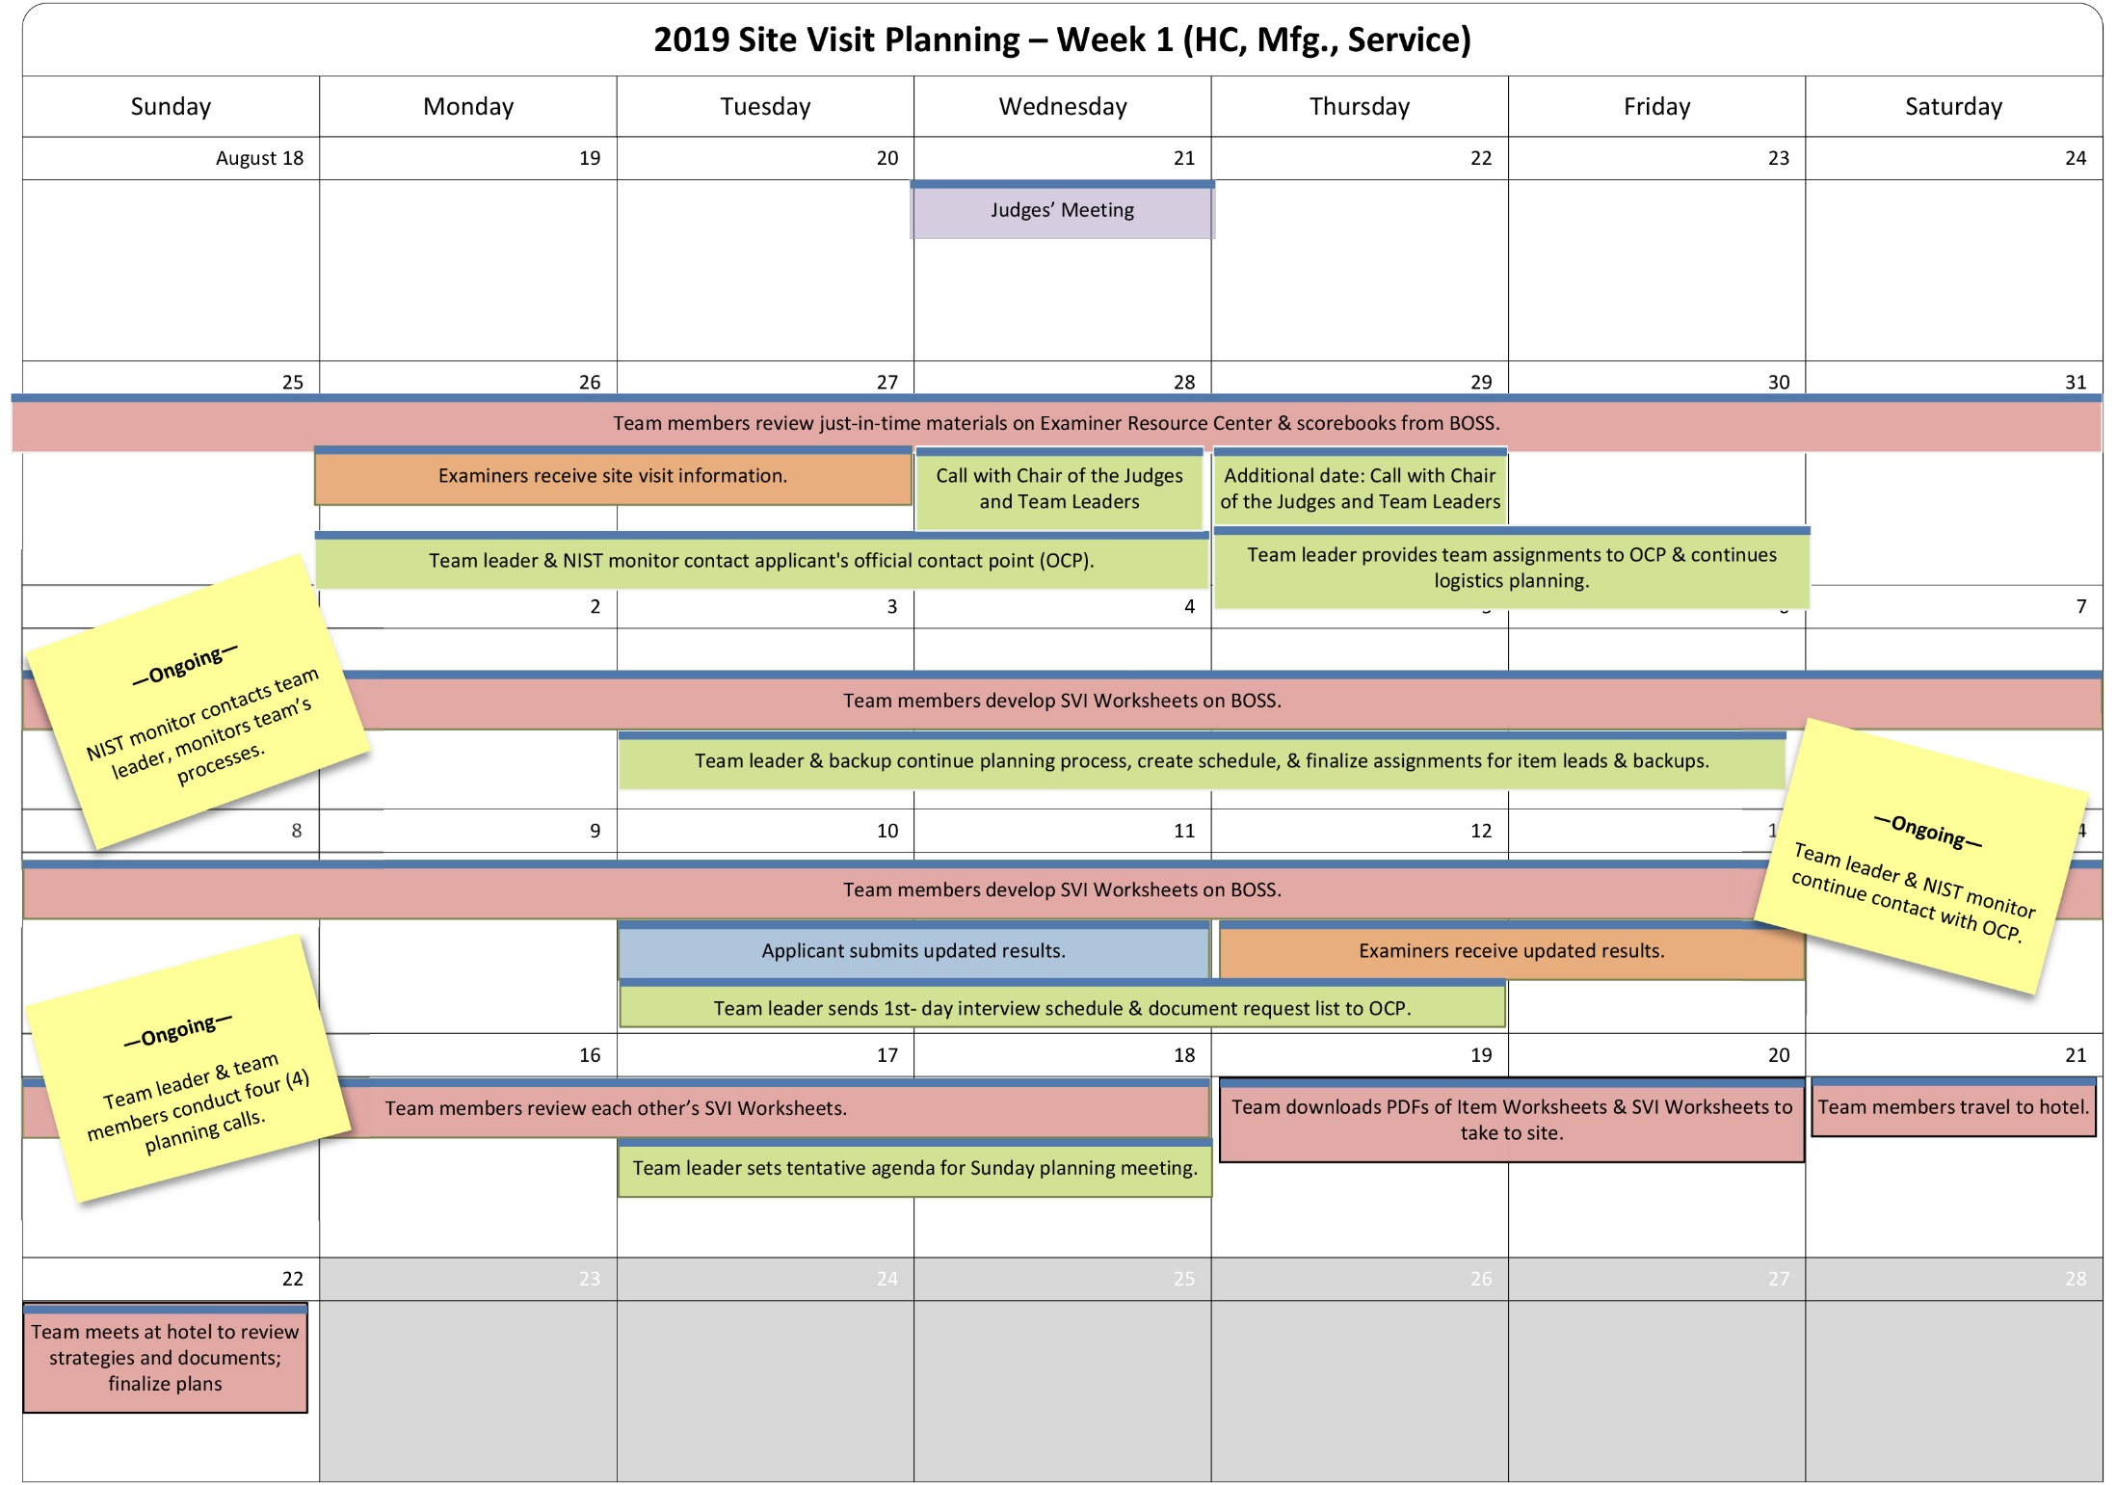

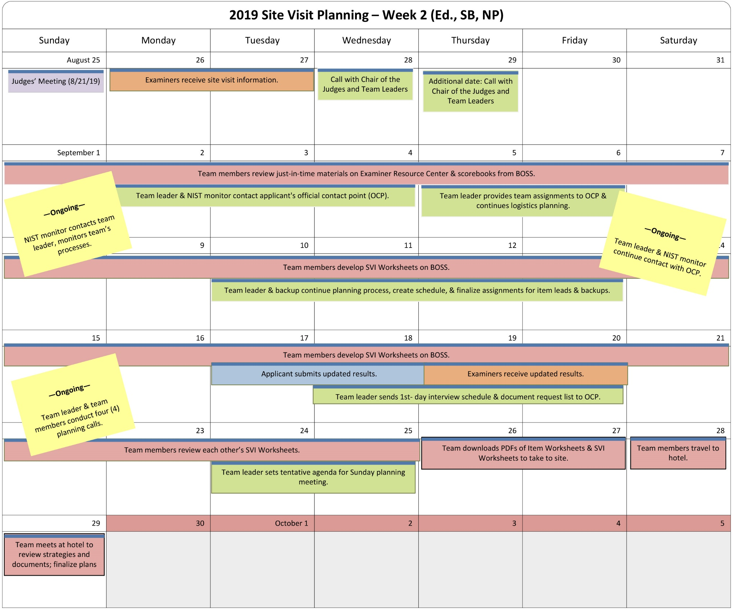

Team Leader/OCP Discussion Agendas

Note: There may be a need for more than one call in any given week. For example, the agenda below for “4 weeks out” is very heavy and may take two calls in that week.
4 Weeks Out:
- Congratulate the applicant, provide number of site visits in each sector.
- Validate the dates of the site visit (if necessary), rough start times each day.
- Validate that the applicant can host a one-hour and 15-minute opening meeting on-site with the examiner team.
- Ask if there are any concerns.
- Initiate discussions on the overall schedule, including the following:
Day 1:
- Kickoff meeting (Team Leader) – 15 minutes
- In-brief meeting and Q&A (Applicant) – 1 hour
- 6 Category Meetings 2 ½ hours each (both sides)
- Category Leads review needed documents – 30 minutes and provide document request to team leader.
- Team Leader/OCP close for the day

- Discuss how the Category 7 data updates need to be presented (particularly if the applicant does not have the internal capability to duplicate the graphics in the application). Discuss how the examiners will know what has changed.
- Discuss any conflicts with known leadership schedules.
- Remind them to ensure, if possible, that key leaders are available as requested.
- Have a preliminary discussion of where the meetings will be held; team prefers that the meetings are held in the areas where the documents for that topic exist or can be easily accessed.
- Have an initial conversation on the locations the team may wish to visit.
- Ask the applicant to expand the site listing from the eligibility form with more details on the following:
- Locations
- Employees
- Functions
- Shifts
- Unique services not provided elsewhere
- Establish a regular phone contact schedule before the site visit. Put the times on both calendars.
- Discuss the timing of the overall process, including the following: when the team is coming into town, when the team will be working at the hotel, and when the team plans to leave (time required for consensus).
- Ask who are the applicant’s category team leaders and team members, as well as their functions or job titles?
- Ask about any key committees not noted in the application (e.g., medical committees, board committees).
- Let applicant know that team will be sharing examiner category lead names in planning week 3.
- Ask about any issues surrounding security and access at the applicant facilities.
- Ask transport questions; e.g., how will the pick-up be handled each morning?
- Listen to the applicant regarding constraints (travel, rush hour times, etc.)
- Explain timing for the initial data request. Suggest that they number every document. For example, Category 1:
- 1-1
- 1-2
- 1-3, etc.
- Let them know that during the Site Visit, owners should put their name and location on every document requested by team members and provide to the Applicant’s Official Contact Point (OCP)
- If possible, hold the category meetings in rooms with a computer, projector, and screen to show documents to the examiners.
- Remind applicant that in the site visit email correspondence from ASQ there will be a set of questions to address in the opening presentation to ensure that the examiner team understands applicant’s business model.
- Discuss and agree to the ground rules for the site visit (see page 29); there should be a feedback loop to either the team leader or the monitor.
- Abide by the 1-hour rule: if it takes the applicant longer than one hour to prepare an answer to an examiner question, the question should be discussed with the team leader or the examiner.

3 Weeks Out:
- Revisit any open issues from 4 weeks out.
- Provide the applicant with the team list (i.e., names of examiners) and what category each team member will lead.
- Verify that the applicant understands the process for responding to the team’s initial document request (documents which will need to be provided prior to the site visit).
- Verify that the documents are being numbered.
- Validate that there is a team room on-site with a phone for calling applicant’s employees, as needed, as well as key(s) to the room (room must be lockable with entry by team only).
- Review high-level schedule for day 1, allowing travel time/restroom breaks/stand-up breaks between meetings, as appropriate.
- Discuss if there are special:
  - Health/dress/diet requirements for the team
  - Dress/safety requirements for the facilities (e.g., closed-toed shoes, no high heels?)
  - Dress code
  - Any cultural issues/sensitivities beyond the norm
- Let the applicant know that the team will plan to arrive 30 minutes before the opening meeting (7:30 am) to allow time for meet and greet.
2 Weeks Out:
- Review the open issues from previous discussions.
- Discuss venue for meetings (i.e., confirm that the meetings during the site visit will be in the area where the documents are; for example, when examiners meet with HR representatives, they should meet in the HR department).
- Confirm other on-site logistics for:
  - Team’s work room at the applicant’s site
  - Meeting rooms (such as in HR department, as stated above)
  - Process to return documents after the site visit
  - Facility visit plan (do they need a map?)
- Finalize transportation plan to and from site and whether applicant guides are needed on-site.
1 Week Out:
- Finalize any loose ends from earlier topics.
- Discuss any aspects of the initial document request that are unclear.
- Validate the leaders who are needed and/or will not be available.

GUIDELINES ON TEAM SIZE & LENGTH OF TIME ON APPLICANT’S SITE

Applicant Size | Complexity
 | Low | Medium | High
Small | 7  team members  *2–2.5 days | 7–8  team members  *2–2.5 days | 7–8  team members  *2.5–3 days
Medium | 7–8  team members  *2.5 days | 8  team members  *3 days | 8  team members  *3–3.5 days
Large | 8  team members  *3 days | 8  team members  *3.5 days | 9  team members  *3.5-4 days
*Average time spent with the applicant (i.e., the on-site portion of the site visit), not including time for planning or scorebook writing

Team Member Assignment: Examples

Team Member Assignments — 7-Member Team (Example)
Examiner Name | Category Lead | Backup | Cross-Cutting Issue/  Key Process | Other
Laura | Key Factors Worksheet,  Summary of Sites Visited,  HRO Interview Worksheet |  | Corporate support  Leadership system  Deployment  Organizational succession planning | Team leader  Leadership team interview  Scorebook editor  HRO interview  Daily check-in with OCP  Document request list
Roger | 2.1, 2.2 | 4.1, 4.2, 7.5 | Strategic planning | Backup team leader  Logistics
Sharon | 3.1, 3.2, 7.2 | 1.1, 1.2, 7.4 | Customer relationships | Senior executives’ interview questions (coordinate)
Michael | 4.1, 4.2, 7.5 | 2.1, 2.2, 7.3 | Management by fact  FOCUS Scorecard | Meeting coordination during site visit  Computer expert
Julie | 5.1, 5.2, 7.3 | 6.1, 6.2, 7.1 | Decentralized management  Workforce empowerment | Walk-around questions (draft)  Process checker and timekeeper
John | 6.1, 6.2, 7.1 | 5.1, 5.2, 7.3 | Operations Focus | Scribe (as needed)
Liza | 1.1, 1.2, 7.4 | 3.1, 3.2, 7.2 | Organizational results | Criteria cop

Team Member Assignments — 8-Member Team (Example)

Examiner Name | Category Lead | Backup | Cross-Cutting Issue/  Key Process | Other
Laura | Key Factors Worksheet,  Summary of Sites Visited,  HRO Interview Worksheet |  | Parent interaction  Leadership system  Overall deployment | Team leader duties  Leadership team Interview questions (coordinate)  Scorebook editor  HRO interview  Daily check-in with OCP  Document request list (coordinate)  Daily schedule
Roger | Key Themes |  | Board governance | Backup team leader duties  Logistics  Daily team meetings (coordinate)
Sharon | 3.1, 3.2, 7.2 | 1.1, 1.2, 7.4 | Customer and patient relationships | Timekeeper
Michael | 4.1, 4.2, 7.5 | 2.1, 2.2 | Management by fact | Computer expert
Julie | 5.1, 5.2, 7.3 | 6.1, 6.2, 7.1 | Decentralized management  Workforce empowerment | Walk-around questions (coordinate)  Process checker
John | 6.1, 6.2, 7.1 | 5.1, 5.2 | Process focus | Scribe (as needed)  (Health Care) VBP SVI
Liza | 1.1, 1.2, 7.4 | 3.1, 3.2, 7.2 | Organizational succession planning | Criteria Cop
Brian | 2.1, 2.2 | 4.1, 4.2, 7.5 | Strategic planning | Clinical perspective

Team Member Assignments — 9-Member Team (Example)

Examiner Name | Category Lead | Backup | Cross-Cutting Issue/  Key Process | Other
Laura | Key Factors Worksheet,  Summary of Sites Visited,  HRO Interview Worksheet |  | Parent interaction  Overall deployment | Team leader duties  Scorebook editor  HRO interview  Daily check-in with OCP  Document request list (coordinate)  Daily schedule
Roger | Key Themes |  | Board governance | Backup team leader duties  Leadership team Interview questions (coordinate)  Backup for all examiners  Logistics  Daily team meetings (coordinate)
Sharon | 3.1, 3.2, 7.2 | 1.1, 1.2, 7.4 | Customer and patient relationships | Timekeeper
Michael | 4.1, 4.2, 7.5 | 2.1, 2.2, 7.1 | Management by fact | Computer expert
Julie | 5.1, 5.2, 7.3 | 6.1, 6.2 | Decentralized management  Workforce empowerment | Walk-around questions (coordinate)  Process checker
John | 6.1, 6.2 | 5.1, 5.2 | Process focus  IT System stability | Scribe (as needed)
Liza | 1.1, 1.2, 7.4 | 3.1, 3.2, 7.2 | Organizational succession planning | Criteria Cop
Chris | 7.1 | Key Themes | Health care results focus  Leadership system | Physician, nursing, and volunteers
Brian | 2.1, 2.2 | 4.1, 4.2, 7.5 | Strategic planning | Clinical perspective

On-Site Team Schedule Example (medium size, medium complexity)

Monday
Time | Activity | Sub Team 1 | Sub Team 2 | Sub Team 3 | Sub Team 4
7:30 a.m. | Leave hotel for opening meeting | X | X | X | X
8:00–8:30 | Arrive  Move to kickoff | X | X | X | X
8:30–8:45 | Kickoff meeting  (Team Leader) | X | X | X | X
8:45–9:45 | Opening Meeting  (Applicant) | X | X | X | X
10:00–12:30 | Category Meetings | Category 1 | Category 2 | Category 3 | HRO Interview
12:30-1:30 | Lunch and Team Caucus
1:30 -4:00 | Category Meetings | Category 4 | Category 5 | Category 6 | 7.1, 7.2
4:00 -4:30 | Category Lead Review for Needed Documents | X | X | X | X
4:30 -5:00 | Team caucus | X | X | X | X
5:00–5:30 | TL and monitor meet with OCP to discuss needs for next day and coordination. Rest of team return to hotel | X | X | X | TL/OCP/  Monitor Planning Mtg.

Tuesday
Time | Activity | Sub Team 1 | Sub Team 2 | Sub Team 3 | Sub Team 4
7:30 a.m. | Leave hotel | X | X | X | X
8:00–9:00 | Team interviews and data gathering | X  (names) | Category 1  (names) | Site #2  (names) | Process owners  (names)
9:05–10:00 | Team interviews and data gathering | Managers’ group  (names) | Web/intranet  (names) | Site #2  (names) | Site #2  (names)
10:05–11:00 | Team interviews and data gathering | Site #2  (names) | Category 2  (names) | Category 4  (names) | X  (names)
11:05–12:00 | Team interviews and data gathering | Category 3  (names) | Safety Comm.  (names) | Item 7.4  (names) | Item 7.1  (names)
12:05–1:00 | Lunch and discussion | X | X | X | X
12:45–1:00 | TL and monitor meet with OCP re: schedule adjustments and additional documents needed
1:05–2:00 | Team interviews and data gathering | Site #1  (names) | Category 2  (names) | Category 1  (names) | Category 3  (names)
2:00–2:25 | Team caucus | X | X | X | X
2:30–3:00 | Team interviews and data gathering | Travel to site #1 | Travel to site #1 | Call center  (names) | Category 6  (names)
3:05–4:00 | Team interviews and data gathering | Follow up with HRO  (names) | Site #1  (names) | Document review  (names) | Site #2  (names)
4:05–5:00 | Team interviews and data gathering | Site #1  (names) | Document review  (names) | Site #2  (names) | Document review  (names)
5:00–6:00 | Return to hotel  Prepare for working dinner | X | X | X | X

Wednesday
Time | Activity | Sub Team 1 | Sub Team 2 | Sub Team 3 | Sub Team 4
7:30 a.m. | Leave hotel | X | X | X | X
8:00–9:00 | Team interviews and data gathering (ensure that all SVIs can be closed out)  Follow-up meetings | Finalize categories & items | Finalize categories & items | Finalize categories & items | Finalize categories & items
9:05–10:00 | Team interviews and data gathering (ensure that all SVIs can be closed out)  Follow-up meetings | Finalize categories & items | Finalize categories & items | Finalize categories & items | Finalize categories & items
10:05–11:00 | Team interviews and data gathering (ensure that all SVIs can be closed out)  Follow-up meetings | Finalize categories & items | Finalize categories & items | Finalize categories & items | Finalize categories & items
11:05–11:25 | Team caucus (ensure that all SVIs can be closed out) | X | X | X | X
11:10–11:45 | TL and monitor meet with OCP re: schedule adjustments and additional documents needed
11:45 - 1:00 | Return to hotel  Prepare for working lunch | X | X | X | X
Notes: (1) For larger applicant with more facilities, there may be a need to build in more visits in the morning to those facilities, extending the day. (2) Note: Closing meeting normally would occur Thursday mid-morning or early afternoon with team leader, backup team leader, monitor, OCP, HRO, and possibly others from leadership team if requested.

Proposed Team Ground Rules

- Working as a Team: Our objective is to conduct an effective and objective site visit by using all the expertise of our team members. This means we listen carefully to each other and take full advantage of our broad experience and the diversity of our collective thinking. It also means we are flexible about pitching in and helping each other throughout the process. None of us leaves until the job is completed. Working as a team also means that we present a uniform and united front during all interactions with the applicant.
- Customers: Our immediate internal customers are team members, who need to understand oral and written communication and to benefit from each of our contributions. Another internal customer is the Judges Panel, which is looking for our objective evaluation of the applicant based on the award Criteria. The judges in turn determine if the applicant has national role-model practices to share. The applicant is the primary external customer, which is looking for insightful, nonprescriptive feedback that helps reinforce its strengths and identify actionable OFIs.
Feedback-Ready Comments: As we complete our work, we make every effort to draft consolidated comments that are feedback ready. That means we imagine that the applicant is reading the comments as we write and can understand how each comment is applicable and actionable. In addition, we need to make it easy for the judges to follow the trail from the Item Worksheets with the consensus comments, which are the beginning of the trail, to the Site Visit Issue Worksheets, to the Site Visit Item Worksheets, to the Key Themes Worksheet.

- Item Ownership: No one “owns” any item. Instead, we are trying to get the best collective thinking. Cross-team sharing of observations and input is a necessity.
- Time Management: We try very hard to begin and end on time. We stick to the agreed-upon overall schedule of events. It is important to document as we go. Site Visit Issue Worksheets must be kept up-to-date. If we get behind, it will be difficult to catch up!
- Facilitation: We all have a responsibility for facilitation. For example, if we get away from the more important points and into minutia, anyone can call a “process check” to help us get back on track.
- Active Listening and Consensus: We listen to other points of view, particularly those that are different, in addition to expressing our own. We can and do respectfully disagree, but we are striving for consensus. Consensus means we have heard, have been heard, and thus can and will support the team’s conclusions.
- Professional Behavior: We want the applicant to feel that we are prepared, listen well, and thoroughly understand its organization.
- Have Fun and Learn from Each Other: We intend to have fun and encourage humor at the same time that we are working. We can even share some humorous moments with the applicant, as we get to know its staff members during the site visit.
- Personal Information: We may tell the applicant only our names and the names of our organizations, not professional expertise and experience with Baldrige.
- Other: We all take collective ownership and responsibility for the Site Visit Scorebook. In addition, we do not take any souvenirs (pens, stationery, etc.) from the applicant’s site or from the hotel.

ON-SITE PHASE

Topics for End-of-Day Check-in Meeting with OCP and Monitor
- Validate that the applicant is getting the chance to tell its story
- Adjust schedule as needed
- Document requests (on-site)
- Report to the team leader the data given to the team during the day
- Review any open Document requests (if any)
- Discuss if there are meetings which need to be scheduled or rescheduled
- Verify the timing of the Closing Meeting

Generic Walk-Around Questions

In what part of the organization do you work? How long have you been with the organization? How long have you been in your current position?

What are the most significant changes that you have personally experienced in the last two to three years? Why?

Do you have direct interactions with your customers and/or stakeholders? How often? Could you describe a couple of examples of these interactions? In general, do you know what your customers and/or stakeholders expect from you?

What departments or groups do you depend on to do your job? How is the work allocated to you? Do you provide these groups feedback on what improvements could be made? How often? How (formal/informal feedback)?

Are you involved in community activities? Do these involve time off from work? Does the organization allow you time or pay you while you volunteer?

Are you currently participating on any work teams? How long have you been a member? What is the team’s mission/role? Are your team activities worth the time you spend? Why?

How do you share information with others or receive information from others to help you do your job?

When was the last time you attended a formal training class? Topic? Length? What knowledge from the training were you able to use back on your job?

Do you receive information about the organization’s key strategic objectives? How (e-mail, newsletters, group meetings, etc.)? Which method is most effective? Are there other ways you would like to get information and/or other information you would like to have?

Do you receive information on key organizational results? How do you use this information to make decisions?

How often do you see your direct supervisor? His or her supervisor? His or her supervisor? Under what circumstances?

Who are your major competitors? What do they do better than you? Are you aware of any efforts to improve in these areas?

How do you see this organization’s future? How do you share any concerns or ideas you might have with your senior leaders? Have they asked you for input? How/how often?

How do you fit into the organization’s strategic plan?

How does what you do align with the organization’s mission, vision, and/or values?

POST-SITE PHASE

Post-Site Phase: Estimated Time to Complete the Scorebook
TASK | HOURS
Complete first draft of Site Visit Issue (SVI) Worksheets (started during the planning phase). | 8
Review and revise SVI Worksheets. | 4
Finalize SVI Worksheets. | 1
Revise Item Worksheets. | 6
Review/further revise Item Worksheets. | 4
Finalize Item Worksheets. | 1
Finalize scoring for each item. | 1
Discuss key themes and key factors. | 2
Revise key themes and key factors. | 2
Finalize key themes and key factors. | 1
Finalize Summary of Sites Visited. | 1
Identify the most appropriate overall process and results scoring bands. | 1
Upload to Team Files - HRO Interview (PDF) and Summary of Sites Visited (PDF) | 2
Print and sign completed Scorebook Signature page (PDF) | 1
TOTAL | 35

Participating in the Call with the Judges Panel

Scheduling and Logistics
Team leaders are required to participate in two conference calls with the judges during the November Judges’ meeting.
BPEP will request information on how to contact team leaders during the five days of the Judges’ meeting. Because of team leaders’ schedules, BPEP might need to contact them by cell phone. During the meeting, the judges may reconsider an applicant at any time during their five-day meeting.
If the team leader is not available for the conference call with the judges, the backup team leader needs to participate on the call. Also, the team leader should know how to reach each team member during this time in case he/she needs to contact any of them to clarify the judges’ questions.
BPEP will notify the team leader 15–60 minutes before the Judges Panel is ready to discuss the applicant. This will enable the team leader to go to a secure office and phone, if necessary.
Preparation
To prepare for the call with the Judges Panel, the team leader reviews the Site Visit Scorebook and makes notes of any special issues that the team found during the site visit or any that may not be adequately conveyed in the scorebook.
Team leaders must avoid advocating for or against the applicant organization—rather, it is their job to provide facts, findings, and conclusions.
During call one, the team leader presents changes in key factors; an overview of the key themes—particularly potential role-model practices and key vulnerabilities; changes to the scoring ranges; and any major discrepancies discovered in the scorebook after it was posted for the judges’ review. The lead judge may then provide the team leader with potential topics the panel may want to focus on during the 2nd call. After completing the 1st call, the judges deliberate on this information and develop follow-up questions. During the 2nd call, the judges ask any questions that emerged during their deliberations.
1st Call
The team leader should focus on responding to the question at the bottom of the Key Factors Worksheet that asks, “Thinking about the questions in the Organizational Profile, did the team have any new insights about the applicant as a result of the site visit?” The team leader describes to the judges any new or expanded understandings of the applicant’s organization and environment.
After sharing these insights, the team leader provides a presentation on the key themes that aims to convey key strengths and vulnerabilities without simply reading the text. This presentation helps the judges to better understand any possible role-model practices or key areas of vulnerability for the applicant in both process and results areas.
If the Site Visit Team recommended a scoring band change, the team leader explains the key drivers for that change.
Finally, if the team leader discovers any major discrepancies, such as conflicts or missing information, he or she shares this information with the judges.
2nd Call
The team leader answers any questions that the judges formulated during their discussion following the 1st call.
Participating in the Editing Call with the Lead Judge
After the judges have concluded their review of an applicant, the lead judge and the monitor call the team leader and discuss any recommended changes to the Site Visit Scorebook. During this call, the judge provides input on changes to the comments, including insights gained during the judges’ discussions. The team leader incorporates these changes into the final Site Visit Scorebook.
Receiving and Providing Feedback on the Process
At the conclusion of the final Site Visit Scorebook discussion, the lead judge provides feedback to the team leader concerning the calls with the judges and the Site Visit Scorebook. Specific feedback and related comments from the judges may include the following:
Did the team leader conduct an effective presentation of insights related to the Organizational Profile, key themes, and scoring changes?
In responding to questions from the Judges Panel, did the team leader provide unbiased insights that enabled the judges to reach closure on the issues? This question includes the following elements:
- All responses were based on facts established throughout the evaluation cycle.
- Responses were clear and concise.
- Responses focused on specific questions at hand.
- The team leader asked clarifying questions to ensure understanding.
- Did the scorebook present an integrated view of the applicant? This question includes the following elements:
  - All materials were well integrated.
  - The scorebook reflected the collective input and perspective of the entire team.
  - Through the “audit trail,” conclusions could be traced back to origin and evidence.
  - The scorebook enabled fair voting among the judges
In addition, the lead judge asks the team leader for input/feedback on the judges’ process and conference call. Team leaders are encouraged to be honest and forthright in their comments, as this feedback helps improve the judging process.

Appendix

SUMMARY OF SITES VISITED (example)

This worksheet conveys the extent and thoroughness of the site visit.
Length of the site visit (number of days with the applicant)
3 days
Sites visited (List the applicant’s major sites visited and describe any important aspects of the sites that are not apparent from the Site Listing and Descriptors section in the Eligibility Certification Form.)
Corporate Office—Baldrigeville, Maryland
Regional Offices—Annapolis, Maryland; Richmond, Virginia; Asheville, North Carolina; Morgantown, West Virginia
Main Facilities/Manufacturing Plants/Transportation Hubs—Annapolis, Maryland; Richmond, Virginia; Asheville, North Carolina; Morgantown, West Virginia
The Morgantown plant currently is being upgraded to reduce emissions. The Morgantown plant also is the only facility that does not have a third shift.
The Annapolis plant was a recent acquisition (six months ago).
Approaches used to evaluate sites not visited, including sites outside the United States (if appropriate)
Video conferences were used at manufacturing plants and retail units in Tampa and Orlando, Florida (these plants are managed by the Asheville, North Carolina, Regional Office and represent 8% of the applicant’s sales and retail operations, as well as 10% of the manufacturing operations).
The Tampa and Orlando plants were called twice in order to cover two of the three shifts, and the applicant’s sales and retail operations were called during their daytime hours.
Other information on the team’s strategy for a thorough site visit (e.g., categories, types, and shifts of employees interviewed)
All sites visited were selected by the Site Visit Team based on observing 90% of the applicant’s manufacturing operations, 100% of the corporate/management and support, 92% of the retail and sales operations, and 100% of its transportation hubs.
Data-gathering methods consisted of document reviews and employee interviews that included meeting settings, lunchroom settings, and walk-around questions at all sites visited.
The team interviewed all categories of employees: 23% of manufacturing (all three shifts), 22% of sales and retail, 32% of corporate/management and support, 23% of transportation hub (all three shifts), and 6% of distribution.
The team interviewed 251 of the applicant’s 1,012 employees. (Note: A low percentage of the drivers were interviewed because of the nature of their jobs. Most of the drivers are dispersed throughout the East Coast. These unavailable employees were represented by available employees at their home sites.)

TEAM ROLES AND RESPONSIBILITIES

 | Role | Initial Planning Preparation | Final Preparation  & Sunday Planning Meeting | On-Site | Preparation of the Site Visit  Scorebook
TEAM  LEADER  (TL) | - Serves as contact point for OCP and NIST monitor  - Manages completion of scorebook components  - Works closely with backup TL to help the team work effectively  - Assigns leads and backups for all items (if possible, TL does not lead any items, allowing more time to back up and coach the entire team) | - Calls team members and OCP  - Drafts tentative site visit plan and shares plan with team and NIST monitor  - Works with the team to develop and finalize SVIs, focusing on issues of central importance to Criteria and applicant  - Prepares a list of documents for team review, aggregated in BOSS, to request from the OCP, as well as a tentative interview schedule. If appropriate, interview requests include staff at multiple locations  - Keeps OCP apprised of plans during regularly scheduled telephone calls  - Notifies NIST monitor of inter-site travel, if applicable  - Completes and forwards necessary forms to ASQ  - Develops a timeline to help manage the work of the team throughout all phases of the Site Visit Review  - Downloads all items and SVI Worksheets as PDF files to take to site | - Leads development of, reviews, and finalizes site visit strategy, agendas, document requests, and interview schedules  - Sends OCP the document request list and a tentative agenda for day one of the site visit ten days in advance  - Prepares for opening meeting, featuring BPEP slides  - Reviews requested documents | - Begins opening meeting using BPEP slides and providing brief remarks  - Adjusts the site visit plan as required  - Monitors progress on completion of SVI Worksheets  - Keeps the team on task and on schedule  - Plans and conducts caucuses to help keep the team focused on key themes and other important issues  - Informs OCP of changes and needs  - Conducts HRO interview, with NIST monitor, and completes HRO Interview Worksheet  - Ensures that the team has all relevant information and documents to close out each SVI before ending the on-site phase  - Ends the site visit with a short “thank you” and next steps, using BPEP slides, at the closing meeting at the applicant’s location | - Provides the team with a time frame for completion  - Facilitates discussion of findings and review of scorebook components  - Reviews scorebook and provides edits as necessary  - Ensures that SVI, Item, and Key Themes Worksheets are appropriately prepared, reviewed, and finalized in BOSS  - Retains an electronic copy of all Item Worksheets and SVIs in PDF and other documents in Word. (Keeping a paper copy is optional.)  - Reviews and edits the scorebook as necessary after leaving the hotel, using BOSS or importing any changes to BOSS, by midnight PDT on Monday after site visit  - Prepares for the judges’ call in November  - Responds to and works with BPEP and judges to address questions/comments on Site Visit Scorebook after Judges’ meeting
BACKUP TEAM LEADER | - Steps in for the TL if the TL is unable to go on-site  - Works closely with TL to plan, coordinate, and communicate with the team  - Serves as a mentor for team members on-site and assists as needed to keep the team on track  - Depending on the makeup of the team and complexity of the applicant, may not have items to lead in order to help coach team members and provide feedback to them on their work. | Assists TL as needed. For example, the backup TL could  - review the draft site visit plan  - review other team members’ SVIs and give feedback on improvements  - schedule planning calls  - suggest item and other team assignments  - draft call agendas  - take the lead in site visit logistics planning  - join TL/NIST monitor on planning call(s)  - review the initial document request and edit as needed  - orient new team members  - review confidentiality requirements  - participate in planning calls with TL and OCP  - review, manage, and track the leadership questions, walk-around questions, and/or interview requests | Assists TL as needed. For example, the backup TL could  - draft the agenda for the team’s Sunday planning meeting at the hotel  - coordinate the initial document request  - mentor less-experienced teammates  - review requested documents | Assist the TL as needed. For example, the backup TL could  - mentor less-experienced teammates  - take the lead on the Key Factors Worksheet, Key Themes Worksheet, and/or Summary of Sites Visited  - track progress on completion of SVIs  - keep team on task and on schedule  - lead daily debrief and/or caucus discussions  - take leadership role for traveling teams so TL can remain at headquarters | Assists TL as needed. For example, the backup TL could  - facilitate the discussion of findings and review of scorebook components  - review the scorebook and provide edits as necessary  - ensure that SVI, Item, and Key Themes Worksheets are appropriately prepared, reviewed, updated, and finalized  - retain an electronic copy of the Site Visit Scorebook (a paper copy is optional)  - help TL prepare for the judges’ call in November
TEAM MEMBERS | • Plan, maintain focus, contribute, and communicate effectively in performing assigned site visit tasks  - Meet TL’s and backup TL’s schedules and deadlines | - Arrange transportation to and from the site (between home and hotel) and provide travel details to ASQ  - Review evaluation materials  - Review online training materials  - Working with item backup, develop SVIs and start work on SVI Worksheets  - Review rules of conduct  - Complete other assignments (consolidate document requests, establish interview schedule, etc.)  - Provide feedback on team’s SVIs  - Export all assigned documents as PDFs to take to site | - Finalize interview plans, the lists of required documents, and strategies for SVI Worksheets  - Attend and participate in Sunday planning meeting at hotel  - Review requested documents | - Work in pairs for 2–4 days on-site  - Gaither information to clarify and verify assigned SVIs  - Conduct interviews with applicant’s representatives  - Review documents and data  - Attend all team caucuses and meetings  - Take thorough notes  - Record findings and conclusions on SVI Worksheets as site visit progresses  - Have all documents needed to close out all SVIs before the closing meeting, which marks the end of the on-site phase | - Share findings with team at team caucuses/meetings  - Update SVI Worksheets, seeking shared understanding among team members  - In BOSS, review and provide feedback for all SVI, Item, and Key Themes Worksheets  - Complete scorebook components, building on content of the Consensus Scorebook  - Review scorebook components of other team members  - Stay with team until scorebook is completed and signed by all team members (2–3 days after the on-site phase)
SCOREBOOK  EDITOR  (TL, backup TL, or another team member) | Ensures that the scorebook adheres to Criteria questions and follows the Comment Guidelines | SAME AS TEAM MEMBERS | SAME AS TEAM MEMBERS | SAME AS TEAM MEMBERS | In addition to team member responsibilities:  - Clarifies and aligns the language among item comments and key themes  - Eliminates any conflicts between strengths and OFIs within and between items and key themes  - Ensures that all statements such as “it is not clear,” “it does not appear that,” and “it is not evident” are changed to reflect the findings of the site visit  - Revises scorebook as necessary to ensure that comments adhere to Comment Guidelines
NIST  MONITOR | - Assists the team and TL in planning and conducting the site visit as needed  - Assists the applicant in understanding the site visit process and serves as a contact for the applicant to address issues and concerns | - Monitors the process  - Supports TL in planning the site visit as needed  - Provides coordination and guidance  - Contacts OCP to explain the process and answer questions  - Reviews draft SVI Worksheets  - Participates in planning calls  - Coordinates with OCP delivery of documents requested before Sunday planning meeting  - Downloads all documents as PDFs before leaving for site | - Supports TL  - Stays in contact with OCP  - Ensures that all necessary equipment and supplies are available before the beginning of the Sunday planning meeting  - Ensures that the team room is set up appropriately  - Coordinates arrival of applicant materials at team room before the Sunday planning meeting  - Attends Sunday planning meeting to monitor the process and provide logistical assistance | - Attends HRO meeting with TL  - Attends team meetings  - Answers process questions from applicant and team  - Keeps OCP apprised of plans and answers questions each day  - Provides logistical support for team (hotel issues, food, etc.)  - Serves as the contact person to deal with on-site problems or issues  - Coordinates pickup of the applicant’s materials at the end of the visit  - Answers any questions from OCP/HRO regarding Category Best Recognition requirements | - Assists team with BOSS  - Reviews the work of the team and provides feedback related to the process and Comment Guidelines  - Ensures that all applicant materials are returned to OCP at completion of the site visit  - Reviews the Site Visit Scorebook, checking comments for consistency with Comment Guidelines  - Prepares summary of applicant’s highlights for Judges’ meeting  - Prepares summary of applicant used in briefing the Secretary of Commerce about award recommendations  - Retains an electronic copy of the entire Scorebook
JUDGES | - Recommend applicants to receive the award | - Chair conducts training conference call for TLs |  |  | - Review scorebooks after site visits  - Lead judge for each applicant: prepare highlights for briefing other judges  - Recommend award recipients and Category Best Recognition  - Conduct evaluation of judges’ process  - Review and edit Scorebooks
OCP  or  ALTERNATE  OCP | - Works with TL and BPEP | - Coordinates arrangements, including on-site meeting space  - Works with TL on scheduling and logistics for interviews  - Provides information to TL and NIST monitor  - Schedules inter-site travel and travel of team to/from hotel, as needed  - Provides updated data for results charts and graphs | - Based on TL’s request, compiles documents and arranges meetings for first day of site visit  - Ensures applicant documents arrive at the hotel conference room before Sunday planning meeting  - Arranges logistics and prepares for opening meeting presentation | - Works with TL to schedule interviews  - Provides inter-site transportation  - Provides additional requested documents  - Coordinates adjustments to schedule as needed  - Informs NIST monitor of any concerns or questions about Site Visit Team interactions | - At the completion of the site visit, picks up all materials from NIST monitor

CHARTS FOR TRACKING TEAM PROGRESS

Instruction: Team Members place a checkmark with their color marker in the appropriate box as they complete the work. Team leaders, ask your monitor to prepare these charts for you on flipchart paper.
Tracking SVI Completion (SAMPLE ONLY)
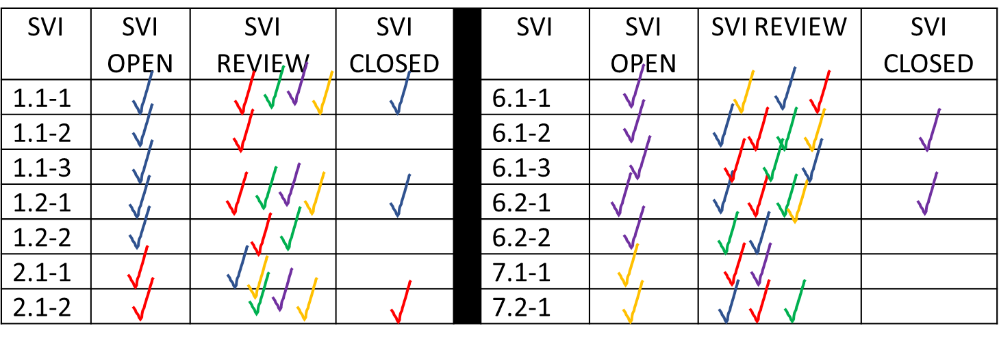
Tracking Item Worksheets (SAMPLE ONLY)
* Note: No need for checking off R-2 , which is the team review meeting. Input from this meeting will inform R-3.
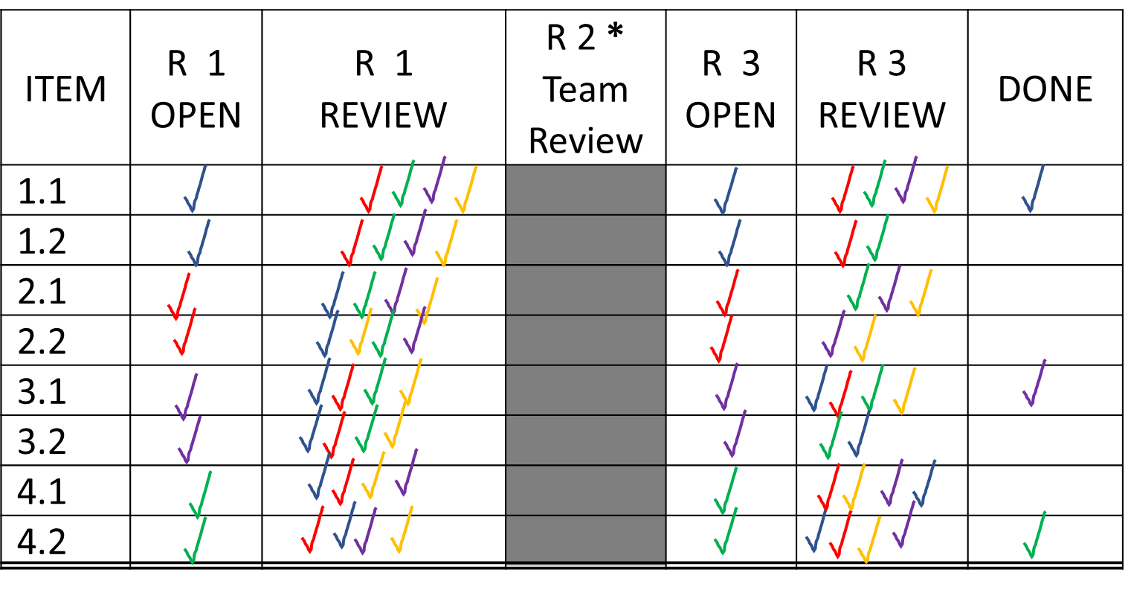

Key Themes Tracking Chart (SAMPLE ONLY)
Team Member | R-1  OPEN | R-1  REVIEW | R-2  OPEN | R-2  REVIEW | R-3*  OPEN | R-3  REVIEW | KT  DONE
Trish
Hermey
Rashid
Chris
Debbie
Bob
Karen
Patrice

* Note: Three reviews may not be needed for key themes if the team leader believes editing can be sufficiently completed after input from R-2.

Another variation of the chart above: If tracking specific key theme areas is needed, an option is to have team members place their checkmarks all in the same review box with their different color markers, as in the previous charts.
Key Theme Section | R-1  OPEN | R-1  REVIEW | R-2  OPEN | R-2  REVIEW | R-3*  OPEN | R-3  REVIEW | KT  DONE
a. process strengths
b. process OFIs
c. results strengths
d. results OFIs

