

**Site Visit Manual**

2018

Table of Contents

**(Ctrl + click to follow links)**

SITE VISIT PROCESS 3

SITE VISIT OVERVIEW 3

TEAM ROLES AND RESPONSIBILITIES 6

SITE VISIT: PLANNING PHASE 12

TIMELINE 12

PREPARATION 15

DO’S AND DON’TS FOR THE PLANNING PHASE 16

Do’s 16

Don’ts 16

SCOREBOOK PREPARATION AT THE PLANNING PHASE 17

Introduction and General Instructions 17

Scorebook Requirements 17

Building the Site Visit Scorebook 18

**How to Prepare Process Item Worksheets and SVI Worksheets** 23

**How to Prepare Results Item Worksheets and SVI Worksheets** 25

**Computer Use Instructions** 34

SITE VISIT: ON-SITE PHASE 35

ON-SITE PHASE OVERVIEW 35

OPENING MEETING 35

CLOSING MEETING 38

DO’S AND DON’TS AT THE ON-SITE PHASE: 39

**Do’s** 39

**Don’t’s** 40

ON-SITE SCOREBOOK DEVELOPMENT 41

**Scorebook Development Checklist** 41

**Document Log** 42

**Interview Log** 43

**Information Request** 44

ON-SITE PHASE: AGENDAS AND OTHER TOOLS 45

**Sunday Planning Meeting Agenda** 45

**Effective Interviewing Steps** 47

**Providing Feedback to Team Members using BOSS Online** 49

**Agenda for Evening Meetings** 50

**Using the Scorebook On-Site**: (between the opening and closing meetings) 50

SITE VISIT: POST-SITE PHASE 51

POST SITE OVERVIEW 51

SITE VISIT SCORING 54

COMPLETING THE SCOREBOOK (before leaving the site visit) 55

SUMMARY OF SITES VISITED (example) 57

GUIDANCE FOR TEAM LEADERS 58

PLANNING PHASE OVERVIEW 58

PLANNING GUIDELINES ON TEAM SIZE & LENGTH OF THE ON-SITE PHASE 62

**Proposed Ground Rules (modify as needed)** 62

**Generic Walk-Around Questions** 64

**Team Leader/OCP Discussion Agendas** 66

**Team Member Assignments — 7-Member Team (Example)** 69

**Team Member Assignments — 8-Member Team** 70

**Team Member Assignments — 9-Member Team** 71

**On-Site Team Schedule Example (medium size, medium complexity)** 72

**Large Applicant, High Complexity Example** 75

**Site Visit Schedule: Small Applicant/Low Complexity** 78

ON-SITE PHASE 80

POST-SITE PHASE 80

**Participating in the Call with the Judges Panel** 82

**CREATING SITE VISIT ISSUE AND ITEM WORKSHEETS IN PDF** 84

# SITE VISIT PROCESS

## SITE VISIT OVERVIEW

The Site Visit Review is a critical phase of the evaluation process. Site visits entail a team of Baldrige examiners traveling to an applicant’s site(s) to more fully understand how well the organization is applying the Baldrige Criteria and concepts. The ultimate purpose of the site visit is to verify the team’s understanding of key strengths and to clarify its understanding of key vulnerabilities. For each selected applicant that receives a site visit, the team will (1) communicate findings to the judges, (2) determine the feedback that is most relevant for the applicant, and (3) help ensure that the applicant can demonstrate role-model practices to the public should it be named an award recipient.

The Baldrige Award process consists of three components: the Independent Review of the application, which occurs in June; te Consensus Review, which begins immediately following the Independent Review and continues into August; and the Site Visit Review, which begins with the Panel of Judges’ Meeting in August--when applicants are selected for site visits--and ends with the final Panel of Judges’ Meeting in November, when the Judges finalize their recommendations for the Award. While every Award applicant undergoes the Independent Review and Consensus Review, a site visit takes place only when the Panel of Judges determines that the applicant is a strong candidate for the Baldrige Award. Historically, about 30 percent of applicants have received site visits.

What is the purpose of the Site Visit Review?

* **Verify and Clarify the comments from the Consensus Review Scorebook**
* **Determine the most relevant feedback**
* **Identify role model practices**

What is the one deliverable of the site visit process? The Site Visit Scorebook. Through the production of this scorebook, the team reaches agreement on the applicant’s strengths and opportunities for improvement (OFIs), the resulting scoring range for each item, and the overall scoring band for the application. The team members accomplish their work through extensive planning, focusing on what is most important to the applicant, communicating with each other and the applicant, and contributing to a shared understanding of findings—which is presented in the form of a scorebook.

The Site Visit Scorebook includes several worksheets:

* Key Factors Worksheet and a Key Themes Worksheet, which are updated to reflect new information collected during the site visit process;
* Item Worksheets containing the applicant’s important strengths and opportunities for improvement;
* Highest-Ranking Official (HRO) Worksheet listing questions and answers obtained during the interview with the Applicant’s **highest-ranking** official;
* Scoring Summary Sheet that captures changes to team scores for each of the 18 Items of the Baldrige Criteria along with an overall scoring band for the applicant;
* Site Visit Issue Worksheets, which are used to record the findings and conclusions of the Examiners related to specific issues needing clarification or verification; and
* Summary of Sites Visited
* Signature page, on which all Examiners sign and attest to the accuracy of the feedback report.

The Site Visit Team gathers the information needed to confirm and further develop the findings from the Consensus Review regarding the applicant’s strengths and opportunities for improvement.

These findings will then be communicated to the Panel of Judges so that they can make accurate decisions about whether to recommend the applicant for the Award. The Judges also help refine the feedback that will go to the applicant. Finally, they help determine whether the applicant will be able to share role model practices with the public if the applicant receives an Award.

There are three phases of the site visit process. They are:

* the Planning Phase
* the On-Site Phase
* the Post-Site Phase

The Planning Phase begins soon after the Panel of Judges has the candidates and the Examiner teams have been selected, typically during mid-September. During the Planning Phase, the team members can expect to spend about 35 hours preparing for the site visit itself. This time includes conference calls and preparing Site Visit Issues Worksheets, which will be described later in this manual. This phase also includes traveling to and meeting at a nearby hotel early Sunday afternoon, the day before the site visit kicks off. In past years, this meeting has averaged about 11 hours in duration. Time spent in advance preparing plans and documents will affect the time needed in this session.

The On-Site Phase of the process is where team members travel to the applicant’s site to investigate and analyze information presented in the application, along with the conclusions reached through Consensus Review so that the team can complete the Site Visit Issue Worksheets developed during the Planning Phase.

The On-Site Phase is an intense time for the team members. This phase starts in late September – early October and usually lasts three days, Monday through Wednesday, but can vary from two to four days depending on the size and geographic locations of the applicant. During this phase, team members can expect to spend about 10 hours traveling to and from and visiting the applicant’s facility each day and as much as 4 hours each evening back at the hotel doing both individual work and work with the team. These times vary by individual, but the important point is that team members must work diligently during this phase to ensure that they have the information and evidence they need from the applicant before closing the On-Site Phase.

Depending on the size of the organization, it will likely require visiting more than one site. For example, if the organization’s headquarters is in Maryland but its largest production facility is in Ohio, the team may need to visit both sites.

Day 1 of the site visit begins with a one-hour meeting with the applicant at the applicant’s headquarters, during which the Team Leader makes introductory remarks and introduces the Site Visit Team members. The Team Leader presents a brief overview of the Baldrige Award and site visit process and procedures. The applicant then welcomes the team, introduces its representatives, and presents other material as it chooses.

Team members then meet with the applicant’s representatives and pursue the specific Criteria Items that the team members have been assigned. As needed, the team members may request additional documents to review. Team members identify and schedule activities or individuals to see on days 2 and 3 of the visit, and day 4 if needed.

Days 2 and 3 and possibly 4 are spent at the applicant’s facilities either conducting follow-up meetings and interviews to obtain additional information to clarify site visit issues or reviewing additional documents from the applicant.

Each day throughout the visit, the team caucuses at least twice to review progress, identify missing information, and adjust the schedule as necessary. Each evening after dinner, team members gather at the hotel to discuss findings, identify any missing information; and finalize the next day’s schedule. They also complete Site Visit Issue Worksheets for review by the rest of the team. During this process, each team member reviews other team members’ work in BOSS to help them identify points that they may have missed or that may be unclear, or to provide input from their own findings that may substantiate or conflict with what is online. . In this way, team members can integrate their findings and develop a shared understanding of the applicant’s processes and results. This process is repeated each evening so that the Site Visit Issue Worksheets are continuously fine-tuned.

After the team is satisfied that all issues have been verified or clarified, the team holds a brief closing meeting with appropriate representatives of the organization. The Team Leader explains the next steps in the process, thanks the applicant for the hospitality shown to the Examiners and commends the applicant for being selected for the site visit. The applicant also makes brief closing remarks. This is the last opportunity for the applicant to provide information to the team. Once the team departs for the hotel, team members will have no further contact with the applicant.

After the closing meeting at the applicant’s facility, the team returns to the hotel to close out its work. It completes drafts of all remaining Site Visit Issue Worksheets and reviews and finalizes Site Visit Issue Worksheets. Team members revise key factors, key themes, Item Worksheets, and the Score Summary Worksheet.

The purpose of the Post-Site Phase is to complete the Site Visit Scorebook, updating it with the findings from the site visit. This scorebook, along with the Site Visit Issue Worksheets, combine to provide the Judges an audit trail of the findings of the site visit for use in making Award recipient recommendations.

The Post-Site Phase involves the team members meeting at the hotel to finalize the Site Visit Scorebook and all other documents. This phase typically involves 48 hours of work between Thursday and Saturday immediately following the On-Site Phase.

Once the Scorebook is finalized, each member of the team signs the signature page (a file contained in the BOSS PDF Export files).

## TEAM ROLES AND RESPONSIBILITIES

|  | **Role** | **Initial Planning Preparation** | **Final Preparation  & Sunday Planning Meeting** | **On-Site** | **Preparation of the Site Visit**  **Scorebook** |
| --- | --- | --- | --- | --- | --- |
| **TEAM**  **LEADER**  **(TL)** | * Serves as contact point for OCP and NIST monitor * Manages completion of scorebook components * Works closely with backup TL to help the team work effectively * Assigns leads and backups for all items (if possible, TL does not lead any items, allowing more time to back up and coach the entire team) | * Calls team members and OCP * Drafts tentative site visit plan and shares plan with team and NIST monitor * Works with the team to develop and finalize SVIs, focusing on issues of central importance to Criteria and applicant * Prepares a list of documents for team review, aggregated in BOSS, to request from the OCP, as well as a tentative interview schedule. If appropriate, interview requests include staff at multiple locations * Keeps OCP apprised of plans during regularly scheduled telephone calls   Notifies NIST monitor of inter-site travel, if applicable   * Completes and forwards necessary forms to ASQ * Develops a timeline to help manage the work of the team throughout all phases of the Site Visit Review * Downloads all items, SVI Worksheets, and as PDFs to take to site | Leads development of, reviews, and finalizes site visit strategy, agendas, document requests, and interview schedules  Sends OCP the document request list and a tentative agenda for day one of the site visit ten days in advance  Prepares for opening meeting, featuring BPEP slides  Reviews requested documents | * Begins opening meeting using BPEP slides and providing brief remarks * Makes adjustments to the site visit plan as required * Monitors progress on completion of SVI Worksheets * Keeps the team on task and on schedule * Plans and conducts caucuses to help keep the team focused on key themes and other important issues * Informs OCP of changes and needs * Conducts HRO interview, with NIST monitor, and completes HRO Interview Worksheet * Ensures that the team has all relevant information and documents to close out each SVI before ending the on-site phase * Ends the site visit with a short “thank you” and next steps, using BPEP slides, at the closing meeting at the applicant’s location | * Provides the team with a time frame for completion * Facilitates discussion of findings and review of scorebook components * Reviews scorebook and provides edits as necessary * Ensures that SVI, Item, and Key Themes Worksheets are appropriately prepared, reviewed, and finalized in BOSS * Retains an electronic copy of all Item Worksheets and SVIs in PDF and other documents in Word. (Keeping a paper copy is optional.) * Reviews and edits the scorebook as necessary after leaving the hotel, using BOSS or importing any changes to BOSS, by midnight PDT on Monday after site visit * Prepares for the judges’ call in November * Responds to and works with BPEP and judges to address questions/ comments on Site Visit Scorebook after Judges’ Meeting |
| **Backup Team Leader** | * Steps in for the TL if the TL is unable to go on-site * Works closely with TL to plan, coordinate, and communicate with the team * Serves as a mentor for team members on-site and assists as needed to keep the team on track * Depending on the makeup of the team and complexity of the applicant, may not have items to lead in order to help coach team members and provide feedback to them on their work. | Assists TL as needed. For example, the backup TL could   * review the draft site visit plan * review other team members’ SVIs and give feedback on improvements * schedule planning calls * suggest item and other team assignments * draft call agendas * take the lead in site visit logistics planning * join TL/NIST monitor on planning call(s) * review the initial document request and edit as needed * orient new team members * review confidentiality requirements * participate in planning calls with TL and OCP * review, manage, and track the leadership questions, walk-around questions, and/or interview requests | Assists TL as needed. For example, the backup TL could   * draft the agenda for the team’s Sunday planning meeting at the hotel * coordinate the initial document request * mentor less-experienced teammates * review requested documents | Assist the TL as needed. For example, the backup TL could   * mentor less-experienced teammates * take the lead on the Key Factors Worksheet, Key Themes Worksheet, and/or Summary of Sites Visited * track progress on completion of SVIs * keep team on task and on schedule * lead daily debrief and/or caucus discussions * take leadership role for traveling teams so TL can remain at headquarters | Assists TL as needed. For example, the backup TL could   * facilitate the discussion of findings and review of scorebook components * review the scorebook and provide edits as necessary * ensure that SVI, Item, and Key Themes Worksheets are appropriately prepared, reviewed, updated and finalized * retain an electronic copy of the Site Visit Scorebook (a paper copy is optional) * help TL prepare for the judges’ call in November |
| **Team Members** | • Plan, maintain focus, contribute, and communicate effectively in performing assigned site visit tasks   * Meet TL’s and backup TL’s schedules and deadlines | * Arrange transportation to and from the site (between home and hotel) and provide travel details to ASQ * Review evaluation materials * Review online training materials * Working with item backup, develop SVIs and start work on SVI Worksheets * Review rules of conduct * Complete other assignments (consolidate document requests, establish interview schedule, etc.) * Provide feedback on team’s SVIs * Exports all assigned documents as PDFs to take to site | * Finalize interview plans, the lists of required documents, and strategies for SVI Worksheets and by the TL * Attend and participate in Sunday planning meeting at hotel * Review requested documents | * Work in pairs for 2-4 days on-site * Gaither information to clarify and verify assigned SVIs * Conduct interviews with applicant’s representatives * Review documents and data * Attend all team caucuses and meetings * Take thorough notes * Record findings and conclusions on SVI Worksheets as site visit progresses * Have all documents needed to close out all SVIs before the closing meeting, which marks the end of the on-site phase | * Share findings with team at team caucuses/meetings * Update SVI Worksheets, seeking shared understanding among team members * In BOSS, review and provide feedback for all SVI, Item, and Key Themes Worksheets * Complete scorebook components, building on content of the Consensus Scorebook * Review scorebook components of other team members * Stay with team until scorebook is completed and signed by all team members (2 – 3 days after the on-site phase) |
| **SCOREBOOK**  **EDITOR**  **(TL, backup TL, or another team member)** | Ensures that the scorebook adheres to Criteria requirements and follows the Comment Guidelines | SAME AS TEAM MEMBERS | SAME AS TEAM MEMBERS | SAME AS TEAM MEMBERS | In addition to team member responsibilities:   * Clarifies and aligns the language among item comments and key themes * Eliminates any conflicts between strengths and OFIs within and between items and key themes * Ensures that all statements such as “it is not clear.” “it does not appear that,” and “it is not evident” are changed to reflect the findings of the site visit * Revises scorebook as necessary to ensure that comments adhere to Comment Guidelines |
| **NIST**  **MONITOR** | * Assists the team and TL in planning and conducting the site visit as needed * Assists the applicant in understanding the site visit process and serves as a contact for the applicant to address issues and concerns | * Monitors the process * Supports TL in planning the site visit as needed * Provides coordination and guidance * Contacts OCP to explain the process and answer questions * Reviews draft SVI Worksheets * Participates in planning calls * Coordinates with OCP delivery of documents requested before Sunday planning meeting * Downloads all documents as PDFs before leaving for site | * Supports TL * Stays in contact with OCP * Ensures that all necessary equipment and supplies are available before the beginning of the Sunday planning meeting * Ensures that the team room is set up appropriately * Coordinates arrival of applicant materials at team room before the Sunday planning meeting * Attends Sunday planning meeting to monitor the process and provide logistical assistance | * Attends HRO meeting with TL * Attends team meetings * Answers process questions from applicant and team * Keeps OCP apprised of plans and answers questions each day * Provides logistical support for team (hotel issues, food, etc.) * Serves as the contact person to deal with on-site problems or issues * Coordinates pickup of the applicant’s materials at the end of the visit * Answers any questions from OCP / HRO regarding Category Best Recognition requirements | * Assists team with BOSS * Reviews the work of the team and provides feedback related to the process and Comment Guidelines * Ensures that all applicant materials are returned to OCP at completion of the site visit * Reviews the Site Visit Scorebook, checking comments for consistency with Comment Guidelines * Prepares summary of applicant’s highlights for Judges’ Meeting * Prepares summary of applicant used in briefing the Secretary of Commerce about award recommendations * Retains an electronic copy of the entire Scorebook |
| **JUDGES** | * Recommend applicants to receive the award | * Chair conducts training conference call for TLs |  |  | * Review scorebooks after site visits * Lead judge for each applicant: prepare highlights for briefing other judges * Recommend award recipients & Category Best Recognition * Conduct evaluation of judges’ process * Review and edit Scorebooks |
| **OCP**  **or**  **ALTERNATE  OCP** | * Works with TL and BPEP | * Coordinates arrangements, including on-site meeting space * Works with TL on scheduling and logistics for interviews * Provides information to TL and NIST monitor * Schedules inter-site travel and travel of team to/from hotel, as needed * Provides updated data for results charts and graphs | * Based on TL’s request, compiles documents and arranges meetings for first day of site visit * Ensures applicant documents arrive at the hotel conference room before Sunday planning meeting * Arranges logistics and prepares for opening meeting presentation | * Works with TL to schedule interviews * Provides inter-site transportation * Provides additional requested documents * Coordinates adjustments to schedule as needed * Informs NIST monitor of any concerns or questions about Site Visit Team interactions | * At the completion of the site visit, picks up all materials from NIST monitor |

# SITE VISIT: PLANNING PHASE

## TIMELINE

|  |  |
| --- | --- |
| **30+ days** | BPEP identifies site visit team leader (TL) & backup, team members, and NIST monitor. |
| **30 days** | Team receives the site visit materials from ASQ |
| **30 – 25 days** | Team members review just-in-time materials on Examiner Resource Center and scorebooks from BOSS. TL schedules weekly OCP calls.  TL and NIST monitor contact the OCP and request that applicant assemble relevant documents referenced in the application; reminds applicant to submit updated results.  TL and backup begin planning and create schedule. (planning calls, logistics, SVIs)  TL and backup finalize assignments for item leads and backups.  TL schedules four weekly team planning calls. |
| **28 – 25 days** | 1st team planning call - On-board / orient new team members; give an overview of what will happen between now and boarding the plane to go to site; agree to a schedule and key due dates pre-visit; affirm category assignments for team members; explanation of SVI worksheet and how to complete one. |
| **25 - 24 days** | TL training conference call with BPEP staff and the Chair of the Judges Panel |
| **23 – 16 days** | Team members develop SVI worksheets for assigned items. |
| **16 – 14 days** | 2nd team planning call - share any insights from calls with OCP; Ask team if there are any specific questions for the OCP; Have several examiners walk through a well completed SVI worksheet (have everyone in BOSS following along); Begin logistics planning. |
| **11 - 10 days** | Team members receive updated results. |
| **14 – 7 days** | Team members review each other’s SVI Worksheets, review updated results, and revise SVI Worksheets |
| **10 – 7 days** | 3rd team planning call - share any insights from calls with OCP; Ask team members who have not walked the team through one of their SVI worksheets to do so; complete logistics planning. |
| **7 – 3 days** | TL sets agenda for Sunday planning meetings |
| **4 – 1 day out** | 4th team planning call – Final check on logistics; any final discussion on SVI worksheets; discuss the schedule for Sunday (arrival day)  Also, team members download PDFs to take to site. Team members travel to site visit location to arrive for 9 am Sunday team meeting. |
| **0 days out** | Team meets Sunday to review strategies, finalize plans, and review documents |

2018 Site Visit Planning – Week 1 (HC, Mfg., Service)
Dates Task(s) or Event(s)
8/22 Judges’ Meeting
8/24-8/25 Examiners receive site visit information.
8/26-9/1 Team members review just-in-time materials on Examiner Resource Center & scorebooks from BOSS.
8/29 Call with Chair of the Judges and Team Leaders
8/30 Additional date: Call with Chair of the Judges and Team Leader
8/27-8/29 Team leader & NIST monitor contact applicant’s official contact point (OCP).
8/30-8/31 Team leader provides team assignments to OCP & continues logistics planning.
9/2-9/8 Team members develop SVI Worksheets in BOSS.
9/4-9/7 Team leader & backup continue planning process, create schedule, & finalize assignments for item leads & backups.
9/9-9/15 Team members develop SVI Worksheets in BOSS.
9/11-9/12 Applicant submits updated results.
9/13-9/14 Examiners receive updated results.
9/11-9/13 Team leader sends 1st-day interview schedule & document request list to OCP.
9/16-9/19 Team members review each other’s SVI Worksheets.
9/18-9/19 Team leader sets tentative agenda for Sunday planning meeting.
9/20-9/21 Team downloads PDFs of Item Worksheets & SVI Worksheets to take to site.  
9/22 Team members travel to hotel.
9/23 Team meets at hotel to review strategies and documents; finalize plans.
Ongoing NIST monitor contacts team lead, monitors team’s processes.  Team leader & team members conduct four planning calls. Team leader & NIST monitor continue contact with OCP.


Dates Task(s) or Event(s)
8/22 Judges’ Meeting
8/27-8/28 Examiners receive site visit information.
8/29 Call with Chair of the Judges and Team Leaders
8/30 Additional date: Call with Chair of the Judges and Team Leader
9/2-9/8 Team members review just-in-time materials on Examiner Resource Center & scorebooks from BOSS.
9/3-9/5 Team leader & NIST monitor contact applicant’s official contact point (OCP).
9/6-9/7 Team leader provides team assignments to OCP & continues logistics planning.
9/9-9/15 Team members develop SVI Worksheets in BOSS.
9/11-9/14 Team leader & backup continue planning process, create schedule, & finalize assignments for item leads & backups.
9/16-9/22 Team members develop SVI Worksheets in BOSS.
9/18-9/19 Applicant submits updated results.
9/20-9/21 Examiners receive updated results.
9/19-9/21 Team leader sends 1st-day interview schedule & document request list to OCP.
9/23-9/26 Team members review each other’s SVI Worksheets.
9/25-9/26 Team leader sets tentative agenda for Sunday planning meeting.
9/27-9/28 Team downloads PDFs of Item Worksheets & SVI Worksheets to take to site.  
9/29 Team members travel to hotel.
9/30 Team meets at hotel to review strategies and documents; finalize plans.
Ongoing NIST monitor contacts team lead, monitors team’s processes.  Team leader & team members conduct four planning calls. Team leader & NIST monitor continue contact with OCP.


## PREPARATION

* **Make travel arrangements:** If flying in, plan to arrive by Saturday evening, as the Sunday planning meeting begins at 9 a.m. Sunday morning. If driving, it may be possible for you to arrive Sunday morning in time for the 9 a.m. meeting. Otherwise, plan on arriving Saturday evening as well. The team leader and NIST monitor will provide guidance on when you may plan to leave for home on the following Saturday. Remember that the entire team must stay until the scorebook is completed and the signature page is signed by all examiners. Your hotel reservations will be made for you.
* **Review the application:** Review and be familiar with the entire application.
* **Review the Consensus Scorebook:** Review and be familiar with the entire Consensus Scorebook, paying particular attention to cross-cutting issues identified on the Key Themes Worksheet.
* **Review materials from BPEP:** Review the information from BPEP, including this manual and the online Site Visit Toolkit.
* **Follow instructions for developing a set of worksheets:** Begin by opening the Item Worksheets for site visit and review the format. For process items, develop 1-3 SVI Worksheets to clarify and verify comments. For results items, there will be one Results SVI Worksheet per item. Use this SVI worksheet to describe the figures and results included in the comments for that item. (See “***Scorebook Preparation at the Planning Phase***” following this section.)
* **Plan how to represent sites you will not be able to visit:** Ifthe applicant has overseas sites, the team needs to plan how to interview staff members from those sites. The OCP will help. Strategies include meeting the staff members at a central location or region or via telephone or video conferencing. If the applicant has many U.S. locations, the team might visit a sampling of the sites depending on locations, products, and/or services provided.
* **Draft cross-cutting issue strategies:** For your assigned SVIs, determine whether other team members will be verifying and clarifying similar SVIs that have a common theme. Work together on how to explore these SVIs (e.g., through interviews, walk-around questions, data review).
* **Prepare an interview question for the applicant’s senior leaders:** Each team member prepares one cross-cutting question to ask the senior executive team during the interview (if you are having one) that follows the opening meeting. The information gathered from these questions is validated during the remainder of the on-site phase.
* **Discuss SVIs with backup:** Discuss your proposed SVIs with your backup before the team’s planning call.
* **Share drafts with the team:** Draft your Item Worksheets for site visit, SVI Worksheets with proposed cross-cutting issues, and proposed site visit strategies on BOSS for review by your team and the NIST monitor. This needs to be done no later than the September deadline set by your team leader. The team will briefly review the list of SVIs and agree on them during the planning call.
* **Review updated results:** Three weeks before the site visit, the team will review copies of the applicant’s updated results. Be sure to include any updates in the fields for the appropriate comments on the results SVI Worksheets.
* **Finalize the draft documents:** Use the Import / Export tab in BOSS to Export all PDF files on to an external flash drive and bring this with you to the site visit. The PDF files will serve as a backup in case a comment or worksheet is deleted by mistake.

## DO’S AND DON’TS FOR THE PLANNING PHASE

### Do’s

Do come prepared for a heavy schedule; expect 14- to 16-hour work days. The agenda is very full.

Do plan to stay for the entire site visit. Everyone must remain through the completion and signing of the Site Visit Scorebook.

### Don’ts

Don’t bring or wear clothing or other items that feature Baldrige logos.

Don’t contact the applicant before the site visit unless you are the team leader or backup team leader.

Don’t depart before the Site Visit Scorebook is finished and signed.

Don’t take cameras or video recorders to the applicant’s site(s).

Don’t bring family members or friends on site visit trips.

## SCOREBOOK PREPARATION AT THE PLANNING PHASE

### Introduction and General Instructions

The Site Visit Scorebook is your final deliverable. You will begin preparing it as soon as you are notified that your team will be going on-site, and the process will continue through the course of the visit. As a member of your team, you will be an important contributor to the scorebook’s content and quality, as both a writer and a reviewer. The judges will read the scorebook to learn your conclusions from your interviews with staff and your review of various documents and data. Your scorebook is the basis for the judges’ recommendations regarding your applicant. It will also be the foundation of the feedback report for the applicant.

### Scorebook Requirements

The goal of the Site Visit Scorebook is to provide a well-documented, nonbiased trail of evidence that demonstrates how the final scorebook conclusions relate to information obtained from the written application and the site visit. The trail of evidence is captured in the Item Worksheets, which include consensus comments, a summary of evidence, and updated comments to clearly show the evolution of comments based on findings; flows from the SVI Worksheets, which contain more-detailed evidence of findings leading to changes in the Item Worksheets and scores; is reflected in the Key Themes Worksheet, which flows from the Item Worksheets; and shows the appropriate key factors that are reflected in the comments.

### Building the Site Visit Scorebook

All teams need to export their files from the Export / Import tab on BOSS before arriving at the hotel.

If wifi is available, teams can work in online BOSS on the items listed under BOSS Worksheets below. If wifi is not available, teams will need to use the PDF files from the export.

If working online, each evening the Team Leader should perform an export of all files to use in case of a wifi interruption. If wifi is restored, these files would need to be Imported if the team wishes to continue working in online BOSS to make sure that the team is working in the most current version.

All teams will need to complete the PDF forms listed below. These forms can be found in the Export set of files.

The components of the Site Visit Scorebook are listed here and then described in detail.

|  |  |
| --- | --- |
| BOSS Worksheets | Scorebook PDF Forms |
| Key Factors Worksheet | Cover Page (optional) |
| Key Themes Worksheet | Summary of Sites Visited |
| Item Worksheets | HRO Interview Worksheet |
| SVI Worksheets | Signature Page |
| Score Summary Worksheet |  |

**New BOSS Features in 2018**

* Navigate all SVIs via new dropdown button—you are able to switch between SVIs without having to return to the SVIs tab.
* Import SVI Evidence button on Item Worksheet—there must be evidence recorded on SVI itself in order for the button to be activated. The purpose of this button is to eliminate the copy / paste from the SVI to the Item Worksheet. However, the evidence **must then be edited and summarized**, not simply repeated from the SVI.
* Save & Continue/ Save & Close – this is already in use at Consensus Review stage.
* Monitors can leave Feedback in the Feedback pane by impersonating the Team Leader—a Monitor will be unable to make any other changes. A team member will have to acknowledge the feedback. The Monitor’s userid and time that they left the feedback will be displayed.

**Key Factors Worksheet**

The Key Factors Worksheet records the key business/organization factors that the team considered in evaluating the applicant. Key factors help define what is important and relevant to the applicant. These are listed in the Consensus Scorebook and modified as necessary to reflect new information obtained during the site visit. Knowledge and use of the key factors are essential to the proper conduct of a site visit evaluation. In anticipation of the team leader’s discussion with the Judges Panel, the team provides the consensus key factors, which remain the same in the body of the worksheet, and completes the question at the bottom: “Thinking about the questions in the Organizational Profile, did the team have any new insights about the applicant as a result of the site visit?”

**Key Themes Worksheet**

The Key Themes Worksheet provides key points and an overall summary of the Site Visit Team’s evaluation of the applicant. It is an update of the Key Themes Worksheet from Consensus Review.

Key themes are based on the overall context provided by the evaluation framework (the Criteria categories) and the core values and concepts (found in the Criteria for Performance Excellence booklets). The Key Themes Worksheet does not just repeat the findings given in the Item Worksheets. Rather, it puts them in perspective, considering category linkages, key factors, and core values.

The Key Themes Worksheet responds to the following questions:

What are the most important strengths or outstanding practices (of potential value to other organizations) identified in the applicant’s response to process items?

What are the most significant opportunities, concerns, or vulnerabilities identified in the applicant’s response to process items?

Considering the applicant’s key business/organization factors, what are the most significant strengths (related to data, comparisons, and linkages) found in its response to results items?

Considering the applicant’s key business/organization factors, what are the most significant opportunities, vulnerabilities, and/or gaps (related to data, comparisons, and linkages) found in its response to results items?

Key themes comments for questions a. and b. address the evaluation factors of approach, deployment, learning, and integration (ADLI). The comments for questions c. and d. address levels, trends, comparisons, and integration (LeTCI), including segmentation, as well as linkage to the applicant’s organizational requirements and gaps.

**Item Worksheets**

This worksheet is the record of your final evaluation of the applicant for each of the Criteria items.

As you clarify or verify all OFIs and all strengths that are bolded and/or appear in the key themes, capture the findings and conclusions on this worksheet. All other comments, whether fully investigated or not, should be reviewed, refined, and included on the Item Worksheet. If you discover nothing related to one of these comments, you may indicate on the worksheet “not investigated on-site.” By the end of the site visit, “it is unclear,” “it is not apparent,” or similar words must not remain in any comment.

BOSS automatically transfers Consensus Review comments and their item references into the appropriate columns of the Item Worksheets for the Site Visit Scorebook and assigns each comment a unique number (ID).

Information gaps or lack of understanding must be resolved through the site visit, using SVI Worksheets.

You will complete the “Summary of Conclusions/Impact on Comments” column of the Item Worksheet on-site, after the strengths and opportunities have been verified and clarified through the accomplishment of the strategies listed on the SVI Worksheet for the item. Then, you integrate these findings into a revised set of strengths and OFIs for each item. These revised, feedback-ready comments are included in the last column.

If new information arises during the site visit, you may add comments to the Item Worksheet. Similarly, if your findings remove a strength or an OFI, you may indicate a comment is deleted but leave the reference as “This comment is deleted” and what happened to it. Describe the findings leading to new or deleted comments in the appropriate SVI Worksheets so that the judges understand how the comments emerged or were deleted.

For items that you lead, indicate in the scoring section your recommendation for the item scoring range. Scoring ranges, not individual item scores, are provided to site-visited applicants. After your team mates individually review and provide feedback on your recommended score, the team will discuss scoring as a final step. Any differences not resolved during the team review process can be resolved during this discussion.

**In the case where online BOSS is not available, and you must use PDFs**: Do not delete or re-order comments in the PDF Key Theme or Item Worksheets because it will cause errors during the import back into BOSS at the end of the site visit. Rather, indicate in the Comments after Site Visit column that “This comment is deleted”. To re-order, indicate that “This comment should become STR-1” or “This comment should become OFI-2” for example. The Team Leader will be able to do the re-ordering later in online BOSS and BPEP will check in the feedback report.

**Site Visit Issue (SVI) Worksheets**

You use SVI Worksheets as the primary tool to plan your strategy for finding evidence on site to verify or clarify what is written in the consensus scorebook. All OFIs must be clarified, and all bolded strengths and those strengths that appear within the key themes must be verified. There are usually 1 to 3 strength and/or OFI comments in the consensus scorebook that are related enough to combine into a single site visit issue (SVI). We do this combining of comments where possible to reduce the potential duplication of effort and time wasted devising a strategy to explore every eligible comment.

SVI Worksheets are the judges’ major vehicle for understanding what you heard and saw on your site visit. The judges look for clear “audit trails” from the Consensus Review comments to the site visit conclusions and scores, based on evidence you found on site during your interviews and document and data reviews.

For process items: Issues for on-site verification of strengths and clarification of OFIs include the applicant’s approach (A) and could also include the extent of the approach’s deployment (D), organizational learning (L), and integration (I) related to the approach if indicated in the consensus scorebook comment. For example, if a bolded strength comment discusses the existence of a systematic process called for by a Criteria requirement, you would verify that the process exists and operates as presented in the written application. If it also mentioned the deployment of that approach, you would verify that as well on site. If it appears that the consensus review team gave the applicant the benefit of the doubt, you would need to verify that as well.

During the planning phase of the site visit, you develop two or three SVIs per process item. When you list comments in the “Comments Affected” column of an SVI Worksheet for process items, BOSS will list them in the space provided on the Item Worksheets. These SVIs focus on key processes so that your investigation of each of them provides information needed to finalize more than one comment. Each SVI has its own SVI Worksheet. It is quite possible that your comments may come from other Items as well because of the cross-cutting nature of the Criteria. This will require discussion between you and other Item Leads involved.

**The SVI Worksheet asks you to plan out the questions you will ask on site. There are two levels of questions; analysis questions and interview questions. Analysis questions are the primary questions needing to be explored in order to resolve site visit issues. These questions relate directly to the Baldrige Criteria requirements for the Items involved in the SVI and should sound very similar to the overall or multiple level Criteria requirements. They should also address the approach, deployment, learning and integration (ADLI) associated with the requirement, as appropriate. At the next level, the interview questions are the specific questions that need to be asked of certain individuals or groups that provide evidence of meeting the requirements cited in the analysis questions. If the SVI Worksheet has been done correctly, there should be an easily identified logical connection from the interview question through the analysis question to the site visit issue.**

For results items: The SVI Worksheet for results items differs from the one for process items. Each results item has just one SVI Worksheet that combines the strengths that require verification and the OFIs that require clarification for that Item. You select a strength or OFI comment, write a brief summary, and then list the figures associated with it, as well as its beneficial trends and favorable comparisons. Analyses indicate whether the data represent (1) good-to-excellent levels, beneficial trends, and favorable comparisons; (2) segmented results to measure performance across customer groups, products, and/or services, market segments, and workforce groups; and (3) data derived from the applicant’s updated results received one week before the site visit.

Unlike process SVIs, results SVIs have only one level of question – the interview question. The results data is straightforward, so analysis questions are not needed.

Before the site visit, export your SVI Worksheets into PDF documents as a zip file from the Import/Export tab in BOSS. This is for back up in case wifi becomes unavailable at your hotel. Remember to Extract and Save the files on to your laptop and a jump drive. You may want to print copies of the partially completed worksheets in order to make notes on them during on-site meetings. Each evening of the site visit, you will review your teammates’ notes and electronically record these findings in BOSS. Final SVI Worksheets will be part of the Site Visit Scorebook to inform the judges in their decisions.

In team meetings, you and your team mates will use their SVI Worksheets to discuss preliminary findings and conclusions. Findings might include observations, specific answers, and/or updated results that may lead to revised comments. Conclusions indicate how the findings affect item comments. Until the site visit ends, preliminary conclusions are subject to change as new information becomes available. Your team’s discussions and preliminary conclusions will help guide your work during the site visit.

**Score Summary Worksheet** (this separate file is part of the Export zip file) If using online BOSS, you do not need to upload; if using PDFs only, you DO need to import.

BOSS transfers the percent score and scoring range for each item and the overall score from the Consensus Review Score Summary Worksheet to the Site Visit Review Score Summary Worksheet. As scores are refined through site visit findings, you finalize the scoring range for each item and record resulting changes (higher range, lower range, same range). Finally, you and the team use the Scoring Band Descriptors to determine which descriptor for process items and which descriptor for results items best reflect the team’s view of the applicant, and the scorekeeper inputs these band numbers on the Score Summary Worksheet.

Summary of Sites Visited (also part of the Export zip file) (all teams upload to Team Files)

The Summary of Sites Visited contains information about the extent and thoroughness of the site visit. The team lists the major locations it visited and describes any important aspects of the sites that are not apparent from the Site Listing and Descriptors section of the Eligibility Certification Form. For example, the list might include “oldest facility,” “site with a major reduction in force,” “location where the newest product will be manufactured,” or “telephone or data service center that runs three shifts.” In addition, examiners describe approaches they used to evaluate sites that they did not visit, including sites outside the United States.

This worksheet also contains any other information about the team’s strategy for a thorough site visit, such as:

* “Interviewed employees on all three shifts”
* “Interviewed categories/types of employees [specify categories/types]”
* “Visited at least one location in each of the operating regions”
* “Did a sampling at all levels and in all locations of the organization’s critical data systems”

HRO Interview Worksheet (also part of the Export zip file) (all teams upload to Team Files)

This worksheet’s purpose is two-fold: 1) to summarize key role-model discussions during the conversation among the team leader, NIST monitor, and HRO. It is used to share information within the Site Visit Team; 2) record discussion of any issues that might reflect negatively on the applicant or the Baldrige Program in the event that the applicant would receive the award.

A discussion of the content of this worksheet typically occurs in the evening after the HRO interview has taken place. Based on this discussion, you and your team mates decide which issues require further investigation or need documentation in the scorebook.

**Signature Page** (Hard Copy; NIST monitor will take for BPEP files)

The final requirement of the Site Visit Team is completion of the signature page of the scorebook. The page includes the following statement: “I support the findings of the Site Visit Team contained in this scorebook.” In the spaces provided, you and your team mates each prints their name and then signs the form.

The NIST monitor brings this form to the site and returns with it signed by the team members.

This completes the elements of the Site Visit Scorebook.

##### Site Visit Scorebook Composition

If using the PDFs offline, at the end of the site visit, data from the Item Worksheets, SVI Worksheets, Key Factors Worksheet, the Key Themes Worksheet, and the Score Summary Worksheet in PDF forms are imported into BOSS. For all teams, the Summary of Sites Visited and the HRO Interview Worksheet are posted directly to the Team Files.

##### Site Visit Scorebook Submission

If wifi is unavailable, then three electronic versions of the completed Site Visit Scorebook are kept—one each for the NIST monitor, the team leader, and the backup team leader. In addition, the NIST monitor retains a paper copy of the signature page. Once there is assurance that these electronic versions are saved, the rest of the team must delete all information associated with the applicant.

The team leader may review and make final refinements to the scorebook via online BOSS by midnight (PDT) on the Monday immediately following the site visit’s completion. This review is not intended to encourage or even permit the team leader’s extensive editing of the report; its purpose is to ensure that the scorebook is complete and accurate. For example, it is not uncommon for one or more worksheets to be missing, for comments to be misplaced or included more than once, for words such as “it is not clear” to be missed in comments, or for scoring information to be missing or inaccurate. All team members must watch for these sorts of edits to give the judges an accurate representation of the team’s findings and conclusions. Tweaking comments for grammar and style is not appropriate at this time.

#### How to Prepare Process Item Worksheets and SVI Worksheets

In preparation for the site visit, each team member will be named the Item Lead for several process items and/or results items. Two major types of documents—the Item Worksheets and the Site Visit Issue (SVI) Worksheets—will become part of the scorebook submitted to the judges.

When your team is moved from Consensus Review to Site Visit Review, BOSS fills in eight columns of an Item Worksheet for each item. The first columns are headed with “ID,” “Item Ref, ”Comment at CR,” and “SVI.” The final columns are “Summary of Evidence”, “Summary of Conclusions / Impact on Comments,” “Comments after Site Visit,”, and if it is a double-plus strength or double-plus OFI it will be bolded. As BOSS populates each Item Worksheet with comments from the Consensus Scorebook, it assigns a unique ID to each comment and loads the corresponding item reference. Familiarize yourself with the Item Worksheets.

Here is one way to start an SVI:

Select one OFI comment, since all must be clarified, and determine to which key process it relates. Consider in your SVI the process evaluation factors (approach, deployment, learning, and integration [ADLI]) addressed in the comment.

Review other OFIs and strengths to determine if the issues related to that key process can be clarified and verified through one integrated SVI.

Integration within an SVI is not the same thing as combining consensus scorebook comments. It can be tempting to put as many comments as possible into a single SVI. This is not helpful when those comments are not related to the same key process. This creates a patchwork of SVI Worksheets that will confuse the team and the judges. If the comments will not be investigated through the same methods (e.g., talking to the same people, reviewing the same documents, making the same observations), it is probably not appropriate to integrate them.

When you have addressed all relevant OFIs, check to see if there are bolded or key theme-related strengths that are related that can also be explored through this SVI.

To add your Process SVI, click on the SVI Worksheets tab. Or, open a Process Item Worksheet and click the “Add SVI” button. Note that the SVI is numbered automatically and sequentially. To add your Results SVI, click on the Edit icon to begin. Note that as we have already stated, there is only one SVI per Results Item and each one is automatically started.

Describe the SVI that you are developing, indicating which processes you will clarify or verify.

Click the button labeled “Edit Comments Affected.” All comments and key themes in the scorebook are available for selection; you can display a comment’s full text by clicking on it. When you click “Add,” the comment ID will be displayed under “Selected Comments.” Select the appropriate evaluation factors for this comment or key theme. Click the “Save” button to complete the “Comments Affected” section.

SVIs may involve elements of the key themes. The team leader must ensure that the collective SVIs verify and clarify the key themes.

Write the analysis questions to resolve the SVI in the “Analysis Required” section. Design the questions to elicit information that verifies or clarifies the original comments in the scorebook. Craft these analysis questions to address the process evaluation factors (ADLI) included in the comments. Click “Add a Question” to enter the question on the SVI Worksheet. After you enter the question, select the appropriate evaluation factors. You will complete the “Evidence” and “Conclusions” on-site.

Continue through the Site Visit Issue Worksheet, filling in Interviews, Documents to Review, Walk-Around Questions, and Observations to Make. These are the multiple methods to obtain the evidence you need. As you add an interview, for example, a prompt will ask you for the people or group to talk with and the specific questions. You will also list documents that you want to review and walk-around questions to determine deployment. List each document or question separately, by clicking the “Add” button.

BOSS will aggregate the list of documents and walk-around questions for the team leader to use in planning the site visit. These two files will be created during the Export and will be included in the SiteVistExport.zip file.

SVIs can be a key source of shared understanding for the team. If the entire team is involved in developing and vetting SVIs during the planning phase, team members will enter the site visit with a common view of their understanding of the applicant and how to fill gaps. This will save much time on site. Use the feedback panel, similar to consensus review, to give a team member feedback on an SVI or strategy. Allowing individual team members to “own” particular issues can lead to difficulties in reaching consensus. Therefore, spend time as a team examining and critiquing SVIs and during planning, the Sunday planning meeting, and throughout the visit.

As you prepare to leave for the site visit, export all the files from BOSS.

To download the complete scorebook of all item worksheets, SVI Worksheets, and other documents, go to the “Export/Import” tab. This is a button you can use to export the complete scorebook into a .zip file. You would then Extract the documents you wish to review or modify. These documents will be in PDF. Again, we do this as back up in case wifi becomes unavailable. To read and work in these PDF documents, you will need to have Adobe Reader installed on your computer. If you are using Google Chrome you may need to enable Chrome's PDF Viewer from:

Top-right-- Chrome Menu/three vertical dots **(** **⋮ )** > Settings > Show advanced settings > Privacy > Content settings

Export the PDF documents onto the laptop you are taking to site and onto a flash drive. Open and navigate in the PDFs and test your laptop and USB ports to make sure they still function when disconnected from work or home network(s). If you have questions, contact your Team Leader, NIST monitor or Award Process Hotline at 877-237-9064, Option 3.

On Sunday, the team will cover the worksheets and logistics planning. See the sample “Sunday Meeting Planning Agenda” in the Tools section.

#### How to Prepare Results Item Worksheets and SVI Worksheets

**During the site visit planning phase (through the Sunday planning meeting)**

The format of the Item Worksheet for results items is the same as for process items. However, there is only one SVI Worksheet for each item in category 7. The SVI Worksheet is organized by comments in the Item Worksheet and documents the figures included within the comments. On the SVI Worksheet, you will also list any interviews required or additional documents to review.

When your team moves from Consensus Review to Site Visit Review, BOSS begins not only the Item Worksheet but also the SVI Worksheet for each results item. Go to the SVI Worksheets tab and find the Result SVIs under the Process SVIs. As you open the SVI, you will see several fields. Under “Verify,” list all strength comments with information about the figures included in the comment. Under “Clarify,” do the same for all OFI comments.

Complete the sections headed “People/Groups to Interview” and “Documents to Review” as you did for process items, listing each on a separate line. The sections for “(To be completed on-site) New Data Found On-Site” and “(To be completed on-site) Newly Recognized Gaps Discovered On-Site” later.

Under “Verify,” click “Add Strength.” Select the ID of the strength from the drop-down list. BOSS will display the text of the strength for your review. Some comments are preceded by ++ or, for OFIs, indicate if the comment was doubled/bolded during Consensus Review.

Click “Continue.” BOSS displays a window where you can enter information about the strength. Start by entering a “Brief Summary,” perhaps a tag line you would use to describe it. (Note that you have a spell-check function for this and other fields.)

After you enter the brief summary, list the figures included in the comment. Separate the figures by commas.

Check whether the figures show “Good-to-Excellent Levels.”

To list any “Beneficial Trends,” click the “Add Trend” button. Summarize the trend data by the appropriate figure number. Use the “Notes” field to expand on results or other findings that you might explore during the site visit.

Follow the same process with “Comparisons” and “Segmentation/Linkages.”

When you have completed entering information about the results for this comment, click “Save & Continue,” or “Save & Close” as appropriate.

Once you have completed data for each individual strength and OFI, consider the “People/Groups to Interview” and the “Documents to Review.” Consider which people and documents would answer your questions and save your work.

When you receive updated results from the applicant, select each results SVI and then each comment within the SVI. Complete the three fields for each comment under “List Updated Results.” Not all results will have updates, but the data received may lead to a new OFI or help clarify an existing OFI. DO NOT WAIT UNTIL YOU ARRIVE ON SITE TO COMPLETE THIS STEP.

Before you leave home for the site visit, export all files using the Export / Import tab in BOSS. This creates a SiteVisitExport.zip file. Extract and Save these files on to your laptop and a jump drive.

**On-site (at the applicant’s location[s])**

Complete the “Conclusions/Impact on Comments” for each comment on the SVI Worksheet after you have verified and clarified the strengths and opportunities by accomplishing your SVI strategy for this item. This is a summary of your findings rather than a written transcript. However, provide sufficient data and clear conclusions to give the Judges Panel a clear trail from Consensus Review comments to site visit conclusions to site visit comments and, finally, to scores.

Complete the final sections on the SVI Worksheet: “New Data Found On-Site” and “Newly Recognized Gaps Discovered On-Site.” Write as much detail as necessary for the Judges Panel to understand your findings and their impact on the related comments.

**Post-site (after the closing meeting)**

Use the “Import SVI Evidence” button to load the evidence from the SVI in to the Summary of Evidence box on the Item Worksheet. This will need to be edited as it will probably exceed the character limit and is intended to be a summary of the evidence, not just a copy of the SVI evidence.

Summarize the conclusions for each relevant comment in the column labeled “Summary of Conclusions/Impact on Comments.” in the appropriate Item Worksheet.

In the last column of the Item Worksheet, as appropriate, revise comments to reflect these conclusions. Check the box if the comment should be doubled/bolded. If you have a new comment, click the appropriate “Add Comment” button for a strength or OFI and enter the text directly in the “Comments after Site Visit” column.

If using PDFs, go to the last page of the Item Worksheet PDF and review the consensus score and scoring range, determine whether the scoring range needs to change, and document the rationale. If using online BOSS, click on the Score tab from the Item Worksheet.

Let your team know when your revisions are complete and ready for review in BOSS. Based on the team’s feedback, you may edit the Item Worksheet comments or score and then undergo another review if needed.

BOSS Worksheet Samples

The following pages are samples of the Item and SVI Worksheets for Process Item 5.1 and Results Item 7.3 as they would look online in BOSS at the end of the planning phase, before the export to PDFs.

Please note that the samples may contain less content or editing than the actual worksheets developed for a site visit but are provided to show how information flows through BOSS.

Save & Continue / Save & Close, SVI navigation dropdown, and Import SVI Evidence buttons are new to the user interface and are not in these screenshots. These are enhancements but do not affect the scorebook creation process.

Additional tools and information are available at [Examiner Resource Center / Site Visit Review](https://www.nist.gov/baldrige/examiner-resource-center/site-visit-review) .

BOSS Online Process Item Worksheet 5.1 Planning Phase (screenshot 1 of 1)Start a Process SVI Worksheet by clicking on the “Add Process SVI” button or go to the SVI Worksheets tab. 
The ID, Item Ref, and Comment at CR are filled in by BOSS automatically after the team is switched to site visit stage by BPEP

*The ID, Item Ref, and Comment at CR are filled in by BOSS automatically after the team is switched to site visit stage by BPEP*

*Start a Process SVI Worksheet by clicking on the “Add Process SVI” button or go to the SVI Worksheets tab*

BOSS Online Process Site Visit Issue Worksheet 5.1-1 Planning Phase (screenshot 1 of 3)

Verify/Clairy is where to write the stie visit issue.
Once clicked, a popup window will appear where Comments, Key Themes, and Evaluation Factors can be selected
Once clicked, a popup will appear where Questions and Evaluation Factors can be selected 

*Once clicked, a popup window will appear where Comments, Key Themes, and Evaluation Factors can be selected*

*Once clicked, a popup will appear where Questions and Evaluation Factors can be selected*

*This is where to write the site visit issue*

BOSS Online Process Site Visit Issue Worksheet 5.1-1 Planning Phase (screenshot 2 of 3)

Add Interview: A popup window will appear to fill in relevant interview information.  This will be compiled from the entire team in to the Consolidated Interview List PDF; one of the Export files
Add Document: Add each Document to Review that is being requested from the applicant.  This information from the entire team will be added to the Consolidated Document List PDF; one of the Export files

*Add each Document to Review that is being requested from the applicant. This information from the entire team will be added to the Consolidated Document List PDF; one of the Export files*

*A popup window will appear to fill in relevant interview information. This will be compiled from the entire team in to the Consolidated Interview List PDF; one of the Export files*

BOSS Online Process Site Visit Issue Worksheet 5.1-1 Planning Phase (screenshot 3 of 3)

These Walk-Around Questions will be compiled from the entire team to the Consolidated Question List PDF; one of the Export files
Observations to Make could include online demos or processes that need to be seen in person

*Observations to Make could include online demos or processes that need to be seen in person*

*These Walk-Around Questions will be compiled from the entire team to the Consolidated Question List PDF; one of the Export files*

BOSS Online Results Item Worksheet 7.3 Planning Phase (screenshot 1 of 1)There is only one SVI Worksheet per Results Item
The ID, Item Ref, and Comment at CR are filled in by BOSS automatically after the team is switched to site visit stage by BPEP

*The ID, Item Ref, and Comment at CR are filled in by BOSS automatically after the team is switched to site visit stage by BPEP*

*There is only one SVI Worksheet per Results Item*

BOSS Online Results Site Visit Issue Worksheet 7-3-1 Planning Phase (screenshot 1 of 2)

After clicking Add Strength or Add OFI, a popup window appears to select Comments, provide a Brief Summary; describe Levels, Trends, Comparisons, Segmentation; and list applicable Figures.
A popup appears to fill in relevant interview information.  This will be added to the team’s Consolidated Interview List PDF; one of the Export files
A popup appears to Add Document that is being requested from the applicant.  This will be added to the Consolidated Document List PDF; one of the Export files

*After clicking Add Strength or Add OFI, a popup window appears to select Comments, provide a Brief Summary; describe Levels, Trends, Comparisons, Segmentation; and list applicable Figures*

*A popup appears to Add Document that is being requested from the applicant. This will be added to the Consolidated Document List PDF; one of the Export files*

*A popup appears to fill in relevant interview information. This will be added to the team’s Consolidated Interview List PDF; one of the Export files*

BOSS Online Results Site Visit Issue Worksheet 7-3-1 Planning Phase (screenshot 2 of 2)

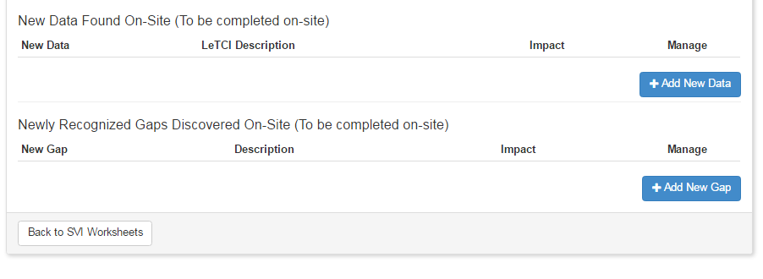

#### Computer Use Instructions

During a planning conference call, the team will discuss the following practices and consderations relating to personal computer use. Please follow this guidance in preparing for the site visit.

**In General**

Bring your own laptop computer and flash drive on the site visit. Test your flash drive independent of your regular network to make sure that it will still accept and read downloaded files. The NIST monitor will inquire about the availability of laptop computers and appropriate software before the site visit.

Ensure that your virus software is the most recent version and that it will scan all files automatically for viruses (verifying through the software’s options setting).

Keep the laptop computer secured in such a way as to preclude tampering with and removal of components and/or files.

Save files frequently to avoid the loss of critical data.

Back up! Back up! Back up computer files!

When not using the computer, close all applications and shut it down properly to avoid lost files.

Always secure and protect applicant-specific data.

**Preparing for the Site Visit**

Export all PDF files from BOSS.

**While in Transit:**

Do not pack the computer in a suitcase.

Always carry the computer with you onto an aircraft; do not check it as luggage.

When traveling in a car, store the computer in the locked trunk if you leave the vehicle. However, excessive heat or cold could damage it and/or result in the loss of data integrity.

**While at the Applicant’s Site(s)**

You may use your laptop while on the applicant’s site with OCP permission. However, its use is restricted to the team conference room, unless the OCP approves use during interviews.

Do not use the applicant’s computers. If data are needed, request the data, but do not extract or retrieve the data yourself.

Do not remove any data files from the applicant’s site.

**While at the Hotel**

Leave computers in the most secure location and out of general view.

# SITE VISIT: ON-SITE PHASE

## ON-SITE PHASE OVERVIEW

The on-site phase of the Site Visit Review begins with the opening meeting and ends with the closing meeting, which both take place at the applicant’s site. The entire site visit process is complete when the Site Visit Scorebook is finished and signed by each team member (completion of the scorebook usually takes two-to-three days after the closing meeting with the applicant).

## OPENING MEETING

The opening meeting is held for employees/faculty/staff of the applicant and the Site Visit Team. The applicant will discuss any deviation(s) from this guideline with the team leader and the NIST monitor.

If examiners are asked to introduce themselves, they provide only their name and current employer. Examiners are NOT to provide additional background information, such as their Malcolm Baldrige National Quality Award experience, credentials, title, work experience, or specialty in their organization.

The key components of the opening meeting are:

a presentation by the applicant (up to one hour) which includes their business model presentation

introductions of the Site Visit Team members and, using visuals provided by BPEP, a presentation by the Site Visit team leader (five minutes) about the Baldrige Award and the Site Visit Review

The order of the presentations is optional.

**Photographs and/or Videotape Parameters**

The applicant may take pictures before the opening meeting. The opening meeting may also be videotaped. The applicant is asked not to photograph or videotape the examiner team. Pictures and videotapes are restricted to internal use only by the applicant.

**Consideration of Prior Baldrige Feedback**

Two methods are allowed for the applicant to share previous feedback findings: (1) the Highest-Ranking Official (HRO) may present strengths and/or opportunities from previous reports in his/her opening meeting remarks, and (2) the applicant may voluntarily share its most recent feedback report with the team, provided the report was received within the past two years. However, the team does not request the report.

If a Site Visit Team receives a previous feedback report, the team is not obligated to review the report; the team should use its discretion in deciding whether to conduct a review and, if so, to what extent. If the team chooses to use the report, it must consider the report along with all other data collected on the site visit.

**Emphasis on Changes to Key Factors**

While on-site, many teams identify new or expanded understandings of the applicant’s organization and environment. These changes are considered in the investigation of site visit issues (SVIs). These new key factors are recorded at the bottom of the Key Factors Worksheet, and the team considers their impact, if any, on the organization. The team considers carefully the question on the worksheet, “Thinking about the questions in the Organizational Profile, did the team have any new insights about the applicant as a result of the site visit?” The team leader will expand on these insights during the judges’ call.

**Additional Meetings with the Applicant**

After the opening meeting, the team meets with the applicant’s category counterparts. In addition, the examiners conduct interviews in pairs, and they review documents and associated results. In most cases, examiners are not permitted to interview customers, suppliers, patients, students, parents, or nonemployees (except for volunteers who are supervised by the applicant). Site Visit Teams check with their NIST monitor for guidance. The HRO interview is limited to the HRO, team leader, and NIST monitor. Each day the team leader checks in with the official contact point (OCP) to finalize the schedule for the next day and to discuss any emerging issues.

**Applicant Materials**

Examiners need to track all materials they receive from the applicant whether paper, flash drives, or other media. The team needs to keep in mind the site visit’s time constraints and request only necessary information. The applicant is asked to attach a business card or to write the originator’s name on each separate document. The Site Visit Team develops a tracking system using the Document Log at the hotel and the Information Request on-site (see Additional Tools) to ensure that all materials are accounted for and returned to the applicant. The NIST monitor will coordinate with the OCP the return of all the materials taken to the hotel.

**Team Meetings**

Daytime: these meetings are scheduled each day at the applicant’s site, preferably midmorning and midafternoon, to exchange information and adjust the schedule. When examiners are at multiple locations, the team leader works with the NIST monitor to schedule conference calls so that all examiners can participate in these meetings.

Evening.: team members debrief on their assigned items and the related SVIs during the nightly team meeting. These meetings include discussion on key themes, concerns, needed adjustments to strategies and interviews, and any newly identified SVIs.

The team leader also uses the evening meetings to monitor team members’ progress on closing out their SVIs and on their assignments. If any examiners are not making sufficient progress, it may be necessary for the team leader to determine who will provide assistance to them. Make sure that the “analysis questions” on the SVI Worksheets are not forgotten as examiners prepare their worksheets.

During the on-site and post-site phases, team members keep all notes of their interviews and meetings. This helps the examiners to properly document findings and conclusions on SVI Worksheets. These notes are given to the NIST monitor for shredding or the Team Leader to refer to (and later shred or delete) at the close of the site visit.

**Last Chance**

Before the closing meeting at the applicant’s site, the Site Visit Team must identify any important, remaining site visit issues and discuss what information is needed to close them. It may be necessary to reassign team members to address critical issues. This is normally done on the evening before the day of the closing meeting. Throughout the site visit, the team follows the site visit plan but is flexible, expects surprises, and adjusts as necessary.

The team needs to be sensitive to the applicant. If the applicant says the team is missing the point, the team must make time to listen. If a team member behaves inappropriately, the team leader must immediately confer with the NIST monitor and take the necessary action.

## CLOSING MEETING

The closing meeting signifies the end of the on-site phase of the site visit. The closing meeting occurs the day after the team has departed the site for the final time. This is to provide the team with time to do a final check to ensure they have enough information to close all SVIs.

The closing meeting should last 10 – 30 minutes. The team leader and the NIST monitor will attend this meeting. The rest of the team stays at the hotel to complete their work. To the extent possible, the applicant should limit its attendees to the HRO, the OCP, and designated members of the Sr. Leadership team if requested. At the end of the meeting, the team leader presents a five-minute closing, using visuals provided by BPEP. The meeting is intended to simply present the next steps (using the slides / handouts provided by BPEP) and thank the applicant for its hospitality and support of the Program.

If the applicant requests a send-off or some kind of celebration for the team, that can be arranged when the whole team departs the site for the last time.

After the closing meeting, the team may not accept any data or documents, and it has no further contact with the applicant.

## DO’S AND DON’TS AT THE ON-SITE PHASE:

#### Do’s

Before the site visit, do ask the team leader to request items or information that will require special preparation by the applicant (e.g., requests for interviews with staff members in remote locations or for data that will need compilation or other preparation).

Do exercise common sense when scenarios arise that you have not encountered. Do what makes sense and is consistent with the principles reinforced in the Examiner Preparation Course and through the Code of Ethical Conduct. Discuss issues with your NIST monitor.

Do ask for whatever information is needed to clarify or verify your assigned issues. Ask spontaneous questions. However, be realistic, and do not place an undue burden on the applicant by requesting anything unnecessary.

Do work in pairs during interviews. Walk-around questions may be conducted either in pairs or by individuals. The NIST monitor may be the second person, although he/she doesn’t participate in the evaluation process.

Do adhere to the agenda items,but be flexible. It is vital for the applicant to feel there were sufficient opportunities to “tell its story.”

Do be prompt for all appointments.

Do take thorough notes for documenting the findings. Note the kinds of things that will help the applicant via the feedback report and will assist the judges in understanding the applicant’s processes and results. When backing up another examiner during an interview, offer to take notes for him/her.

Do have originators of documents attach business cards or place their names, locations, and phone numbers on the front of all documents so they can be returned to the correct people.

Do participate in daily meetings and debriefings to share information and impressions, to ensure that all relevant information is obtained, to ask questions of other examiners about their interviews, and to adjust strategy as needed.

Do arrange with the NIST monitor for the return or disposal of all materials after the site visit. All applicant materials must be returned to the applicant (exception: the team leader and backup team leader retain a copy of the scorebook, application, and updated results to prepare for the judges’ call). All notes, drafts, Consensus Scorebooks, drafts of SVI Worksheets, applications, and flip charts must be given to the NIST monitor. All digitally stored material about the site visit must be deleted. The team leader will advise you when files should be deleted.

Do bring your Baldrige name badge and represent yourself as a Baldrige examiner when at the applicant’s site(s).

Do wear comfortable clothing appropriate for the types of facilities you will visit and the off-site team sessions where discussion and writing occur.

#### Don’t’s

Don’t discuss any of the following with the applicant:

* personal or team observations, findings, conclusions, or decisions, whether in a critical or complimentary way
* practices of other applicants
* team observations about other applicants
* names of or any other information about other applicants
* your personal or professional qualifications
* information about your own organization

Don’t drink alcohol until the Site Visit Scorebook is completed.

Don’t give verbal or nonverbal feedback during interviews. Do not let the applicant’s representatives know your evaluation of their answers.

Don’t interview consultants, customers/students/patients, or suppliers. In rare instances an exception may be granted by your team leader in consultation with the NIST monitor.

Don’t hold debriefings, meetings, or discussions of the site visit in an open area.

Don’t take applicant materials, reports, documentation, etc., off-site unless doing so is essential, and only after checking with your team leader.

Don’t write on any of the applicant’s materials.

Don’t leave for home with any of the applicant’s materials.

Don’t accept gifts of any sort.

Don’t interact with the applicant after leaving the site.

## ON-SITE SCOREBOOK DEVELOPMENT

#### Scorebook Development Checklist

* Assigned team member(s) revise the Key Factors Worksheet, the Key Themes Worksheet, and the Summary of Sites Visited. Updating these worksheets continues throughout the visit.
* During the on-site phase of the site visit, team members close out assigned SVI Worksheets and revise Item Worksheets. Remember that updating worksheets continues throughout the visit. Occasionally, new SVIs arise because of additional information gathered during the site visit.
* Starting with the Sunday planning meeting and throughout the site visit, team members present an oral summary and status of their SVIs to the team. Team members follow along using BOSS online to call up the SVIs being discussed. Later, they discuss how the Item Worksheets have changed from the Consensus Scorebook. The team discusses, agrees, and revises, using online BOSS. There are typically a couple iterations of this process.
* Team members modify and finalize their SVI Worksheets based on the team’s input.
* In BOSS, team members post their draft Item Worksheets with updated comments, and they recommend a scoring range resulting from their respective SVI Worksheets. Team members review all Item Worksheets and provide input on the comments directly in BOSS. Again, this process usually has a few iterations. The team will later agree on a scoring range for each item, again based on comments and impacts of the SVIs.
* Team members modify their Item Worksheets based on the team’s input.
* An assigned team member refines the Key Themes Worksheet on an ongoing basis.
* The team conducts a final discussion on the Key Themes Worksheet. The assigned team member makes final edits.
* An assigned team member transfers scores from each Item Worksheet to the Score Summary Worksheet. To finalize scoring, the team discusses the selected range determined during a review for each item and whether the range is higher, the same, or lower than at Consensus Review. Also, the team discusses and comes to agreement on the overall process items and results items scoring bands. These determinations are based on results from the findings and their implications on the Item Worksheets. If the team is considering a change in a scoring band, it should discuss the key drivers behind this decision.
* Based on any final discussion of the Site Visit Scorebook, remaining corrections are made on the spot, and all sign the signature page of the scorebook.

During Site Visit Scorebook preparation, the NIST monitor collects all documents that are to be returned to the applicant. Examiners (except the team leader and backup team leader) will not take any applicant materials, the application, or scorebook documents with them.

#### Document Log

(editable version on the Site Visit Review section of the Examiner Resource Center)

EXAMINER NAME:________________________________ CATEGORY:_______________________

|  |  |  |  |
| --- | --- | --- | --- |
| DOCUMENT | CATEGORY | SOURCE | RETURNED |
|  |  |  |  |
|  |  |  |  |
|  |  |  |  |
|  |  |  |  |
|  |  |  |  |
|  |  |  |  |
|  |  |  |  |
|  |  |  |  |
|  |  |  |  |
|  |  |  |  |
|  |  |  |  |
|  |  |  |  |
|  |  |  |  |
|  |  |  |  |
|  |  |  |  |
|  |  |  |  |
|  |  |  |  |
|  |  |  |  |
|  |  |  |  |

#### Interview Log

(editable version on the Site Visit Review page of the Examiner Resource Center)

Interview Log

#### Information Request

Use this form to request supporting information during an interview. Please provide the applicant the question to be answered. The applicant will provide the supporting information (documents, data, examples, verbal verification, etc.) to address the question.

Category Item _________________Requestor: __________________________________

Question to be answered:

Information Provided: By:_____________________________________

1. _______________________________________________________________________________________________

2. _______________________________________________________________________________________________

3. _______________________________________________________________________________________________

4. _______________________________________________________________________________________________

5. _______________________________________________________________________________________________

6. _______________________________________________________________________________________________

7. _______________________________________________________________________________________________

8. _______________________________________________________________________________________________

9. _______________________________________________________________________________________________

10. ______________________________________________________________________________________________

## ON-SITE PHASE: AGENDAS AND OTHER TOOLS

#### Sunday Planning Meeting Agenda

**9a.m**. **Document Review**: Team members review documents, begin updating evidence in the SVI Worksheets, and prepare for team meeting.

**11:30 a.m. Open Team Meeting**

* Introduction
* Safety Briefing
* Examiners sign confidentiality statements (one copy for BPEP, one copy for the applicant).
* Review team assignments for site visit.
* Review team roles for the day: scribe, timekeeper, etc.
* Review overall purpose of the site visit.
* Review final output of the site visit—the Site Visit Scorebook.
* Review each Scorebook component and its purpose.
* Present the work schedule for the week. Discuss the process of updating SVIs and Item Worksheets (Item Lead updates, informs team when ready for review, team provides feedback and let’s item Lead know when complete, repeat as needed). Provide what products are due by when.
* Talk about the site visit experience. Who has been on a site visit, and what’s it like?
* Review expectations: what would we like the applicant to say about our site visit? What are our expectations of each other?
* Point out the need for a connected story from the Consensus Scorebook to the final Site Visit Scorebook to facilitate the judges’ understanding.
* Highlight issues to expect (e.g., it is not uncommon for the applicant to research the team members) and requirements of each team member (e.g., surviving a long, intense week; not writing on the applicant’s documents; keeping all notes confidential; not sharing issues with the applicant; providing no feedback to the applicant [verbal or nonverbal] and remaining gracious; sticking to your agenda; providing only your name and the name of your employer).

**12:30 p.m. Working Lunch**

* Go over team ground rules:
* Group meeting times: be prompt.
* Backup meetings: because traveling teams’ schedules change and land-line phones are not always available, it may be necessary to schedule backup team meetings.
* Keep up with SVI Worksheet documentation.
* Interviewing: review effective interviewing steps (see Effective Interviewing Steps immediately following this section).
* Buddy system: Interview in pairs and give one another feedback. Walk-around questions may be conducted by pairs or individuals.
* Schedule regular team meetings throughout the day.
* Discuss the use of laptops and printers, virus checking, restrictions on cell phone use on-site, etc.
* Any others?

**1:30 pm.** **Review the site visit schedule.** Not that this is just a review, that it may be adjusted as a result of today’s planning meeting. We’ll circle back.

**2:00 pm.** **Site Visit Issue Worksheet Review: (Round Robin)** (Note: This is intended to be a final review of what has already been reviewed on planning calls and feedback in BOSS before this meeting.)

* Give the status of SVIs. Any closed due to the document review?
* What information is still needed, and how best to get that information? What other documents are needed that you didn’t get?
* ensure that all of the applicant’s key organizational units are interviewed
* suggest any strategy enhancements
* identify any cross-category issues and how to modify to address these
* be prepared to eliminate or combine issues and to prioritize issues for each item (given limited time, priority issues need to be addressed first)

**4 p.m.** **Item Leads adjust and redraft SVI Worksheets** Let team know when you are finished with SVIs.

**5 p.m.** **Schedule walk-around questions** from the collated list downloaded from BOSS.

**6 p.m. Dinner**

**7 p.m. Meet with item backup** to finalize strategies for interviews with category leads. Determine specific questions for the interviews to be conducted on the first day. *

**7:30 p.m. Loop back to and finalize the schedule** for the next day. If time, consider a tentative schedule for day two.*

**8:30 p.m.** Agree on a gathering time and place for the morning. Adjourn and REST!!

#### Effective Interviewing Steps

(Review during the Sunday Planning Meeting)

Establish the Goal: Since the interviewing pairs need to gather a lot of information in a short time, they need a clear picture of what each of the interviews aims to accomplish. They set goals by asking, “What do I want to receive from this interview?” and “What specifically am I looking for?”

Know the Audience: Knowing people’s positions within the organization helps the examiners prepare for the interviews. This knowledge also helps examiners determine how to develop rapport with the interviewees so that they feel comfortable and talk freely. Examiners are sensitive and alert to the interviewees’ nonverbal feedback to the questions; they listen with their eyes, as well as their ears.

Prepare the Questions: Develop specific questions based on the site visit issues and Criteria items. Identifying questions in advance creates the interview framework. Some site visit issues can be “closed out” by asking questions that can be answered with specific, fact-based answers. Open-ended questions gather information on whether or not the mission, vision, and values, as well as processes, are deployed throughout the organization. These questions also allow the interviewees the opportunity to share their thoughts, beliefs, and examples of specific behaviors. The ultimate goal of all the questions is to enable the team to generalize the findings across the organization. If, however, all planned questions were answered in advance of a scheduled meeting, it is best to cancel the meeting and use the time to better meet the team’s needs.

Assess the Environment: Before starting, examiners need to assess the environment to ensure that it is conducive to the interview and data gathering. Consider the location, the amount of time, and who the interviewees are, as well as the total number of people being interviewed. The size of the interviewee pool will influence the type of the interview (e.g., focus group or one-on-one). Focus groups are typically more effective and efficient with a large number of interviewees.

Review the Information: To ensure that they have understood the answers to the questions, the examiners quickly review the information with the interviewees. This enables the interviewees to clarify what was meant and to provide additional information. Reviewing the information also provides a mechanism for closing the interview.

Capture the Information: One examiner leads the interview; the other captures the notes. After the interview, examiners review their notes once more to ensure that the needed information was obtained. Examiners can make notes about linkages or other areas to explore in the next interviews. The pair also reviews each other’s notes to verify the information.

Be Self-Aware: Examiners need to be conscious of their own nonverbal communication to ensure that they do not send messages to the applicant. Also, they need to be aware of how their biases can influence the questions that they ask.

**Interview Tips and Techniques**

Be prompt in starting the interview.

Introduce yourself: “Hello, I’m __________ from the Baldrige Site Visit Team.” Ask the person’s name if it is not offered. Ask the person some questions about his or her background to help put him or her at ease.

If the NIST monitor is observing your interview, explain his/her role as an observer.

Begin the interview by saying that examiners are not looking for right answers but, rather, that they are trying to fully understand processes and results.

Say that you will be taking notes. Also say that if we cut you off its not because we are rude; we have limited time to collect and analyze information.

As appropriate and functional, keep a separate page for each meeting or person with whom you talk and for each SVI. This permits easier sharing of information within the Site Visit Team.

Have interviewees fill out the interview log to track interviewees’ names, job functions, department or unit, and site.

Ask simple, straightforward questions using the applicant’s language. Avoid Baldrige or other types of jargon.

Listen actively! Paraphrase and repeat back to check for understanding. Be respectful!

Do not ask leading questions and be careful not to inadvertently prompt answers. For example, ask, “How often does the planning team meet?” rather than “Does the planning team meet every week?”

Ask the interviewee if he or she would like to add anything. You may have missed something the applicant feels is vital.

Thank the interviewee for his or her time and communicate appreciation for the applicant’s efforts.

Record materials requested and received.

Applicants are typically interested in assessing their progress on a site visit and may ask, “How are we doing?” Simply tell the applicant that the team is still gathering information on its site visit issues and, as such, it is premature to answer. However, you can complement the applicant’s hospitality, flexibility, and cooperation in helping the team obtain the information it needs.

#### Providing Feedback to Team Members using BOSS Online

**Review and Feedback Process**

Complete SVI Worksheets

Review Each Other’s SVI Worksheets in Feedback Pane

Review Item, Key Themes Worksheets in Feedback Pane

Complete Item and Key Themes Worksheets

Update SVI Worksheets

Update Item and Key Themes Worksheets

Sunday Planning Meeting and Monday Evening, Tuesday Evening as needed.

On-Site and Post-Site Phases

#### Agenda for Evening Meetings

* Record applicant materials received.
* Update key findings:
* Key Factors
* Site Visit Issues (SVIs) by item - Each team member posts documentation on one SVI on Sunday, Monday evening at the latest, for the team leader to check detail and focus. Each item lead presents status of SVIs, whether it’s open, closed, or nearly closed. Item backups take notes, modify SVI Worksheets as needed.
* Key Themes Worksheet
* Role-model strengths
* Vulnerabilities
* Results
* Discuss walk-around questions for the next day.
* Set agenda for the next day: who, what, when, where.
* Reminder: give no verbal or nonverbal feedback to the applicant
* Discuss issues raised by the OCP.
* On the evening before the closing meeting with the applicant, consider what information and documents the team needs to close out each SVI before the on-site phase is completed.

#### Using the Scorebook On-Site: (between the opening and closing meetings)

After you interview the applicant’s employees/staff/faculty/volunteers and review documents, fill in the evidence needed to support a conclusion to the core questions on the SVI Worksheets. This evidence guides you in determining when you have collected enough information.

In presenting this evidence, be sure to provide your teammates and the judges with enough detail that they are able to evaluate your conclusion. Include brief citations of the source of the data, such as “in interview with seven hiring managers,” “through analysis of the past three years’ SPP input documents,” and “during walk-around interviews with approximately 24 staff members from all levels and departments.”

Next, draft a succinct conclusion that responds to the core question and draws on the evidence presented. You must be able to answer each SVI’s core questions, thus “closing” the SVI, before the closing meeting. Your conclusion directly indicates any changes you need to make in the original comments on the Item Worksheets.

During this phase, you will update the SVI Worksheets for your team members to review using online BOSS. You may edit the SVI for clarity or to add information and then open for feedback again if needed.

# SITE VISIT: POST-SITE PHASE

## POST SITE OVERVIEW

The post-site visit phase consists of two major components. The first is the completion of the Site Visit Scorebook by the Site Visit Team. The second involves the team leader’s conference call with the Judges Panel during the Judges’ Meeting early November and the technical edit conference call with the lead judge and the NIST monitor at the conclusion of the Judges’ Meeting. The post site phase begins immediately following the On-site Closing Meeting.

The deliverable at this phase is the Site Visit Scorebook. The scorebook shows the progression of comments from Consensus Review to Site Visit Review in order to provide the judges with an audit trail of the team’s findings and conclusions. The judges use what they learn from this scorebook, in combination with the call to the team leader, to determine which applicants they will recommend as award recipients.

Completing the Site Visit Scorebook is the culmination of the Site Visit Review. Team members should keep in mind that completing the scorebook requires a significant amount of time and energy. To make the process most efficient and effective, team members must update their SVI Worksheets throughout the week. This helps the team track their progress and ensures that all needed information is obtained before the closing meeting at the applicant’s site. Typically, it takes 28–35 work hours to finish the scorebook after the on-site phase is completed. On the following pages you will see examples of completed worksheets using BOSS online. If you were not able to use BOSS online and had to use the PDF version of the worksheets, there are examples in the Appendix.

Post‐Site Example of Process Item WS in Online BOSS

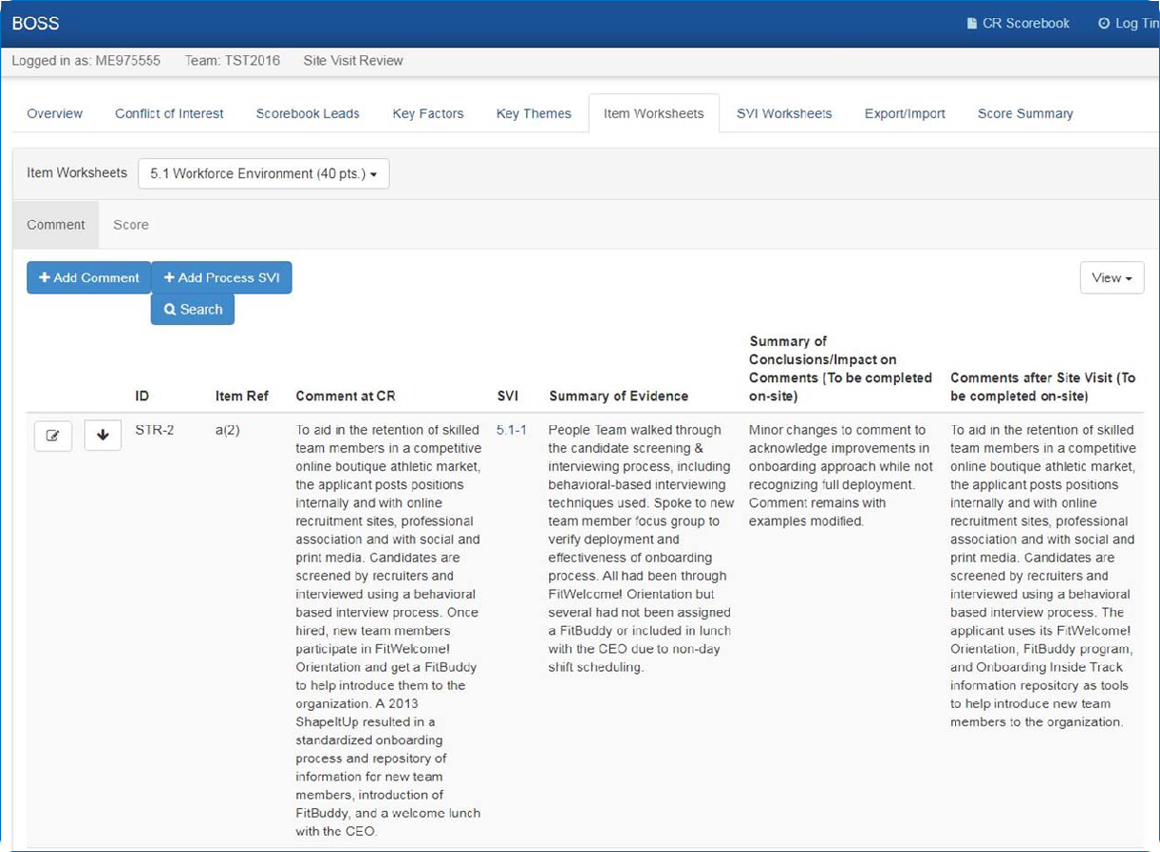

Columns are

filled in during the post‐site phase.

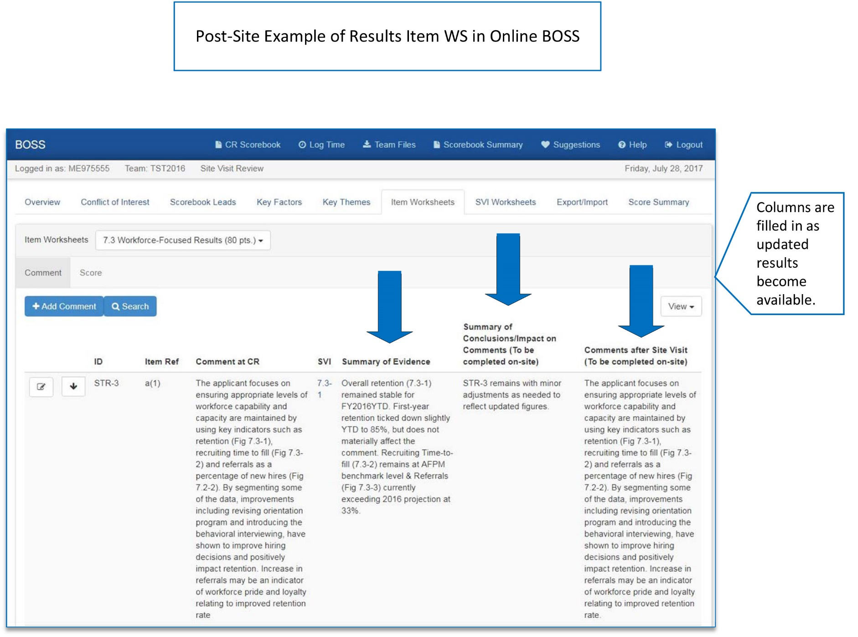

**Work Process Essentials**

All team members complete the following tasks:

Share key data or observations relevant to SVIs or key factors daily with the team member responsible for writing the appropriate SVI and Item Worksheets.

Update SVI Worksheets daily.

As necessary because of data sharing, update strategies.

Revise all draft SVI Worksheets and open for feedback..

Review all other SVI Worksheets and provide input on the information or conclusions they contain. This may be done by using the Feedback Panel in BOSS.

Finalize SVI Worksheets based on the team’s input.

Transfer conclusions and impact on comments to Item Worksheets and summarize them

Revise comments, as appropriate.

Confirm or adjust scores to align with the findings and conclusions.

Complete Item Worksheets and open feedback for others to review.

Review all other Item Worksheets and provide input on the summaries and comments.

Finalize Item Worksheets for each assigned item based on the team’s input and indicate their concurrence with each final Item Worksheet.

The team leader helps the team maintain focus on key processes and results and, most important, the refinement of key themes.

## SITE VISIT SCORING

As a final step in the evaluation process, the team works as a group to confirm the scoring range for each item and to determine the overall bands for process items and for results items.

In BOSS, Item Leads propose recommended scoring ranges and provide rationale using the Score tab BOSS transfers the scores from the Item Worksheets to the Score Summary Worksheet and indicates whether the scoring range changed or stayed the same .

Finally, the team leader conducts a scoring discussion to confirm the ranges or to come to consensus if needed. It is important for the team leader to ensure that the impact on comments, the scores on the Item Worksheets, and the scores on the Score Summary Worksheet match.

The team then refers to the Scoring Band Descriptors and determines which band descriptor for process items and which for results items most accurately reflects the team’s view of the applicant. If the team is considering a scoring band change, the discussion must include reasons for that change (the team leader records the reasons to share during the first call at the November Judges’ Meeting). These scoring band numbers are included on the Score Summary Worksheet. The Scoring Band Descriptors are used in the opening paragraph of the applicant’s feedback report.

## COMPLETING THE SCOREBOOK (before leaving the site visit)

The scorebook editor or team leader revises the final Key Themes Worksheet with updated comments resulting from the findings and the conclusions noted on the SVI and Item Worksheets. Team members provide input on the comments on the Key Themes Worksheet through ongoing discussion and online BOSS review and feedback. To finalize key themes, just as for scoring, the team leader facilitates a team discussion.

The assigned team member drafts the Summary of Sites Visited, shares it with team members, and uploads it to Team Files.

If using PDFs, team members copy the PDF files of their completed Item Worksheets and SVI Worksheets to one flash drive or laptop.

If using PDFs, the team leader imports the Item Worksheets and SVI Worksheets into BOSS. Copies of the scorebook can be made for the backup team leader and the monitor.

All team members sign the signature page of the paper version.

Team members (except the team leader and backup team leader) leave all materials, including the application, with the NIST monitor.

**Conducting Final Checks (may be performed on-site or after returning home)**

Clarify and standardize the language of the item comments and the key themes (e.g., names of the applicant and processes).

Eliminate any conflicts between strengths and OFIs both within and between items and key themes.

Ensure that all comments conform to the Comment Guidelines (e.g., avoid jargon, prescriptive sentences, and negative tone; include specific examples and figure references; focus on the Criteria requirements).

Verify that all statements such as “it is not clear,” “it does not appear that,” and “it is not evident” are changed to reflect the site visit findings.

**Making Copies**

The team leader and backup team leader leave the site visit with an electronic copy of the scorebook. Paper copies are optional.

The NIST monitor returns to BPEP with an electronic copy of the scorebook and the team’s signature page. BPEP recommends that the monitor also bring back a printed copy of the scorebook, if the scorebook has not been posted to BOSS.

**Checking and Refining Comments in the Site Visit Scorebook**

The team leader may make additional edits after the site visit, posting the scorebook on BOSS by midnight Pacific Time on the Monday following the site visit.

After the site visit has been completed and the examiners have returned home, the team leader prepares for the November conference call with the Judges Panel and the technical edit call with the lead judge and the NIST monitor. The team leader reviews the report for significant corrections and clarifications. This may take place after the deadline for finalizing in to BOSS and, if revisions are needed, they are discussed on the call with the Judges Panel.

After the technical edit call with the lead judge and NIST monitor, the team leader may be asked to make additional edits.

## SUMMARY OF SITES VISITED (example)

This worksheet conveys the extent and thoroughness of the site visit.

Length of the site visit (number of days with the applicant)

3 days

Sites visited (List the applicant’s major sites visited and describe any important aspects of the sites that are not apparent from the Site Listing and Descriptors section in the Eligibility Certification Form.)

Corporate Office—Baldrigeville, Maryland

Regional Offices—Annapolis, Maryland; Richmond, Virginia; Asheville, North Carolina; Morgantown, West Virginia

Manufacturing Plants/Transportation Hubs—Annapolis, Maryland; Richmond, Virginia; Asheville, North Carolina; Morgantown, West Virginia

The Morgantown plant currently is being upgraded to reduce emissions. The Morgantown plant also is the only facility that does not have a third shift.

The Annapolis plant was a recent acquisition (six months ago).

Approaches used to evaluate sites not visited, including sites outside the United States (if appropriate)

Video conferences were used at manufacturing plants and retail units in Tampa and Orlando, Florida (these plants are managed by the Asheville, North Carolina, Regional Office and represent 8% of the applicant’s sales and retail operations, as well as 10% of the manufacturing operations).

The Tampa and Orlando plants were called twice in order to cover two of the three shifts, and the applicant’s sales and retail operations were called during their daytime hours.

Other information on the team’s strategy for a thorough site visit (e.g., categories, types, and shifts of employees interviewed)

All sites visited were selected by the Site Visit Team based on observing 90% of the applicant’s manufacturing operations, 100% of the corporate/management and support staff, 92% of the retail and sales operations, and 100% of its transportation hubs.

Data-gathering methods consisted of document reviews and employee interviews that included meeting settings, lunchroom settings, and walk-around questions at all sites visited.

The team interviewed all categories of employees: 23% of manufacturing (all three shifts), 22% of sales and retail, 32% of corporate/management and support, 23% of transportation hub (all three shifts), and 6% of distribution.

The team interviewed 251 of the applicant’s 1,012 employees. (Note: A low percentage of the drivers were interviewed because of the nature of their jobs. Most of the drivers are dispersed throughout the East Coast. These unavailable employees were represented by available employees at their home sites.)

# GUIDANCE FOR TEAM LEADERS

## PLANNING PHASE OVERVIEW

The planning phase of the site visit begins after BPEP notifies the team leader that the applicant will be receiving a site visit. This section addresses planning essentials.

**Contact the Applicant**

* The team leader contacts the applicant’s OCP within 72 hours after the August Judges’ Meeting.

Only the team leader, backup team leader (as appropriate), and NIST monitor may talk to the OCP. The applicant may identify an alternate OCP who also may communicate with the team leader. The team’s communication with the applicant in the planning phase is limited to the OCP and any designated alternate(s).

During the initial call, the team leader provides the following:

* congratulations on the selection
* his or her name and employer
* his or her telephone number(s), reminding the OCP not to leave any messages that could reveal “the who” and “the where” of the visit
* the name and telephone number(s) of the backup team leader and an explanation of his or her role
* dates of the site visit: (see the Timeline for specific dates)
* Week 1 for health care, manufacturing, and service organizations
* Week 2 for education, small business, and nonprofit organizations
* The team leader discusses/reviews the purpose and outcomes of the site visit OCP (see Agenda for TL-OCP Calls in the Appendix).
* Establish Ongoing Communication with the Applicant
* During the weekly calls with the OCP, obtain further information for planning the site visit. These calls also help the OCP understand the Site Visit Review and provide the opportunity for the OCP to ask questions. (See Agenda for TL-OCP Calls in the Planning Phase of the Appendix)

**Early in the Planning Process**

Review the opening and closing meeting processes, including expectations of both the applicant and the Site Visit Team. (BPEP will provide you with PowerPoint presentations for both the opening and the closing meetings with the applicant.) (See Opening Meeting and Closing Meeting in the On-Site Phase section.)

* Remind the OCP of the site visit boundaries:
* In most cases, the Site Visit Team cannot meet with any suppliers or customers/students/  
  patients. Examiners should check with the NIST monitor for guidance.
* Examiners must not accept gifts.
* No data or documents will be asked for or accepted by the Site Visit Team after the closing meeting.
* No feedback of any type (verbal or nonverbal) is provided by the Site Visit Team during the site visit.
* Request information regarding lunch while the team is on-site (to be arranged and provided by the applicant in the employee cafeteria, if available). If some team members are working in evenings, dinner will need to be arranged as well.
* Ask about appropriate clothing for the team to wear while visiting the applicant site(s).
* Confirm the availability of key people and ask for a list of the applicant’s points of contact for each of the seven Criteria categories.
* Discuss the on-site portion of the site visit schedule, which begins with the opening meeting and ends with the closing meeting. To assist the applicant in arranging for the availability of key people for interviews, discuss and send your preferred interview schedule for day one of the on-site phase at least ten days before the start of the site visit.
* Prepare a list of documents the team will need to have immediately available in the hotel conference room for the Sunday planning meeting and give the list to the OCP at least ten days before the start of the site visit. Clarify that the team will request additional documents during the site visit.
* The OCP has been notified to have all documents referenced in the application available for the team to review. The OCP also has been notified to provide ASQ with updated results at least 10-11 days before the site visit.
* Discuss other team needs (see Agenda for TL-OCP Calls in Appendix)

The applicant is responsible for providing transportation to and from its locations, and the OCP will appreciate as much lead time as possible for arranging this travel.

* Clarify that no word-processing assistance for the Site Visit Team is allowed. **Develop the Initial High-Level Plan**
* Determine the following to finalize the plan for sites to be visited and to begin work on the day one schedule (see sample schedules in the On-Site Phase section and in the Appendix)
* Provide the team’s inter-site travel plans to the OCP and the NIST monitor as soon as possible but no later than two weeks before the start of the visit. The day one schedule is to be delivered to the OCP ten days in advance of the site visit.

**Communicate with BPEP**

A member of the BPEP staff is assigned as a site visit monitor (i.e., NIST monitor). The team leader includes the NIST monitor in planning efforts and maintains regular contact. The NIST monitor is included in all team calls and is a recipient of all team communications. The NIST monitor may, but is not required to, participate in the weekly telephone calls between the team leader and the OCP. The NIST monitor also establishes a separate, regular schedule for calls with the OCP (the team leader does not participate in these calls).

**Participate in Team Leader conference call**

BPEP will conduct a conference call for Site Visit team leaders and an alternate date for those that cannot participate in the first call. Please check the Timeline at the front of this manual for specific days and times. Each team leader must participate in one of these events. The call is optional for backup team leaders.

**Communicate with Team Members**

During the planning phase, the Site Visit Team conducts weekly conference calls. These calls keep the team informed, review just-in-time materials, and cover all aspects of the planning activities to ensure that team members are completing all necessary tasks (e.g., determining strategies to close out SVIs, developing SVI Worksheets, and discussing travel arrangements). The team’s advance planning is essential for ensuring an effective site visit.

**Request Information and Materials**

The team leader may request information and materials from the applicant at only three times:

During site visit planning, the team leader requests and secures from the OCP materials needed to plan the strategy for the site visit (See Appendix)

Ten days in advance of the site visit, the team leader submits to the OCP a list of documents to be available in the hotel conference room for the Sunday planning meeting. The NIST monitor coordinates with the OCP to ensure the materials are available. This list should contain a maximum of 15 documents for categories 1 – 6, and only missing results for category 7.

Immediately upon completion of the opening meeting and during the on-site phase of the site visit, the team leader and team members may request additional documents.

After the closing meeting, no furthermaterials or information may be requested from the applicant.

**Ensure That You Have Communicated Appropriately**

If there will be inter-site travel, provide where, when, and who will travel two weeks before the site visit. (The applicant makes these arrangements.)

Inform the applicant that, during the site visit, examiners will verify and clarify elements of the written application; and review updates to the charts and graphs and, in many cases, review the source documents for the data in the charts and graphs.

**Do not tell the applicant**

Specific information about team members, such as professional experience or backgrounds. (The applicant receives a team listing that will include the examiners’ names and their employers only.)

Specific site visit issues and themes.

**Ask the applicant to provide**

Time for interviews with people from remote or foreign sites (The team leader indicates the person by name, title, or function. Interviews may be done in person, by telephone or video conferencing, or through other media.)

**Direct, Support, and Mentor the Team**

* The team leader’s role includes the following tasks:
* Tell team members when and where they should arrive and depart from the hotel. Individual travel plans must not adversely affect the team or the evaluation of the applicant.
* Ask the backup team leader to help plan and carry out tasks.
* Develop team assignments and instructions for the site visit. Discuss the plan with team members and the NIST monitor.
* Assign team members in pairs; match examiners who have sector experience with those who do not. In addition, consider Baldrige experience as well as site visit experience.
* Works with the team to develop and finalize SVIs, focusing on issues of central importance to Criteria and applicant. This includes reviewing the quality of SVI Worksheets during both the planning and on-site phases.
* Send a copy of all team correspondence to the NIST monitor and ask the team members to do the same. Include the NIST monitor in all conference calls.
* Set expectations and develop a work schedule with all team members.
* Remind the team that all materials are confidential.
* Stress that all assigned planning tasks need to be completed before the beginning of the site visit.
* Ensure that all are ready, have completed their assignments, and have exchanged appropriate materials with each other before arriving at the applicant’s site.

**Develop a Detailed Draft Schedule (see sample On-Site Team Schedule in the Planning Phase section)**

* Follow these steps to draft the on-site schedule:
* Determine the numbers and types of employees to interview to ensure that the team can adequately assess the organization’s maturity, deployment, and consistency.
* Select sufficient and appropriate sites to visit, based on examiners’ documented requests (i.e., related to their most important site visit issues), balanced by the applicant’s need to experience a thorough evaluation.
* Determine sites to visit in person and sites that can be “visited” via telephone or video conferencing to effectively obtain the needed information and reduce inter-site travel.
* Calculate costs in time versus the benefit(s) and importance of traveling to another site.
* Identify those sites where the team can best verify and clarify important issues. Work with the team to get ideas and buy-in.
* Identify which team members to send to which site, on what days, and when to hold conference calls. Ask the OCP to arrange for speaker phones at the applicant’s locations and to confirm the availability of existing conference call accounts for these calls.
* Decide the number of days and the dates to be spent with the applicant on-site. Coordinate with BPEP.
* Provide the NIST monitor and the OCP with the schedule of the sites to be visited, the dates of the visits, and who will be traveling where.
* In addition to the day one agenda that you will provide to the OCP ten days in advance, develop a projected agenda for the remainder of the on-site portion of the visit. Although it must remain flexible, an initial plan will save time as the site visit evolves.

**Conduct the Sunday Planning Meeting (See the sample Sunday Planning Meeting Agenda in the On-Site Phase section of the Appendix)**

## PLANNING GUIDELINES ON TEAM SIZE & LENGTH OF THE ON-SITE PHASE

#### Proposed Ground Rules (modify as needed)

|  |  |  |  |  |  |  |  |  |  |  |  |  |  |  |  |  |  |  |  |
| --- | --- | --- | --- | --- | --- | --- | --- | --- | --- | --- | --- | --- | --- | --- | --- | --- | --- | --- | --- |
| | Applicant Size | Complexity | | | | --- | --- | --- | --- | | Low | Medium | High | | Small | 7  team members  *2-2.5 days | 7–8  team members  *2–2.5 days | 7–8  team members  *2.5–3 days | | Medium | 7–8  team members  *2.5 days | 8  team members  *3 days | 8  team members  *3–3.5 days | | Large | 8  team members  *3 days | 8  team members  *3.5–4 days | 9  team members  *3.5-4 days |   \**Average time spent with the applicant (i.e., the on-site portion of the site visit), not including time for planning or scorebook writing.* |

* Working as a Team: Our objective is to conduct an effective and objective site visit by using all the expertise of our team members. This means we listen carefully to each other and take full advantage of our broad experience and the diversity of our collective thinking. It also means we are flexible about pitching in and helping each other throughout the process. None of us leaves until the job is completed. Working as a team also means that we present a uniform and united front during all interactions with the applicant.
* Customers: Our immediate internal customers are team members, who need to understand oral and written communication and benefit from each of our contributions. Another internal customer is the Judges Panel, which is looking for our objective evaluation of the applicant based on the award Criteria. The judges in turn determine if the applicant has national role-model practices to share. The applicant is the primary external customer, which is looking for insightful, non-prescriptive feedback that helps reinforce its strengths and identify actionable OFIs.
* Feedback-Ready Comments: As we complete our work, we make every effort to draft consolidated comments that are feedback ready. That means we imagine that the applicant is reading the comments as we write and can understand how each comment is applicable and actionable. In addition, we need to make it easy for the judges to follow the trail from the Consensus Scorebook to the Site Visit Issue Worksheets to the Item Worksheets to the Key Themes Worksheet.
* Item Ownership: No one “owns” any item. Instead, we are trying to get the best collective thinking. Cross-team sharing of observations and input is a necessity.
* Time Management: We try very hard to begin and end on time. We stick to the agreed-upon overall schedule of events. It is important to document as we go. Site Visit Issue Worksheets must be kept up-to-date. If we get behind, it will be difficult to catch up!
* Facilitation: We all have a responsibility for facilitation. For example, if we get away from the more important points and into minutia, anyone can call a “process check” to help us get back on track.
* Active Listening and Consensus: We listen to other points of view, particularly those that are different, in addition to expressing our own. We can and do respectfully disagree, but we are striving for consensus. Consensus means we have heard, have been heard, and thus can and will support the team’s conclusions.
* Professional Behavior: We want the applicant to feel that we are prepared, listen well, and thoroughly understand its organization.
* Have Fun and Learn from Each Other: We intend to have fun and encourage humor at the same time that we are working. We can even share some humorous moments with the applicant, as we get to know its staff members during the site visit.
* Personal Information: We may tell the applicant only our name and the name of our organization, not professional expertise and experience with Baldrige.
* Other: We all take collective ownership and responsibility for the Site Visit Scorebook. In addition, we do not take any souvenirs (pens, stationery, etc.) from the applicant’s site or from the hotel.

#### Generic Walk-Around Questions

In what part of the organization do you work? How long have you been with the organization? How long have you been in your current position?

What are the most significant changes that you have personally experienced in the last two to three years? Why?

Do you have direct interactions with your customers and/or stakeholders? How often? Could you describe a couple of examples of these interactions? In general, do you know what your customers and/or stakeholders expect from you?

What departments or groups do you depend on to do your job? How is the work allocated to you? Do you provide these groups feedback on what improvements could be made? How often? How (formal/informal feedback)?

Are you involved in community activities? Do these involve time off from work? Does the organization allow you time or pay you while you volunteer?

Are you currently participating on any work teams? How long have you been a member? What is the team’s mission/role? Are your team activities worth the time you spend? Why?

How do you share information with others or receive information from others to help you do your job?

When was the last time you attended a formal training class? Topic? Length? What knowledge from the training were you able to use back on your job?

Do you receive information about the organization’s key strategic objectives? How (e-mail, newsletters, group meetings, etc.)? Which method is most effective? Are there other ways you would like to get information and/or other information you would like to have?

Do you receive information on key organizational results? How do you use this information to make decisions?

How often do you see your direct supervisor? His or her supervisor? His or her supervisor? Under what circumstances?

Who are your major competitors? What do they do better than you? Are you aware of any efforts to improve in these areas?

How do you see this organization’s future? How you share any concerns or ideas you might have with your senior leaders? Have they asked you for input? How/how often?

How do you fit into the organization’s strategic plan?

#### Team Leader/OCP Discussion Agendas

*Note: There may be a need for more than 1 call in any given week. For example, the agenda below for “4 weeks out” is very heavy and may take two calls in that week.*

**4 Weeks Out:**

* Congratulate the applicant, provide number of site visits in each sector
* Validate the dates of the site visit (if necessary), rough start times each day
* Validate that the applicant gets an in-brief meeting of 1-hour
* Ask if there are any concerns
* Initiate discussions on the overall schedule, including:

|  |
| --- |
| Day 1:   * Kickoff meeting (Team Leader) – 15 minutes * In-brief meeting and Q&A (Applicant) – 1 hour * 6 Category Meetings 2 ½ hours each (both sides) * Category Leads review needed documents – 30 minutes and provide document request to team leader. * Team Leader/OCP close for the day |

* Discuss how the Category 7 data updates need to be presented (particularly if the applicant does not have the internal capability to duplicate the graphics in the application). Discuss how the examiners will know what has changed
* Any conflicts with known leadership schedules
* Any key leader they want to ensure is available
* Preliminary discussion of where the meetings will be held (Team prefers that the meetings are held in the areas where the documents for that topic exist or can be easily accessed)
* Initial conversation on the locations we may wish to visit
* Expand the site listing from the eligibility form with more details on:
* Locations
* Employees
* Functions
* Shifts
* Unique services not provided elsewhere
* Establish a regular phone contact schedule before the site visit. Put the times on both calendars.
* Timing of the overall process, including:
* Team coming into town
* Hotel
* Team plans to leave (time required for consensus)
* Who are the applicant’s category team leaders, members, and function or job title
* Key committees not noted in the Application (e.g., Medical Staff Committees, Board Committees)
* We will be sharing our examiner team and category leads with you in week 3.
* Any issues surrounding security and access at the applicant facilities.
* Transport questions: pick-up each morning
* Listen to the Applicant regarding constraints (Travel, rush hour times, etc.)
* Timing for the Initial Data Request. Suggest that they number every document. Example:

Category 1:

* 1-1
* 1-2
* 1-3, etc.
* During the Site Visit: Put the owner of the document’s name and location on the document and track the documents with a unique number (use a document request form)
* If possible, hold the Category meetings in rooms with a computer, projector & screen to show documents to the examiners.
* Remind them that in the site visit email correspondence from ASQ there will be a set of questions to address in your opening presentation to ensure that the team understands your business model
* Discuss and agree to rules for the site visit to make sure we are working together – there is a feedback loop to either the team leader or the NIST monitor.
* 1-hour rule – If it takes the applicant longer than one hour to prepare an answer to an examiner question, discuss with the team leader or the examiner

**3 Weeks Out:**

* Any open issues from week 4
* Provide the team list and what category each team member will lead
* Verify the schedule to complete the initial document request (documents which will need to be provided prior to the site visit)
* Verify that the documents are being numbered
* Validate that there is a team room on site with phone for calling applicant’s employees as needed, and key(s) to the room. (room must be lockable with entry by team only)
* High-level schedule for Day 1; allowing travel time / restroom breaks/ stand up breaks between meetings, as appropriate
* Discuss if there are special:
* Health/dress/diet requirements for the team
* Dress/safety requirements for the facilities (closed-toed shoes, no high heels?)
* Dress Code
* Any cultural issues /sensitivities beyond the norm
* Arrive 30 minutes before the opening meeting (7:30) to allow meet & greet.

**2 Weeks Out:**

Review the open issues from previous discussions

Venue for meetings – i.e., confirm that the meetings during the Site Visit will be in the area where the documents are – for example, when they meet with HR representatives, they will meet in the HR department

Confirm other on-site logistics for:

Team’s work room at the Applicant’s site

Meeting rooms (such as in HR as stated above)

Process to return documents after the site visit

Facility visit plan (do they need a map?)

Finalize Transportation plan, Guides needed

**1 Week Out:**

Finalize any loose ends from earlier topics

Any aspects of the initial document request which are unclear

Validate the leaders which are needed and/or will not be available

#### Team Member Assignments — 7-Member Team (Example)

Here are the team assignments for our site visit.

Thanks again for your flexibility and indulgence. We have had to change category assignments to reflect the changing composition of our team.

|  |  |  |  |  |
| --- | --- | --- | --- | --- |
| Examiner Name | Category Lead | Backup | Cross-Cutting Issue/ Key Process | Other |
| Laura | Key Factors & Key Themes Worksheets, Summary of Sites Visited, HRO Interview Worksheet |  | Corporate support  Leadership system  Deployment  Organizational succession planning | Team leader  Leadership team interview  Scorebook editor  HRO interview  Daily check-in with OCP  Document request list |
| Roger | 2.1, 2.2 | 4.1, 4.2, 7.5 | Strategic planning | Backup team leader  Logistics |
| Sharon | 3.1, 3.2, 7.2 | 1.1, 1.2, 7.4 | Customer relationships | Senior executives’ interview questions (coordinate) |
| Michael | 4.1, 4.2, 7.5 | 2.1, 2.2, 7.3 | Management by fact  FOCUS Scorecard | Meeting coordination during site visit  Computer expert |
| Julie | 5.1, 5.2, 7.3 | 6.1, 6.2, 7.1 | Decentralized management  Workforce empowerment | Walk-around questions (draft)  Process checker and timekeeper |
| John | 6.1, 6.2, 7.1 | 5.1, 5.2, 7.3 | Operations Focus | Scribe (as needed) |
| Liza | 1.1, 1.2, 7.4 | 3.1, 3.2, 7.2 | Organizational results | Criteria cop |

#### Team Member Assignments — 8-Member Team

|  |  |  |  |  |
| --- | --- | --- | --- | --- |
| Examiner Name | Category Lead | Backup | Cross-Cutting Issue/ Key Process | Other |
| Laura | Key Factors Worksheet, Summary of Sites Visited,  HRO Interview Worksheet |  | Parent interaction  Leadership system  Overall deployment | Team leader duties  Leadership team Interview questions (coordinate)  Scorebook editor  HRO interview  Daily check-in with OCP  Document request list (coordinate)  Daily schedule |
| Roger | Key Themes |  | Board governance | Backup team leader duties  Logistics  Daily team meetings (coordinate) |
| Sharon | 3.1, 3.2, 7.2 | 1.1, 1.2, 7.4 | Customer and patient relationships | Timekeeper |
| Michael | 4.1, 4.2, 7.5 | 2.1, 2.2 | Management by fact | Computer expert |
| Julie | 5.1, 5.2, 7.3 | 6.1, 6.2, 7.1 | Decentralized management  Workforce empowerment | Walk-around questions (coordinate)  Process checker |
| John | 6.1, 6.2, 7.1 | 5.1, 5.2 | Process focus | Scribe (as needed)  (Health Care) VBP SVI |
| Liza | 1.1, 1.2, 7.4 | 3.1, 3.2, 7.2 | Organizational succession planning | Criteria Cop |
| Brian | 2.1, 2.2 | 4.1, 4.2, 7.5 | Strategic planning | Clinical perspective |

#### Team Member Assignments — 9-Member Team

Here are the team assignments for our site visit.

Thanks again for your flexibility and indulgence. We have had to change category assignments to reflect the changing composition of our team.

|  |  |  |  |  |
| --- | --- | --- | --- | --- |
| Examiner Name | Category Lead | Backup | Cross-Cutting Issue/ Key Process | Other |
| Laura | Key Factors Worksheet, Summary of Sites Visited,  HRO Interview Worksheet |  | * Parent interaction   Overall deployment | * Team leader duties * Scorebook editor * HRO interview * Daily check-in with OCP * Document request list (coordinate)   Daily schedule |
| Roger | Key Themes |  | Board governance | * Backup team leader duties * Leadership team Interview questions (coordinate) * Back-up for all examiners * Logistics   Daily team meetings (coordinate) |
| Sharon | 3.1, 3.2, 7.2 | 1.1, 1.2, 7.4 | Customer and patient relationships | Timekeeper |
| Michael | 4.1, 4.2, 7.5 | 2.1, 2.2, 7.1 | Management by fact | Computer expert |
| Julie | 5.1, 5.2, 7.3 | 6.1, 6.2 | * Decentralized management   Workforce empowerment | * Walk-around questions (coordinate)   Process checker |
| John | 6.1, 6.2 | 5.1, 5.2 | * Process focus   IT System stability | Scribe (as needed) |
| Liza | 1.1, 1.2, 7.4 | 3.1, 3.2, 7.2 | Organizational succession planning | Criteria Cop |
| Chris | 7.1 | Key Themes | * Health care results focus   Leadership system | Physician, nursing, and volunteers |
| Brian | 2.1, 2.2 | 4.1, 4.2, 7.5 | Strategic planning | Clinical perspective |

#### On-Site Team Schedule Example (medium size, medium complexity)

Monday

|  |  |  |  |  |  |
| --- | --- | --- | --- | --- | --- |
| **Time** | **Activity** | **Sub Team 1** | **Sub Team 2** | **Sub Team 3** | **Sub Team 4** |
| 7:30 a.m. | Leave hotel for opening meeting | X | X | X | X |
| 8:00–8:30 | Arrive  Move to kickoff | X | X | X | X |
| 8:30–8:45 | Kickoff meeting  (Team Leader) | X | X | X | X |
| 8:45–9:45 | Opening Meeting  (Applicant) | X | X | X | X |
| 10:00–12:30 | Category Meetings | Cat 1 | Cat 2 | Cat 3 | HRO Interview |
| 12:30-1:30 | Lunch and Team Caucus |  |  |  |  |
| 1:30 -4:00 | Category Meetings | Cat 4 | Cat 5 | Cat 6 | 7.1,7.2 |
| 4:00 -4:30 | Cat Lead Review for Needed Documents | X | X | X | X |
| 4:30 -5:00 | Team caucus | X | X | X | X |
| 5:00–5:30 | TL and monitor meet with OCP to discuss needs for next day and coordination. Rest of team return to hotel | X | X | X | TL / OCP / Monitor Planning Mtg. |

Tuesday

|  |  |  |  |  |  |
| --- | --- | --- | --- | --- | --- |
| **Time** | **Activity** | Sub Team 1 | Sub Team 2 | Sub Team 3 | Sub Team 4 |
| 7:30 a.m. | Leave hotel | X | X | X | X |
| 8:00–9:00 | Team interviews and data gathering | X Staff  (names) | Category 1  (names) | Site #2  (names) | Process owners  (names) |
| 9:05–10:00 | Team interviews and data gathering | Managers’ group  (names) | Web/intranet  (names) | Site #2  (names) | Site #2  (names) |
| 10:05–11:00 | Team interviews and data gathering | Site #2  (names) | Category 2  (names) | Category 4  (names) | X Staff  (names) |
| 11:05–12:00 | Team interviews and data gathering | Category 3  (names) | Safety Comm.  (names) | Item 7.4  (names) | Item 7.1  (names) |
| 12:05–1:00 | Lunch and discussion | X | X | X | X |
| 12:45–1:00 | TL and monitor meet with OCP re: schedule adjustments and additional documents needed |  |  |  |  |
| 1:05–2:00 | Team interviews and data gathering | Site #1  (names) | Category 2  (names) | Category 1  (names) | Category 3  (names) |
| 2:00–2:25 | Team caucus | X | X | X | X |
| 2:30–3:00 | Team interviews and data gathering | Travel to site #1 | Travel to site #1 | Call center  (names) | Category 6  (names) |
| 3:05–4:00 | Team interviews and data gathering | Follow up with HRO  (names) | Site #1  (names) | Document review  (names) | Site #2  (names) |
| 4:05–5:00 | Team interviews and data gathering | Site #1  (names) | Document review  (names) | Site #2  (names) | Document review  (names) |
| 5:00–6:00 | Return to hotel  Prepare for working dinner | X | X | X | X |

Wednesday

|  |  |  |  |  |  |
| --- | --- | --- | --- | --- | --- |
| **Time** | **Activity** | Sub Team 1 | Sub Team 2 | Sub Team 3 | Sub Team 4 |
| 7:30 a.m. | Leave hotel | X | X | X | X |
| 8:00–9:00 | Team interviews and data gathering (ensure that all SVIs can be closed out) | Finalize categories & items | Finalize categories & items | Finalize categories & items | Finalize categories & items |
| 9:05–10:00 | Team interviews and data gathering (ensure that all SVIs can be closed out) | Finalize categories & items | Finalize categories & items | Finalize categories & items | Finalize categories & items |
| 10:05–11:00 | Team interviews and data gathering (ensure that all SVIs can be closed out) | Finalize categories & items | Finalize categories & items | Finalize categories & items | Finalize categories & items |
| 11:05–11:25 | Team caucus (ensure that all SVIs can be closed out) | X | X | X | X |
| 11:10–11:25 | TL and monitor meet with OCP re: schedule adjustments and additional documents needed |  |  |  |  |
| 11:30–12:00 | Closing meeting | X | X | X | X |
| 12:00–1:00 | Return to hotel  Prepare for working lunch | X | X | X | X |

#### Large Applicant, High Complexity Example

Sunday, October XX,

9:00 Document Review (see On-Site Phase section for a sample Sunday PlanningMeeting Agenda).

11:00 Team meets in XYZ Hotel for planning meeting

Monday, October XX

7:30 a.m. Team is picked up at hotel.

8:00 Kickoff Meeting

8:15 Opening meeting (no more than one hour)

Organization overview by the HRO/OCP

Baldrige Program overview by the team leader

9:30 Category Meetings and HRO Interview

12:00 Lunch and team caucus

1:00 Category Meetings

2:30 Additional Interviews, data, document reviews

4:30 Team Caucus

5:00 Team Leader and Monitor meet with OCP. Rest of team departs for hotel. Traveling teams, if needed, depart for airport to visit other sites

Marcia and Mark depart for Site 2.

Herb and Louise depart for Site 3.

Rona and Larry depart for Site 4.

All team members update SVI Worksheets, prepare interviews for next day, and review applicant materials.

6:30 At headquarters, Allen, Bev, and NIST monitor eat dinner and conduct interviews via conference call with plant manager’s leadership team.

6:30 While traveling, team members update Site Visit Issue Worksheets, prepare interviews

for the next day, and review applicant materials. They individually summarize notes for the day and review documentation received. The objective is to determine how many SVIs can be closed, what additional interviews are needed, and what conclusions can be made to Item Worksheets based on the day’s findings.

8:00–close Team members review with their respective traveling team members the results of their activities for the day and conclusions drawn. All identify emerging themes, surprises, and issues that have been reinforced, as well as areas to address over the next several days. Whole team caucus call may take place.

Tuesday and Wednesday, October XX–XX,

Morning Team conducts interviews/walk-around questions and data gathering.

Site Headquarters–Allen and Bev

Site 2–Marcia and Mark

Site 3–Herb and Louise

Site 4–Rona and Larry

10:30 a.m. Team holds caucus conference call or team meeting.

11:45 Lunch interviews at all sites

Afternoon Team conducts interviews, including walk-around interviews, and gathers data.

4:00 p.m. Team holds caucus conference call or team meeting. Team leader, monitor, and OCP discuss schedule adjustments and additional documents.

4:45 Team conducts interviews, including asking walk-around questions, at all sites.

Evening Interviews, walk-arounds, closing out of SVIs

6:00 Dinner interviews with employees at all sites

7:00–11:00 Team completes documentation and closes out SVIs.

7:00 Tuesday—Sites 2 and 3 only: interviews, walk-around questions for third shift

7:00 Wednesday–Site 4 only: interviews, walk-around questions for third shift

7:00–8:00 Team members individually summarize notes for the day and review documentation received. The objective is to determine how many SVIs can be closed, what additional interviews need to be done, and what conclusions can be made to Item Worksheets based on the day’s findings.

8:00–close Team members review findings, requested documents for the day, and the conclusions they have drawn with the rest of the team. They identify emerging themes, surprises, and issues that have been reinforced, as well as areas to address before the closing meeting.

*Note to team leader: From a review of this work, you should be able to determine who is asking the right questions and getting the required data, as well as who can draw conclusions. If team members cannot form conclusions, this is a good time to review their approach and give them some help!*

9:00 Team holds caucus call.

Thursday, October XX

Morning Team conducts interviews and data gathering.

Headquarters–Allen and Bev

Site 2—Marcia and Mark

Site 3—Herb and Louise

Site 4—Rona and Larry

10:30 a.m. Team holds conference caucus call or team meeting. Team leader, monitor, and OCP discuss schedule adjustments and additional documents.

11:00 All examiner teams travel back to headquarters.

Afternoon Team conducts interviews and data gathering.

2:30 p.m. All teams arrive from other sites to headquarters.

2:30 Team meeting

3:00 If needed, final interviews and document requests take place. The team ensures that it can close all SVIs before the closing meeting.

3:30 Closing meeting

4:15 Team departs for hotel.

6:00 Team meets to plan scorebook writing.

Evening Working dinner

Team debrief

Exchange findings for SVIs

Completion of SVI documentation

Friday and Saturday, October XX–XX, XXXX.

Scorebook completion of Item Worksheets, Key Factors, Key Themes

Team uploads HRO Interview & Summary of Sites Visited to Team Files in BOSS and signs Signature Page.

Team takes inventory/prepares materials for return to applicant.

Sunday, October XX

8 a.m. Earliest possible departure

#### Site Visit Schedule: Small Applicant/Low Complexity

Sunday, October XX

9:00 Document Review (see On-Site Phase section for a sample Sunday Planning Meeting Agenda).

11:00 Team meets in XYZ Hotel for planning meeting

Monday, October XX

7:45 a.m. Team is picked up at hotel.

8:00 Team arrives at site.

8:30 Kickoff Meeting

Organization overview by the HRO/OCP

Baldrige Program overview by the team leader

10:00 Category meetings and HRO Interview

12:30 Lunch and Team Caucus

1:30 Category Meetings.

4:00 Cat Lead Review for Needed Documents

4:30 Team Caucus

5:00 Team Leader and Monitor meet with OCP, rest of team returns to hotel.

6:30 Working dinner/evening meeting: Team updates Site Visit Issue Worksheets, prepares interviews for the second day, and reviews applicant materials. Team members individually summarize notes for the day and review documentation received. The objective is to determine how many SVIs can be closed, what additional interviews need to be done, and what conclusions can be made to Item Worksheets based on the day’s findings.

8:00–close Team members review with the rest of the team results of their activities for the day and the conclusions they have drawn. They identify emerging themes, surprises, and issues that have been reinforced, as well as areas to address over the next couple of days.

*Note to team leader: From a review of this work, you should be able to determine who is asking the right questions and getting the required data, as well as who can draw conclusions. If team members cannot form conclusions, this is a good time to review their approach and give them some help!*

Tuesday, October XX

6:30 a.m. Night-shift employee interviews

8:00 Category interviews and/or data review

10:00 Team meeting

10:30 Category interviews and/or data review

Noon Luncheon roundtable with three production teams

1:00 p.m. Category interviews and/or data review

Team focuses on clearing up final questions and details.

2:00 Team meeting

Team checks on applicant materials requested.

2:30 Category interview and/or data review

3:45 Team holds meeting and discusses the need for any final interviews and document requests. The team ensures that it can close all SVIs before the closing meeting.

4:00 Category interviews and/or data review

4:45 TL, monitor, and OCP discuss schedule adjustments and additional documents needed.

5:00 Team departs site.

6:30 Dinner

7:00–8:00 Team members work individually to summarize notes for the day and review documentation received. The objective is to determine how many SVIs can be closed, what additional interviews need to be done, and what conclusions can be made to Item Worksheets based on the day’s findings.

8:00–close Team members review results of their activities for the day and the conclusions they have drawn with the rest of the team. They identify emerging themes, surprises, and issues that have been reinforced, as well as areas to address the next morning.

Wednesday, October XX

8:00 a.m. Team focuses on clearing up final questions and details.

9:30 Team holds meeting and does final check on materials requested. The team needs to ensure that it can close all SVIs before the closing meeting.

10:30 Closing meeting

11:30 Team departs for hotel.

12:30 Team meeting: scorebook preparation plan

Team prepares the Site Visit Scorebook including Key Factors and Key Themes

Thursday and possibly Friday, October XX–XX

Team uploads HRO Interview & Summary of Sites Visited to Team Files in BOSS and signs Signature Page.

Team takes inventory/prepares materials for return to applicant.

Friday, October XX

2:00 p.m. Earliest possible departure

## ON-SITE PHASE

**Checklist**

Afternoon of Each Day of The Site Visit (Official Contact Point – OCP) and Team Leader Meeting:

* Validate that the applicant is getting the chance to tell their story
* Adjust schedule as needed
* Document requests (on site)
* Report to the team leader the data given to the team during the day
* Review any open Document requests (if any)
* Discuss if there are meetings which need to be scheduled or rescheduled
* Verify the timing of the Closing Meeting

# POST-SITE PHASE

**Post-Site Phase: Estimated Time to Complete the Scorebook**

|  |  |
| --- | --- |
| **TASK** | **HOURS** |
| Complete first draft of Site Visit Issue (SVI) Worksheets (started during the planning phase). | 8 |
| Review and revise SVI Worksheets. | 4 |
| Finalize SVI Worksheets. | 1 |
| Revise Item Worksheets. | 6 |
| Review/further revise Item Worksheets. | 4 |
| Finalize Item Worksheets. | 1 |
| Finalize scoring for each item. | 1 |
| Discuss key themes and key factors | 2 |
| Revise key themes and key factors. | 2 |
| Finalize key themes and key factors. | 1 |
| Finalize Summary of Sites Visited. | 1 |
| Identify the most appropriate overall process and results scoring bands. | 1 |
| Upload to Team Files - HRO Interview PDF and Summary of Sites Visited PDF | 2 |
| Print and sign completed Scorebook Signature page (PDF) | 1 |
| **TOTAL** | **35** |

#### Participating in the Call with the Judges Panel

**Scheduling and Logistics**

Team leaders are required to participate in two conference calls with the judges during the November Judges’ Meeting.

BPEP will request information on how to contact team leaders during the five days of the Judges’ Meeting. Because of team leaders’ schedules, BPEP might need to contact them by cell phone. During the meeting, the judges may reconsider an applicant at any time during their five-day meeting,

If the team leader is not available for the conference call with the judges, the backup team leader needs to participate on the call. Also, the team leader knows how to reach each team member during this time in case he/she needs to contact any of them to clarify the judges’ questions.

BPEP will notify the team leader 15–60 minutes before the Judges Panel is ready to discuss the applicant. This will enable the team leader to go to a secure office and secure phone, if necessary.

**Preparation**

To prepare for the call with the Judges Panel, the team leader reviews the Site Visit Scorebook and makes notes of any special issues that the team found on the site visit or any that may not be adequately conveyed in the scorebook.

Team leaders must avoid advocating for or against the applicant organization—rather, it is their job to provide the team’s facts, findings, and conclusions.

During call one, the team leader presents changes in key factors; an overview of the key themes—particularly potential role-model practices and key vulnerabilities; changes to the scoring ranges; and any major discrepancies discovered in the scorebook after it was posted for the judges’ review. The lead judge may then provide the team leader with potential topics the panel may want to focus on during the 2nd call. After completing the 1st call, the judges deliberate on this information and develop follow-up questions. During call two, the judges ask any questions that emerged during their deliberations.

**1st Call**

The team leader focuses on responding to the question at the bottom of the Key Factors Worksheet that asks, “Thinking about the questions in the Organizational Profile, did the team have any new insights about the applicant as a result of the site visit?” The team leader describes to the judges any new or expanded understandings of the applicant’s organization and environment.

After sharing these insights, the team leader provides a presentation on the key themes that aims to convey key strengths and vulnerabilities without simply reading the text. This presentation helps the judges to better understand any possible role-model practices or key areas of vulnerability for the applicant in both process and results areas.

If the Site Visit Team recommended a scoring band change, the team leader explains the key drivers for that change.

Finally, if the team leader discovers any major discrepancies, such as conflicts or missing information, he or she shares this information with the judges.

**2nd Call**

The team leader answers any questions that the judges formulated during their discussion following call one.

**Participating in the Editing Call with the Lead Judge**

After the judges have concluded their review of an applicant, the lead judge and the NIST monitor call the team leader and discuss any recommended changes to the Site Visit Scorebook. During this call, the judge provides input on changes to the comments, including insights gained during the judges’ discussions. The team leader incorporates these changes into the final Site Visit Scorebook.

**Receiving and Providing Feedback on the Process**

At the conclusion of the final Site Visit Scorebook discussion, the lead judge provides feedback to the team leader concerning the calls with the judges and the Site Visit Scorebook. Specific feedback and related comments may include the following:

Did the team leader conduct an effective presentation of insights related to the Organizational Profile, key themes, and scoring changes?

In responding to questions from the Pane of Judges, did the team leader provide unbiased insight that enabled the judges to reach closure on the issues? This question includes the following elements:

All responses were based on facts established throughout the evaluation cycle.

Responses were clear and concise.

Responses focused on specific questions at hand.

The team leader asked clarifying questions to ensure understanding.

Did the scorebook present an integrated view of the applicant? This question includes the following elements:

All materials were well integrated.

The scorebook reflected the collective input and perspective of the entire team.

Through the “audit trail,” conclusions could be traced back to origin and evidence.

The scorebook enabled fair voting among the judges

In addition, the lead judge asks the team leader for input/feedback on the judges’ process and conference call. Team leaders are encouraged to be honest and forthright in their comments, as this feedback helps improve the judging process.

# APPENDIX

CREATING SITE VISIT ISSUE AND ITEM WORKSHEETS IN PDF

In the event that wifi service at the hotel becomes unavailable for an extended period, the team will need to update the PDF files that were created and downloaded during the planning phase. At the end of the site visit week, they will then need to be imported to BOSS. Following are examples of how these PDFs are to be completed.

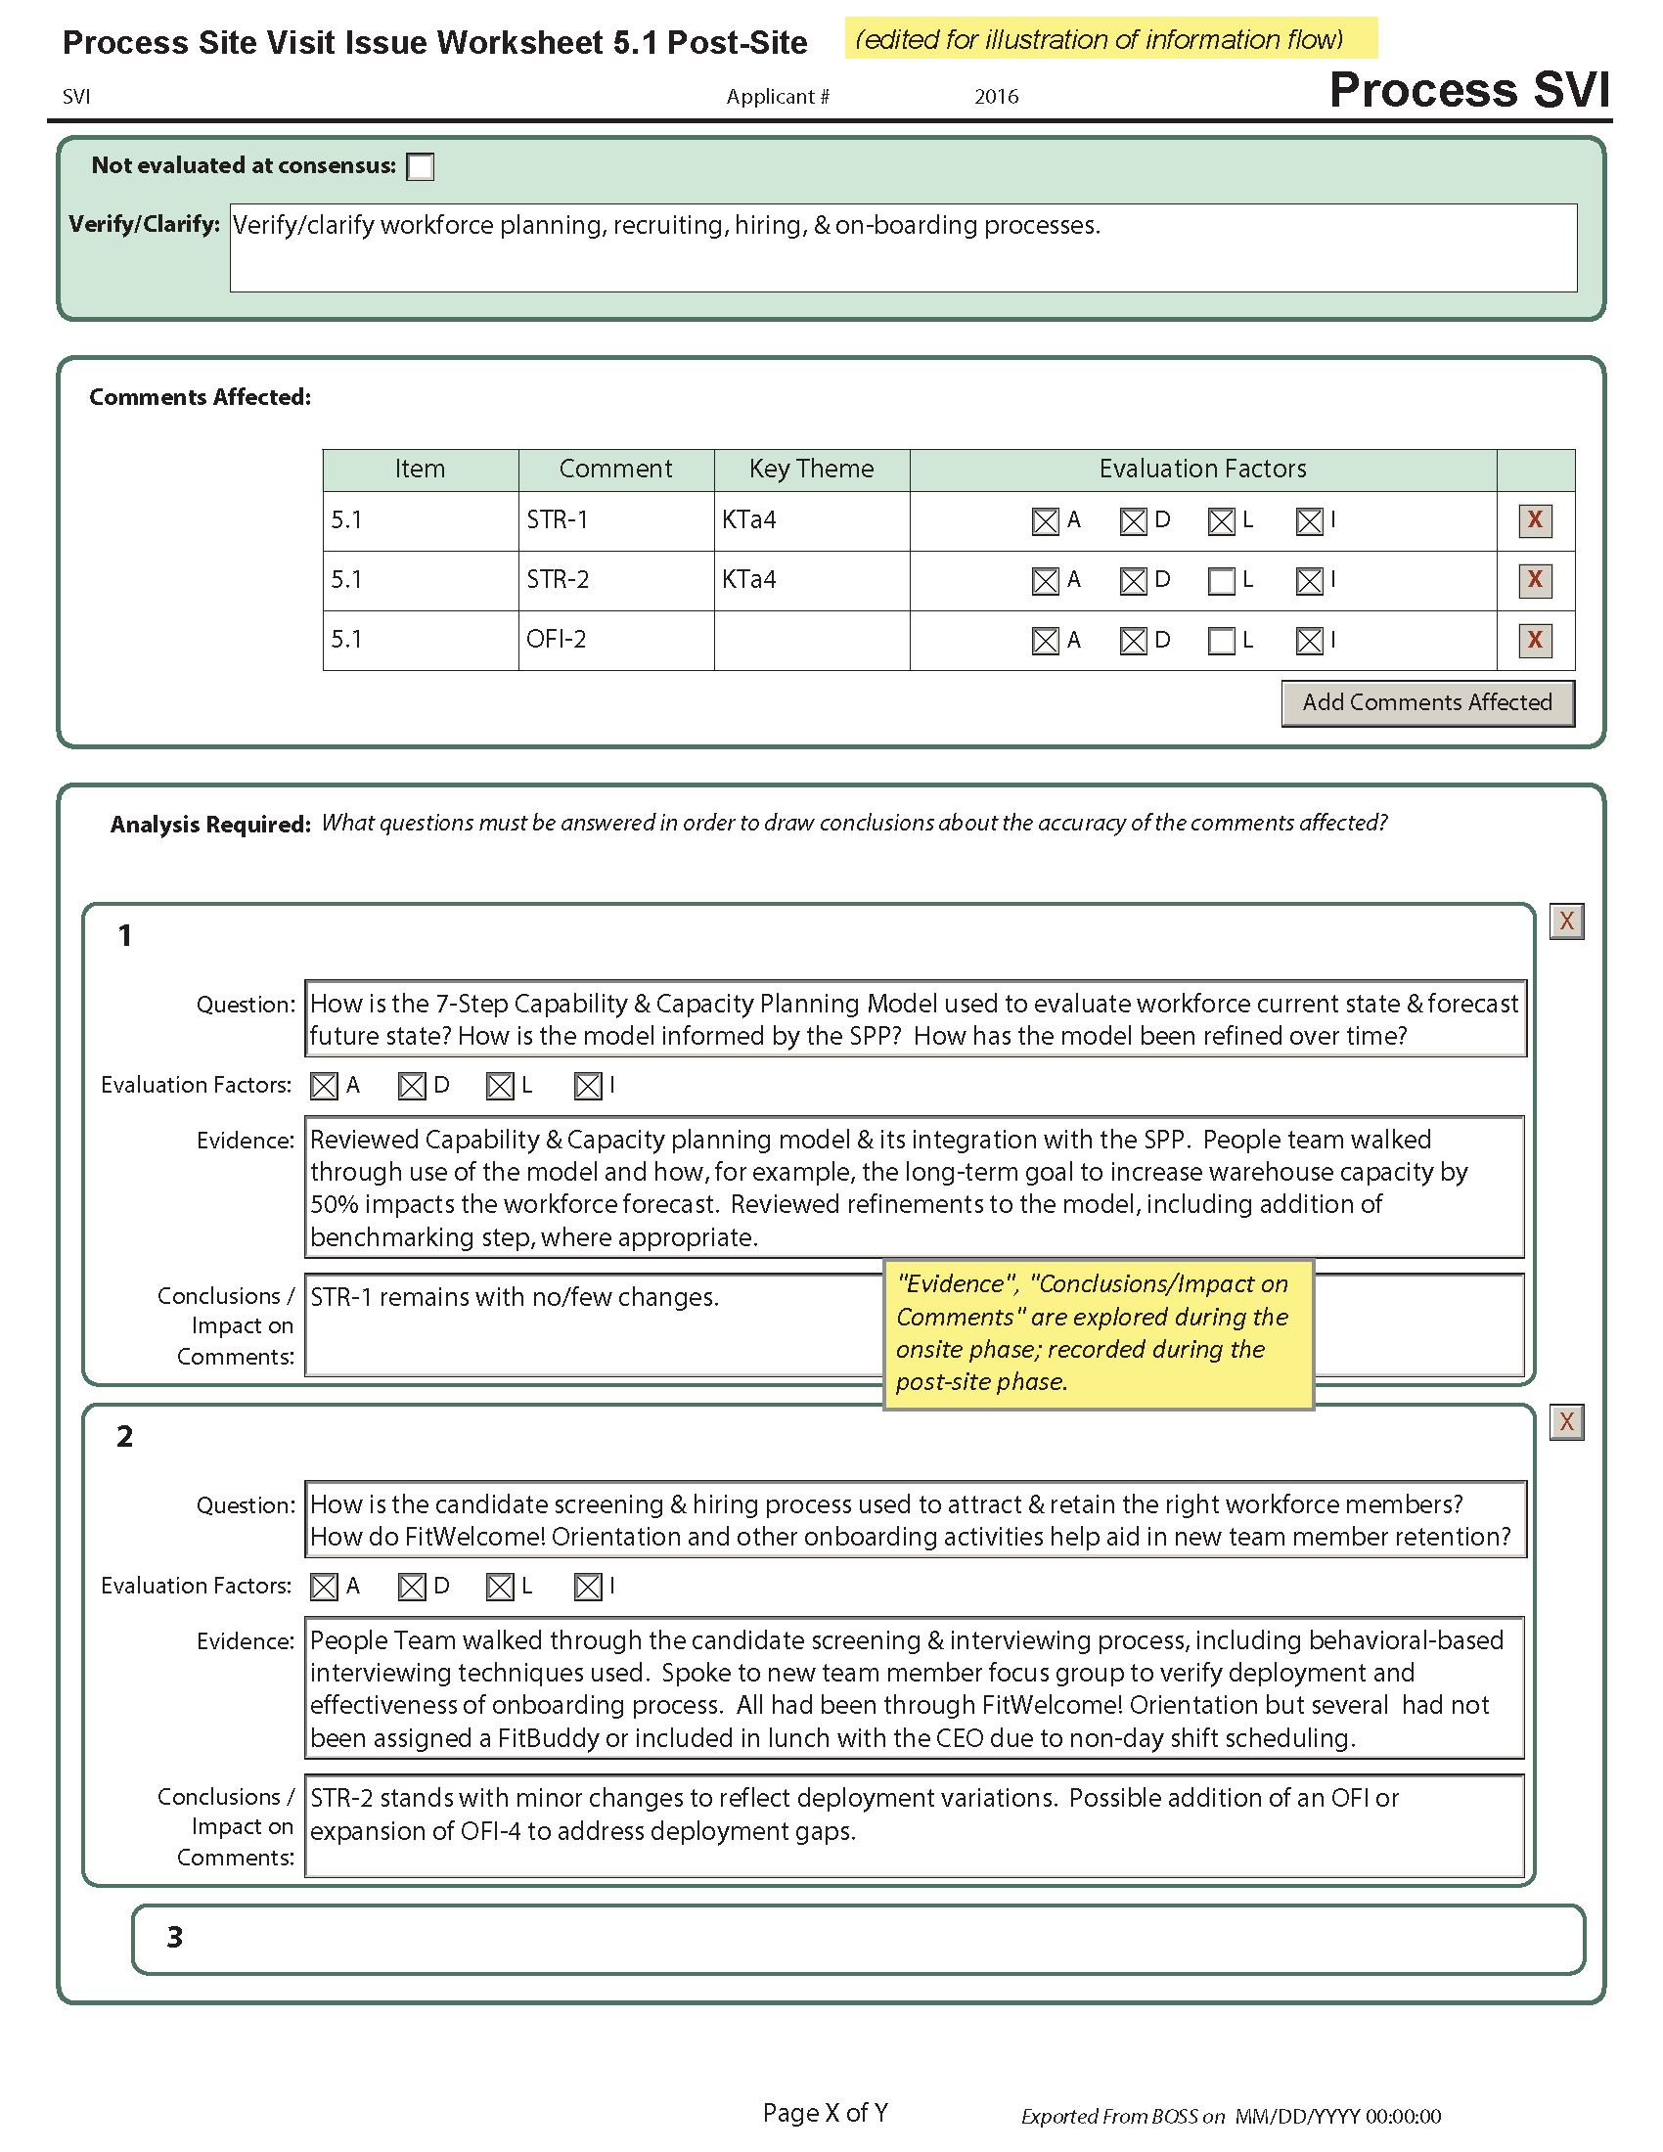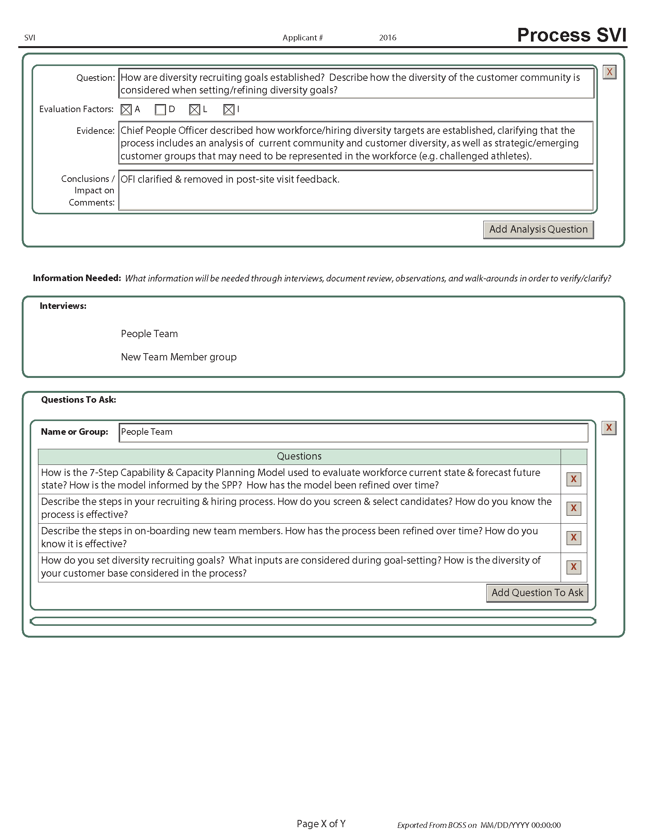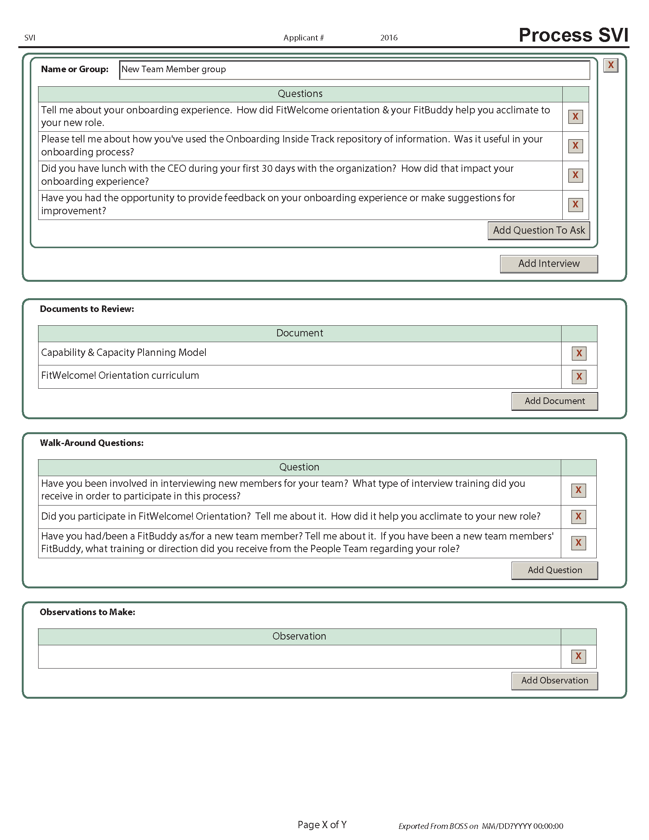

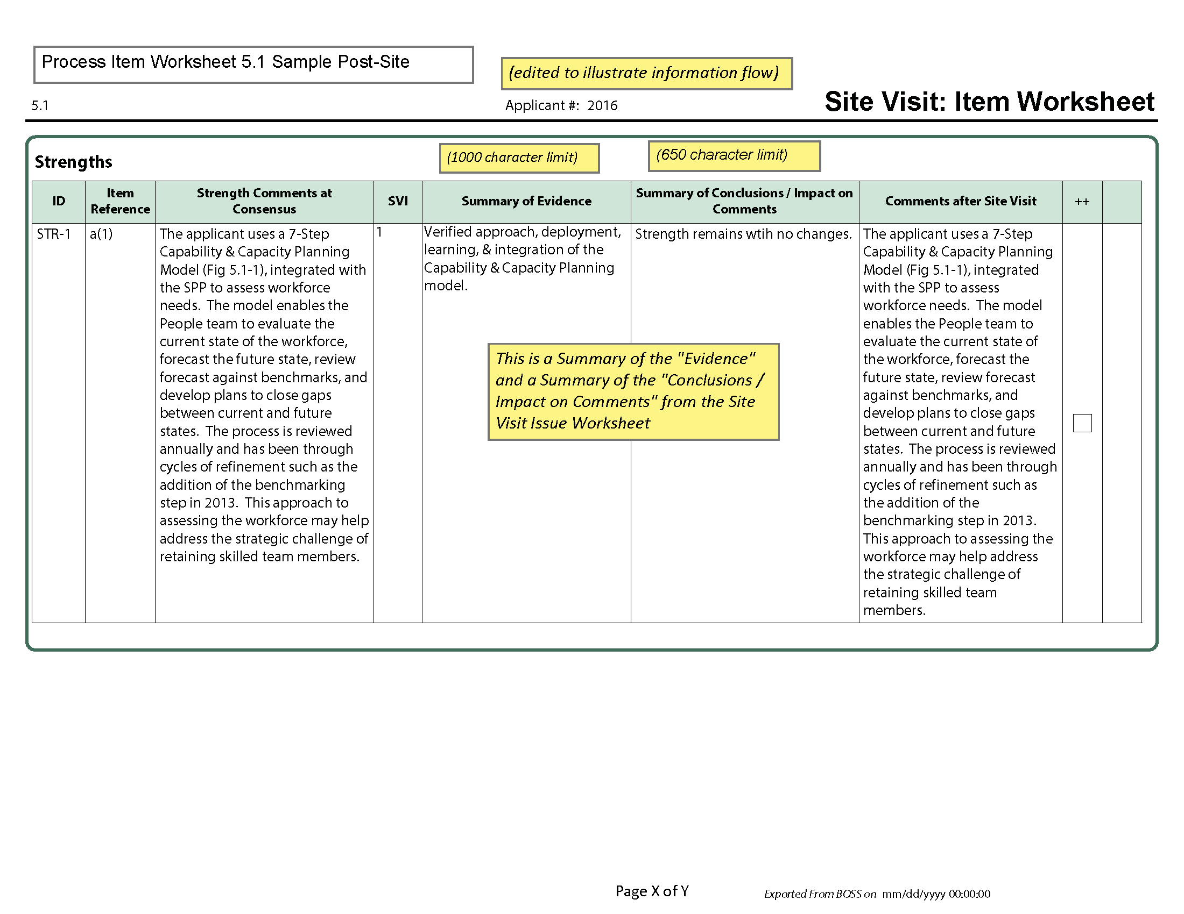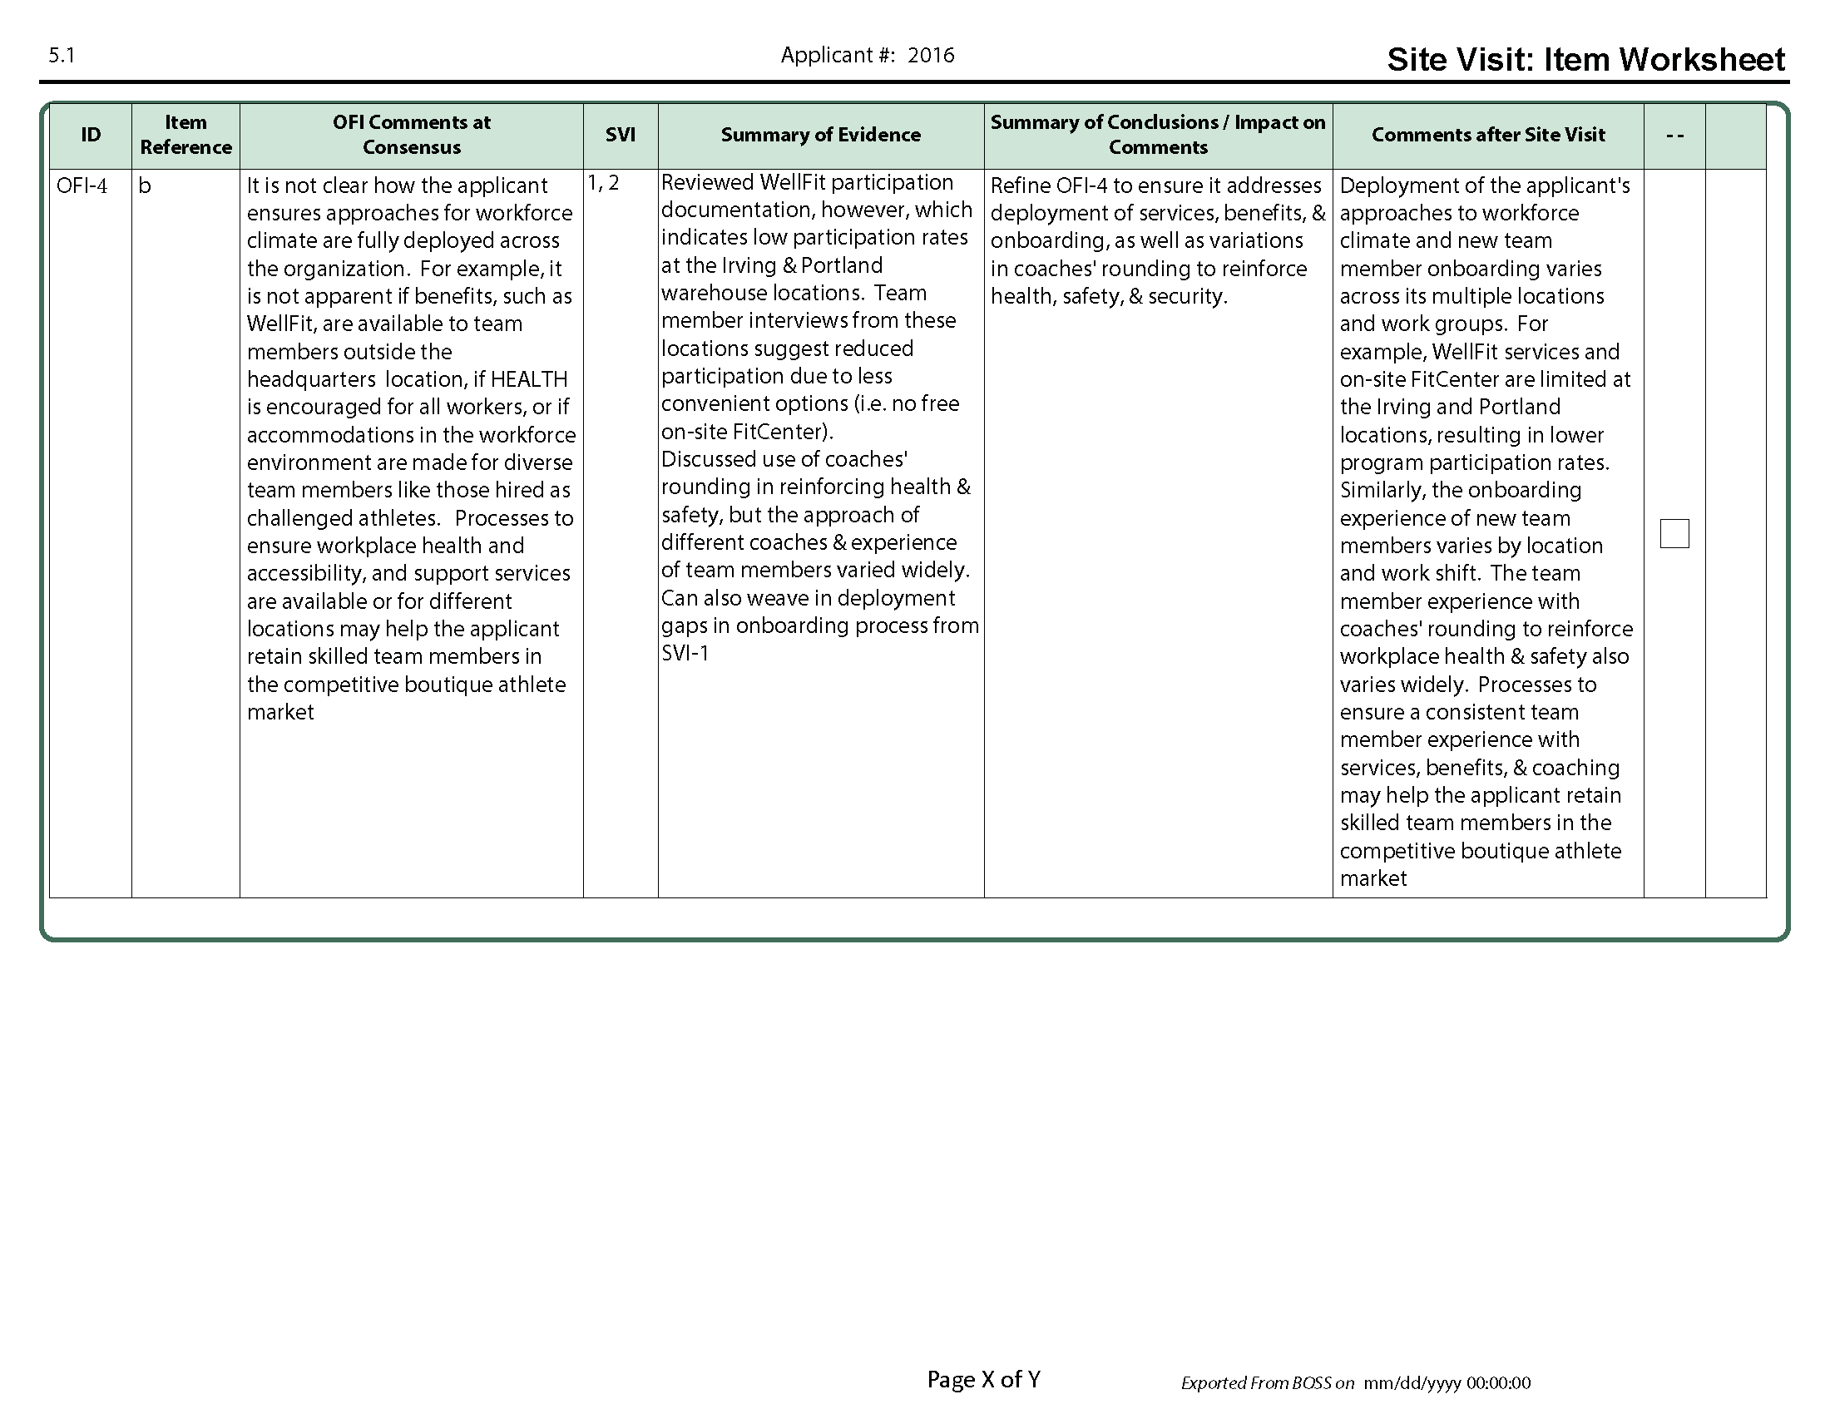

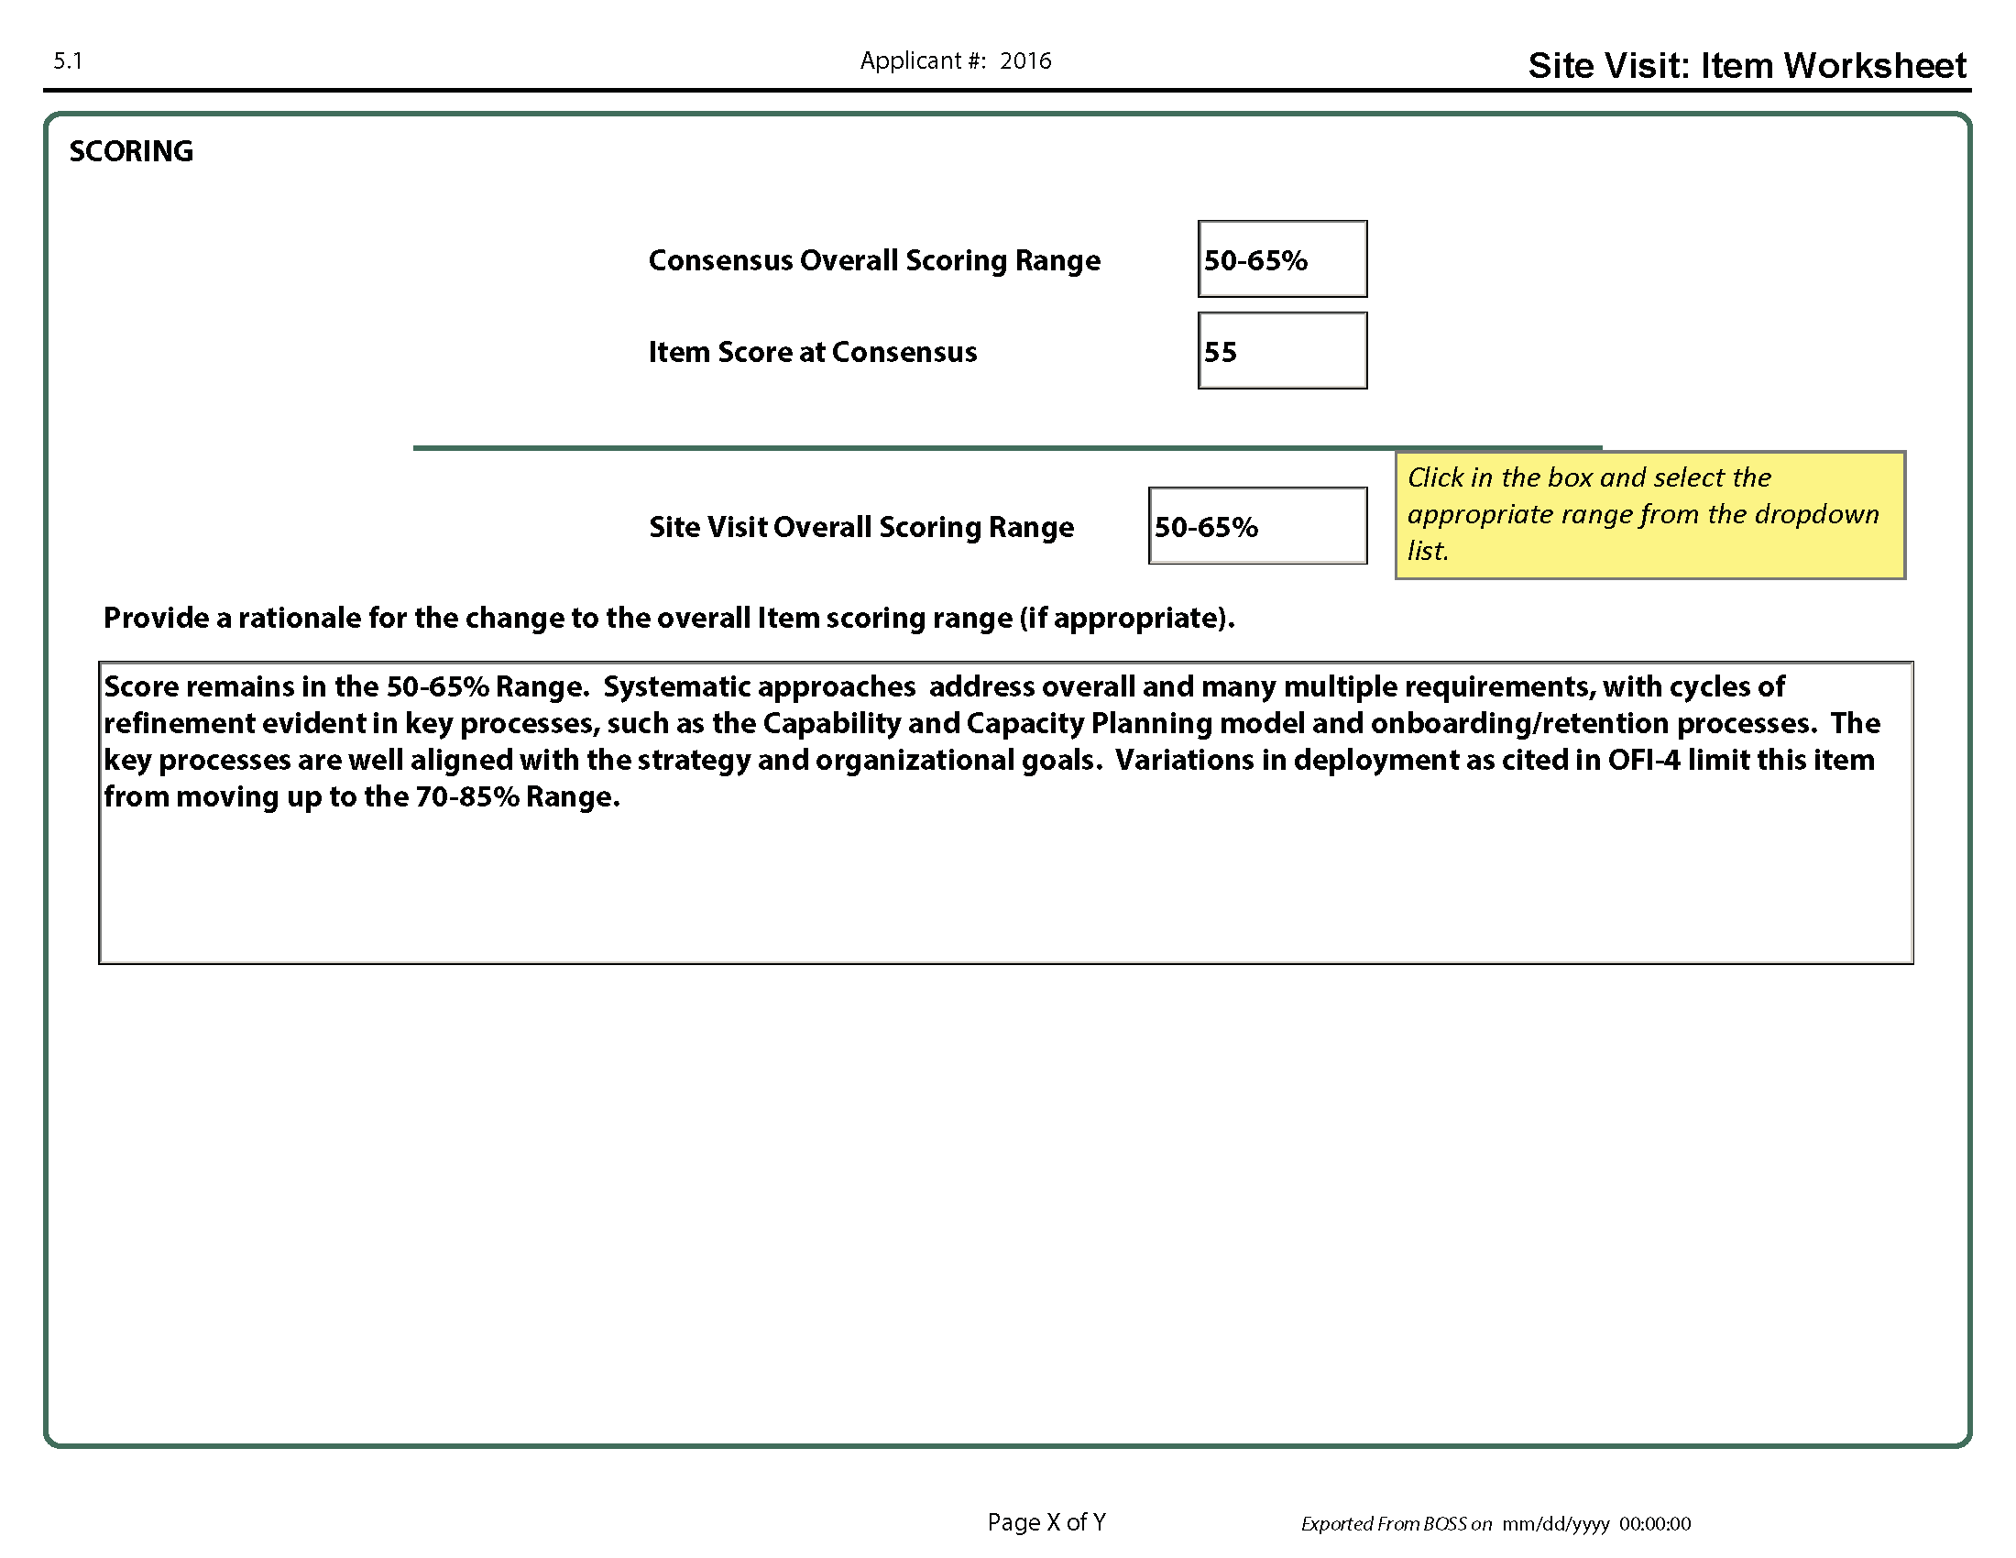

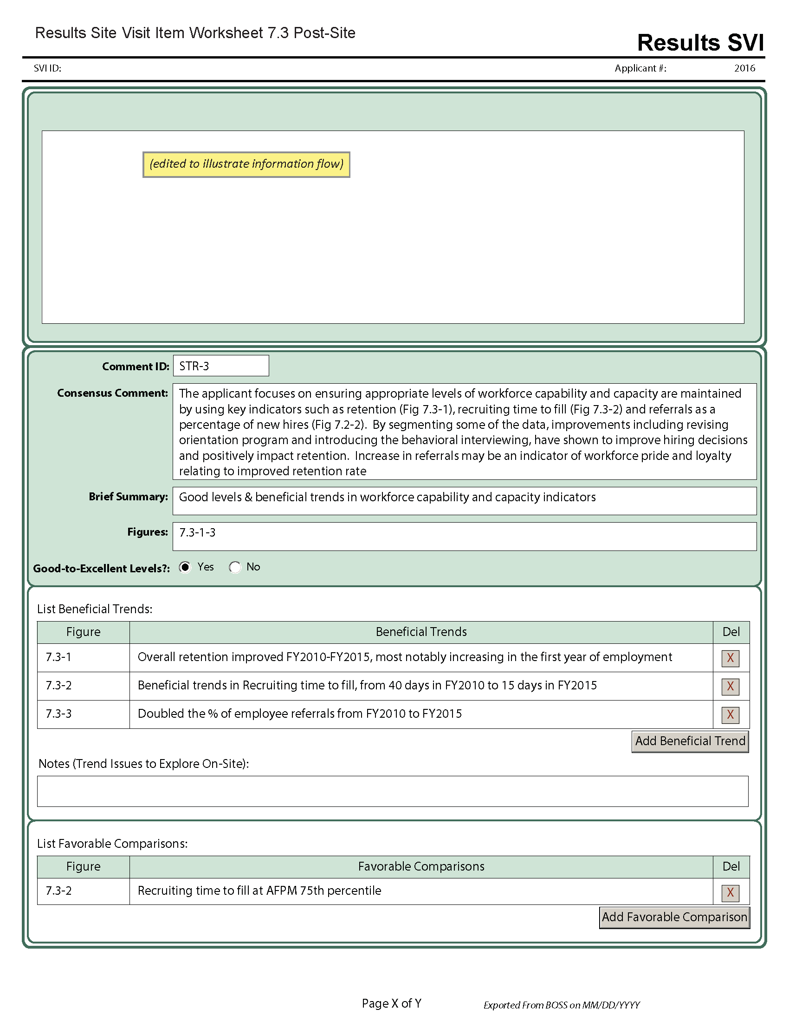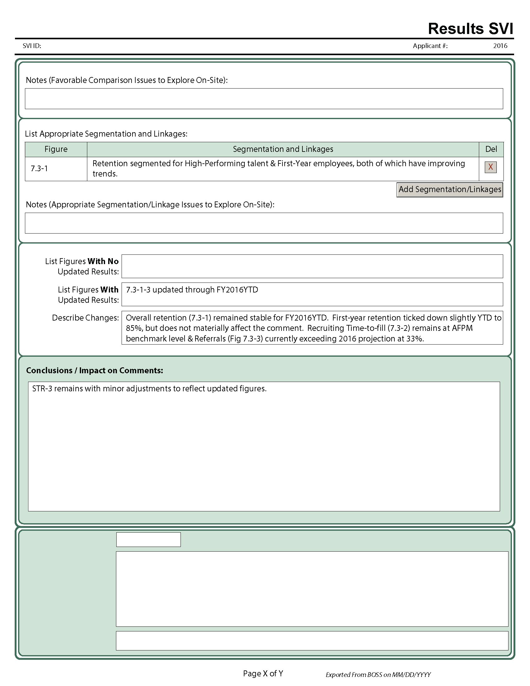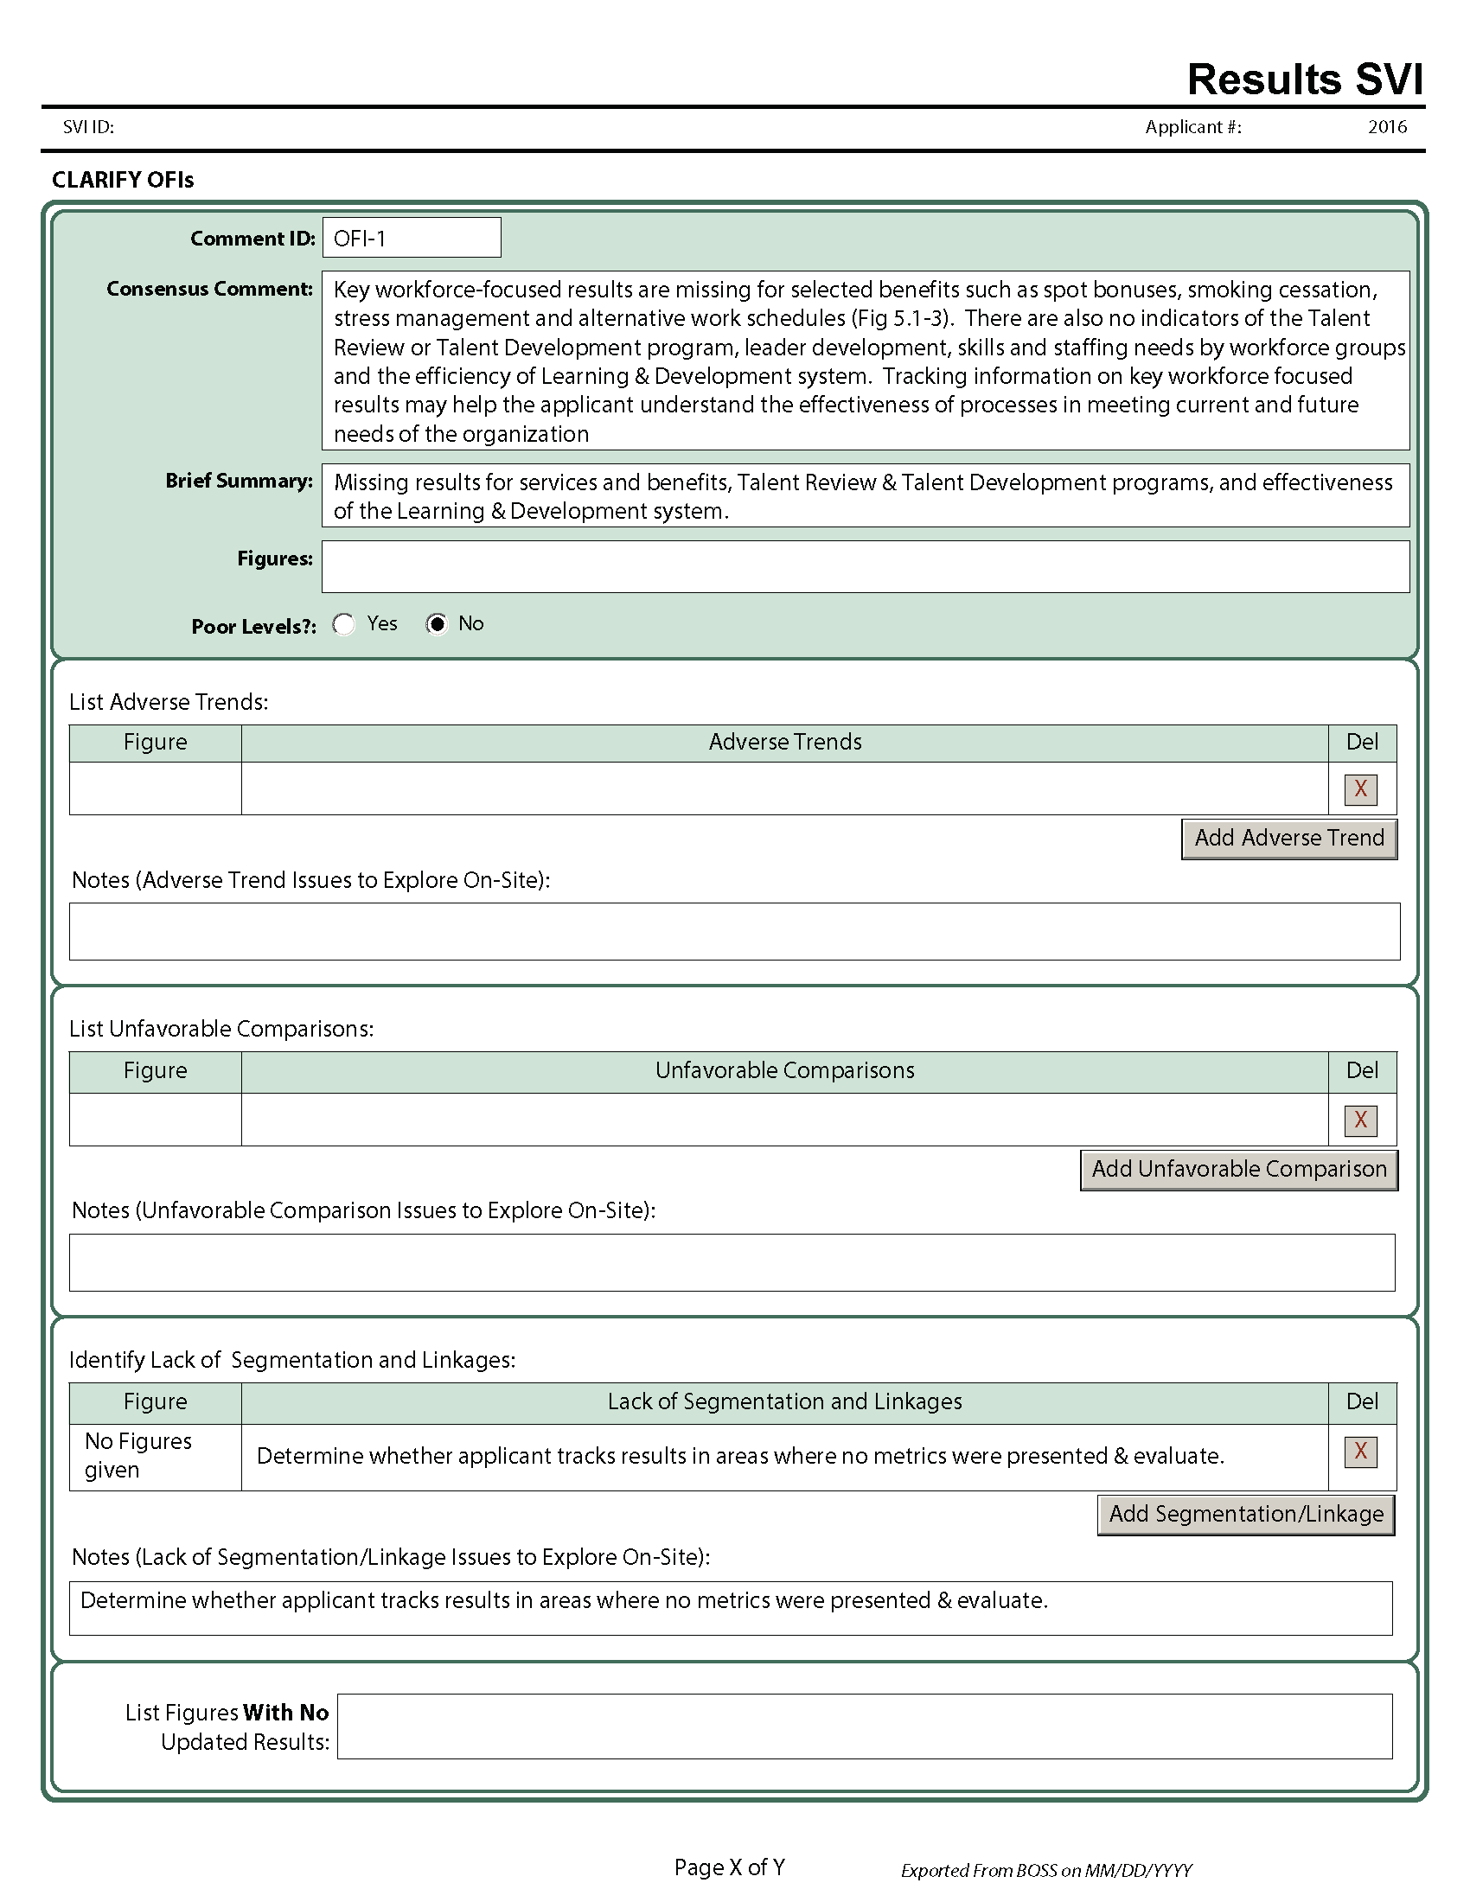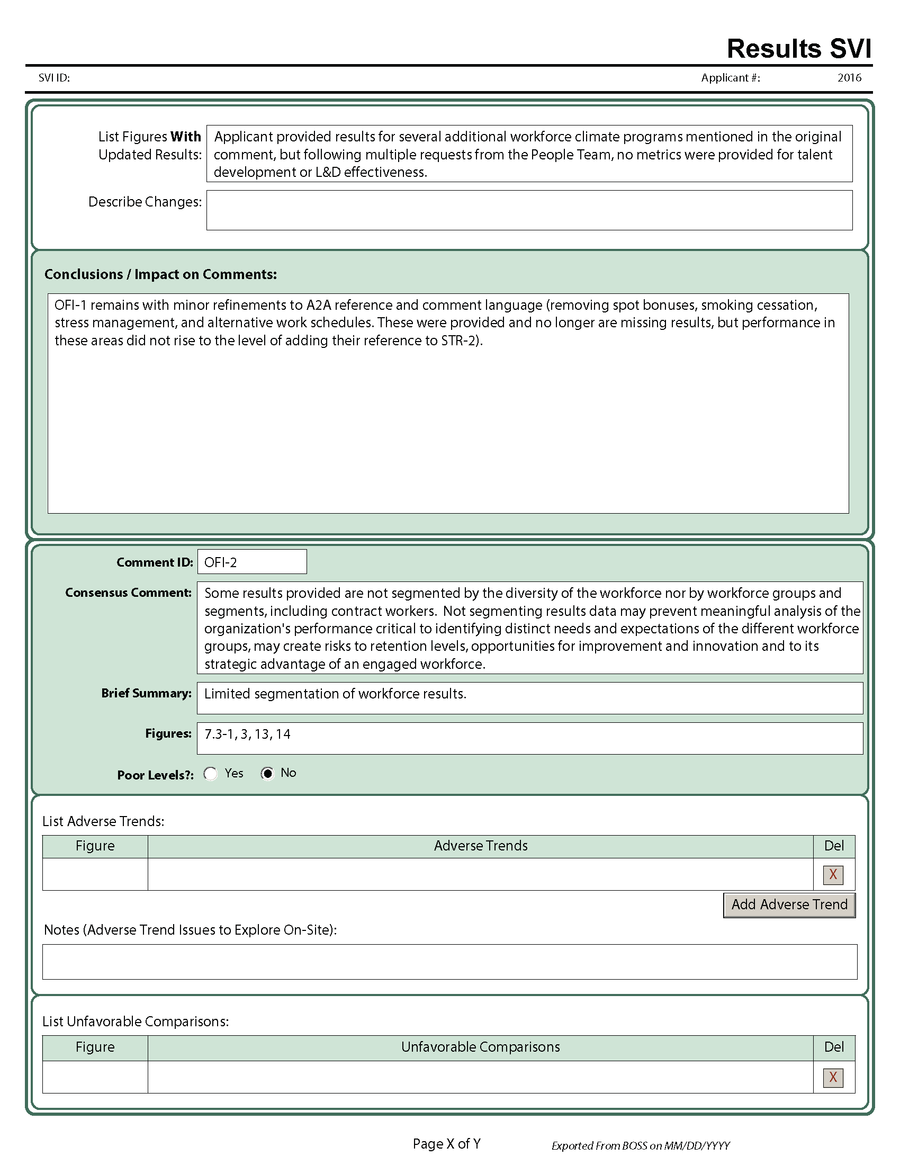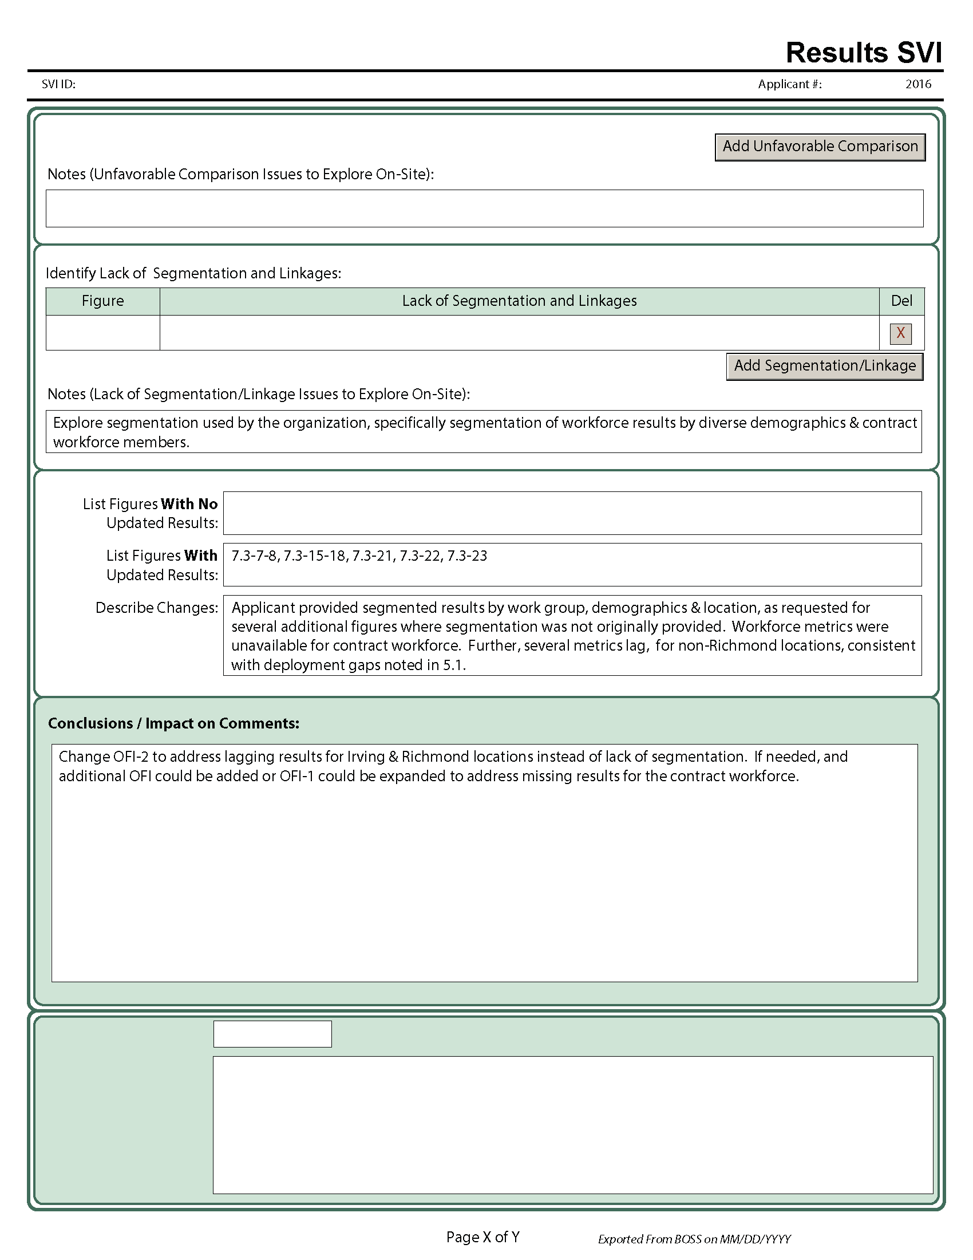

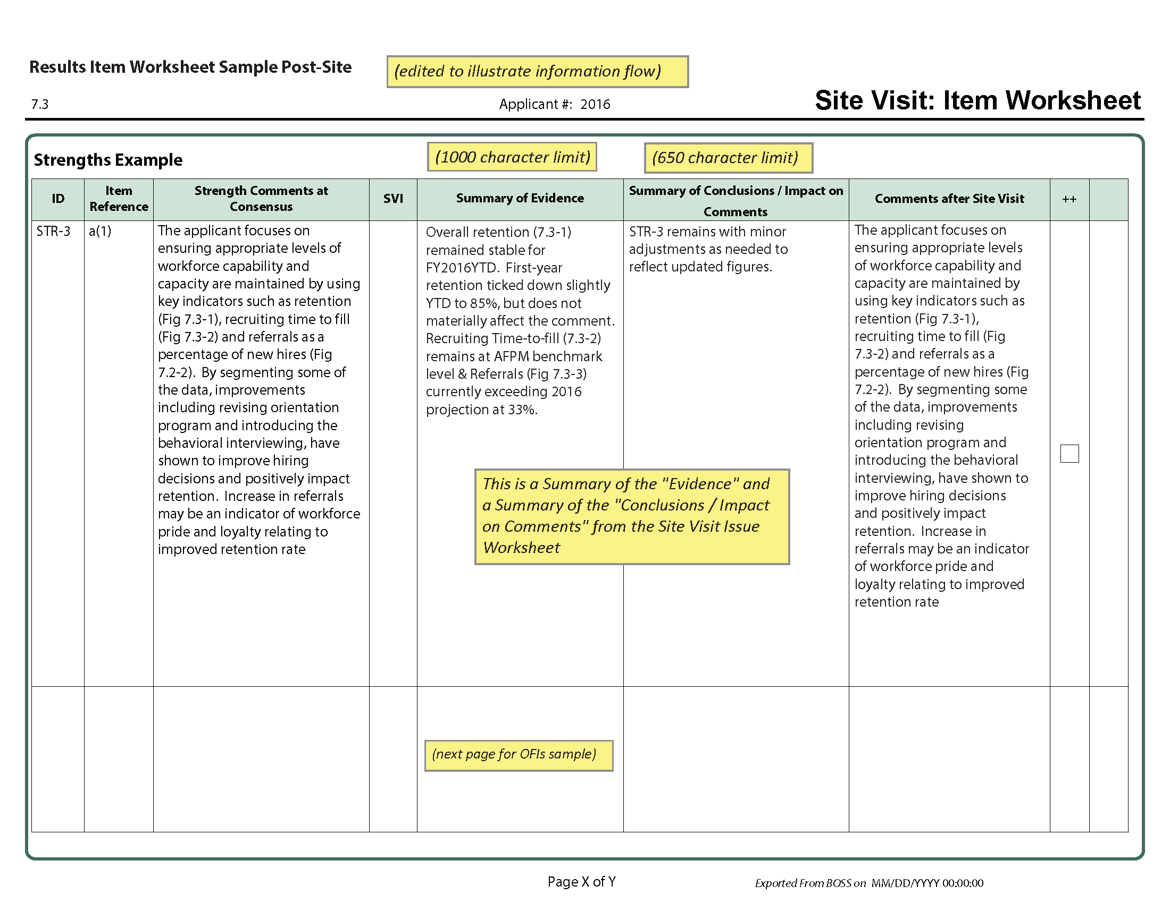

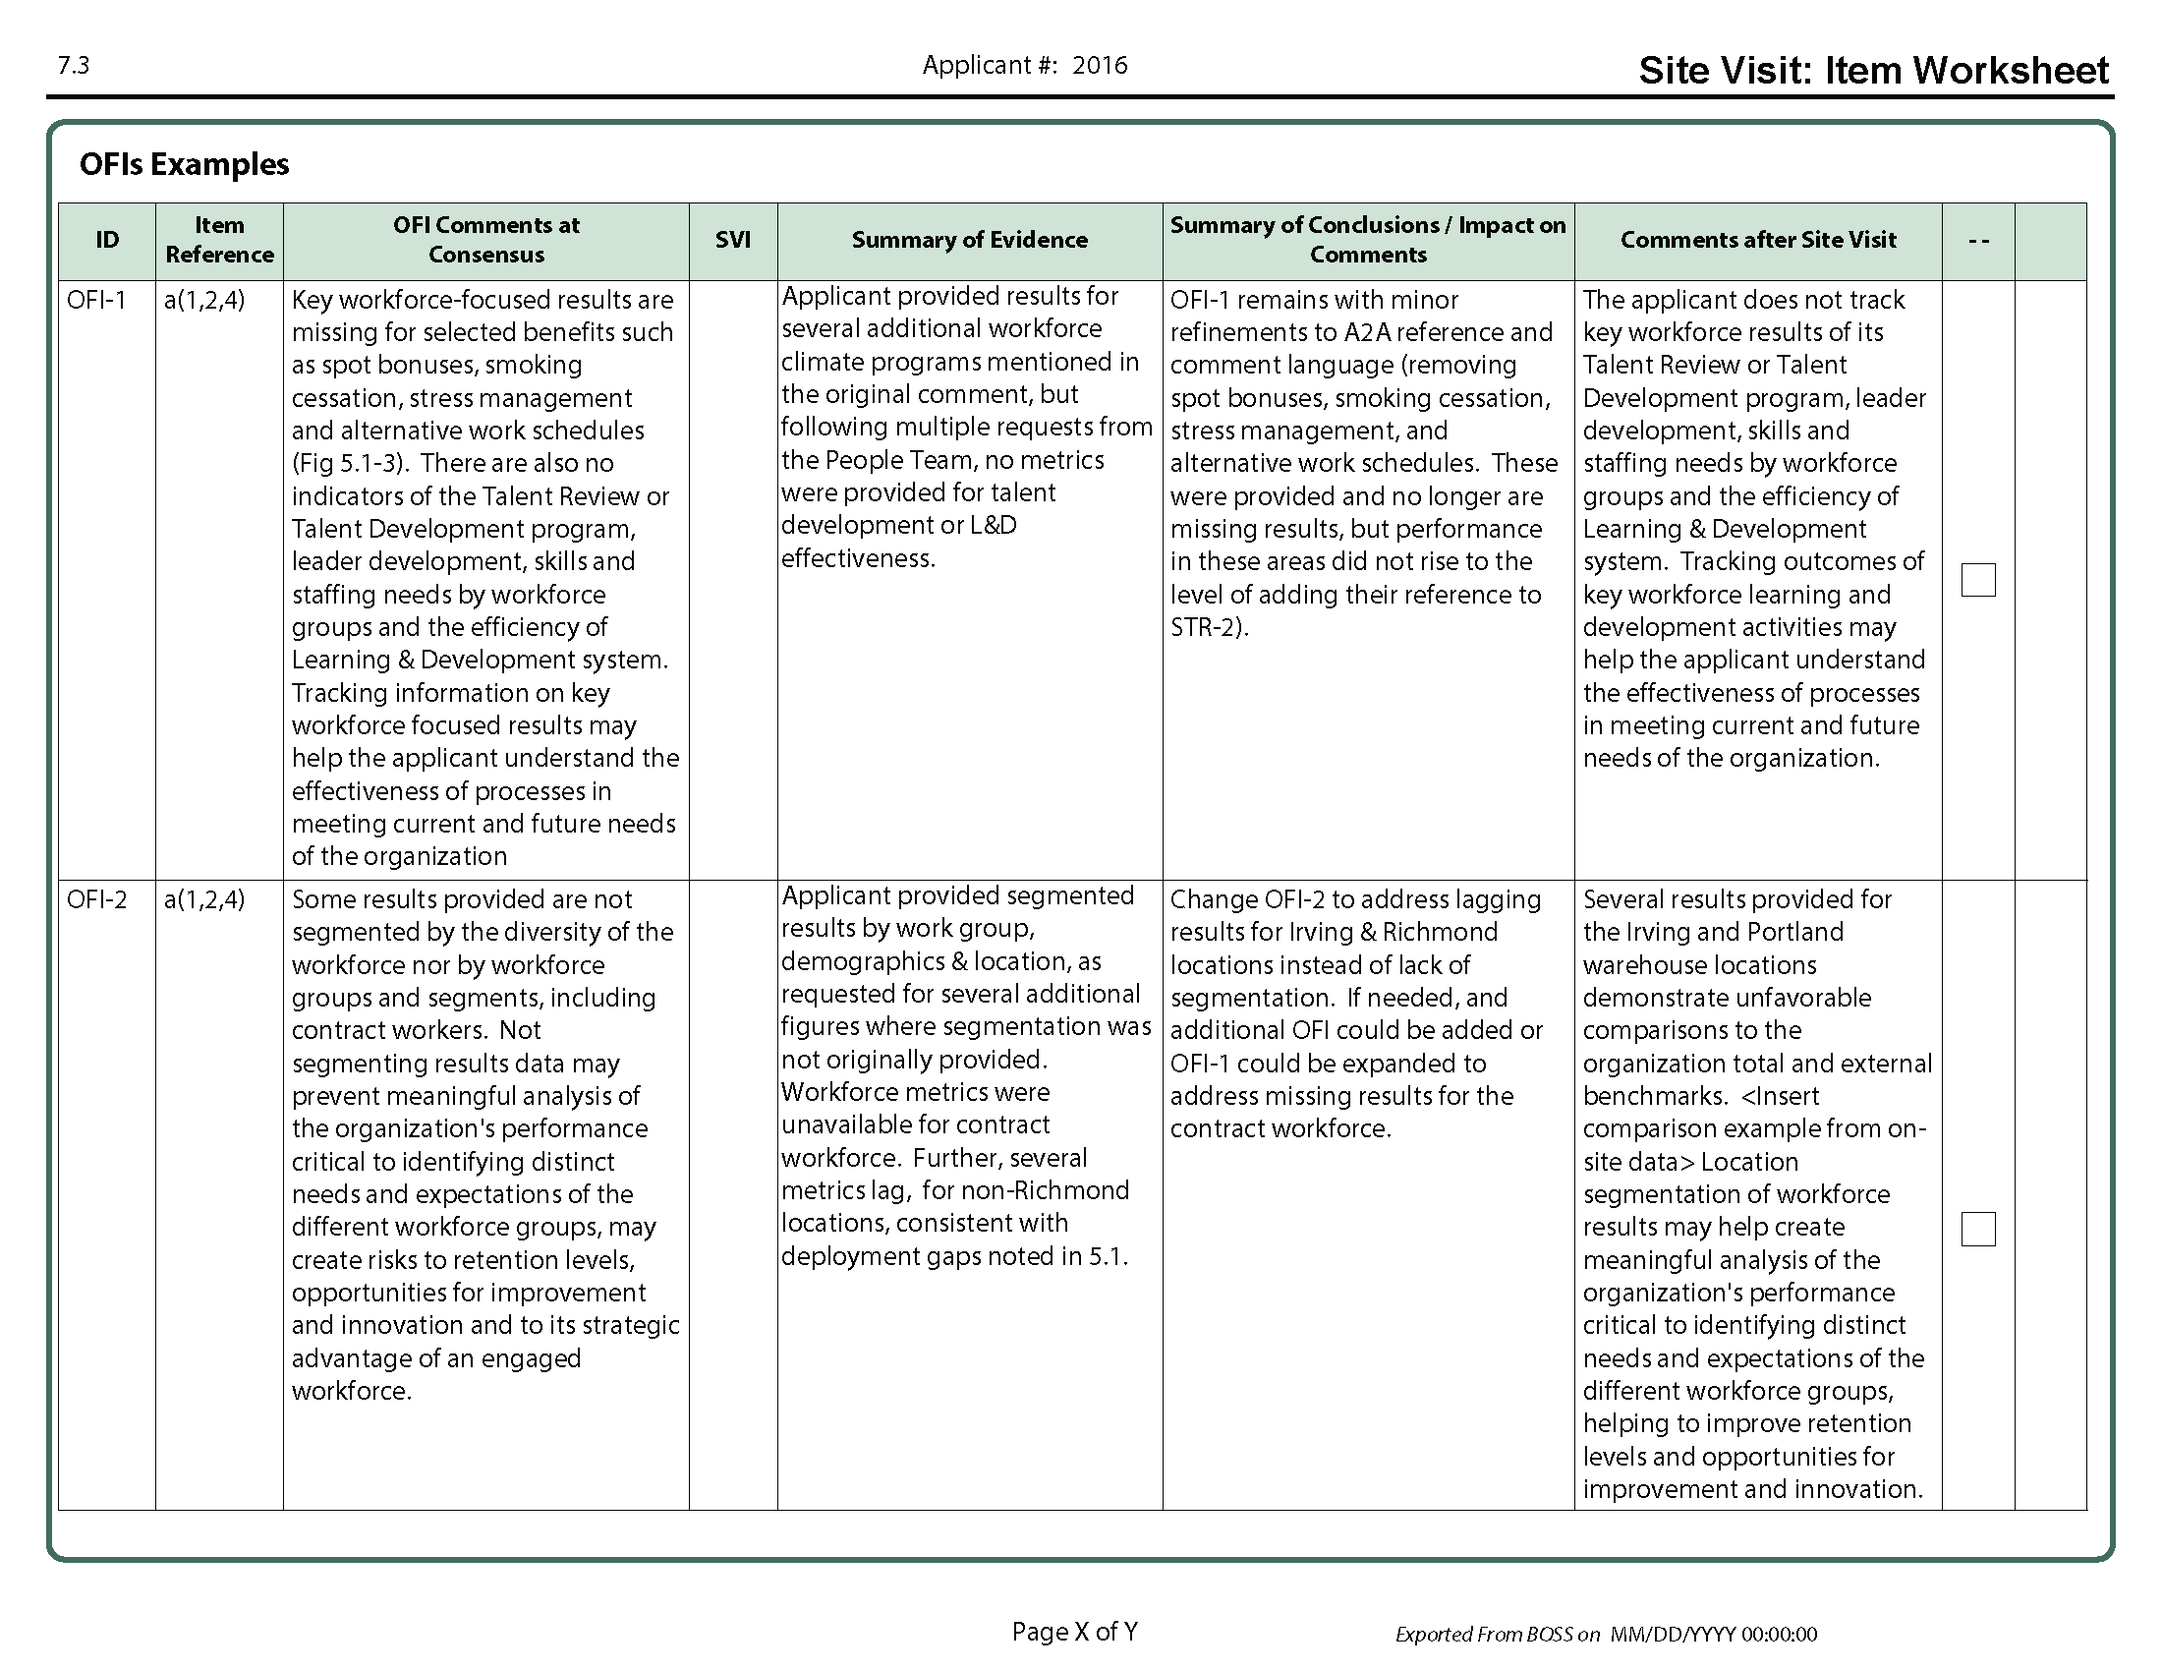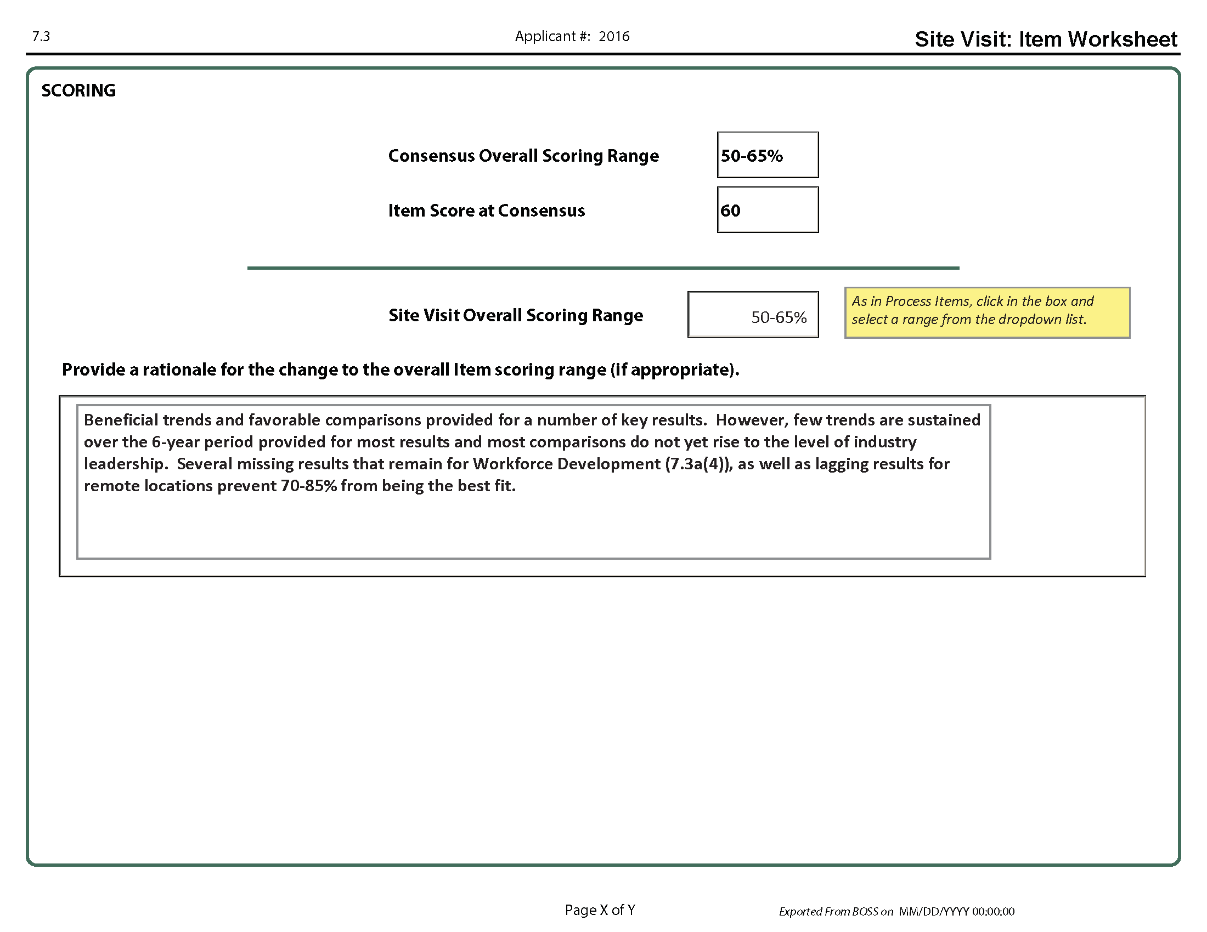

Education Team

Baldrige Performance Excellence Program

National Institute of Standards and Technology

Gaithersburg, MD 20899