**2016 Site Visit Manual**

**Baldrige Performance Excellence Program**

**TABLE OF CONTENTS**

**SITE VISIT OVERVIEW AND TEAM 1**

**SITE VISIT PLANNING 8**

**SITE VISIT SCOREBOOK 14**

**GUIDANCE FOR TEAM LEADERS 47**

**APPENDIX**

**PLANNING PHASE: SAMPLE AGENDAS, SCHEDULES, AND OTHER TOOLS 58**

**ON-SITE PHASE: SAMPLE AGENDAS AND OTHER TOOLS 81**

**POST-SITE PHASE 87**

# SITE VISIT OVERVIEW & TEAM

## Site Visit Overview

The Site Visit Review is a critical phase of the evaluation process. Site visits entail a team of Baldrige examiners traveling to an applicant’s site(s) to more fully understand how well the organization is applying the Baldrige Criteria and concepts. The ultimate purpose of the site visit is to verify the team’s understanding of key strengths and to clarify its understanding of key vulnerabilities. For each selected applicant that receives a site visit, the team will (1) communicate findings to the judges, (2) determine the feedback that is most relevant for the applicant, and (3) help ensure that the applicant can demonstrate role-model practices to the public should it be named an award recipient.

## The Site Visit Team

A Site Visit Team typically consists of 7-9 members from the Board of Examiners. The number and composition of team members depend on the size of the applicant and the anticipated complexity of the site visit.

The team includes at least two senior or alumni examiners—typically, one serves as team leader and the other serves as the backup team leader—who have site visit experience. Often examiners who have participated in the Consensus Review for the applicant are assigned to the Site Visit Team. It is not uncommon that an examiner who participates during IR/CR is asked to drop off the team. Additional team members are selected based on experience, sector knowledge, and availability. Roles such as Criteria cop and process checker are assigned to various team members. Also participating in the site visit is a National Institute of Standards and Technology (NIST) monitor (also known as a BPEP monitor), who does not take part in the evaluation process but helps to ensure that a consistent review process is followed for all site visits.

## Team Roles and Responsibilities

|  | **Role** | **Initial Planning Preparation** | **Final Preparation  & Sunday Planning Meeting** | **On-Site** | **Preparation of the Site Visit**  **Scorebook** |
| --- | --- | --- | --- | --- | --- |
| **TEAM**  **LEADER**  **(TL)** | * Serves as contact point for OCP and BPEP monitor * Manages completion of scorebook components * Works closely with backup TL to help the team work effectively * Assigns leads and backups for all items (if possible, TL does not lead any items, allowing more time to back up and coach the entire team) | * Calls team members and OCP * Drafts tentative site visit plan and shares plan with team and BPEP monitor * Works with the team to develop and finalize SVIs, focusing on issues of central importance to Criteria and applicant * Prepares a list of documents for team review, aggregated in BOSS, to request from the OCP, as well as a tentative interview schedule. If appropriate, interview requests include staff at multiple locations * Keeps OCP apprised of plans during regularly scheduled telephone calls   Notifies BPEP monitor of inter-site travel, if applicable   * Completes and forwards necessary forms to ASQ * Develops a timeline to help manage the work of the team throughout all phases of the Site Visit Review * Downloads all items, SVI Worksheets, and as PDFs to take to site | Leads development of, reviews, and finalizes site visit strategy, agendas, document requests, and interview schedules  Sends OCP the document request list and a tentative agenda for day one of the site visit ten days in advance  Prepares for opening meeting, featuring BPEP slides  Reviews requested documents | * Begins opening meeting using BPEP slides and providing brief remarks * Makes adjustments to the site visit plan as required * Monitors progress on completion of SVI Worksheets * Keeps the team on task and on schedule * Plans and conducts caucuses to help keep the team focused on key themes and other important issues * Informs OCP of changes and needs * Conducts HRO interview, with BPEP monitor, and completes HRO Interview Worksheet * Ensures that the team has all relevant information and documents to close out each SVI before ending the on-site phase * Ends the site visit with a short “thank you” and next steps, using BPEP slides, at the closing meeting at the applicant’s location | * Provides the team with a time frame for completion * Facilitates discussion of findings and review of scorebook components * Reviews scorebook and provides edits as necessary * Ensures that SVI, Item, and Key Themes Worksheets are appropriately prepared, reviewed, finalized, and imported to BOSS * Retains an electronic copy of all Item Worksheets and SVIs in PDF and other documents in Word. (Keeping a paper copy is optional.) * Reviews and edits the scorebook as necessary after leaving the hotel, using BOSS or importing any changes to BOSS, by midnight PDT on Monday after site visit * Prepares for the judges’ call in November * Responds to and works with BPEP and judges to address questions/ comments on Site Visit Scorebook after Judges’ Meeting |
| **Backup Team Leader** | * Steps in for the TL if the TL is unable to go on-site * Works closely with TL to plan, coordinate, and communicate with the team * Serves as a mentor for team members on-site and assists as needed to keep the team on track * Depending on the makeup of the team and complexity of the applicant, may not have items to lead in order to help coach team members | Assists TL as needed. For example, the backup TL could   * review the draft site visit plan * review other team members’ SVIs and give feedback on improvements * schedule planning calls * suggest item and other team assignments * draft call agendas * take the lead in site visit logistics planning * join TL/BPEP monitor on planning call(s) * review the initial document request and edit as needed * orient new team members * review confidentiality requirements * participate in planning calls with TL and OCP * review, manage, and track the leadership questions, walk-around questions, and/or interview requests | Assists TL as needed. For example, the backup TL could   * draft the agenda for the team’s Sunday planning meeting at the hotel * coordinate the initial document request * mentor less-experienced teammates * review requested documents | Assist the TL as needed. For example, the backup TL could   * mentor less-experienced teammates * take the lead on the Key Factors Worksheet, Key Themes Worksheet, and/or Summary of Sites Visited * track progress on completion of SVIs * keep team on task and on schedule * lead daily debrief and/or caucus discussions * take leadership role for traveling teams so TL can remain at headquarters | Assists TL as needed. For example, the backup TL could   * facilitate the discussion of findings and review of scorebook components * review the scorebook and provide edits as necessary * ensure that SVI, Item, and Key Themes Worksheets are appropriately prepared, reviewed, updated and finalized * retain an electronic copy of the Site Visit Scorebook (a paper copy is optional) * help TL prepare for the judges’ call in November |
| **Team Members** | • Plan, maintain focus, contribute, and communicate effectively in performing assigned site visit tasks   * Meet TL’s and backup TL’s schedules and deadlines | * Arrange transportation to and from the site (between home and hotel) and provide travel details to ASQ * Review evaluation materials * Review online training materials * Working with item backup, develop SVIs and start work on SVI Worksheets and * Review rules of conduct * Complete other assignments (consolidate document requests, establish interview schedule, etc.) * Provide feedback on team’s SVIs and * Exports all assigned documents as PDFs to take to site | * Finalize interview plans, the lists of required documents, and strategies for SVI Worksheets and by the TL * Attend and participate in Sunday planning meeting at hotel * Review requested documents | * Work in pairs for 2-4 days on-site * Gaither information to clarify and verify assigned SVIs * Conduct interviews with applicant’s representatives * Review documents and data * Attend all team caucuses and meetings * Take thorough notes * Record findings and conclusions on SVI Worksheets as site visit progresses * Have all documents needed to close out all SVIs before the closing meeting, which marks the end of the on-site phase | * Share findings with team at team caucuses/meetings * Update SVI Worksheets, seeking shared understanding among team members * “Walk the Wall” to review and provide feedback for all SVI, Item, and Key Themes Worksheets * Complete scorebook components, building on content of the Consensus Scorebook * Review scorebook components of other team members * Stay with team until scorebook is completed and signed by all team members (2 – 3 days after the on-site phase) |
| **SCOREBOOK**  **EDITOR**  **(TL, backup TL, or another team member)** | Ensures that the scorebook adheres to Criteria requirements and follows the Comment Guidelines | SAME AS TEAM MEMBERS | SAME AS TEAM MEMBERS | SAME AS TEAM MEMBERS | In addition to team member responsibilities:   * Clarifies and aligns the language among item comments and key themes * Eliminates any conflicts between strengths and OFIs within and between items and key themes * Ensures that all statements such as “it is not clear.” “it does not appear that,” and “it is not evident” are changed to reflect the findings of the site visit * Revises scorebook as necessary to ensure that comments adhere to Comment Guidelines |
| **BPEP**  **MONITOR** | * Assists the team and TL in planning and conducting the site visit as needed. * Assists the applicant in under-standing the site visit process and serves as a contact for the applicant to address issues and concerns | * Monitors the process * Supports TL in planning the site visit as needed. * Provides coordination and guidance * Contacts OCP to explain the process and answer questions * Reviews draft SVI Worksheets * Participates in planning calls * Coordinates with OCP delivery of documents requested before Sunday planning meeting * Downloads all documents as PDFs before leaving for site | * Supports TL * Stays in contact with OCP * Ensures that all necessary equipment and supplies are available before the beginning of the Sunday planning meeting * Ensures that the team room is set up appropriately * Coordinates arrival of applicant materials at team room before the Sunday planning meeting * Attends Sunday planning meeting to monitor the process and provide logistical assistance | * Attends HRO meeting with TL * Attends team meetings * Answers process questions from applicant and team * Keeps OCP apprised of plans and answers questions each day * Provides logistical support for team (hotel issues, food, etc.) * Serves as the contact person to deal with on-site problems or issues * Coordinates pickup of the applicant’s materials at the end of the visit * Answers any questions from OCP / HRO regarding Category Best Recognition requirements | * Assists team with logistics of BOSS, printing, and posting * “Walks the wall” to review the work of the team and provides feedback related to the process and Comment Guidelines * Ensures that all applicant materials are returned to OCP at completion of the site visit * Reviews the Site Visit Scorebook, checking comments for consistency with Comment Guidelines * Prepares summary of applicant’s highlights for Judges’ Meeting * Prepares summary of applicant used in briefing the Secretary of Commerce about award recommendations * Provides copies of the Site Visit Scorebook to TL and backup TL and retains an electronic copy |
| **JUDGES** | * Recommend applicants to receive the award | * Chair conducts training conference call for TLs |  |  | * Review scorebooks after site visits * Lead judge for each applicant: prepare highlights for briefing other judges * Recommend award recipients & Category Best Recognition * Conduct evaluation of judges’ process * Review and edit feedback reports |
| **OCP**  **or**  **ALTERNATE  OCP** | * Works with TL and BPEP | * Coordinates arrangements, including on-site meeting space * Works with TL on scheduling and logistics for interviews * Provides information to TL and BPEP monitor * Schedules inter-site travel and travel of team to/from hotel, as needed * Provides updated data for results charts and graphs | * Based on TL’s request, compiles documents and arranges meetings for first day of site visit * Ensures applicant documents arrive at the hotel conference room before Sunday planning meeting * Arranges logistics and prepares for opening meeting presentation | * Works with TL to schedule interviews * Provides inter-site transportation * Provides additional requested documents * Coordinates adjustments to schedule as needed * Informs BPEP monitor of any concerns or questions about Site Visit Team interactions | * At the completion of the site visit, picks up all materials from BPEP monitor |

## SITE VISIT PLANNING

The site visit includes planning, on-site, and post-site activities. The on-site and post-site activities require five-to-seven days, depending on the size and complexity of the applicant. Before the site visit, the team leader (in conjunction with team members) does extensive planning, which is conducted primarily by telephone and through the Baldrige Online Scoring Solution (BOSS). On the Sunday before the first day on-site, all team members meet at their hotel to finalize strategies, plans, and assignments and to review documents. The next day, the team visits one or more of the applicant’s locations. Later in the week, after the on-site portion of the site visit ends, team members have no further contact with the applicant—yet they continue to work together to complete the scorebook.

## 2016 Site Visit Process Planning Timeline

|  |  |
| --- | --- |
| **30+ days** | BPEP identifies site visit team leader (TL) & backup, team members, and BPEP monitor. |
| **30 days** | Team receives the site visit materials from ASQ |
| **30 – 25 days** | Team members review just-in-time materials on Examiner Resource Center and scorebooks from BOSS. |
| **29 - 24 days** | TL and BPEP monitor contact the OCP and request that applicant assemble relevant documents referenced in the application; reminds applicant to submit updated results.  TL schedules weekly OCP call  TL and backup begin planning and create schedule (planning calls, logistics, SVIs)  TL and backup finalize assignments for item leads and backups. |
| **25 - 24 days** | TL Call with BPEP and Lead Judge |
| **25 – 23 days** | First team planning call |
| **23 – 14 days** | Team members develop SVI worksheets for assigned items |
| **11 - 10 days** | Team members receive updated results |
| **14 – 7 days** | Team members review each other’s SVI Worksheets, review updated results, and revise SVI Worksheets |
| **10 – 7 days** | 2nd team planning call  Team members revise SVI Worksheets |
| **7 – 3 days** | TL sets agenda for Sunday planning meetings |
| **4 – 1 day out** | 3rd Team planning call  Team members download PDFs to take to site  Team members travel to site visit location. |
| **0 days out** | Team meets Sunday to review strategies, finalize plans, and review documents |
|  |  |

## 

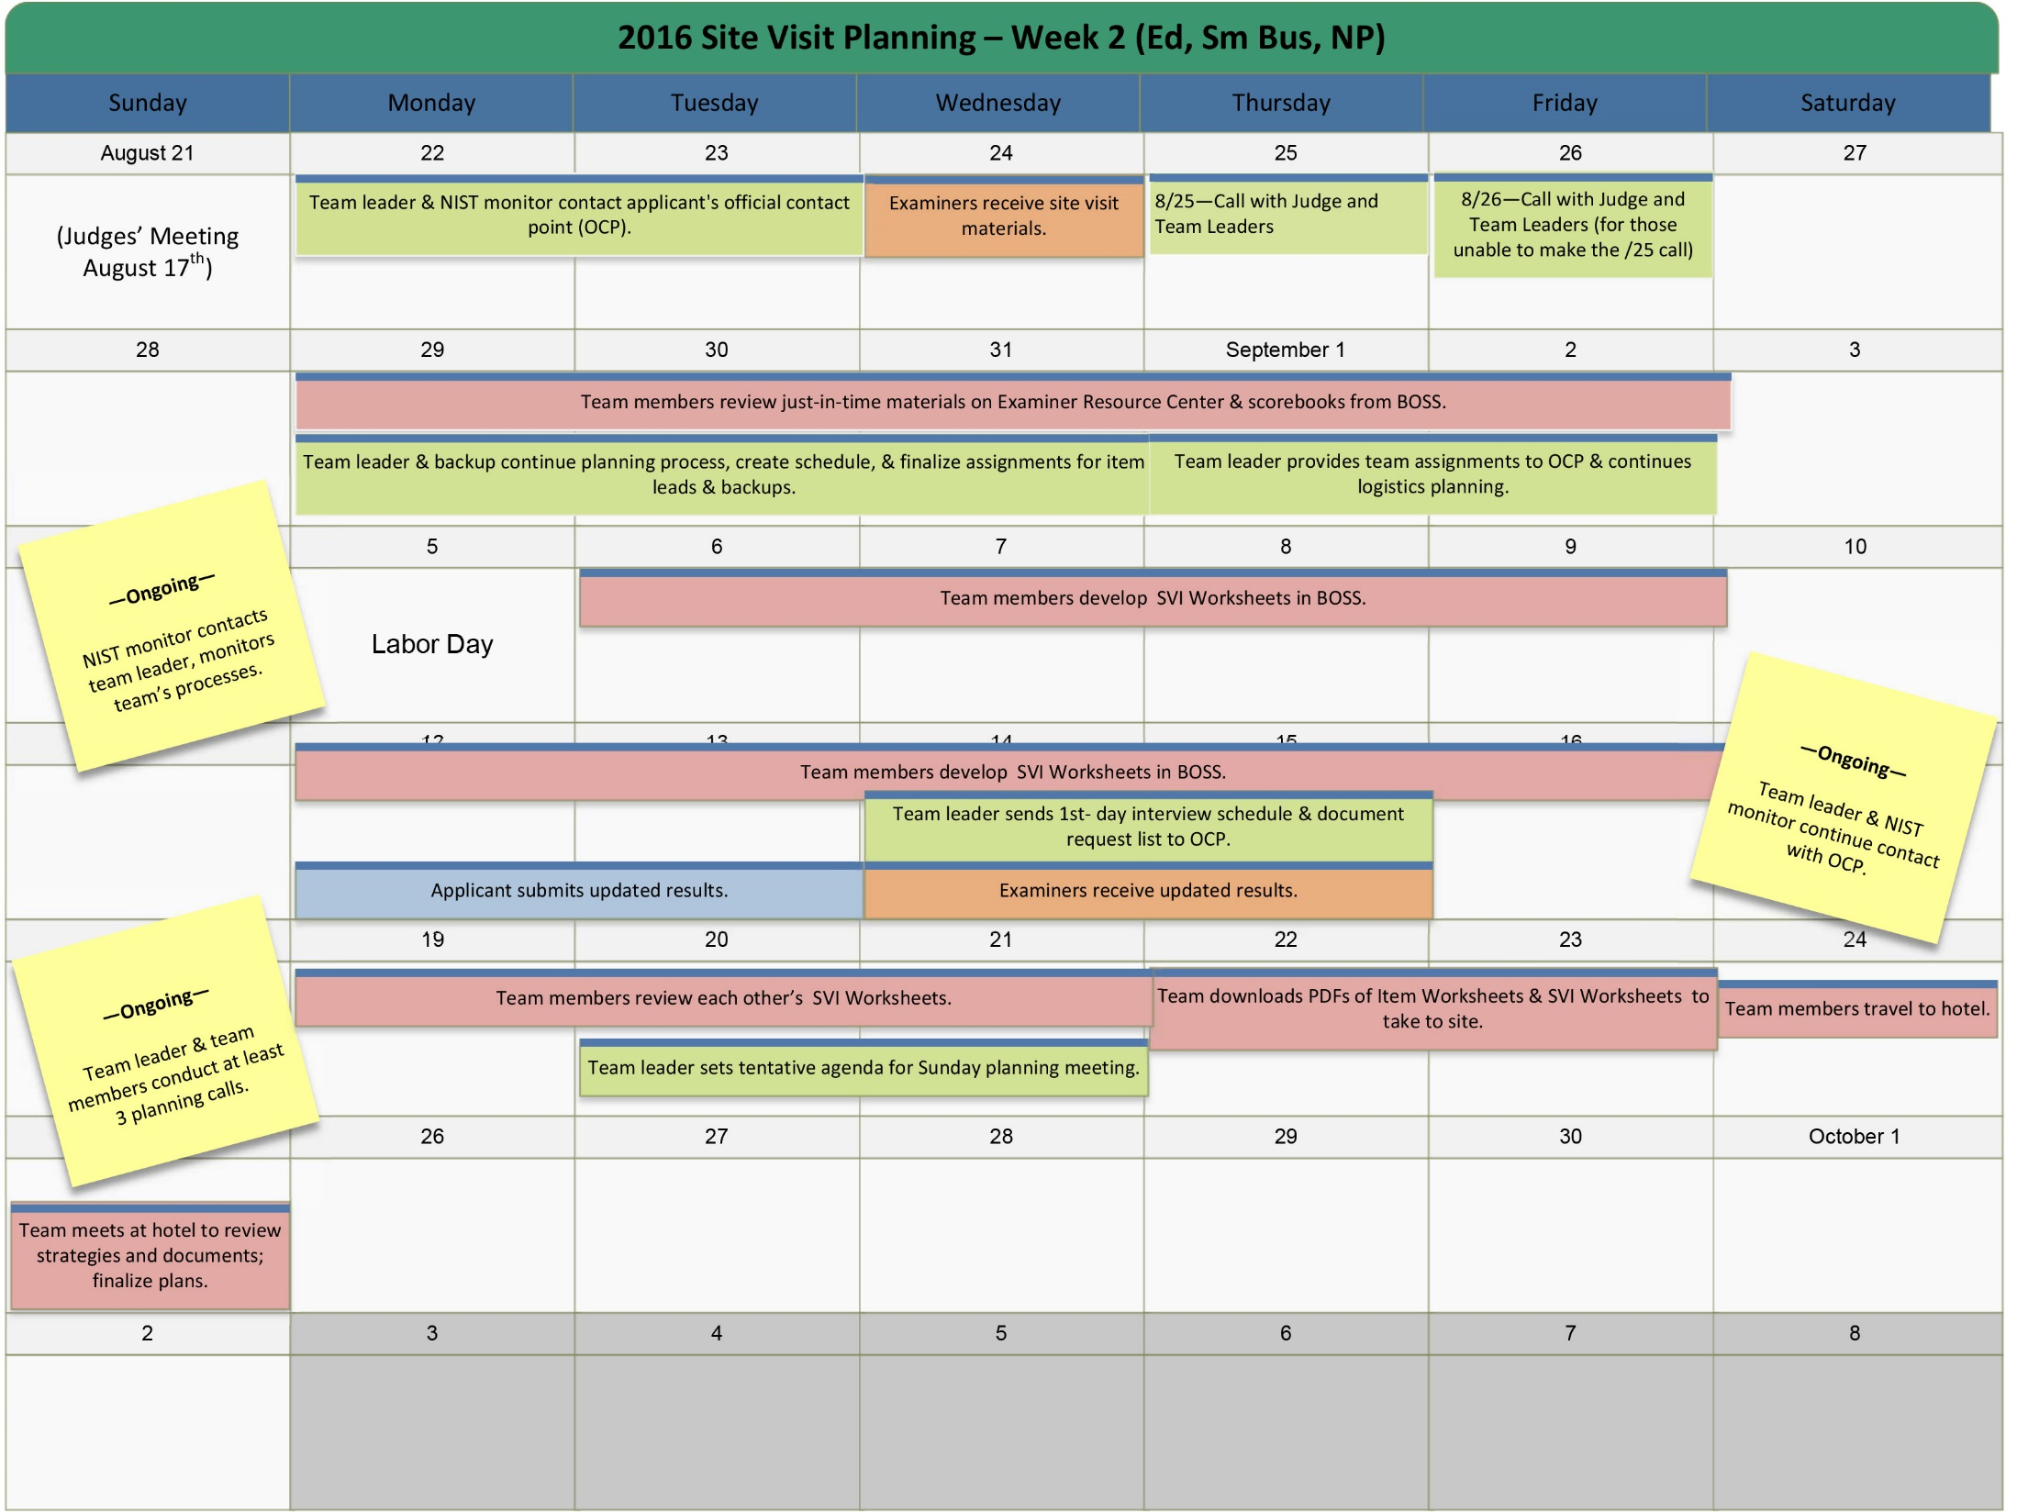

### Site Visit Preparation

* **Make travel arrangements:** Schedule your arrival so that you allow enough time to check in and be ready with your computer and files in the team room before the start of the Sunday planning meeting. Most team members travel on Saturday. The team leader and BPEP monitor will provide guidance on when you may plan to leave for home on the following Friday, Saturday, or Sunday. Remember that the entire team must stay until the scorebook is completed and the signature page is signed by all examiners. Your hotel reservations will be made for you.
* **Review the application:** Review and be familiar with the entire application.
* **Review the Consensus Scorebook:** Review and be familiar with the entire Consensus Scorebook, paying particular attention to cross-cutting issues identified on the Key Themes Worksheet.
* **Review materials from BPEP:** Review the information from BPEP, including this manual and the online Site Visit Toolkit.
* **Follow instructions for developing a set of worksheets:** Begin by opening the Item Worksheets for site visit and review the format. For process items, develop 1-3 SVI Worksheets to clarify and verify comments. For results items, there will be to one Results SVI Worksheet per item. Use this SVI worksheet to describe the figures and results included in the comments for that item.
* **Follow instructions to draft SVI strategies:** Use the Site Visit Worksheet to draft a strategy to “close out” each SVI for process items and the Site Visit Issue Worksheet for results items. The strategies may change as team members obtain more information. Determine whom you will interview (if possible), questions to ask, documents you need, and walk-around questions that will help test the extent of deployment.
* **On the Site Visit Issue Worksheet, develop the list of people or groups to interview:** Prepare a list of the people you would like to interview and the topic(s) to be discussed. Estimate the length of time needed and the preferred day to conduct the interview(s). Have this information prepared for the team leader, who will coordinate the interview requests so that the team will not be asking the applicant to have people in two places at once. Please remember that day one of the site visit will include a meeting with the leadership team and your category counterparts.
* **On the Site Visit Issue Worksheet, list the documents to review:** Prepare a list of the documents you would like to review. BOSS will aggregate this list of documents from all for the team leader. The team leader will send the document list to the applicant ten days before the site visit. This will help the applicant to have the materials available to you at the hotel conference room before the team’s Sunday planning meeting. You will be able to request more documents after the opening meeting at the applicant’s site.
* **On the Site Visit Issue Worksheet, prepare walk-around questions:** Prepare one-to-three walk-around questions for each item that you lead. BOSS will aggregate them into a master list for the team leader. The team will review the list and finalize the questions at the Sunday planning meeting.
* **Export your documents to PDF to test that process.** Update the version of your PDF Adobe Reader, if needed.
* **Plan how to represent sites you will not be able to visit:** Ifthe applicant has overseas sites, the team needs to plan how to interview staff members from those sites. The OCP will help. Strategies include meeting the staff members at a central location or region or via telephone or video conferencing. If the applicant has many U.S. locations, the team might visit a sampling of the sites depending on locations, products, and/or services provided.
* **Draft cross-cutting issue strategies:** For your assigned SVIs, determine whether other team members will be verifying and clarifying similar SVIs that have a common theme. Work together on how to explore these SVIs (e.g., through interviews, walk-around questions, data review).
* **Prepare an interview question for the applicant’s senior leaders:** Each team member prepares one cross-cutting question to ask the senior executive team during the interview that follows the opening meeting. The information gathered from these questions is validated during the remainder of the on-site phase.
* **Discuss SVIs with backup:** Discuss your proposed SVIs with your backup before the team’s planning call.
* **Share drafts with the team:** Draft your Item Worksheets for site visit, SVI Worksheets with proposed cross-cutting issues, and proposed site visit strategies on BOSS for review by your team and the BPEP monitor. This needs to be done no later than the September deadline set by your team leader. The team will briefly review the list of SVIs and agree on them during the planning call.
* **Review updated results:** Three weeks before the site visit, the team will review copies of the applicant’s updated results. Be sure to include any updates in the fields for the appropriate comments on the results SVI Worksheets.
* **Finalize the draft documents:** Using the Import / Export tab in BOSS, Export all PDF files with you to the Sunday planning meeting at the hotel. You will update your worksheets throughout the site visit.

# SITE VISIT SCOREBOOK

**Introduction and General Instructions**

The Site Visit Scorebook is your final deliverable. You will begin preparing it as soon as you are notified that your team will be going on-site, and the process will continue through the course of the visit. As a member of your team, you will be an important contributor to the scorebook’s content and quality, as both a writer and a reviewer. The judges will read the scorebook to learn your conclusions from your interviews with staff and your review of various documents and data. Your scorebook is the basis for the judges’ recommendations regarding your applicant. It will also be the foundation of the feedback report for the applicant.

**Scorebook Requirements**

The goal of the Site Visit Scorebook is to provide a well-documented, nonbiased trail of evidence that demonstrates how the final scorebook conclusions relate to information obtained from the written application and the site visit. The trail of evidence

* is captured in the Item Worksheets, which include consensus comments, a summary of evidence, and updated comments to clearly show the evolution of comments based on findings;
* flows from the SVI Worksheets, which contain more-detailed evidence of findings leading to changes in the Item Worksheets and scores;
* is reflected in the Key Themes Worksheet, which flows from the Item Worksheets; and
* shows the appropriate key factors that are reflected in the comments.

To prepare the Site Visit Scorebook, you will start your work in BOSS by identifying the site visit issues (SVIs) based on the consensus review of the applicant. Next, you will determine strategies to clarify and verify the SVIs in order to develop meaningful feedback for the applicant. These SVIs and strategies to verify / clarify them will be documented on SVI Worksheets in BOSS.

As you finish your planning and prepare to leave for the site, you will export all of your SVI and Item worksheets from BOSS and save them as PDF documents. During the on-site phase, you will document your findings and revise the worksheets in their PDF format. You will review other team members’ work and receive their feedback during “walk the wall.” Once finalized, the scorebook will be imported back into BOSS to prepare for the judges’ review and the feedback report.

### Building the Site Visit Scorebook

The Site Visit Scorebook consists of a combination of BOSS worksheets and scorebook forms in PDF. When completed, the PDF forms are posted to Team Files on BOSS, and the PDF worksheets are imported back to BOSS.

The components of the Site Visit Scorebook are listed below. Check the BOSS SiteVisitExport file of PDFs for each of these components.

|  |  |
| --- | --- |
| **BOSS worksheets** | **Scorebook forms** |
| * Key Factors Worksheet | * Cover Page |
| * Key Themes Worksheet | * Summary of Sites Visited |
| * Item Worksheets | * HRO Interview Worksheet |
| * SVI Worksheets | * Signature Page |
| * Score Summary Worksheet |  |

**Key Factors Worksheet**

The Key Factors Worksheet records the key business/organization factors that the team considered in evaluating the applicant. Key factors help define what is important and relevant to the applicant. These are listed in the Consensus Scorebook and modified as necessary to reflect new information obtained during the site visit. Knowledge and use of the key factors are essential to the proper conduct of a site visit evaluation. In anticipation of the team leader’s discussion with the Judges Panel, the team provides the consensus key factors, which remain the same in the body of the worksheet, and completes the question at the bottom: “Thinking about the questions in the Organizational Profile, did the team have any new insights about the applicant as a result of the site visit?”

**Key Themes Worksheet**

The Key Themes Worksheet provides key points and an overall summary of the Site Visit Team’s evaluation of the applicant. It is an update of the Key Themes Worksheet from Consensus Review.

Key themes are based on the overall context provided by the evaluation framework (the Criteria categories) and the core values and concepts (found in the Criteria for Performance Excellence booklets). The Key Themes Worksheet does not just repeat the findings given in the Item Worksheets. Rather, it puts them in perspective, taking into account category linkages, key factors, and core values.

The Key Themes Worksheet responds to the following questions:

1. What are the most important strengths or outstanding practices (of potential value to other organizations) identified in the applicant’s response to process items?
2. What are the most significant opportunities, concerns, or vulnerabilities identified in the applicant’s response to process items?
3. Considering the applicant’s key business/organization factors, what are the most significant strengths (related to data, comparisons, and linkages) found in its response to results items?
4. Considering the applicant’s key business/organization factors, what are the most significant opportunities, vulnerabilities, and/or gaps (related to data, comparisons, and linkages) found in its response to results items?

Key themes comments for questions a. and b. address the evaluation factors of approach, deployment, learning, and integration (ADLI). The comments for questions c. and d. address levels, trends, comparisons, and integration (LeTCI), including segmentation, as well as linkage to the applicant’s organizational requirements and gaps.

**Item Worksheets**

This worksheet is the record of your final evaluation of the applicant for each of the Criteria items.

As you clarify or verify all OFIs and all strengths that are bolded and/or appear in the key themes, capture the findings and conclusions on this worksheet. All other comments, whether fully investigated or not, should be reviewed, refined, and included on the Item Worksheet. If you discover nothing related to one of these comments, you may indicate on the worksheet “not investigated on-site.” By the end of the site visit, “it is unclear,” “it is not apparent,” or similar words must not remain in any comment.

BOSS automatically transfers Consensus Review comments and their item references into the appropriate columns of the Item Worksheets for the Site Visit Scorebook and assigns each comment a unique number (ID).

**Do not delete or re-order comments in the PDF Key Theme or Item Worksheets because it will cause errors during the import back into BOSS at the end of the site visit. Rather, indicate in the Comments after Site Visit column that “This comment is deleted”. To re-order, indicate that “This comment should become STR-1” or “This comment should become OFI-2” for example. The Team Leader will be able to do the re-ordering in online BOSS and BPEP will check in the feedback report.**

Information gaps or lack of understanding must be resolved through the site visit, using SVI Worksheets.

You will complete the “Summary of Conclusions/Impact on Comments” column of the Item Worksheet on-site, after the strengths and opportunities have been verified and clarified through the accomplishment of the strategies listed on the SVI Worksheet for the item. Then, you integrate these findings into a revised set of strengths and OFIs for each item. These revised, feedback-ready comments are included in the last column.

If new information arises during the site visit, you may add comments to the Item Worksheet. Similarly, if your findings remove a strength or an OFI, you may indicate a comment is deleted but leave the reference as “This comment is deleted” and what happened to it. Describe the findings leading to new or deleted comments in the appropriate SVI Worksheets so that the judges understand how the comments emerged or were deleted.

For items that you lead, indicate in the scoring section your recommendation for the item scoring range. Scoring ranges, not individual item scores, are provided to site-visited applicants. After your team mates individually review and provide feedback on your recommended score, the team will discuss scoring as a final step. Any differences not resolved during the team review process can be resolved during this discussion.

**SVI Worksheets**

You use SVI Worksheets to track the major/important issues that need to be verified or clarified during Site Visit Review along with the strategies used. Remember to clarify all OFIs and verify all strengths that are bolded and/or appear in the key themes.

SVI Worksheets are the judges’ major vehicle for understanding what you heard and saw on your site visit. The judges look for clear “audit trails” from the Consensus Review comments to the site visit conclusions and scores, which are based on your interviews and document and data reviews.

For process items: Issues for on-site verification of strengths and clarification of OFIs include the applicant’s approach (A), the extent of the approach’s deployment (D), organizational learning (L), and integration (I) related to the approach. For example, if a strength comment discusses the existence of a systematic process, you would verify that the process exists and operates as presented in the written application. During the site visit, you verify that appropriate credit was given during the Consensus Review of the written application. This is particularly true when the Consensus Team gave the applicant the benefit of the doubt.

During the planning phase of the site visit, you develop two or three SVIs per process item. When you list comments in the “Comments Affected” column of an SVI Worksheet for process items, BOSS will list them in the space provided on the Item Worksheets. These SVIs focus on key processes so that your investigation of each of them provides information needed to finalize more than one comment. Each SVI has its own SVI Worksheet.

For results items: The SVI Worksheet for results items differs from the one for process items. Each results item has one SVI Worksheet that includes the strengths that require verification and the OFIs that require clarification. You select a strength or OFI comment, write a brief summary, and then list the figures associated with it, as well as its beneficial trends and favorable comparisons. Analyses indicate whether the data represent (1) good-to-excellent levels, beneficial trends, and favorable comparisons; (2) segmented results to measure performance across customer groups, products, and/or services, market segments, and workforce groups; and (3) data derived from the applicant’s updated results received one week before the site visit.

You will complete the “Summary of Conclusions/Impact on Comments” on-site. This is a summary of all the conclusions reached from associated SVI Worksheet. However, be sure to provide sufficient data and clear conclusions for the judges. These data and analyses will be reflected in the “Comments after Site Visit” column.

Before the site visit, export your SVI Worksheets into PDF documents as a zip file from the Import/Export tab in BOSS. Remember to Extract and Save the files on to your laptop and a jump drive. You may want to print copies of the partially completed worksheets in order to make notes on them during on-site meetings. Each evening of the site visit, you will review your teammates’ notes and electronically record these findings on master copies of the SVI Worksheets. Final SVI Worksheets will be part of the Site Visit Scorebook to inform the judges in their decisions.

In team meetings, you and your team mates will use their SVI Worksheets to discuss preliminary findings and conclusions. Findings might include observations, specific answers, and/or updated results that may lead to revised comments. Conclusions indicate how the findings affect item comments. Until the site visit ends, preliminary conclusions are subject to change as new information becomes available. Your team’s discussions and preliminary conclusions will help guide your work during the site visit.

**Score Summary Worksheet—Site Visit (upload to Team Files)**

BOSS transfers the percent score and scoring range for each item and the overall score from the Consensus Review Score Summary Worksheet to the Site Visit Review Score Summary Worksheet. As scores are refined through site visit findings, you finalize the scoring range for each item and record resulting changes (higher range, lower range, same range). Finally, you and the team use the Scoring Band Descriptors to determine which descriptor for process items and which descriptor for results items best reflect the team’s view of the applicant, and the scorekeeper inputs these band numbers on the Score Summary Worksheet.

**Summary of Sites Visited (upload to Team Files)**

The Summary of Sites Visited contains information about the extent and thoroughness of the site visit. The team lists the major locations it visited and describes any important aspects of the sites that are not apparent from the Site Listing and Descriptors section of the Eligibility Certification Form. For example, the list might include “oldest facility,” “site with a major reduction in force,” “location where the newest product will be manufactured,” or “telephone or data service center that runs three shifts.” In addition, examiners describe approaches they used to evaluate sites that they did not visit, including sites outside the United States.

This worksheet also contains any other information about the team’s strategy for a thorough site visit, such as

* “Interviewed employees on all three shifts”
* “Interviewed categories/types of employees [specify categories/types]”
* “Visited at least one location in each of the operating regions”
* “Did a sampling at all levels and in all locations of the organization’s critical data systems”

**HRO Interview Worksheet (upload to Team Files)**

This worksheet’s purpose is two-fold: 1) to summarize key role-model discussions during the conversation among the team leader, BPEP monitor, and HRO. It is used to share information within the Site Visit Team; 2) record discussion of any issues that might reflect negatively on the applicant or the Baldrige Program in the event that the applicant would receive the award.

A discussion of the content of this worksheet typically occurs in the evening after the HRO interview has taken place. Based on this discussion, you and your team mates decide which issues require further investigation or need documentation in the scorebook.

**Signature Page (Hard Copy; NIST Monitor)**

The final requirement of the Site Visit Team is completion of the signature page of the scorebook. The page includes the following statement: “I support the findings of the Site Visit Team contained in this scorebook.” In the spaces provided, you and your team mates each prints their name and then signs the form.

The BPEP monitor brings this form to the site and returns with it signed by the team members.

**Site Visit Scorebook Composition**

At the end of the site visit, data from the Item Worksheets, SVI Worksheets, Key Factors Worksheet, the Key Themes Worksheet, and the Score Summary Worksheet in PDF form are imported into BOSS. The Summary of Sites Visited and the HRO Interview Worksheet are posted directly to the Team Files.

**Site Visit Scorebook Submission**

At the conclusion of the site visit, three electronic versions of the Site Visit Scorebook are made—one each for the BPEP monitor, the team leader, and the backup team leader. In addition, the BPEP monitor retains a paper copy of the signature page.

Based on Internet availability, all documents may be imported and posted to BOSS before leaving for home. In other cases, the team leader can import the documents to BOSS after returning home. If the scorebook has not been uploaded to BOSS, it is advisable for the monitor to retain a paper copy of the entire Site Visit Scorebook. Paper copies of the scorebook are optional for the team leader and the backup team leader.

The team leader may review and make final refinements to the scorebook on BOSS by midnight (PDT) on the Monday immediately following the site visit’s completion. This review is not intended to encourage or even permit the team leader’s extensive editing of the report; its purpose is to ensure that the scorebook is complete and accurate. For example, it is not uncommon for one or more worksheets to be missing, for comments to be misplaced or included more than once, for words such as “it is not clear” to be missed in comments, or for scoring information to be missing or inaccurate. All team members must watch for these sorts of edits to give the judges an accurate representation of the team’s findings and conclusions. Tweaking comments for grammar and style is not appropriate at this time.

### How to Prepare Process Item Worksheets and SVI Worksheets

**During the site visit planning phase (BOSS online) until**

In preparation for the site visit, each team member will be named the item lead for several process items and/or results items. Two major types of documents—the Item Worksheets and the SVI Worksheets—will become part of the scorebook submitted to the judges.

1. When your team is moved from Consensus Review to Site Visit Review, BOSS fills in eight columns of an Item Worksheet for each item. The first columns are headed with “ID,” “Item Ref,” Strength (or OFI) Comments at Consensus,” and “SVI.” The final columns are “Summary of Evidence”, “Summary of Conclusions / Impact on Comments,” “Comments after Site Visit,”, and if it is a double-plus strength or double-plus OFI which will be completed on-site. As BOSS populates each Item Worksheet with comments from the Consensus Scorebook, it assigns a unique ID to each comment and loads the corresponding item reference. Familiarize yourself with the Item Worksheets.
2. Start by developing one-to-three SVIs at the key process level for each item. Here is one way to start an SVI:
   1. To understand the key processes involved, review the key inputs to the item (e.g., Criteria requirements, key factors, and comments).
   2. Select one OFI comment, since all must be clarified, and determine to which key process it relates. Consider in your SVI the process evaluation factors (approach, deployment, learning, and integration [ADLI]) addressed in the comment.
   3. Review other OFIs and strengths to determine if the issues related to that key process can be clarified and verified through one integrated SVI.

**Integration within an SVI is not the same thing as combining issues.** It can be tempting to put as many issues as possible into a single SVI. This is not helpful when those issues are not related to the same key process. This creates a patchwork SVI Worksheet that will confuse the team and the judges. If the issues will not be investigated through the same methods (e.g., talking to the same people, reviewing the same documents, making the same observations), it is probably not appropriate to integrate them.

* 1. When you have addressed all OFIs, check to see if the SVIs also verify first, all bolded (significant) strengths and then, the remaining strengths. Every comment should be addressed by an SVI. If not, you may need to craft a separate SVI.

1. To add a Process SVI, click on the SVI Worksheets tab. Or, open a Process Item Worksheet and click the “Add SVI” button. Note that the SVI is numbered automatically and sequentially.
2. There is only one SVI per Results Item and each one is automatically started. Click on the Edit icon to begin.
3. Describe the SVI that you are developing, indicating which processes you will clarify or verify.
4. Click the button labeled “Edit Comments Affected.” All comments and key themes in the scorebook are available for selection; you can display a comment’s full text by clicking on it. When you click “Add,” the comment ID will be displayed under “Selected Comments.” Select the appropriate evaluation factors for this comment or key theme. Click the “Save” button to complete the “Comments Affected” section.

SVIs may involve elements of the key themes. The team leader must ensure that the collective SVIs verify and clarify the key themes.

1. Define the core questions to resolve the SVI in the “Analysis Required” section. Design the questions to elicit information that verifies or clarifies the original comments in the scorebook. Craft these core questions to address the process evaluation factors (ADLI) included in the comments. Click “Add a Question” to enter the question on the SVI Worksheet. After you enter the question, select the appropriate evaluation factors. You will complete the “Evidence” and “Conclusions” on-site.
2. Continue through the Site Visit Issue Worksheet, filling in Interviews, Documents to Review, Walk-Around Questions, and Observations to Make. These are the multiple methods to obtain the evidence you need. As you add an interview, for example, a prompt will ask you for the people or group to talk with and the specific questions. You will also list documents that you want to review and walk-around questions to determine deployment. List each document or question separately, by clicking the “Add” button.
3. BOSS will aggregate the list of documents and walk-around questions for the team leader to use in planning the site visit. These two files will be created during the Export and will be included in the SiteVistiExport.zip file.

SVIs can be a key source of shared understanding for the team. If the entire team is involved in developing and vetting SVIs and before leaving for the site, team members will enter the site visit with a common view of their understanding of the applicant and how to fill gaps. Use the feedback panel, similar to consensus review, to give a team member feedback on an SVI or strategy. Allowing individual team members to “own” particular issues can lead to difficulties in reaching consensus. Therefore, spend time as a team examining and critiquing SVIs and during planning, the Sunday planning meeting, and throughout the visit.

1. As you prepare to leave for the site visit, export all the files from BOSS.

To download the complete scorebook of all item worksheets, SVI Worksheets, and other documents, go to the “Import/Export” tab. This is a button you can use to export the complete scorebook into a .zip file. You would then extract the documents you wished to review or modify.

1. Export the PDF documents onto the laptop you are taking to site and onto a flash drive. Open and navigate in the PDFs and test your laptop and USB ports to make sure they still function when disconnected from work or home network(s). If you have questions, contact your Team Leader, BPEP monitor or Award Process Hotline Telephone: 877-237-9064, Option 3.
2. On Sunday, the team will cover the worksheets and logistics planning. See the sample “Sunday Meeting Planning Agenda” in the Tools section.

To read and work in these PDF documents, you will need to have Adobe Reader or Adobe Acrobat installed on your computer. If you get a warning when you open the PDF, you may need to update to the latest version. Determine which version of the Reader you have on your system by checking “Help.”

If you are using Google Chrome you may need to enable a plug-in to open PDF files properly. Go to chrome://plugins. Under “Chrome PDF Viewer”, click **Enable PDF viewing**.

**On-site (between the opening and closing meetings at the applicant’s location[s])**

1. After you interview the applicant’s employees/staff/faculty/volunteers and review documents, fill in the evidence needed to support a conclusion to the core questions on the SVI Worksheets, now in PDF. This evidence guides you in determining when you have collected enough information.
2. In presenting this evidence, be sure to provide your teammates and the judges with enough detail that they are able to evaluate your conclusion. Include brief citations of the source of the data, such as “in interview with seven hiring managers,” “through analysis of the past three years’ SPP input documents,” and “during walk-around interviews with approximately 24 staff members from all levels and departments.”
3. Next, draft a succinct conclusion that responds to the core question and draws on the evidence presented. You must be able to answer each SVI’s core questions, thus “closing” the SVI, before the closing meeting. Your conclusion directly indicates any changes you need to make in the original comments on the Item Worksheets.

During this phase, you will post the SVI Worksheets for your team members to review during “walk the wall.” You may edit the SVI for clarity or to add information and then print and repost for another “walk the wall.”

**Post-site (after the closing meeting)**

1. In the last column of the Item Worksheet, revise comments as appropriate to reflect these conclusions. Check the box if the comment should be doubled/bolded. If you have a new comment, click the appropriate “Add Comment” button for a strength or OFI and enter the text directly in the “Comments after Site Visit” column.
2. Go to the last page of the PDF and review the consensus score and scoring range, determine whether the scoring range needs to change, and document the rationale.

The Item Worksheet will also be printed and posted for review during “walk the wall.” Based on the team’s feedback, you may edit the Item Worksheet comments or score and then undergo another round of “walk the wall.”

1. After all work is complete and the team is ready to sign off on the Site Visit Scorebook, the team leader will gather all Item Worksheets and SVI Worksheets and import them back into BOSS.

### How to Prepare Results Item Worksheets and SVI Worksheets

**During the site visit planning phase (through the Sunday planning meeting)**

The format of the Item Worksheet for results items is the same as for process items. However, there is only one SVI Worksheet for each item in category 7. The SVI Worksheet is organized by comments in the Item Worksheet and documents the figures included within the comments. On the SVI Worksheet, you will also list any interviews required or additional documents to review.

1. When your team moves from Consensus Review to Site Visit Review, BOSS begins not only the Item Worksheet but also the SVI Worksheet for each results item. Go to the SVI Worksheets tab and find the Result SVIs under the Process SVIs. As you open the SVI, you will see several fields. Under “Verify,” list all strength comments with information about the figures included in the comment. Under “Clarify,” do the same for all OFI comments.
2. Complete the sections headed “People/Groups to Interview” and “Documents to Review” as you did for process items, listing each on a separate line. The sections for “(To be completed on-site) New Data Found On-Site” and “(To be completed on-site) Newly Recognized Gaps Discovered On-Site” later.
3. Under “Verify,” click “Add Strength.” Select the ID of the strength from the drop-down list. BOSS will display the text of the strength for your review. Some comments are preceded by ++ or, for OFIs, indicate if the comment was doubled/bolded during Consensus Review.
4. Click “Continue.” BOSS displays a window where you can enter information about the strength. Start by entering a “Brief Summary,” perhaps a tag line you would use to describe it. (Note that you have a spell-check function for this and other fields.)
5. After you enter the brief summary, list the figures included in the comment. Separate the figures by commas.
6. Check whether the figures show “Good-to-Excellent Levels.”
7. To list any “Beneficial Trends,” click the “Add Trend” button. Summarize the trend data by the appropriate figure number. Use the “Notes” field to expand on results or other findings that you might explore during the site visit.
8. Follow the same process with “Comparisons” and “Segmentation/Linkages.”
9. When you have completed entering information about the results for this comment, click “Save,” and BOSS will return you to the SVI page for this item.
10. Once you have completed data for each individual strength and OFI, consider the “People/Groups to Interview” and the “Documents to Review.” Consider which people and documents would answer your questions. Complete each of these sections and click “Save and Close” to return to the main SVI list.

**Upon receipt of updated results (one week before the site visit)**

1. When you receive updated results from the applicant, select each results SVI and then each comment within the SVI. Complete the three fields for each comment under “List Updated Results.” Not all results will have updates, but the data received may lead to a new OFI or help clarify an existing OFI.
2. Before you leave home for the site visit, export all files using the Import / Export tab in BOSS. This creates a SiteVisitExport.zip file. Extract and Save these files on to your laptop and a jump drive. On-site, use the PDF documents to record your findings, analyses, conclusions, and revised comments.

**On-site (at the applicant’s location[s])**

1. Complete the “Conclusions/Impact on Comments” for each comment on the SVI Worksheet after you have verified and clarified the strengths and opportunities by accomplishing your SVI strategy for this item. This is a summary of your findings rather than a written transcript. However, provide sufficient data and clear conclusions to give the Judges Panel a clear trail from Consensus Review comments to site visit conclusions to site visit comments and, finally, to scores.
2. Complete the final sections on the SVI Worksheet: “New Data Found On-Site” and “Newly Recognized Gaps Discovered On-Site.” Write as much detail as necessary for the Judges Panel to understand your findings and their impact on the related comments.

**Post-site (after the closing meeting)**

1. Working in your PDF documents, copy your conclusions for each comment from the SVI Worksheet to the Item Worksheet in the column labeled “Summary of Conclusions/Impact on Comments.”
2. In the last column of the Item Worksheet, as appropriate, revise comments to reflect these conclusions. Check the box if the comment should be doubled/bolded. If you have a new comment, click the appropriate “Add Comment” button for a strength or OFI and enter the text directly in the “Comments after Site Visit” column.
3. Go to the last page of the Item Worksheet PDF and review the consensus score and scoring range, determine whether the scoring range needs to change, and document the rationale.

The Item Worksheet will be posted for review during “walk the wall.” Based on the team’s feedback, you may edit the Item Worksheet comments or score and then undergo another round of “walk the wall.”

***BOSS Worksheet Samples***

*(thanks to Amy Katschman)*

*The following pages are samples of the Item and SVI Worksheets for Process Item 5.1 and Results Item 7.3 as they would look online in BOSS at the end of the planning phase, before the export to PDFs.*

*Please note that the samples may contain less content or editing than the actual worksheets developed for a site visit but are provided to show how information flows through BOSS.*

*Additional tools and information are available at* [Examiner Resource Center / Site Visit Review](https://www.nist.gov/baldrige/examiner-resource-center/site-visit-review) .

**BOSS Online Process Item Worksheet 5.1 Planning Phase (screenshot 1 of 1)**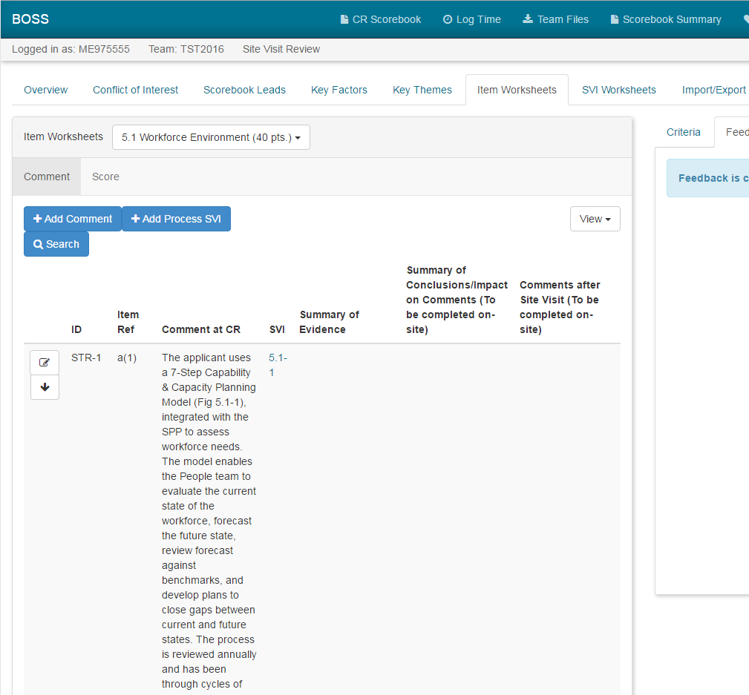

*The ID, Item Ref, and Comment at CR are filled in by BOSS automatically after the team is switched to site visit stage by BPEP*

*Start a Process SVI Worksheet by clicking on the “Add Process SVI” button or go to the SVI Worksheets tab*

**BOSS Online Process Site Visit Issue Worksheet 5.1-1 Planning Phase (screenshot 1 of 3)**

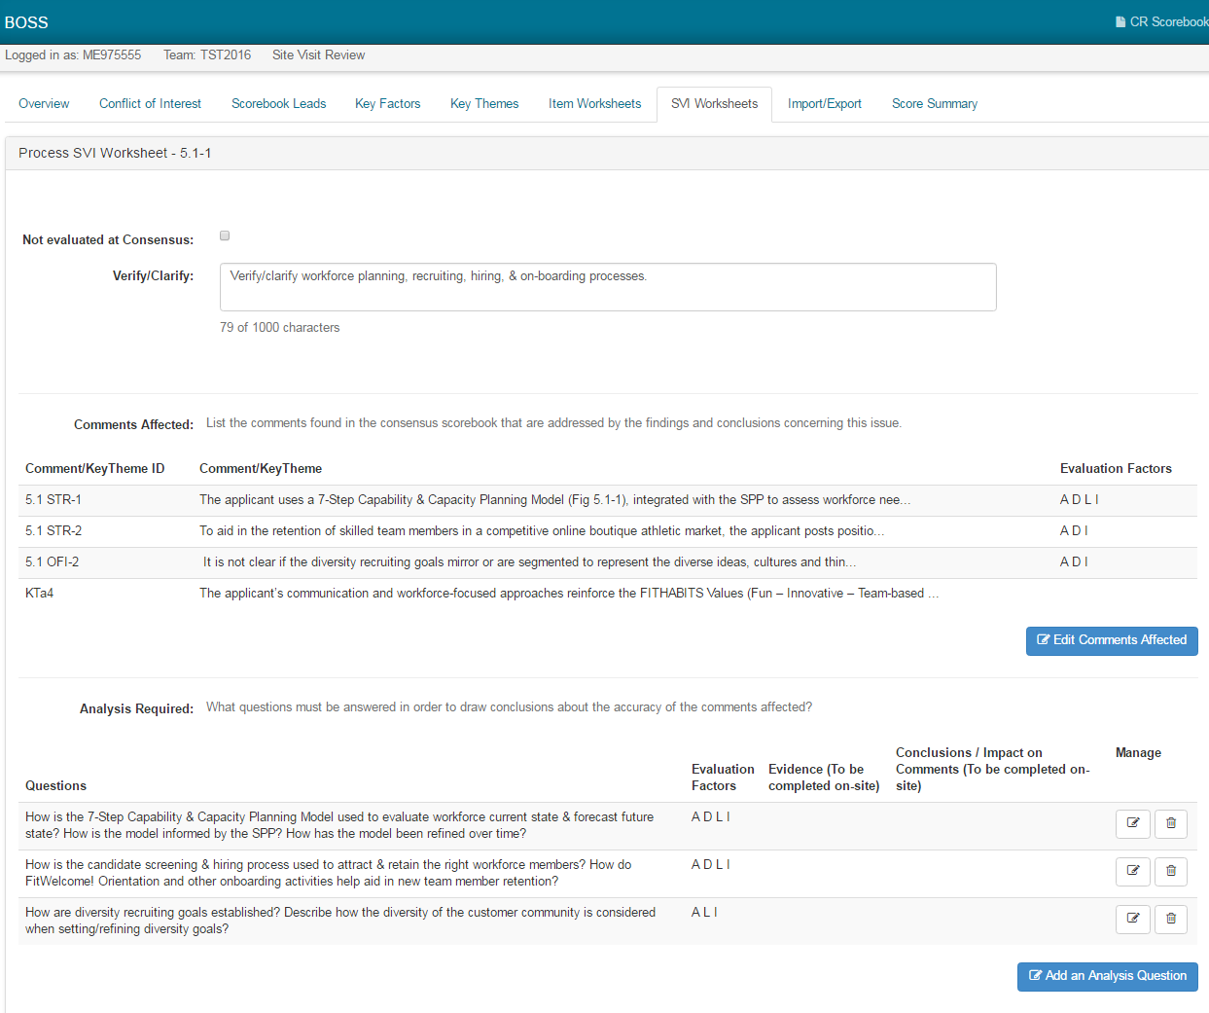

*Once clicked, a popup window will appear where Comments, Key Themes, and Evaluation Factors can be selected*

*Once clicked, a popup will appear where Questions and Evaluation Factors can be selected*

*This is where to write the site visit issue*

**BOSS Online Process Site Visit Issue Worksheet 5.1-1 Planning Phase (screenshot 2 of 3)**

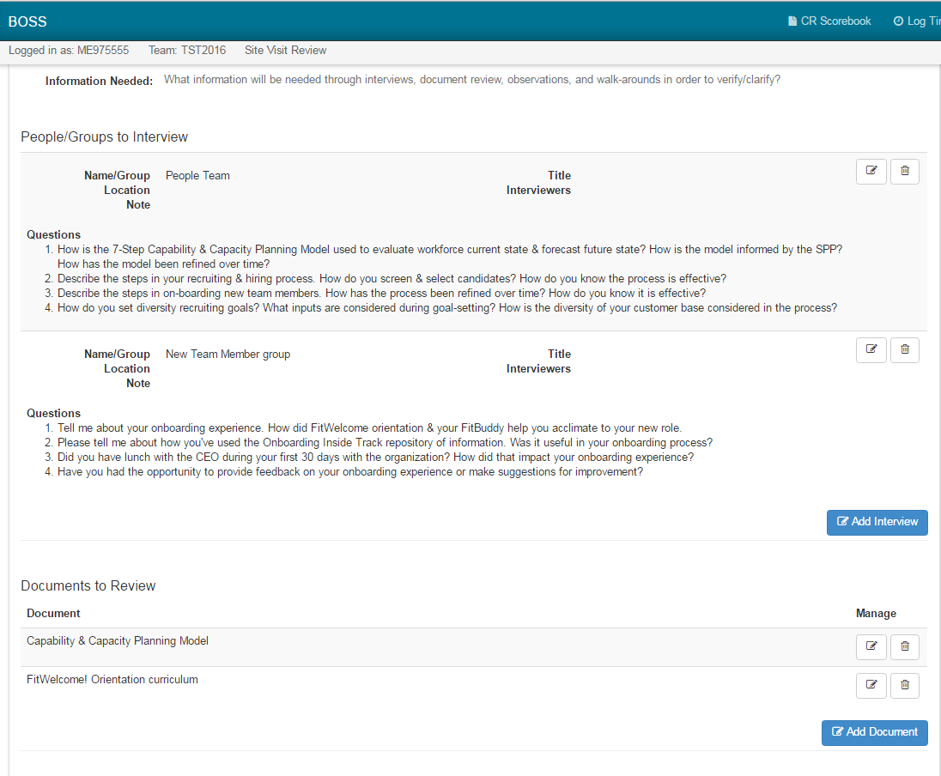

*Add each Document to Review that is being requested from the applicant. This information from the entire team will be added to the Consolidated Document List PDF; one of the Export files*

*A popup window will appear to fill in relevant interview information. This will be compiled from the entire team in to the Consolidated Interview List PDF; one of the Export files*

**BOSS Online Process Site Visit Issue Worksheet 5.1-1 Planning Phase (screenshot 3 of 3)**

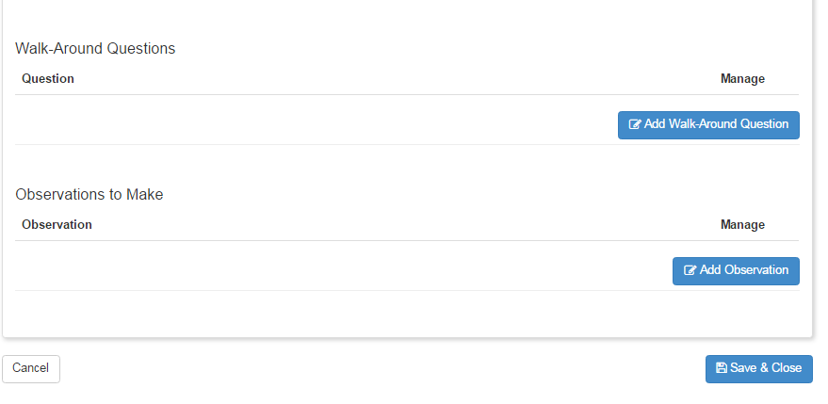

*Observations to Make could include online demos or processes that need to be seen in person*

*These Walk-Around Questions will be compiled from the entire team to the Consolidated Question List PDF; one of the Export files*

**BOSS Online Results Item Worksheet 7.3 Planning Phase (screenshot 1 of 1)**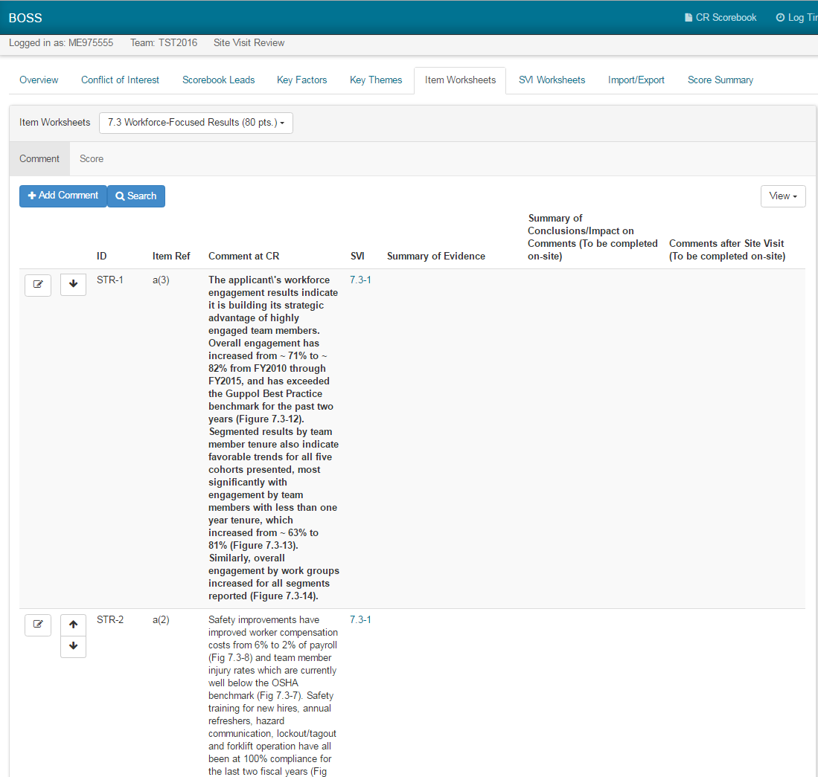

*The ID, Item Ref, and Comment at CR are filled in by BOSS automatically after the team is switched to site visit stage by BPEP*

*There is only one SVI Worksheet per Results Item*

**BOSS Online Results Site Visit Issue Worksheet 7-3-1 Planning Phase (screenshot 1 of 2)**

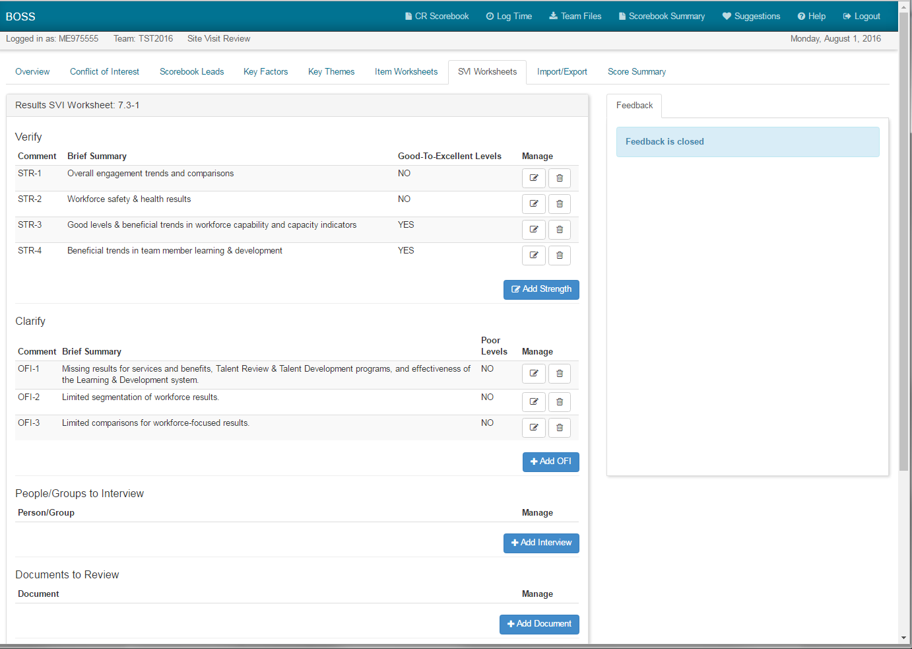

*A popup appears to Add Document that is being requested from the applicant. This will be added to the Consolidated Document List PDF; one of the Export files*

*After clicking Add Strength or Add OFI, a popup window appears to select Comments, provide a Brief Summary; describe Levels, Trends, Comparisons, Segmentation; and list applicable Figures*

*A popup appears to fill in relevant interview information. This will be added to the team’s Consolidated Interview List PDF; one of the Export files*

**BOSS Online Results Site Visit Issue Worksheet 7-3-1 Planning Phase (screenshot 2 of 2)**

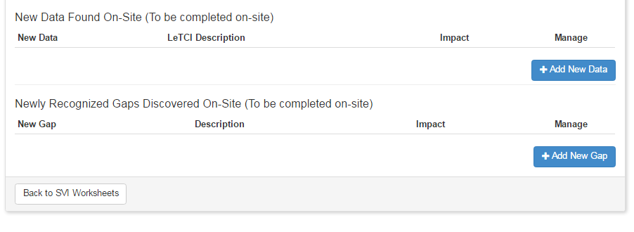

**Process and Results Item and Site Visit Issue Worksheets – Post–Site PDF Versions**

The following pages contain sample worksheets for Items 5.1 and 7.3.

Typically, Item and SVI worksheets will contain more information; these have been edited to illustrate flow and placement.

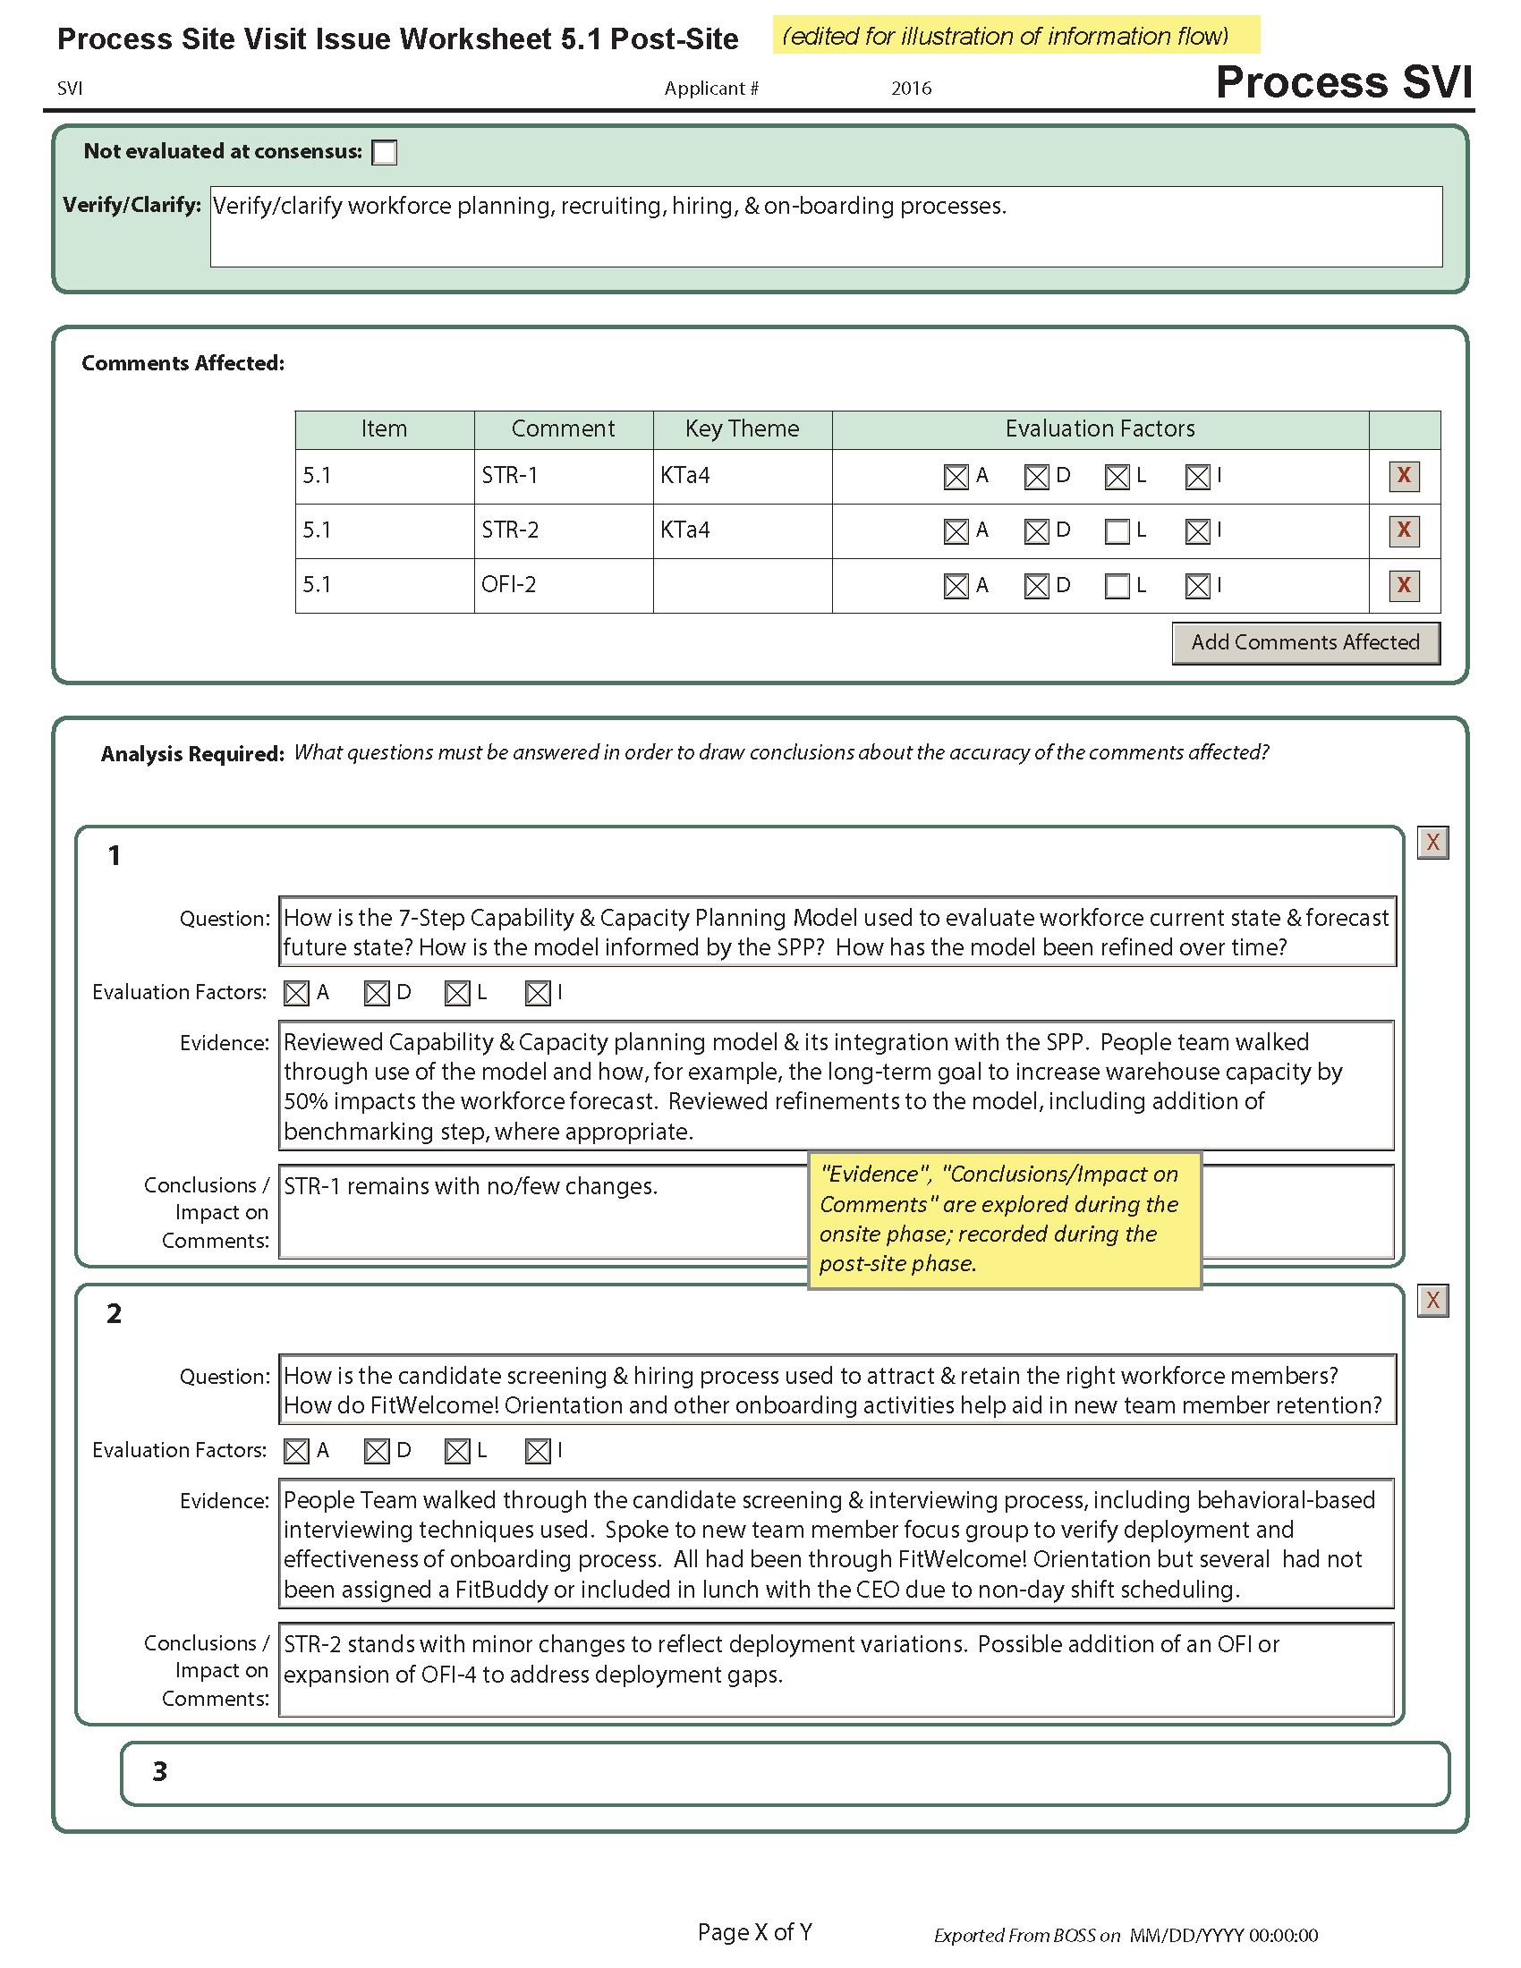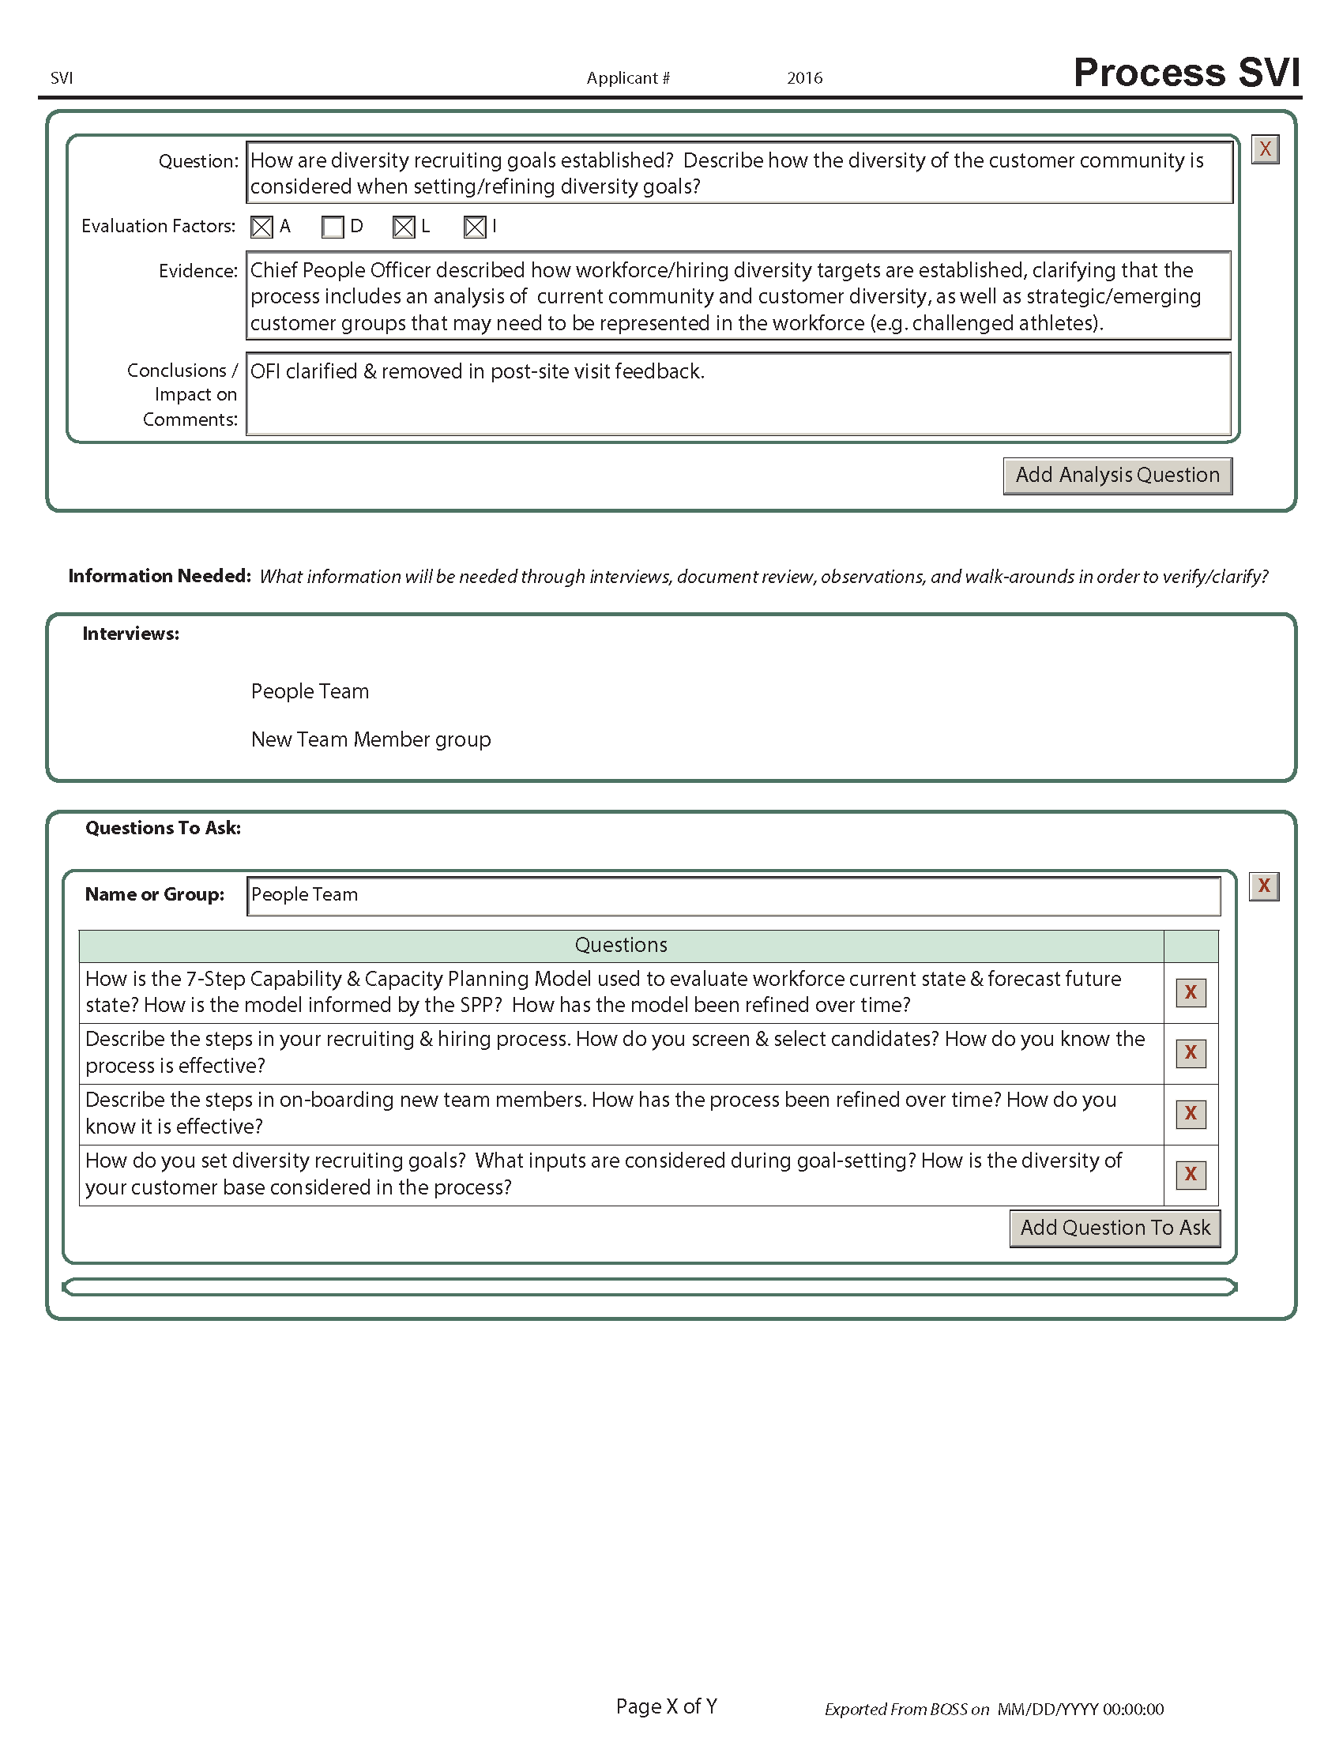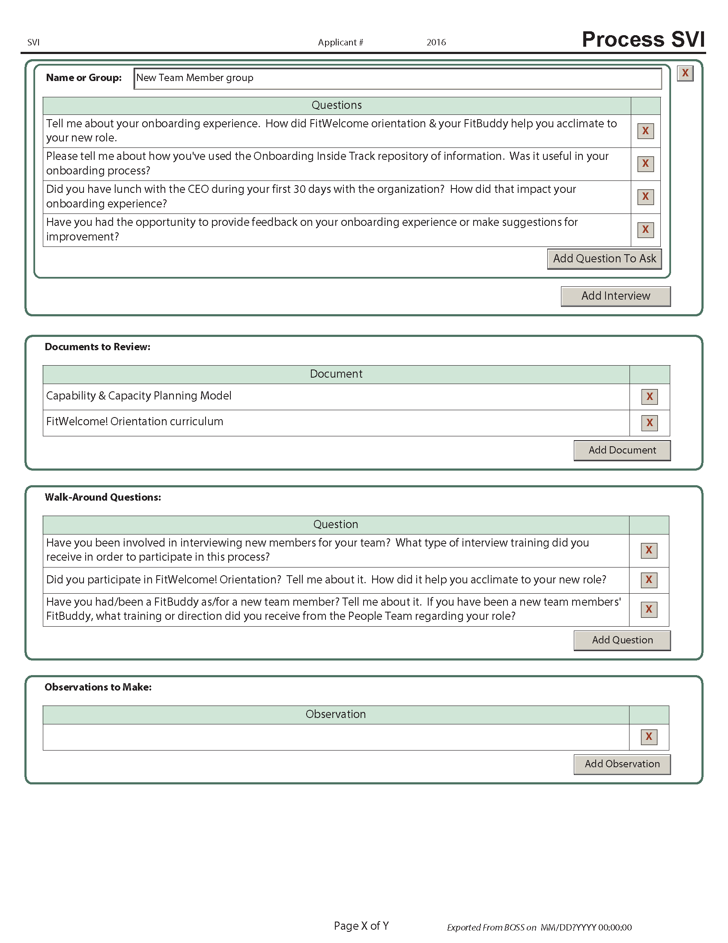

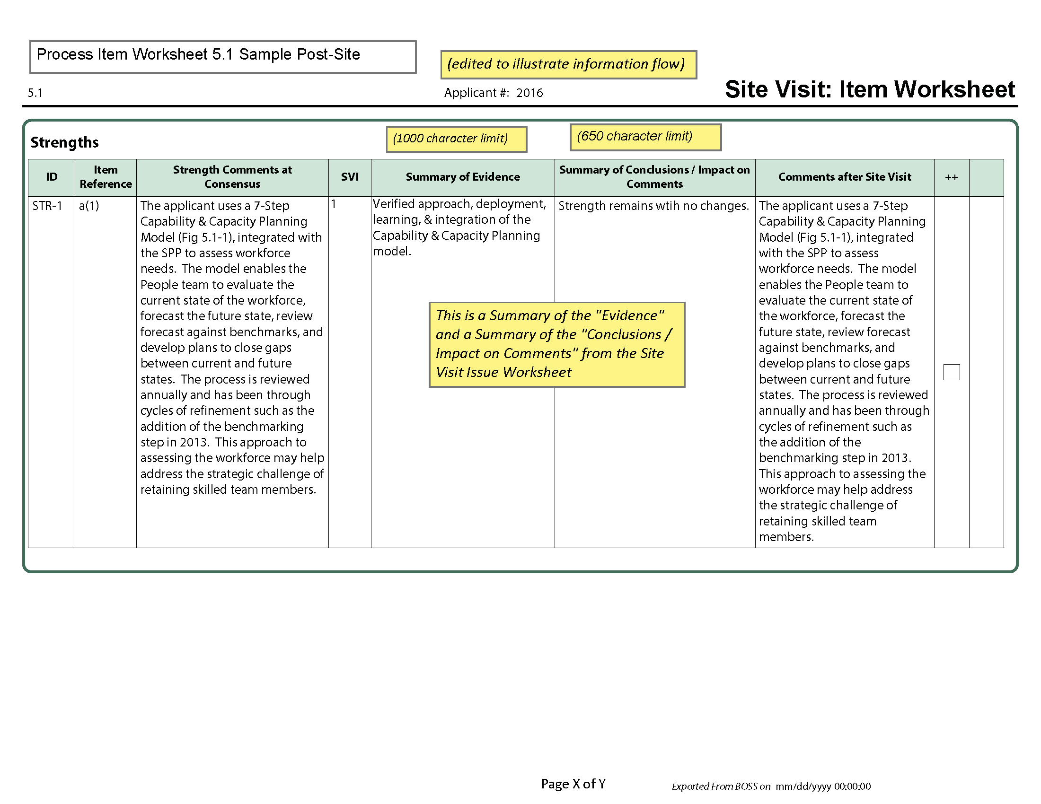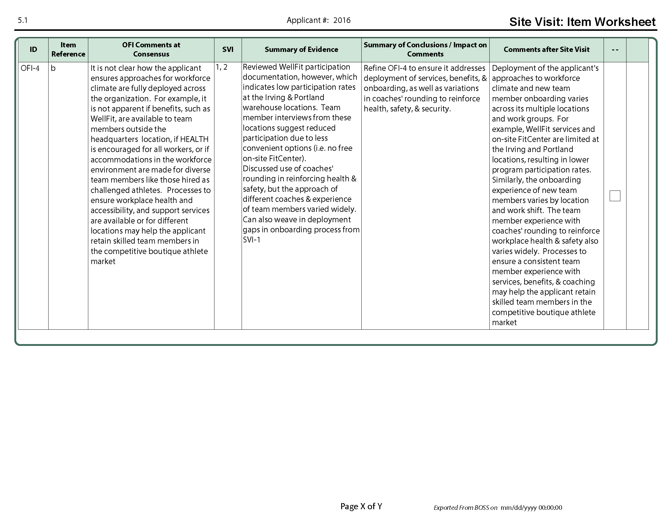

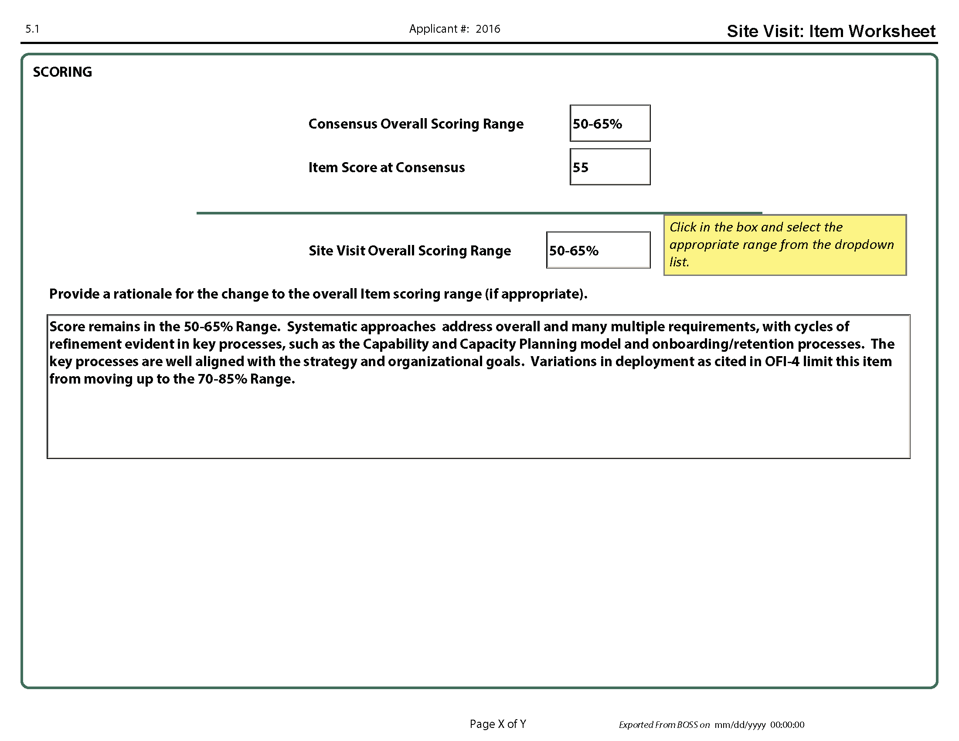

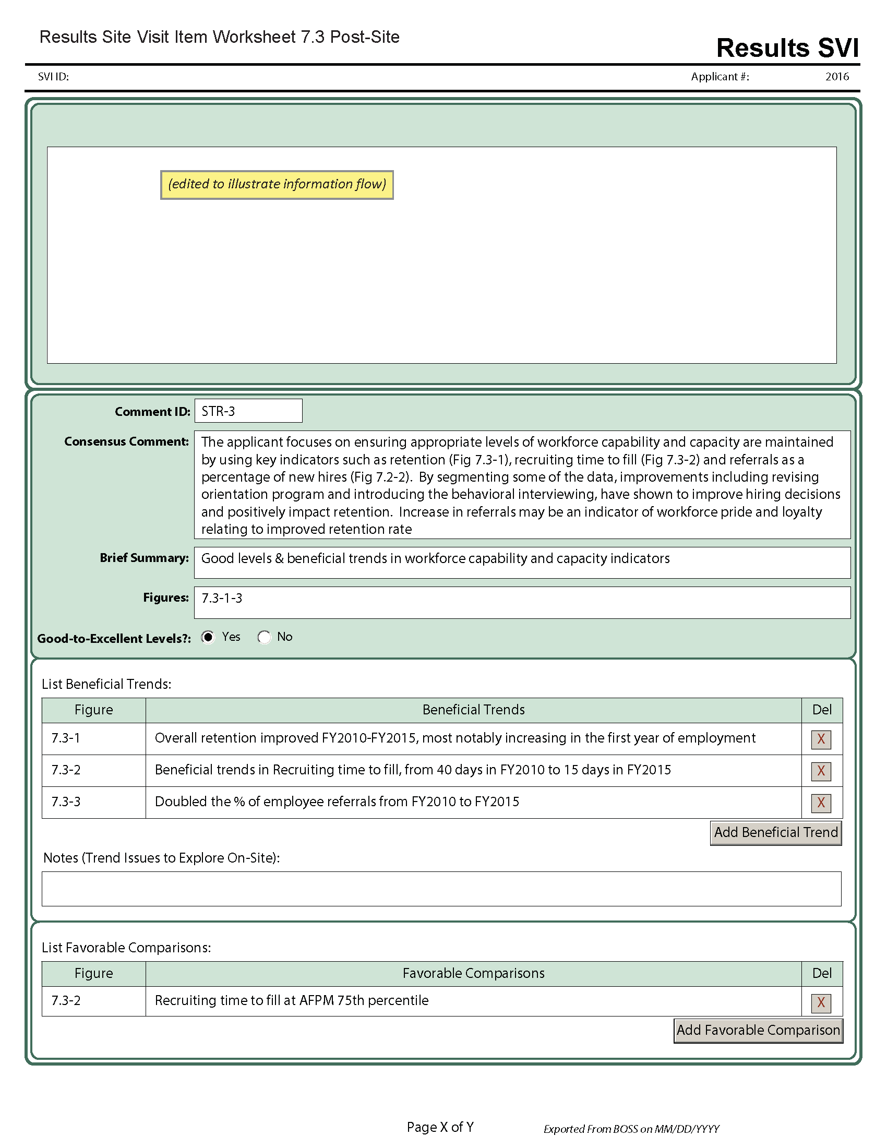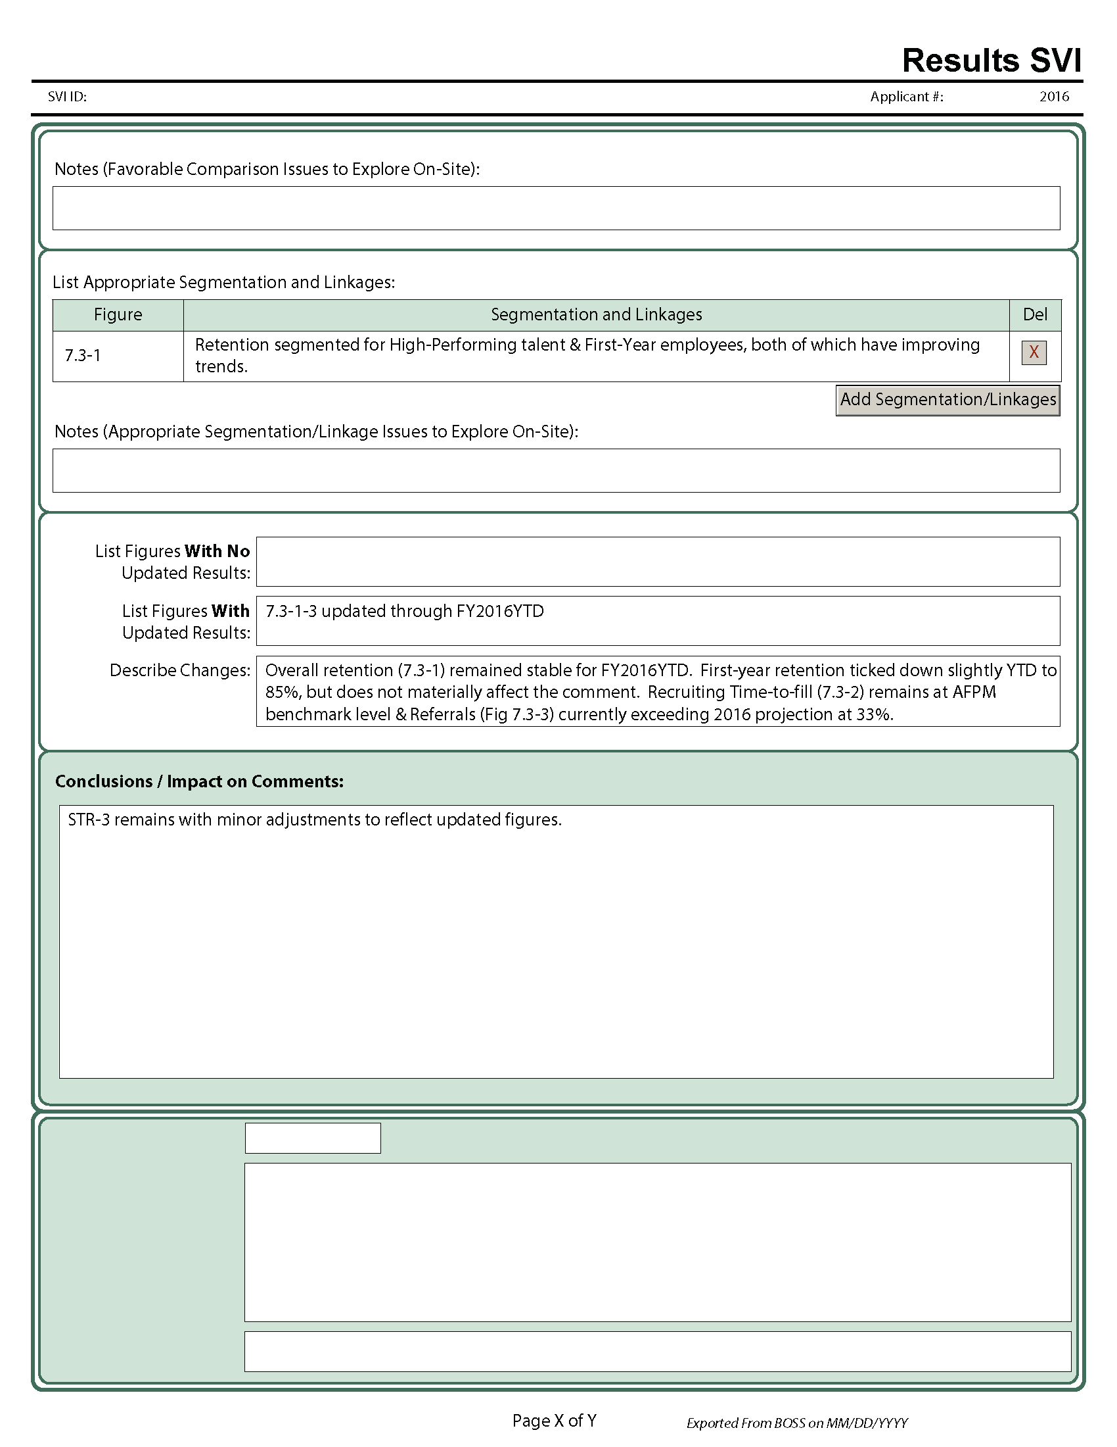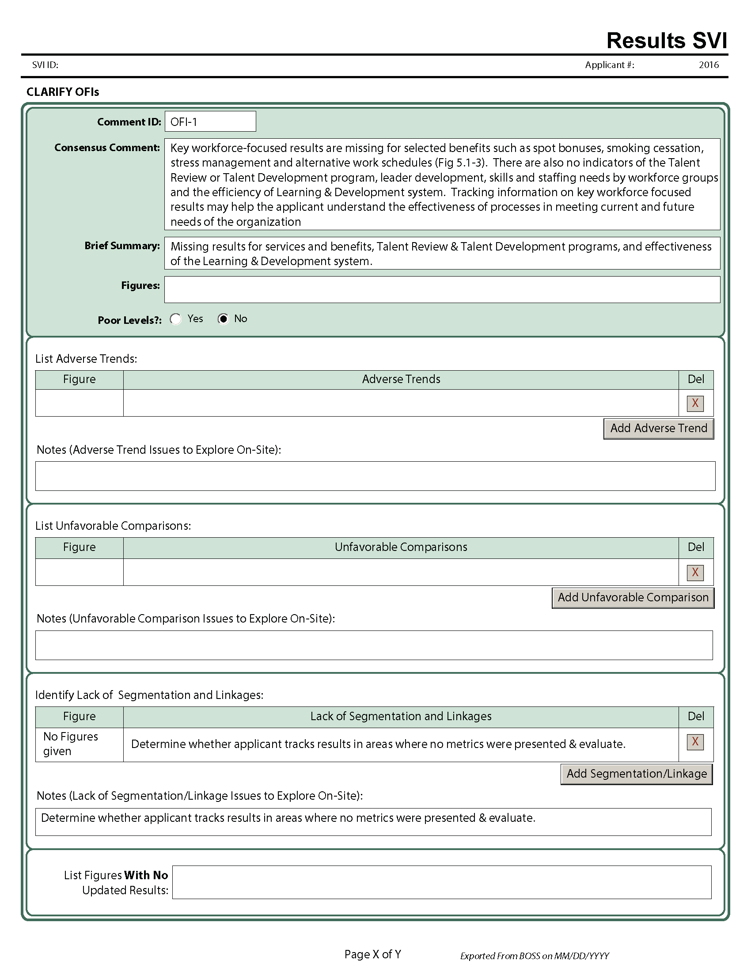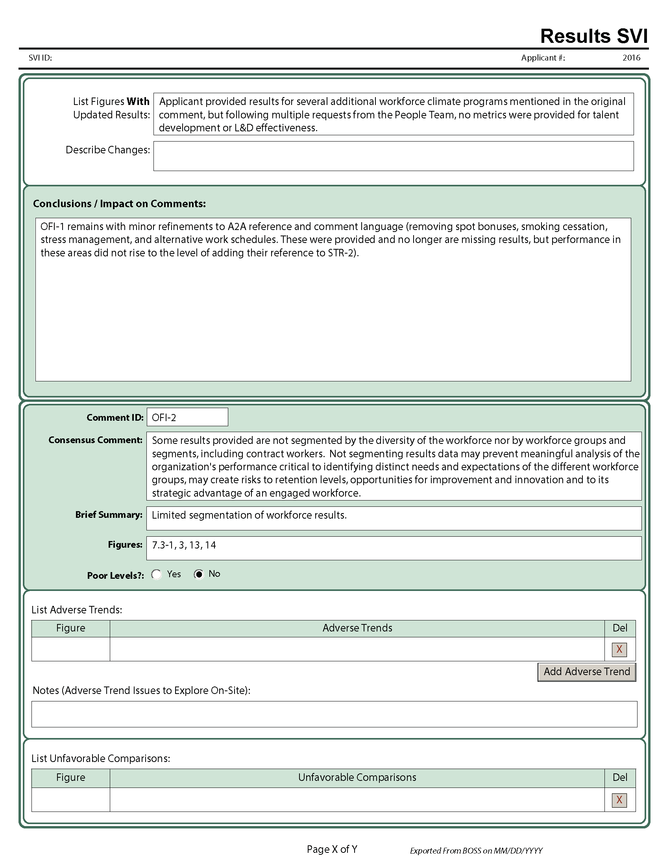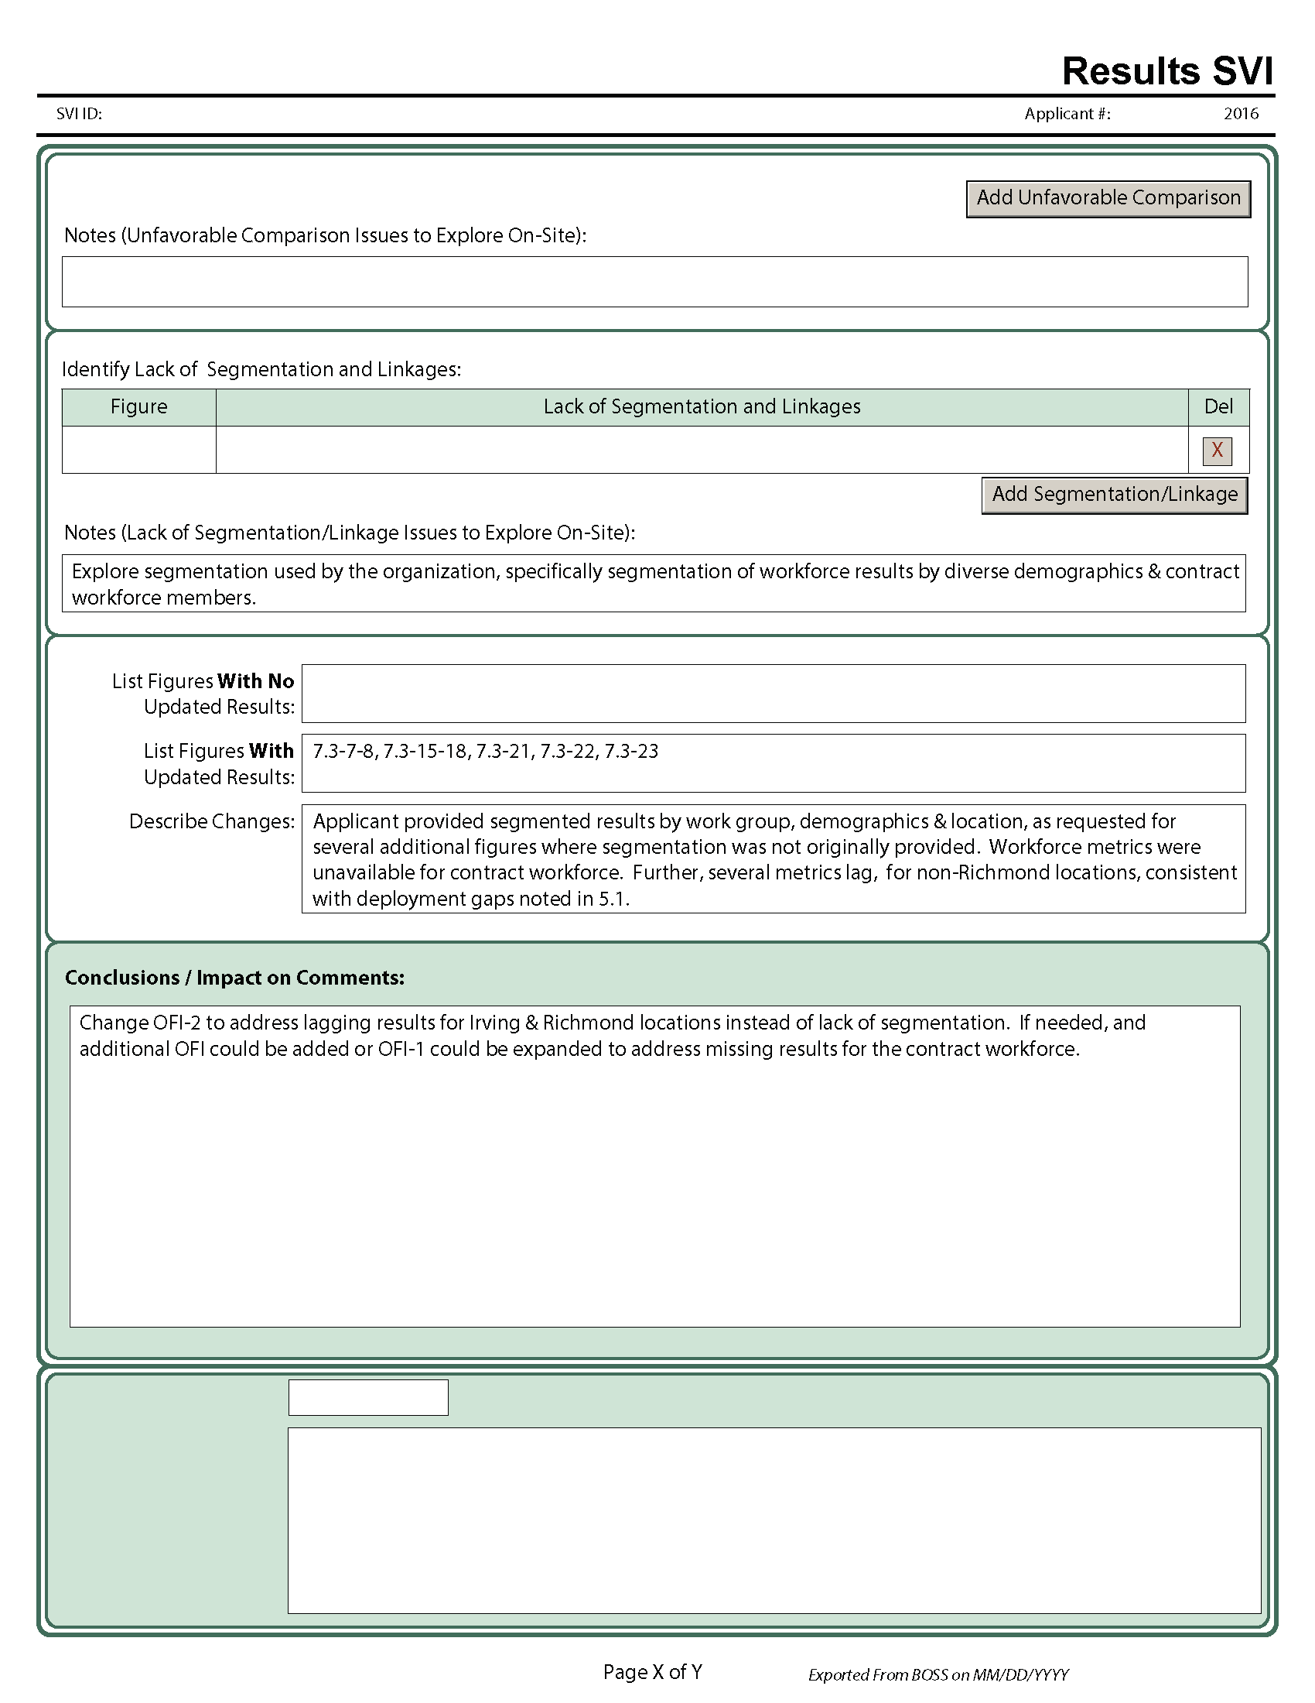

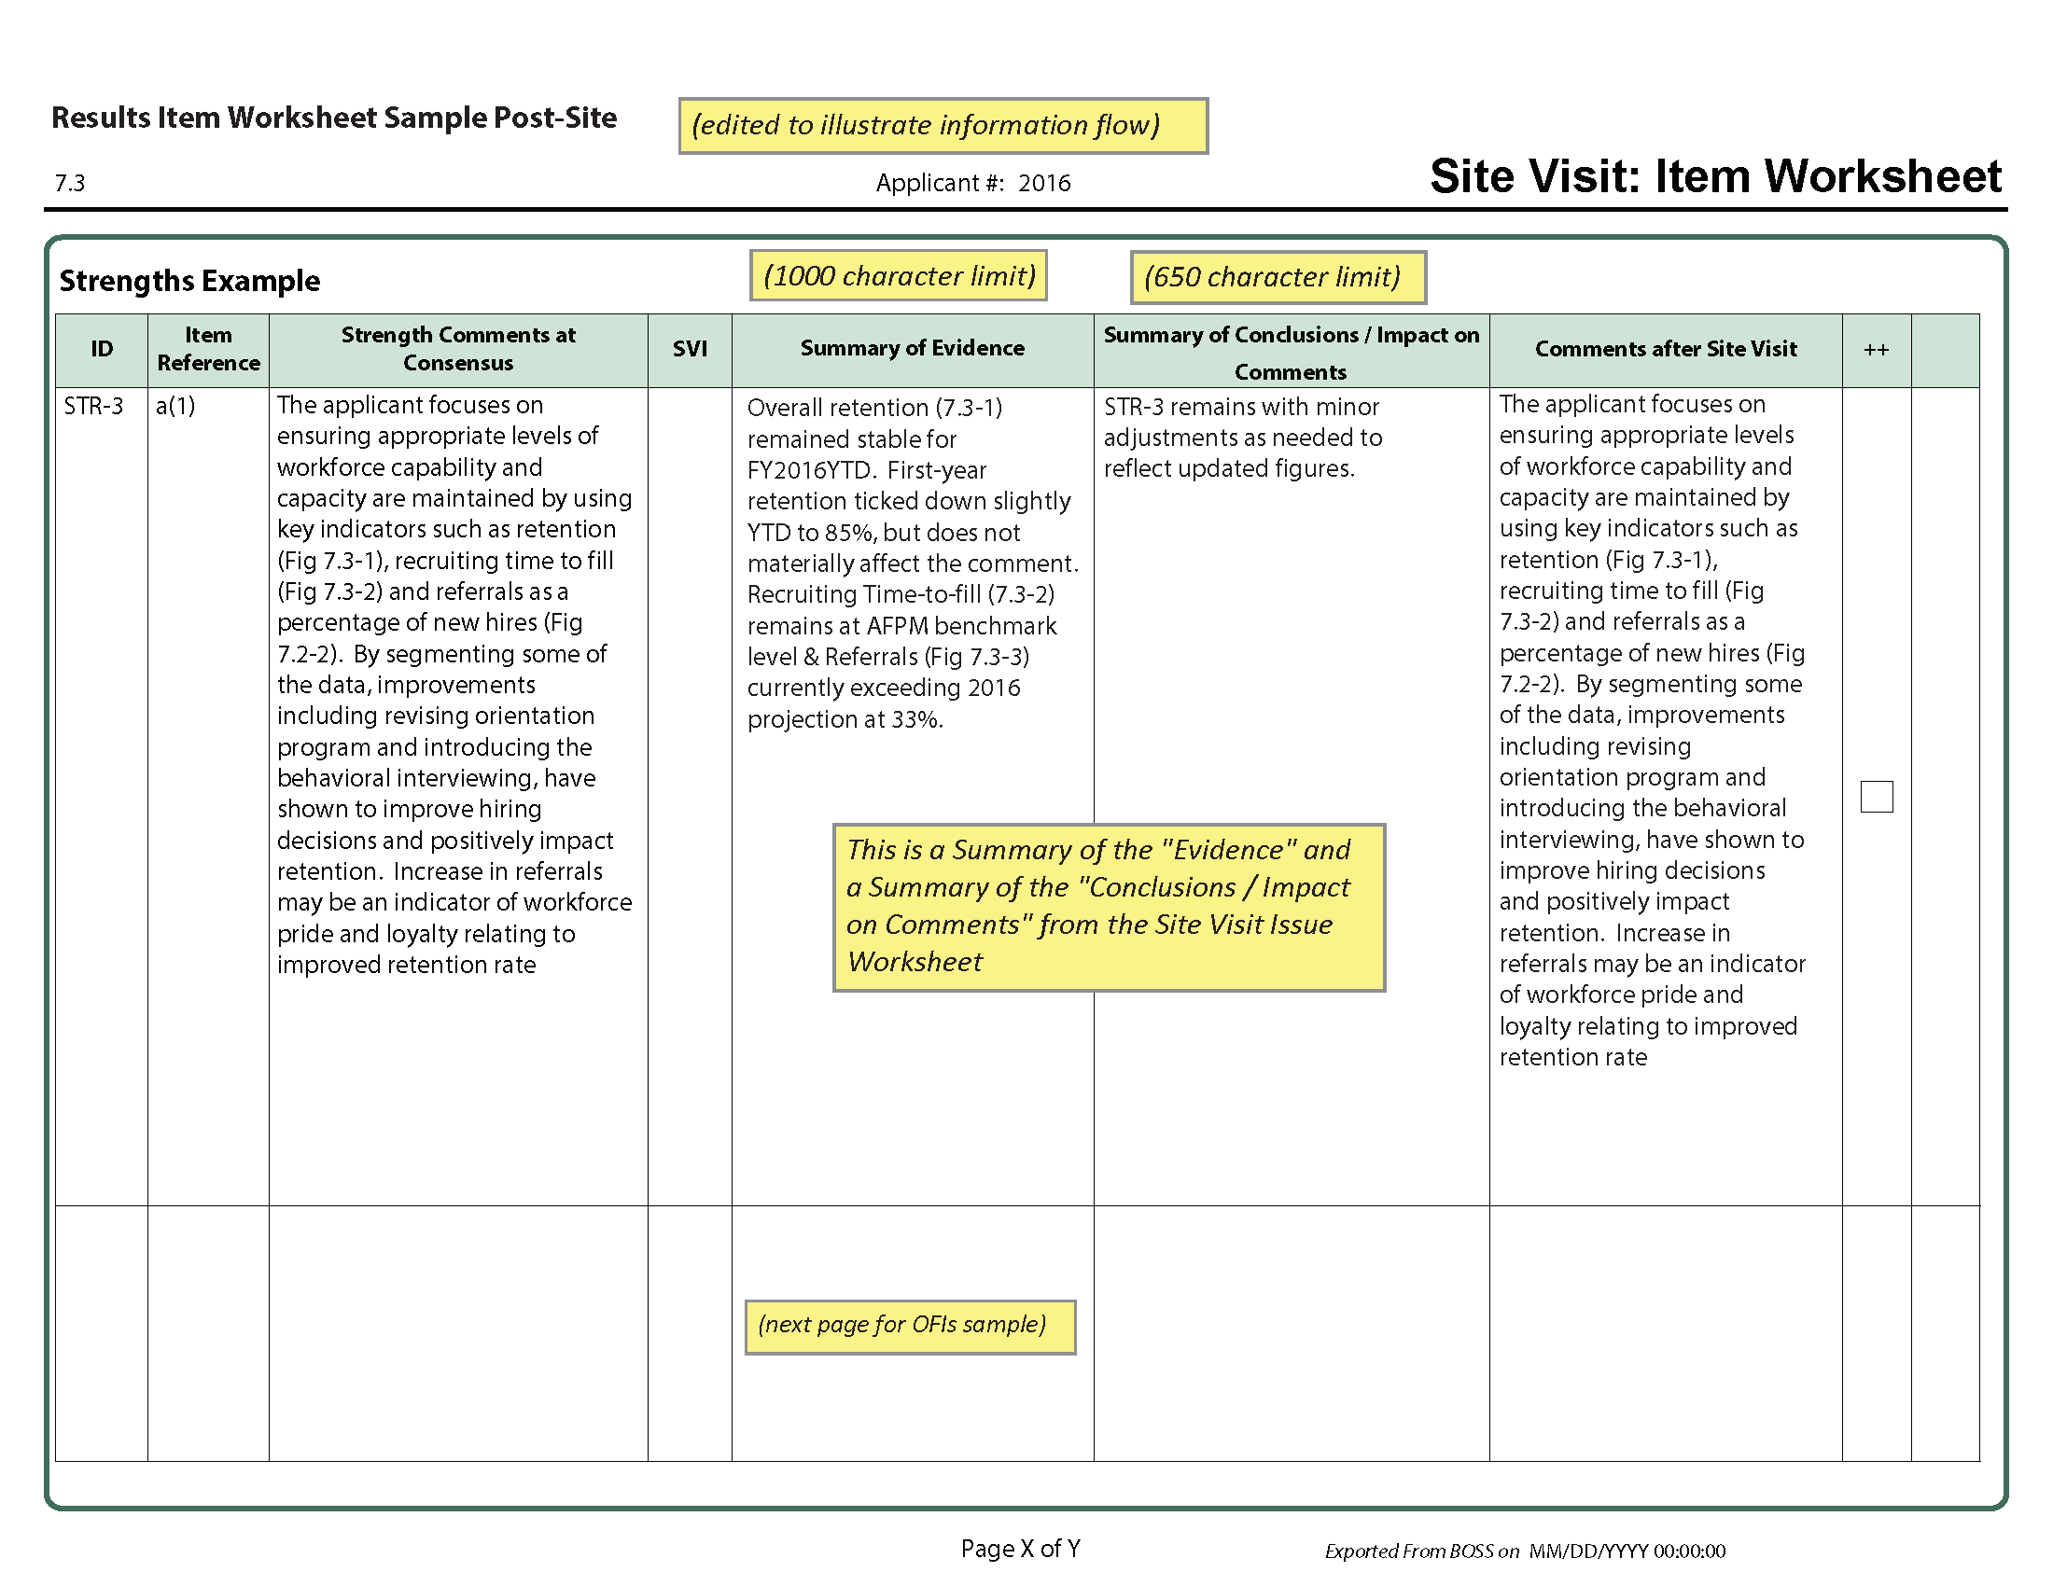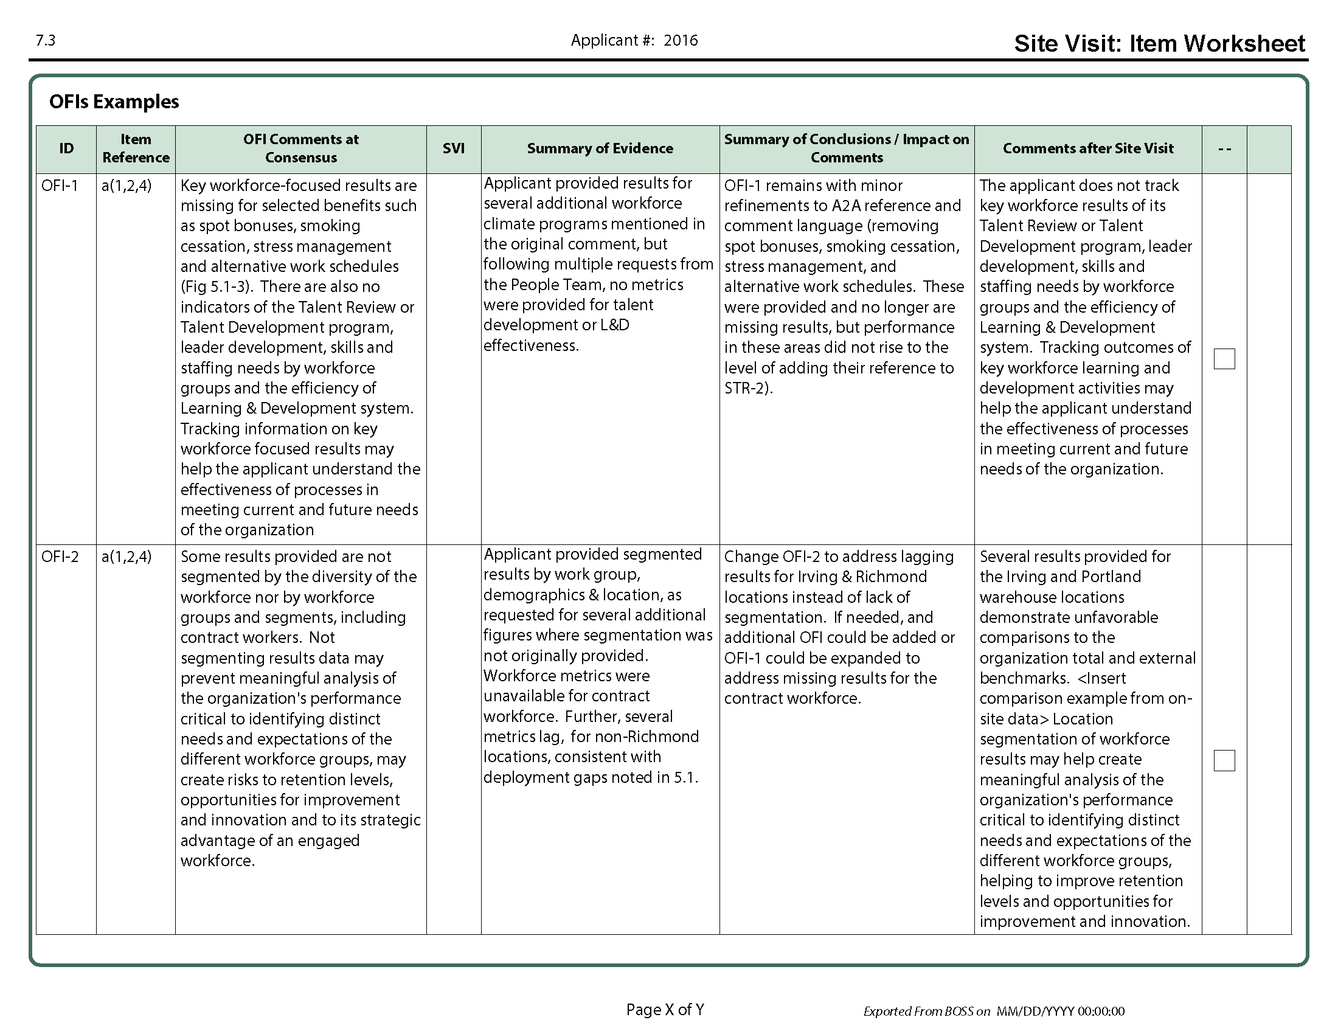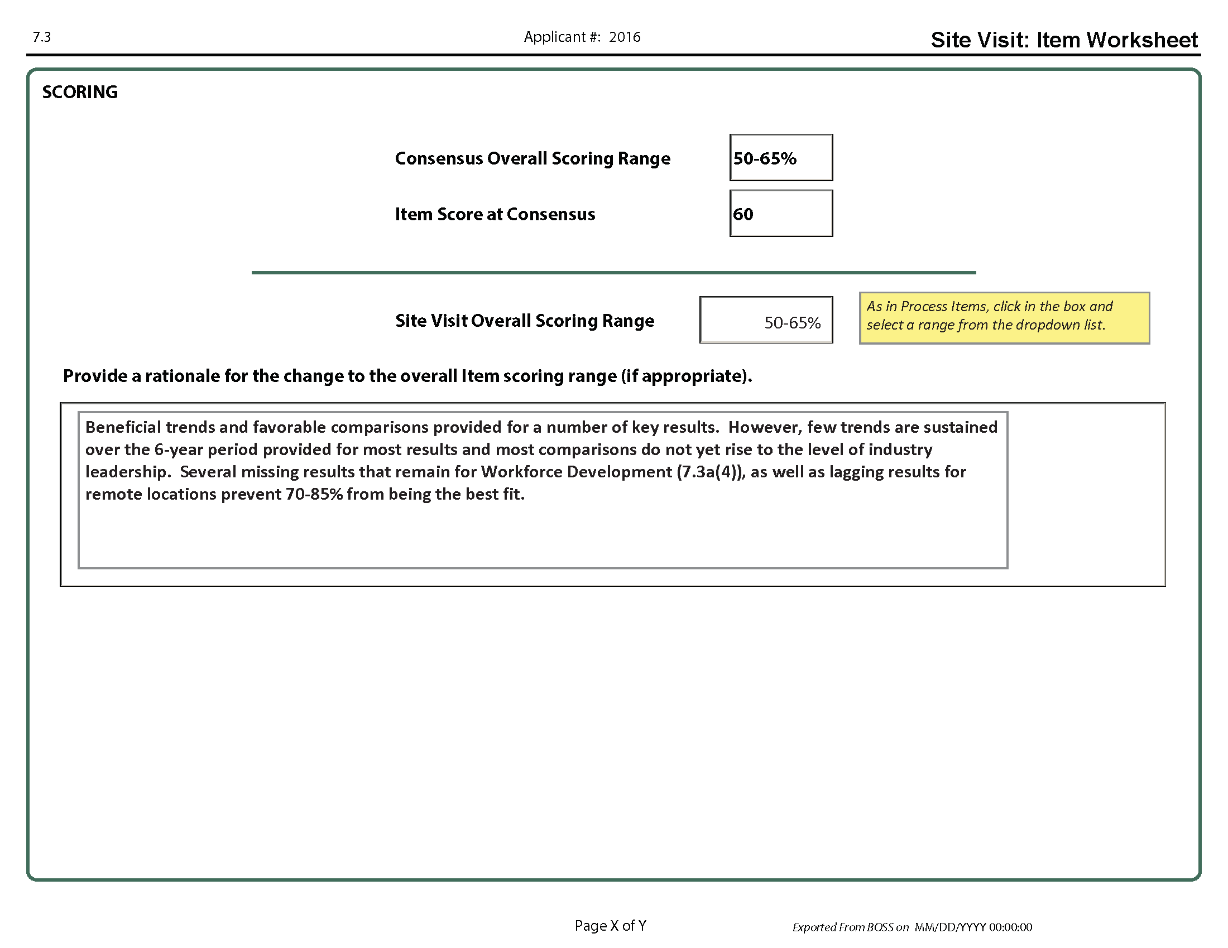

### Summary of Sites Visited

This worksheet conveys the extent and thoroughness of the site visit.

**Length of the site visit** (number of days with the applicant)

3 days

**Sites visited** (List the applicant’s major sites visited, and describe any important aspects of the sites that are not apparent from the Site Listing and Descriptors section in the Eligibility Certification Form.)

* Corporate Office—Baldrigeville, Maryland
* Regional Offices—Annapolis, Maryland; Richmond, Virginia; Asheville, North Carolina; Morgantown, West Virginia
* Manufacturing Plants/Transportation Hubs—Annapolis, Maryland; Richmond, Virginia; Asheville, North Carolina; Morgantown, West Virginia
  + The Morgantown plant currently is being upgraded to reduce emissions. The Morgantown plant also is the only facility that does not have a third shift.
  + The Annapolis plant was a recent acquisition (six months ago).

**Approaches used** to evaluate sites not visited, including sites outside the United States (if appropriate)

* Video conferences were used at manufacturing plants and retail units in Tampa and Orlando, Florida (these plants are managed by the Asheville, North Carolina, Regional Office and represent 8% of the applicant’s sales and retail operations, as well as 10% of the manufacturing operations).
* The Tampa and Orlando plants were called twice in order to cover two of the three shifts, and the applicant’s sales and retail operations were called during their daytime hours.

**Other information** on the team’s strategy for a thorough site visit (e.g., categories, types, and shifts of employees interviewed)

* All sites visited were selected by the Site Visit Team based on observing 90% of the applicant’s manufacturing operations, 100% of the corporate/management and support staff, 92% of the retail and sales operations, and 100% of its transportation hubs.
* Data-gathering methods consisted of document reviews and employee interviews that included meeting settings, lunchroom settings, and walk-around questions at all sites visited.
* The team interviewed all categories of employees: 23% of manufacturing (all three shifts), 22% of sales and retail, 32% of corporate/management and support, 23% of transportation hub (all three shifts), and 6% of distribution.
* The team interviewed 251 of the applicant’s 1,012 employees. (Note: A low percentage of the drivers were interviewed because of the nature of their jobs. Most of the drivers are dispersed throughout the East Coast. These unavailable employees were represented by available employees at their home sites.)

### Scorebook Preparation Checklist

* After you have updated all your assigned SVIs, export them with your Item Worksheets, to PDF documents via the Import / Export tab in BOSS.
* Assigned team member(s) revise the Key Factors Worksheet (scroll to the bottom of the worksheet), the Key Themes Worksheet, and the Summary of Sites Visited. Updating these worksheets continues throughout the visit.
* During the on-site phase of the site visit, team members close out assigned SVI Worksheets and revise Item Worksheets. Remember that updating worksheets continues throughout the visit. Occasionally, new SVIs arise because of additional information gathered during the site visit.
* Starting with the Sunday planning meeting and throughout the site visit, team members present an oral summary and status of their SVIs to the team. Later, they discuss how the Item Worksheets have changed from the Consensus Scorebook. The team discusses, agrees, and revises. After discussion and edits to the SVI Worksheets, each member agrees to the findings and the conclusions for each SVI. By posting each SVI Worksheet on walls around the team meeting room, each team member has the opportunity to comment on all SVI Worksheets. Commonly known as “walk the wall,” this process usually has several iterations.
* Team members modify and finalize their SVI Worksheets based on the team’s input.
* Team members post their draft Item Worksheets with updated comments, and they recommend a scoring range resulting from their respective SVI Worksheets. Using “walk the wall,” team members review all Item Worksheets and provide input on the comments directly on the worksheets. Again, this process usually has several iterations. The team will later agree on a scoring range for each item, again based on comments and impacts of the SVIs.
* Team members modify their Item Worksheets based on the team’s input.
* An assigned team member refines the Key Themes Worksheet on an ongoing basis.
* The team conducts a final discussion on the Key Themes Worksheet. The assigned team member makes final edits.
* An assigned team member transfers scores from each Item Worksheet to the Score Summary Worksheet. To finalize scoring, the team discusses the selected range determined during “walk the wall” for each item and whether the range is higher, the same, or lower than at Consensus Review. Also, the team discusses and comes to agreement on the overall process items and results items scoring bands. These determinations are based on results from the findings and their implications on the Item Worksheets. If the team is considering a change in a scoring band, it should discuss the key drivers behind this decision.
* Based on any final discussion of the Site Visit Scorebook, remaining corrections are made on the spot, and all sign the signature page of the scorebook.

During Site Visit Scorebook preparation, the BPEP monitor collects all documents that are to be returned to the applicant. Examiners (except the team leader and backup team leader) will not take any applicant materials, the application, or scorebook documents with them.

**GUIDANCE FOR TEAM LEADERS**

**Planning Phase Overview**

The planning phase of the site visit begins after BPEP notifies the team leader that the applicant will be receiving a site visit. This section addresses planning essentials.

**Contact the Applicant**

The team leader contacts the applicant’s OCP within 72 hours after the August Judges’ Meeting.

Only the team leader, backup team leader (as appropriate), and BPEP monitor may talk to the OCP. The applicant may identify an alternate OCP who also may communicate with the team leader. The team’s communication with the applicant in the planning phase is limited to the OCP and any designated alternate(s).

During the initial call, the team leader provides the following:

* congratulations on the selection
* his or her name and employer
* his or her telephone number(s), reminding the OCP not to leave any messages that could reveal “the who” and “the where” of the visit
* the name and telephone number(s) of the backup team leader and an explanation of his or her role
* dates of the site visit: (see the Timeline for specific dates)
* Week 1 for health care, manufacturing, and service organizations
* Week 2 for education, small business, and nonprofit organizations

The team leader discusses/reviews the purpose and outcomes of the site visit OCP (see Agenda for TL-OCP Calls in the Appendix).

**Establish Ongoing Communication with the Applicant**

During the weekly calls with the OCP, obtain further information for planning the site visit. These calls also help the OCP understand the Site Visit Review and provide the opportunity for the OCP to ask questions. (See Agenda for TL-OCP Calls in the Planning Phase of the Appendix)

**Early in the Planning Process**

Review the opening and closing meeting processes, including expectations of both the applicant and the Site Visit Team. (BPEP will provide you with PowerPoint presentations for both the opening and the closing meetings with the applicant.) (See *Opening Meeting* and *Closing Meeting* in the On-Site Phase section.)

* Remind the OCP of the site visit boundaries:
* In most cases, the Site Visit Team cannot meet with any suppliers or customers/students/  
  patients. Examiners should check with the BPEP monitor for guidance.
* Examiners must not accept gifts.
* No data or documents will be asked for or accepted by the Site Visit Team after the closing meeting.
* No feedback of any type (verbal or nonverbal) is provided by the Site Visit Team during the site visit.
* Request information on lunch while the team is on-site (to be arranged and provided by the applicant in the employee cafeteria, if available). If some team members are working in evenings, dinner will need to be arranged as well.
* Ask about appropriate clothing for the team to wear while visiting the applicant site(s).
* Confirm the availability of key people, and ask for a list of the applicant’s points of contact for each of the seven Criteria categories.
* Discuss the on-site portion of the site visit schedule, which begins with the opening meeting and ends with the closing meeting. To assist the applicant in arranging for the availability of key people for interviews, discuss and send your preferred interview schedule for day one of the on-site phase at least ten days before the start of the site visit.
* Prepare a list of documents the team will need to have immediately available in the hotel conference room for the Sunday planning meeting, and give the list to the OCP at least ten days before the start of the site visit. Clarify that the team will request additional documents during the site visit.
* *The OCP has been notified to have all documents referenced in the application available for the team to review. The OCP also has been notified to provide the Site Visit Team with updated results at least three weeks before the site visit.*
* Discuss other team needs (see Agenda for TL-OCP Calls in Appendix)
* Clarify that no word-processing assistance for the Site Visit Team is allowed.

**Develop the Initial High-Level Plan**

Determine the following to finalize the plan for sites to be visited and to begin work on the day one schedule (see sample schedules in the On-Site Phase section and in the Appendix)

Provide the team’s inter-site travel plans to the OCP and the BPEP monitor as soon as possible but no later than two weeks before the start of the visit.

The applicant is responsible for providing transportation to and from its locations, and the OCP will appreciate as much lead time as possible for arranging this travel.

The day one schedule is to be delivered to the OCP ten days in advance of the site visit.

**Communicate with BPEP**

A member of the BPEP staff is assigned as a site visit monitor (i.e., BPEP monitor). The team leader includes the BPEP monitor in planning efforts and maintains regular contact. The BPEP monitor is included in all team calls and is a recipient of all team communications. The BPEP monitor may, but is not required to, participate in the weekly telephone calls between the team leader and the OCP. The BPEP monitor also establishes a separate, regular schedule for calls with the OCP (the team leader does not participate in these calls).

**Participate in Team Leader conference call**

BPEP will conduct a conference call for Site Visit team leaders and an alternate date for those that cannot participate in the first call. Please check the Timeline at the front of this manual for specific days and times. Each team leader must participate in one of these events. The call is optional for backup team leaders.

**Communicate with Team Members**

During the planning phase, the Site Visit Team conducts weekly conference calls. These calls keep the team informed, review just-in-time materials, and cover all aspects of the planning activities to ensure that team members are completing all necessary tasks (e.g., determining strategies to close out SVIs, developing SVI Worksheets, and discussing travel arrangements). The team’s advance planning applicant’s location is essential for ensuring an effective site visit.

**Request Information and Materials**

The team leader may request information and materials from the applicant at only three times:

* *During site visit planning*, the team leader requests and secures from the OCP materials needed to plan the strategy for the site visit (See Appendix)
* *Ten days in advance of the site visit*, the team leader submits to the OCP a list of documents to be available in the hotel conference room for the Sunday planning meeting. The BPEP monitor coordinates with the OCP to ensure the materials are available. This list should contain a maximum of 15 documents for categories 1 – 6, and only missing results for category 7.
* *Immediately upon completion of the opening meeting and during the on-site* *phase of the site* *visit*, the team leader and team members may request additional documents.

After the closing meeting, no furthermaterials or information may be requested from the applicant.

**Ensure That You Have Communicated Appropriately**

* If there will be inter-site travel, provide where, when, and who will travel two weeks before the site visit. (The applicant makes these arrangements.)

**Inform the applicant that, during the site visit, examiners will**

* verify and clarify elements of the written application.
* review updates to the charts and graphs and, in many cases, review the source documents for the data in the charts and graphs.
* address specific site visit issues.

**Do not tell the applicant**

* specific information about team members, such as professional experience or backgrounds. (The applicant receives a team listing that will include the examiners’ names and their employers only.)
* specific site visit issues and themes.

**Ask the applicant to provide**

* time for interviews with people from remote or foreign sites (The team leader indicates the person by name, title, or function. Interviews may be done in person, by telephone or video conferencing, or through other media.)
* deployment and results information from representative sites not visited (including remote offshore and foreign sites)

**Direct, Support, and Mentor the Team**

The team leader’s role includes the following tasks:

* Tell team members when and where they should arrive and depart from the hotel. Individual travel plans must not adversely affect the team or the evaluation of the applicant.
* Ask the backup team leader to help plan and carry out tasks.
* Develop team assignments and instructions for the site visit. Discuss the plan with team members and the BPEP monitor.
* Assign team members in pairs; match examiners who have sector experience with those who do not. In addition, consider Baldrige experience as well as site visit experience.
* Send a copy of all team correspondence to the BPEP monitor, and ask the team members to do the same. Include the BPEP monitor in all conference calls.
* Set expectations, and develop a work schedule with all team members.
* Remind the team that all materials are confidential.
* Stress that all assigned planning tasks need to be completed before the beginning of the site visit.
* Ensure that all are ready, have completed their assignments, and have exchanged appropriate materials with each other before arriving at the applicant’s site.

**Develop a Detailed Draft Schedule *(see sample On-Site Team Schedule in the Planning Phase section)***

Follow these steps to draft the on-site schedule:

* Determine the numbers and types of employees to interview to ensure that the team can adequately assess the organization’s maturity, deployment, and consistency.
* Select sufficient and appropriate sites to visit, based on examiners’ requests documented in their (i.e., related to their most important site visit issues), balanced by the applicant’s need to experience a thorough evaluation.
* Determine sites to visit in person and sites that can be “visited” via telephone or video conferencing to effectively obtain the needed information and reduce inter-site travel.
* Calculate costs in time versus the benefit(s) and importance of traveling to another site.
* Identify those sites where the team can best verify and clarify important issues. Work with the team to get ideas and buy-in.
* Identify which team members to send to which site, on what days, and when to hold conference calls. Notify your BPEP monitor to arrange for speaker phones at the applicant’s locations and to confirm the availability of existing conference call accounts for these calls.
* Decide the number of days and the dates to be spent with the applicant on-site. Coordinate with BPEP.
* Provide the BPEP monitor and the OCP with the schedule of the sites to be visited, the dates of the visits, and who will be traveling where.
* In addition to the day one agenda that you will provide to the OCP ten days in advance, develop a projected agenda for the remainder of the on-site portion of the visit. Although it must remain flexible, an initial plan will save time as the site visit evolves.

**Conduct the Sunday Planning Meeting** *(See the sample Sunday Planning Meeting Agenda in the On-Site Phase section of the Appendix)*

|  |  |  |  |  |  |  |  |  |  |  |  |  |  |  |  |  |  |  |  |
| --- | --- | --- | --- | --- | --- | --- | --- | --- | --- | --- | --- | --- | --- | --- | --- | --- | --- | --- | --- |
| | ***Applicant Size*** | ***Complexity*** | | | | --- | --- | --- | --- | | ***Low*** | ***Medium*** | ***High*** | | ***Small*** | *7*  *team members*  *\*2 days* | *7–8*  *team members*  *\*2–2.5 days* | *7–8*  *team members*  *\*2.5–3 days* | | ***Medium*** | *7–8*  *team members*  *\*2.5 days* | *8*  *team members*  *\*3 days* | *8*  *team members*  *\*3–3.5 days* | | ***Large*** | *8*  *team members*  *\*3 days* | *8*  *team members*  *\*3.5–4 days* | *8*  *team members*  *\*4 days* |   *\*Average time spent with the applicant (i.e., the on-site portion of the site visit), not including time for planning or scorebook writing.* |

### Planning Guidelines on Team Size and Length of the On-Site Phase

### On-Site Phase Overview

The on-site phase of the Site Visit Review begins with the opening meeting and ends with the closing meeting, which both take place at the applicant’s site. The entire site visit process is complete when the Site Visit Scorebook is finished and signed by each team member (completion of the scorebook usually takes two-to-three days after the closing meeting with the applicant).

**Opening Meeting**

The opening meeting is held for employees/faculty/staff of the applicant and the Site Visit Team. The applicant will discuss any deviation(s) from this guideline with the team leader and the BPEP monitor.

If examiners are asked to introduce themselves, they provide only their name and current employer. Examiners are NOT to provide additional background information, such as their Malcolm Baldrige National Quality Award experience, credentials, title, work experience, or specialty in their organization.

The key components of the opening meeting are:

* a presentation by the applicant (up to one hour) which includes their business model presentation
* introductions of the Site Visit Team members and, using visuals provided by BPEP, a presentation by the Site Visit team leader (five minutes) about the Baldrige Award and the Site Visit Review

The order of the presentations is optional.

**Photographs and/or Videotape Parameters**

The applicant may take pictures before the opening meeting. The opening meeting may also be videotaped. The applicant is asked not to photograph or videotape the examiner team. Pictures and videotapes are restricted to internal use only by the applicant.

**Consideration of Prior Baldrige Feedback**

Two methods are allowed for the applicant to share previous feedback findings: (1) the Highest-Ranking Official (HRO) may present strengths and/or opportunities from previous reports in his/her opening meeting remarks, and (2) the applicant may voluntarily share its most recent feedback report with the team, provided the report was received within the past two years. However, the team does not request the report.

If a Site Visit Team receives a previous feedback report, the team is not obligated to review the report; the team should use its discretion in deciding whether to conduct a review and, if so, to what extent. If the team chooses to use the report, it must consider the report along with all other data collected on the site visit.

**Emphasis on Changes to Key Factors**

While on-site, many teams identify new or expanded understandings of the applicant’s organization and environment. These changes are considered in the investigation of site visit issues (SVIs). These new key factors are recorded at the bottom of the Key Factors Worksheet, and the team considers their impact, if any, on the organization. The team considers carefully the question on the worksheet, “Thinking about the questions in the Organizational Profile, did the team have any new insights about the applicant as a result of the site visit?” The team leader will expand on these insights during the judges’ call.

**Additional Meetings with the Applicant**

After the opening meeting, the team meets with the applicant’s category counterparts. In addition, the examiners conduct interviews in pairs, and they review documents and associated results. In most cases, examiners are not permitted to interview customers, suppliers, patients, students, parents, or nonemployees (except for volunteers who are supervised by the applicant). Site Visit Teams check with their BPEP monitor for guidance. The HRO interview is limited to the HRO, team leader, and BPEP monitor. Each day the team leader checks in with the official contact point (OCP) to finalize the schedule for the next day and to discuss any emerging issues.

**Applicant Materials**

Examiners need to track all materials they receive from the applicant. *The team needs to* *keep in mind the site visit’s time constraints and request only necessary information.* The applicant is asked to attach a business card or to write the originator’s name on each separate document. The Site Visit Team develops a tracking system using the Document Log at the hotel and the Information Request on-site (see Additional Tools) to ensure that all materials are accounted for and returned to the applicant. The BPEP monitor will coordinate with the OCP the return of all the materials taken to the hotel.

**Team Meetings**

*Daytime.* These meetings are scheduled each day at the applicant’s site, preferably midmorning and midafternoon, to exchange information and adjust the schedule. When examiners are at multiple locations, the team leader works with the BPEP monitor to schedule conference calls so that all examiners can participate in these meetings.

*Evening*. Team members debrief on their assigned items and the related SVIs during the nightly team meeting. These meetings include discussion on key themes, concerns, needed adjustments to strategies and interviews, and any newly identified SVIs.

The team leader also uses the evening meetings to monitor team members’ progress on closing out their SVIs and on their assignments. If any examiners are not making sufficient progress, it may be necessary for the team leader to determine who will provide assistance to them. Make sure that the “core questions” on the SVI Worksheets are not forgotten as examiners prepare their worksheets.

*During the on-site and post-site phases, team members keep all notes of their interviews and meetings*. This helps the examiners to properly document findings and conclusions on SVI Worksheets. These notes are given to the BPEP monitor for shredding at the close of the site visit.

**Last Chance**

*Before the closing meeting at the applicant’s site, the Site Visit Team must identify any important, remaining site visit issues and discuss what information is needed to close them.* It may be necessary to reassign team members to address critical issues. This is normally done on the evening before the day of the closing meeting. Throughout the site visit, the team follows the site visit plan but is flexible, expects surprises, and adjusts as necessary.

The team needs to be sensitive to the applicant. If the applicant says the team is missing the point, the team must make time to listen. If a team member behaves inappropriately, the team leader must immediately confer with the BPEP monitor and take the necessary action.

**Closing Meeting**

The closing meeting signifies the end of the on-site phase of the site visit. New this year, the closing meeting occurs the day after the team has departed the site for the final time. This is to provide the team with time to do a final check to ensure they have enough information to close all SVIs.

The closing meeting should last 10 – 30 minutes. The team leader and the BPEP monitor will attend this meeting. The rest of the team stays at the hotel to complete their work. To the extent possible, the applicant should limit its attendees to the HRO, the OCP, and designated members of the Sr. Leadership team if requested. At the end of the meeting, the team leader presents a five-minute closing, using visuals provided by BPEP. The meeting is intended to simply present the next steps (using the slides / handouts provided by BPEP) and thank the applicant for its hospitality and support of the Program.

If the applicant requests a send-off or some kind of celebration for the team, that can be arranged when the whole team departs the site for the last time.

After the closing meeting, the team may not accept any data or documents, and it has no further contact with the applicant.

**Post-Site Phase Overview**

The post-site visit phase consists of two major components. The first is the completion of the Site Visit Scorebook by the Site Visit Team. The second involves the team leader’s conference call with the Judges Panel during the Judges’ Meeting early November and the technical edit conference call with the lead judge and the BPEP monitor at the conclusion of the Judges’ Meeting.

**Deliverable: the Site Visit Scorebook** (see the Appendix Sample Correspondence and Tools, Planning Phase, Scorebook Preparation)

* The scorebook shows the progression of comments from Consensus Review to Site Visit Review in order to provide the judges with an audit trail of the team’s findings and conclusions. The judges use what they learn from this scorebook, in combination with the call to the team leader, to determine which applicants they will recommend as award recipients.
* Completing the Site Visit Scorebook is the culmination of the Site Visit Review. Team members should keep in mind that *completing the scorebook requires a significant amount of time and energy*. To make the process most efficient and effective, *team members must update their SVI Worksheets throughout the week*. This helps the team track their progress and ensures that all needed information is obtained before the closing meeting at the applicant’s site. Typically, it takes 28–35 work hours to finish the scorebook after the on-site phase is completed.

**Work Process Essentials**

All team members complete the following tasks:

* Share key data or observations relevant to SVIs or key factors *daily* with the team member responsible for writing the appropriate SVI and Item Worksheets.
* Update SVI Worksheets *dail*y.
* As necessary because of data sharing, update strategies.
* Post all draft SVI Worksheets.
* Review all other SVI Worksheets, and provide input on the information or conclusions they contain. (One suggested review method is to post the worksheets on the walls around the team meeting room so that team members may manage their own time in reviewing the documents. This is known as “walk the wall.”)
* Finalize SVI Worksheets based on the team’s input.
* Summarize findings and conclusions, and transfer them to Item Worksheets.
* Revise comments, as appropriate.
* Confirm or adjust scores to align with the findings and conclusions.
* Post the completed Item Worksheets for others to review.
* Review all other Item Worksheets, and provide input on the summaries and comments.
* Finalize Item Worksheets for each assigned item based on the team’s input, and indicate their concurrence with each final Item Worksheet.

The team leader helps the team maintain focus on key processes and results and, most important, the refinement of key themes.

**Site Visit Scoring**

As a final step in the evaluation process, the team works as a group to confirm the scoring range for each item and to determine the overall bands for process items and for results items.

* As a first step, the team leader or designated member completes the Score Summary Worksheet by transferring the item scoring ranges from the Item Worksheets.
* During “walk the wall,” item leads propose and receive feedback on recommended scoring ranges.
* Finally, the team leader conducts a scoring discussion to confirm the ranges or to come to consensus if needed. A designated team member indicates on the Score Summary Worksheet whether the scoring range changed due to site visit findings. It is important for the team to ensure that the scores on the Item Worksheets and the Score Summary Worksheet match.
* The team then refers to the Scoring Band Descriptors and determines which band descriptor for process items and which for results items most accurately reflects the team’s view of the applicant. *If the team is considering a scoring band change, the discussion must include reasons for that change (the team leader records the reasons to share during the first call at the November Judges’ Meeting).* These scoring band numbers are included on the Score Summary Worksheet.The Scoring Band Descriptors are used in the opening paragraph of the applicant’s feedback report.

**Completing the Scorebook (before leaving the site visit)**

* The scorebook editor or team leader revises the final Key Themes Worksheet with updated comments resulting from the findings and the conclusions noted on the SVI and Item Worksheets. Team members provide input on the comments on the Key Themes Worksheet through ongoing discussion and “walk the wall.” To finalize key themes, just as for scoring, the team leader facilitates a team discussion.
* The assigned team member drafts the Summary of Sites Visited, shares it with team members, and uploads it to Team Files.
* Team members copy the PDF files of their completed Item Worksheets and SVI Worksheets to one flash drive or laptop.
* The team leader imports the Item Worksheets and SVI Worksheets into BOSS. Copies of the scorebook are made for the backup team leader and the monitor.
* *Important:* The team prints the scorebook and checks it against the worksheet files on BOSS.
* All team members sign the signature page of the paper version.
* Team members (except the team lead*er and bac*kup team leader) leave all materials, including the application, with the BPEP monitor.

**Conducting Final Checks (may be performed on-site or after returning home)**

* Clarify and standardize the language of the item comments and the key themes (e.g., names of the applicant and processes).
* Eliminate any conflicts between strengths and OFIs both within and between items and key themes.
* Ensure that all comments conform to the Comment Guidelines (e.g., avoid jargon, prescriptive sentences, and negative tone; include specific examples and figure references; focus on the Criteria requirements).
* Verify that all statements such as “it is not clear,” “it does not appear that,” and “it is not evident” are changed to reflect the site visit findings.

**Making Copies**

* The team leader and backup team leader leave the site visit with an electronic copy of the scorebook. Paper copies are optional.
* The BPEP monitor returns to BPEP with an electronic copy of the scorebook and the team’s signature page. BPEP recommends that the monitor also bring back a printed copy of the scorebook, if the scorebook has not been posted to BOSS.

**Checking and Refining Comments in the Site Visit Scorebook**

* The team leader may make additional edits after the site visit, posting the scorebook on BOSS by midnight Pacific Time on the Monday following the site visit.
* After the site visit has been completed and the examiners have returned home, the team leader prepares for the November conference call with the Judges Panel and the technical edit call with the lead judge and the BPEP monitor. The team leader reviews the report for significant corrections and clarifications. This may take place after the deadline for posting to BOSS and, if revisions are needed, they are discussed on the call with the Judges Panel.
* After the technical edit call with the lead judge and BPEP monitor, the team leader may be asked to make additional edits.

**Participating in the Call with the Judges Panel**

***Scheduling and logistics***

* Team leaders are required to participate in two conference calls with the judges during the November Judges’ Meeting.
* BPEP will request information on how to contact team leaders during the five days of the Judges’ Meeting. Because of team leaders’ schedules, BPEP might need to contact them by cell phone. During the meeting, the judges may reconsider an applicant at any time during their five-day meeting,
* If the team leader is not available for the conference call with the judges, the backup team leader needs to participate on the call. *Also, the team leader knows how to reach each team member during this time in case he/she needs to contact any of them to clarify the judges’ questions.*
* BPEP will notify the team leader 15–60 minutes before the Judges Panel is ready to discuss the applicant. This will enable the team leader to go to a secure office and secure phone, if necessary.

***Preparation***

To prepare for the call with the Judges Panel, the team leader reviews the Site Visit Scorebook and makes notes of any special issues that the team found on the site visit or any that may not be adequately conveyed in the scorebook.

*Team leaders must avoid advocating for or against the applicant organization—rather, it is their job to provide the team’s facts, findings, and conclusions.*

During call one, the team leader presents changes in key factors; an overview of the key themes—particularly potential role-model practices and key vulnerabilities; changes to the scoring ranges; and any major discrepancies discovered in the scorebook after it was posted for the judges’ review. After this call, the judges deliberate on this information and develop follow-up questions. During call two, the judges ask any questions that emerged during their deliberations.

***Call one***

* The team leader focuses on responding to the question at the bottom of the Key Factors Worksheet that asks, “Thinking about the questions in the Organizational Profile, did the team have any new insights about the applicant as a result of the site visit?” The team leader describes to the judges any new or expanded understandings of the applicant’s organization and environment.
* After sharing these insights, the team leader provides a presentation on the key themes that aims to convey key strengths and vulnerabilities without simply reading the text. This presentation helps the judges to better understand any possible role-model practices or key areas of vulnerability for the applicant in both process and results areas.
* If the Site Visit Team recommended a scoring band change, the team leader explains the key drivers for that change.
* Finally, if the team leader discovers any major discrepancies, such as conflicts or missing information, he or she shares this information with the judges.

***Call two***

The team leader answers any questions that the judges formulated during their discussion following call one.

**Participating in the Editing Call with the Lead Judge**

After the judges have concluded their review of an applicant, the lead judge and the BPEP monitor call the team leader and discuss any recommended changes to the Site Visit Scorebook.During this call, the judge provides input on changes to the comments, including insights gained during the judges’ discussions. The team leader incorporates these changes into the final Site Visit Scorebook.

**Receiving and Providing Feedback on the Process**

At the conclusion of the final Site Visit Scorebook discussion, the lead judge provides feedback to the team leader concerning the calls with the judges and the Site Visit Scorebook. Specific feedback and related comments may include the following:

* Did the team leader conduct an effective presentation of insights related to the Organizational Profile, key themes, and scoring changes?
* In responding to questions from the Pane of Judges, did the team leader provide unbiased insight that enabled the judges to reach closure on the issues? This question includes the following elements:
  + All responses were based on facts established throughout the evaluation cycle.
  + Responses were clear and concise.
  + Responses focused on specific questions at hand.
  + The team leader asked clarifying questions to ensure understanding.
* Did the scorebook present an integrated view of the applicant? This question includes the following elements:
  + All materials were well integrated.
  + The scorebook reflected the collective input and perspective of the entire team.
  + Through the “audit trail,” conclusions could be traced back to origin and evidence.
  + The scorebook enabled fair voting among the judges

In addition, the lead judge asks the team leader for input/feedback on the judges’ process and conference call. Team leaders are encouraged to be honest and forthright in their comments, as this feedback helps improve the judging process.

# Appendix

Planning phase: Sample Agendas, Schedules, and Other Tools

### Proposed Ground Rules

Here are some proposed ground rules. Please review and prepare to discuss them during our planning calls. We will modify them as necessary.

* **Working as a Team:** Our objective is to conduct an effective and objective site visit by using all the expertise of our team members. This means we listen carefully to each other and take full advantage of our broad experience and the diversity of our collective thinking. It also means we are flexible about pitching in and helping each other throughout the process. None of us leaves until the job is completed. Working as a team also means that we present a uniform and united front during all interactions with the applicant.
* **Customers:** Our immediate internal customers are team members, who need to understand oral and written communication and benefit from each of our contributions. Another internal customer is the Judges Panel, which is looking for our objective evaluation of the applicant based on the award Criteria. The judges in turn determine if the applicant has national role-model practices to share. The applicant is the primary external customer, which is looking for insightful, non-prescriptive feedback that helps reinforce its strengths and identify actionable OFIs.
* **Feedback-Ready Comments:** As we complete our work, we make every effort to draft consolidated comments that are feedback ready. That means we imagine that the applicant is reading the comments as we write and can understand how each comment is applicable and actionable. In addition, we need to make it easy for the judges to follow the trail from the

1. the Consensus Scorebook ***to***
2. Site Visit Issue Worksheets ***to***
3. Item Worksheets ***to***
4. the Key Themes Worksheet

* **Item Ownership:** No one “owns” any item. Instead, we are trying to get the best collective thinking. Cross-team sharing of observations and input is a necessity.
* **Time Management:** We try very hard to begin and end on time. We stick to the agreed-upon overall schedule of events. It is important to document as we go. Site Visit Issue Worksheets must be kept up-to-date. If we get behind, it will be difficult to catch up!
* **Facilitation:** We all have a responsibility for facilitation. For example, if we get away from the more important points and into minutia, anyone can call a “process check” to help us get back on track.
* **Active Listening and Consensus:** We listen to other points of view, particularly those that are different, in addition to expressing our own. We can and do respectfully disagree, but we are striving for consensus. Consensus means we have heard, have been heard, and thus can and will support the team’s conclusions.
* **Professional Behavior:** We want the applicant to feel that we are prepared, listen well, and thoroughly understand its organization.
* **Have Fun and Learn from Each Other:** We intend to have fun and encourage humor at the same time that we are working. We can even share some humorous moments with the applicant, as we get to know its staff members during the site visit.
* **Personal Information:** We may tell the applicant only our name and the name of our organization, not professional expertise and experience with Baldrige.
* **Other:** We all take collective ownership and responsibility for the Site Visit Scorebook. In addition, we do not take any souvenirs (pens, stationery, etc.) from the applicant’s site or from the hotel.

### 

### Generic Walk-Around Questions

* In what part of the organization do you work? How long have you been with the organization? How long have you been in your current position?
* What are the most significant changes that you have personally experienced in the last two to three years? Why?
* Do you have direct interactions with your customers and/or stakeholders? How often? Could you describe a couple of examples of these interactions? In general, do you know what your customers and/or stakeholders expect from you?
* What departments or groups do you depend on to do your job? How is the work allocated to you? Do you provide these groups feedback on what improvements could be made? How often? How (formal/informal feedback)?
* Are you involved in community activities? Do these involve time off from work? Does the organization allow you time or pay you while you volunteer?
* Are you currently participating on any work teams? How long have you been a member? What is the team’s mission/role? Are your team activities worth the time you spend? Why?
* How do you share information with others or receive information from others to help you do your job?
* When was the last time you attended a formal training class? Topic? Length? What knowledge from the training were you able to use back on your job?
* Do you receive information about the organization’s key strategic objectives? How (e-mail, newsletters, group meetings, etc.)? Which method is most effective? Are there other ways you would like to get information and/or other information you would like to have?
* Do you receive information on key organizational results? How do you use this information to make decisions?
* How often do you see your direct supervisor? His or her supervisor? His or her supervisor? Under what circumstances?
* Who are your major competitors? What do they do better than you? Are you aware of any efforts to improve in these areas?
* What concerns do you have about the future of this organization? Have you shared these with your senior leaders? Have they asked you for input? How/how often?
* How do you fit into the organization’s strategic plan?

### Team Leader/OCP Discussion Agendas

*Note: There may be a need for more than 1 call in any given week. For example, the agenda below for “4 weeks out” is very heavy and may take two calls in that week.*

**4 Weeks Out:**

* Congratulate the applicant, provide number of site visits in each sector
* Validate the dates of the site visit (if necessary), rough start times each day
* Validate that the applicant gets an in-brief meeting of 1-hour
  + Ask if there are any concerns
* Initiate discussions on the overall schedule, including:
  + Day 1:
    - Kickoff meeting (Team Leader) – 15 minutes
    - In-brief meeting (Applicant) – 1 hour
    - 6 Category Meetings 2 ½ hours each (both sides)
      * Reviewing the data provided (which will have been reviewed by the team on Sunday)
      * Reviewing the results
      * Category questions
    - Category Leads review needed documents – 30 minutes
    - Team Leader/OCP close for the day
* Changes in the organization since the application was written
* Ask for updated Category 7 Results – Due 21 days prior to the site visit. (Reference the Letter from ASQ)
* Discuss how the Category 7 data updates need to be presented (particularly if the applicant does not have the internal capability to duplicate the graphics in the application)
  + New Graphics?
  + Hand-drawn?
  + Excel tables?
  + How the examiners will know what has changed
  + CMS Report (VBP)
* Any conflicts with known leadership schedules
* Any key leader they want to ensure is available
* Preliminary discussion of where the meetings will be held:
  + We would prefer that the meetings are held in the areas where the documents for that topic exist or can be easily accessed
* Initial conversation on the locations we may wish to visit
  + Expand the site listing from the eligibility form with more details on:
    - Locations
    - Employees
    - Functions
    - Shifts
    - Unique services not provided elsewhere
* Establish a regular phone contact schedule before the site visit
  + Team Leader Choice – Suggested 2 Per Week (Monday pm and Friday am)
    - These can be very short calls (15 – 30 minutes, as needed)
  + Put the times on both calendars.
* Timing of the overall process, including:
  + Team coming into town
  + Hotel
  + Team plans to leave (time required for consensus)
* Who are the applicant’s:
  + Category team leaders, members, and function or job title
  + Key committees not noted in the Application (e.g., Medical Staff Committees, Board Committees)
* We will be sharing our examiner team and category leads with you in week 3.
* Any issues surrounding security and access at the applicant facilities.
* Transport questions
  + Pick-up at airport
  + Pick-up each morning
* Hotel questions?
  + Listen to the Applicant regarding constraints (Travel, rush hour times, etc.)
* Timing for the Initial Data Request
  + Suggest that they number every document:
    - Before the Site Visit: The list should be numbered, such as:
      * Category 1:
        + 1-1
        + 1-2
        + 1-3, etc.
    - Documents ready as early as Saturday Night (work with monitor for delivery)
    - The process to validate that the team received/used documents:
      * Discussed in the Monday Category team meetings
      * 30 Minute review Monday afternoon to verify:
        + Understanding
        + Additional requests
      * During the Site Visit: Put the owner of the document’s name and location on the document and track the documents with a unique number (use a document request form)
* If possible, hold the Category meetings in rooms with a computer, projector & screen to show documents to the examiners.
* Remind them that in the ASQ packet there will be a set of questions to address in your opening presentation to ensure that the team understands your business model
* Discuss and agree to rules for the site visit to make sure we are working together – there is a feedback loop to either the team leader or the BPEP monitor:
  + 1-hour rule – If it takes the applicant longer than one hour to prepare an answer to an examiner question, discuss with the team leader or the examiner
  + Hidden costs – Any significant cost that is incurred that may not be apparent to the team

**3 Weeks Out:**

* Any open issues from week -4
* Provide the team list and what category each team member will lead
* Verify the schedule to complete the initial document request (documents which will need to be provided prior to the site visit)
  + Verify that the documents are being numbered
  + Category Team meetings can ask for any document mentioned in that Category
* *Monitor will discuss* - Validate that Hotel Arrangements are made, including the work-room in the hotel
* Validate that there is a team room on site:
  + Copying, printing, other supply needs
  + High-level schedule for Day 1
* Discuss if there are special:
  + Health/dress/diet requirements for the team
  + Dress/safety requirements for the facilities (closed-toed shoes, no high heels?)
  + Dress Code
  + Any cultural issues
* Arrive 30 minutes before the opening meeting (7:30) to allow meet & greet.

**2 Weeks Out:**

* Review the open issues from previous discussions
* Venue for meetings – i.e., Confirm that the meetings during the Site Visit will be in the area where the documents are – for example, when they meet with HR they will meet in the HR area
  + Preferably near the team room at the Applicant
* Confirm other on-site logistics for:
  + Team’s work room at the Applicant’s site
  + Meeting rooms (such as in HR as stated above)
  + Data requests and Data to be taken to the hotel
  + Process to return Data after the site visit
* Facility visit plan (do they need a map?)
* Finalize:
  + Transportation plan
  + Hotels
  + Guides needed
  + Work Room equipment (printer, copier, phone, flipcharts)

**1 Week Out:**

* Finalize the loose ends from the earlier topics
* Any aspects of the initial data request which are unclear
* Validate the leaders which are needed and/or will not be available

**2 Days Out: (Saturday evening)**

* Finalize the loose ends from the earlier topics
* Accommodate the arrival:
  + Airport pick-up
  + Hotel pick-up
  + Arrive 30 minutes before the beginning (7:30) to allow meet & greet

**Morning of 1st Day of the Site Visit:**

* Finalize any loose ends
* Pick-up the examiners at the hotel
* Arrive 30 minutes before the beginning (7:30) to allow:
  + Show them their team room & verify the printer, etc. works
  + Set up projector/their presentation
  + Meet/Greet
  + Coffee
* Verify the schedule for the visit (a few minutes before the visit starts)
* Verify that the organization will get the chance to validate that all of the Initial Data Requests were met

**Afternoon Of Each Day Of The Site Visit (Official Contact Point – OCP) and Team Leader Meeting:**

* Validate that the applicant is getting the chance to tell their story
  + Adjust schedule as needed
* Document requests (on site)
  + Report to the team leader the data given to the team during the day
  + Review any open Document requests (if any)
* Discuss if there are meetings which need to be scheduled or rescheduled
* Verify the timing of the Closing Meeting (at least 24 hours after the team has finished their on-site work)

### Team Member Assignments — 7-Member Team

Here are the team assignments for the site visit.

Thanks again for your flexibility and indulgence. We have had to change category assignments to reflect the changing composition of our team.

|  |  |  |  |  |
| --- | --- | --- | --- | --- |
| **Examiner Name** | **Category Lead** | **Backup** | **Cross-Cutting Issue/ Key Process** | **Other** |
| Laura | Key Factors & Key Themes Worksheets, Summary of Sites Visited, HRO Interview Worksheet |  | * Corporate support * Leadership system * Deployment * Organizational succession planning | * Team leader * Leadership team interview * Scorebook editor * HRO interview * Daily check-in with OCP * Document request list |
| Roger | 2.1, 2.2 | 4.1, 4.2, 7.5 | * Strategic planning | * Backup team leader * Logistics |
| Sharon | 3.1, 3.2, 7.2 | 1.1, 1.2, 7.4 | * Customer relationships | * Senior executives’ interview questions (coordinate) |
| Michael | 4.1, 4.2, 7.5 | 2.1, 2.2, 7.3 | * Management by fact * FOCUS Scorecard | * Meeting coordination during site visit * Computer expert |
| Julie | 5.1, 5.2, 7.3 | 6.1, 6.2, 7.1 | * Decentralized management * Workforce empowerment | * Walk-around questions (draft) * Process checker and timekeeper |
| John | 6.1, 6.2, 7.1 | 5.1, 5.2, 7.3 | * Operations Focus | * Scribe (as needed) |
| Liza | 1.1, 1.2, 7.4 | 3.1, 3.2, 7.2 | * Organizational results | * Criteria cop |

### Team Member Assignments — 8-Member Team

Here are the team assignments for the site visit.

Thanks again for your flexibility and indulgence. We have had to change category assignments to reflect the changing composition of our team.

|  |  |  |  |  |
| --- | --- | --- | --- | --- |
| **Examiner Name** | **Category Lead** | **Backup** | **Cross-Cutting Issue/ Key Process** | **Other** |
| Laura | Key Factors Worksheet, Summary of Sites Visited,  HRO Interview Worksheet |  | * Parent interaction * Leadership system * Overall deployment | * Team leader duties * Leadership team Interview questions (coordinate) * Scorebook editor * HRO interview * Daily check-in with OCP * Document request list (coordinate) * Daily schedule |
| Roger | Key Themes |  | * Board governance | * Backup team leader duties * Logistics * Daily team meetings (coordinate) |
| Sharon | 3.1, 3.2, 7.2 | 1.1, 1.2, 7.4 | * Customer and patient relationships | * Timekeeper |
| Michael | 4.1, 4.2, 7.5 | 2.1, 2.2 | * Management by fact | * Computer expert |
| Julie | 5.1, 5.2, 7.3 | 6.1, 6.2, 7.1 | * Decentralized management * Workforce empowerment | * Walk-around questions (coordinate) * Process checker |
| John | 6.1, 6.2, 7.1 | 5.1, 5.2 | * Process focus | * Scribe (as needed) * (Health Care) VBP SVI |
| Liza | 1.1, 1.2, 7.4 | 3.1, 3.2, 7.2 | * Organizational succession planning | * Criteria Cop |
| Brian | 2.1, 2.2 | 4.1, 4.2, 7.5 | * Strategic planning | * Clinical perspective |

### On-Site Team Schedule Example (medium size, medium complexity)

**Monday**

|  |  |  |  |  |  |
| --- | --- | --- | --- | --- | --- |
|  |  | **Sub Team 1** | **Sub Team 2** | **Sub Team 3** | **Sub Team 4** |
| 7:30 a.m. | Leave hotel for opening meeting | X | X | X | X |
| 8:00–8:30 | Arrive  Move to kickoff | X | X | X | X |
| 8:30–8:45 | Kickoff meeting  (Team Leader) | X | X | X | X |
| 8:45–9:45 | Opening Meeting  (Applicant) | X | X | X | X |
| 10:00–12:30 | Category Meetings | Cat 1 | Cat 2 | Cat 3 | HRO Interview |
| 12:30-1:30 | Lunch and Team Caucus |  |  |  |  |
| 1:30 -4:00 | Category Meetings | Cat 4 | Cat 5 | Cat 6 | 7.1,7.2 |
| 4:00 -4:30 | Cat Lead Review for Needed Documents | X | X | X | X |
| 4:30 -5:00 | Team caucus | X | X | X | X |
| 5:00–5:30 | TL and monitor meet with OCP to discuss needs for next day and coordination. Rest of team return to hotel | X | X | X | TL / OCP / Monitor Planning Mtg. |

**Tuesday**

|  |  |  |  |  |  |
| --- | --- | --- | --- | --- | --- |
|  |  | **Sub Team 1** | **Sub Team 2** | **Sub Team 3** | **Sub Team 4** |
| 7:30 a.m. | Leave hotel | X | X | X | X |
| 8:00–9:00 | Team interviews and data gathering | X Staff  (names) | Category 1  (names) | Site #2  (names) | Process owners  (names) |
| 9:05–10:00 | Team interviews and data gathering | Managers’ group  (names) | Web/intranet  (names) | Site #2  (names) | Site #2  (names) |
| 10:05–11:00 | Team interviews and data gathering | Site #2  (names) | Category 2  (names) | Category 4  (names) | X Staff  (names) |
| 11:05–12:00 | Team interviews and data gathering | Category 3  (names) | Safety Comm.  (names) | Item 7.4  (names) | Item 7.1  (names) |
| 12:05–1:00 | Lunch and discussion | X | X | X | X |
| 12:45–1:00 | TL and monitor meet with OCP re: schedule adjustments and additional documents needed |  |  |  |  |
| 1:05–2:00 | Team interviews and data gathering | Site #1  (names) | Category 2  (names) | Category 1  (names) | Category 3  (names) |
| 2:00–2:25 | Team caucus | X | X | X | X |
| 2:30–3:00 | Team interviews and data gathering | Travel to site #1 | Travel to site #1 | Call center  (names) | Category 6  (names) |
| 3:05–4:00 | Team interviews and data gathering | Follow up with HRO  (names) | Site #1  (names) | Document review  (names) | Site #2  (names) |
| 4:05–5:00 | Team interviews and data gathering | Site #1  (names) | Document review  (names) | Site #2  (names) | Document review  (names) |
| 5:00–6:00 | Return to hotel  Prepare for working dinner | X | X | X | X |

**Wednesday**

|  |  |  |  |  |  |
| --- | --- | --- | --- | --- | --- |
|  |  | **Sub Team 1** | **Sub Team 2** | **Sub Team 3** | **Sub Team 4** |
| 7:30 a.m. | Leave hotel | X | X | X | X |
| 8:00–9:00 | Team interviews and data gathering (ensure that all SVIs can be closed out) | Finalize categories & items | Finalize categories & items | Finalize categories & items | Finalize categories & items |
| 9:05–10:00 | Team interviews and data gathering (ensure that all SVIs can be closed out) | Finalize categories & items | Finalize categories & items | Finalize categories & items | Finalize categories & items |
| 10:05–11:00 | Team interviews and data gathering (ensure that all SVIs can be closed out) | Finalize categories & items | Finalize categories & items | Finalize categories & items | Finalize categories & items |
| 11:05–11:25 | Team caucus (ensure that all SVIs can be closed out) | X | X | X | X |
| 11:10–11:25 | TL and monitor meet with OCP re: schedule adjustments and additional documents needed |  |  |  |  |
| 11:30–12:00 | Closing meeting | X | X | X | X |
| 12:00–1:00 | Return to hotel  Prepare for working lunch | X | X | X | X |

### Site Visit Schedule: Large Applicant/High Complexity

Sunday, October XX,

9:00 Document Review (see On-Site Phase section for a sample *Sunday Planning Meeting Agenda*).

11:00 Team meets in XYZ Hotel for planning meeting

Monday, October XX

7:30 a.m. Team is picked up at hotel.

8:00 Kickoff Meeting

8:15 Opening meeting (no more than one hour)

* Organization overview by the HRO/OCP
* Baldrige Program overview by the team leader

9:30 Category Meetings and HRO Interview

12:00 Lunch and team caucus

1:00 Category Meetings

2:30 Additional Interviews, data, document reviews

4:30 Team Caucus

5:00 Team Leader and Monitor meet with OCP. Rest of team departs for hotel. Traveling teams, if needed, depart for airport to visit other sites

* Marcia and Mark depart for Site 2.
* Herb and Louise depart for Site 3.
* Rona and Larry depart for Site 4.

All team members update SVI Worksheets, prepare interviews for next day, and review applicant materials.

6:30 At headquarters, Allen, Bev, and BPEP monitor eat dinner and conduct interviews via conference call with plant manager’s leadership team.

6:30 While traveling, team members update Site Visit Issue Worksheets, prepare interviews

for the next day, and review applicant materials. They individually summarize notes for the day and review documentation received. The objective is to determine how many SVIs can be closed, what additional interviews are needed, and what conclusions can be made to Item Worksheets based on the day’s findings.

8:00–close Team members review with their respective traveling team members the results of their activities for the day and conclusions drawn. All identify emerging themes, surprises, and issues that have been reinforced, as well as areas to address over the next several days. Whole team caucus call may take place.

Tuesday and Wednesday, October XX–XX,

Morning Team conducts interviews/walk-around questions and data gathering.

* Site Headquarters–Allen and Bev
* Site 2–Marcia and Mark
* Site 3–Herb and Louise
* Site 4–Rona and Larry

10:30 a.m. Team holds caucus conference call or team meeting.

11:45 Lunch interviews at all sites

Afternoon Team conducts interviews, including walk-around interviews, and gathers data.

4:00 p.m. Team holds caucus conference call or team meeting. Team leader, monitor, and OCP discuss schedule adjustments and additional documents.

4:45 Team conducts interviews, including asking walk-around questions, at all sites.

Evening Interviews, walk-arounds, closing out of SVIs

6:00 Dinner interviews with employees at all sites

7:00–11:00 Team completes documentation and closes out SVIs.

7:00 Tuesday—Sites 2 and 3 only: interviews, walk-around questions for third shift

7:00 Wednesday–Site 4 only: interviews, walk-around questions for third shift

7:00–8:00 Team members individually summarize notes for the day and review documentation received. The objective is to determine how many SVIs can be closed, what additional interviews need to be done, and what conclusions can be made to Item Worksheets based on the day’s findings.

*Note to team leader: From a review of this work, you should be able to determine who is asking the right questions and getting the required data, as well as who can draw conclusions. If team members cannot form conclusions, this is a good time to review their approach and give them some help!*

8:00–close Team members review findings, requested documents for the day, and the conclusions they have drawn with the rest of the team. They identify emerging themes, surprises, and issues that have been reinforced, as well as areas to address before the closing meeting.

9:00 Team holds caucus call.

Thursday, October XX

Morning Team conducts interviews and data gathering.

* Headquarters–Allen and Bev
* Site 2—Marcia and Mark
* Site 3—Herb and Louise
* Site 4—Rona and Larry

10:30 a.m. Team holds conference caucus call or team meeting. Team leader, monitor, and OCP discuss schedule adjustments and additional documents.

11:00 All examiner teams travel back to headquarters.

Afternoon Team conducts interviews and data gathering.

2:30 p.m. All teams arrive from other sites to headquarters.

2:30 Team meeting

3:00 If needed, final interviews and document requests take place. The team ensures that it can close all SVIs before the closing meeting.

3:30 Closing meeting

4:15 Team departs for hotel.

6:00 Team meets to plan scorebook writing.

Evening Working dinner

* Team debrief
* Exchange findings for SVIs
* Completion of SVI documentation

Friday and Saturday, October XX–XX, XXXX.

Team assembles all on-site files and then uploads/imports them to BOSS.

Team takes inventory/prepares materials for return to applicant.

Sunday, October XX

8 a.m. Earliest possible departure

### Site Visit Schedule: Small Applicant/Low Complexity

Sunday, October XX

9:00 Document Review (see On-Site Phase section for a sample *Sunday Planning Meeting Agenda*).

11:00 Team meets in XYZ Hotel for planning meeting

Monday, October XX

7:45 a.m. Team is picked up at hotel.

8:00 Team arrives at site.

8:30 Kickoff Meeting

* Organization overview by the HRO/OCP
* Baldrige Program overview by the team leader

10:00 Category meetings and HRO Interview

12:30 Lunch and Team Caucus

1:30 Category Meetings.

4:00 Cat Lead Review for Needed Documents

4:30 Team Caucus

5:00 Team Leader and Monitor meet with OCP, rest of team returns to hotel.

6:30 Working dinner/evening meeting: Team updates Site Visit Issue Worksheets, prepares interviews for the second day, and reviews applicant materials. Team members individually summarize notes for the day and review documentation received. The objective is to determine how many SVIs can be closed, what additional interviews need to be done, and what conclusions can be made to Item Worksheets based on the day’s findings.

*Note to team leader: From a review of this work, you should be able to determine who is asking the right questions and getting the required data, as well as who can draw conclusions. If team members cannot form conclusions, this is a good time to review their approach and give them some help!*

8:00–close Team members review with the rest of the team results of their activities for the day and the conclusions they have drawn. They identify emerging themes, surprises, and issues that have been reinforced, as well as areas to address over the next couple of days.

Tuesday, October XX

6:30 a.m. Night-shift employee interviews

8:00 Category interviews and/or data review

10:00 Team meeting

10:30 Category interviews and/or data review

Noon Luncheon roundtable with three production teams

1:00 p.m. Category interviews and/or data review

Team focuses on clearing up final questions and details.

2:00 Team meeting

Team checks on applicant materials requested.

2:30 Category interview and/or data review

3:45 Team holds meeting and discusses the need for any final interviews and document requests. The team ensures that it can close all SVIs before the closing meeting.

4:00 Category interviews and/or data review

4:45 TL, monitor, and OCP discuss schedule adjustments and additional documents needed.

5:00 Team departs site.

6:30 Dinner

7:00–8:00 Team members work individually to summarize notes for the day and review documentation received. The objective is to determine how many SVIs can be closed, what additional interviews need to be done, and what conclusions can be made to Item Worksheets based on the day’s findings.

8:00–close Team members review results of their activities for the day and the conclusions they have drawn with the rest of the team. They identify emerging themes, surprises, and issues that have been reinforced, as well as areas to address the next morning.

Wednesday, October XX

8:00 a.m. Team focuses on clearing up final questions and details.

9:30 Team holds meeting and does final check on materials requested. The team needs to ensure that it can close all SVIs before the closing meeting.

10:30 Closing meeting

11:30 Team departs for hotel.

12:30 Team meeting: scorebook preparation plan

Team prepares the Site Visit Scorebook.

Thursday and possibly Friday, October XX–XX

Team assembles all on-site files and then uploads/imports them to BOSS.

Team takes inventory/prepares materials for return to applicant.

Friday, October XX

2:00 p.m. Earliest possible departure

## Do’s and Don’ts:

**DOs**

* Do come prepared for a heavy schedule; expect 14- to 16-hour work days. The agenda is very full.
* Do plan to stay for the entire site visit. Everyone must remain through the completion and signing of the Site Visit Scorebook.
* Before the site visit, do ask the team leader to request items or information that will require special preparation by the applicant (e.g., requests for interviews with staff members in remote locations or for data that will need compilation or other preparation).
* Do exercise common sense when scenarios arise that you have not encountered. Do what makes sense and is consistent with the principles reinforced in the Examiner Preparation Course and through the Code of Ethical Conduct. Discuss issues with your BPEP monitor.
* Do ask for whatever information is needed to clarify or verify your assigned issues. Ask spontaneous questions. However, be realistic, and do not place an undue burden on the applicant by requesting anything unnecessary.
* Do work in pairs during interviews. Walk-around questions may be conducted either in pairs or by individuals. The BPEP monitor may be the second person, although he/she doesn’t ask questions or participate in the evaluation process.
* Do adhere to the agenda items, but be flexible. It is vital for the applicant to feel there were sufficient opportunities to “tell its story.”
* Do be prompt for all appointments.
* Do take thorough notes for documenting the findings. Note the kinds of things that will help the applicant via the feedback report and will assist the judges in understanding the applicant’s processes and results. When backing up another examiner during an interview, offer to take notes for him/her.
* Do have originators of documents attach business cards or place their names, locations, and phone numbers on the front of all documents so they can be returned to the correct people.
* Do participate in daily meetings and debriefings to share information and impressions, to ensure that all relevant information is obtained, to ask questions of other examiners about their interviews, and to adjust strategy as needed.
* Do arrange with the BPEP monitor for the return or disposal of all materials after the site visit. All applicant materials must be returned to the applicant (exception: the team leader and backup team leader retain a copy of the scorebook, application, and updated results to prepare for the judges’ call). All notes, drafts, Consensus Scorebooks, drafts of SVI Worksheets, applications, and flip charts must be given to the BPEP monitor. All digitally stored material about the site visit must be deleted. The team leader will advise you when files should be deleted.
* Do bring your Baldrige name badge and represent yourself as a Baldrige examiner when at the applicant’s site(s).
* Do wear comfortable clothing appropriate for the types of facilities you will visit and the off-site team sessions where discussion and writing occur.

**DON’Ts**

* Don’t bring or wear clothing or other items that feature Baldrige logos.
* Don’t contact the applicant before the site visit unless you are the team leader or backup team leader.
* Don’t depart before the Site Visit Scorebook is finished and signed.
* Don’t take cameras or video recorders to the applicant’s site(s).
* Don’t discuss any of the following with the applicant:
  + personal or team observations, findings, conclusions, or decisions, whether in a critical or complimentary way
  + practices of other applicants
  + team observations about other applicants
  + names of or any other information about other applicants
  + your personal or professional qualifications
  + information about your own organization
* Don’t drink alcohol until the Site Visit Scorebook is completed.
* Don’t give verbal or nonverbal feedback during interviews. Do not let the applicant’s representatives know your evaluation of their answers.
* Don’t interview consultants, customers/students/patients, or suppliers. In rare instances an exception may be granted by your team leader in consultation with the BPEP monitor.
* Don’t hold debriefings, meetings, or discussions of the site visit in an open area.
* Don’t take applicant materials, reports, documentation, etc., off-site unless doing so is essential, and only after checking with your team leader.
* Don’t write on any of the applicant’s materials.
* Don’t leave for home with any of the applicant’s materials.
* Don’t accept gifts of any sort.
* Don’t bring family members or friends on site visit trips.
* Don’t interact with the applicant after leaving the site.

## Computer Use Instructions

During a planning conference call, the team will discuss the following practices and considerations relating to personal computer use. Please follow this guidance in preparing for the site visit.

**In General**

* Bring your own laptop computer and flash drive on the site visit. **Test your flash drive independent of your regular network to make sure that it will still accept and read downloaded files**. The BPEP monitor will inquire about the availability of laptop computers and appropriate software before the site visit.
* Ensure that your virus software is the most recent version and that it will scan all files automatically for viruses (verifying through the software’s options setting).

1. Keep the laptop computer secured in such a way as to preclude tampering with and removal of components and/or files.

* Save files frequently to avoid the loss of critical data.
* Back up! Back up! Back up computer files!
* When not using the computer, close all applications and shut it down properly to avoid lost files.
* Always secure and protect applicant-specific data.

**Preparing for the Site Visit**

* Review just-in-time learning modules in the [Examiner Resource Center Site Visit Review page](http://www.nist.gov/baldrige/examiners/resource_center/site_visit.cfm).
* Export from BOSS into PDFs all items that you lead: Item Worksheets, SVI Worksheets, and .

**While in Transit**

1. Do not pack the computer in a suitcase.
2. Always carry the computer with you onto an aircraft; do not check it as luggage.
3. When traveling in a car, store the computer in the locked trunk if you leave the vehicle. However, excessive heat or cold could damage it and/or result in the loss of data integrity.

**While at the Applicant’s Site(s)**

* You may use your laptop while on the applicant’s site. However, its use is *restricted to the team conference room*, unless the OCP approves use during interviews. Do not use your computer while asking walk-around questions.
* Do not use the applicant’s computers. If data are needed, request the data, but do not extract or retrieve the data yourself.
* Do not remove any data files from the applicant’s site.

**While at the Hotel**

1. Leave computers in the most secure location and out of general view.

### 

### Document Log

(editable version on the Site Visit Review section of the Examiner Resource Center)

EXAMINER NAME:________________________________ CATEGORY:_______________________

|  |  |  |  |
| --- | --- | --- | --- |
| DOCUMENT | CATEGORY | SOURCE | RETURNED |
|  |  |  |  |
|  |  |  |  |
|  |  |  |  |
|  |  |  |  |
|  |  |  |  |
|  |  |  |  |
|  |  |  |  |
|  |  |  |  |
|  |  |  |  |
|  |  |  |  |
|  |  |  |  |
|  |  |  |  |
|  |  |  |  |
|  |  |  |  |
|  |  |  |  |
|  |  |  |  |
|  |  |  |  |
|  |  |  |  |
|  |  |  |  |

### Interview Log

(editable version on the Site Visit Review page of the Examiner Resource Center)



### Information Request

Use this form to request supporting information during an interview. Please provide the applicant the question to be answered. The applicant will provide the supporting information (documents, data, examples, verbal verification, etc.) to address the question.

Category Item _________________ Requestor: __________________________________

Question to be answered:

Information Provided: By:_____________________________________

1. _______________________________________________________________________________________________

2. _______________________________________________________________________________________________

3. _______________________________________________________________________________________________

4. _______________________________________________________________________________________________

5. _______________________________________________________________________________________________

6. _______________________________________________________________________________________________

7. _______________________________________________________________________________________________

8. _______________________________________________________________________________________________

9. _______________________________________________________________________________________________

10. ______________________________________________________________________________________________

### Scoring Band Descriptors

|  |  |  |
| --- | --- | --- |
| Band Score | Band No. | PROCESS Descriptors |
| 0–150 | 1 | The organization demonstrates early stages of developing and implementing approaches to the basic Criteria requirements, with deployment lagging and inhibiting progress. Improvement efforts are a combination of problem solving and an early general improvement orientation. |
| 151-200 | 2 | The organization demonstrates effective, systematic approaches responsive to the basic requirements of the Criteria, but some areas or work units are in the early stages of deployment. The organization has developed a general improvement orientation that is forward-looking. |
| 201-260 | 3 | The organization demonstrates effective, systematic approaches responsive to the basic requirements of most Criteria items, although there are still areas or work units in the early stages of deployment. Key processes are beginning to be systematically evaluated and improved. |
| 261-320 | 4 | The organization demonstrates effective, systematic approaches responsive to the overall requirements of the Criteria, but deployment may vary in some areas or work units. Key processes benefit from fact-based evaluation and improvement, and approaches are being aligned with overall organizational needs. |
| 321-370 | 5 | The organization demonstrates effective, systematic, well-deployed approaches responsive to the overall requirements of most Criteria items. The organization demonstrates a fact-based, systematic evaluation and improvement process and organizational learning, including innovation, that result in improving the effectiveness and efficiency of key processes. |
| 371-430 | 6 | The organization demonstrates refined approaches responsive to the multiple requirements of the Criteria. These approaches are characterized by the use of key measures, good deployment, and evidence of innovation in most areas. Organizational learning, including innovation and sharing of best practices, is a key management tool, and integration of approaches with current and future organizational needs is evident. |
| 431-480 | 7 | The organization demonstrates refined approaches responsive to the multiple requirements of the Criteria items. It also demonstrates innovation, excellent deployment, and good-to-excellent use of measures in most areas. Good-to-excellent integration is evident, with organizational analysis, learning through innovation, and sharing of best practices as key management strategies. |
| 481-550 | 8 | The organization demonstrates outstanding approaches focused on innovation. Approaches are fully deployed and demonstrate excellent, sustained use of measures. There is excellent integration of approaches with organizational needs. Organizational analysis, learning through innovation, and sharing of best practices are pervasive. |

|  |  |  |
| --- | --- | --- |
| Band Score | Band No. | RESULTS Descriptors |
| 0-125 | 1 | A few results are reported responsive to the basic Criteria requirements, but they generally lack trend and comparative data. |
| 126-170 | 2 | Results are reported for several areas responsive to the basic Criteria requirements and the accomplishment of the organization’s mission. Some of these results demonstrate good performance levels. The use of comparative and trend data is in the early stages. |
| 171-210 | 3 | Results address areas of importance to the basic Criteria requirements and accomplishment of the organization’s mission, with good performance being achieved. Comparative and trend data are available for some of these important results areas, and some beneficial trends are evident. |
| 211-255 | 4 | Results address some key customer/stakeholder, market, and process requirements, and they demonstrate good relative performance against relevant comparisons. There are no patterns of adverse trends or poor performance in areas of importance to the overall Criteria requirements and the accomplishment of the organization’s mission. |
| 256-300 | 5 | Results address most key customer/stakeholder, market, and process requirements, and they demonstrate areas of strength against relevant comparisons and/or benchmarks. Improvement trends and/or good performance are reported for most areas of importance to the overall Criteria requirements and the accomplishment of the organization’s mission. |
| 301-345 | 6 | Results address most key customer/stakeholder, market, and process requirements, as well as many action plan requirements. Results demonstrate beneficial trends in most areas of importance to the Criteria requirements and the accomplishment of the organization’s mission, and the organization is an industry* leader in some results areas. |
| 346-390 | 7 | Results address most key customer/stakeholder, market, process, and action plan requirements. Results demonstrate excellent organizational performance levels and some industry* leadership. Results demonstrate sustained beneficial trends in most areas of importance to the multiple Criteria requirements and the accomplishment of the organization’s mission. |
| 391-450 | 8 | Results fully address key customer/stakeholder, market, process, and action plan requirements and include projections of future performance. Results demonstrate excellent organizational performance levels, as well as national and world leadership. Results demonstrate sustained beneficial trends in all areas of importance to the multiple Criteria requirements and the accomplishment of the organization’s mission. |

* “Industry” refers to other organizations performing substantially the same functions, thereby facilitating direct comparisons.

on-site phase: Sample AGENDAS AND OTHER TOOLS

Sunday Planning Meeting Agenda

Sunday, October XX

9a.m. Team members review documents and begin updating evidence column of Item Worksheet

11a.m. Open Team Meeting

* Introduction
* Safety Briefing
* Examiners sign confidentiality statements (one copy for BPEP, one copy for the applicant).
* Review team assignments for site visit.
* Review team roles for the day: scribe, timekeeper, etc.
* Review overall purpose of the site visit.
* Review expectations: what would we like the applicant to say about our site visit?
* Review final output of the site visit—the Site Visit Scorebook.
* Review each Site Visit Worksheet and its purpose.
* Point out the need for a connected story from the Consensus Scorebook to the final Site Visit Scorebook to facilitate the judges’ understanding.
* Discuss “walk the wall” (brief illustration follows).

12 p.m. Working Lunch

* Review the site visit schedule.
* If not already planned, identify special lunch interviews to schedule in advance.
* Discuss each step and address questions.
* Highlight issues to expect (e.g., it is not uncommon for the applicant to research the team members) and requirements of each team member (e.g., surviving a long, intense week; not writing on the applicant’s documents; keeping all notes confidential; not sharing issues with the applicant; providing no feedback to the applicant [verbal or nonverbal] and remaining gracious; sticking to your agenda; providing only your name and the name of your employer).
* Point out the special importance of the following:
  + Group meeting times: be prompt.
  + Backup meetings: because traveling teams’ schedules change and land-line phones are not always available, it may be necessary to schedule backup team meetings.
  + Keep up with SVI Worksheet documentation.
  + Interviewing: review effective interviewing steps (see Effective Interviewing Steps immediately following this section).
  + Buddy system: Interview in pairs and give one another feedback. Walk-around questions may be conducted by pairs or individuals.
  + Schedule regular team meetings throughout the day.
  + Discuss the use of laptops and printers, virus checking, restrictions on cell phone use on-site, etc.

1 pm. Site Visit Issue Worksheet Review:

(Note: It is best if this step is completed through sharing on planning calls and BOSS before this meeting.)

If the team has not already done so, review each Site Visit Issue Worksheet to:

* + ensure that key issues are covered
  + finalize key themes
  + ensure that all of the applicant’s key organizational units are interviewed
  + suggest any strategy enhancements
  + identify any cross-category issues and how to modify to address these
  + be prepared to eliminate or combine issues and to prioritize issues for each item (given limited time, priority issues need to be addressed first)

2 p.m. Sub team Breakout – Detailed Schedule

Each group prepares a detailed schedule of places and organizational units to visit based on .

* Consider coverage of unique operations at each location as they relate to resolving issues.
* Develop the plan for which pair to go where, when and how.
* Schedule visits for 24-hour operations, if applicable.

3 p.m. Each sub team presents its plan for input. Final products are (1) a detailed schedule for each day for each pair and (2) the related questions.

4 p.m. Schedule walk-around questions from the collated list downloaded from BOSS.

5 p.m. Individual Team Member Work Time

* Include a final review of documents provided by applicant, if needed recording evidence in the Evidence column on the Item Worksheet.

6 p.m. Dinner

7 p.m.

* Meet with item backup to finalize strategies for interviews with category leads. Determine specific questions for the interviews to be conducted on the first day. *
* Review interviewing.

7:30 p.m.

* Finalize the schedule for the next day. If time, consider a tentative schedule for day two.*

8:30 p.m.

* Agree on a gathering time and place for the morning. Adjourn and REST!!

## Effective Interviewing Steps

**(Review during the Sunday Planning Meeting)**

**Establish the Goal:** Since the interviewing pairs need to gather a lot of information in a short time, they need a clear picture of what each of the interviews aims to accomplish. They set goals by asking, “What do I want to receive from this interview?” and “What specifically am I looking for?”

**Know the Audience:** Knowing people’s positions within the organization helps the examiners prepare for the interviews. This knowledge also helps examiners determine how to develop rapport with the interviewees so that they feel comfortable and talk freely. Examiners are sensitive and alert to the interviewees’ nonverbal feedback to the questions; they listen with their eyes, as well as their ears.

**Prepare the Questions:** Develop specific questions based on the site visit issues and Criteria items. Identifying questions in advance creates the interview framework. Some site visit issues can be “closed out” by asking questions that can be answered with specific, fact-based answers. Open-ended questions gather information on whether or not the mission, vision, and values, as well as processes, are deployed throughout the organization. These questions also allow the interviewees the opportunity to share their thoughts, beliefs, and examples of specific behaviors. The ultimate goal of all the questions is to enable the team to generalize the findings across the organization. If, however, all planned questions were answered in advance of a scheduled meeting, it is best to cancel the meeting and use the time to better meet the team’s needs.

**Assess the Environment:** Before starting, examiners need to assess the environment to ensure that it is conducive to the interview and data gathering. Consider the location, the amount of time, and who the interviewees are, as well as the total number of people being interviewed. The size of the interviewee pool will influence the type of the interview (e.g., focus group or one-on-one). Focus groups are typically more effective and efficient with a large number of interviewees.

**Review the Information:** To ensure that they have understood the answers to the questions, the examiners quickly review the information with the interviewees. This enables the interviewees to clarify what was meant and to provide additional information. Reviewing the information also provides a mechanism for closing the interview.

**Capture the Information:** One examiner leads the interview; the other captures the notes. After the interview, examiners review their notes once more to ensure that the needed information was obtained. Examiners can make notes about linkages or other areas to explore in the next interviews. The pair also reviews each other’s notes to verify the information.

**Be Self-Aware:** Examiners need to be conscious of their own nonverbal communication to ensure that they do not send messages to the applicant. Also, they need to be aware of how their biases can influence the questions that they ask.

## Interview Tips and Techniques

* Be prompt in starting the interview.
* Introduce yourself: “Hello, I’m __________ from the Baldrige Site Visit Team.” Ask the person’s name if it is not offered. Ask the person some questions about his or her background to help put him or her at ease.
* If the BPEP monitor is observing your interview, explain his/her role as an observer.
* Begin the interview by saying that examiners are not looking for right answers but, rather, that they are trying to fully understand processes and results.
* Say that you will be taking notes. Also say that if we cut you off its not because we are rude; we have limited time to collect and analyze information.
* As appropriate and functional, keep a separate page for each meeting or person with whom you talk and for each SVI. This permits easier sharing of information within the Site Visit Team.
* Have interviewees fill out the interview log to track interviewees’ names, job functions, department or unit, and site.
* Ask simple, straightforward questions using the applicant’s language. Avoid Baldrige or other types of jargon.
* Do not ask leading questions, and be careful not to inadvertently prompt answers. For example, ask, “How often does the planning team meet?” rather than “Does the planning team meet every week?”
* Ask the interviewee if he or she would like to add anything. You may have missed something the applicant feels is vital.
* Thank the interviewee for his or her time, and communicate appreciation for the applicant’s efforts.
* Record materials requested and received.

Applicants are typically interested in assessing their progress on a site visit and may ask, “How are we doing?” Simply tell the applicant that the team is still gathering information on its site visit issues and, as such, it is premature to answer. However, you can complement the applicant’s hospitality, flexibility, and cooperation in helping the team obtain the information it needs.

## Walk the Wall

**Walk the Wall**

Post SVI Worksheets

Review SVI Worksheets

Review Item and Key Themes Worksheets

Post Item and Key Themes Worksheets

Update SVI Worksheets

Update Item and Key Themes Worksheets

**Final Scoreboo**k

Cover sheet

Summary of Sites Visited

Key Factors Worksheet

Key Themes Worksheet

HRO Interview Worksheet

Item Worksheets

Score Summary Worksheet

SVI Worksheets

Signature Page

Sunday Planning Meeting and Monday Evening, Tuesday Evening as needed.

On-Site and Post-Site Phases

## Agenda for Evening Meetings

* Record applicant materials received.
* Update key findings:
  + key factors
  + site visit issues by item (Each team member posts documentation on one SVI on Monday evening for the team leader to check detail and focus. Each item lead presents status of SVIs, whether it’s open, closed, or nearly closed. Item backups take notes, modify SVI Worksheets as needed.
  + Key Themes Worksheet
  + Role-model strengths
  + Vulnerabilities
  + Results
* Discuss walk-around questions for the next day.
* Set agenda for the next day: who, what, when, where.
  + Reminder: give no verbal or nonverbal feedback to the applicant
* Discuss issues raised by the OCP.
* On the evening before the closing meeting with the applicant, consider what information and documents the team needs to close out each SVI before the on-site phase is completed.

POST-site phase

## Post-Site Phase: Estimated Time to Complete the Scorebook

|  |  |
| --- | --- |
| **TASK** | **HOURS** |
| Complete first draft of Site Visit Issue (SVI) Worksheets  (started during the planning phase). | 8 |
| Review and revise SVI Worksheets. | 4 |
| Finalize SVI Worksheets. | 1 |
| Revise Item Worksheets. | 6 |
| Review/further revise Item Worksheets. | 4 |
| Finalize Item Worksheets. | 1 |
| Finalize scoring for each item. | 1 |
| Discuss key themes and key factors. | 2 |
| Revise key themes and key factors. | 2 |
| Finalize key themes and key factors. | 1 |
| Finalize Summary of Sites Visited. | 1 |
| Complete Score Summary Worksheet, and identify the  most appropriate overall process and results scoring bands. | 1 |
| Gather all documents in the scorebook and upload or import them to BOSS. | 2 |
| Print and sign completed scorebook. | 1 |
| **TOTAL** | **35** |

Education Team

Baldrige Performance Excellence Program

National Institute of Standards and Technology

Gaithersburg, MD 20899