Appendix G

Industry Letters: Verified Conformity Assessment Program (VCAP)

Letter to the Editor, Weights and Measures Magazine
re: “Open Letters to NCWM”, December 2009 Issue

Three types of parties are involved in weights and measures activity:
- buyers and sellers of goods and services based on measurement
- manufacturers, dealers and service organizations that provide measuring devices
- regulators that set measurement laws and regulations and enforce them

NTEP matters affect all and the issues should be openly discussed in proper forums. Rather than after the fact, any interested individual could have participated and still can participate in the development of standards and procedures by joining with the NCWM Conference and its various NTEP Sectors and Task Forces. The same is true with international standards by joining US National Working Groups dealing with OIML issues.

I have read the article, “Open Letters to NCWM” by Rudi Kolaci that appeared in W&M Magazine’s December 09 issue. I respect Rudi, his desire to be open, and his opinions but in this case they are lacking in knowledge.

Rudi suggests the ultimate measure of quality of a specific measuring device is the number of red tags issued by a W&M official for it and that the marketplace itself will then weed out non-conforming ones. While accepting the need for enforcement, he sets aside the lesson learned over time that this level of enforcement alone is insufficient.

Rather than expect each and every field inspector to evaluate a device against all W&M requirements, the NTEP system employs specialists that perform type evaluations thereby relieving the field inspector from having to perform certain specialized evaluations, particularly those requiring a change in environmental conditions that is not readily possible in the field. The field inspector may then concentrate on determining the device’s validity of measurement on-site and at the environmental condition existing at the moment of testing.

Rudi infers that, when applied to load cells, the NTEP system stifles innovation, new products and new companies from developing new products. When any company wishes to enter a market there are hurdles to overcome. In the case of measuring devices to be used in legal metrology, one hurdle is to gain the necessary authorizations to employ a particular device in legal for trade measurements. This is true for any NTEP kind of device.

The evaluation time and cost to gain authorization might slow the introduction of products with new innovations. NTEP is very conscious of the need to not stifle innovation. The NTEP Administrative Procedure specifically anticipates that the NTEP will encounter features for which test criteria or procedures have not yet been developed. To that effect:
- NIST and Participating Laboratory representatives are to develop “ad hoc” criteria and procedures as expeditiously as possible.
- these are then submitted to the NTEP Technical Committee for ballot or the convening of a specially called meeting depending on complexity and sensitivity of the material. The accepted material will be immediately introduced into the NCWM process, however
- pending completion of the NCWM process, NTEP will issue Provisional Certificates of Conformance based on the material accepted by the Technical Committee.

Rudi correctly identifies that some scales having an NTEP Certificate use non-NTEP load cells. These are scales that can be evaluated through temperature in a chamber. NTEP offers type evaluation of load cells as a separate main component in order to not force the construction of special chambers for the evaluation of larger scales. Likewise, some scales use non-NTEP A/D converters while NTEP offers type evaluation of others. This is not to raise barriers to entry but to reduce them.

Rudi sites an example of innovation being stifled when the load cell temperature compensation might be effected remotely. Each load cell has differing characteristics that must be determined. This is no different than various combinations of smart load cell technology. Regardless of where and how various compensations are performed, the scale must meet requirements. Load cells provide outputs and do not normally indicate. When one chooses to gain a NTEP load cell certificate no matter how the cell is configured it cannot be evaluated without the use of an appropriate corresponding readout. The conditions on which a certificate is based are listed thereon.

I expect that despite attempts to twist things about, wisdom will prevail.

JOHN ELENGO
NCWM Member (Retired) and former measurement industry executive

December 26, 2009



SCALE MANUFACTURERS ASSOCIATION

6724 Lone Oak Blvd. Naples, FL 34109
Tel: 239-514-3441  Fax: 239-514-3470
Web Site: http://www.scalemanufacturers.org

January 18, 2010

Judy Cardin
NTEP Chair
PO Box 8911
Madison, WI 53708

Dear Judy,

As you know, SMA has been a longtime supporter of the NCWM and NTEP process. While we have had some differences on some issues in the past, supporting VCAP has never been one of them.

The SMA and our members have supported the need for a VCAP program from the first time it appeared on the NCWM/NTEP radar. Our support has not wavered. All interested individuals and companies could have participated in the development of VCAP and attended the NTEP weighing sector meetings. Some chose not to.

It is difficult to understand how a reputable company would not be in favor of such a program. Further refinement and development of VCAP is only natural but we urge you to not waiver from your commitment to a level playing field for all parties.

We’ve all faced the same hurdles in obtaining NTEP Certificates of Conformance. A good quality system is necessary to ensure that production devices perform like those submitted for NTEP evaluation. Let’s not allow those deliberately taking shortcuts circumventing the requirements to weaken or eliminate this valuable program.

The time has arrived to level the playing field by removing non-conforming load cells and devices from the marketplace.

Very truly yours,
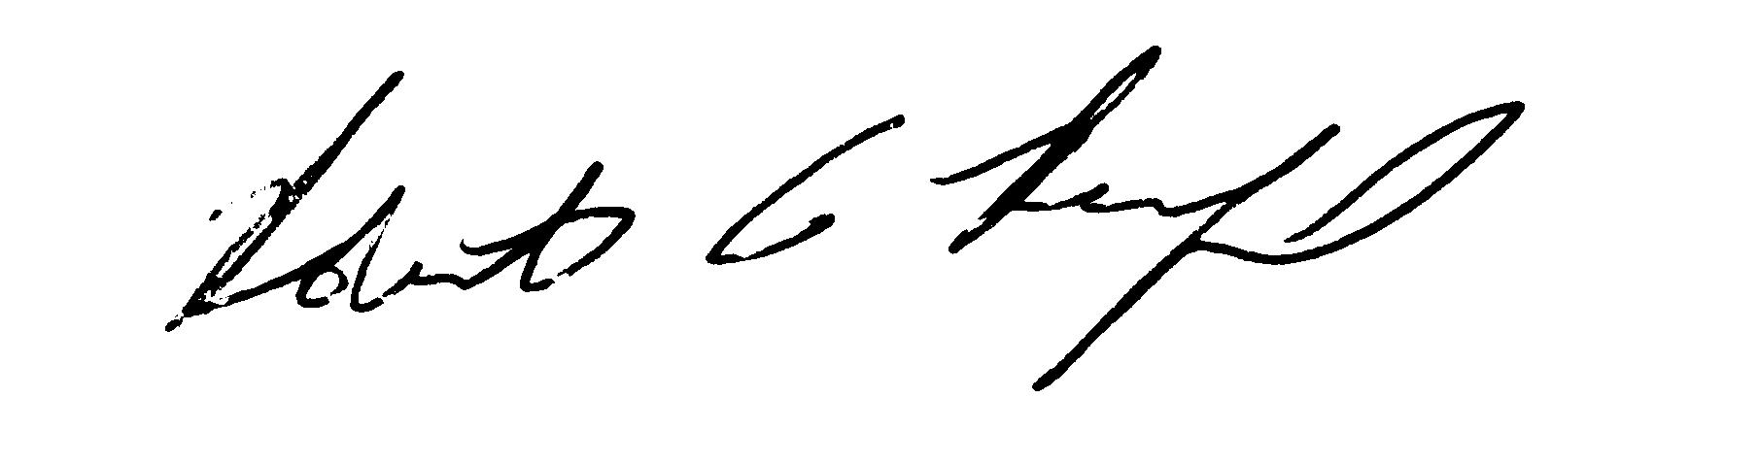
Robert A. Reinfried
Executive Director
C: Don Onwiler
Jim Truex

This page intentionally left blank

