Report of the
Professional Development Committee (PDC)

Ross Andersen, Chairman
New York Weights and Measures
Albany, New York

Reference
Key Number

INTRODUCTION

The Professional Development Committee (Committee) will address the following items at the National Conference on Weights and Measures (NCWM) January 2010 Interim Meeting.

Table A identifies the agenda items in the Report by Reference Key Number, Item Title, and Page Number. An item marked with an “I” after the reference key number is an Informational item. An item marked with a “D” after the reference key number is a Developing item. The developing designation indicates an item has merit; however, the item was returned to the submitter for further development before any action can be taken at the national level. Table B lists the appendices to the agenda.

In some cases, background information will be provided for an item. The fact that an item appears on the agenda does not mean that the item will be presented to the Conference for a vote. The Committee will review its agenda at the Interim Meeting and may withdraw some items, present some items for information meant for additional study, issue interpretations, or make specific recommendations that will be presented for a vote at the Annual Meeting.

The recommendations are statements of proposals and are not necessarily those of the Committee.

Table A
Index to Reference Key Items
Reference
Key Number Title of Item Page
400 INTRODUCTION 1
401 EDUCATION 2
401-1 I National Certification Program (NCP) 2
401-2 I Create a Curriculum Plan 5
401-3 D Instructor Improvement 7
401-4 D Certification 8
401-5 D Recommended Topics for Conference Training 10
402 PROGRAM MANAGEMENT 12
402-1 I Safety Awareness 12
402-2 D PDC Publication 12

Table B
Appendices
Appendix Title Page

A NCWM Curriculum Work Plan A1
B Certification Discipline for Retail Motor Fuel Devices (RMFD) – Beta Exam B1

Details of All Items
(In Order by Reference Key Number)

401 EDUCATION

401-1 I National Certification Program (NCP)

Source: Carryover Item 401-1. (This item originated from the Committee and first appeared on its agenda in 2003.)

Background/Discussion: For complete background information, see the PDC page of the NCWM website, www.ncwm.net.

The PDC encourages each regional association to dedicate a portion of their Annual Meeting to the National Certification Program (NCP).

During the 2008 Interim Meeting, the Committee discussed the Western Weights and Measures Association’s (WWMA) suggestion to establish an action plan and timeline. The Committee has developed an NCP, Critical Component Analysis, and an action plan of the components of the NCP. The Committee presents a draft of this document below.

National Conference on Weights and Measures
National Certification Program
Critical Component Analysis
DRAFT, February 21, 2008

The Committee has begun a comprehensive effort to identify critical resources and tasks necessary for the project, and the logical sequence in which those tasks must be performed, including the possible use of parallel activities.

Critical path analysis techniques were developed to manage complex projects just like the National Certification Program. The Committee is planning to use those techniques to the extent possible to plan future activities in working toward a certification program.

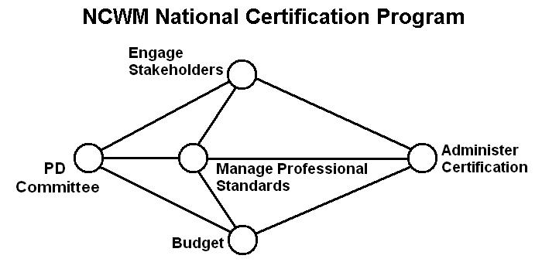
The Committee sees its task as one of managing four critical elements that come together as a certification program (as depicted above). Each bubble in the figure represents a milestone that must be reached in order to complete the objective. Those four main elements are:

Budget – involves tasks to secure necessary funding from the Board and other sources to undertake and complete all the other tasks.

Engage Stakeholders – involves tasks necessary to identify stakeholders and the resources they can bring to the project, encourage them to participate at all levels, and particularly to incorporate the professional standards in their training programs and to eventually take part in the certification program. The stakeholders, not the NCWM, will conduct the training. The NCWM will only be coordinating the professional standards and administering the certifications.

Manage Professional Standards – involves tasks necessary to create and manage a set of standards for the profession. The Committee has identified the creation of professional standards (i.e., the Curriculum) as the first task in the process. The completion of the curriculum plan, the curriculum template, the guide to preparing curriculum segments, and the guide to preparing test questions are some of those important steps toward that goal. The work groups are now finalizing the first seven curriculum segments and corresponding test questions. This is a great start and there still is a significant amount of additional work necessary in this area.

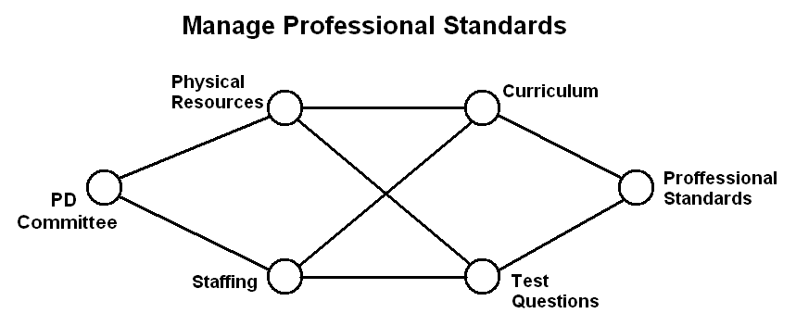

Administer Certification – involves tasks necessary to create certification exams, administer those exams, and issue certifications to those who qualify. The Committee will manage staffing, both paid and volunteer, and physical resources to secure the exams and record and issue the certificates.

As the necessary curriculum segments are completed and test questions prepared, we may begin to embark on some of the steps toward certification. Over the coming months, the Committee will continue to elaborate on the details in this project and keep refining it as we move forward.

The Central Weights and Measures Association (CWMA) PDC Committee at their 2008 fall meeting proposed changing the name of the program to the National Certification Program. They further made recommendations regarding the creation of a standard like HB 130 or HB 44 that might be the mechanism to document the work on the curriculum and the certification program. (Also, see Item 402-2 for more on PDC publications.)

The PDC had learned that the Associate Membership Committee might be interested in funding the work on the curriculum and the certification package. The Committee will consider suitable projects that might make good use of that funding.

At the 2009 NCWM Interim Meeting, the PDC developed an action plan based upon the critical path analysis already completed. In this plan, responsibilities will be divided between the NCWM Board of Directors and the PDC. The PDC will develop and maintain the curricula and test questions. The Board will provide physical resources and staffing to compile the exams, issue certificates, and maintain records.

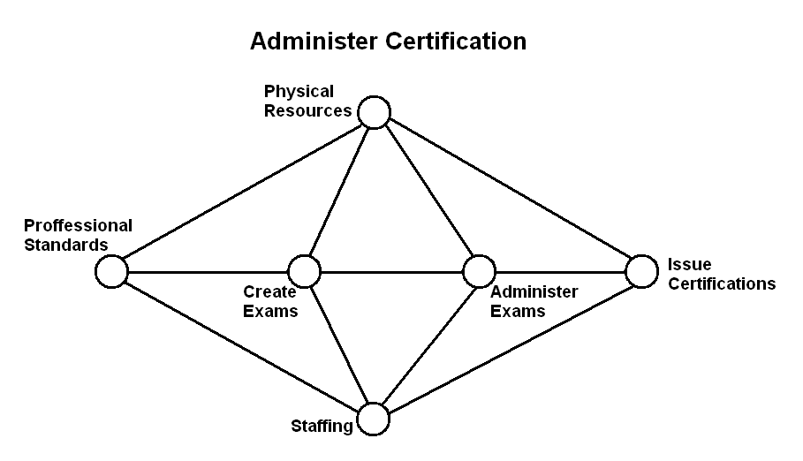
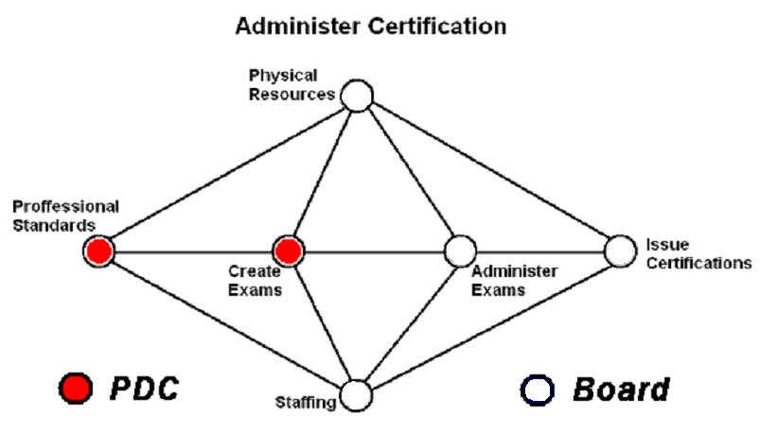

A goal was set to have all the elements in place to begin beta testing a certification examination in one competency area by November 2009, and in three more competency areas by 2010. The initial plans are to target retail motor fuel devices (RMFDs), small capacity Class III scales, package checking, and VTMs. (See Item 401-4 for details of the proposed certification program.) The plan below shows action items and target dates for the first certification area (tentatively RMFDs).

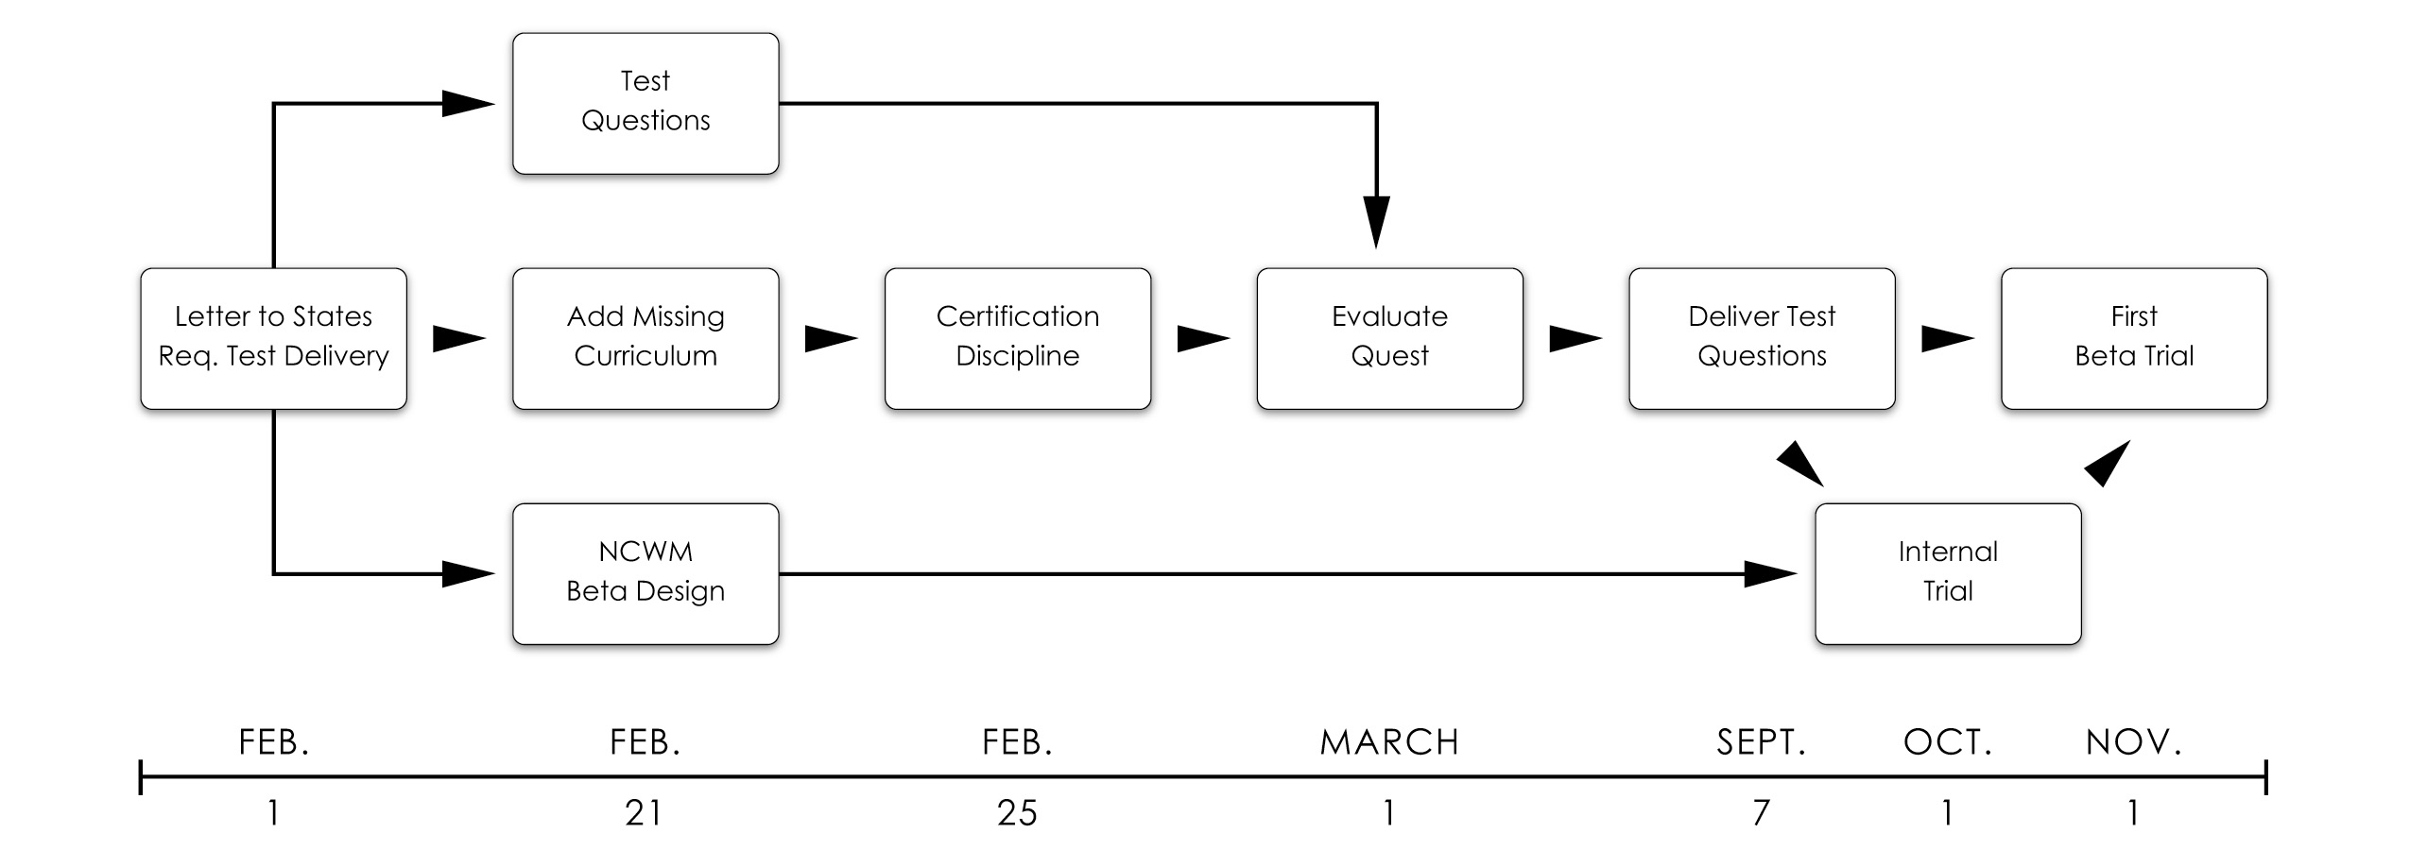

Discussion: The Committee received compliments on its work thus far and a suggestion that the CWMA might be willing to share the exams member states use for testing service agents. The Committee was asked to share its work with the regions in order to receive feedback on whether the PDC is on the right track. California indicated it has certification experience and extensive testing materials already developed for review. California also has curriculum material available on Investigative Techniques.

At the 2009 Annual Meeting, the Committee formally changed the name of the program to the National Certification Program (NCP) to reflect that the program offers certification and not training.

The steps outlined in the timeline developed at the 2009 Interim Meeting are being implemented. The Board of Directors has contracted with an online testing company. The format of the test and the details of test-result reporting are being worked out. Development of test questions is slightly behind schedule. The guide to writing test questions required revision to accommodate the format needed for an online test. The anticipated beta testing for the RMFD curriculum will be ready for evaluation in November 2009.

Action for 2010 Interim Meeting: The Committee will review progress and revise the plan as necessary to accommodate other planned beta exams.

401-2 I Create a Curriculum Plan

Source: Carryover Item 401-2 (This item originated from the Committee and first appeared on its agenda in 2003.)

Background/Discussion: For complete background information, see the PDC page of the NCWM website www.ncwm.net.

Prior to the 2007 Annual Meeting, the Committee reviewed the curriculum segments submitted thus far. At the 2007 Annual Meeting, the Committee decided, based on comments from several of the regions and its own assessment, it was essential to have a standardized format to ensure uniformity. Based on a collective review of curriculum plans received, the Committee created a sample template and example for regions to use in developing other curricula. The Committee updated its curriculum (Curriculum Package) to include the NCWM Core Competency Model, which provides a model for improving the quality of education in a select discipline. The Committee included this information as a general guideline for the regions to use as they develop other curriculum topics. In addition, the Committee revisited the original “National Training Curriculum Outline” from its 2004 NCWM Annual Report (Final Report). The Committee prepared an accompanying “NCWM Curriculum Work Plan,” which is intended to assist in the management of curriculum development. The Committee also revised the original curriculum outline to match the Work Plan see Appendix A. (This was Appendix H from the 2008 Final Report.)

The Committee updated the Curriculum Package as shown below, which is accessible from the NCWM website members’ page at www.ncwm.net.

- Cover Memorandum (guide to curriculum development),
- NCWM Core Competency Model,
- NCWM Curriculum Template (curriculum guideline),
- NCWM Sample Curriculum (examples of desired format),
- Guide for Writing Test Questions (including examples),
- National Training Curriculum Outline, and
- NCWM Curriculum Work Plan.

The Committee has received the following curriculum drafts (region responsible):

- 4.2 NIST Handbook 44 – Introduction to Device Control, (NEWMA);
- 4.3.1 Static Electronic Weighing Systems, General, (NEWMA);
- 4.3.5 Small Capacity Weighing Systems, Class III, (NEWMA);
- 4.3.7 Vehicle Class III or III L, (SWMA);
- 4.4.1 Retail Motor Fuel Dispensers, (WWMA); and
- 5.3.1 Commodities, General, (CWMA).

The Committee will return the curriculum drafts received, along with the newly revised curriculum package to the development team in each region to make revisions based on the Committee’s recommendations and continue work on preparing test questions related to each segment.

The Committee will also be requesting that each region set aside time for a presentation of the new curriculum package at their upcoming Annual or Interim Meeting. In addition, the Committee is requesting volunteers develop additional segments. The Committee acknowledges that the CWMA volunteered to sponsor the first training session on the use of the completed curriculum.

Mike Cleary, California, contacted the PDC in October concerning training on Investigative Techniques. California has developed a course and expressed willingness to share that with the Committee.

The CWMA PDC Committee at its 2008 fall meeting asked to get feedback on the segment they prepared. They also expressed interest in seeing what the other work groups had done on their segments and associated test questions.

At the Interim Meetings, the Committee will review progress on the curriculum including the feedback to the regional work groups. It will then establish priorities for preparing the next segments and search for volunteers to begin the work.

At the 2009 Interim Meeting, the PDC reaffirmed its commitment to completing all the curriculum items, but recognized the need to prioritize the completion of those curriculum items necessary for the four competency areas, which are to be beta tested by the end of 2010. (See PERT Diagram in Item 401-1 for timeline on completion.)

At the 2009 Annual Meeting, the Committee reported it considers the curriculum segments to be the critical element of the certification program. They set the standards to which the candidate will be tested. The National Training Curriculum Outline is already available online on the NCWM website. The actual curricula for Segment 4.2 Introduction to Device Control, Segment 4.4 Dynamic Liquid Measuring Systems – General, and Segment 4.4.1 Retail Motor Fuel Dispensers (RMFD) will be posted as soon as possible. Using these three documents plus the table below (copied from page PDC–8 of Publication 16, 2009), jurisdictions would be able to prepare their staff to take the RMFD test and/or evaluate the strengths and weakness of their training programs based upon those curricula. In addition, the Committee will be developing the segments for Small Capacity Class III Scales, package checking, and vehicle-tank meters. These segments will be posted online as they are developed.

Curriculum Discipline for Retail Motor Fuel Devices (RMFD) Certificate
Curriculum Areas (RMFD Certificate) | # Quest/50 Quest Exam | Approx %
1.0 Fundamentals of Weights and Measures | 7 | 14
4.2 NIST Handbook 44 – Introduction to Device Control | 8 | 16
4.4 Dynamic Measuring Systems - General
4.4(1) Technology and Terminology | 3 | 6
4.4(2) Device Operations & Functionality | 3 | 6
4.4(3) Technical Requirements | 3 | 6
4.4(4) User Requirements | 3 | 6
4.4(5) Test Methods | 3 | 6
4.4.1 Retail Motor Fuel Dispensers
4.4.1(1) Technology and Terminology | 4 | 8
4.4.1(2) Device Operations and Functionality | 4 | 8
4.4.1(3) Technical Requirements | 4 | 8
4.4.1(4) User Requirements | 4 | 8
4.4.1(5) Test Methods | 4 | 8

Action for 2010 Interim Meeting: The Committee expects to have posted the beta exam for retail-motor fuel devices prior to the Interim Meeting. Those test questions were based on three curriculum segments and a certification discipline that should be posted on the PDC pages of the NCWM website (www.ncwm.net). The certification discipline is included in Appendix B. At the 2010 Interim Meeting, the Committee hopes to be able to evaluate test scores from those who have taken the beta examination. The Committee will review progress and continue work on the RMFD exam to move to an active version. Work will also continue on the curriculum segments necessary to support the planned beta exams for small capacity scales, package checking and vehicle tank meters.

401-3 D Instructor Improvement

Source: Carryover Item 401-3 (This item originated from the Committee and first appeared on its agenda in 2003.)

Background/Discussion: The Committee is charged with the coordination of activities to improve the competence of instructors and the uniformity of delivery of the curriculum. For complete background information, see the PDC pages of the NCWM website www.ncwm.net. After logging in under the members’ area, look under the PDC Legacy Documents for the PDC Formal Scope.

Industry has continued to support and sponsor training on their new technology for weighing and measuring devices. NIST has assured the Committee work will continue work towards providing technical training for the trainers. The Committee supports the recommendation from the WWMA to encourage jurisdictions to participate in the NIST, WMD Instructor Training program as those classes become available.

At the NCWM 2009 Interim Meeting, a work group from the NCWM BOD provided information to the Committee on initiatives it was considering to use the NCWM website to provide training materials and other trainer aids, such as presentations, videos, etc. The Committee applauds these efforts by the Board and will support the NCWM efforts. However, the Committee will continue to maintain this item as low priority until other parts of the certification program are completed.

At the 2009 Annual Meeting, the Committee reported that no action is being taken on this item while the Committee concentrates on curriculum development and the establishment of the certification program.

401-4 D Certification

Source: Carryover Item 401-4. (This item originated from the Committee and first appeared on its agenda in 2003.)

Background/Discussion: For complete background information, please see the PDC page of the NCWM website (www.ncwm.net).

Subsequent to the 2006 NCWM Annual Meeting, all states not previously contacted received a letter requesting the name of their State Certification Coordinator (SCC). The state director becomes the default SCC in the absence of a designated contact. The SCC contact list is available on the PDC page of the NCWM website (www.ncwm.net).

The Committee continues to hear support from the regions concerning the establishment of a certification program.

The Committee has contacted the SCC of each state to gather information on its current training and certification programs. The Committee will be reviewing the Model Professional Development Training and Certification Standards Statute for Inspectors and Sealers of Weights and Measures that was submitted by NEWMA. The Committee will study the sample with the possibility that it might ultimately be used to establish model criteria for a certification program.

The Committee has created a Guide for Developing Test Questions in the curriculum package referenced in Item 401-2. At the 2008 Interim Meeting, the Committee brought forth two options for building the bank of questions for certification. The first option was to build one large bank of questions developed for use in training and during the certification exam. The second option would be to develop two banks of questions using one bank of questions for training and the second bank of protected questions used for certification.

Recommendations heard during the open hearing included having jurisdictions take the lead on developing the questions, administering the examination, and grading. The NCWM would issue certificates based on the jurisdictions’ reported results.

Pursuant to the recommendations from the WWMA and the CWMA, the Committee is in the process of developing a model for the infrastructure of the program. The Committee believes that a model is necessary to determine what the program will look like and what the roles of the states and the NCWM should be.

CWMA PDC Committee at their 2008 fall meeting proposed changing the name of the program to the National Certification Program. They further made recommendations regarding the creation of a standard like HB 130 or HB 44 that might be the mechanism to document the work on the curriculum and the certification program. (Also, see Item 402-2 for more on PDC publications.)

At the 2009 Interim Meeting, the PDC set a goal of being ready to start beta testing a component of a certification program for at least one competency area by November 2009, with the intention of having four areas completed by the end of 2010. The basic elements of the proposed program are:

- The PDC will develop curricula, which will be published in second section of the NCWM National Certification Guide (see also Item 402-2). Until that Guide is created, completed curriculum sections will be posted on the NCWM website (PDC files section under Members Only Section).

- The PDC will develop Certification Disciplines that outline which curriculum segments and objectives will be covered under each certificate, and how they will be weighted on the exam. Those Certification Disciplines will be published in the third section of the NCWM National Certification Guide (see also Item 402-2). Until that Guide is created, completed Certification Disciplines will be posted on the NCWM website.

- The PDC will provide the NCWM BOD with a pool of test questions for each curriculum segment and objective. Pool size will be proportional to the assigned weight of each curriculum item.
- It will be the BOD responsibility to develop and administer a testing program. NCWM staff will compile the exam from the questions pools, issue certificates, and maintain records.

The first draft of a Certification Discipline for RMFD’s is presented below. The Discipline outlines which curriculum segments and objectives must be mastered, what percentage of the test will be devoted to each item, and how many questions will be included from each area on a typical exam. The Committee is considering a fifty-question test format with a two hour test time limit in the beta test phase. Refer to the Curriculum Outline that is published on the NCWM website or the Curriculum Workplan in Appendix A for an overview of curriculum areas. The Committee is interested in feedback on the percentage weighting of the various curriculum areas.

Curriculum Discipline for Retail Motor Fuel Devices (RMFD) Certificate
Curriculum Areas (RMFD Certificate) | # Quest/50 Quest Exam | Approx %
1.0 Fundamentals of Weights and Measures | 7 | 14
4.2 NIST Handbook 44 – Introduction to Device Control | 8 | 16
4.4 Dynamic Measuring Systems - General
4.4(1) Technology and Terminology | 3 | 6
4.4(2) Device Operations and Functionality | 3 | 6
4.4(3) Technical Requirements | 3 | 6
4.4(4) User Requirements | 3 | 6
4.4(5) Test Methods | 3 | 6
4.4.1 Retail Motor Fuel Dispensers
4.4.1(1) Technology and Terminology | 4 | 8
4.4.1(2) Device Operations and Functionality | 4 | 8
4.4.1(3) Technical Requirements | 4 | 8
4.4.1(4) User Requirements | 4 | 8
4.4.1(5) Test Methods | 4 | 8

At the 2009 Interim Meetings, the AMC offered financial assistance to support development of the certification program. The AMC will consider effective ways to utilize such support in the coming months. The Committee recognizes that certification will initially be developed for regulatory inspectors, but they would like to quickly extend the program to the private sector as well.

At the 2009 Annual Meeting, the Committee identified three pieces critical to the Certification Program:

- Standards as defined by the curriculum

- Certification Discipline - weighting of the curriculum segments (see example on PDC-9)

- Evaluation of competence - the test

The first two steps are completed for the RMFDs test, and the Committee is busy developing the actual test. The Committee asked state directors for test questions and would like to thank California, New Hampshire, Massachusetts, New York, and the CWMA for their assistance in providing questions. The questions must now be evaluated, assigned to the relevant curriculum segments, and formatted according to the requirements of the online testing company.

The first test on RMFDs will be a beta test. The purpose of the beta test is to introduce online testing procedures, to troubleshoot any possible difficulties, and to help the Committee evaluate test questions in terms of weighting them for difficulty and curriculum coverage. The initial plan is to require a passing score of 85 % on a two hour, 50-question test. In answer to the question from the floor on whether there would be a time-out function, the answer is “no.” The test taker must commit two hours to taking the test in one session. However, the results will be informational, and no certificates will be issued based upon the results of the beta test.

There was a question from the floor on whether it would be better to concentrate on core competencies rather than developing difficulty levels. The Committee responded that the overall objective is to develop an exam that challenges the test taker with reasonable and fair questions so that a passing score is truly indicative of competence in the respective discipline. The goal is not to have overly difficult questions, but to have questions that cover the breadth of issues included in the curricula.

The look and feel of the first test was demonstrated at the open hearing by presenting attendees with samples of test questions. Typical questions will be a multiple choice, fill-in-the-blank, and situational questions where the answer is either “Yes” (if the device is in compliance as described) or a citation of the section of the handbook being violated (if the device is not in compliance in the situation described).

A question regarding test fees disclosed that there would be no fee for the beta test. The Board will make the decision regarding the cost of testing, and whether the fees will vary for members versus non-members and service people versus regulatory personnel when the certification program is operational.

The Committee is working with the test company to develop a report that can be provided to both the test taker and a designated other, such as the state certification coordinator or state director. The report would detail the score for each segment of the test, as well as the over-all test score. The report will not identify specific questions missed within any given segment nor the correct answers to those questions.

The integrity of the test questions is going to be protected by blocking screen prints and copy functions during the administration of the test. A recommendation was made to have at least three versions of the test available to allow for retests. Randomizing the selection of test questions will ensure that no one takes the same test twice and eliminate the need for creating multiple versions of the same test.

Jurisdictions and service companies will be encouraged to participate in the beta test within the limits of participation set by the Board. The Committee will make an announcement when the Committee is ready to accept volunteers for the beta test.

Although no certificates will be issued based upon the test results, the Committee feels that participating jurisdictions will benefit by being able to evaluate the success of their training programs, and by having the opportunity to familiarize their staff with the experience of online testing. The Committee will benefit by using the evaluation programs of the testing service to evaluate the difficulty and appropriateness of each test question, as well as the overall effectiveness of the test and the testing process.

Interest was expressed from the floor in having state-specific testing. The Committee feels that questions on State Program Scope and Overview will necessarily be state-specific. However, that is a refinement that needs to be addressed later by the Committee and the Board.

A comment was received from the floor that if the PDC Committee still needs additional questions, a request could be put out on the various NIST and NCWM list serves.

Finally, the Committee appreciates the many positive comments received on the progress of the Certification Program.

Action for 2010 Interim Meeting: The Committee expects to have posted the beta exam for RMFDs prior to the Interim Meeting. Those test questions were based on three curriculum segments and a certification discipline that should be posted on the PDC pages of the NCWM website (www.ncwm.net). The certification discipline is included in Appendix B. At the 2010 Interim Meeting, the Committee hopes to evaluate test scores from those who have taken the beta examination. The Committee will review progress and continue work on the RMFD exam to move to an active version. At the 2010 Interim Meeting, the Committee will review progress and continue work on the certification disciplines necessary to support the planned beta exams for small capacity scales, package checking, and vehicle tank meters.

401-5 D Recommended Topics for Conference Training

Source: Carryover Item 401-5 (This item originated from the Committee and first appeared on its agenda in 2003.)

Background/Discussion: The Board has charged the Committee with responsibility for selecting appropriate topics for the technical sessions at future Annual Meetings. The Board asked that the Committee review and prioritize possible presentations and submit those to the Chairman. The Chairman would then work with NCWM staff to make the arrangements and schedule the sessions.

The Committee continues to carry the following list and recommends these topics for possible training seminars, roundtables, or symposia for presentation at the NCWM meetings:

- Risk-based Inspections (Robert Williams, Tennessee, volunteered to present his state’s RMFD testing program);
- Marketplace Surveys;
- Auditing the Performance of Field Staff (Will Wotthlie, Maryland, volunteered to lead the session);
- Alternative Fuels (including motor-fuel trends and technology updates);
- Device Inspections Using a Sampling Model;
- Emerging Issues;
- Proper Lifting Techniques (recommended by Ken Deitzer, Pennsylvania);
- Overview of OIML and its Relationship to Standards Development (recommended by Julie Quinn, Minnesota);
- Back and Stress Techniques (recommended by Don Onwiler);
- Public Relations, specifically dealing with aggressive/angry people (recommended by the SWMA);
- Inspector Investigative Procedures (recommended by the SWMA);
- General Safety Issues (recommended by the WWMA);
- Defensive Driving (recommended by the WWMA);
- Administrative Civil Penalty Process (recommended by the WWMA);
- Price Verification (recommended by the WWMA);
- Customer Service (recommended by the WWMA);
- Ethics (recommended by the CWMA);
- Automatic Temperature Compensation (ATC) testing for field inspectors;
- Hydrogen Measuring Systems; and
- OSHA Safety.

For the 2008 NCWM Annual Meeting Technical Education Sessions, the Committee recommended ATC testing for field inspectors and OSHA Safety. The Board accepted these topics and presentations on both were made during the 2008 Annual Meeting.

For the 2009 NCWM Annual Meeting Technical Education Sessions, the Committee recommended seven possible topics for consideration of the NCWM Chairman:

- Investigative Techniques (offered by Michael Cleary);
- Handbook 44 Scale Code Tare Changes;
- Wet Tare/U.S. Department of Agriculture (USDA) Issues;
- ATC;
- Moisture Loss;
- Fuel Volatility Issues and Ethanol Blending; and
- Ergonomic Lifting Techniques.

At the 2009 NCWM Annual Meeting, technical sessions were presented on Investigative Techniques, Fuel Volatility, and on an emerging issue, Diesel Emission Fluid (DEF).

The Committee believes that the training sessions at the NCWM could be taped and the video materials made available on the website to start building a library. The Committee plans to approach the AMC for funding for video equipment expressly for this purpose. Just prior to the 2009 Annual Meeting, the Committee sent a letter asking the Associate Membership Committee (AMC) for video equipment funding to record future technical presentations. The intention is to provide an online library. The AMC announced from the floor that they had approved the request for funding at their meeting. The Committee has been informed that NCWM staff purchased video equipment under that grant from the AMC, and it will be used in future training sessions.

Action for 2010 Interim Meeting: The Committee will continue to solicit suggestions for future presentations and make recommendations to the NCWM Chair for the next Annual Meeting.

402 PROGRAM MANAGEMENT

402-1 I Safety Awareness

Source: Carryover Item 402-1 (This item originated from the Committee and first appeared on its agenda in 2003.)

Background/Discussion: In the past, the Committee’s responsibility extended to the identification of safety issues in the weights and measures field and included efforts to increase safety awareness. Jurisdictions are encouraged to send their safety reports and issues to their regional safety liaison, who in turn will forward them to the Charles Gardner, the NCWM Safety Coordinator. Below is a list of the Regional Safety Liaisons.

SWMA Steve Hadder, Florida Department of Agriculture and Consumer Services
WWMA Dennis Ehrhart, Arizona Department of Weights and Measures
CWMA Julie Quinn, Minnesota Department of Commerce
NEWMA Michael Sikula, New York Bureau of Weights and Measures

The Committee will also continue to ask the regions to prepare articles for the NCWM newsletter and will be extending the schedule to cover the next year. The Committee revised the schedule as follows for future issues. The Committee plans to notify the Regional Safety Coordinators as their assignment date approaches.

Association | Issue | Publication Date | Article Deadline
NEWMA | 2009, Issue 2 | June | April 15, 2009
SWMA | 2009, Issue 3 | September | July 15, 2009
WWMA | 2010, Issue 1 | February | January 15, 2010
CWMA | 2010, Issue 2 | June | April 15, 2010

All articles should be e-mailed to the NCWM headquarters at info@ncwm.net.

Action for 2010 Interim Meeting: The Committee will review any safety issues submitted to the Regional Safety Liaisons and expand the publication schedule for future NCWM Newsletters.

402-2 D PDC Publication

Background/Discussion: This item originally served to record the development of various documents prepared in pursuit of our training and certification programs. These are available on the members section of the NCWM website at www.ncwm.net. At the 2008 Annual Meeting, the Committee indicated its desire to eliminate this item from the agenda. However, in the report from the CWMA PDC Committee, the Committee received a proposal to create a standard like HB 130, Uniform Laws and Regulations in the Areas of Legal Metrology and Engine Fuel Quality, or HB 44, Specifications, Tolerances, and Other Technical Requirements for Weighing and Measuring Devices, to serve as the work product of the Committee. This standard could be reviewed, amended, and adopted by the NCWM to make it a living document. The Committee considered this proposal during discussions held at the 2009 Interim Meetings.

Based on feedback at the 2009 NCWM Interim Meeting, the PDC decided to move forward on the new publication to be titled NCWM Publication XX National Certification Program Guide. This publication will serve to document the details of the Certification Program.

The guide will remain under control of the PDC Committee but will not require formal NCWM vote to add new sections or revise existing sections. The Committee will add and modify sections continuously to meet its priority objectives with a concerted effort to respond to feedback from program users and the NCWM membership. The three main sections of the Guide would include:

- Program Administration – combines historical documentation (curriculum outline and work plan, etc.) with administrative procedures on administering exams and records of certifications,

- Competency Standards – includes the curriculum segments that describe the objectives and measurable competencies that will be used in certification, and

- Certification Disciplines – includes one document per certification area delineating the standards from the curricula that will be covered in the exam and the weighting of the competencies.

All segments of the PDC publication will be posted online as they are developed. New pages within the NCWM website will be created for the curriculum disciplines and segments so that interested parties can easily find and utilize this material.

Guidelines for operation of the Certification Program still need developing and posted online when they are completed.

Action for 2010 Interim Meeting: Members are encouraged to review the documents on the NCWM website relating to the RMFD certification. This includes the three curriculum segments and the certification discipline also provided in Appendix B. The Committee will be reviewing them as well and will be working on additions for the new certification areas as described in Item 401-4. The Committee will also be reviewing all of the documents relating to the certification program on the PDC pages of the NCWM site to ensure they are current and relevant.

Ross Andersen, Chair, New York

Stacy Carlsen, Marin County, California
Julie Quinn, Minnesota
Dale Saunders, Virginia
John Sullivan, Mississippi
Steven Grabski, Walmart
Tina Butcher, NIST, Weights and Measures Division

Professional Development Committee

THIS PAGE INTENTIONALLY LEFT BLANK
Appendix A

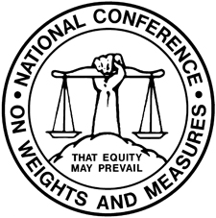

National Conference on Weight and Measures
National Certification Program

NCWM CURRICULUM WORK PLAN
Revised January 2009

Segment/Subject

Level 1/Level 2/Level 3

- Fundamentals of Weights and Measures
  - Introduction to Weights and Measures Programs
  - W&M Laws and Regulations
  - Field Standards and Test Equipment
  - State Program Scope and Overview
  - Enforcement Powers

- W&M Administration
  - Fundamentals of W&M Administration (Commercial System, Powers and Duties, etc.)
  - Administration Functions (Personnel, Management, Budget, Safety, etc.)
  - Legislation and Regulations (Legal Considerations, Interaction with Legislature, Stakeholders, Industry, etc.)
  - Regulatory Control (Device Inspection, Commodities, Complaints)
  - Laboratory Metrology Administration (Purpose of Laboratory, Responsibilities of Metrologist, NIST Expectations for Recognition of Laboratory, Quality System, Training Requirements, etc.)
  - Public Relations and Communications (Publicity, Public Relations, Communications)

- Laboratory Metrology
  - NIST Basic Metrology
  - NIST Intermediate Metrology
  - NIST Advanced Metrology

- Device Control Program
  - Safety Considerations
  - NIST Handbook 44 – Introduction to Device Control
  - Weighing Systems, General
    - Precision Weighing Systems Class I and II
    - Small Capacity Weighing Systems Class III
    - Medium Capacity Weighing Systems Class III
    - Vehicle Scale Class III or III L
    - Vehicle Scale Class III or III L – Advanced
    - Railroad Track Scales
    - In-Motion Railroad Track Scales
    - Hopper Scale Systems
    - Automatic Bulk Weighing Systems
    - Automatic Weighing Systems
    - Belt Conveyor Weighing Systems
    - In-Motion Monorail Scales
    - Point-of-Sale Scale Systems
    - Other Specialty Weighing Systems
  - Dynamic Measuring Systems – General
    - Retail Motor Fuel Dispensers
    - Loading Rack and Other Stationary Metering Systems
    - Loading Rack and Other Stationary Metering Systems – Advanced
    - Vehicle-Tank Meter Systems
    - Vehicle-Tank Meter Systems – Advanced
    - Milk Metering Systems
    - Water Meters
    - LPG/Anhydrous Ammonia Liquid Metering Systems
    - LPG/Anhydrous Ammonia Liquid Metering Systems – Advanced
    - LPG Vapor Meter Systems
    - Mass Flow Metering Systems
    - Other Metering Systems (Cryogenics, Carbon Dioxide, etc.)
  - Static Volume Measuring Systems – General
    - Liquid Measures
    - Farm Milk Tanks
    - Dry Measures
  - Other Measuring Systems
    - Taximeters and Odometers
    - Wire and Cordage Measuring Systems
    - Linear Measures
    - Timing Devices
    - Weights
    - Multiple Dimension Measuring Systems
  - Quality Measuring Systems
    - Grain Moisture Meters
    - NIR Grain Analyzers
    - Carcass Evaluation Systems

- Market Practices, Laws and Regulations (NIST HB 130) and Commodities (NIST HB 133)
  - Safety Considerations – Market Practices, NIST Handbook 130, NIST Handbook 133
  - NIST Handbook 130 – Laws and Regulations
    - NIST Handbook 130 – General Provisions
    - Packaging and Labeling Regulations
    - Method of Sale Regulations
    - Quality of Automotive Fuels and Lubricants
    - Price Verification
  - NIST Handbook 133 – Package Net Contents Control
    - Commodities – General
    - Packages Labeled by Weight, Standard and Random
    - Packages Labeled by Weight, Special Commodities
    - Packages Labeled by Volume (Volumetric and Gravimetric Testing)
    - Packages Labeled by Volume, Special
    - Packages Labeled by Length/Area/Thickness
    - Packages Labeled by Count
    - Other Package Types
  - Test Purchases
  - E-Commerce

Note: Initial Verification has been intentionally been left off this listing and will be addressed later.
Appendix B

National Conference on Weights and Measures
National Training Program
Certification Discipline
for

Retail Motor Fuel Devices (RMFD)
Beta Exam - November 2009

Prepared by the NCWM Professional Development Committee

The NCWM is offering a (beta) certification examination on the subject above. The examination will be taken online via the NCWM website. You must register with the NCWM and be granted a user authorization to access the test site. For registration information, call NCWM at 402-434-4880 or email info@ncwm.net. Be sure to include “RMFD exam” in the subject line.

Format and Duration:
The examination will be in three sections. There will be a total of 50 questions with a two hour time limit to complete all three parts. The test will be given in one session and you may not log off and then attempt to return to that exam. You must complete each section before moving to the next section.

The exam is OPEN BOOK, and you may make use of any reference materials, training documents, procedural guides at your disposal. You are expected to take the examination alone and may not receive assistance from any other person. You will be asked to affirm that at the conclusion of the examination.

Instructions on how to take the test will be provided online. Since the test is electronically graded, the answer must be marked or answer typed correctly. The test questions will be either multiple choice, fill in the blank, or compliance/citation. For multiple choice questions, you will be asked to pick the best answer from four options. For fill in the blank questions, you must enter the specific answer, typed correctly. For compliance/citation questions, you will be given information describing a situation and asked to assess compliance. Answer “yes” if the situation complies based on the information provided, otherwise provide the specific citation if the device does not comply. The form of the citation will typically be something like S.X.X. for a specification, T.X.X. for a tolerance or UR.X.X. for a user requirement. You will typically be directed to a specific Handbook code, so reference to the numerical code designation, such as 1.10. for the General Code, will usually not be necessary. If the potential answers span many codes, you will be specifically directed to include the numerical code reference.

Subject of Examination:

- Segment 4.2. Introduction to Device Control – 15 questions
These questions test for knowledge, understanding, and ability to apply the basic requirements applicable to all weighing and measuring devices. This may include questions on the legal basis of NIST Handbook 44, the selection, care and use of standards, the organization of that Handbook, understanding of Fundamental Considerations, knowledge of systems of measurement bunits, understanding and application of General Code requirements, and understanding of the NTEP program and Certificates of Conformance.
- Segment 4.1. Dynamic Measuring Systems – General – 15 questions
These questions test for knowledge and understanding of the basic technologies used in liquid measuring devices, ability to operate liquid measuring devices and associated controls and interpret indications, understanding and ability to apply code requirements from NIST Handbook 44 Liquid Measuring Device Code, and understanding and ability to conduct basic tests of liquid measuring devices.
- Segment 4.2. Retail Motor Fuel Dispensers – 20 questions
These questions test for knowledge and understanding of the basic technologies used in RMFDs, understanding and ability to apply code requirements from NIST Handbook 44 Liquid Measuring Device Code for RMFDs, and understanding and ability to conduct basic tests of RMFDs.
Passing Score and Grading:

Weights and Measures regulatory officials 85 % (43 or more correct answers)

Service agents 75 % (38 or more correct answers)

You will be given a score for each section and total score immediately after completing the exam (or upon reaching the two hour time limit). To protect the integrity of the test questions, you will not be advised of the specific questions answered incorrectly. The PDC Committee will be reviewing incorrect answers in periodic reviews and will make adjustment to scores in select cases. If your score is affected, you will be notified.

If you wish to challenge any of the questions, there will be a section at the end where you can offer comments. You may also contact the NCWM PDC Committee through the NCWM staff at the same email address used for registration.

