Professional Development Committee (PDC)
Interim Agenda

Ross Andersen, Chairman
New York Weights and Measures
Albany, New York

Reference
Key Number

400 INTRODUCTION

The Professional Development Committee (Committee) will address the following items at the National Conference on Weights and Measures (NCWM) January 2009 Interim Meeting.

Table A identifies the agenda items in the Report by Reference Key Number, Item Title, and Page Number. An item marked with an “I” after the reference key number is an Informational item. An item marked with a “D” after the reference key number is a developing item. The developing designation indicates an item has merit; however, the item was returned to the submitter for further development before any action can be taken at the national level. Table B lists the appendices to the agenda.

In some cases, background information will be provided for an item. The fact that an item appears on the agenda does not mean that the item will be presented to the Conference for a vote. The Committee will review its agenda at the Interim Meeting and may withdraw some items, present some items for information meant for additional study, issue interpretations, or make specific recommendations that will be presented for a vote at the Annual Meeting.

The recommendations are statements of proposals and are not necessarily those of the Committee.

Table A
Index to Reference Key Items
Reference
Key Number Title of Item Page
400 INTRODUCTION 1
401 EDUCATION 2
401-1 I National Training Program (NTP) 2
401-2 I Create a Curriculum Plan 4
401-3 D Instructor Improvement 6
401-4 D Certification 6
401-5 D Recommended Topics for Conference Training 7
402 PROGRAM MANAGEMENT 7
402-1 I Safety Awareness 7
402-2 D PDC Publication 8

Table B
Appendices
Appendix Title Page

A NCWM Curriculum Work Plan A1
B Model Professional Development Training and Certification Standards Statute for Inspectors and Sealers of Weights and Measures (Legislative Model) B1

Details of All Items
(In Order by Reference Key Number)

401 EDUCATION

401-1 I National Training Program (NTP)

Source: Carryover Item 401-1 (This item originated from the Committee and first appeared on its agenda in 2003.)

Background: For complete background information, see the PDC page of the NCWM website, www.ncwm.net/members.

Discussion: The PDC encourages each regional association to dedicate a portion of their Annual Meeting to the National Training Program (NTP).

During the 2008 Interim Meeting, the Committee discussed the WWMA’s suggestion to establish an action plan and timeline. The Committee has developed an NTP, Critical Component Analysis, an action plan of the components of the NTP. The Committee presents a draft of this document below.

National Conference on Weights and Measures
National Training Program
Critical Component Analysis
DRAFT, February 21, 2008

The Committee has begun a comprehensive effort to identify critical resources and tasks necessary for the project, and the logical sequence in which those tasks must be performed, including the possible use of parallel activities.

Critical path analysis techniques were developed to manage complex projects just like the National Training Program. The Committee is planning to use those techniques to the extent possible to plan our future activities as we work toward a certification program.

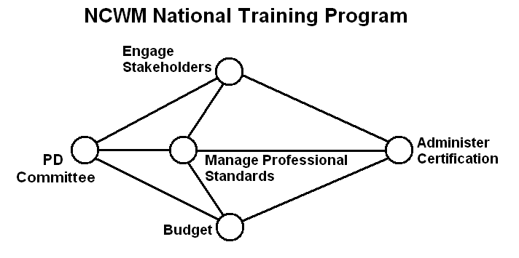

The Committee sees its task as one of managing four critical elements that come together as a certification program (as depicted above). Each bubble in the figure represents a milestone that must be reached in order to complete the objective. Those four main elements are:

Budget – involves tasks to secure necessary funding from the Board and other sources to undertake and complete all the other tasks.

Engage Stakeholders – involves tasks necessary to identify stakeholders and the resources they can bring to the project, encourage them to participate at all levels, and particularly to incorporate the professional standards in their training programs and to eventually take part in the certification program. It should be noted that The stakeholders will conduct the training; not the NCWM. The NCWM will only be coordinating the professional standards and administering the certifications.

Manage Professional Standards – involves tasks necessary to create and manage a set of standards for the profession. The Committee has identified the creation of professional standards (i.e., the Curriculum) as the first task in the process. The completion of the curriculum plan, the curriculum template, the guide to preparing curriculum segments, and the guide to preparing test questions are some of those important steps toward that goal. The work groups are now finalizing the first seven curriculum segments and corresponding test questions. This is a great start and there still is a significant amount of additional work necessary in this area.
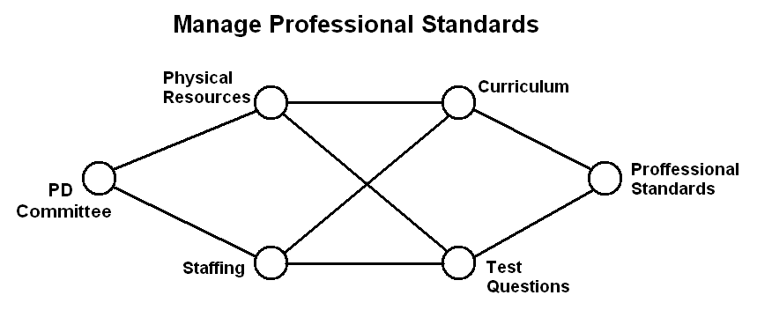

Administer Certification – involves tasks necessary to create certification exams, administer those exams, and issue certifications to those who qualify. The Committee will manage staffing, both paid and volunteer, and physical resources to secure the exams and record and issue the certificates.

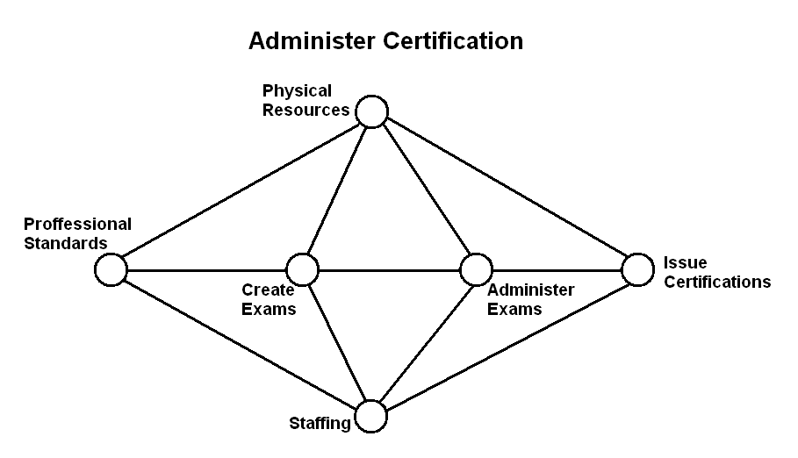
As the necessary curriculum segments are completed and test questions prepared, we may begin to embark on some of the steps toward certification. Over the coming months, the Committee will continue to elaborate on the details in this project and keep refining it as we move forward.

The Central Weights and Measures Association (CWMA) PDC Committee at their 2008 fall meeting proposed changing the name of the program to the National Certification Program. They further made recommendations regarding the creation of a standard like HB 130 or HB 44 that might be the mechanism to document the work on the curriculum and the certification program. (Also, see Item 402-2 for more on PDC publications.)

The PDC had learned that the Associate Membership Committee might be interested in funding the work on the curriculum and the certification package. The Committee will consider suitable projects that might make good use of that funding.

401-2 I Create a Curriculum Plan

Source: Carryover Item 401-2 (This item originated from the Committee and first appeared on its agenda in 2003.)

Background: For complete background information, see the PDC page of the NCWM website www.ncwm.net/members.

Discussion: Prior to the 2007 Annual Meeting, the Committee reviewed the curriculum segments submitted thus far. At the 2007 Annual Meeting, the Committee decided, based on comments from several of the regions and its own assessment, it was essential to have a standardized format to ensure uniformity. Based on a collective review of curriculum plans received, the Committee created a sample template and example for regions to use in developing other curricula. The Committee updated its curriculum (Curriculum Package) to include the NCWM Core Competency Model, which provides a model for improving the quality of education in a select discipline. The Committee included this information as a general guideline for the regions to use as they develop other curriculum topics. In addition, the Committee revisited the original “National Training Curriculum Outline” from its 2004 NCWM Annual Report (Final Report). The Committee prepared an accompanying “NCWM Curriculum Work Plan,” which is intended to assist in the management of curriculum development. The Committee also revised the original curriculum outline to match the Work Plan see Appendix A (This was Appendix H from the 2008 Final Report.).

The Committee updated the Curriculum Package as shown below, which is accessible from the NCWM website members’ page at www.ncwm.net.

- Cover Memorandum (guide to curriculum development),

- NCWM Core Competency Model,

- NCWM Curriculum Template (curriculum guideline),

- NCWM Sample Curriculum (examples of desired format),

- Guide for Writing Test Questions (including examples),

- National Training Curriculum Outline,

- NCWM Curriculum Work Plan.

The Committee has received the following curriculum drafts (Region responsible):

- 4.2 NIST Handbook 44 – Introduction to Device Control, (NEWMA);

- 4.3.1 Static Electronic Weighing Systems, General, (NEWMA);

- 4.3.5 Small Capacity Weighing Systems, Class III, (NEWMA);

- 4.3.7 Vehicle Class III or III L, (SWMA);

- 4.4.1 Retail Motor Fuel Dispensers, (WWMA); and

- 5.3.1 Commodities, General, (CWMA).

The Committee will return the curriculum drafts received, along with the newly-revised curriculum package to the development team in each region to make revisions based on the Committee’s recommendations and continue work on preparing test questions related to each segment.

The Committee will also be requesting that each region set aside time for a presentation of the new Curriculum Package at their upcoming Annual or Interim Meeting. In addition, the Committee is requesting volunteers develop additional segments. The Committee acknowledges that the CWMA volunteered to sponsor the first training session on the use of the completed curriculum.

Mike Cleary, California, contacted the PDC in October concerning training on Investigative Techniques. California has developed a course and expressed willingness to share that with the Committee.

The CWMA PDC Committee at its 2008 fall meeting asked to get feedback on the segment they prepared. They also expressed interest in seeing what the other work groups had done on their segments and associated test questions.

At the Interim Meetings, the Committee will review progress on the curriculum including the feedback to the regional work groups. It will then establish priorities for preparing the next segments and search for volunteers to begin the work.

401-3 D Instructor Improvement

Source: Carryover Item 401-3 (This item originated from the Committee and first appeared on its agenda in 2003.)

Background: For complete background information, see the PDC page of the NCWM website www.ncwm.net/members.

Industry has continued to support and sponsor training on their new technology for weighing and measuring devices. NIST has assured the Committee they will continue their work towards providing technical training for the trainers.

Discussion: The Committee supports the recommendation from the Western Weights and Measures Association (WWMA) to encourage jurisdictions to participate in the NIST, WMD Instructor Training program as those classes become available.

401-4 D Certification

Source: Carryover Item 401-4 (This item originated from the Committee and first appeared on its agenda in 2003.)

Background: For complete background information, please see the PDC page of the NCWM website www.ncwm.net/members.

Subsequent to the 2006 NCWM Annual Meeting, all states not previously contacted received a letter requesting the name of their State Certification Coordinator (SCC). The state director becomes the default SCC in the absence of a designated contact. The SCC contact list is available on the PDC page of the NCWM website (www.ncwm.net/members).

Discussion: The Committee continues to hear support from the regions concerning the establishment of a certification program.

The Committee has contacted the SCC of each state to gather information on its current training and certification programs. The Committee will be reviewing the Model Professional Development Training and Certification Standards Statute for Inspectors and Sealers of Weights and Measures (Appendix B) that was submitted by NEWMA. The Committee will study the sample with the possibility that it might ultimately be used to establish model criteria for a certification program.

The Committee has created a Guide for Developing Test Questions in the curriculum package referenced in Item 401-2. At the 2008 Interim Meeting, the Committee brought forth two options for building the bank of questions for certification. The first option was to build one large bank of questions developed for use in training and during the certification exam. The second option would be to develop two banks of questions using one bank of questions for training and the second bank of protected questions used for certification.

Recommendations during the open hearing included having jurisdictions take the lead on developing the questions, administering the examination, and grading. The NCWM would issue certificates based on the jurisdictions’ reported results.

Pursuant to the recommendations from the WWMA and the CWMA, the Committee is in the process of developing a model for the infrastructure of the program. The Committee believes that a model is necessary to determine what the program will look like and what the roles of the states and the NCWM should be.

The CWMA PDC Committee at their 2008 fall meeting proposed changing the name of the program to the National Certification Program. They further made recommendations regarding the creation of a standard like HB 130 or HB 44 that might be the mechanism to document the work on the curriculum and the certification program. (Also see Item 402-2 for more on PDC publications.)

401-5 D Recommended Topics for Conference Training

Source: Carryover Item 401-5 (This item originated from the Committee and first appeared on its agenda in 2003.)

Background: The Board has charged the Committee with responsibility for selecting appropriate topics for the technical sessions at future Annual Meetings. The Board asked that the Committee review and prioritize possible presentations and submit those to the Chairman. The Chairman would then work with NCWM staff to make the arrangements and schedule the sessions.

The Committee continues to carry the following list and recommends these topics for possible training seminars, roundtables, or symposia for presentation at the NCWM meetings:

- Risk-based Inspections (Robert Williams, Tennessee, volunteered to present his state’s Retail Motor-Fuel Device (RMFD) testing program);
- Marketplace Surveys;
- Auditing the Performance of Field Staff (Will Wotthlie, Maryland, volunteered to lead the session);
- Alternative Fuels (including motor-fuel trends and technology updates);
- Device Inspections Using a Sampling Model;
- Emerging Issues;
- Proper Lifting Techniques (recommended by Ken Deitzer, Pennsylvania);
- Overview of OIML and its Relationship to Standards Development (recommended by Julie Quinn, Minnesota);
- Back and Stress Techniques (recommended by Don Onwiler);
- Public Relations, specifically dealing with aggressive/angry people (recommended by the SWMA);
- Inspector Investigative Procedures (recommended by the SWMA),
- General Safety Issues (recommended by the WWMA);
- Defensive Driving (recommended by the WWMA);
- Administrative Civil Penalty Process (recommended by the WWMA);
- Price Verification (recommended by the WWMA);
- Customer Service (recommended by the WWMA);
- Ethics (recommended by the CWMA);
- Automatic Temperature Compensation (ATC) testing for field inspectors;
- Hydrogen Measuring Systems; and
- OSHA Safety.

For the 2008 NCWM Annual Meeting Technical Education Sessions, the Committee recommended Automatic Temperature Compensation (ATC) testing for field inspectors and OSHA Safety. The Board accepted these topics and presentations on both were made the 2008 Annual Meeting. The Committee will be considering topics for the 2009 Annual Meeting and welcomes suggestions from everyone.

402 PROGRAM MANAGEMENT

402-1 I Safety Awareness

Source: Carryover Item 402-1 (This item originated from the Committee and first appeared on its agenda in 2003.)

Background: In the past, the Committee’s responsibility extended to the identification of safety issues in the weights and measures field and included efforts to increase safety awareness.

At the 2005 Annual Meeting, Past-Chairman Dennis Ehrhart recommended the committee make training its highest priority. The Voluntary Quality Assurance Assessment program, NCWM Associate Membership Scholarships, and safety awareness efforts were carryover items from the Committee on Administration and Public Affairs (A&P) and not PDC items.

Jurisdictions should send their safety reports and issues to their regional safety liaison, who in turn will forward them to Charles Gardner, the NCWM Safety Coordinator. Charles recommends the reports or report summaries be published in the NCWM newsletter. At the 2005 Interim Meeting, a CD-ROM on safety produced for the U.S. Environmental Protection Agency was made available for review. The Committee believes safety awareness should be a part of every aspect of training for NCWM stakeholders. The regional safety liaisons are listed below.

SWMA Steve Hadder, Florida Department of Agriculture & Consumer Services
WWMA Dennis Ehrhart, Arizona Department of Weights & Measures
CWMA Julie Quinn, Minnesota Department of Commerce
NEWMA Michael Sikula, New York Bureau of Weights & Measures

At the 2007 Interim Meeting, the Committee decided to reach out to the regional safety liaisons and ask that they write newsletter articles designed to raise safety awareness and provide safety tips to the weights and measures community. These archived articles are on the PDC page of the NCWM website. The NCWM newsletter is published three times a year and all articles should be e-mailed to the NCWM headquarters at info@ncwm.net.

Association | Issue | Article Deadline
WWMA | 2008, Issue 2 | March 15, 2008
CWMA | 2008, Issue 3 | July 15, 2008
NEWMA | 2009, Issue 1 | November 15, 2008
SWMA | 2009, Issue 2 | March 15, 2009

Discussion: The Committee is sad to hear that Charles Gardner, our long-standing Safety Liaison has retired. The PDC would like to thank Mr. Gardner for his many years of service to this project, which he initiated. At the Interim Meetings, the Committee will consider how we move forward from here, either seeking a new liaison or changing how the safety issues will be handled.

The Committee will also continue to ask the regions to prepare articles for the NCWM Newsletter and will be extending the schedule to cover the next year.

402-2 D PDC Publication

This item originally served to record the development of various documents prepared in pursuit of our training and certification programs. These are available on the members section of the NCWM website at www.ncwm.net. At the 2008 Annual Meeting, the Committee indicated its desire to eliminate this item from the agenda. However, in the report from the CWMA PDC Committee, the Committee received a proposal to create a standard like HB 130 or HB 44 to serve as the work product of the Committee. This standard could be reviewed, amended, and adopted by the NCWM to make it a living document. The Committee will consider this proposal in discussions at the 2009 Interim Meetings.

_________________________

Ross Andersen, Chair, New York

John Sullivan, Mississippi
Richard Cote, New Hampshire
Stacy Carlsen, Marin County, California
Julie Quinn, Minnesota
Tina Butcher, NIST, Weights and Measures Division

Professional Development Committee
Appendix A

Curriculum Package

The National Conference on Weights and Measures
National Training Program
CURRICULUM WORK PLAN
Revised November 2007

Segment/Subject

Level 1/Level 2/Level 3

- Fundamentals of Weights and Measures
  - Introduction to W&M Programs
  - W&M Laws and Regulations
  - Field Standards & Test Equipment
  - State Program Scope and Overview

- W&M Administration
  - Fundamentals of W&M Administration (Commercial System, Powers & Duties, etc.)
  - Administration Functions (Personnel, Management, Budget, Safety, etc.)
  - Legislation and Regulations (Legal Considerations, Interaction with Legislature, Stakeholders, Industry, etc.)
  - Regulatory Control (Device inspection, commodities, complaints)
  - Laboratory Metrology Administration (Purpose of Laboratory, Responsibilities of Metrologist, NIST Expectations for Recognition of Laboratory, Quality System, Training Requirements, etc.)
  - Public Relations & Communications (Publicity, Public Relations, Communications)

- Laboratory Metrology
  - NIST Basic Metrology
  - NIST Advanced Metrology

- Device Control Program
  - Safety Considerations
  - NIST Handbook 44 – Introduction to Device Control
  - Weighing Systems General
    - Static Electronic Weighing Systems, General
    - Static Mechanical and Hybrid Weighing Systems, General
    - Dynamic Weighing Systems, General
    - Precision Weighing Systems Class I and II
    - Small Capacity Weighing Systems Class III
    - Medium Capacity Weighing Systems Class III
    - Vehicle Scale Class III or III L
    - Vehicle Scale Class III or III L – Advanced
    - Railroad Track Scales
    - In-Motion Railroad Track Scales
    - Hopper Scale Systems
    - Automatic Bulk Weighing Systems
    - Automatic Weighing Systems
    - Belt Conveyor Weighing Systems
    - In-Motion Monorail Scales
    - Point-of-Sale Scale Systems
    - Other Specialty Weighing Systems
  - Dynamic Measuring Systems – General
    - Retail Motor Fuel Dispensers
    - Loading Rack and Other Stationary Metering Systems
    - Loading Rack and Other Stationary Metering Systems – Advanced
    - Vehicle-Tank Meter Systems
    - Vehicle-Tank Meter Systems – Advanced
    - Milk Metering Systems
    - Water Meters
    - LPG/Anhydrous Ammonia Liquid Metering Systems
    - LPG/Anhydrous Ammonia Liquid-Metering Systems – Advanced
    - LPG Vapor Meter Systems
    - Mass Flow Metering Systems
    - Other Metering Systems (Cryogenics, Carbon Dioxide, etc.)
  - Static Volume Measuring Systems – General
    - Liquid Measures
    - Farm Milk Tanks
    - Dry Measures
  - Other Measuring Systems
    - Taximeters and Odometers
    - Wire and Cordage Measuring Systems
    - Linear Measures
    - Timing Devices
    - Weights
    - Multiple Dimension Measuring Systems
  - Quality Measuring Systems
    - Grain Moisture Meters
    - NIR Grain Analyzers
    - Carcass Evaluation Systems

- Market Practices, Laws and Regulations (NIST HB 130), & Commodities (NIST HB 133)
  - Safety Considerations – Market Practices, NIST HB 130, NIST HB 133
  - NIST Handbook 130 – Laws & Regulations
    - NIST Handbook 130 – General Provisions
    - Packaging and Labeling Regulations
    - Method of Sale Regulations
    - Quality of Automotive Fuels and Lubricants
    - Price Verification
  - NIST Handbook 133 – Package Net Contents Control
    - Commodities – General
    - Packages Labeled by Weight, Standard and Random
    - Packages Labeled by Weight, Special Commodities
    - Packages Labeled by Volume (Volumetric and Gravimetric Testing)
    - Packages Labeled by Volume, Special
    - Packages Labeled by Length/Area/Thickness
    - Packages Labeled by Count
    - Other Package Types
  - Test Purchases
  - E-Commerce

Note: Initial Verification has been intentionally been left off this listing and will be addressed later.

Appendix B

Model Professional Development Training and Certification
Standards Statute for Inspectors and Sealers of Weights and Measures

Submitted by NEWMA, October 2007

DRAFT

- Definition of Terms: Unless defined otherwise by statute, the definitions contained herein shall apply to this statute.

  - Commission: The permanent advisory Commission appointed pursuant to this statute to develop, plan, and certify training standards, certification, and continuing education.

  - Director [Commissioner or other senior state official]: Charged by statute to administer, guide, or direct weights and measures activities within the state at state, county, or municipal level.

  - Sealers and Inspectors of Weights and Measures: Those public officials appointed pursuant to existing law to inspect, approve, or condemn weighing and measuring devices or perform other activities as directed by statute or regulation. This definition shall also apply to deputy, assistant, or associate sealers and inspectors of weights and measures.

  - Industry Specialists: Those individuals approved and/or licensed by the State Director to inspect, approve, or condemn specific classes or types of weighing and measuring devices.

- Certification and Standards Commission

  - Appointment: There shall be a permanent standing advisory Commission comprised of the Director of the state weights and measures department or his designee, and a designee from each of the following organizations: the State Weights and Measures Association, the various Regional Weights and Measures Associations, and one individual representing industry specialists. Members of said Commission shall serve without compensation. Said Commission shall be chaired by the Director or Deputy Director of weights and measures.

  - Rule Making Authority: The Commission shall promulgate rules and regulations necessary to implement and maintain this statute consistent with existing rule-making state legislation.

  - Duties: The Commission shall develop, and from time to time, revise the certification and continuing education requirements that are established by the Department of Weights and Measures with the advice and consent of the Commission. The Commission shall certify all inspectors, sealers and deputies and industry specialists in accordance with sections [insert specific statue citation covering the appointment of these officials] and regulations promulgated by the Commission including, but not limited to, regulations covering initial written certification testing for inspectors, sealers and deputies and industry specialists as well as mandatory continuing education programs for inspectors, sealers and deputies, and industry specialists to maintain their certifications. Every store, retail establishment, food store or food department and all merchants within the jurisdiction of the state department of weights and measures shall provide adequate space for the display of information relative to how the state inspector, local sealer or inspector or the department of weights and measures can be contacted as provided in regulations to be promulgated by the Commission. Notwithstanding any certification exemption, all sealers, inspectors, deputy sealers, deputy inspectors, and industry specialists shall participate in continuing education programs. The Commission shall establish a training and education fee to be paid by the state, county, municipality, or industry specialist’s organization, which employs such sealer, inspector, deputy sealer and deputy inspector, or industry specialist sufficient to offset the cost of providing such training and education.

  - Fees: There shall be a revolving account established into which shall be deposited any training and education fees paid by the state, county, municipality, or industry specialist. These fees shall be used to offset any cost associated with providing such training and education mandated by the Commission.

- Appointment of Sealers, Inspectors, Deputy Sealers

  - Appointment: The sealer, inspector, and all deputies shall be certified by the Commission within one year after assuming their powers and duties. Failure to become certified within one year shall be cause for termination; provided, however, sealers, inspectors or deputy sealers or deputy inspectors, employed by the state, county, or a municipality upon the effective date of this paragraph, shall become certified within two years. Sealers, inspectors or deputy sealers or deputy inspectors who pass a civil service exam for a position as a sealer, inspector or deputy sealer or deputy inspector of weights and measures, shall be exempt from initial certification requirements provided that said civil service exam contains questions and/or practices consistent with initial certification requirements.

  - Continuing Education: Notwithstanding any certification exemption, all sealers, inspectors and deputy sealers and deputy inspectors shall participate in continuing education programs. The Commission shall establish a training and education fee to be paid by the county or municipality which employs such sealer, inspector, deputy sealer and deputy inspector sufficient to offset the cost of providing such training and education.

- Appointment of Industry Specialists

  - Appointment: All industry specialists shall be certified by the Commission prior to assuming their powers and duties as licensed industry specialists; provided, however, industry specialists performing such duties shall become certified within one year from the effective date of this statute. Failure to become certified prior to assuming their powers and duties as industry specialists shall render any inspections conducted null and void and such individuals shall be barred from further inspections for a period of not less than one year.

  - Continuing Education: Notwithstanding the appointment of industry specialists, they shall participate in continuing education programs approved by the Commission. The Commission shall establish a training and education fee to be paid by the business or organization employing industry specialists sufficient to offset the cost of providing such training and education.

- Conflict with other Laws: Whenever the application of any provision of any other law of this state conflict with the application of any provision of sections one through four, inclusive, said sections shall prevail.

- Partial Invalidity: If any provision of said sections one to four, inclusive, or the application of said sections shall be held invalid, the remainder of said sections, or the application of such provision to any person or circumstance other than that as to which it is invalid, shall not be affected thereby.

