Appendix F

Handbook 133 – Checking the Net Contents of Packaged Goods

Items:
Item 260-4: 4.3. Paper Plates and Sanitary Paper Products

Table of Contents
Items | L&R Appendix F – Page
Georgia Pacific 3
Foodservice Packing Institute, October 7, 2012 10
Richard Davis, Response to Plate Dimension Tester, January 22, 2013 12
Georgia Pacific, Paper Plate Tester Drawings 14

THIS PAGE INTENTIONALLY LEFT BLANK

Handbook 133: Section 4.5. Paper Plates and Sanitary Paper Products

Georgia Pacific

Contents:

- Standard Test Method using a Plate Dimension Tester

- Pictures of a Plate Dimension Tester

- Reproducibility Data

- Blueprint of a Plate Dimension Tester

STANDARD TEST METHOD

Title: Diameter of Plates and Bowls PPR:
Original: New Authorized by:
Effective: September 1, 2010
- Purpose/Scope

  - This method is for determining the diameter of plates and bowls utilizing the National Institute of Standards and Technology (NIST) Handbook 133 Section 4.5 (Fourth Edition) and/or Section 5.5 (Third Edition) method.

- Apparatus/Materials

  - Plate Diameter Gauge, accurate to 1/50th (0.02) of an inch available from:
Research Dimensions
1720 Oakridge Road
Neenah, WI 54956
920-722-2289

  - Acrylic weights (4, 6 and 8-inch diameter), weighing each 225 +/- 10 grams available from Research Dimensions (2.1).

2.3 Magnifying glass
2.4 6-inch calibration gauge block available from:
McMaster-Carr
Part no. 19575A299
www.mcmaster.com
630-833-0300

  - 9/64-inch Allen wrench

- Training/Safety

  - The Primary Person Responsible (PPR) trains operators for this method.

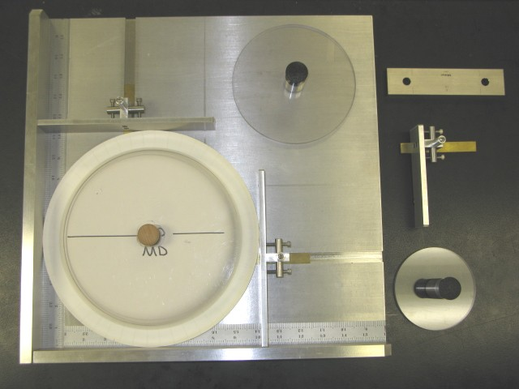
Vertical Slide
Horizontal Slide
Figure 1: Plate diameter gauge.

- Specimen Preparation

  - Obtain samples, precondition and condition according to TAPPI procedures.

- Maintenance/Calibration

  - The PPR maintains the apparatus for this method.

  - Perform a calibration check before the instrument is used.

    - Place the 6-inch gauge block over the vertical slot with one end against the stationary horizontal edge of the fixture. Move the vertical slide against the gauge block and read the measurement (Figure 2). The measurement should be 6.00 inches. If you encounter any problems contact the PPR for calibration.

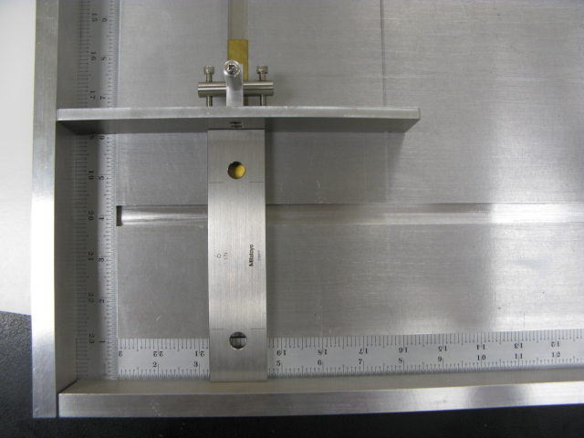
Figure 2: Vertical slide calibration check
    - Place the 6-inch gauge block over the horizontal slot with one end against the stationary vertical edge of the fixture. Move the large horizontal slide against the gauge block and read the measurement (Figure 3). The measurement should be 6.00 inches. If you encounter any problems contact the PPR for calibration.

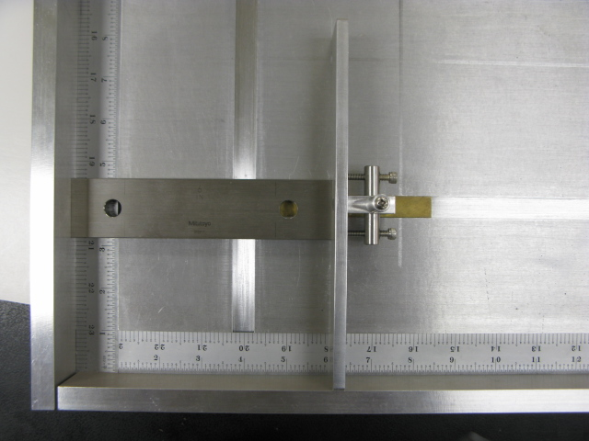
Figure 3: Large horizontal slide calibration check
    - Remove the large horizontal slide from the tester and place the small horizontal slide on the tester. Move it against the gauge block and read the measurement (Figure 4). The measurement should be 6.00 inches. If you encounter any problems contact the PPR for calibration.

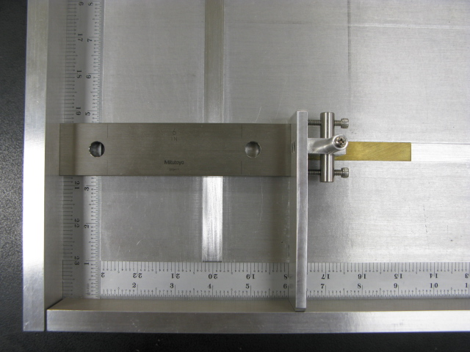
Figure 4: Small horizontal slide calibration check
- Procedure
  - Mark the MD direction of the plate or bowl.
  - Place the plate or bowl to be measured on the measuring base plate, eating surface down, so that two sides of the plate or bowl touch both the stationary horizontal and vertical edge of the diameter gauge. The MD direction of the plate should be in the horizontal position (Figure 1).
  - Place the appropriate size Acrylic weight on top of the plate or bowl. The Acrylic weight should cover the entire base of the plate or bowl but not large enough to interfere with the diameter measurement.
  - Gently move the vertical and horizontal slides against the edge of the plate or
bowl. Slide contact should be light so the sample is not deformed by the contact.
  - If the plate or bowl is smaller than 8 inches in diameter, replace the moving large horizontal guide with the small horizontal guide. If the plate or bowl is circular, record the smallest diameter measurement.
  - If the plate is oblong, use the Acrylic weight that is closest to the smaller dimension that does not interfere with its measurement. Record the plate diameter in both dimensions.
  - A magnifying glass can be used to aid in reading the measurements.

- Report

  - For circular plates and bowls record the minimum diameter measurement to the nearest 0.02-inch.

  - For oblong plates record both the small and large dimension to the nearest 0.02-inch.
  - Clearly state any deviations from the standard procedure, and note any unusual features or characteristics of the sample.
- References/Additional Information
  - U.S. Department of Commerce - National Institute of Standards and Technology - NIST Handbook 133, Fourth Edition Section 4.5 and/or Third Edition section 5.5.

Plate Dimension Tester Photos

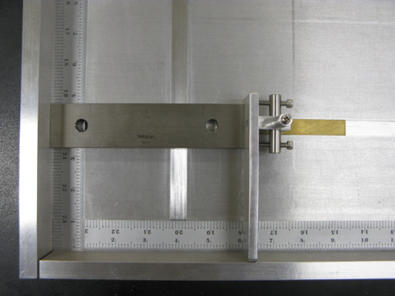

Reproducibility Data

Descriptive Statistics Plate Dimension Tester

Based on the 60 data points available (10 plates, 3 operators, 2 repeats), the variation observed in the measurements is reflective of the resolution in the gage. The minimum gradient in the gage is 1/50th of an inch (0.02 in), and the confident interval for both the 9 and 10 inch plates is well within this tolerance.

Variable | Descriptive Statistics (Gauge RnR – NBS Plate Dia 1)
Variable | Valid N | Minimum | Maximum | Mean | Std. Dev. | Confidence  -95.000% | Confidence  +95.000%
9-inch Plate Diameter | 60 | 8.66 | 8.70 | 8.673 | 0.0109 | 8.670 | 8.676
10-inch Plate Diameter | 60 | 10.12 | 10.18 | 10.143 | 0.0089 | 10.141 | 10.145

For the 9 inch plate, the expected average is 8.673 +/- 0.003 inches.
For the 10 inch plate, the expected average is 10.143 +/- 0.002 inches.

October 15th, 2012 questions – Response on 1-22-2013 by Richard Davis

Questions regarding the Plate Dimension Tester, submitted by David Sefcik, following the Southern W&M meeting.

Below are some thoughts and considerations regarding the proposal. We support your efforts and for bringing this modern equipment and specification improvements to our current test methods.

Let me know if it would be possible to borrow or bring one of the devices to try out and demonstrate at the Interim?

- The statement in the video to “take the shorter of the two measurements” may raise some questions. When dimensional testing is done on other products, and variations are found, inspectors are taught to take several readings and then the average. Also with dimensional testing, inspectors are taught to take a minimum 3 measurements, then average. This allows for reasonable variations (e.g., in addition, in 4.5 c, Step 2, it states that if the dimensions vary, that at least 10 items from each package should be measured. Measure and average the dimension.)
  - The point is well taken. We use the shorter of the two dimensional readings as a very conservative measurement. However, we have considered your comment and have altered the test method such that the plate dimension will be recorded as the average of the two 90 degree measurements. As to the number of items to be tested, we leave that to the circumstances of the testing purpose as described in an appropriate sampling and testing scenario. When testing on the production line, 1 sample may be enough to verify the process is lined out, but sampling a lot, delivery, or shipment may be quite a different case. The test method shows how to conduct the test, the sampling procedure should address the sample size required – so we did not specify it.

- For weights and measures enforcement, the (stationary) rulers will have to be certified by a state metrology laboratory, so they should be removable for certification, re-certification, or replacement. Is there also a metric ruler? Making them removable will enable metric (SI) measures to be used.
  - Based on the placement of the rulers in an indented groove of the tester, they should not have stress on them to require re-certification; however, they are removable so they could be recertified if desired. The calibration block is also certified and intended to be used to verify no change in the rulers. It can be recertified as needed as well.

- The 6 inch block in the video provides a means to only verify 1 graduation on the ruler. Are there plans to have different blocks available suitable to different size plates (i.e., 10 inch)? Regardless, weights and measures will verify all of the graduations before use, but it wouldn’t hurt reliability if you were testing for example, 10 inch plates, to be able to do a quick verification of the graduation at that point too.
  - Our feeling is - if the rulers are certified and can be recertified if necessary, and the block is also certified, then if you can validate any one point on the certified ruler as being accurate, the whole ruler should be accurate. You therefore would not need two certification blocks.

- The current test procedure in the Note in 4.5 a, states: “do not distort the item’s shape during measurement”. Placing a weighted disk on the plate may be viewed as a distortion. You may want to elaborate on how the determination of the proper weight of the disks was arrived. The specifications for the discs are important because pressing down on the plates can distort the product as some plates are pretty flimsy, so there needs to be some guidance on how much weight the industry wants for different plates. The plate in the video appeared to be fairly rigid but others in the marketplace are not so sturdy.
  - We conducted a series of testing scenarios to test whether or not a single weight of disk was appropriate. We used a variety of products (paper, foam, and molded pulp) to show that the one weight was sufficient for testing a wide range of products. We have submitted data to show our findings. We remain confident that the 225 gram weights are sufficient to be used across the broad range of products.

- You may want to describe more about how the increased usability of this device can be used to accommodate a greater number of products such as napkins, paper towels, plastic plates, sandwich bags, etc… so that its cost can be better justified. For paper towels you may want to include a piece a Plexiglas that can be used to flatten and help take out creases of flat paper products (napkins).
  - We have not addressed the use of this device for anything other than disposable plates, bowls, and platters. It may be possible to adapt it for other products but we have not taken the time and resources to do that. Potentially a good idea, but one that hasn’t been explored at this time.

- You will likely be asked and need to include the specifications to build the device as part of HB133 test procedure. States may choose to build the device themselves or have another 3rd party do it. It needs to be available for all and not a reliance on one manufacturer. This is generally accomplished by providing the specifications right in the Handbook.
  - The engineering drawings were included in the original submission to the Southern Conference. Based on some of the feedback we received from you and others, we made a couple minor changes so the new drawings will also be available to the Conference if anyone chooses to build their own devise.

L&R Committee 2013 Final Report
Appendix F – Item 260-4: Handbook 133, 4.3. Paper Plates and Sanitary Paper Products

L&R – F14
