Appendix A

Pelletized Ice Cream

Table of Contents

Page
International Ice Cream Association Letter (IICA) to the Food and Drug Administration (FDA)/RE: Request
for Interpretation of FDA Food Labeling Regulations for Net Quantity of Contents and Serving Size of Pelletized Ice Cream and Frozen Desserts A3
Food and Drug Administration (FDA) Decision on Pelletized Ice Cream A5
Food and Drug Administration (FDA) Letter to the International Ice Cream Association (IICA) on Uniform Compliance Date for Pelletized Ice Cream A8
International Ice Cream Association Letter (IICA) to Food and Drug Administration (FDA)/RE: IICA
Additional Information on Pelletized Frozen Desserts Measurement and Net Contents Declaration A10
Comparison of Volumetric Declaration and Measurement vs. Gravimetric (weight) for Pelletized Ice Cream A13
Food and Drug Administration (FDA) Letter to M. Hahn, Hogan & Hartson LLP A14

THIS PAGE INTENTIONALLY LEFT BLANK

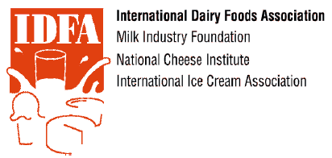
May 14, 2010
Ms. Loretta A. Carey Consumer Safety Officer
Food Labeling and Standards Staff
Office of Nutrition, Labeling, and Dietary Supplements
CF SAN, FDA
5100 Paint Branch Parkway College Park, MD 20740
Sent Via E-mail to: Loretta.Carey@fda.hhs.gov
RE: IICA Additional Information on Pelletized Frozen Desserts Measurement and Net Contents Declaration.
Dear Ms. Carey:
The International Ice Cream Association (IICA) is providing this information in response to your request for additional information about pelletized frozen desserts before responding to our request for confirmation of the appropriate manner of declaring net content on these products.
Pelletized frozen desserts are unique and novel products that entered the market in 1988 with the pelletized frozen ice cream sold under the brand name Dippin' DotsTM, which was predominantly sold in food service venues to consumers for immediate consumption. Due to the commercialization and development of processing technology, packaged pelletized ice cream entered the retail marketplace about four years ago. While Dippin' Dots and similar pelletized ice creams meet the standard of identity for ice cream specified in 21 C.F.R 135.110, some other pelletized frozen desserts do not meet the ice cream standard. These include the three flavors of Unilever's Popsicle Shots Ice Beads and four flavors of Kemps Itti Bitz Icee Bits currently on the market. We have provided two examples to demonstrate the different types of pelletized ice cream and frozen dessert products that are currently in the market place.
Regardless of whether the pelletized products meet the ice cream standard, they are manufactured and sold in much the same manner In short, these products are beads of ice cream, water ice, sherbet or other frozen dessert that are quick frozen with liquid nitrogen. The beads are relatively small, but they can vary in shape and size.
In a June 27, 2008 meeting with officials from FDA's Office of Food Labeling, along with staff from the National Institute of Standards and Technology (NIST) Weights and Measures Division, IICA discussed the appropriate manner of net contents declarations for these pelletized products. In a follow-up letter to FDA in July 2008, IICA further explained its position that the net quantity of content statement for both pelletized ice creams and other frozen desserts should be a volumetric declaration that excludes the external air. At that time, IICA explained that such a declaration would be consistent with the volumetric declarations used on other ice cream and frozen dessert products. In response to a request to provide additional information, specifically with regard to the measurements used for other frozen novelties and the pros and cons associated with volumetric measures that include and exclude the external air, IICA provided this information in a September 8, 2008 letter.
On April 17, 2009, FDA sent a letter to IICA expressing its disagreement with the position that a volumetric declaration is appropriate. IICA and its members respected this decision and made the changes necessary to comply with the agency's position. Because FDA made clear in a subsequent October 22, 2009 letter that its decision "applied to pelletized ice cream only and not to other frozen dessert" and further noted "we were not aware that there were similar questions regarding other frozen dessert products," IICA sent its letter earlier this year seeking the agency's confirmation that indeed all pelletized frozen desserts should bear net content declarations in terms of weight, not volume.
As explained in that April 2, 2010 letter, the rationale that supported FDA's decision with regard to pelletized ice creams should apply to other pelletized frozen desserts. We see no reason for a departure. As a preliminary matter, 21 CFR 101.105(a) specifies that the quantity of contents be declared in terms of weight if the product is solid, semisolid, viscous, or a mixture of solid and liquid, unless there is a firmly established history of declaring the content of the product in terms of volume. Because pelletized ice cream is a unique and new product, FDA determined that this exception did not apply. We see no reason why a contrary rationale would be applied to pelletized frozen desserts, which are newer to the market than the pelletized ice creams. Additionally, we have provided updated information in the table below on the pros and cons of labeling pelletized frozen dessert with net weight declaration compared to the volume declaration used by conventional ice cream and frozen dessert products.
Further, as set forth in FDA's April 2009 letter, "The FPLA is concerned with the labeling of packaged consumer goods for retail sale to enable consumers to obtain accurate information about the quantity of contents and to facilitate value comparisons." Now that it has been determined that pelletized ice cream products must have net content statements in terms of weight, it would best facilitate value comparisons if all pelletized frozen desserts declared net contents in terms of weight. To determine otherwise would seem to run contrary to the dictates of the FPLA.
Because the National Conference on Weights and Measures will meet in early July and consider amendments to NIST Handbooks 130 and 133, including an amendment to reflect FDA's position with regard to net content statements for pelletized ice cream and frozen desserts, we would like the agency's timely confirmation of its position with regard to pelletized frozen desserts.

If you have any questions or require any further information, please feel free to contact me at (202) 220-3543 or via e-mail at cfrye@idfa.org.
Sincerely,
Cary Frye
Vice President,
Regulatory Affairs
cc: G. June, ONDLS, FDA
- Butcher, NIST
- Warfield, NIST

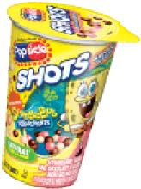
Comparison of Volumetric Declaration and Measurement vs. Gravimetric (weight)
for Pelletized Frozen Desserts
Option | Pros |  | Cons
Label by weight | •  •  • | Consistent with  pelletized ice cream (FDA decision April 2009)  Measurement method will be easy to  implement in the field No concerns around product settling or melting | • | Method inconsistent with all traditional ice cream and novelties
Label by volume (Excluding external air) | • | Method consistent with all other ice cream and novelties | •  •  • | Accurate measurement method needs to be developed  Water displacement methods are difficult to implement in the field Inconsistency between Net Content declaration and Nutrition Facts  Panel

Strawberry, Chocolate and
Vanilla Flavored Ice Cream Beads
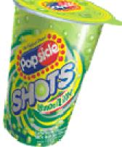 | Lemon Lime Flavored Ice Beads | 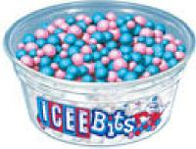 | Icee Bits Pelletized Frozen Dessert

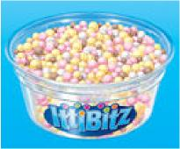 | Itti Bitz Pelletized Ice Cream

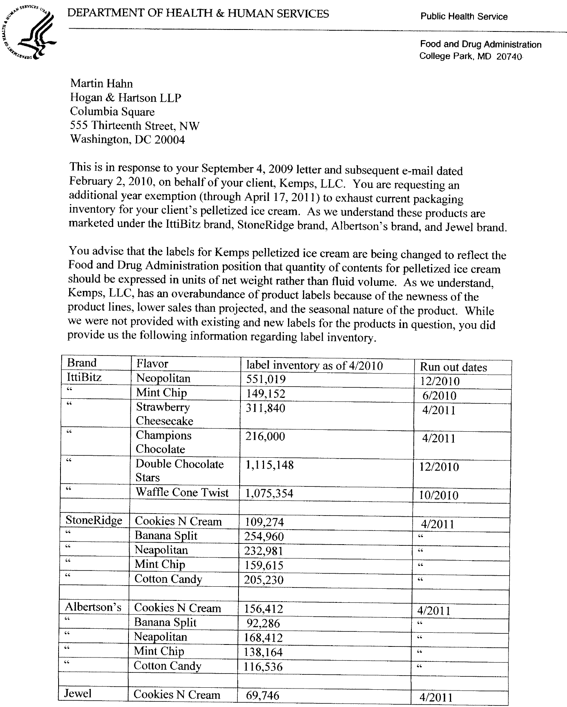
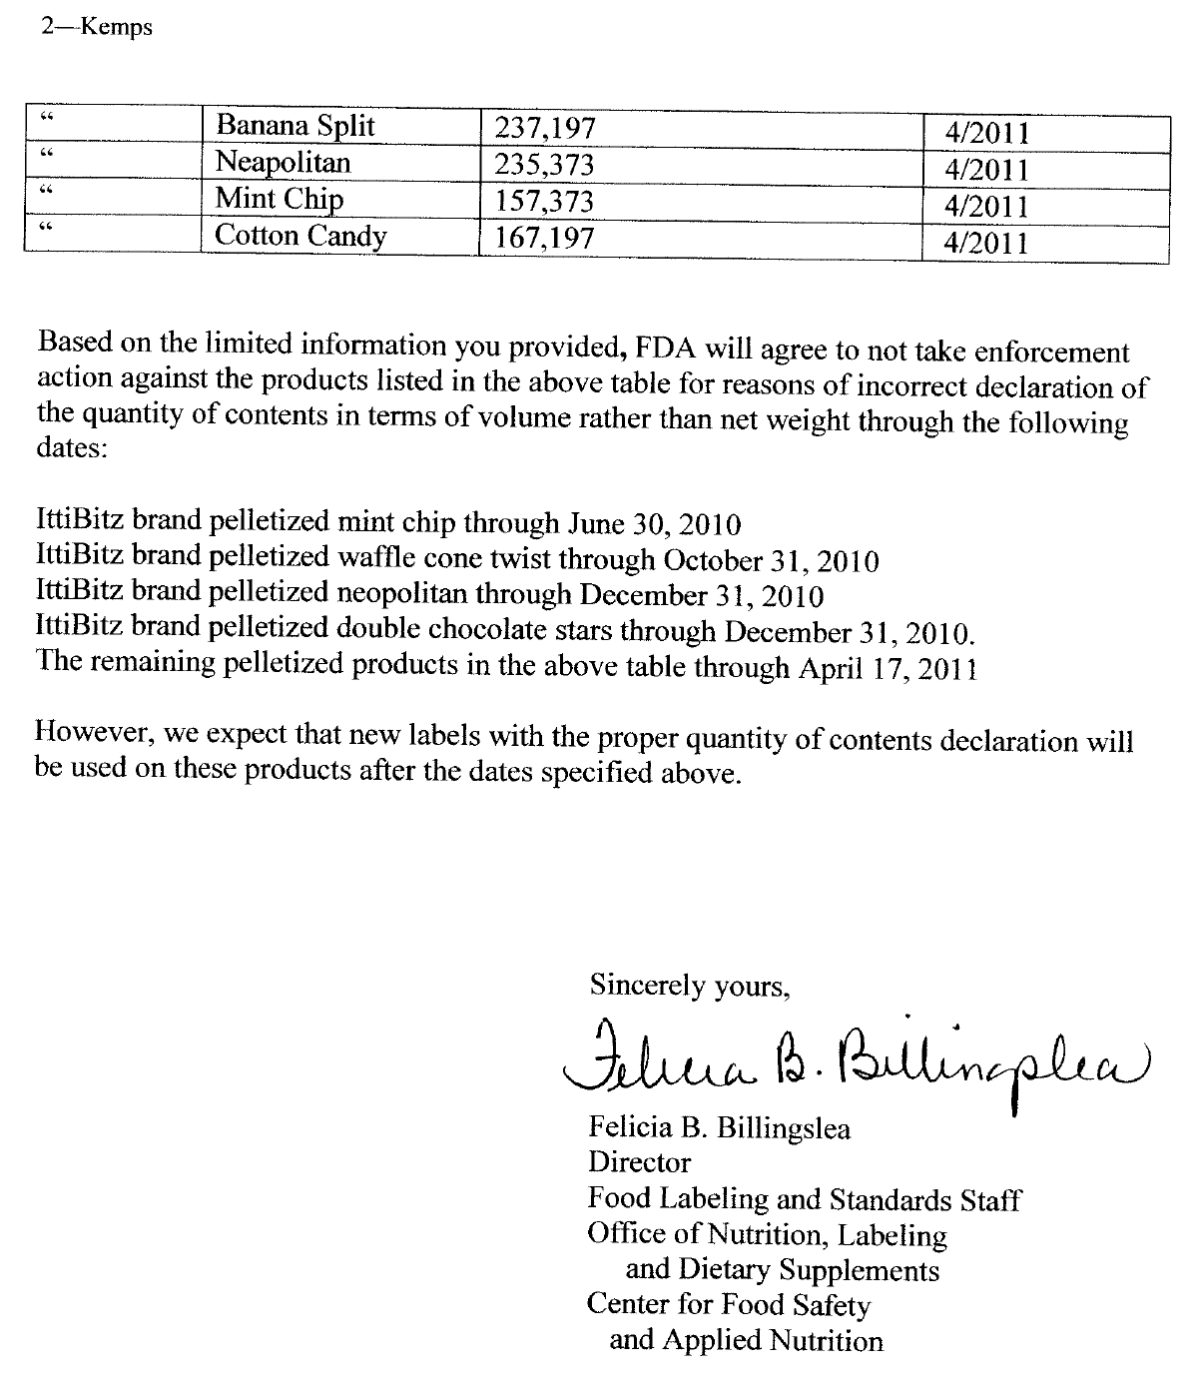

THIS PAGE INTENTIONALLY LEFT BLANK

