Appendix I

Polyethylene Sheeting

Table of Contents
Page
Berry Plastics Corporation (June 8, 2009) I3
Sigma Stretch Film I5
Berry Plastics (June 26, 2010) I6
Safety Data Sheets I8

This page intentionally left blank
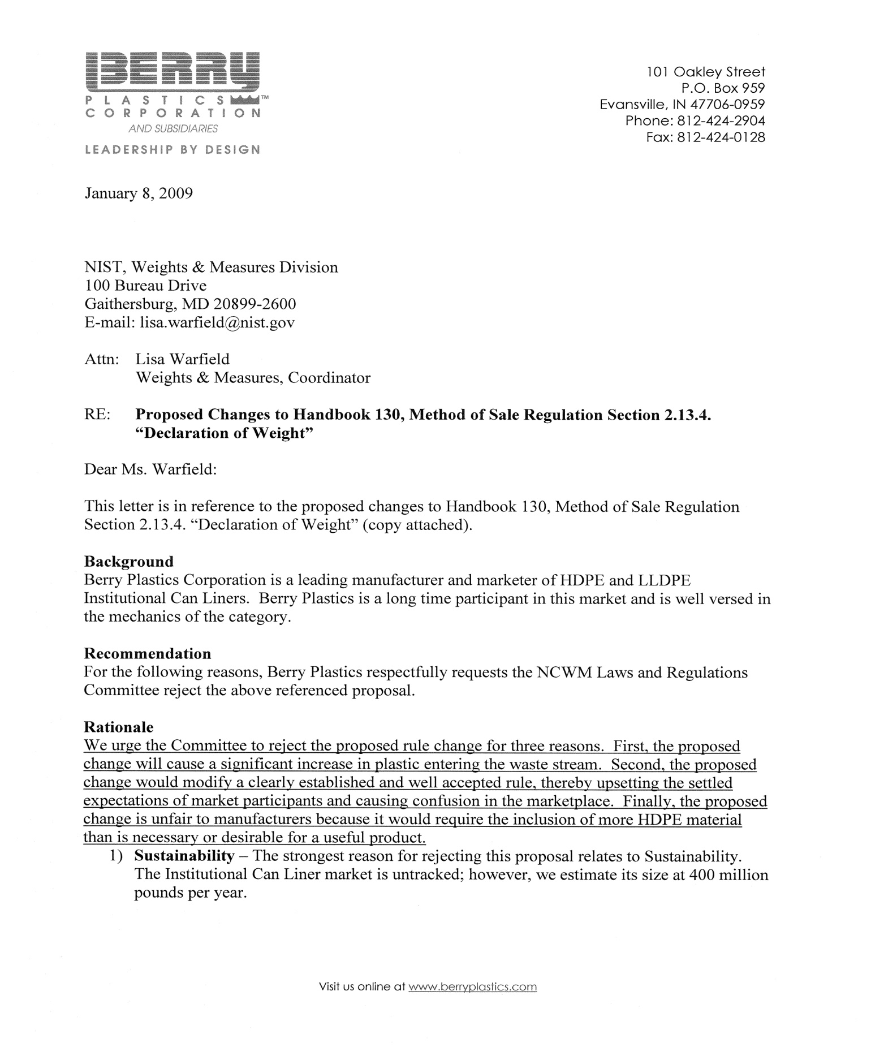
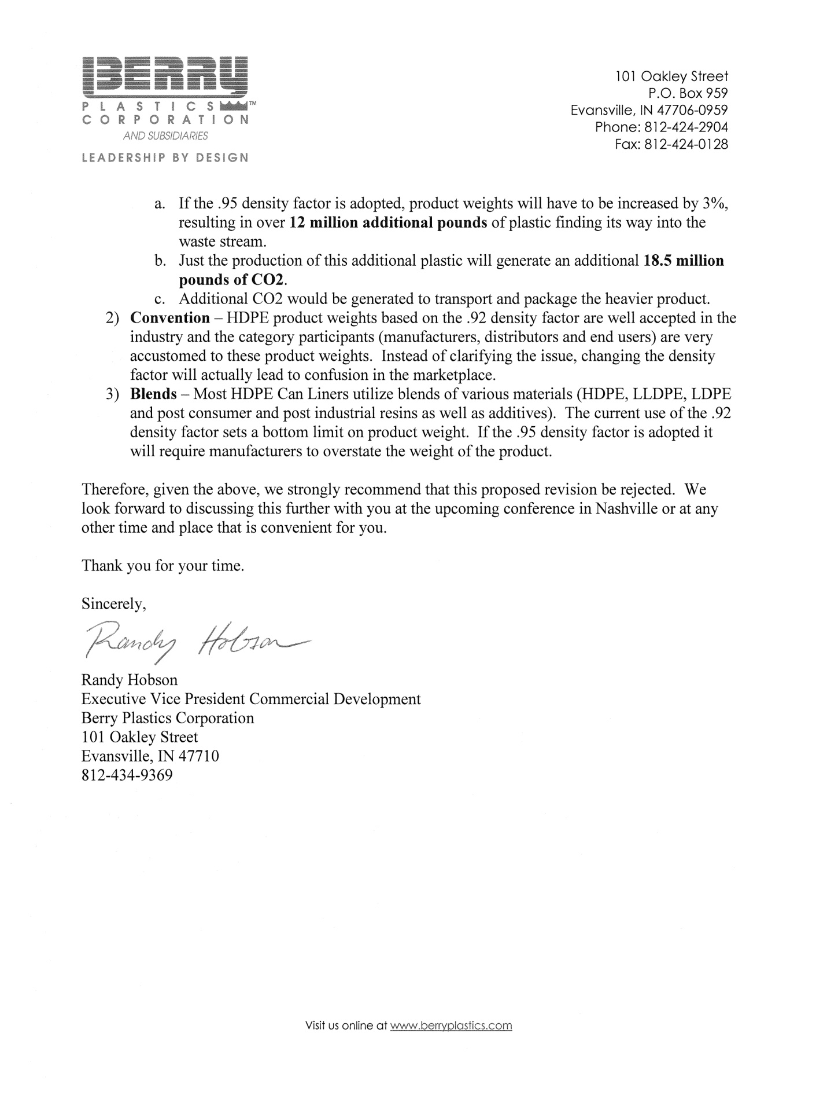

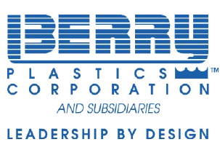

June 26, 2010
National Conference on Weights and Measures 1135 M Street
Suite 110
Lincoln, Nebraska 68508
E-mail• don.onwiler@ncwm.net
Attn: Don Onwiler
RE: Proposed Changes to Handbook 130, Method of Sale Regulation Section 2.13.4. "Declaration of Weight"
Dear Don:
This letter is in reference to the proposed changes to Handbook 130, Method of Sale Regulation Section 2.13.4. "Declaration of Weight" (copy attached).
As you know, we attended the NCWM meeting in Nashville this year to present Berry Plastics' opposition to the above referenced Handbook 130 proposed changes. The purpose of this letter is to reiterate our opposition to this proposal.
Background
Berry Plastics Corporation is a leading manufacturer and marketer of HDPE and LLDPE Institutional Can Liners. Berry Plastics is a long time participant in this market and is well versed in the category mechanics and needs of stakeholders (end user, distributor and manufacturer).
Recommendation
Berry Plastics respectfully requests the NCWM Laws and Regulations Committee reject the above referenced proposal for three reasons:
- Blends — Most HDPE Can Liners utilize blends of various materials (HDPE, LLDPE, LDPE and post consumer and post industrial resins as well as additives). The current use of the .92 density factor sets a bottom limit on product weight. If the .95 density factor is adopted it will require manufacturers to overstate the weight of the product.
- Convention — HDPE Can Liner product weights based on the .92 density factor are well accepted in the industry and the category participants (manufacturers, distributors and end users) are very accustomed to these product weights. Instead of clarifying the issue, changing the density factor will actually lead to confusion in the marketplace.

3) Sustainability — The strongest reason for rejecting this proposal relates to
Sustainability. The Institutional Can Liner market is untracked; however, we estimate the size of the HDPE segment at 400 million pounds per year.
- If the .95 density factor is adopted, and if industry increases product weights an additional 12 million pounds of plastic will find its way into the waste stream.
- Just the production of this additional plastic will generate an additional 18.5 million pounds of CO2.
- Additional CO2 would be generated to transport and package the heavier product.
Given the above, we strongly recommend that this proposed revision be rejected.
Don, as always we appreciate all you do for the organization and we thank you for reviewing our position on this proposal.
I look forward to seeing you in St. Paul this July. Best regards,
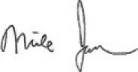
Michael T. Jackelen
Vice President
Berry Plastics Corporation
1401 West 94th Street
Minneapolis, MN 55431
mikejackelen@berryplastics.com Telephone Number — 952/885-9232
CC Lisa Warfield (lisa.warfield@nist.gov)

THIS PAGE INTENTIONALLY LEFT BLANK

This page intentionally left blank

