Appendix H

Agricultural Seed Count Rule

Table of Contents

Page
American Seed Trade Association (ASTA) Seed Count Rule H3
Association of American Seed Analyst (AASA) H11
Association of American Seed Control Officials (AASCO) H13
National Corn Growers Association (NCGA) H15
American Soybean Association (ASA) H16
Iowa Soybean Association H17
Association of Official Seed Control Analysts (AOSA) H18
Iowa State University of Science and Technology H19
Iowa Department of Agriculture and Land Stewardship H21
Iowa Department of Agriculture and Land Stewardship H22
Association of American Seed Anaylst (AASA) H23
Illinois Soybean Association H24
The National Association of State Departments of Agriculture (NASDA) H25

THIS PAGE INTENTIONALLY LEFT BLANK
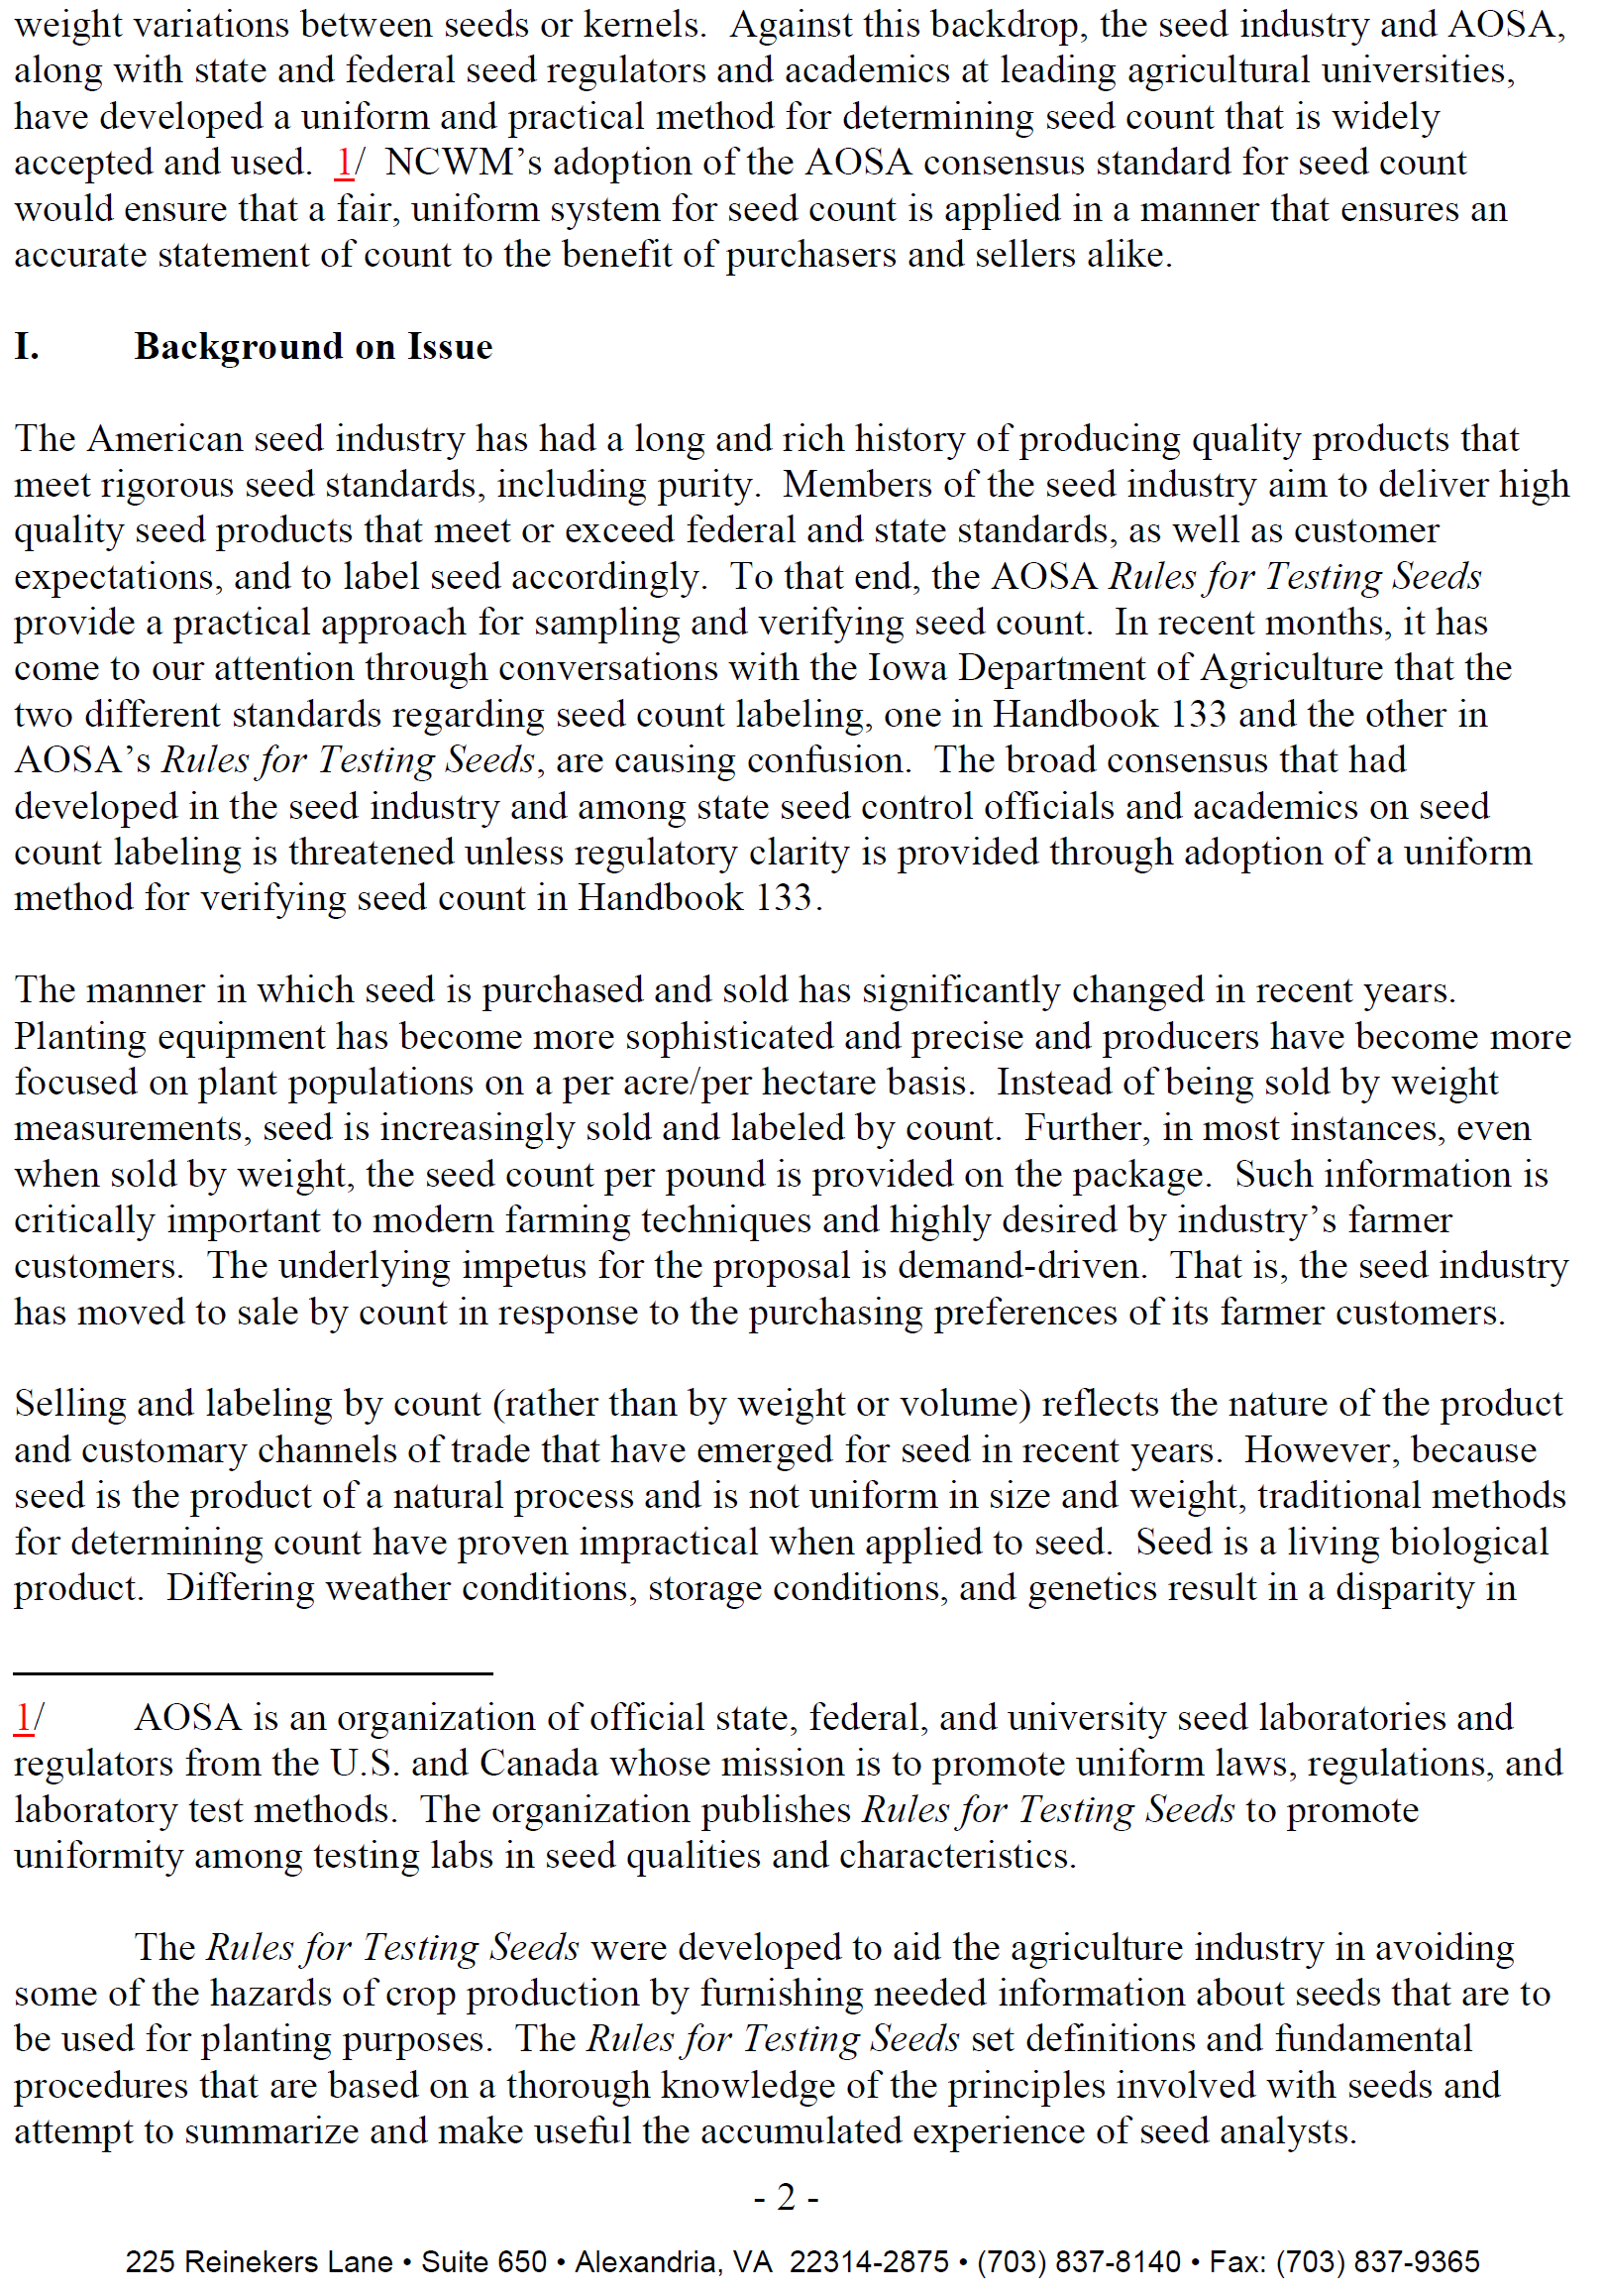
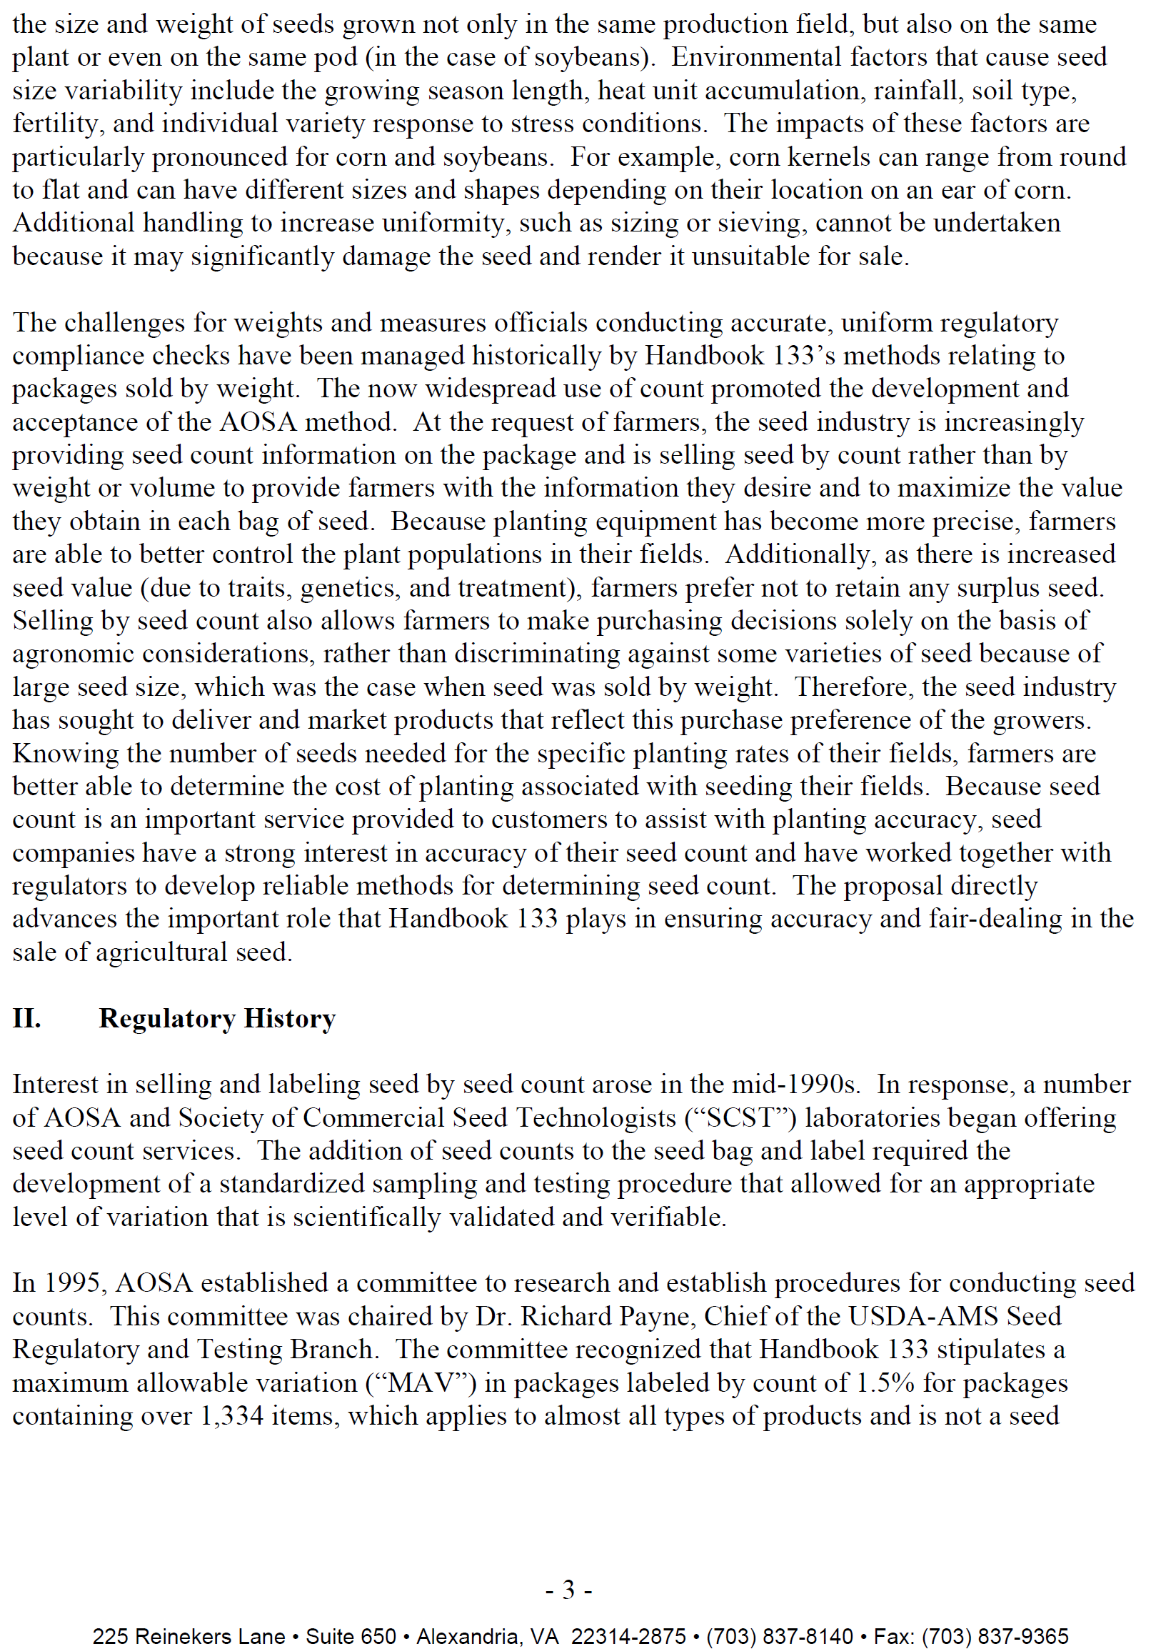
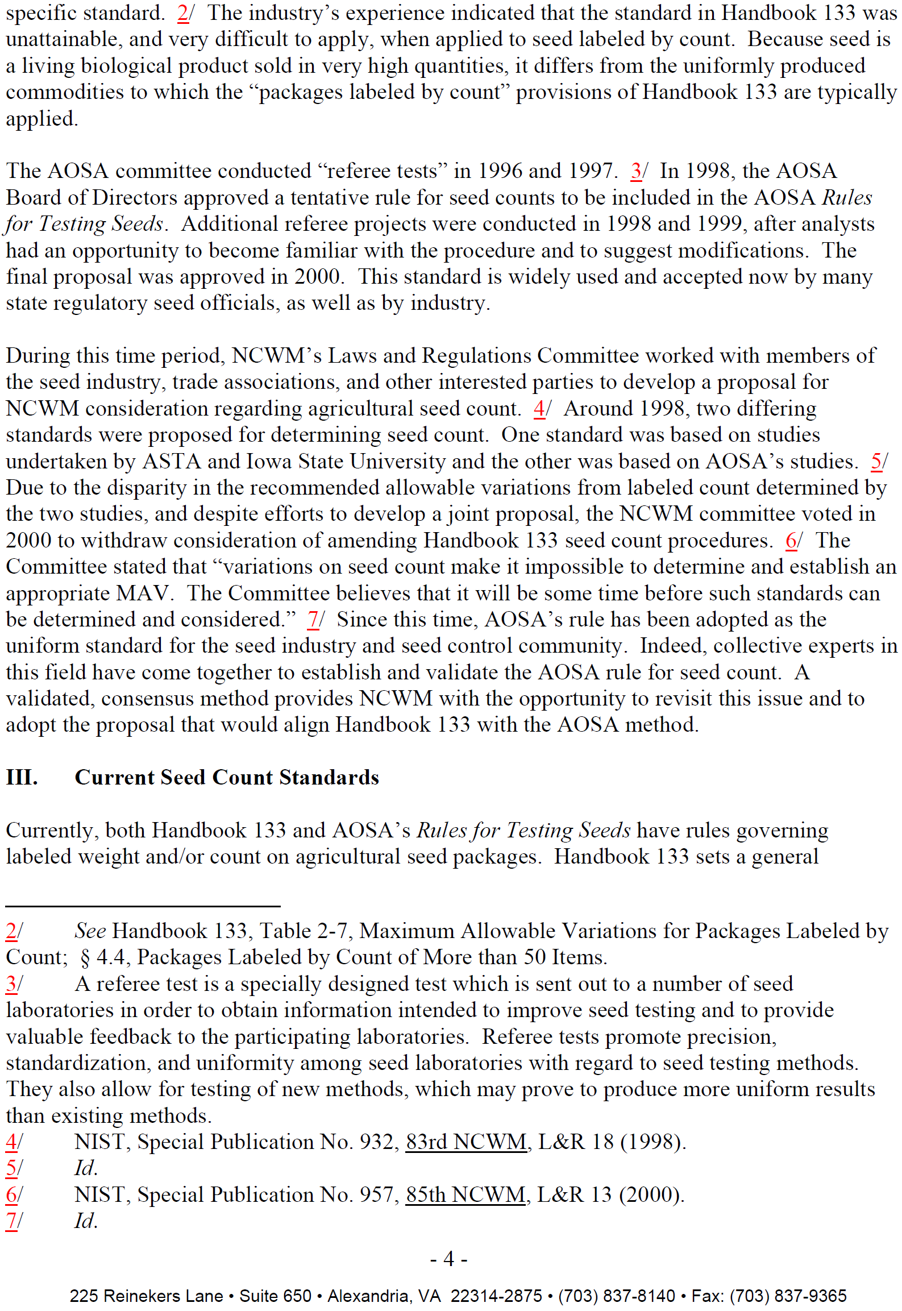
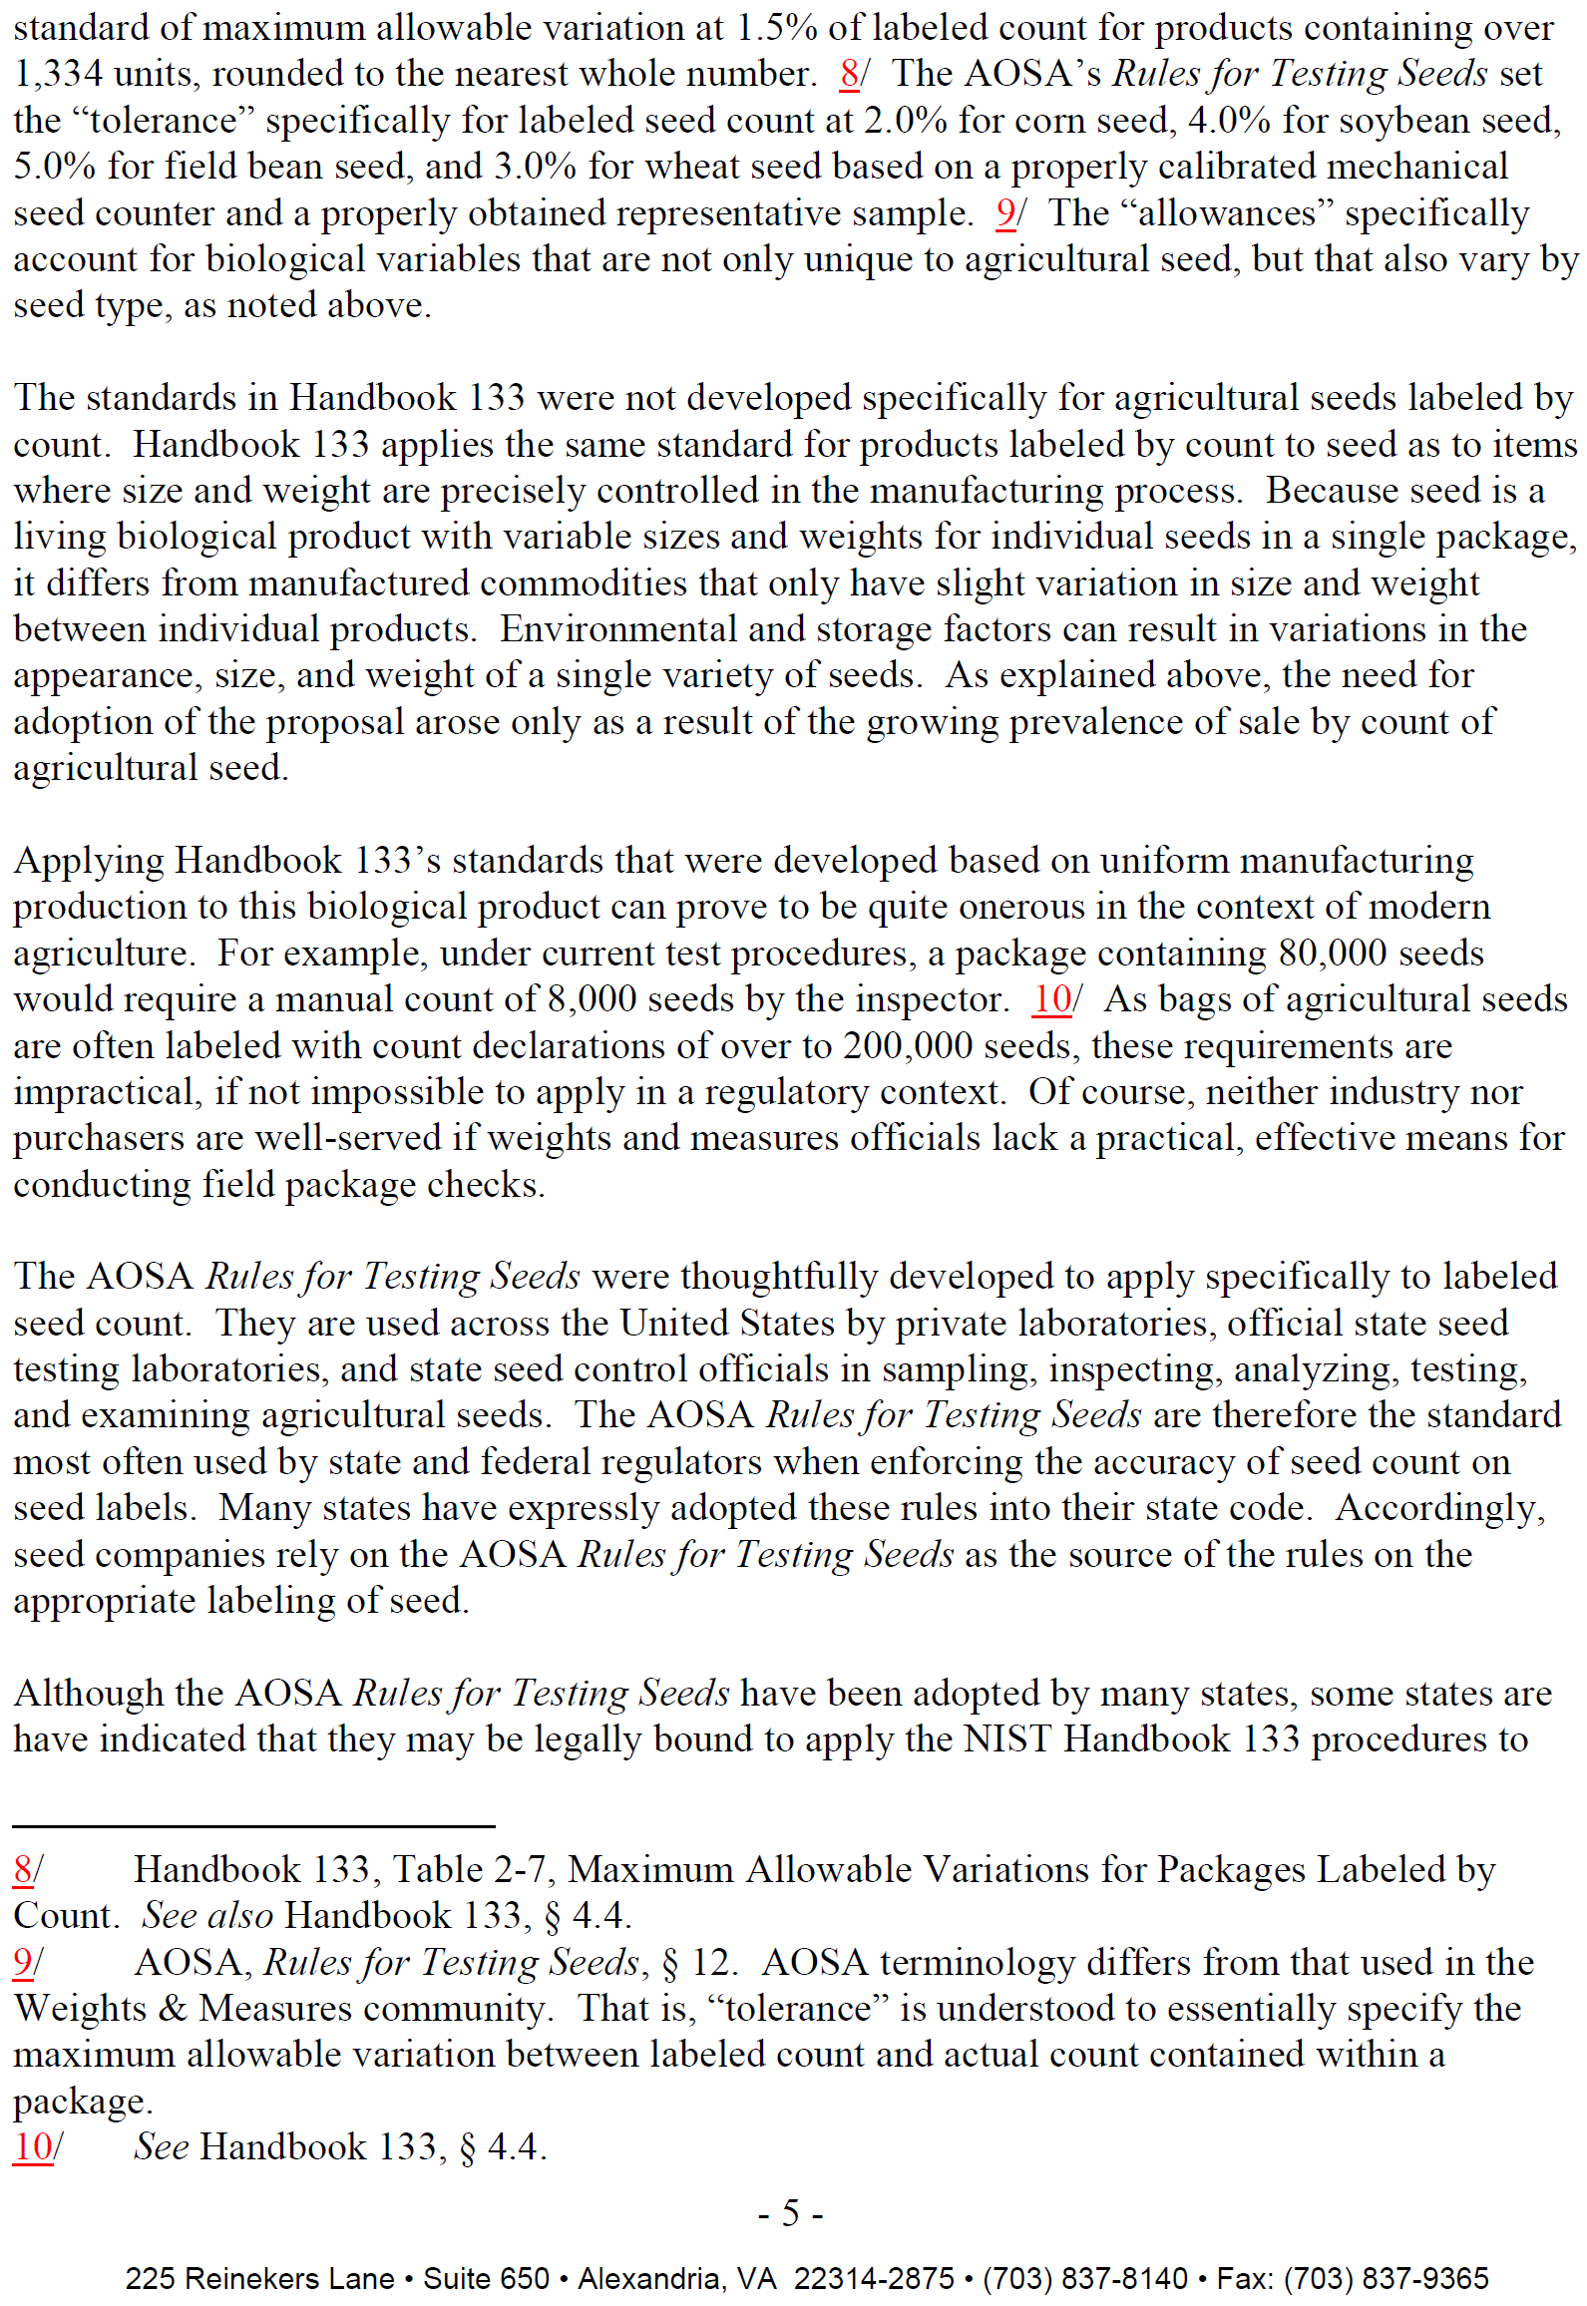
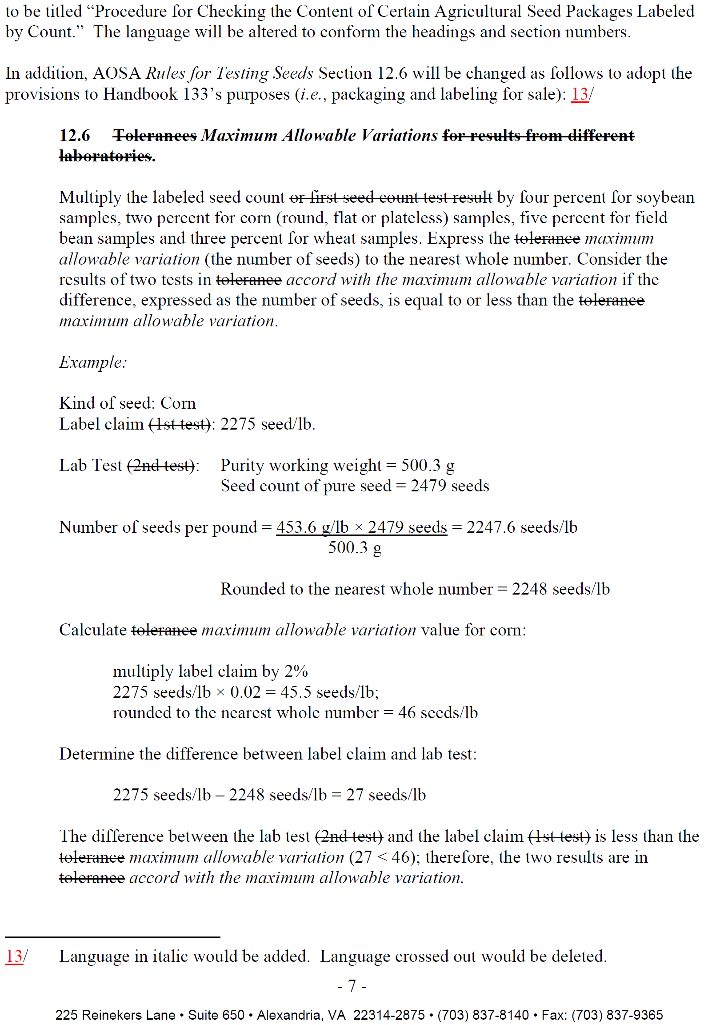
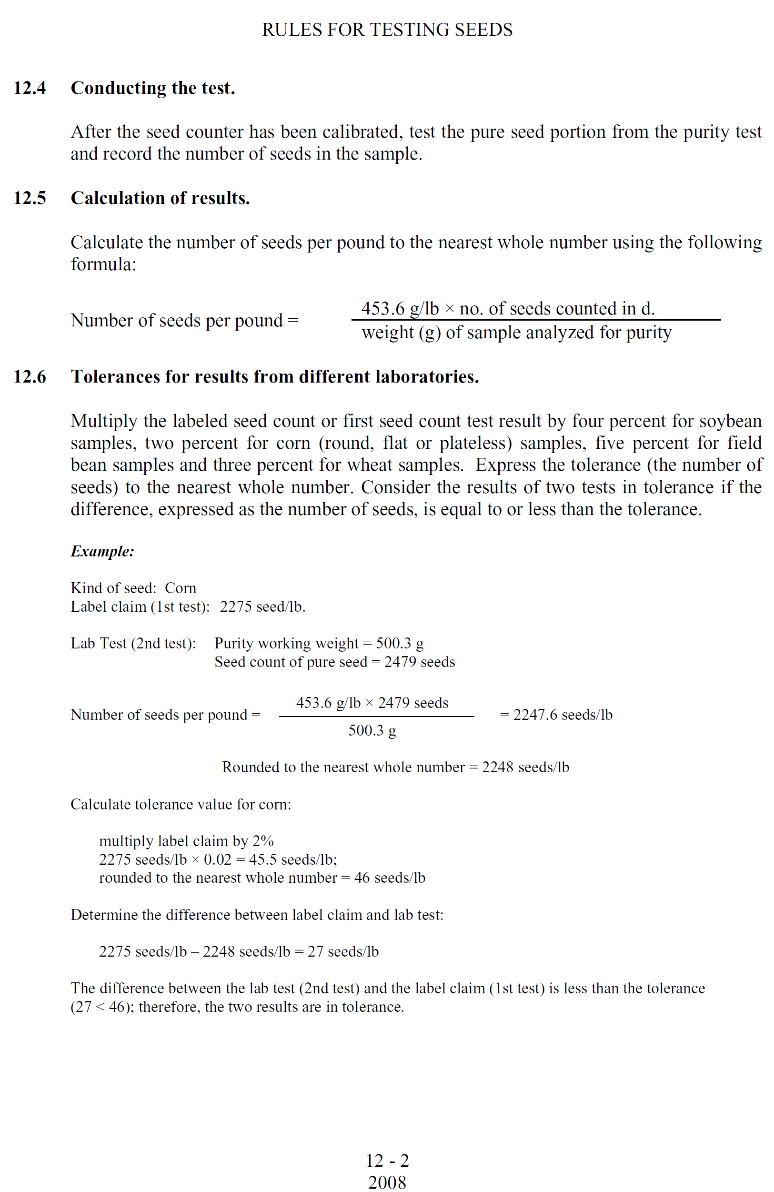

Dear Mr. Onwiler:
The National Corn Growers Association (NCGA) supports adoption of the proposal requesting the National Conference on Weights and Measures amend the National Institute for Standards and Technology (NIST) Handbook 133 by adopting the mechanical seed count procedures for agricultural seed promulgated by the Association of Official Seed Analysts (AOSA) in its Rules for Testing Seeds. Founded in 1957, NCGA represents approximately 35,000 dues-paying corn growers and the interests of more than 300,000 farmers who contribute through corn checkoff programs in their states. NCGA and its 48 affiliated state associations and checkoff organizations work together to help protect and
advance corn growers’ interests.
We believe that farmers currently prefer to purchase bulk seed by count rather than weight. We also believe that a 2% Maximum Allowable Variation (MAV) for corn would be a more accurate way for farmers to purchase the right amount of seed.
We believe the National Conference on Weights and Measures should approve the use of AOSA’s seed count rules and that the AOSA documented MAV’s for corn seed count be harmonized into NIST.
Sincerely,
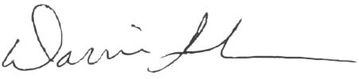
Darrin Ihnen President
HEADQUARTER OFFICE WASHINGTON DC OFFICE 632 Cepi Drive 122 C Street NW, Suite 510 Chesterfield, Missouri 63005 Washington, DC 20001-2109 (636)733-9004 (202) 628-7001 FAX: (636) 733-9005 FAX: (202) 628-1933

Mr. Don Onwiler Executive Director National Conference on Weights and Measures 1135 M Street, Suite 110 Lincoln, Nebraska 68508
January 22, 2010
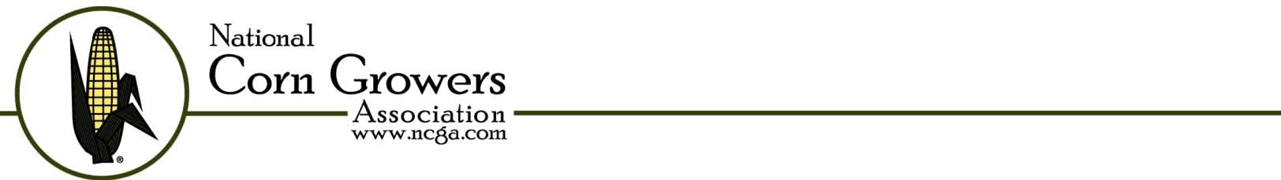

January 14, 2010

Andrew W. LaVigne
President and CEO
American Seed Trade Association

Dear Andrew:

On behalf of the American Soybean Association (ASA), I would like to express our support for the seed count procedures for agricultural seed recommended by the Association of Official Seed Analysts (AOSA). Adoption of the AOSA standard would provide a consistent seed count that benefits both seed customers and seed merchants.

Soybean producers prefer to purchase bulk seed by count rather than weight. Since soybean seeds vary in size, newer, more precise planting equipment is designed to plant by numbered populations rather than by weight. Larger seeds weigh more, so purchasing by weight could end up shorting a farmer on population density. Therefore, having a count (within the 4% maximum allowable variance established by AOSA) is a more accurate way for farmers to purchase the right amount of seed.

AOSA has developed uniform and practical methods for testing seed which are widely accepted. We believe the National Conference on Weights and Measures should approve the use of AOSA’s seed count rules, relying on the extensive testing that has gone into the accuracy of the process. We also ask that the National Institute for Standards and Technology (NIST) adopt the methods and variances for soybean seed count as found in AOSA rules.

Sincerely,
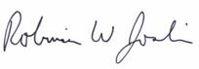
Robinson L. Joslin, President
American Soybean Association

WASHINGTON OFFICE PHONE: 202.969.7040, FAX: 202.969.7036

600 PENNSYLVANIA AVENUE, S.E., STE. 320, WASHINGTON, DC 20003 www.soygrowers.com

November 23, 2009

Andrew W. LaVigne
President and CEO
American Seed Trade Association

Dear Andrew:

On behalf of Iowa’s soybean farmers, the Iowa Soybean Association wishes to speak in support of adopting the seed count procedures for agricultural seed as put forth by the Association of Official Seed Analysts (AOSA). We believe that farmers currently prefer to purchase bulk seed by count rather than weight. Soybean seeds vary in size but newer, more precise planting equipment plants by numbered populations rather than by weight. Larger seeds weigh more, so purchasing by weight could end up shorting a farmer on population density. Therefore, having a count (within the 4% maximum allowable variance established by AOSA) is a more accurate way for farmers to purchase the right amount of seed.

We believe that AOSA has developed uniform and practical methods for testing seed which are widely accepted. Adoption of the AOSA standard would provide a consistent seed count that benefits both seed customers and seed merchants.

We believe the National Conference on Weights and Measures should approve the use of AOSA’s seed count rules, relying on the extensive testing that has gone into the accuracy of the process. We also ask that the National Institute for Standards and Technology (NIST) adopt the methods and variances for soybean seed count as found in AOSA rules.

Sincerely,

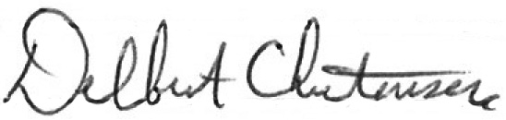

Delbert Christensen, President
Iowa Soybean Association


January 7, 2010
Don Onwiler, Executive Director National Conference on Weights and Measures
1135 M Street, Suite 110 Lincoln, Nebraska 68508
RE: Seed Count for Agricultural Seeds
Dear Mr. Onwiler,
The Association of Official Seed Control Analysts (AOSA) strongly supports the amendment of NIST Handbook 133 to adopt the procedures and maximum acceptable variances to determine seed counts as established in the Association of Official Seed Analysts’ (AOSA) “Rules for Testing Seeds”. These standardized seed testing methods and procedures are the primary basis for seed testing and seed labeling in the United States seed community. The vast majority of states recognized the AOSA Rules in their state seed laws and the Federal Seed Act incorporates AOSA testing methods and is periodically updated with AOSA Rule amendments. Adoption of these rules by the weights and measures community would promote uniformity and consistency in state laws.
Precision planting of seeds has led to changes in the way seed is labeled and sold. Farmers need to know the number of seeds in a bag in order to predetermine their planting rates and to figure the costs associated with seeding a field. Seed is the product of a natural, biological process and therefore is not uniform in size and weight. Differing weather conditions and genetics will result in disparity in the size and weight of varieties of seed corn, soybeans, field beans and wheat seed. In order to compensate for the variability of these seeds, seed companies have started to sell seed by seed count rather than by weight. Selling seed by seed count provides farmers the information they need to purchase a specific and accurate amount of seed to plant their fields.
Research had indicated that there are a number of factors that must be considered when conducting a seed count. The AOSA Rules for Testing Seeds specify sampling procedures, calibration of mechanical seed counters, pure seed unit analysts, formulas for determining the number of seeds per pound and provides scientifically based tolerances for comparing results between laboratories or comparing the label against a regulatory laboratory test.
The AOSA Seed Count Rule is the industry standard and has been accepted practice for more than a decade. It is also the standard used by seed control regulatory officials in the states that have adopted the AOSA Rules for Testing Seeds. There is clear, scientific evidence to support the procedures and tolerances included in the AOSA Rules for Testing Seeds. Seed companies are serving the consumer by selling their seed by seed count. Seed companies should be held to a consistent, fair, and practical standard in all states. It is our position that this standard should be the AOSA Rules for Testing Seeds.
Sincerely,
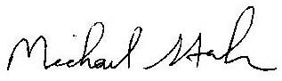
Michael G. Stahr, AOSA President Iowa State University Seed Science Center 128A Seed Science Center Iowa State University Ames, Iowa 50011 515-294-0117 (phone) Email: mgstahr@iastate.edu
101 East State St., #214, Ithaca, NY USA Phone: 607-256-3313 aosa.office@twcny.rr.com
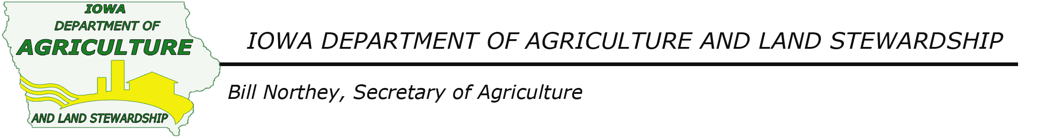
Mr. Don Onwiler, Executive Director
National Conference on Weights and Measures
1135 M Street, Suite 110
Lincoln, Nebraska 68508

Dear Mr. Onwiler:

The Iowa Department of Agriculture has been following with interest the amendment of the NIST Handbook 133 to adopt the procedures and maximum acceptable variances to determine seed counts. Our understanding is that this initiative continues to gain the support and endorsement of key agricultural groups, including the Iowa State Soybean Association.

Precision planting reinforces the benefits of this proposed amendment to the Handbook. Iowa farmers, like farmers all across the country rely on seed count when making their planting decisions each season. And, because seed is a natural biological product, it is not uniform in size and weight. In fact, differing weather conditions, storage, genetics can and often does result in disparity as it relates to weight. Farmers continue to utilize both seed count and weight when they purchase their seed. For their part, seed companies continue to respond to the farmers and are selling by count and working closely with their customers to ensure that they receive the information they need when making this important investment each planting season.

Research in seed count has indicated that there are a number of factors that must be considered when conducting a seed count. Currently, the Association of Official Seed Analysts (AOSA) has compiled its official Rules for Testing Seeds. This industry standard has been accepted practice for more than a decade. In fact, seed control regulatory officials reference these standards and use them and endorse them, too.

The Iowa Department of Agriculture and Land Stewardship is pleased to join the Iowa Soybean Association, the Association of Official Seed Analysts and the American Association of Seed Control Officials in supporting the amendment to Handbook 133. One other key ally supporting these efforts is the Iowa State University.

In summary, farmers in Iowa rely on seed count. We appreciate the leadership of the National Conference on Weights and Measures on this important initiative. We believe that this amendment is consistent and complementary to our mission to ensure that our farmers are protected and informed when purchasing seed. Confidence in seed count labeling is important to our farmers and we believe that the AOSA standards reinforce this practice and will provide additional protection, information and assistance to our farmers.

Sincerely,
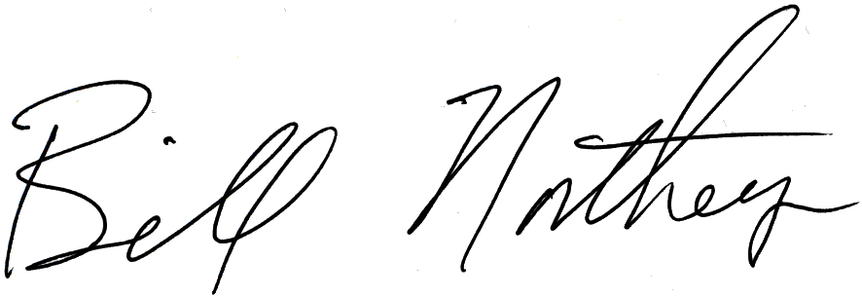
Bill Northey
Iowa Secretary of Agriculture

Henry A. Wallace Building Des Moines, Iowa 50319 515-281-5321 agri@idals.state.ia.us
The Iowa Department of Agriculture and Land Stewardship is an equal opportunity employer and provider

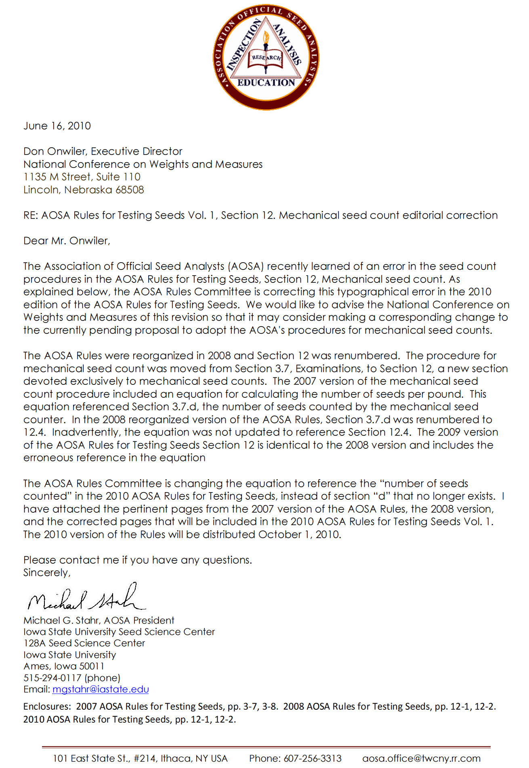
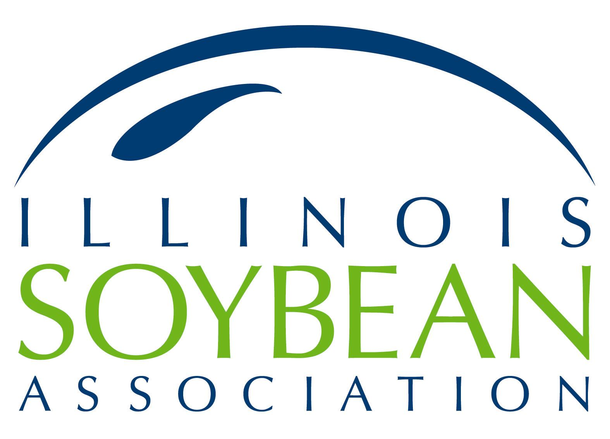 | ll  1605 Commerce Parkway  Bloomington, IL 61704  (309) 663-7692 telephone  (309) 663-6981 fax  E-mail: ilsoy@ilsoy.org  www.ilsoy.org

June 29, 2010

Mr. Andrew W. LaVigne
President and CEO
American Seed Trade Association
225 Reinekers Lane, Suite 650
Alexandria, VA 22314-2875

Dear Andrew:

On behalf of Illinois soybean farmers, the Illinois Soybean Association wishes to speak in support of the seed count procedures for agricultural seed as put forth by the Association of Official Seed Analysts (AOSA). When purchasing soybean seed, most farmers focus on count rather than weight. Soybean seeds vary in size but newer, more precise planting equipment plants by numbered populations rather than by weight. Having a count within the 4% maximum allowable variance established by AOSA is a more accurate way for farmers to purchase and use the right amount of seed.

We believe that AOSA has developed uniform and practical methods for testing seed which are widely accepted. Adoption of the AOSA standard would provide a consistent seed count that benefits both seed customers and seed merchants.

We believe the National Conference on Weights and Measures should approve the use of AOSA’s seed count rules, relying on the extensive testing that has gone into the accuracy of the process. We also ask that the National Institute for Standards and Technology (NIST) adopt the methods and variances for soybean seed count as found in AOSA rules.

Sincerely,

ILLINOIS SOYBEAN ASSOCIATION
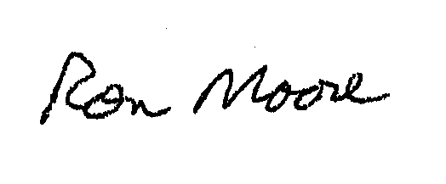
Ron Moore
President

PRODUCING RESULTS
