Appendix G

Item 237-6: Handbook 130, Engine Fuels and Automotive Lubricants Regulation

Section 3.13. Oil

Table of Contents

Page

Supporting Documentation for Item 237-6 L&R - G3
Independent Lubricant Manufacturers Association/July 15, 2011 L&R - G36

THIS PAGE INTENTIONALLY LEFT BLANK

Presentation from Dennis Bachelder, API’s Engine Oil Licensing and Certification System

Good morning. I am Dennis Bachelder from API’s Engine Oil Licensing and Certification System, and I want to thank the Chair and members of the Northeastern Weights and Measures Association Law and Regulations Committee for this opportunity to recommend a change to Handbook 130 section 3.13.1, Labeling of Vehicle Motor Oil.

Handbook 130 has for many years required that labels on motor oil packages identify the oil’s SAE viscosity and API performance level. Both of these items are important pieces of information for vehicle owners and operators and maintenance personnel entrusted with the responsibility of selecting the right motor oil for a car or truck.

While section 3.13.1 continues to meet this need for motor oil packages, it does not address bulk motor oils, the manner by which many motor oils are distributed and installed today. Over the last two decades, the distribution and installation of motor oils has undergone a radical change, shifting from a do-it-yourself process with oil installed by vehicle owners from bottles to a do-it-for-me system where the oil is installed by service providers from tanks filled by distributors. According to Kline and Company, do-it-for-me installed more than 60 percent of passenger car motor oil last year. Consumers who once scrutinized motor oil labels in auto parts stores before installing them in their cars or trucks now travel to auto dealers, quick lubes, or service centers and wait while their vehicle’s oil is changed with motor oil from a bulk oil tank. These consumers might be selecting a specific oil for their vehicle, but many are probably trusting that the service provider is installing a quality bulk oil recommended for their car or truck. API samples and tests motor oils purchased from bulk oil installers annually, and I can say that this is often the case. However, API has also found the opposite to be true. Bulk oil installers don’t always know the identity of the oil in their tanks, and in some cases they actually consciously or unconsciously misrepresent what they’re installing. More than once API sampling has found installers claiming they are dispensing one brand of oil when in fact they are installing another brand. To complicate matters further, many times the customer receipt does not identify what’s been installed. Imagine how many of these types of transactions occur every day.

The changes proposed for Handbook 130 are intended to apply the labeling requirements for packaged motor oils to oils sold in bulk. These changes as proposed would require motor oil manufacturers and distributors to identify the oils they deliver and installers the oils they dispense. Requiring distributors to identify the motor oils they deliver to installers will help ensure that installers know what they’re dispensing, and requiring installers to do the same on their invoices will provide the same level of information for consumers.

I urge the Laws and Regulations Committee of the Northeastern Weights and Measures Association to amend Handbook 130 section 3.13.1 as API has proposed.

Presentation from Kevin Ferrick, Manager of API’s Engine Oil Licensing and Certification System

Good morning. I am Kevin Ferrick, Manager of API’s Engine Oil Licensing and Certification System, and I want to thank the Chair and members of the Southern Weights and Measures Association Law and Regulations Committee for this opportunity to recommend a change to Handbook 130 section 3.13.1, Labeling of Vehicle Motor Oil.

Handbook 130 has for many years required that labels on motor oil packages identify the oil’s SAE viscosity and API performance level. Both of these items are important pieces of information for vehicle owners and operators and maintenance personnel entrusted with the responsibility of selecting the right motor oil for a car or truck.

While section 3.13.1 continues to meet this need for motor oil packages, it does not address bulk motor oils, the manner by which many motor oils are distributed and installed today. Over the last two decades, the distribution and installation of motor oils has undergone a radical change, shifting from a do-it-yourself process with oil installed by vehicle owners from bottles to a do-it-for-me system where the oil is installed by service providers from tanks filled by distributors. According to Kline and Company, do-it-for-me installed more than 60 percent of passenger car motor oil last year. Consumers who once scrutinized motor oil labels in auto parts stores before installing them in their cars or trucks now travel to auto dealers, quick lubes, or service centers and wait while their vehicle’s oil is changed with motor oil from a bulk oil tank. These consumers might be selecting a specific oil for their vehicle, but many are probably trusting that the service provider is installing a quality bulk oil recommended for their car or truck. API samples and tests motor oils purchased from bulk oil installers annually, and I can say that this is often the case. However, API has also found the opposite to be true. Bulk oil installers don’t always know the identity of the oil in their tanks, and in some cases they actually consciously or unconsciously misrepresent what they’re installing. More than once API sampling has found installers claiming they are dispensing one brand of oil when in fact they are installing another brand. To complicate matters further, many times the customer receipt does not identify what’s been installed. Imagine how many of these types of transactions occur every day.

The changes proposed for Handbook 130 are intended to apply the labeling requirements for packaged motor oils to oils sold in bulk. These changes as proposed would require motor oil manufacturers and distributors to identify the oils they deliver and installers the oils they dispense. Requiring distributors to identify the motor oils they deliver to installers will help ensure that installers know what they’re dispensing, and requiring installers to do the same on their invoices will provide the same level of information for consumers.

I urge the Laws and Regulations Committee of the Southern Weights and Measures Association to amend Handbook 130 section 3.13.1 as API has proposed.


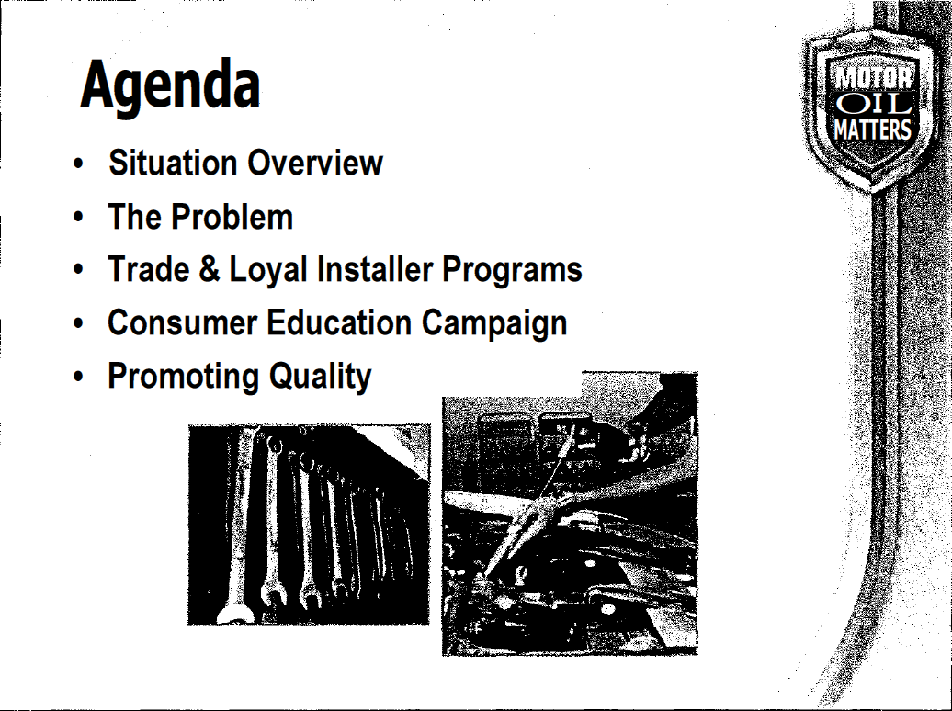
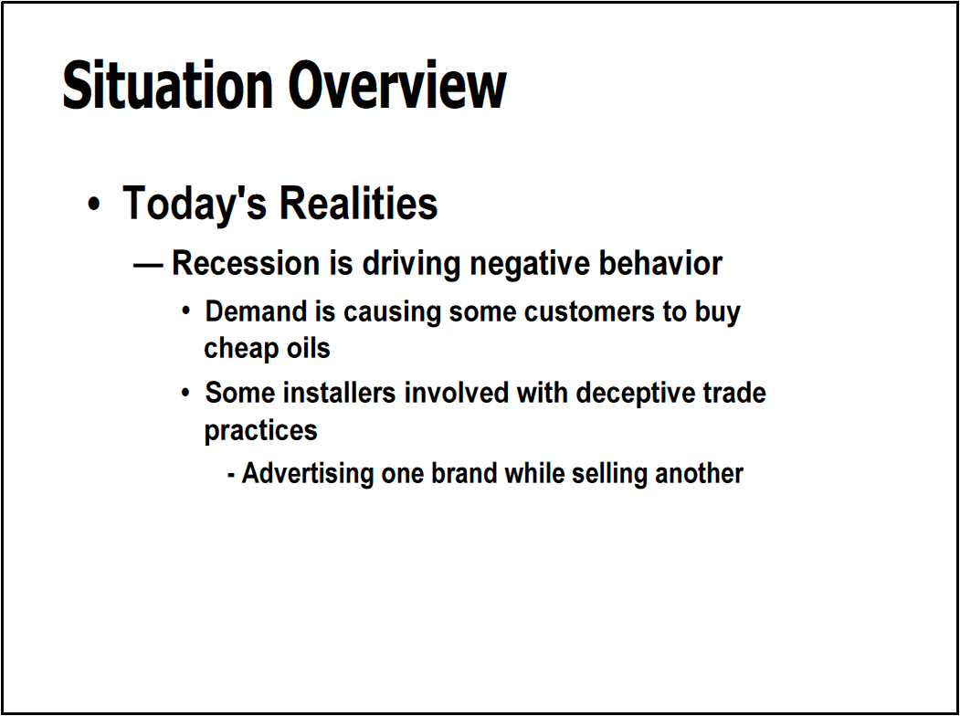
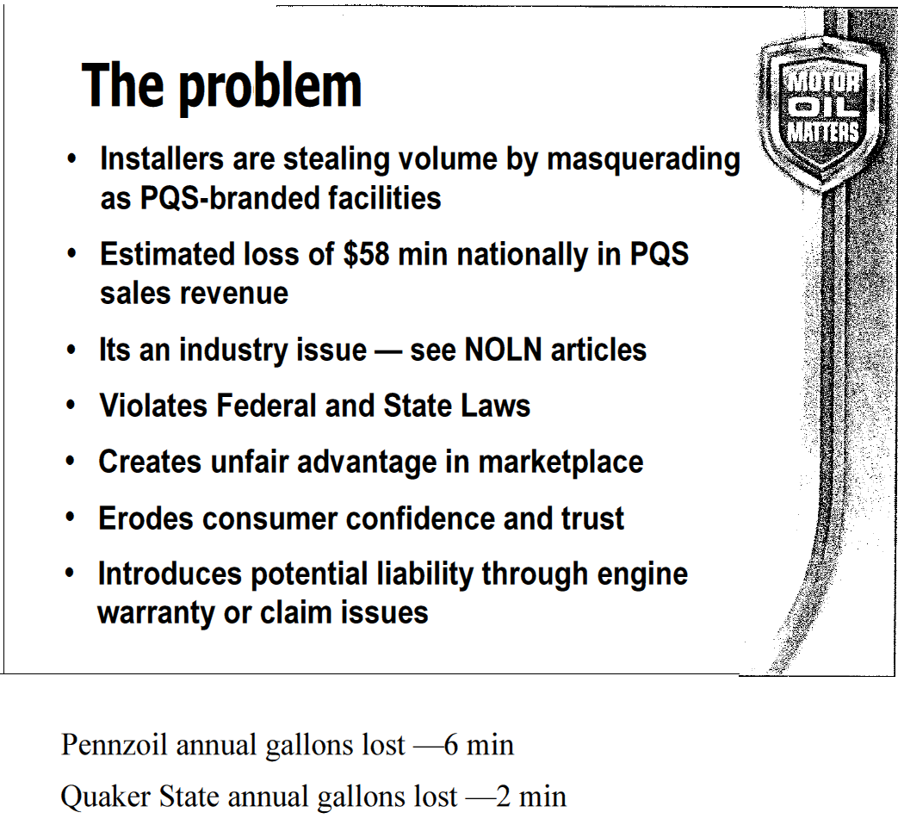
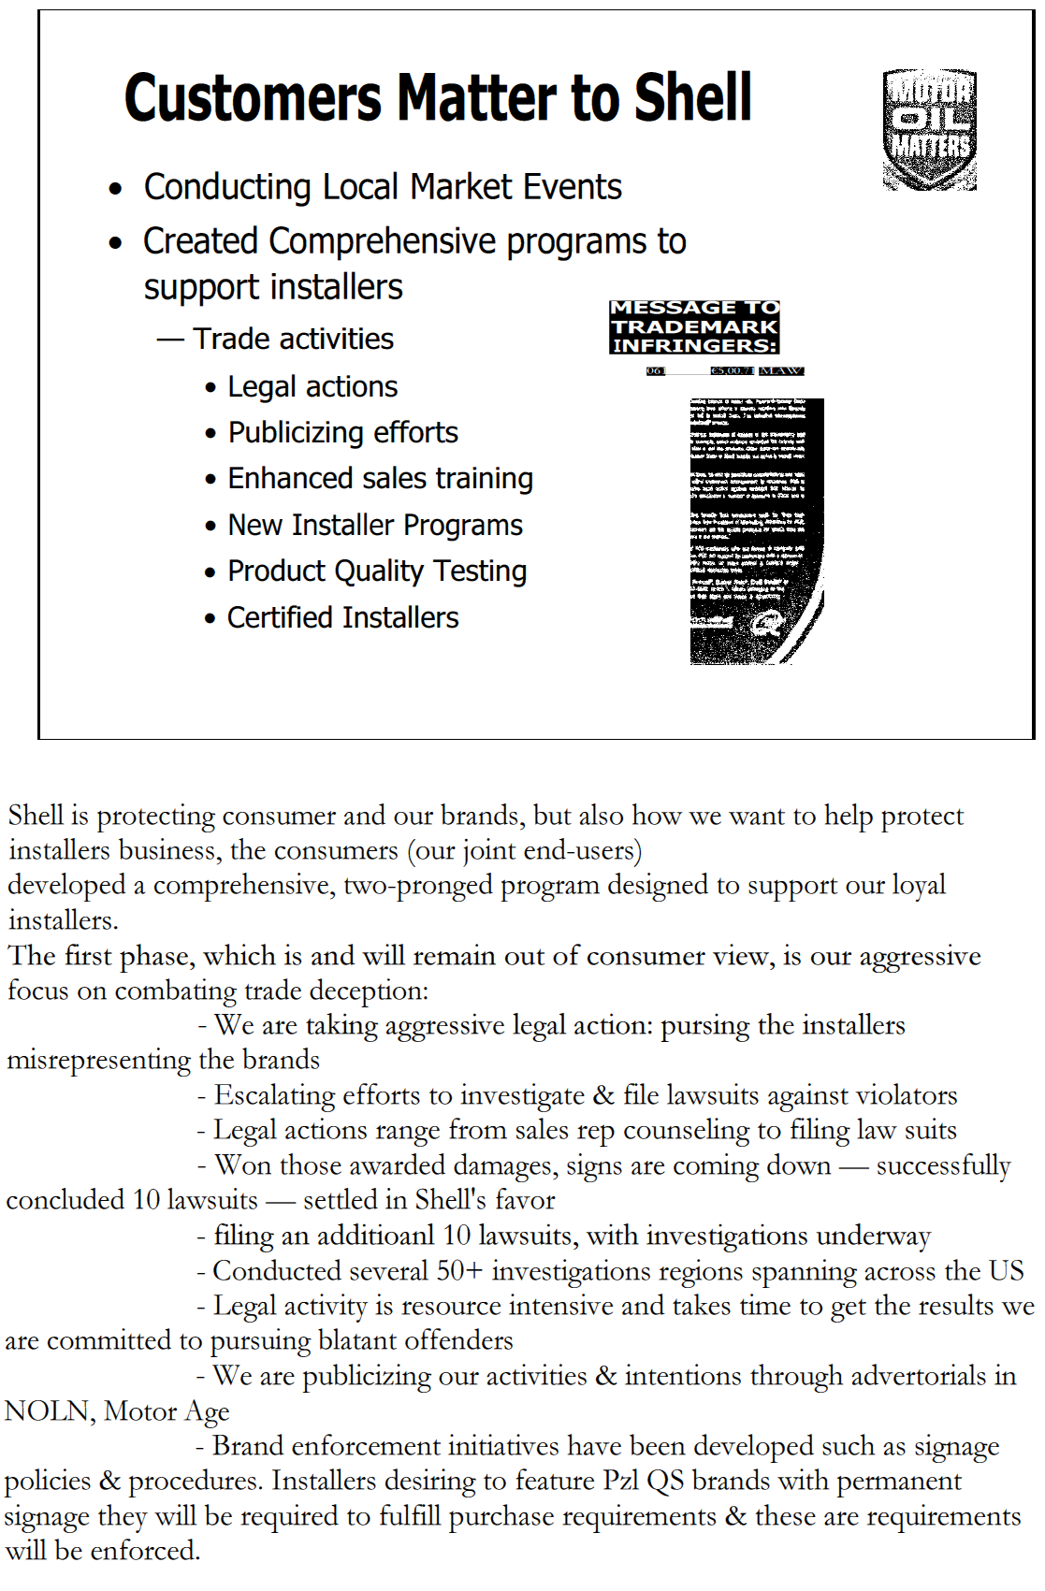
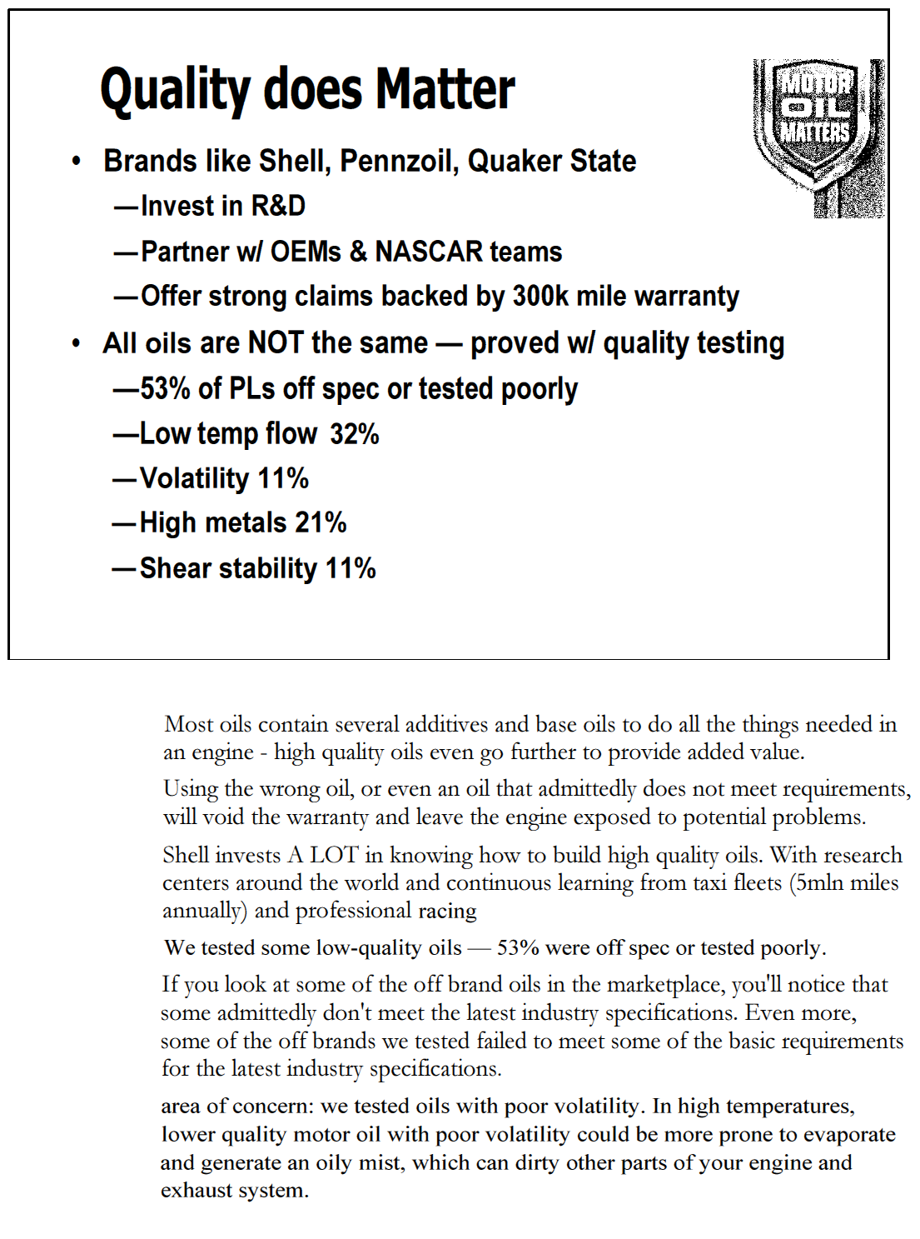
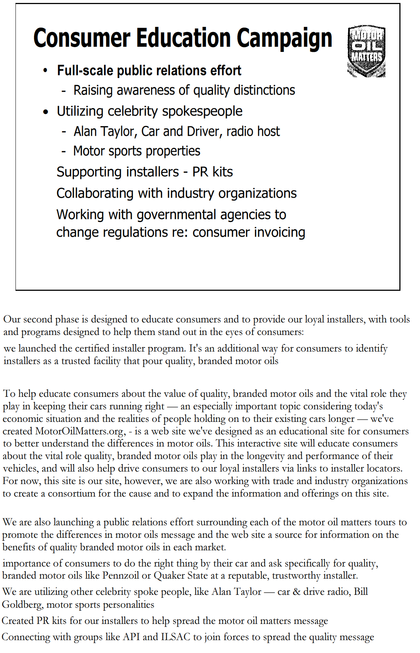
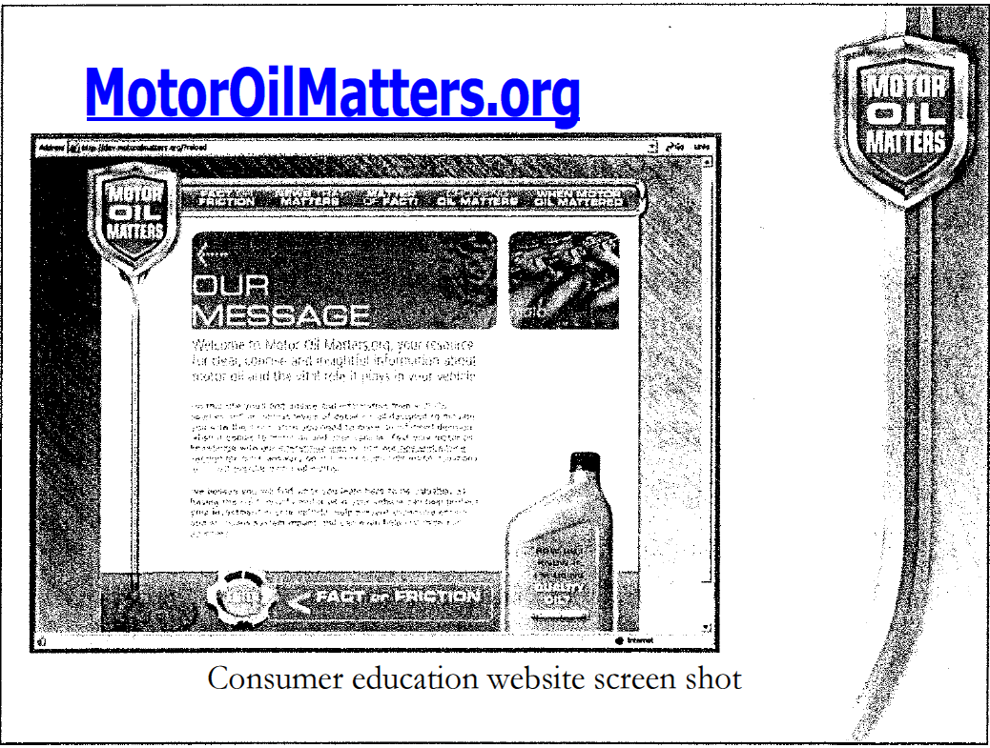
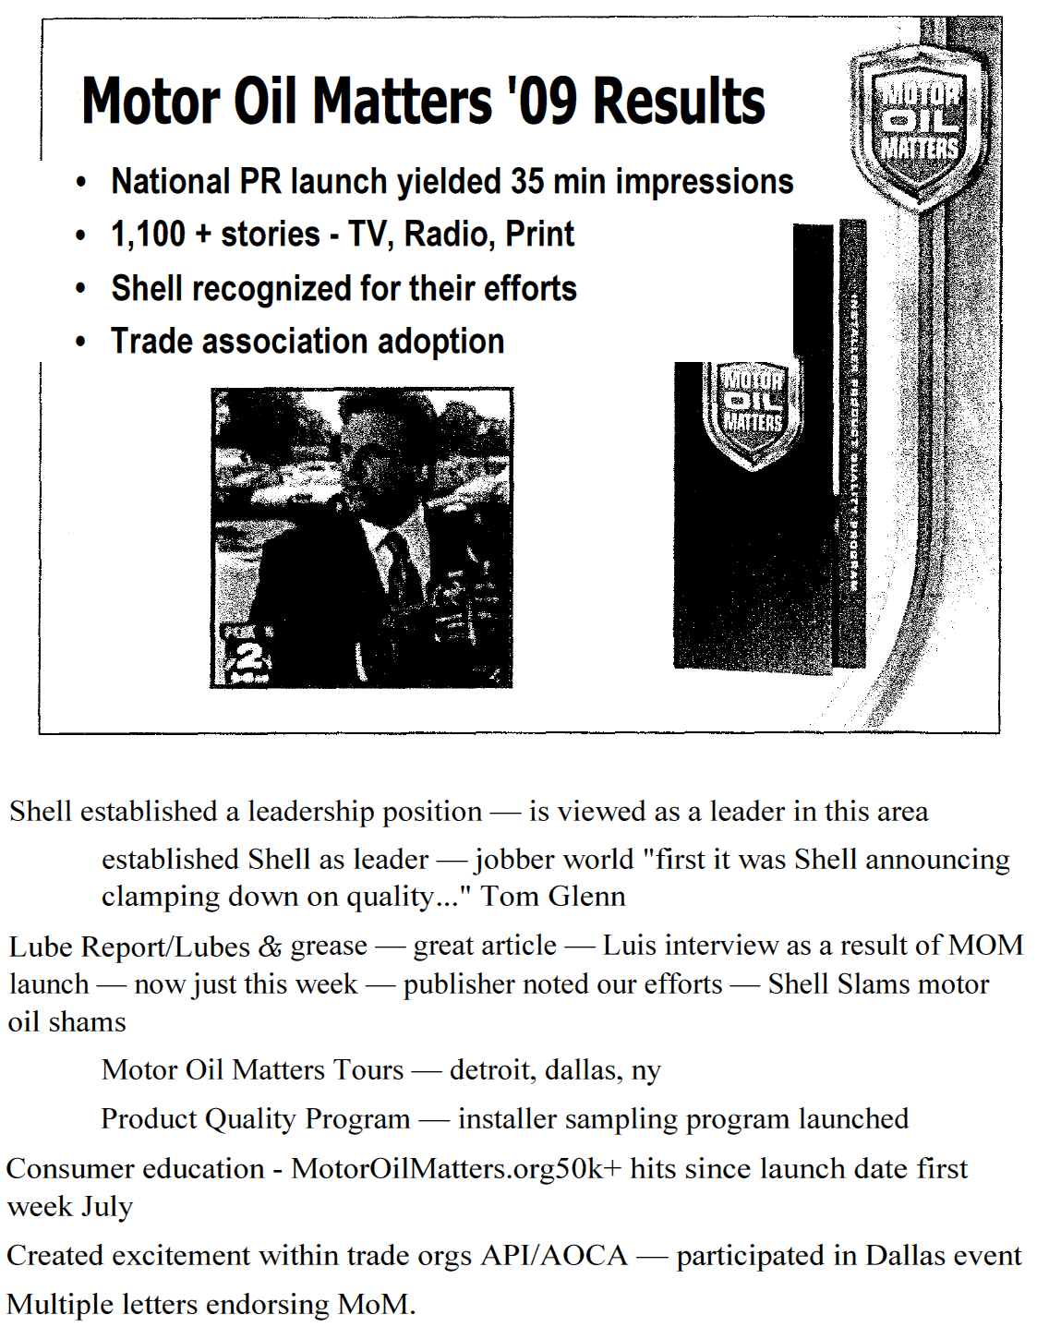
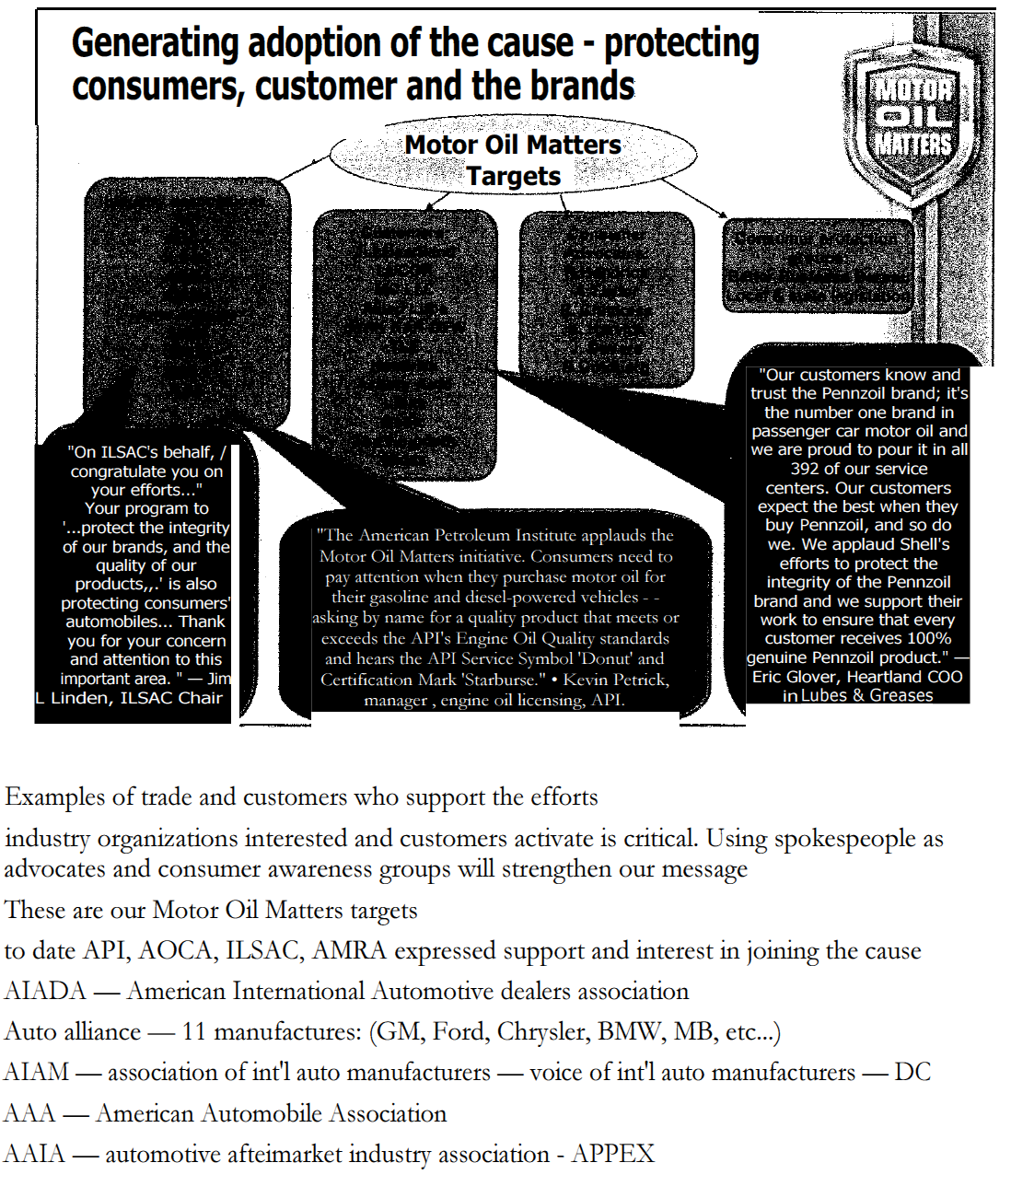
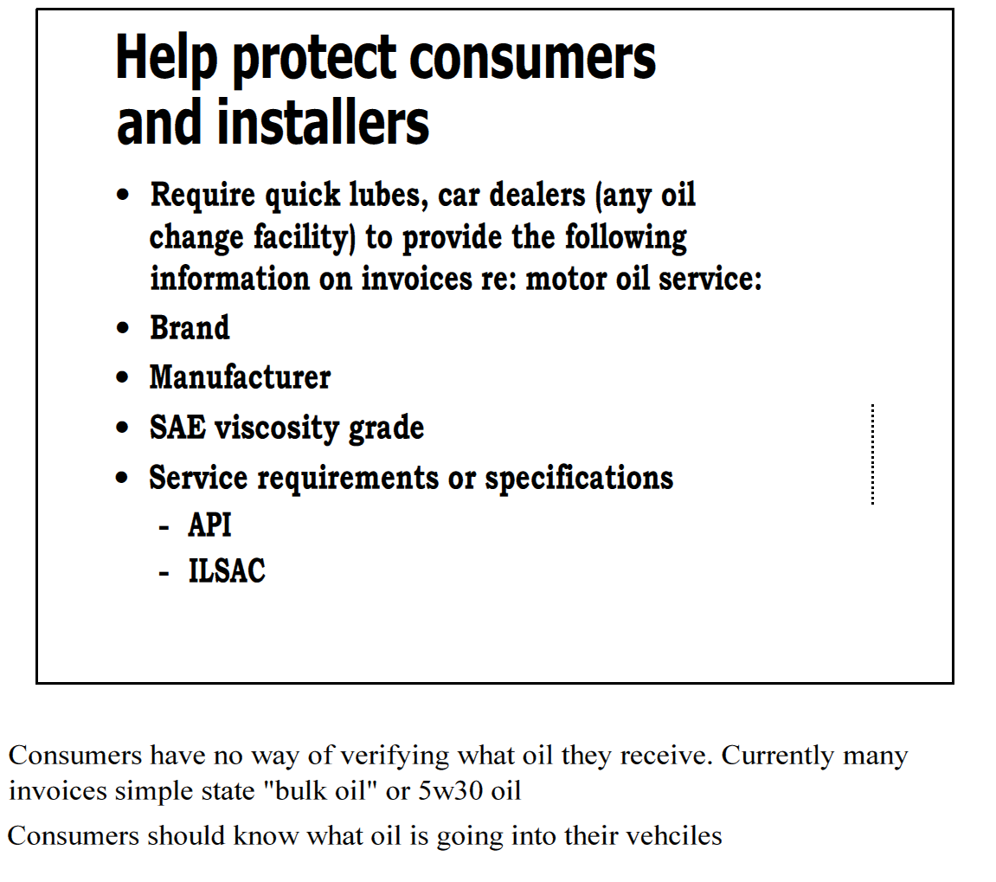

August 6, 2009
Luis Guimaraes
General Manager — Marketing Shell Lubricants North America
Mr. Guimaraes,
The International Lubricant Standardization and Approval Committee (ILSAC) (General Motors, Ford, Chrysler, and JAMA) recently learned about Shell's new initiative to monitor lubricant quality in the market (reference the attached Lube Report article by George Gill of LNG Publishing). On ILSAC's behalf, I congratulate you on your efforts to ensure that consumers are receiving the quality of oils they are expecting and paying for, and that their Owners Manuals are recommending. ILSAC, in partnership with the Oil and Additive industries, expends considerable time, effort, and money in developing the specifications for good quality oils that our mutual customers need for use in their automobiles. However, if the consumer is supplied with oils of questionable or poor quality, your industry and mine both suffer, along with the wronged consumer. Your program to "...protect the integrity of our brands, and the quality of our products..." is also protecting consumers' automobiles by helping to keep high quality lubricants available, and as such, is applauded by the automobile manufacturers. Thank you for your concern and attention to this important area. 1LSAC extends an offer to you personally or a Shell representative to meet with the ILSAC to review the findings of your product quality program. Please contact me if you have any questions.
Jim Linden, Chair ILSAC
General Motors Research and Development 586-986-1888, 248-321-5343 (mobile) james.I.Iinden@gm.com

C: Scott Lindholm

 |  | 
 |  |  |  | GM

INTERNATIONAL LUBRICANT
STANDARDIZATION AND APPROVAL
COMMITTEE
American International
AutomobileDealers
November 2, 2009
Elizabeth Boehm-Miller
Growth Manager, US
Shell Lubricants North America 700 Milam
Houston, TX 77002
Dear Ms. Boehm-Miller:
The American International Automobile Dealers Association would like to commend Shell Lubricants for their Motor Oil Matters initiative and ongoing efforts to educate consumers about the vital role of quality motor oils. AIADA represents the more than 10,000 international automobile franchises and their more than 500,000 employees in the United States.
AIADA recognizes the need to make consumers aware of the importance of using quality motor oil and how it can help extend engine life and improve overall engine efficiency. An efficient engine can result in lower emissions and increased fuel economy. Low quality motor oils that do not meet a vehicle manufacturer's requirements or industry standards can potentially damage a vehicle's engine or void the manufacturer's warranty, costing the consumer in the long run.
AIADA is dedicated exclusively to the economic and political interests of America's international nameplate automobile dealers. The manufacturers of the vehicles our dealers sell and service have spent considerable time and money to design and build engines with the fuel economy and performance that consumers demand. Quality motor oils that meet the stringent requirements manufacturers recommend are vital to the proper operation of these engines in a variety of conditions and can help to ensure a long life of reliable performance. We laud your Motor Oil Matters initiative for educating consumers to specifically request quality motor oils, as well as encouraging any facility that changes oil to do their part to help consumers receive the quality of oil they need to protect their vehicles.
Thank you for bringing this important message to vehicle owners.
Best regards,

American International Automobile Dealers Association
211 N Union Street, Suite 300, Alexandria, Virginia 22314
T: 703.519.7800 • F: 703.519.7810
www.aiada.org
AUGUST 2009 VOL. 15 ISSUE 8
LUBES 'N' GREASES

PUBLISHER'S LETTER

Nancy DeMarco
