Appendix F

Item 237-4: Handbook 130, Engine Fuels and
Automotive Lubricants Regulation

Secion 2.1.2. Gasoline-Oxygentated Blends and Section 2.1.3. Gasoline-Ethanol Blends

Table of Contents

Page

ASTM Specification Change Process F3
Update: New Ethanol Blends F5
Summary of Auto/Oil E10+ Test Program for Highway “Non-FFV” Vehicles F9
Mid Level Ethanol Blends Research Coordination Group Compilation of Projects with E10+ Fuel Formulation Information F11
Growmark F50
Illinois Renewable Fuels Association (ILRFA) F51

THIS PAGE INTENTIONALLY LEFT BLANK

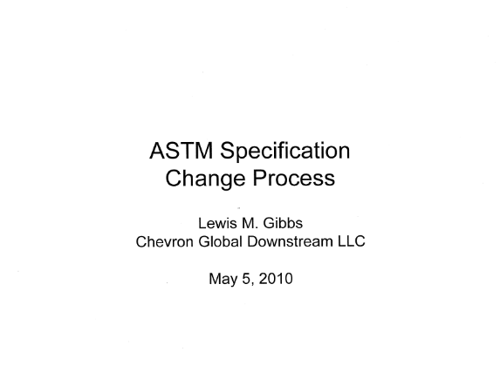 | 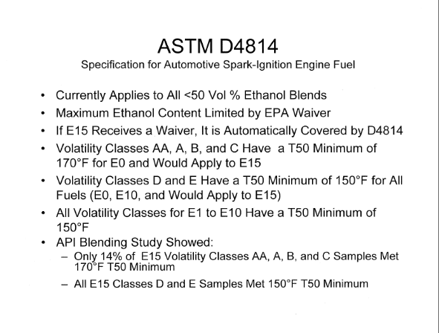
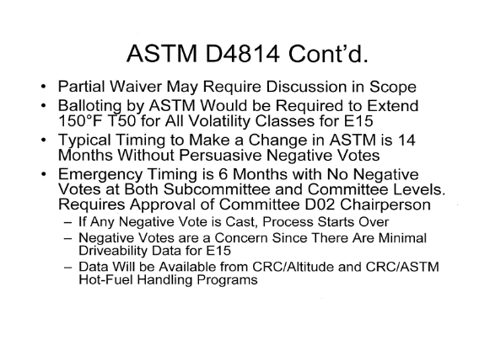 | 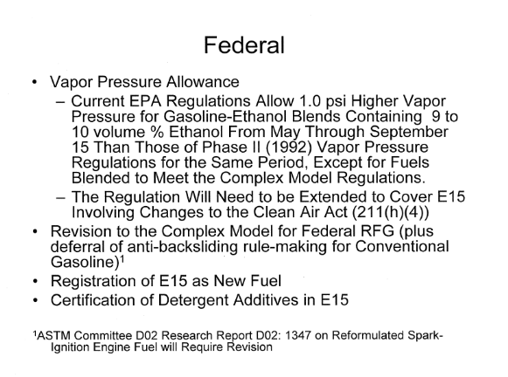
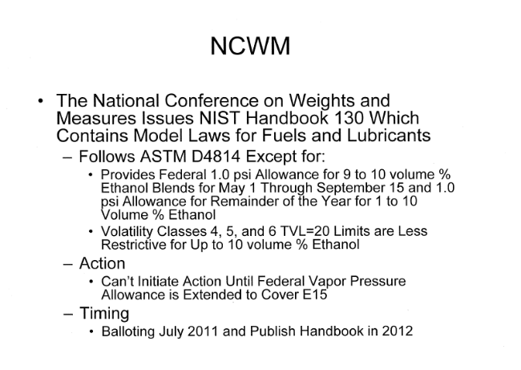 | 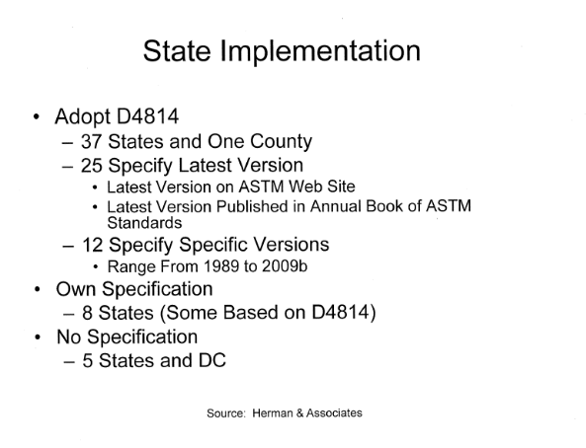

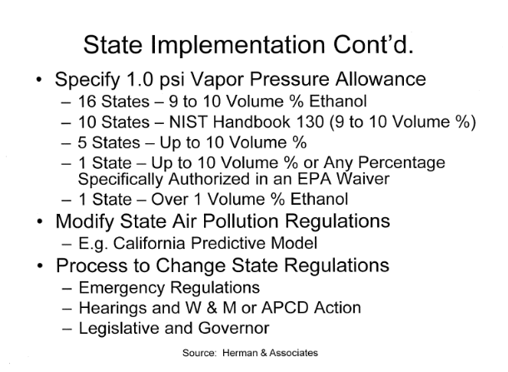 | 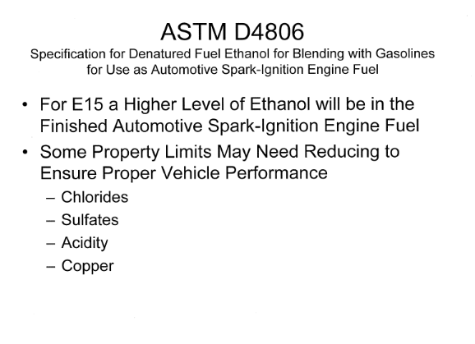

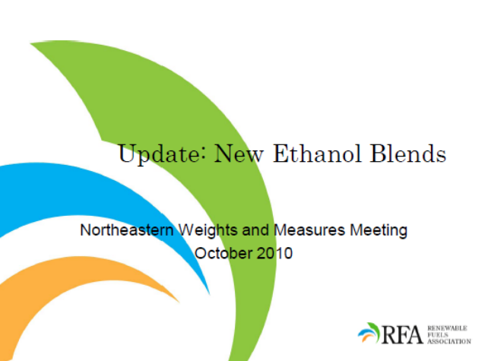 | 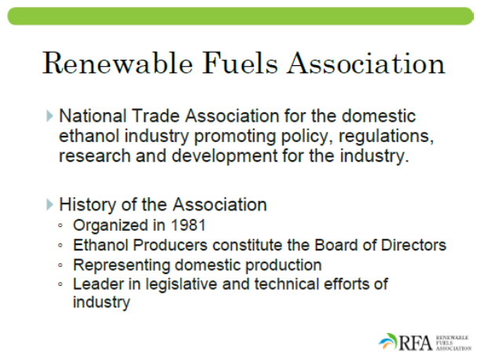
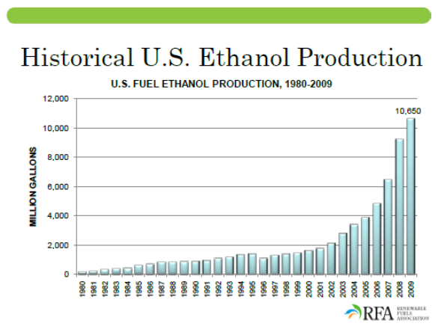 | 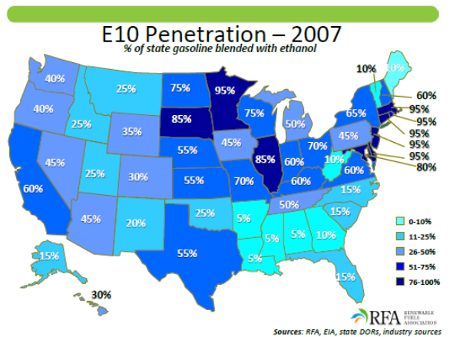
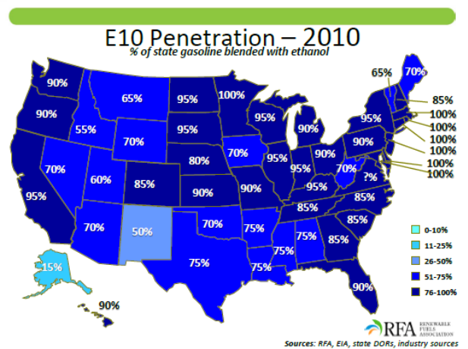 | 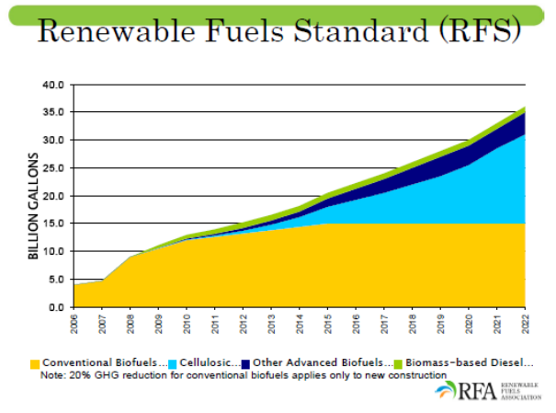

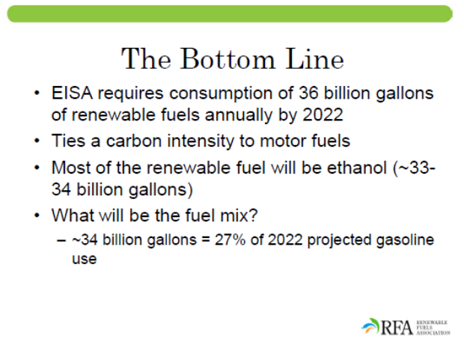 | 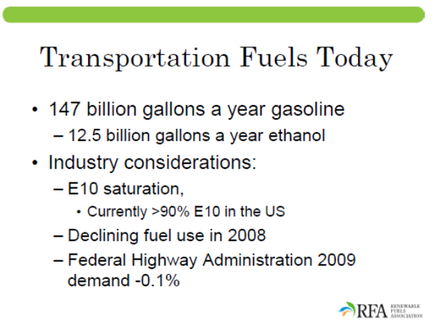
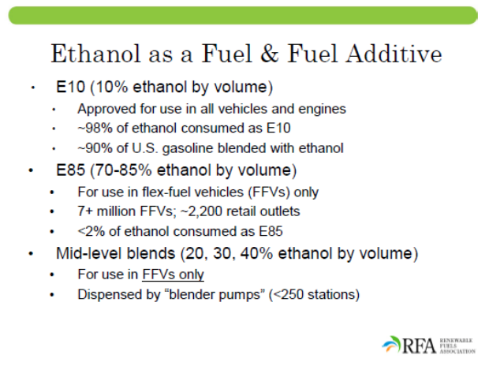 | 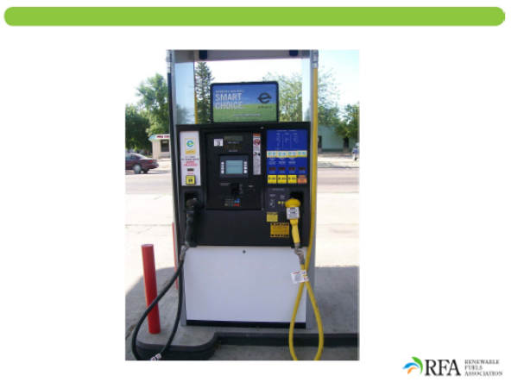
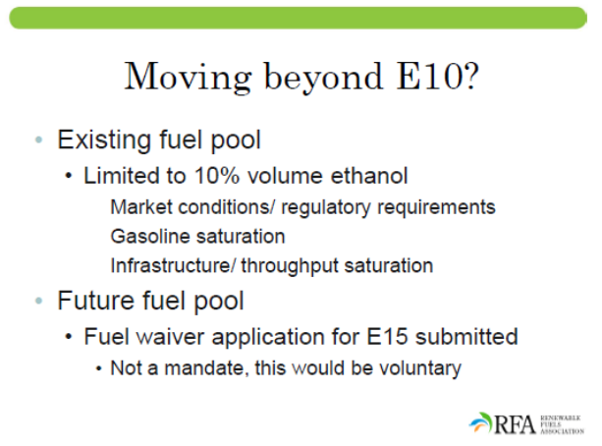 | 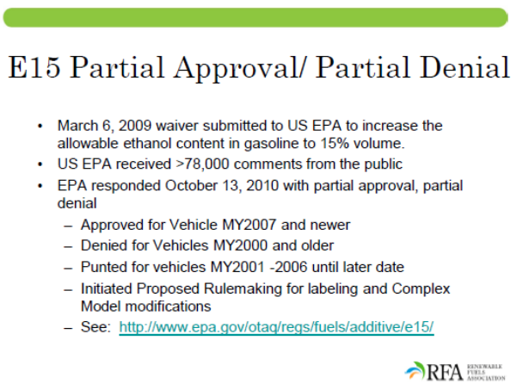

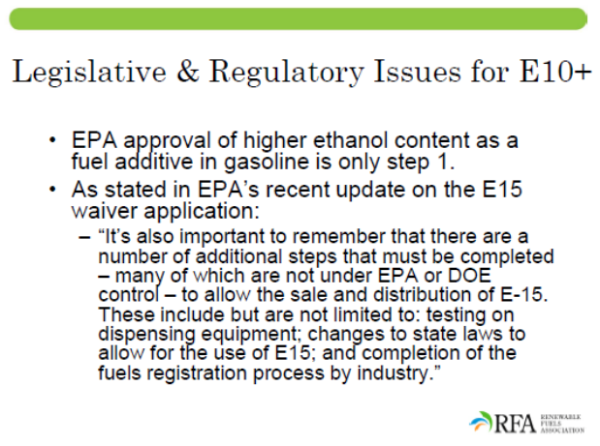 | 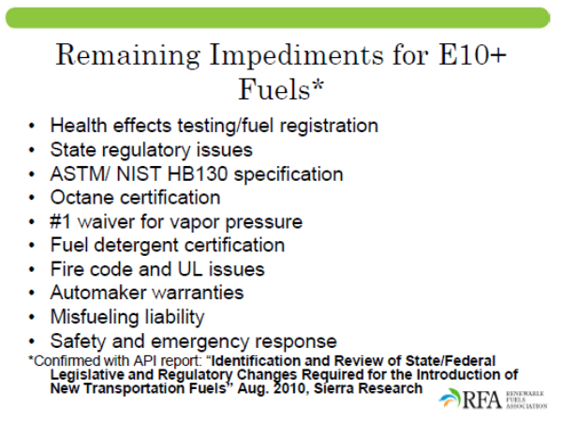
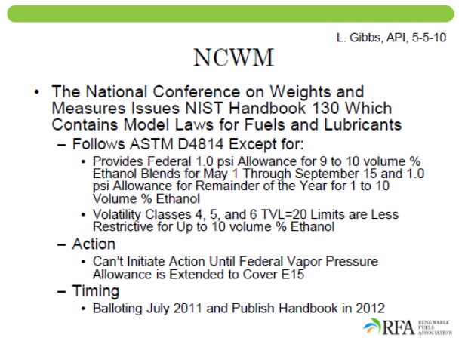 | 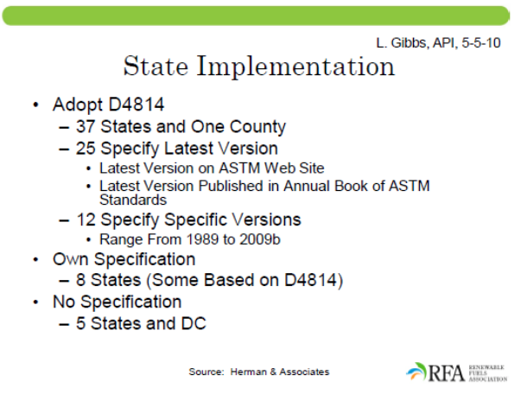
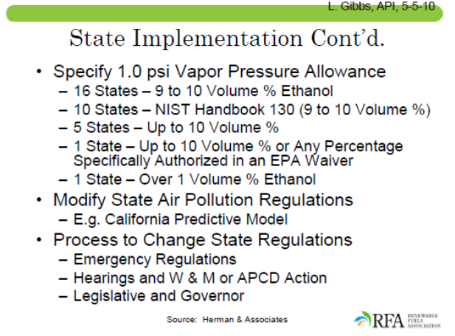 | 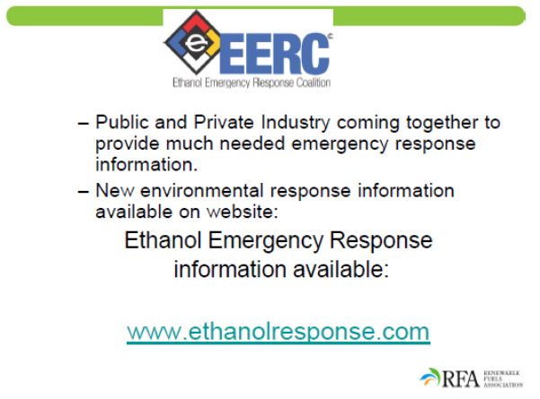



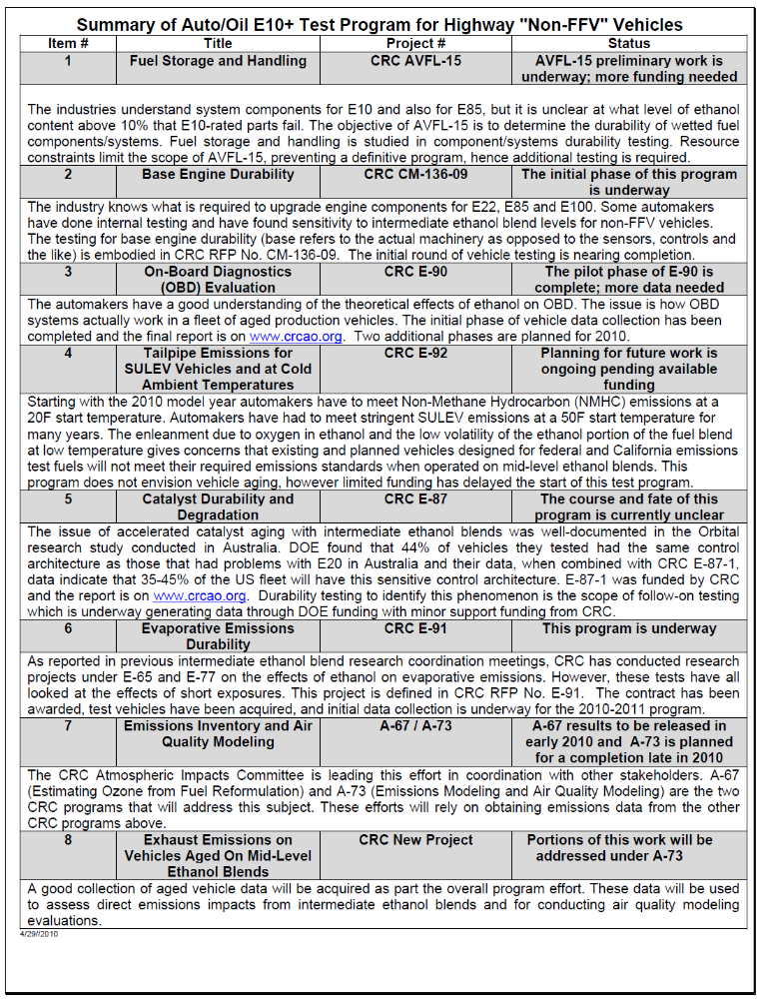

Mid Level Ethanol Blends Research Coordination Group Compilation of Projects
with El0+ Fuel Formulation Information
Updated August 27, 2010
CRC Projects/ Reports (www.crcao.org)
1) E-65-3 Fuel Permeation from Automotives
- Conventional vehicles tested on E0, E6, and E20
- Flex fueled Vehicle tested on E85
- Project complete; final report on CRC website
2) E-67 Effects of Ethanol and Volatility Parameters on Exhaust Emissions
- E0, E6 and E10 fuels
- Project complete; final report on CRC website
3) E-74 Effect of CO and RVP on Exhaust Emissions of In-Use Fleet
- E0, E10 and E20 fuels
- Project complete
4) E-77 In-Use Evaporative Emissions
- Pilot program complete (E0 testing only); final report on CRC website
- E0, E10, and E20 fuels
- E-77-2 main program testing ongoing
5) E-80 Exhaust and Evaporative Emissions Testing of Flex-Fueled Vehicles
- Pilot program: E6, E85, 50/50 mix
- Main program E9, E32, E66 and E85
- Project testing in progress
6) E-84 Review of Prior Studies of Fuel Effects on Emissions
- Limited data above 10% ethanol reported
- Project complete; final report on CRC website
7) E-87 Mid Level Ethanol Blend Catalyst Durability Study
- E0, E10, E15 and E20 fuels
- Project testing in progress
8) E-89 EPAct Light Duty Vehicle Fuel Effects
- E0, E10, E15 and E20 fuels
- Project testing by EPA in progress
9) CRC Report No. 629 Coordinating Research Council, Inc., 2002 Hot Fuel Handling Program
- E0, E3, E6, E10 fuels
- Project complete; final report on CRC website
10) CRC Report No. 638 Coordinating Research Council, Inc., 2003 Intermediate-Temperature Volatility Program
- E0 to E10 fuels only
- Project complete; final report on CRC website
11) CRC Report No. 648 Coordinating Research Council, Inc., 2006 Hot-Fuel-Handling Program
- E0, E5, E10 and E20 fuels
- Project complete; final report on CRC website
12) CRC Report No. 652 Coordinating Research Council, Inc., 2008 Cold Start and Warm-up Driveability Program
- E0, EIS, E20, and E85 (fuel-flexed vehicles only)
- Project complete; final report on CRC website
13) AVFL-13b Fuel Chemistry Impacts of Gasoline/Ethanol Blends in HCCI Single Cylinder Test Engine

- Low Temperature Combustion (LTC) fuel effects being investigated in a research engine running in HCCI (Homogeneous Charge Combustion Ignition) mode
- Fuels blended from 4 refinery streams to represent wide range of fuel properties of real world fuels
- Ethanol effects tested up to E30
- Testing complete; data analysis in progress
14) AVFL-15 E20 Fuel System and Fuel Component Durability Study
- E0, E10, and aggressive E20 fuels
- Aggressive E20 fuel used a modified J1681 design in order to keep sulfur and other parameters within both ASTM 4814 specification and J1681 targets
- Project testing in progress
Outside Projects/Reports
15) "Market barriers to the uptake of biofuels study: A testing based assessment to determine impacts of a 10% and 20% ethanol gasoline fuel blend on non-automotive engines-2000hrs material compatibility testing." , Orbital Engine Company. (2003, May)
a. Report to Environment Australia.
16) "Issues Associated with the Use of Higher Ethanol Blends (E17-E24)", NREL/TP-510-32206 (October, 2002)
17) "The Effects of E20 on Elastomers Used in Automotive Fuel System Components", Bruce Jones, Gary Mead, Paul Steevens and Chris Connors Minnesota Center for Automotive Research at Minnesota State University, Mankato (Feb., 2008)
- Contact: Department of Automotive Engineering Technology, Minnesota State University, Mankato
- ASTM Fuel C, C(E10)A, C(E20)A
18) "The Effects of E20 on Plastic Automotive Fuel System Components", Bruce Jones, Gary Mead, and Paul Steevens, Minnesota Center for Automotive Research at Minnesota State University, Mankato (Feb., 2008)
- Contact: Department of Automotive Engineering Technology, Minnesota State University, Mankato
- ASTM Fuel C, C(E10)A, C(E20)A
19) "The Effects of E20 on Automotive Fuel Pumps and Sending Units", Nathan Hanson, Thomas Devens, Colin Rohde, Adam Larson, Bruce Jones, Gary Mead, and Paul Steevens, Minnesota Center for Automotive Research at Minnesota State University, Mankato (Feb., 2008)
- Contact: Department of Automotive Engineering Technology, Minnesota State University, Mankato
- ASTM Fuel C, C(E10)A, C(E20)A
20) "The Effects of E20 on Metals Used in Automotive Fuel System Components", Bruce Jones, Gary Mead, Paul Steevens, and Mike Timanus, Minnesota Center for Automotive Research at Minnesota State University, Mankato (Feb., 2008)
- Contact: Department of Automotive Engineering Technology, Minnesota State University, Mankato
- ASTM Fuel C, C(E10)A, C(E20)A
21) "Demonstration and Driveability Project to Determine the Feasibility of Using E20 as a Motor Fuel", David Kittleson, Andy Tan, and Darrick Zarling, University of Minnesota, Minneapolis, MN 55414, (Oct. 2007)
a. E0 and E20 fuels

22) "An Examination of Fuel Pumps and Sending Units During a 4000 Hour Endurance Test in E20", Gary Mead, Bruce Jones, Paul Steevens, Nathan Hanson, Joe Harrenstein, Minnesota State University, Mankato, (publication pending)
23) "E20 Effects in Small Non-Road SI Engines", Robert Waytulonis, David Kittleson, and Darrick Zarling, University of Minnesota, Center for Diesel Research, Report to the Minnesota Department of Commerce, (Jan. 2008)
24) "Effects of Intermediate Ethanol Blends on Legacy Vehicles and Small Non-Road Engines, Report 1", Brian West, Keith Knoll, Wendy Clark, Ronald Graves, John Orban, Steve Prezesmitzki, Timothy Theis, on behalf of the U.S. Department of Energy, (Oct. 2008)
a. EO, E10, E15, E20
25) Environmental Protection Agency. (1991, January 24). Regulation of fuels and fuel additives; Definition of substantially similar.
Http://www.epa.gov/otaq/regs/fuel/additive/jan91.pdf
26) Sun Refining and Marketing Company. (1998, April). Waiver application for 15% MTBE (EPA Publication No. EN-88-02, Ill-A-1). Washington, DC: U.S. Environmental Protection Agency.
27) "Technical Paper On The Introduction of Greater Than E10-Gasoline Blends", Ranajit Sahu, Outdoor Power Equipment Institute, (June 2007)
28) Proposed Test Plan for Determining the Effect of Mid-grade Ethanol Blends on Handheld Lawn and Garden Engines and Equipment, Ranajit Sahu, Outdoor Power Equipment Institute,( Jan. 2009)
29) "Optimal Ethanol Blend Level Investigation", Richard Shockey, Ted Aulich, Energy & Environmental Research Center, University of North Dakota, Grand Forks, ND, Bruce Jones, Gary Mead, and Paul Steevens, Minnesota Center for Automotive Research, Minnesota State University, Mankato, (Nov. 2007)
30) "Determination of the Potential Property Ranges of E10+ Blends", API
- E0, E10, D12.5, E15, and E30 fuels
- Base stocks are pump gasolines and BOBs taken from all U.S. PADDs
- Fuel analysis in progress
Standards and recommended practices
31) SAE J312: Automotive Gasoline
32) SAE J905: Fuel Filter Test Methods
33) SAE J1297: (R) Alternative Automotive Fuels
34) SAE J1537: Validation Testing of Electric Fuel Pumps for Gasoline Fuel Injection Systems
35) SAE J1681: Gasoline, Alcohol, and Diesel Fuel Surrogates for Materials Testing
36) SAE J1747: Recommended Methods for Conducting Corrosion Tests in Hydrocarbon Fuels or Their Surrogates and Their Mixtures with Oxygenated Additives
37) SAE J1748: Methods for Determining Physical Properties of Polymeric Materials Exposed to Gasoline/ oxygenate Fuel Mixtures
a. Modifies ASTM D471 to make it fuel-testing specific
38) SAE J1832: Low Pressure Gasoline Fuel Injector
39) SAE J1862: Fuel Injection System Fuel Pressure Regulator and Pressure Damper
40) SAE J2260L Nonmetallic Fuel System Tubing with One or More Layers
41) "A rational approach to qualifying materials for use in fuel systems", Warrendale, PA: Harrigan, M., Banda, A., Bonazza, B., Graham,P., & Slimp, B. Society of Automotive Engineers. (2002).
42) SAE's Automotive Fuels Reference Book (2nd ed., 1995)- RVP Impact of blending ethanol into gasoline

- ASTM D 256-06 Standard test methods for determining the Izod pendulum impact resistance of plastics
- ASTM D 412: Vulcanized Rubber and Thermoplastic Elastomers- Tension
- ASTM D 471: Rubber Property- Effect of Liquids
- ASTM D 543 Standard Practices for Evaluating the Resistance of Plastics to Chemical Reagents
- ASTM D 618: Standard Practice for Conditioning plastics for Testing
- ASTM D 638: Standard test method for tensile properties of plastics
- ASTM D 2240: Standard test method for rubber property-durometer hardness
- ASTM D 3183: Rubber- Preparation of Product Pieces for Test Purposes from Products
- ASTM D 4806: Denatured Fuel Ethanol for Blending with Gasolines for Use as Automotive Spark-Ignition Engine Fuel
- ASTM D 4814: Automotive Spark-Ignition Engine Fuel
- ASTM D 4815: Determination of MTBE, ETBE, TAME, DIPE, tertiary-Amyl Alcohol C₁ to C4 Alcohols in Gasoline by Gas Chromatography
- ASTM D 5500: Vehicle Evaluation of Unleaded Automotive Spark-Ignition Engine Fuel for Intake Valve Deposit Formation
- ASTM Gl: Preparing, Cleaning, and Evaluating Corrosion Test Specimens
- ASTM G31: Laboratory Immersion Corrosion Testing of Metals
- Physical Properties of Gasoline/ Alcohol Blends, Bartlesville Energy Technology Center, Department of Energy, Bartlesville, OK, (Sept. 1979)
- Ethanol Fuel Modification for Highway Vehicle Use, Final Report, Science and Technology Division, Union Oil Co. of California, Brea., (Jan. 1980)
- "Alcohols and Ethers, A Technical Assessment of Their Application as Fuels and Fuel Components", API Publication 4261, Third Edition, (June 2001)
- "Determination of the Potential Property Ranges of Mid-Level Ethanol Blends", API, (April 23, 2010)

APPLICATION FOR A WAIVER PURSUANT TO
SECTION 211(0(4) OF THE CLEAN AIR ACT FOR E-15
Submitted by
Growth Energy on Behalf of 52 United States
Ethanol Manufacturers
In partnership with:
American Coalition for Ethanol
Renewal Fuels Association
National Ethanol Vehicle Coalition
Cellulosic Stakeholders:
Khosla Ventures
Coskata
BioGasol
TMO
Microbiogen
Edenspace
ZeaChem Inc.
Qteros
March 6, 2009

I. Executive Summary
This application is submitted pursuant to Clean Air Act section § 211(f)(4) and requests approval for use of an ethanol-gasoline blend containing up to 15 percent ethanol by volume (hereinafter "E-15") by Growth Energy and the following ethanol manufacturers: Absolute Energy, LLC, Agri-Energy LLC/Dakota Renewable, Amaizing Energy, LLC, Arizona Grain Inc., Arkalon Energy, LLC, Big River Resources, LLC, Cardinal Ethanol, LLC, Castle Rock Renewable Fuels, LLC, Conestoga Energy, DENCO, Didion Ethanol, East Kansas Agri Energy, LLC, Front Range Energy LLC, Golden Grain Energy, LLC, Granite Falls Energy, LLC, Green Plains Renewable Energy, Inc., Hawkeye Renewables LLC, IBEC Ethanol, ICM, Kansas Ethanol, LLC, LifeLine Foods, Inc., Little Sioux Corn Processors, LLC, Marquis Energy, LLC, Nesika Energy, LLC, Patriot Renewable Fuels, LLC, Pinal Energy, POET Biorefining — Alexandria, POET Biorefining — Ashton, POET Biorefining — Big Stone, POET Biorefining - Caro, POET Biorefining — Chancellor, POET Biorefining — Coon Rapids, POET Biorefining — Corning, POET Biorefining Emmetsburg, POET Biorefining — Glenville, POET Biorefining — Gowrie, POET Biorefining — Groton, POET Biorefining Hanlontown, POET Biorefining — Hudson, POET Biorefining — Jewell, POET Biorefining — Laddonia; POET Biorefining — Lake Crystal; POET Biorefining — Leipsic, POET Biorefining — Macon, POET Biorefining — Mitchell, POET Biorefining — Portland, POET Biorefining — Preston, POET Ethanol Products, Prairie Horizon Agri-Energy LLC, Quad County Corn Processors,

Renew Energy, Siouxland Ethanol LLC, Sire, and Western Plains Energy, LLC. The request to allow E-15 is further supported by the additional parties and organizations noted on the cover of this application, Ford Motor Company, and numerous leading scientists that have signed a letter supporting introduction of higher ethanol blend fuels. The applicants and supporters of this application seek accelerated renewable fuel use, increased energy security, enhanced economic development, creation of American jobs, reduced transportation costs, and environmental benefits from increased use of ethanol through approval of up to a fifteen percent base blend of ethanol. Importantly, recent and extensive research demonstrates that use of higher ethanol blends will significantly benefit the environment by reducing greenhouse gas emissions,² reducing harmful tailpipe emissions,³ reducing smog,⁴ using less energy for an equivalent amount of fuel^{s}, and protecting natural resources.⁶
See February 20, 2009 Letter from Susan M. Cischke of Ford Motor Company to Jeff Broin of POET noting that "Ford endorses efforts to increase base level blends up to E-15 and collaborate with key stakeholders to overcome challenges with introducing these higher levels of ethanol in the base fuel blend used by all vehicles in the near term."
See, e.g., Improvements in Life Cycle Energy Efficiency and Greenhouse Gas Emissions of Corn-Ethanol, by Adam J. Liska et. al. ("Nebraska Study") (Yale Journal of Industrial Ecology, January 2009) at 9 (demonstrating, on a life-cycle basis, that corn-based ethanol production and use reduces greenhouse gas emissions 48-59 percent compared to
gasoline production and use); Greenhouse Gas Impacts of Expanded Renewable and Alternative Fuels Use, EPA Office of Transportation and Air Quality, EPA420-F-07-035 (April 2007) (finding that cellulosic ethanol production and use will reduce greenhouse gas emissions by more than 90 percent compared to gasoline).
³ See sections IV through VI infra.
Ethanol-blended fuels generally, and E-15 specifically, reduce vehicle tailpipe emissions of carbon monoxide and volatile organic compounds, both of which are smog-

Pursuant to the Clean Air Act, the Administrator of the Environmental Protection Agency ("EPA") may grant a waiver allowing use of a fuel additive upon application by a fuel manufacturer that establishes that use of the fuel additive "will not cause or contribute to the failure of any emission control device or system." This application seeks approval to increase the ethanol portion of the ethanol-gasoline blend to up to fifteen percent. Extensive experience with use of ethanol-gasoline blends, similarities of E-15 to ethanol-gasoline blends containing ten percent ethanol (hereinafter "E-10"), and multiple recent studies involving a range of ethanol and gasoline fuel blends at fifteen percent ethanol and higher
forming emissions. See section IV infra. Ethanol has been the preferred fuel to meet Clean Air Act reformulated gasoline requirements to reduce ozone and many states credit ethanol-blend gasoline with significantly reducing urban ozone levels. The American Lung Association of the Upper Midwest similarly credits ethanol-blend fuels with reducing smog and has embraced ethanol-blend fuels as part of its Clean Air Choice Initiative. Clean Air Choice website, available at http://www.cleanairchoice.org/news/.
⁵ The U.S. Department of Agriculture reports a net energy balance for ethanol production of 1.67 on average. By contrast, the U.S. Department of Energy reports that gasoline refining has a negative energy balance and every unit of energy expended in its production results in just 0.79 energy units in the form of gasoline. The 2001 Net Energy Balance of Corn-Ethanol, prepared by U.S. Department of Agriculture and Agricultural Research Service (2001); The Complete Lifecycle Energy Picture, prepared by the U.S. Department of Energy's Office of Energy Efficiency and Renewable Energy (2005).
Increased substitution of gasoline with ethanol will better protect natural resources by reducing the need to drill for oil in environmentally sensitive areas, such as oceans, critical habitats, and wildlife refuges. Ethanol has low toxicity, is miscible with water, is easily biodegraded in the environment greatly reducing the potential for contamination of surface and ground water compared to oil and gasoline, and produces fewer air emissions when used than gasoline. See, generally, Glenn Ulrich, Ph.D., "The Fate and Transport of Ethanol-Blended Gasoline in the Environment" (Oct. 1999, prepared for the Governors' Ethanol Coalition), available at www.n1c.state.ne.us/epubs/E5700/B055- 1999 .pdf

support that use of E-15 will not cause or contribute to the failure of any emission control device or system.
Ethanol has been widely used in the United States as a gasoline component as a fuel extender due to gasoline shortages,⁷ as an effective octane booster (to prevent early ignition, or "engine knock"), and as an oxygenate (to prevent air pollution from carbon monoxide and ozone). Congressional amendments to the Clean Air Act have encouraged the widespread use of ethanol as a fuel additive, including the Reformulated Gasoline Program ("RFG"),⁸ the Oxygenated Gasoline Program,⁹ and the Renewable Fuels Standard ("RFS").^{1°} E-10 ethanol-gasoline blends have been approved by EPA for more than 30 years, and since 1980, more than 44.5 billion gallons of fuel ethanol have been produced in the United States,'
In fact, ethanol has been used as fuel in the United States for over a century: Henry Ford's Model T was designed to run on either gasoline or ethanol. Renewable Energy Has An icon: Henry Ford, ASSOCIATED PRESS, Thurs., Oct. 12, 2006.
8 The RFG program requires the sale of "reformulated" gasoline in numerous areas to reduce pollutants, specifically those that contribute to ground level ozone, better known as smog. See Clean Air Act, § 211(k). Reformulated gasoline that meets the performance criteria set by the CAA can be reformulated in a number of ways, including the addition of oxygenates to the gasoline. Ethanol has been the primary source of oxygenates used under the RFG program.
⁹ This program requires the sale of oxygenated motor fuels during the winter months in certain major metropolitan areas to reduce carbon monoxide pollution. See id. § 211(m). As with the RFG program, ethanol has been the primary source of oxygenates for this program.
^{I°} This national program imposes requirements with respect to the amount of renewable fuel produced and used. See id. § 211(o). The Energy Independence and Security Act of 2007 modified the required amounts of renewable fuel to 7.5 billion gallons by 2012, rising to 36 billion gallons by 2022.
¹' Renewable Fuels Association website, at http://www.ethanolrfa.org.

the vast majority of it (over ninety-nine percent) blended to form E-10 and used in all types of vehicles and engines.
E-15 is similar in composition to E-10. The sole difference between E-10 and E-15 is the addition of five percent more ethanol in place of gasoline. E-15, like E-10, is comprised primarily of gasoline and the chemical composition of the gasoline and ethanol used in both fuels is the same. E-10 and E-15 have essentially identical lead and sulfur levels.¹² The additional ethanol in E-15 results in approximately five percent fewer hydrocarbons and two percent more oxygen in the blended fuel than E-10.¹³ The volatility of the two fuels also is essentially identical:⁴
¹² Based on ASTM D 4806 Standard Specification for Denatured Fuel Ethanol for Blending with Gasolines for Use as Automotive Spark-Ignition Fuel, the quality of the ethanol used to produce E-10 and E-15 should be identical.
¹³ By calculation, the reduction in hydrocarbons should be equal to the hydrocarbons in the gasoline that ethanol displaces. The increase in oxygen content is arrived at by calculation based on the assumption that the same ethanol quality, denaturant (content and composition) and moisture content are used with E-10 and E-15.
¹⁴ Issues Associated with the Use of Higher Ethanol Blends (E17-E24), prepared by National Renewable Energy Laboratory (October 2002) ("NREL Study") at 11-13. As the NREL Study explains, ethanol on its own has a low volatility (as measured by Reid Vapor Pressure or "RVP") of 2.3 psi, compared to 7-15 psi for motor gasoline. However, in some ethanol blends, blending ethanol with gasoline does not lower vapor pressure, but instead causes the blend's RVP to increase. The increase in RVP is highest at about five volume percent ethanol, raising the RVP slightly over 1 psi from the level of the original 9 psi of the base gasoline. However, as ethanol content increases, the increase in RVP falls gradually. In a 20 vol. % blend, the volatility is lower than a 5 vol. % blend. Id. The result of this curve is that the volatility of E-10 and E-15, measured by RVP, are almost identical, with the intervening blends showing a very slight rise and fall in RVP. For example, Table 3-1 in the NREL Study gives the following volatility levels for ethanol blends between E-10 and E-20: E-10 (9.15 psi), E-12 (9.28 psi), E-14 (9.19 psi), E-17 (9.06 psi), and E-20 (9.02 psi).

E-15 also is similar in performance to E-10. Recent and extensive studies by federal and state government agencies and private groups have evaluated the use of a range of ethanol-gasoline fuel blends. These recent studies are discussed in sections IV through VII below and included in the Appendix to this application. Virtually all of these studies have been undertaken for ethanol-gasoline blends that have an ethanol content of at least E-15, and the majority of studies have evaluated ethanol-gasoline fuel blends at ethanol concentrations higher than fifteen percent. While ongoing studies are anticipated to support use of ethanol-gasoline fuel blends containing twenty percent ethanol or more, the similarity of E-10 to E-15 and studies that have been completed to date provide information necessary for approval of the requested E-15 waiver. As summarized in the application below, available data and multiple recent studies regarding the impact of various intermediate blends on emissions, materials compatibility, durability, and driveability were completed on extensive and representative test fleets, provide a reliable comparison to certification conditions, and demonstrate that use of E-15 will not cause or contribute to a failure of any emission control device or system to meet its certification emissions standards. In sum, these studies find no statistically significant difference in performance between not only E-10 and E-15, but also between E-10 and E-20, which confirms the similarities of ethanol-gasoline blends with less than twenty percent ethanol, and provides further assurance through testing at higher ethanol concentrations that E-15 will not cause or contribute to the failure of emission control devices or systems.

Significantly, not only are today's vehicles capable of successfully using E15, existing fuel dispensation infrastructure in use for decades with E-10 is similarly capable of dispensing E-15. Underwriters Laboratories ("UL"), which independently tests and certifies products, including automotive fuel dispensers, expressly supports the use of existing UL listed fuel dispensation infrastructure with automotive fuel containing up to a maximum of fifteen percent ethanol. ¹⁵ The data UL has gathered as part of the organization's ongoing research to investigate the impact of using higher ethanol blends in fuel dispensing systems supports that existing dispensers may be used successfully with ethanol blends up to E-15.
Accordingly, based on the similarity of E-10 to E-15 and recent and extensive work completed by governmental and private third-party researchers, and the results of those studies that are included as part of this application, Growth Energy and the ethanol manufacturers that submit this application request EPA grant the requested waiver.
¹⁵ Press Release, Underwriters Laboratories Announce Support For Authorities Having Jurisdiction Who Decide To Permit The Use Of Existing UL Listed Gasoline Dispensers With Automotive Fuel Containing Up To A Maximum Of 15% Ethanol (February 19, 2009), available at http://www.ul.com/newsroorn/newsrel/nr021909.html. Indeed, UL certification has long defined the term "gasoline" as gasoline with up 15 percent ethanol: "[t]he term "gasoline" includes gasoline with small amounts of additives such as detergents, solvents for detergents, and anti-icing chemicals and gasoline with up to 15 percent ethanol or methyl tertiary butyl ether (MTBE)." UL 330, Hose and Hose Assemblies for Dispensing Flammable Liquids, at 111.1. See also UL 25, Meters for Flammable and Combustible Liquids and LP-Gas, at 111.2 (defining "Flammable and Combustible Liquids" as including "gasoline/alcohol blends up to 15% Ethanol."); UL 79, Power-Operated Pumps for Petroleum Dispensing Products, at 111.5 (defining "Petroleum Products" as including "gasoline/alcohol blends up to 15% Ethanol.").

H. Requested Wavier
This application seeks a waiver pursuant to Clean Air Act section 211(f)(4) for the introduction into commerce of an alcohol-gasoline blend containing up to fifteen percent ethanol'⁶ by volume in unleaded gasoline ("E-15").
III. Statutory Authority and Standard for Approval of Requested Waiver
Title H of the Clean Air Act (42 U.S.C. §§ 7521-7590) establishes a comprehensive scheme for regulation of motor vehicle emission and fuel standards for the prevention and control of air pollution. 42 U.S.C. § 7545 ("Section 211" of the Clean Air Act), part (f)(1)(B) provides that effective upon November 15, 1990, it shall be unlawful for any manufacturer of any fuel or fuel additive to first introduce into commerce, or to increase the concentration in use of, any fuel or fuel additive for use by any person in motor vehicles manufactured after model year 1974 which is not substantially similar to any fuel or fuel additive utilized in the certification of any model year 1975, or subsequent model year, vehicle or engine under section 206 of the Act.
Under section 211(0(4) of the Clean Air Act, the Administrator of the EPA may waive this prohibition where the Administrator determines that an applicant has established that the fuel or fuel additive, and the emission products thereof, will not cause or contribute to a failure of any emission control device or system
16 For purposes of this application the term "ethanol" shall refer to the definition of "ethanol" contained in ASTM D 4806 Standard Specification for Denatured Fuel Ethanol for Blending with Gasolines for Use as Automotive Spark-Ignition Fuel.

(over the useful life of the motor vehicle, motor vehicle engine, non-road engine or non-road vehicle in which such device or system is used) to meet its certification emissions standards.¹⁷ By statute, EPA must take final action to grant or deny an application for a section 211(f)(4) waiver, after public notice and comment, within 270 days of the receipt of such an application.¹⁸
EPA guidelines¹⁹ and past EPA waiver decision documents, as well as court decisions regarding waivers under section 211(0(4), provide guidance as to the appropriate content of waiver applications and the standard and scope of EPA's review of such applications. Based on the foregoing, a waiver request should contain "data relating to a fuel additive's emissions effects which are derived from vehicle testing," and the data should provide a "reliable basis for comparison with the conditions under which vehicles are certified."^{2°} Where an applicant does not have sufficient test data, the applicant may instead provide a reasonable theory which predicts the emission effects of an additive, and need only conduct a sufficient amount of testing to demonstrate the validity of such a theory.²¹ In addition to presenting data on emissions, a waiver application should include information regarding the proposed fuel's compatibility with materials used in
¹⁷ Clean Air Act, § 211(0(4), 42 U.S.C. 7545(0(4).
¹⁸ Id.
¹⁹ Guidelines for Fuel Additive Waivers, 43 Fed. Reg. 11,258 (Mar. 17, 1978); Guidelines for Section 211(0 Waivers for Alcohol-Gasoline Blends, 43 Fed. Reg. 24,131 (June 2, 1978).
²⁰ Guidelines for Fuel Additive Waivers, 43 Fed. Reg. 11,258, 11,259 (Mar. 17, 1978).
21 Texaco; Grant of Application for Fuel Waiver for TC-11064, Decision Document, 45 Fed. Reg. 58,954, 58,956 (1980).

carburetors or fuel systems to demonstrate that the fuel will not impair the materials to the point that emissions are adversely affected.²² Similarly, applications should include information regarding a vehicle's driveability on the waiver fuel to better ensure that emissions control devices or systems will not be removed or rendered inoperative because of their impact on performance.²³
In evaluating a waiver request, EPA may "look at all of the available data, including data provided by persons other than the applicant"²⁴ as well as preexisting studies.²⁵ Federal case law indicates that waiver decisions are to be "based on one criterion: a fuel additive's effect on emission standards," and EPA's role is "to assess whether the additive's emission products 'causes or contributes' to an emission control device's ability to comply with the Act's emission standards."²⁶ Emissions increases below applicable emissions standards and emission of non-regulated compounds are not relevant to the waiver process.²⁷
²² See, e.g., Sun Refining and Marketing Co.; Conditional Grant of Application for Fuel Waiver for 15% MTBE, Decision Document, 53 Fed. Reg. 33,846 (Sept. 1, 1988).
²³ Guidelines for Fuel Additive Waivers, 43 Fed. Reg. 11,258, 11,259 (Mar. 17, 1978).
²⁴ Petro-Tex Chemical Co., Denial of Application for Fuel Waiver for MTBE (0-15%), Decision Document, 44 Fed. Reg. 1447, 1447 n.2 (1978).
²⁵ See, e.g., Gas Plus, Inc.; Grant of Application for Fuel Waiver for 0-10% Anhydrous Ethanol ("Gasohol"), Decision Document, 44 Fed. Reg. 20,777 (April 6, 1979).
²⁶ Ethyl Corp. v. EPA, Si F.3d 1053, 1058 (D.C. Cir. 1995).
²⁷ id. (holding that EPA Administrator exceeded her authority by denying waiver application on basis of public health concerns); see also Motor Vehicle Mfrs. Ass '71 of U.S. v. EPA, 768 F.2d 385, 390 (D.C. Cir. 1985) ("[B]oth the plain language of the Act and its legislative history support the EPA's view that the Administrator is not required under section 211(0(4) to adopt a "no increase" standard and may grant a waiver as long as the fuel does not cause or contribute to a failure to achieve compliance with emission standards."). See also Petro-Tex Chemical Co., Denial of Application for Fuel Waiver

Recognizing that it would be "virtually impossible" to test all vehicles and emission control systems, EPA and the courts have long recognized that statistical sampling and emissions evaluations based on a representative fleet are sufficient to support that a fuel under consideration for a section 211(0(4) waiver would not cause or contribute to a significant failure of emission standards by vehicles in the national fleet.²⁸
IV. Recent Comprehensive Studies Support The Requested E-15 Waiver.
Recent, significant, and comprehensive studies involving over one-hundred vehicles, eighty-five vehicle and engine types, and thirty-three fuel dispensing units have been completed to evaluate the affects of ethanol-gasoline blends above ten percent ethanol, including, specifically, E-15 and blends as high as E-85. These studies include a yearlong driveability test and over 5,500 hours of materials compatibility testing. In direct support of this waiver application, Growth Energy submits the following recent scientific studies that collectively demonstrate that use of E-15 will not cause or contribute to the failure of any
for MTBE (0-15%), Decision Document, 44 Fed. Reg. 1447 (1978) (stating waiver provision is "solely concerned with the emission standards").
²⁸ ARCO; Grant of Application for Fuel Waiver for Arconol (TBA, 0-7%), Decision Document, 44 Fed. Reg. 10,530 (Feb. 21, 1979); Motor Vehicle Mfrs. Ass'n, 768 F.2d at 392 (agreeing with EPA that "actual 50,000-mile durability testing may not be always required to make the requisite determination that a fuel will not cause a vehicle to exceed emission standards over its useful life").

emission control device or system to meet its certification emissions standards:
- Effects of Intermediate Ethanol Blends on Legacy Vehicles and Small Non-Road Engines, Report 1, prepared by Oak Ridge National Laboratory for the U.S. Department of Energy (October 2008) ("DOE Study") (peer-reviewed report studied the effects of E-15 and E-20 on motor vehicles and small non-road engines and concluded that when E-15 and E-20 were compared to traditional gasoline, there were no significant changes in vehicle tailpipe emissions, vehicle driveability, or small non-road engine emissions as ethanol content increased);
- Optimal Ethanol Blend-Level Investigation, Final Report, prepared by Energy & Environmental Research Center and Minnesota Center for Automotive Research for American Coalition for Ethanol (October 2007) ("ACE Study") (report studied the effects of ethanol blends ranging from E-10 to E-85 on motor vehicles and found that exhaust emissions levels for all vehicles at all levels of ethanol blend were within the applicable Clean Air Act standards);
- The Feasibility of 20 Percent Ethanol Blends by Volume as a Motor Fuel, Executive Summary, Results of Materials Compatibility and Driveability Testing, prepared by the State of Minnesota and the Renewable Fuels Association (RFA) (March 2008) ("Minnesota Compatibility/Driveability Study: Executive Summary")
- The Effects of E20 on Metals Used in Automotive Fuel System
Components ("Metals Study") (study compared the effects of E-0, E-
10 and E-20 on nineteen metals and found that the metals tested
were compatible with all three fuels);
- The Effects of E20 on Elastomers Used in Automotive Fuel System Components ("Elastomers Study") (study compared the effects of E0, E-10 and E-20 on eight elastomers and found that E-20 caused no greater change in properties than E-0 or E-10);
- The Effects of E20 on Plastic Automotive System Components ("Plastics Study") (study compared the effects of E-0, E-10 and E-20 on eight plastics and found that there was no significant difference in the properties of the samples exposed to E-20 and E- 0);
- The Effects of E20 on Automotive Fuel Pumps and Sending Units ("Fuel Pumps Study") (study compared the effects of E-0, E-10 and E-20 on the performance of twenty-four fuel pumps and nine sending units and found that E-20 has similar effect as E-10 and E-0 on fuel pumps and sending units);

e. Demonstration and Driveability Project to Determine the Feasibility of Using E20 as a Motor Fuel ("Driveability Study") (study tested forty pairs of vehicles on E-0 and E-20 and found no driveability or operational issues with either fuel)
(Collectively, "Minnesota Compatibility/Driveability Study");
- Fuel Permeation from Automotive Systems: E-O, E-6, E-10, E-20 and E-85, prepared by the Coordinating Research Council, Inc. (CRC Report No. E65-3) (December 2006) ("CRC Permeation Study") (study evaluated effects of E-0, E-6, E-20 and E-85 on the evaporative emissions rates from permeation in five newer California vehicles and found that there was no statistically significant increase in diurnal permeation rates between E-6 and E-20);
- Report to the US Senate on E-20 Ethanol Research, prepared by the Rochester Institute of Technology (October 2008) ("RIT Study")²⁹ (study evaluated effects of E-20 on ten legacy vehicles; initial results after 75,000 collective miles driven found no fuel-related failures or significant vehicle problems and documented reductions in regulated tailpipe emissions when using E-20 compared to E-0);
- Use of Mid-Range Ethanol/Gasoline Blends in Unmodified Passenger Cars and Light Duty Trucks, prepared by Minnesota Center for Automotive Research (July 1999) ("MCAR Study") (one-year study evaluated the effects of E-10 and E-30 in fifteen older vehicles in "real world" driving conditions; found no effect on driveability or component compatibility from either fuel and found that regulated exhaust emissions from both fuels were well below federal standards);
- Blending of Ethanol in Gasoline for Spark Ignition Engines: Problem Inventory and Evaporative Measurements, prepared by Stockholm University et. al. (2004-05) ("Stockholm Study") (study tested and compared evaporative emissions from E-0, E-5, E-10, and E-15 and found lower total hydrocarbon emissions and lower evaporative emissions from E-15 than from E-10 and E-5).
²⁹ The RIT Study is a draft summary of results to date in an ongoing study of E-20 fuel vehicle driveability, vehicle exhaust, and vehicle maintenance in gasoline vehicles owned and operated by Monroe County, New York.

V. Testing with E-I5 Demonstrates Both That It Has No Significant Effect
On Regulated Emissions As Compared To E-0 And That It Will Not Cause Or Contribute To The Failure Of Any Emission Control Device Or System To Meet Applicable Certified Emissions Standards.
Recent comprehensive studies make clear that use of E- 15 will not have a significant effect on regulated emissions or cause the failure of any emission control device or system. Specifically, the recent DOE Study provides results from a broad testing program initiated by the U.S. Department of Energy ("DOE"), in partnership and consultation with various other organizations including the Coordinating Research Council ("CRC") and the EPA, to evaluate the impacts of using E-15 and E-20 in vehicles and other engines. The DOE study submitted with this application tested conventional vehicles and small non-road engines ("SNREs") for regulated exhaust emissions, exhaust and catalyst temperatures, SNREs engine components temperature, and observable operational issues. Significantly, for the purposes of this application, the DOE Study found that for conventional vehicles, "regulated tailpipe emissions remained largely unaffected by the ethanol content of the fuel."^{3°}
The DOE Study was designed to determine the extent to which ethanol in fuel has an immediate effect on regulated emissions, selected aldehyde emissions, and fuel economy for the "average" light-duty vehicle. DOE designed its test procedures and vehicle samples with guidance and consultation from EPA.³¹ A
30 DOE Study at xvii. 3 I Id. at xvi, 2-2.

fleet of sixteen test vehicles³² was selected, after a 2007 national database characterization, to include vehicles from four groups of emission regulation requirements (based on age) reflecting a range of engine sizes and manufacturers, and including several of the highest selling vehicle models and several models considered most likely to be sensitive to ethanol content in gasoline.³³ This fleet of test vehicles thus provided a good representation of the national fleet likely to use E-15 pursuant to a waiver.
Each vehicle was tested on four fuels of varying ethanol content, E-0, E-10, E-15 and E-20, and emissions were determined using the LA92 drive cycle³⁴ (on EPA's recommendation).³⁵ The test parameters thus allowed for a reliable comparison with the conditions under which the test vehicles have been certified. Once the test results were obtained, they were statistically analyzed to determine whether sufficient evidence existed in the data to conclude that ethanol concentrations of up to twenty percent in the fuel changed emissions or fuel economy, either when averaged across all vehicles or for a majority of vehicles.
³² Results from thirteen of the vehicles are reported in the DOE Report; results from the other three vehicles are expected in 2009.
³³ DOE Study at 2-2 to 2-4.
³⁴ "LA92 Drive Cycle" refers to the California Air Resources Board LA92 Dynamometer Driving Schedule. It was developed as an emission inventory improvement tool using 1992 test data from Los Angeles. Compared to the Federal Test Procedure (FTP 75), the LA92 has a higher top speed, a higher average speed, less idle time, fewer stops per mile, and a higher maximum rate of acceleration (generally representing a more aggressive urban driving style).
³⁵ DOE Study at 2-2. See Appendix A of the DOE Study for a detailed discussion of the test equipment, procedures, and emissions standards used.

The DOE study concluded that regulated tailpipe emissions remained largely unaffected by the ethanol content of the fuel. More specifically, no statistical differences were seen among all ethanol blends regarding emissions of non-methane organic gases ("NMOG"), non-methane hydrocarbons ("NMHC"), carbon monoxide ("CO"), and oxides of nitrogen ("NO_{x}").³⁶ When the higher ethanol blends were compared to E-0, the following statistical differences in regulated emissions were noted: (1) at a ninety-five percent confidence level, lower NMHC at E-10 and E-20 and lower CO at E-10 and E-15; and (2) at a ninety percent confidence level, lower NMHC at E-15 and lower CO at E-20.³⁷ The following chart from the DOE Study displays these results³⁸:
Estimated change (% or mg/mi in emissions and fuel economy
relative to E0 with ±95% confidence limit
Emission (unit) | E-10 | E-15 | E-20
NMOG (%) | -3.99 1 7.90 | 4.23 14.76 | 1.78 ± 10.40
NMHC (%) | -10.09 9.89ª | -11.85 1 12.20^{b} | 46.19 ± 10.79'
CO (%) | 44.87 A: 8.20ª | 43.52 110.72. | -12.58 ± 13.67^{b}
NOx (%) | -3.61 ± 20.87 | -1.78 ± 22.43 | 12.96 f 17.41
Fuel economy (%) | -3.88 ± 0.51" | -5.03 1.21' | -7.72 1 1.11ª
Ethanol (ng/ini) | 2.31 ± 1.51' | 5.43 .1 2.38' | 6.76 2.87ª
Acetaldehyde (ing/mi) | 0.21 .1 me | 0.39 1 0.1? | 0.45 1 0.13'
Formaldehyde (ng/mi) | 0.1140.47. | 0.08 E 0.08^{b} | 0.09 ± 0.10^{h}

a Statistically significant at the 95% confidence level (shaded).
b Marginally significant at the 90% confidence level.
36
DOE Study at 3-1.
37
Id. at 3-1. See DOE Study, section 3, for a detailed explanation of the findings. Similarly, a study published by the Society of Automotive Engineers International (SAE) examined the influences of ethanol fuel on spark engine emissions and concluded that ethanol results in a reduction of NOx and THC emissions as compared to E-0 and that "ethanol is an effective fuel for lowering exhaust emissions." The Effect of Ethanol Fuel on a Spark Ignition Engine, SAE Technical Paper No. 2006-01-3380, at 7 (2006).
³⁸ DOE Study at 3-3, Table 3.1.

The DOE Study also includes emissions data for SNREs that further supports this waiver request. The DOE Study compared regulated emission levels from a comprehensive and nationally representative fleet of twenty-eight SNREs fueled by E-0, E-10, E-15, and E-20 (providing a reliable comparison to certification conditions). The study found that overall, regulated emissions are generally no worse with E-15 (or E-20) than with E-0.³⁹ Accordingly, for the purposes of this waiver request, the DOE Study provides sufficient data to establish, for vehicle exhaust emissions, that E-15 does not cause or contribute to a failure of any emission control device or system to meet its certified emissions standards.
The ACE Study, also included as part of this application, further supports this conclusion. The primary objective of the ACE Study was to investigate a fuel economy-based optimal ethanol blend level° as well as to acquire Highway Fuel Economy Test ("HWFET") tailpipe emission data for all the ethanol-blend fuels surveyed. For this purpose, eight different ethanol blends were used — E-10, E-20, E-30, E-40, E-50, E-60, E-70, and E-85.⁴¹ Fuel economy and emission testing was performed by the Minnesota Center for Automotive Research ("MCAR") using a
³⁹ Id. at xix, 3-19 to 3-20.
⁴⁰ As determined by the Highway Fuel Economy Test ("HWFET"), at which measured miles per gallon is greater than predicted based strictly on per-gallon fuel Btu content. ACE Study at iv.
⁴¹ See ACE Study at 3 for a more detailed description of the fuels used in this study.

California Analytical Instruments dilution system to measure vehicle tailpipe emissions.⁴²
The ACE Study found that exhaust emissions levels for all vehicles at all levels of ethanol blend, obtained from both the FTP-75 and the HWFET driving cycles, were within the applicable Clean Air Act standards.⁴³ Because the ACE study included testing at lower and significantly higher ethanol blends than E-15 and produced emissions within applicable limits, it is expected that E-15 will render analogous results and satisfy all emission standards.⁴⁴
This conclusion is consistent with emissions testing conducted on another higher blend, E-30, as part of a 1999 study conducted by MCAR.⁴⁵ The MCAR Study evaluated the effects on fuel economy, emission characteristics, driveability, and component compatibility of in-use light duty vehicles running on blends of thirty percent and ten percent ethanol. The tests included fifteen vehicles of
⁴² This system includes five specific parts: the SuperFlow AC motor-driven chassis dynamometer, the critical flow venturi, the drive cycle and driver's trace monitor, the FTP-75 driving cycle and the HWFET driving cycle, and the gas analyzers.
⁴³ ACE Study at 18-21. There was one exception: the flex-fuel Chevrolet Impala exceeded the NMOG standard for the FTP-75 on E-20 and Tier 2 gasoline at 0.120 grams/mile and 0.152 grams/mile, respectively.
44 See Gas Plus, Inc.; Interpretation of Grant of Application for Fuel Waiver for 0-10% anhydrous ethanol ("gasohol"), 47 Fed. Reg. 14,596 (Apr. 5, 1982) (concluding, on the basis of ethanol's chemical properties, that waiver approval of E-10 also applied to all blends between E-0 and E-10).
45
Use of Mid-Range Ethanol/Gasoline Blends in Unmodified Passenger Cars and Light Duty Trucks, prepared by Minnesota Center for Automotive Research (July 1999) ("MCAR Study").

various makes and models, ranging in model years from 1985 to 1996.⁴⁶ MCAR measured exhaust emission levels of HC, CO and NO_{x} for E-10 and E-30 fuels in accordance with EPA test procedures.⁴⁷ The study revealed no significant difference in emissions when comparing the vehicles fueled with E-10 and E-30 and, consistent with the ACE Study, found emission levels from both fuels were low and below applicable federal standards.⁴⁸
Accordingly, the results of both the ACE Study and the MCAR Study are consistent with the DOE Study and further support that intermediate ethanol blends, including E-15, do not significantly affect regulated vehicle exhaust emissions.
Available information also supports that no long-term emissions increases will result from use of E-15. Consistent with past agency decisions, long-term exhaust emissions testing (50,000-Mile durability testing) is not necessary for approval of the requested waiver. For example, in the decision document granting Sun Refining's waiver for fuel containing up to fifteen percent methyl tertiary butyl ether ("MTBE") in unleaded gasoline, EPA determined that 50,000-mile durability testing was not required because the agency was "unaware of any long-
⁴⁶ MCAR Study at 2.
⁴⁷ All the MCAR tests run on the dynamometer were based on the Federal Test Procedure as described in the Federal Register Part 86, Subpart B.
⁴⁸ MCAR Study at 7.

term deteriorative effects on exhaust emissions associated with oxygenates."⁴⁹ EPA explained that "[t]he vast majority of data indicate that the effect of oxygenates on exhaust emissions over time has not been a significant issue."^{5°} EPA noted that "reasonable theoretical judgments as to the emission effects of the fuel may be utilized as an alternative to direct testing of vehicles" and that fuel volatility specifications, limited durability emissions testing, and data regarding materials compatibility and driveability could be considered in making such judgments.⁵¹ This approach was upheld by the United States Court of Appeals for the District of Columbia.⁵²
Based on emissions testing completed as part of the DOE, ACE and MCAR studies, materials compatibility studies completed as part of the Minnesota Compatibility/Driveability Study (and discussed in detail in section VI below), and E-15's compositional similarities to E-10, the effect of which upon long-term emissions is well known and has been widely considered acceptable for thirty
⁴⁹ Sun Refining and Marketing Co.; Conditional Grant of Application for Fuel Waiver for 15% MTBE, Decision Document at 13, 53 Fed. Reg. 33,846 (Sept. 1, 1988).
⁵⁰ Id. at 14; see also ARCO; Grant of Application for Fuel Waiver for Arconol (TBA, 07%), Decision Document, 44 Fed. Reg. 10,530 (Feb. 21, 1979) (granting waiver for fuel containing up to 7% of the oxygenate tertiary butyl alcohol and determining that that 50,000-mile durability testing was not required because, "upon examination of the available data on material compatibility and the chemistry of Arconol," a reasonable estimate of the test vehicle's emissions performance on Arconol can be obtained using back-to-back emission test data").
⁵¹ Id. at 10-11.
⁵² Motor Vehicle Mfrs. Ass '17 of U.S. v. EPA, 768 F.2d 385, 392-93 (D.C. Cir. 1985).

years, E-15 is not anticipated to result in any adverse changes in regulated longterm emissions.
This conclusion is further directly supported by a recent study by the Rochester Institute of Technology. The RIT Study examined the effects of E-20 (as compared to E-0) on ten legacy vehicles with significant mileage (between 30,000 and 120,000 miles), which together consumed 5,000 gallons of E-20 fuel over 75,000 miles of driving under real world conditions. Exhaust emissions testing was conducted in accordance with FTP-75 standards with state-of-the-art testing equipment, including specialized vehicle and engine emissions equipment.
Specifically, the RIT Study showed the following significant results for vehicles using E-20 (as compared to E-0):
- CO emissions decreased in nine of the ten vehicles tested, and all vehicles fell well within the EPA full useful life standards for the individual vehicle requirements;
■ Average tailpipe NO_{x} emissions decreased by 2.4 percent, with all vehicles well below EPA's NO_{x} requirements;
- Average total hydrocarbons emissions decreased 13,7 percent, with nine of ten vehicles decreaing the THC.⁵³
Accordingly, the RIT Study results are consistent with the ACE, MCAR, and DOE studies and further support that intermediate ethanol blends, including E15, do not significantly affect regulated vehicle exhaust emissions on a short-term or long-term basis. Consistent with EPA's prior conclusions that ethanol as an
⁵³ The RIT Study also summarized the effects of the use of E-20 on vehicle driveability and vehicle maintenance during this initial phase and found no fuel-related failures or significant vehicle problems. RIT Study at 1.

oxygenate is unlikely to have "long-term deteriorative effects on exhaust emissions," and based on extensive emissions and materials compatibility testing that demonstrates that blends up to E-20 will not have a significant deteriorative effect on applicable vehicle parts, EPA has sufficient information to grant this waiver.
Based on the similar volatility of E-10 to E-15 and the results of recent studies, E-15 also is not anticipated to result in any discernable increase in any evaporative emissions compared to commercially available fuels and may, in fact, result in fewer evaporative emissions. This conclusion is supported by two recent studies that evaluated the effect of higher ethanol blends upon evaporative emissions.
A December 2006 study by the Coordinating Research Council found that there was no statistically significant increase in diurnal permeation" rates between E-6 and E-20.⁵⁵ The study tested five newer California vehicles using six ethanol blends: E-0, E-6 (5.7% ethanol), E-6Hi (5.7% ethanol with increased aromatics content), E-10, E-20 and E-85. Of the five vehicles, two were from 2000 and
⁵⁴ CRC Permeation Study at 2. The CRC Permeation Study explains that there are three mechanisms responsible for evaporative emissions: permeation from automotive systems, leaks (liquid and vapor), and fuel tank venting (canister losses). Id at 1. Of these, permeation is the most relevant to understanding the effect of ethanol on evaporative emissions. This is because ethanol's effect on leaks and fuel tank venting is unlikely to vary from that of non-ethanol-gasoline. Leaks are an anomaly and "not thought to be sensitive to gasoline composition," and gasoline vapor release due to ethanol via non-permeation mechanisms such as fuel tank venting is countered by lowering the RVP of the base gas. Id. at 62
⁵⁵ Id. at 2.

2001 (Rigs 1 and 2) subject to a 2.0 gram/day diurnal emissions standard, and two were newer "near zero" and "zero" vehicles (Rigs "11" and "12") with enhanced evaporative emissions technology, subject to California's "LEV H" requirements (which dropped the limits to 0.5 g/day for a three-day diurnal and 0.65 g/day for the two-day test).⁵⁶ The fifth vehicle was a recent "flex fuel" vehicle (Rig "14"). The tests were conducted using the Sealed Housing for Evaporative Determination ("SHED") method for evaporative emissions.
All of the vehicles, when using any of the ethanol fuel blends, met the standard for which the vehicle had been certified.⁵⁷ Importantly, the testing also confirmed no statistically significant increase in evaporative emissions between E6 and E-10 or between E-10 and E-20.⁵⁸ This information indicates that evaporative emissions from E-15, like E-20, should be no worse than those of widely available commercial fuels and within applicable emissions limits.⁵⁹
An additional study prepared by the University of Stockholm ("Stockholm Study")^{6°} further supports that E-15 will have the same or lower evaporative
⁵⁶ Id. at 5. " Id. at 17.
⁵⁸ Id. at 2.
⁵⁹ E-6 (in fact, E-5.7 in this study) contains approximately 2% oxygen and is thus considered a "substantially similar" for which no waiver is required. See 73 Fed. Reg. 22277, 22281 (Friday April 25, 2008). Likewise, E-10 has been allowed by waiver for 30 years. See Gas Plus, Inc.; Grant of Application for Fuel Waiver for 0-10% anhydrous ethanol ("gasohol"), Decision Document, 44 Fed. Reg. 20,777 (Apr. 6, 1979).
⁶⁰ Blending of Ethanol in Gasoline for Spark Ignition Engines: Problem Inventory and Evaporative Measurements, prepared by Stockholm University et al (2004-05) ("Stockholm Study") at 4. At the time of the study, all gasoline sold in Sweden contained

emissions than commercially available fuels. The Stockholm Study found that E-
15 had lower evaporative emissions of total hydrocarbons than both E-10 and E-5.
The Stockholm Study included SHED testing of evaporative emissions
from two "summer" gasoline fuels, with Reid Vapor Pressures of approximately
9.14 psi and 10.15 psi, respectively,⁶¹ which were blended with varying
percentages of ethanol: 0%, 5%, 10% and 15%, for a total of eight different fuel
blends. For reference purposes, E-85 also was measured.⁶² All tests were
performed at the AVL MTC Motor Test Centre in Haninge, Sweden° using a VT
Shed⁶⁴ gas-proof test container normally used for testing whole cars.⁶⁵ The test
procedure involved placing a specially prepared fuel container containing the
particular blend being tested into the VT Shed, leaving it sealed in the VT Shed for
a two hour period at a consistent temperature of forty degrees Celsius, and
five percent ethanol, with approximately 65,000 m³ produced domestically (from wheat and cellulose) and around 165,000 m³ imported from Brazil. Id. at 7.
⁶¹ The RVPs of the base fuels used in the study were expressed in metric units as 63 kPa and 70 kPa, respectively. See Id. App. 2 at 6 and 7 for detailed specifications of the base fuels.
⁶² Id. App. 2 at 3.
⁶³ Id. App. 2 at 5. The AVL MTC test center is an accredited laboratory for automotive testing that has been in operation for approximately fifteen years. The center has experience of more than ten years of testing for the Swedish Environmental Protection Agency and the Swedish National Road Administration.
⁶⁴ Id. App. 2 at 5. This container is called a "VT shed" as both its volume and temperature are controlled.
⁶⁵ Id. The VT Shed includes a Flame Ionization Detector ("FID") for measuring the total emitted hydrocarbons. This instrument, along with an air sense mass spectrometer, was used for the Stockholm Study's evaporative emission tests.

measuring the change in concentration over time of total hydrocarbons as well as selected specific hydrocarbons.
The study found that with both base fuels (9.14 psi and 10.15 psi), the E-15 blends had fewer evaporative emissions of total hydrocarbons than the corresponding E-10 and E-5 blends.⁶⁶ The study also tested for specific hydrocarbons. When blended with the 10.15 psi base fuel, E-15 had fewer evaporative emissions of benzene, butane, toluene, and xylene, when compared to E-10 and E-5.⁶⁷ Similarly, when blended with the 9.14 psi base fuel, E-15 had fewer evaporative emissions of these same compounds when compared to E-5, and fewer evaporative emissions when compared to E-10 for all but toluene and xylene, for which the E-15 emissions were minimally greater.⁶⁸ Finally, the study measured the Reid Vapor Pressure for each fuel blend tested and found that E-5, E-10 and E-15 had similar vapor pressures.⁶⁹
Taken together, the CRC Permeation Study and the Stockholm Study demonstrate that the evaporative emissions of E-15 will be lower or no greater than those of commercially available fuels such as E-10 and E-5, and will be within applicable emissions limits.
Further, and consistent with past agency practice, to ensure no increases in evaporative emissions above applicable standards, Growth Energy proposes that
⁶⁶ Id. App. 2 at 10.
⁶⁷ Id. App. 2 at 11-19.
⁶⁸ Id. App. 2 at 16.
⁶⁹ Id. App. 2 at 19.

this waiver be granted with a condition requiring E-15 to conform to ASTM fuel volatility specifications for the area and time of year where it is used. EPA has repeatedly granted section 211(0(4) waivers without requiring any testing for evaporative emissions,^{7°} For example, in considering the waiver application by Synco 76 for E-10 plus a proprietary stabilizer, EPA granted the waiver without any evaporative emissions testing, stating: "controlling the volatility of the finished fuel within ASTM volatility specifications should adequately control evaporative emissions, and they should be no worse than those of commercially available fuels."⁷¹ EPA also has consistently stated that it "would be discriminatory to require the applicant's fuel to meet a more stringent volatility limit in order to control evaporative emissions than is characteristic of commercially available fuels."⁷²
^{7°} See, e.g., ARCO; Grant of Application for Fuel Waiver for Arconol (TBA, 0-7%), Decision Document, 44 Fed. Reg. 10,530, 10,532 (Feb. 21, 1979) (approving waiver without SHED testing where ARCO demonstrated that when Arconol-fuel conforms to ASTM volatility specifications its evaporative emissions performance is "no worse than the evaporative emissions of the commercially available fuels of similar volatility"); ARCO; Grant of Application for Fuel Waiver for MTBE (0-7%), 44 Fed. Reg. 12,242, 12,245 (1979); Sun Refining and Marketing Co.; Conditional Grant of Application for Fuel Waiver for 15% MTBE, Decision Document, 53 Fed. Reg. 33,846 (Sept. 1, 1988) (finding no SHED testing required when Sun: (1) conducted limited testing and found that fuels blended with its additive will have final volatility characteristics similar to present commercially available gasoline; and (2) Sun agreed to have the final fuel conform to ASTM fuel volatility standards); ARCO; Grant of Application for Fuel Waiver for Methanol/GTBA (up to 3.5% oxygen), Decision Document, 46 Fed. Reg. 56,361 (1981).
⁷¹ Synco 76 Fuel Corp.; Grant of Application for Fuel Waiver, Decision Document at 9, 47 Fed. Reg. 22404 (1982).
72
See, e.g., Synco 76 Fuel Corp.; Grant of Application for Fuel Waiver, Decision Document at 9, 47 Fed. Reg. 22404 (1982).

Based on the similar volatility of E-10 to E-15, recent testing regarding evaporative emissions for E-15 and for blends with an even greater percentage of ethanol than E-15, and recent materials compatibility testing, no increase in evaporative emissions is anticipated. Accordingly, and consistent with past agency decisions, EPA may grant this waiver based on the information provided in this application.
VI. E-15 Is Compatible With Materials Such That It Will Not Cause Or Contribute To The Failure Of Vehicles To Meet Applicable Certified Emissions Standards.
Recent studies conclusively support that E-15 will not impair the materials used in fuel systems to the point that emissions are adversely affected. The Minnesota Compatibility/Driveability Study supports that even at ethanol concentrations as high as E-20 there are no materials compatibility problems for automotive or fuel dispensing equipment. The Minnesota Compatibility/Driveability Study examined the effect and performance of E-20 on a wide variety of motor vehicle engines and engine components. The study generated four separate and distinct materials compatibility reports (and one driveability report, discussed in section VII below) regarding metals (the "Metals Study"), elastomers (the "Elastomers Study"), plastics (the "Plastics Study"), and common fuel sending unit and fuel pump combinations (the "Fuel Pumps Study") that are currently used in automotive, marine, small engine and fuel system

dispensing equipment." The study used nationally recognized standards,
including Society of Automotive Engineers ("SAE") and American Society of Testing and Materials ("ASTM"), as recommended by both automotive and fuel industry experts.⁷⁴ The E-20 and E-10 test fuels selected for the research were specifically formulated to present a worst-case-scenario fuel (using "aggressive ethanol"⁷⁵) that would still be acceptable under applicable fuel standards. Together, the four materials compatibility reports conclude that E-20 results in no problems for automotive or fuel dispensing equipment.
The Metals Study compared the effects of E-0, E-10 and E-20 on nineteen metals selected for the study following reference to literature reviews and manuals, recommendations from fuel systems and engine manufacturers, and peer review by system engineers from several Original Equipment Manufacturers ("OEMs") and Tier I and II suppliers (suppliers to OEMs). The metals samples were prepared using SAE and ASTM standards and exposed to E-0, E-10, and E20 fuel at an elevated temperature for 2,016 hours. Eighteen of the nineteen metals tested were found to be compatible with all three fuels and did not show
⁷³ Materials used in fuel systems of Flex Fuel Vehicles ("FFV") were accepted as proven compatible and not included in this study.
74 •
Minnesota Compatibility/Driveability Study: Executive Summary at 2.
⁷⁵ The "aggressive ethanol" used in the study contained impurities found in fuel grade ethanol including sulfuric acid, acetic acid, water, and sodium chloride in the following proportions: synthetic ethanol 816.00 g, de-ionized water 8.103 g, sodium chloride 0.004 g, sulfuric acid 0.021 g, and glacial acetic acid 0.061 g.

signs of pitting, loose corrosion by-products in the test fuel, or have a mass loss that exceeds a rate that would cause a failure within a twenty-year life cycle.⁷⁶
The Elastomers Study compared the effects of E-0, E-10 and E-20 on eight elastoiners selected for the study following reference to literature reviews and manuals, recommendations from fuel systems and engine manufacturers, and peer review by system engineers from several OEMs and Tier I and II suppliers. The elastomer samples were prepared using SAE and ASTM standards and exposed to E-0, E-10, and E-20 fuel at an elevated temperature for 500 hours. The study measured several properties of the elastomer samples, including volume, weight, appearance, tensile strength, ultimate elongation, and hardness. In a substantial majority of cases, E-20 caused no greater change in properties than E-0 or E-10.⁷⁷ Where a greater change in properties was caused by E-20, the study concluded that the magnitude of the change was not great enough to represent a concern.⁷⁸ In sum, the differences between E-0, E-10, and E-20 were small and statistically insignificant.
The Plastics Study compared the effects of E-0, E-10 and E-20 on eight plastics selected for the study following reference to literature reviews and
76 Metals Study at 8. The study considers and minimizes the finding regarding one metal found to be incompatible, Zamak 5. The Zamak samples used in the study were not plated — as it often is to increase corrosion resistance for fuel applications — which is believed to be a reason for the corrosion problems found in the study and not found on automobiles being used with E-10. Id.
77
Elastomers Study at 10.
78 Id.

manuals, recommendations from fuel systems and engine manufacturers, and peer review by system engineers from several OEMs and Tier I and Il suppliers. The plastics samples were prepared using SAE and ASTM standards and exposed to E0, E-10, and E-20 fuel at an elevated temperature for 3,024 hours. The study analyzed several properties of the plastics samples, including mass loss/gain, volume, tensile strength, tensile elongation, and impact resistance. The study concluded that there was no significant difference in the properties of the samples exposed to E-20 and E-10.⁷⁹
Finally, the Fuel Pumps Study compared the effects of E-0, E- 10 and E-20 on the performance of twenty-four fuel pumps and nine sending units. The fuel pumps were selected to include a variety of manufacturers, model years, and common pump designs representative of those used in a high volume of vehicles currently making up today's automotive fleet. The sending units were similarly selected; however, fewer sending units were necessary due to the similarity in design in the manufacture of sending units. The study found that E-20 has a similar effect as E-10 and E-0 on fuel pumps and sending units.⁸⁰ In total, these materials compatibility studies demonstrate that the effects of blended fuel
⁷⁹ Plastics Study at 7-8.
⁸⁰ Fuel Pumps Study at 4.

containing up to twenty percent ethanol present no problems for current automotive or fuel dispensing equipment.⁸¹
VII. E-15 Will Result in No Difference In Driveability As Compared to E-O
Recent studies also support that E-15 will result in no difference in driveability compared to E-O. The Driveability Study presents data to support that E-15 will cause no driveability issues and will not lead to "removal or rendering inoperative of [emissions control] devices or systems" based on negative impacts on performance.⁸²
The Driveability Study tested a fleet of forty pairs of vehicles in which one vehicle of each pair was fueled with E-O and the other E-20.⁸³ The vehicles were driven for a full calendar year by lay drivers, each of whom recorded driver logs.
⁸¹ In fact, evidence shows that blended fuels containing up to eighty-five percent ethanol present no problems for fuel dispensing equipment and engine components. The American Coalition for Ethanol fueled a regular, non-FFV vehicle (a 2000 Chevy Tahoe) on E-85 for 98% of the 105,496 miles driven before disassembly and inspection of the fuel dispensing equipment and engine components. An examination of these parts showed normal or better than normal wear than similar or identical parts used in a vehicle with high-80,000 mileage fueled on non-E-85 fuel. No engine parts or emission control devices were rendered inoperable by the use of E-85 (or otherwise) in the Chevy Tahoe. Video: American Coalition for Ethanol, available at http://www.ethanol.org/video. See also, Use of Mid-Range Ethanol/Gasoline Blends in Unmodified Passenger Cars and Light Duty Trucks, prepared by Minnesota Center for Automotive Research (July 1999) (finding no materials compatibility problems after testing E-30 on fifteen in-use cars and light duty trucks with model years ranging from 1985 to 1996).
⁸² Guidelines for Section 211(f) Waivers for Alcohol-Gasoline Blends, 43 Fed. Reg. 24,131, 24,132 (June 2, 1978).
⁸³ Driveability Study at 4.

Additionally, each vehicle was tested quarterly (once each season: fall, winter, spring, summer) by trained driveability raters using industry standard driveability tests.⁸⁴
The Driveability Study found that E-20 provided similar power and performance to E-0 throughout the year and that the test fleet operated satisfactorily on both E-0 and E-20 with no obvious differences between the fuels.⁸⁵ In fact, maintenance records of the forty vehicles fueled by E-20 showed only two instances of vehicle operability failure during the study, neither of which were deemed to be fuel-related. Accordingly, the Driveability Study supports that fuel blends up to E-20 present no driveability concerns with respect to this E-15 waiver request.
The RIT Study also supports the Minnesota's Study's driveability findings. The RIT Study examined the effects of E-20 (as compared to E-0) on ten legacy vehicles with significant mileage (between 30,000 and 120,000 miles), which together consumed 5,000 gallons of E-20 fuel over 75,000 miles of driving under real world conditions.⁸⁶ Tested vehicles were equipped with a wireless vehicle management system that provided real-time connection to the engine control unit and maintenance information including diagnostic trouble codes.⁸⁷ The RIT
⁸⁴ Id. at 5.
⁸⁵ Id.
⁸⁶ RIT Study at I.
⁸⁷ Id. at 5.

Study found that the tested vehicles ran as well or better on E-20 than on E-0.⁸⁸ Significantly, the study found that no malfunction (check engine) light illuminated and drivers did not detect any performance degradation. As for engine part durability, the study found no fuel or engine part failures and no abnormal maintenance was required. In sum, the vehicles "operated normally" when fueled with E-20.⁸⁹
The MCAR Study achieved similar results after a driveability analysis of fifteen in-use cars and light duty trucks, with manufacturing dates ranging from 1985 to 1996, operating on E-10 and on E-30.^{9°} Over the duration of MCAR's one-year study, study participants recorded data on cards with choices of words and phrases, which could be used to best describe abnormal performance. The Study reported no driveability complaints, no reports of cold starting, vapor lock, or hard starting conditions, and no reports of hesitation with the E-30 blend of fuel.⁹¹
The DOE Study⁹² also supports the findings of the Minnesota Study, the RIT Study, and the MCAR Study. The DOE Study found no operability or
⁸⁸ Id. at 4-5.
⁸⁹ Id. at 5.
⁹⁰ Use of Mid-Range Ethanol/Gasoline Blends in Unmodified Passenger Cars and Light Duty Trucks, prepared by Minnesota Center for Automotive Research (July 1999) at 7.
91 Id.
⁹² Effects of Intermediate Ethanol Blends on Legacy Vehicles and Small Non-Road Engines, Study 1, prepared by Oak Ridge National Laboratory for the U.S. Department of Energy (October 2008).

driveability issues with any of the ethanol blends used in that study, including E15 and E-20.⁹³ In the relevant part, the study found:
- None of the vehicles displayed a malfunction indicator light as a result of the ethanol content in the fuel;
- No fuel filter plugging symptoms were observed;
- No cold start problems were observed in 75F and 50F laboratory conditions; and
- No fuel leaks or conspicuous degradation of the fuel systems were observed.⁹⁴
The DOE Study also supports that use of E-15 will not have a discernable impact on the performance and operability of SNREs. The DOE Study tested a range of SNREs to "full useful life" on E-0, E-10, E-15, and E-20 to determine how engine operation changed over time with exposure to various levels of ethano1.⁹⁵ The DOE Study concluded that it is not possible to isolate the effects of ethanol on the operability of SNREs because of the great variance in performance among SNREs, regardless of the fuel used, and concluded that no obvious materials compatibility issues were observed during testing.⁹⁶
⁹³ DOE Study at xviii.
⁹⁴ Id.
95 Id.
⁹⁶ Id. at xix.

VIII. Conclusion.
This waiver request includes recent comprehensive independent third-party studies by both governmental and private groups. This data builds on existing studies and over thirty years' experience with use of ethanol-gasoline fuel blends.⁹⁷ Recent studies included in this application include data regarding exhaust emissions and evaporative emissions, materials compatibility and vehicle driveability based on use of ethanol-gasoline blends for both E-15 as well as for blends with significantly higher ethanol content than E-15. Information provided in this application and available data makes clear that E-15 will not cause or contribute to the failure of any emission control device or system and supports EPA approval of the requested waiver.
97
See e.g., Review of Prior Studies of Fuel Effects on Vehicle Emissions, prepared by Coordinating Research Council, Inc. (CRC Report No. E-84) (August 2008).


P.O. BOX 2500 • BLOOMINGTON, IL 61702-2500 • (309) 557-6000 • http://www.growmark.com

September 7, 2010

Ms. Jonelle Brent
Illinois Department of Agriculture
P.O. Box 19281
Springfield, IL 62794-9281

Dear Ms. Brent:
We need to prepare our existing infrastructure and standards for likely changes to blending specifications of renewable fuels. Congress passed laws requiring that 36 billion gallons of renewable fuel be used annually by 2022 in the Renewable Fuels Standard (RFS) in the Energy Policy Act of 2005, and expanded the RFS in the Energy Independence and Security Act of 2007. The RFS provides incentives for investment in the production and infrastructure of biofuels to reduce America’s use of fossil fuels and dependence on foreign oil. Accelerated renewable fuel use required by the RFS also guarantees that higher fuel blends will be essential to meet the goals.

NIST Handbook 130 §2.1.2 specifies that Gasoline-Oxygenate Blends shall contain no more than 10 volume percent ethanol. Recently the Renewable Fuels Association, (RFA) submitted Form 15 to the National Conference of Weights and Measures suggesting the removal of the limit to 10 percent ethanol content while proposing replacement wording for consideration. RFA’s proposal read such that blends “…shall contain no more than the maximum proportion of ethanol authorized by United States Environmental Protection Agency (U.S. EPA) under Section 211 of the Clean Air Act.”

RFA’s proposal recognizes U.S. EPA’s authority to allow new fuel and fuel additives to be approved for use while providing specific guidance to the states by providing clear expectations for these new fuel and fuel additives. As you know, U.S. EPA currently is considering a March 2009 waiver application pursuant to Clean Air Act §211(f)(4) to blend ethanol with gasoline up to 15 percent (i.e., E15). If the EPA approves this waiver, as it stands NIST Handbook 130 would prevent gasoline marketers from introducing E15 into commerce.

We urge you to advocate passage of this proposed amendment in an effort to broaden the authorized proportion of ethanol for model regulations.

Sincerely,

Charles J. Spencer

Charles J. Spencer
Director Government Affairs
Phone: 309-557-6343/Fax: 309-557-7279
E-mail: cspencer@growmark.com

CS/jw

cc: Tom Jennings, Director, Illinois Department of Agriculture
AFFILIATED WITH FARM BUREAU • ILLINOIS, IOWA, AND WISCONSIN
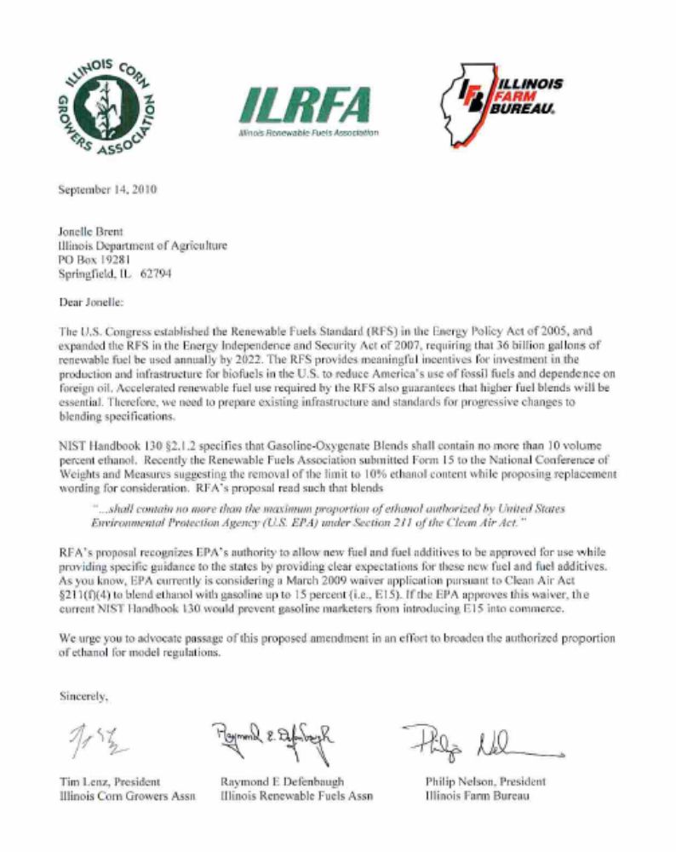

THIS PAGE INTENTIONALLY LEFT BLANK

